Appendix A. Supplementary Data

Improved sulfur dioxide resistance of the Mn/Fe-PILC catalyst by the doping of ceria in the selective catalytic reduction of NO with NH₃

Xinpeng Wangª, Qing Ye*ª, Wenyi Liuª, Fanwei Mengª, Fan Yangª, Xin Zhang^{b}, Hongxing Dai*^{c}

ª Key Laboratory of Beijing on Regional Air Pollution Control, Department of Environmental Science, Faculty of Environment and Life, Beijing University of Technology, Beijing 100124, China
^{b} State Key Laboratory of Heavy Oil Processing, China University of Petroleum, Beijing 102249, China
^{c} Beijing Key Laboratory for Green Catalysis and Separation, Key Laboratory of Beijing on Regional Air Pollution Control, and Laboratory of Catalysis Chemistry and Nanoscience, Department of Chemical Engineering, Faculty of Environment and Life, Beijing University of Technology, Beijing 100124, China

* Corresponding authors:
Prof. Qing Ye (E-mail address: yeqing@bjut.edu.cn)
Tel. No.: +8610-6739-1659; Fax: +8610-6739-1983

Prof. Hongxing Dai (E-mail address: hxdai@bjut.edu.cn)
Tel. No.: +8610-6739-6118; Fax: +8610-6739-1983
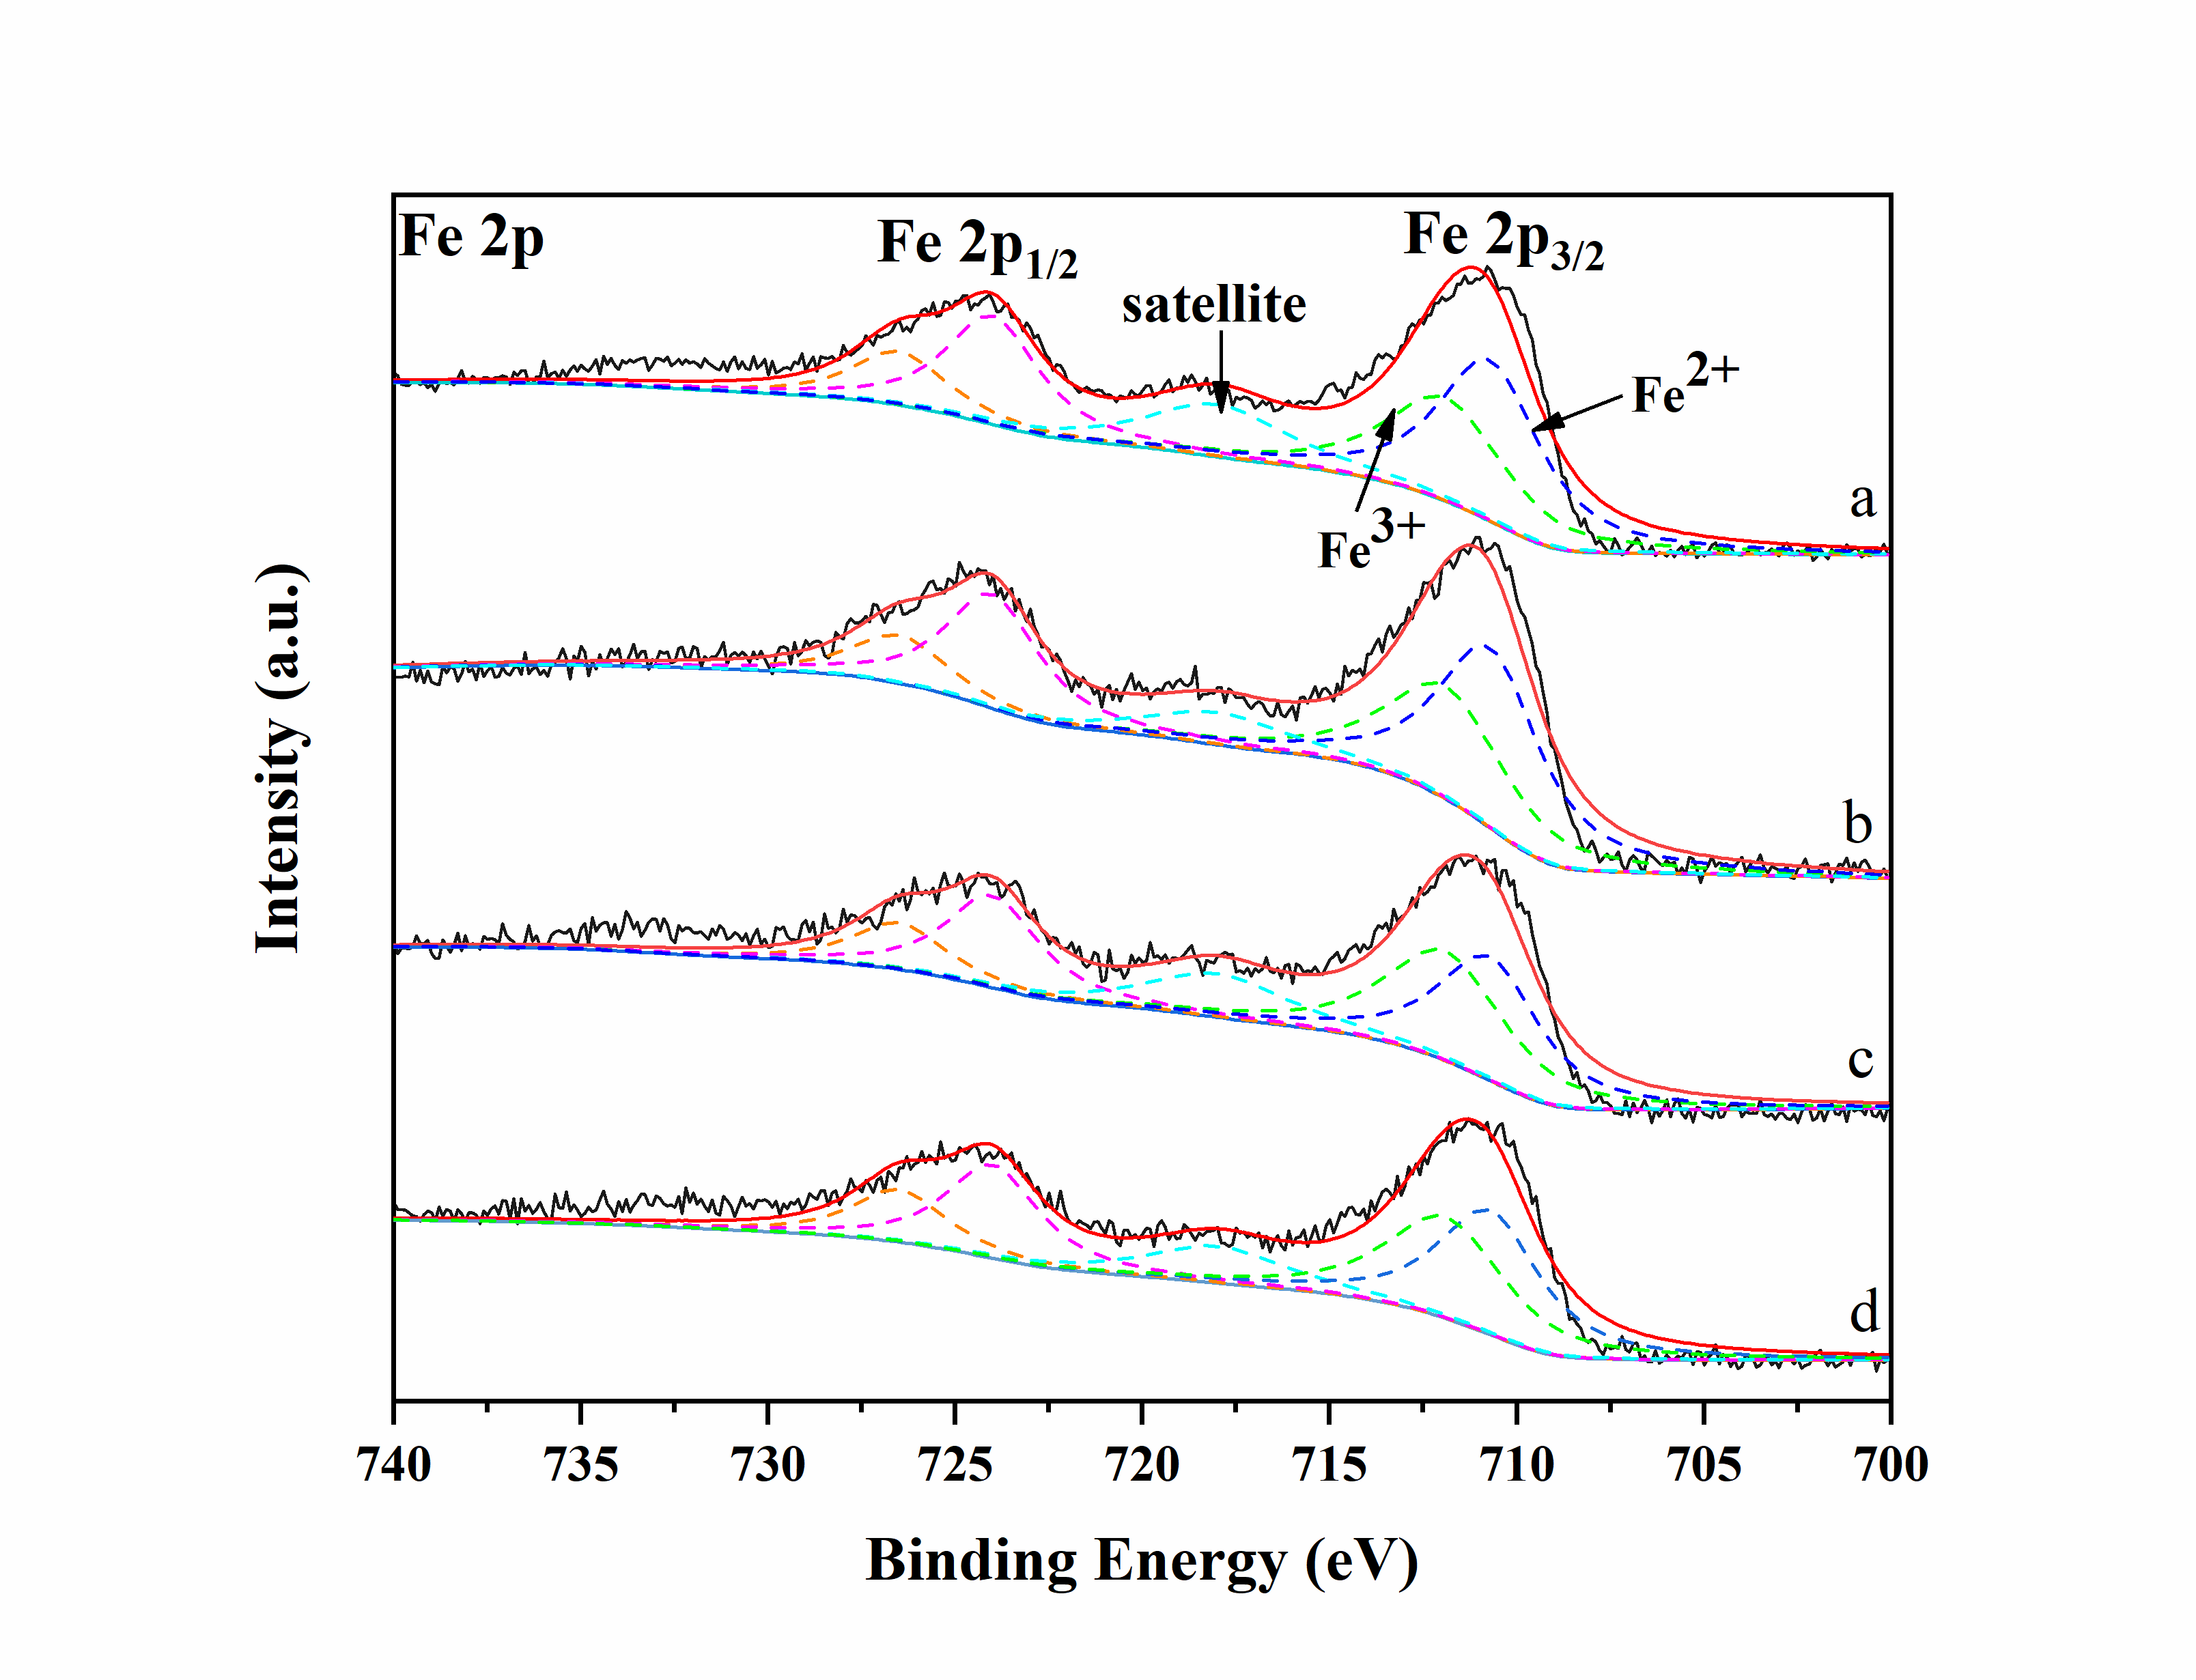
Fig. S1 Fe 2p XPS spectra of (a) 4Mn/Fe-PILC, (b) 4Mn/Fe-PILC-S, (c) 4Ce-4Mn/Fe-PILC, and (d) 4Ce-4Mn/Fe-PILC-S.

Fig. S2 Ce 3d XPS spectra of (a) 4Ce-4Mn/Fe-PILC, and (b) 4Ce-4Mn/Fe-PILC-S.

