Table S1. Characteristics of isolated strains.

Isolates | Mouse No. | Day | Species | Plasmid | ST type
Strain_1 | 13 | 1 | E. coli | IncI2 | 131
Strain_2 | 14 | 1 | E. coli | IncI2 | 131
Strain_3 | 16 | 1 | E. coli | IncI2 | 131
Strain_4 | 17 | 2 | E. coli | IncI2 | 131
Strain_5 | 17 | 7 | E. coli | IncI2 | 131
Strain_6 | 19 | 1 | E. coli | IncI2 | 131
Strain_7 | 16 | 2 | E. coli | IncI2 | 131
Strain_8 | 18 | 1 | E. coli | IncI2 | 131
Strain_9 | 18 | 2 | E. coli | IncI2 | 131

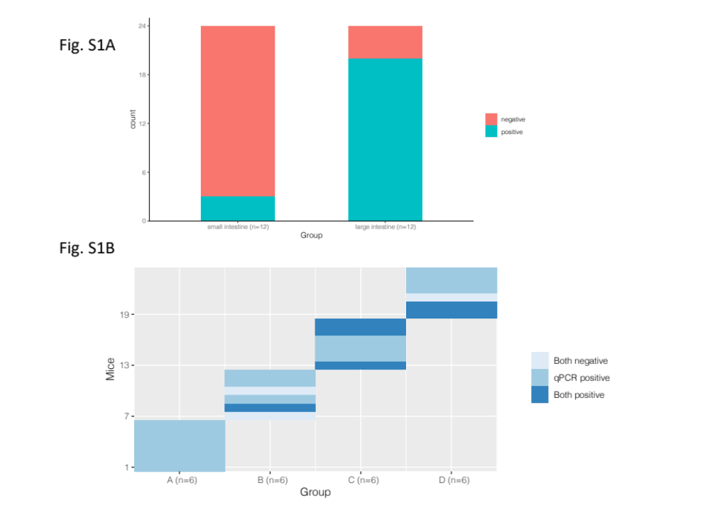
Figure S1. Positive number of successful colonization of MCRPEC or mcr-1 in mice under intestinal microbiota homeostasis. (A) in different segment of mouse intestine. (B) distribution of different mice by gavage times; group A, B, C, and D represent 1, 2, 3, and 4 gavage times, respectively.
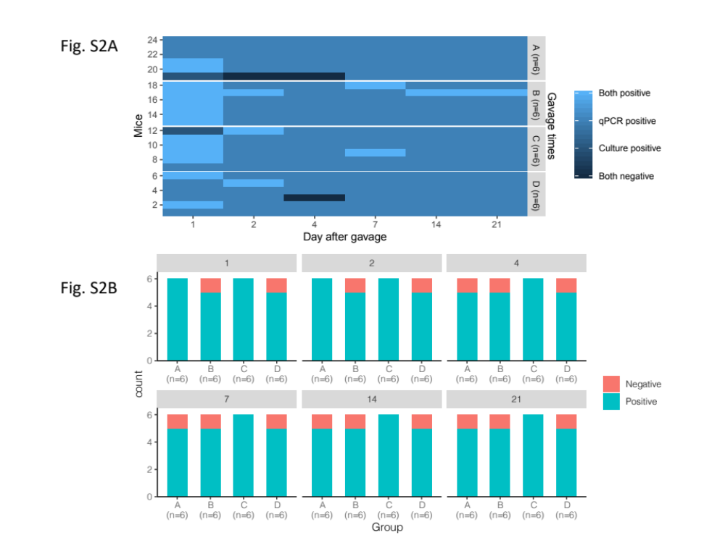
Figure S2. Positive number of successful colonizations of MCRPEC or mcr-1 on different days in mice under intestinal microbiota homeostasis. (A) distribution of different mice by days. (B) distribution of different gavage times and days. Group A, B, C, and D represent 1, 2, 3, and 4 gavage times, respectively.
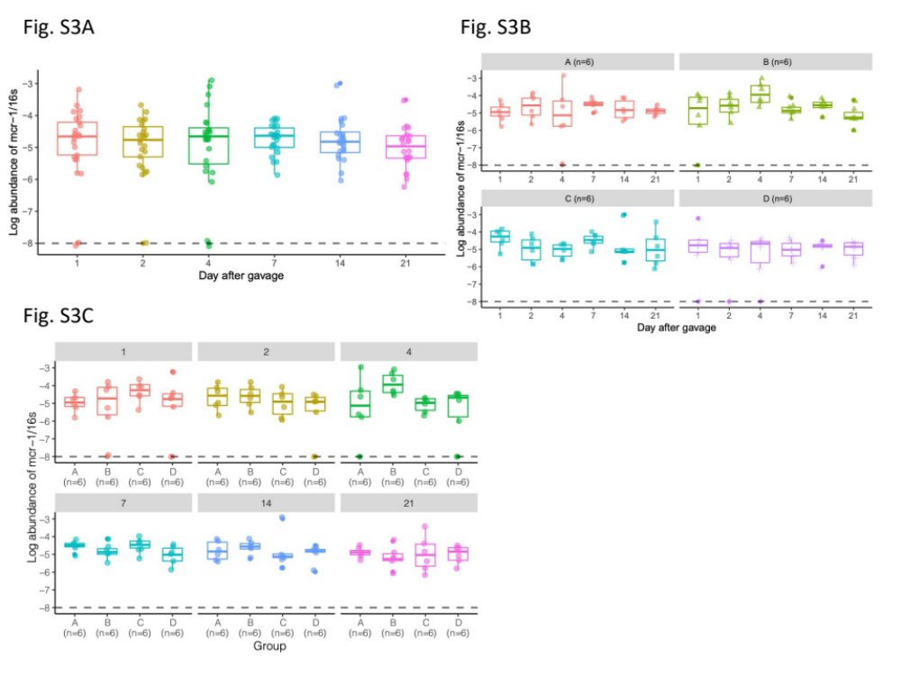
Figure S3. Dynamic abundances of mcr-1 on different days in mice under intestinal microbiota homeostasis. (A) all mice compared by different days (n=24). (B) compared by days. (C) compared by gavage times. Group A, B, C, and D represent 1, 2, 3, and 4 gavage times, respectively. Data are shown as box plots; the horizontal box lines represent the first quartile, the median, and the third quartile. Whiskers denote the range of points within the first quartile – 1.5× the interquartile range and the third quartile + 1.5× the interquartile range. Significant level was labelled with * (P < 0.05), ** (P < 0.01), and *** (P < 0.001), Kruskal-Wallis H test.
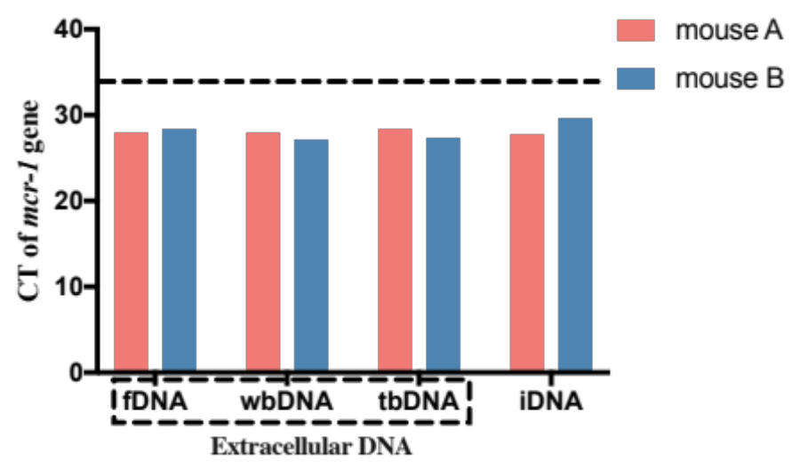
Figure S4. Detection of CT value of mcr-1 gene in extra- and intra-cellular DNA. Dotted line indicates detection of limitation of mcr-1 gene. fDNA: free extracellular DNA; wbDNA: weakly bound extracellular DNA; tbDNA: tightly bound extracellular DNA; iDNA: intracellular DNA.
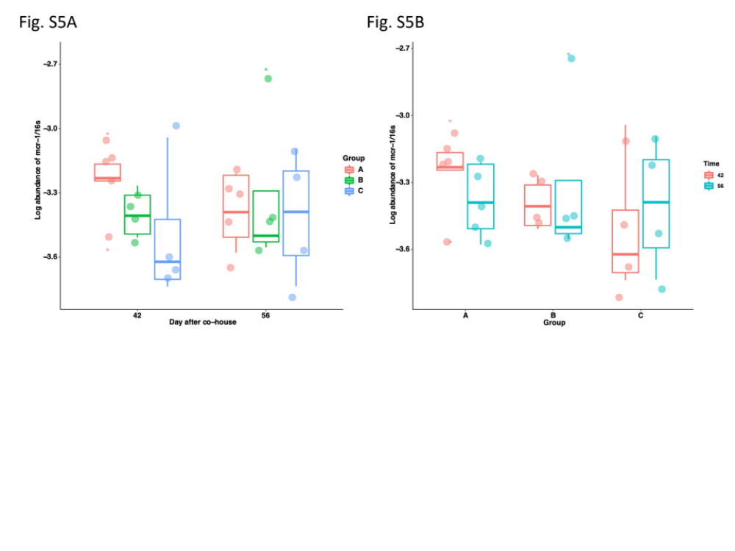
Figure S5. Dynamic abundances of mcr-1 in second stage of co-housing model. (A) compared by group. (B) compared by days. n=5, 4, and 4 of group A, B, and C respectively. Data are shown as box plots; the horizontal box lines represent the first quartile, the median, and the third quartile. Whiskers denote the range of points within the first quartile – 1.5× the interquartile range and the third quartile + 1.5× the interquartile range. Significant level was labelled with * (P < 0.05), ** (P < 0.01), and *** (P < 0.001), Kruskal-Wallis H test.

