Supporting Information for
C₃N Nanodots Impede Aβ Peptides Aggregation Pathogenic Path in Alzheimer's Disease

Xiuhua Yin^{1,2#}, Hong Zhou^{1#}, Mengling Zhang ^{2,5#}, Juan Su³, Xiao Wang ², Sijie Li³, Zaixing Yang^{1,3*}, Zhenhui Kang^{2,5}*, Ruhong Zhou^{1,4}*

- Institute of Quantitative Biology, Shanghai Institute for Advanced Study, College of Life Sciences, Zhejiang University, Hangzhou 310027, China
- Jiangsu Key Laboratory for Carbon-based Functional Materials and Devices, Institute of Functional Nano and Soft Materials (FUNSOM), Soochow University, Suzhou 215123, China
- State Key Laboratory of Radiation Medicine and Protection, School for Radiological and Interdisciplinary Sciences (RAD-X), Soochow University, Suzhou 215123, China
- Department of Chemistry, Columbia University, New York, New York 10027, United States;
- Macao Institute of Materials Science and Engineering (MIMSE), MUST−SUDA Joint Research Center for Advanced Functional Materials, Macau University of Science and Technology, Taipa 999078, Macao, China.

#These authors contribute equally.
*Corresponding authors: rhzhou@zju.edu.cn (R. Zhou); zhkang@suda.edu.cn (Z. Kang); zxyang@suda.edu.cn (Z. Yang)

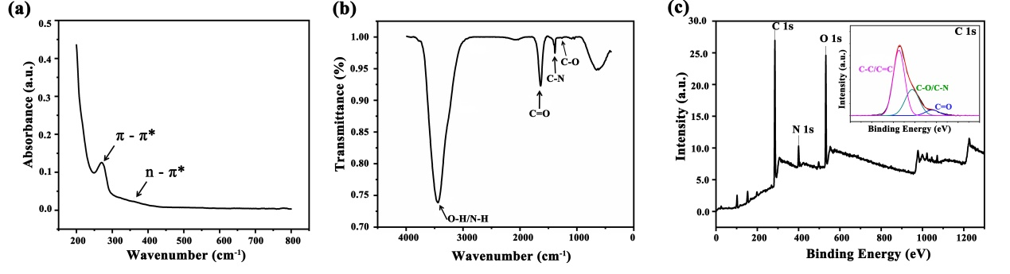
Figure S1. Characterization of C₃N nanodots. (a) UV-vis spectrum, (b) Fourier transform infrared spectrum, and (c) X-ray photoelectron spectroscopy of C₃N nanodots.
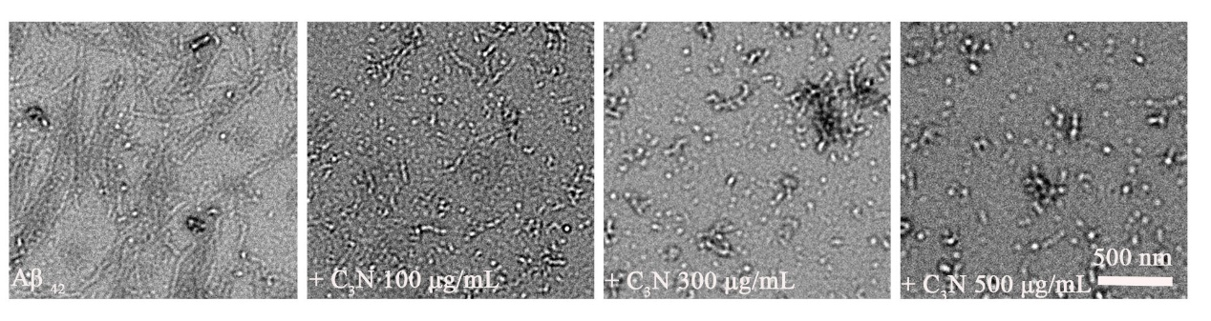
Figure S2. TEM images of Aβ₄₂ peptides treated with/without C₃N nanodots at different concentrations for 24 hours.
Figure S3. (a) C₃N model and (b) the initial Aβ₄₂ structure (PDB ID: 1Z0Q) used in the molecular dynamics simulations.
Figure S4. Time evolutions of the secondary structure of Aβ₄₂ peptides (a) in the presence or (b) in the absence of C₃N nanodots. Three panels from top to bottom in each figure represent three independent runs of each system. Here, the secondary structures of each residue were assigned according to the DSSP definition⁵².
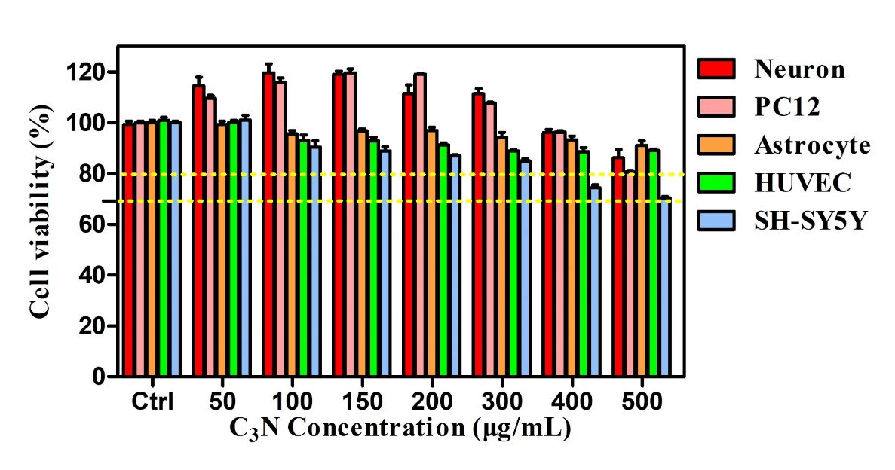
Figure S5. Cytotoxicity of C₃N nanodots on various cell lines for 24 hours by CCK-8 kit. n=5, data are shown as the mean ± SD.

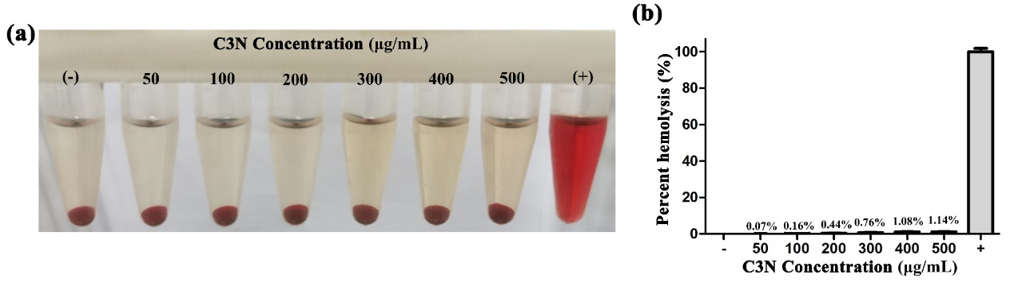
Figure S6. Hemolysis activity of C₃N nanodots. (a) The hemolysis activity of C₃N nanodots via direct observation of color changes of the RBC centrifuge supernatant after incubation with C₃N nanodots at different concentrations (50–500 µg/mL) under 37°C for 3 h. (+) and (−) symbols represented the positive and negative control, respectively. (b) Hemolysis ratio was calculated by spectrophotometric analysis of RBC centrifuge supernatant. Data are shown as the mean ± SD of three independent experiments.

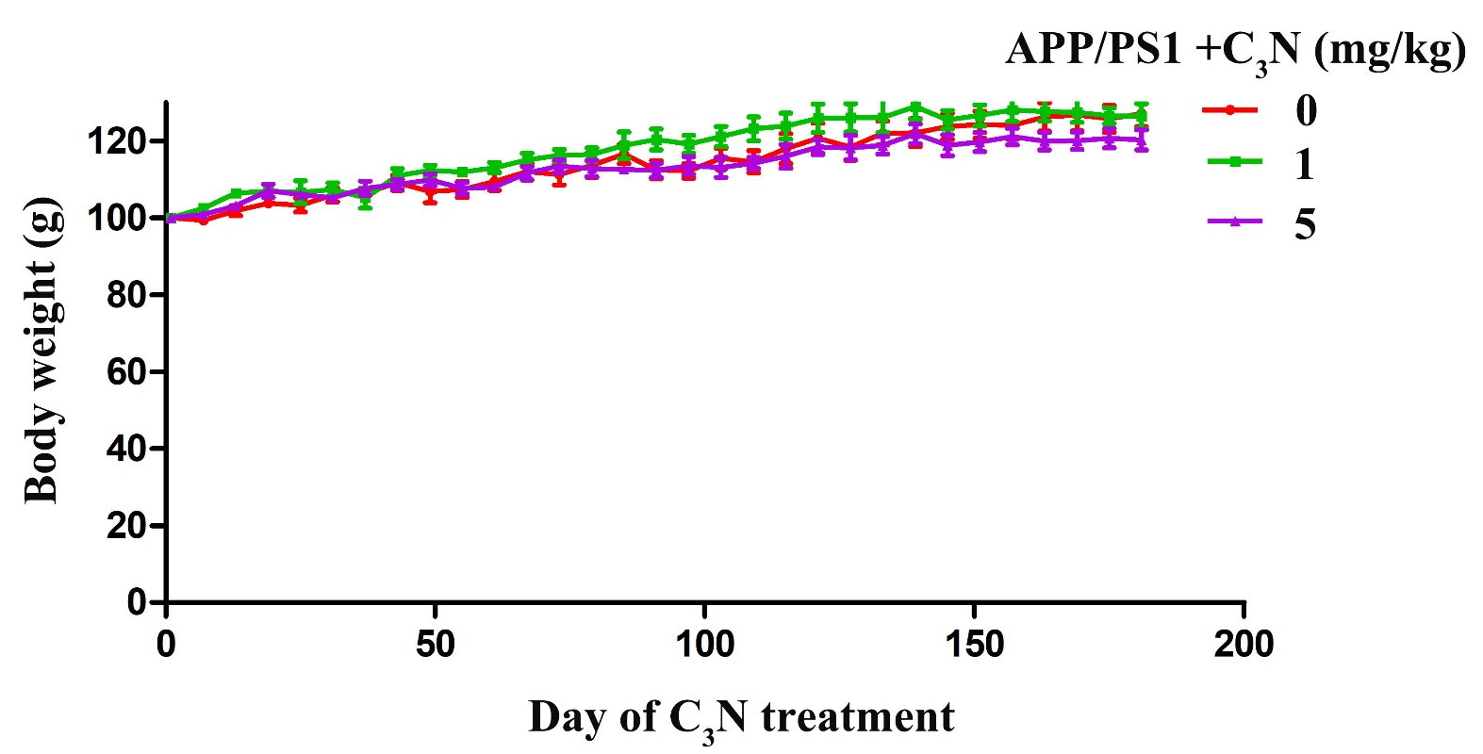
Figure S7. Monitoring changes in body weight of mice in each group during the entire C₃N nanodots administration period. Data are shown as the mean ± SD (n=6).
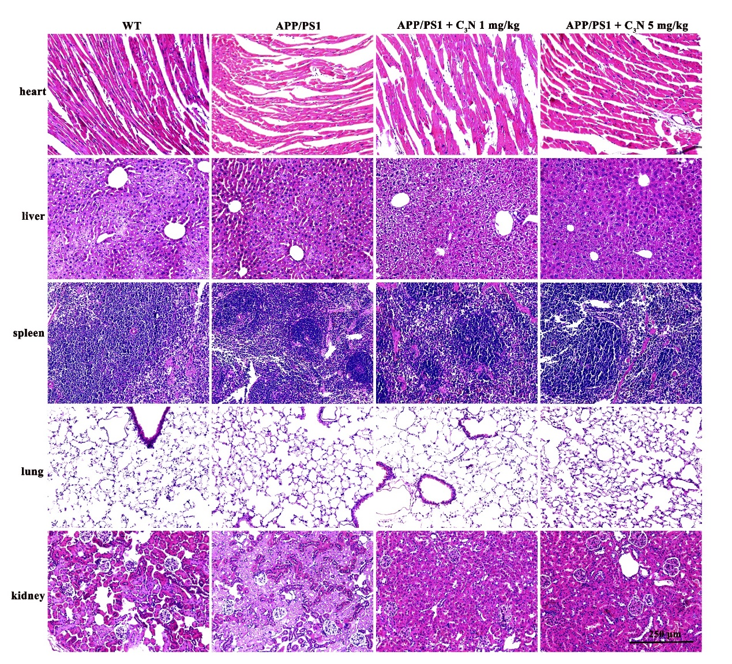
Figure S8. Histopathological (H&E) analyses of important organs of mice in each group.

