Supplementary Information

New constraints of terrestrial and oceanic global gross primary productions from the triple oxygen isotopic composition of atmospheric CO₂ and O₂

Mao-Chang Liang^{1*}, Amzad H. Laskar², Eugeni Barkan³, Sally Newman⁴, Mark H. Thiemens⁵, Ravi Rangarajan^{6*}
¹Institute of Earth Sciences, Academia Sinica, Taipei, Taiwan
²Physical Research Laboratory, Ahmedabad, Gujarat, India
³Institute of Earth Sciences, Hebrew University of Jerusalem, Jerusalem, Israel
⁴Division of Geological and Planetary Science, California Institute of Technology, Pasadena, California, USA; now at Bay Area Air Quality Management District, San Francisco, USA
⁵Department of Chemistry and Biochemistry, University of California at San Diego, La Jolla, California, USA
⁶St. John's Research Institute, Bengaluru, Karnataka, India
*To whom correspondence should be addressed: mcl@gate.sinica.edu.tw, mthiemens@ucsd.edu

Leaf evapotranspiration for the triple-oxygen isotope variation in tropospheric CO₂
Exchanging oxygen isotopes with water is the major process in determining CO₂ fluxes from the biosphere/hydrosphere. The associated λ is well defined experimentally^{1,2} and the fluxes (e.g., the terrestrial flux - the cycling flux between the terrestrial biosphere and atmosphere, inferred from the oxygen isotopic composition of CO₂) can then be constrained (cf.³). Given that the carbon flux estimation presented in this paper is based on the deviations of the oxygen anomalies of reservoirs/processes from those measured in atmospheric CO₂, it is natural to take the λ value best describing the variation of the triple-oxygen isotopic partitioning in tropospheric CO₂. Processes that affect CO₂ isotopocules in the troposphere are terrestrial, oceanic, and anthropogenic, with the first being dominant (e.g., see Figure 4B of Liang et al. ⁴ for their relative importance). In the terrestrial biosphere, leaf water largely governs the oxygen isotope composition of CO₂ (ref.⁵⁻¹¹). The leaf water isotopic composition is known to be affected by evaporation at reduced relative humidity. It has been found previously that the evapotranspiration λ value in water oxygen isotopic systematics is a strong function of ambient air relative humidity¹², whereas dependence on other meteorological variables such as temperature and soil water isotopic composition has not been observed. We set λ = 0.516, as it represents the evapotranspiration λ at 75% relative humidity, a globally averaged humidity near the surface¹³. The regions where vegetation is dense generally have relative humidity 75±5% (ref.¹³), corresponding to λ = 0.5160±0.0004 (with all possible errors included; re-calculated from Landais et al. ¹², following the linear definition of λ defined in the main text). As a result, we take 0.516 as our reference value.
Indeed, from the CO₂ data acquired in the western Pacific (with a total of 327 good measurements, after excluding one outlier having an extremely low Δ¹⁷O value of -0.025 ‰), the linear regression yields a slope of 0.516±0.002 in the δ¹⁷O versus δ¹⁸O plot, conforming with the average relative humidity of 76±4% in the region. Sensitivity tests show that a shift of 0.001 in λ does not impact the finally derived tGPP much; a change of +0.001 in λ at ~0.516 yields a change of +8 PgC/yr in tGPP, or ~24 PgC/yr in the terrestrial gross flux, F_{t} which reduces the recycling time τ by 0.06 year.

Sensitivity of the terrestrial and oceanic processes in the CO₂ cycling
The sensitivity of the terrestrial and oceanic processes can be assessed following equation (2) of the main text. That is,
$\sum_{i}{F_{i}}×(Δ^{17}O_{i}-Δ^{17}O)=0$ (S3)
where “i” is the individual process being evaluated. In general, the greater the abs(Δ¹⁷O_{i} - Δ¹⁷O) value, the higher the sensitivity of the derived F_{i} to the process “i.” As a result, the anthropogenic is the most sensitive process and oceanic the least, a consequence of mass balance of the Δ¹⁷O isoflux. Overall, terrestrial processes are roughly equally sensitive. For example, with a reduction of 100 PgC/yr in soil invasion, to maintain the same level of the isoflux from the terrestrial biosphere, one has to increase either respiration by 100 PgC/yr, or leaf retroflux by 74 PgC/yr. For oceanic, the increase is 333 PgC/yr, in order to balance the reduction of isoflux from the terrestrial biosphere. For anthropogenic CO₂, the increase is 21 PgC/yr only. The above exercise clearly demonstrates the sensitivity of the triple-oxygen isotope approach to the overall terrestrial processes, but the total budget is less sensitive to a particular biological process in the terrestrial biosphere due to the common source of water, meteoric water. A bar chart of the sensitivity is shown in Figure 3 of the main text.

Evenness of the intra- and inter-hemispheric Δ¹⁷O in CO₂
Here, we estimate the spatial homogeneity of annually averaged Δ¹⁷O values and discuss how intra- and inter-hemispheric transport affects the terrestrial gross flux F_{t} and tGPP. The tropospheric mixing time in each hemisphere ranges from 2-3 weeks to ~4 months¹⁴. Largely affected by Hadley circulation, it is known that the exchange of air masses across ~30° latitude is inefficient and the efficiency of the mixing is seasonally dependent. As a result, the exchange time varies between ~0.3 and 4 months, with an average of ~3 months¹⁴; see also Figure S1 for the horizontal wind of the northern hemisphere of the order of 1 m s⁻¹, implying the mixing time is about a few months. Within each latitude bin (0-30° and 30-90°), the mixing time is in general less than 3 weeks, in either hemisphere. Inter-hemispheric mixing time is about 1.1 years^{14,15}. With these time scales, along with the oxygen isotope turnover time, the spatial homogeneity of Δ¹⁷O in CO₂ can be estimated, even before an extensive set of global data comes available.
To start, we adopt the carbon cycling model results from the National Center for Atmospheric Research Community Climate System Model coupled with the Community Land Model 4.0 (CLM4) for 20th century runs¹⁶; there are 30 ensemble runs. The main reason for this model to be selected for comparison is that the model generates tGPP of 147 PgC/yr, one of highest values among the IPCC AR5 models^{16,17}, closer to the new estimate derived in this work and reported by Welp et al. ³. The model can also produce a reasonable global response of the terrestrial biosphere to the changing climate reflected in temperature, precipitation, and atmospheric CO₂ level (see Piao et al. ¹⁸ for details).
We first estimate the difference in Δ¹⁷O in CO₂ between the hemispheres. The respective Δ¹⁷O budget, expanded from equation (S2) for each hemisphere (N denotes the northern hemisphere and S the southern hemisphere), following Hoag et al. ¹⁹, can be written as follows.
$\sum_{i}{F_{N,i}}×\left(Δ^{17}O_{i}-Δ^{17}O_{N}\right)+\frac{M_{S}}{τ_{h}}×(Δ^{17}O_{S}-Δ^{17}O_{N})=0$ (S1)
$\sum_{i}{F_{S,i}}×\left(Δ^{17}O_{i}-Δ^{17}O_{S}\right)+\frac{M_{N}}{τ_{h}}×(Δ^{17}O_{N}-Δ^{17}O_{S})=0$, (S2)
where M_{N} (give value) and M_{S} (give value) are the CO₂ mass loading of each hemisphere and τ_{h} the inter-hemispheric mixing time of 1.1 year. Using the tGPP obtained by CLM4 (northern tGPP is 84 PgC/yr and southern tGPP is 63 PgC/yr), the hemispheric Δ¹⁷O difference is 0.025 ‰, assuming absence of inter-hemispheric transport. Including the 1.1 year inter-hemispheric mixing time, the difference reduces to 0.006 ‰ (=0.025 ‰ × e^{-(1.5 year)/(1.1 year)}, at 1.5 year global oxygen isotope recycling time, τ). This difference would increase our best estimated τ by 0.04 year, much less than the error of 0.2 year reported in the main text. Here, we have assumed that the cross-tropopause exchange is the same between the hemispheres e.g., see Škerlak et al. ²⁰.
We next estimate how intra-hemispheric transport and mixing affects the Δ¹⁷O values of atmospheric CO₂. Given that the mixing time (<3 weeks) in each latitude bin is much less than the derived oxygen isotope residence time (1.2 years, derived in this work versus as short as 0.4 year reported by Welp et al. ³ in the northern hemisphere), the Δ¹⁷O inhomogeneity is less than e^{-(0.4 years)/(3 weeks)} = 0.1 %. The largest contrast comes from the cross 30° latitude transport in the northern hemisphere. If the most conservative value of the oxygen isotope residence time of 0.4 year from Welp et al. ³ is taken, the percentage difference of Δ¹⁷O between 0-30° and 30-90° is e^{-(0.4 year)/(3 months)} = 37 %. We then take the tGPP and soil respiration values from the CLM4 model and assume soil invasion is the same as soil respiration (the most active soil invasion scenario reported by Wingate et al. ⁹). The estimated Δ¹⁷O difference is about 0.1 ‰, or (0.1 ‰ ×37 %) = 0.037 ‰ after considering cross 30° latitude transport; the value at the low latitude band is lower than that at the high latitude band (a consequence of upwelling air transport at low latitudes due to Hadley cell circulation and downwelling transport of air masses from the stratosphere at high latitudes; e.g., see Holton et al. ²¹ and Škerlak et al. ²⁰ for details). Such difference, however, has not been found. Instead, high latitude data from Hofmann et al. ²² show a lower value (by ~0.05 ‰) compared to lower latitude data; the data of Hofmann et al. ²² may be subject to some unknown systematic biases, and as a result, that conclusion of the high latitude depletion needs to be further verified. However, careful examination shows that Taiwan and SCS are likely in the low latitude band (0-30°), whereas Israel and USA are in the high latitude band. This separation is supported by the cross-tropopause exchange pattern analyzed and obtained by Škerlak et al. ²⁰. Within error, no statistically meaningful difference between the two bands is observed (see Table 1 of the main text). If an error of 0.01 ‰ is assumed for the difference, the inferred oxygen isotope turnover time is 0.9 year in the northern hemisphere, consistent with the time of 1.2 year reported in the main text.
In short, our model predicts a negligible difference (<0.01 ‰) in annually averaged Δ¹⁷O between latitudes and between hemispheres, the same conclusion reported earlier by Hoag et al. ¹⁹.

Terrestrial gross primary productivity, tGPP
Plant uptake scenarios affect the estimates of GPP and soil invasion. GPP can be estimated as follows:
$0.88×GPP = \frac{F_{t}- F_{s}}{θ_{eq}κ_{c}+1}$, (S4)
where F_{s} is soil invasion, θ_{eq} represents the degree of hydration of CO₂ inside stomata, and κ_{c} is a measure of stomatal conductance which can be expressed by
κ_{c} = C_{c}/(C_{a} – C_{c}), (S5)
where C_{c} is the CO₂ concentration in chloroplasts at the site of CO₂ hydration and C_{a} is the atmospheric concentration. The factor 0.88 is used to account for leaf respiration²³. For C₃ plants, C_{c}/C_{a} = 2/3; for C₄ plants, C_{c}/C_{a} = 1/3, assuming that C_{c} is equal to intracellular CO₂ concentration²⁴. A globally averaged C_{c}/C_{a} is 0.57 or κ_{c} = 1.33 (ref.^{3,11}). θ_{eq}, however, is variable^{11,24} and a currently globally averaged value is 0.78 (ref.¹¹). Sensitivity analysis shows that over the range of κ_{c} bound between C₃ and C₄ plants, the change in tGPP is -4 PgC/yr for every 0.1 increase in κ_{c}; the calculation is done at θ_{eq} of 0.78. The sensitivity is -8 PgC/yr per 0.1 increase in θ_{eq}; the calculation is performed at κ_{c} = 1.33. It was pointed out previously²⁴ that the current estimate of θ_{eq}, reported by Gillon and Yakir ¹¹ is likely overestimated, but we think the overestimation is not too much, given the extent of global C₄ plants compared to C₃ plants. A likely range of globally averaged θ_{eq} is ~0.6-0.7, which corresponds to the value of tGPP of ~175-185 PgC/yr.
Another factor mentioned above is the selection of λ. At λ ≈ 0.516, the sensitivity to the tGPP is +8 PgC/yr per +0.001 change. The dependence is not linear; the higher the value of λ, the larger the sensitivity of tGPP (and τ) to λ. At λ ≈ 0.520-0.523, the sensitivity increases to +16 PgC/yr, doubling the sensitivity of that at λ ≈ 0.516. The higher sensitivity is because of the equilibration slope of water-CO₂ in the dual-oxygen isotope space, which is 0.5229. At λ of 0.518, κ_{c} of 1.33, and θ_{eq} of 0.7, the tGPP value is 200 PgC/yr.
Overall, based on the assessments presented above, a choice of λ value between 0.516 and 0.518 for describing the Δ¹⁷O budget is reasonable, and θ_{eq} value around 0.7 is preferred. The selection yields a best estimate of tGPP of ~170-200 PgC/yr.

Global primary productivity
Utilization of the triple-oxygen isotopic composition of molecular oxygen in the atmosphere for GPP has been established ²⁵. Unlike CO₂, O₂ does not exchange isotopes with water in a traditional way. During photosynthetic biomass production, O₂ preserves its isotopic composition before getting modified by respiration, following a well-defined slope in the triple-oxygen isotope plot. Following the exact analytical formula for GPP, the globally averaged O₂ GPP at steady state can be written as follows:
GPP×(δ¹⁷O_{p} – 0.516×δ¹⁸O_{p}) + F_{st}×(δ¹⁷O_{st} – 0.516×δ¹⁸O_{st}) = 0, or (S6)
GPP×Δ¹⁷O_{pe} + F_{st}×Δ¹⁷O = 0, (S7)
where δ¹⁷O_{pe} and δ¹⁸O_{pe} are the effective photosynthetic O₂ delta values from the biosphere and δ¹⁷O_{st} and δ¹⁸O_{st} are the values for O₂ from the stratosphere; all the delta values are referenced with respect to tropospheric O₂. The coefficient 0.516 is taken from the recommendation of Luz and Barkan ²⁶. The value of F_{st}×(δ¹⁷O_{st} – 0.516×δ¹⁸O_{st}) is taken from Liang et al. ²⁷ derived for the CO₂ Δ¹⁷O isoflux across the tropopause. Assuming steady state in CO₂-O₃-O₂ coupled chemistry, the positive Δ¹⁷O isoflux in CO₂ is balanced by the negative Δ¹⁷O isoflux in O₂. The latter is then balanced by a positive isoflux from the biosphere.
GPP can be written as functions of tGPP and oGPP, i.e.,
GPP×Δ¹⁷O_{pe} = tGPP×Δ¹⁷O_{p,t} + oGPP×Δ¹⁷O_{p,o} (S8)
The values of δ¹⁷O_{p} and δ¹⁸O_{p} taken from Luz and Barkan ²⁶ are -10.126 ‰ and -20.014 ‰, respectively, with respect to VSMOW water. The actual values include substrate water Δ¹⁷O. That is,
Δ¹⁷O_{p,t} = Δ¹⁷O_{p} + Δ¹⁷O_{mw} = 0.149 ‰
Δ¹⁷O_{p,o} = Δ¹⁷O_{p} + Δ¹⁷O_{o} = 0.202 ‰
The final GPP depends on the partition of tGPP and oGPP. Assuming equally partitioned²⁸, GPP is 283±30 PgC/yr (the error is mainly from the measurement uncertainties in terrestrial and oceanic waters). If we take the derived tGPP from the main text, the GPP increases to 293 PgC/yr. If Δ¹⁷O_{p} is the same as the substrate water value, the GPP increases further to 335 PgC/yr. We think it is more reasonable to use the same photosynthetic O₂ delta values as the marine ones²⁶ for terrestrial photosynthetic O₂. Therefore, the value of 293 PgC/yr should be taken. The sensitivity of the GPP to the tGPP/GPP ratio is insignificant. Changing the ratio of tGPP/GPP from 0.5 to 0.9 changes the GPP value weakly from 283 PgC/yr to 321 PgC/yr.

Table S1: VSMOW2-CO₂ equilibration at 25 °C, determined following Liang et al. ⁴. The values of δ¹⁷O are calculated using the scale determined and adopted previously^{4,29}.
No. | δ¹⁷O (‰) | δ¹⁸O (‰) | ¹⁷α | ¹⁸α | ln(¹⁷α)/ln(¹⁸α)
1 | 21.348 | 41.159 | 1.02135 | 1.04116 | 0.5237
2 | 21.361 | 41.159 | 1.02136 | 1.04116 | 0.5240
3 | 21.373 | 41.232 | 1.02137 | 1.04123 | 0.5234
4 | 21.384 | 41.180 | 1.02138 | 1.04118 | 0.5243
5 | 21.394 | 41.220 | 1.02139 | 1.04122 | 0.5241
6 | 21.365 | 41.180 | 1.02137 | 1.04118 | 0.5239
7 | 21.450 | 41.328 | 1.02145 | 1.04133 | 0.5241
8 | 21.455 | 41.328 | 1.02146 | 1.04133 | 0.5242
9 | 21.387 | 41.232 | 1.02139 | 1.04123 | 0.5237
mean | 21.391 | 41.224 | 1.02139 | 1.04122 | 0.5239
SD | 0.038 | 0.065 | 0.00004 | 0.00007 | 0.0003
SE | 0.013 | 0.022 | 0.00001 | 0.00002 | 0.0001

Table S2: AS-2 CO₂ determined in Israel, following Barkan et al. ³⁰. The values of δ¹⁷O are determined using ¹⁷α of 1.021254 and ¹⁸α of 1.041036. ¹⁷Δ = ln(1+δ¹⁷O) – 0.516×ln(1+δ¹⁸O). Our Academia Sinica nominal ¹⁷Δ value is 0.161 ‰, obtained with calibration against a determined AS-1 reported by Liang and Mahata ³¹.
No. | δ¹⁷O (‰) | δ¹⁸O (‰) | ¹⁷Δ (‰)
1 | 18.857 | 36.61 | 0.128
2 | 18.859 | 36.61 | 0.131
3 | 18.863 | 36.61 | 0.134
4 | 18.858 | 36.61 | 0.129
5 | 18.854 | 36.61 | 0.125
mean | 18.858 | 36.61 | 0.129
SD | 0.003 | N/A | 0.003
SE | 0.001 | N/A | 0.001

Table S3: Summary of the new CO2 data obtained in this work from South China Sea (SCS), Israel, and Palos Verdes (PVD), provided in a separate supplementary table file.

Figure S1: Wind vectors and wind speed (color coded, in m/s) taken from NCEP/NCAR Reanalysis for year 2015 at 700, 850, 925, and 1000 mbar. Three different time periods are averaged: annual, January-June, and July-December.
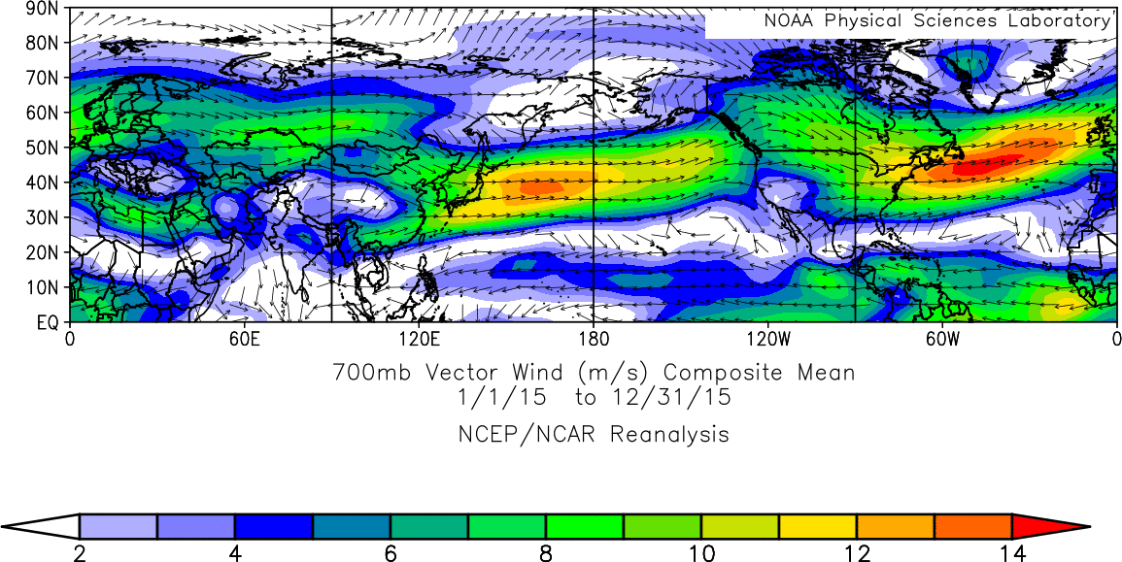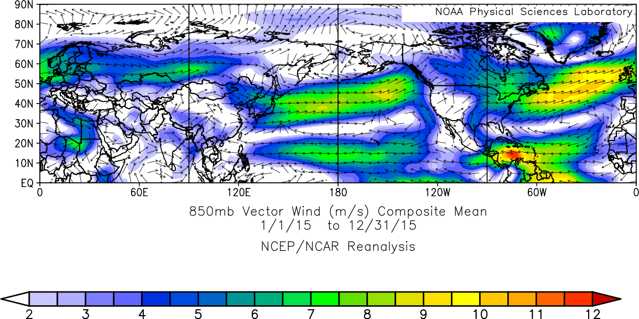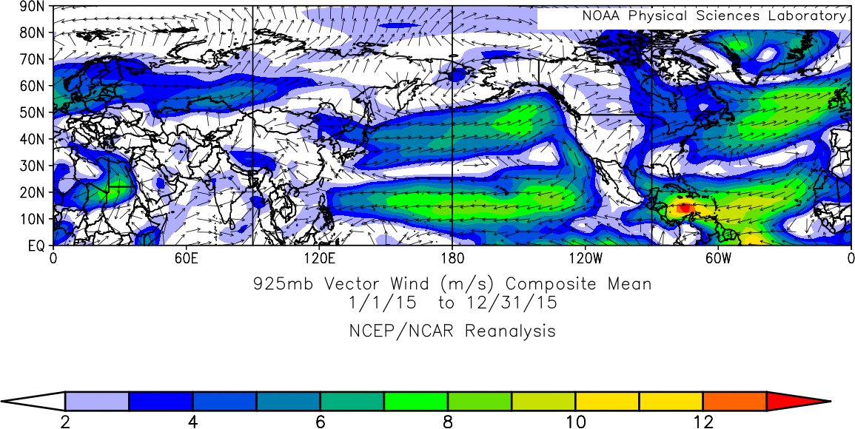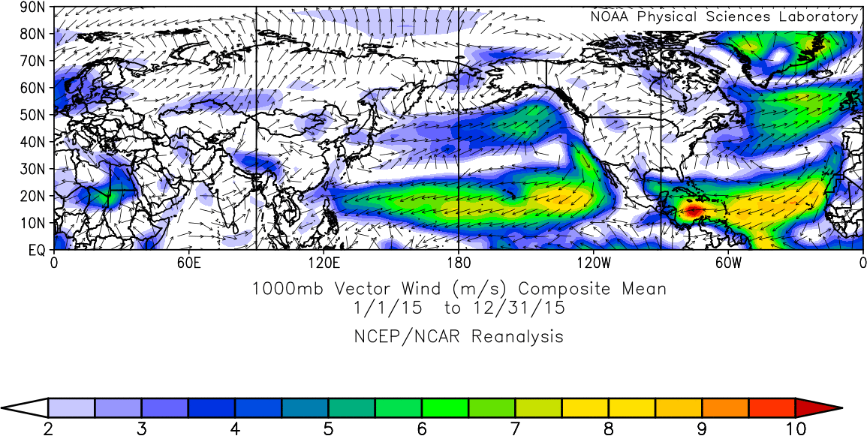

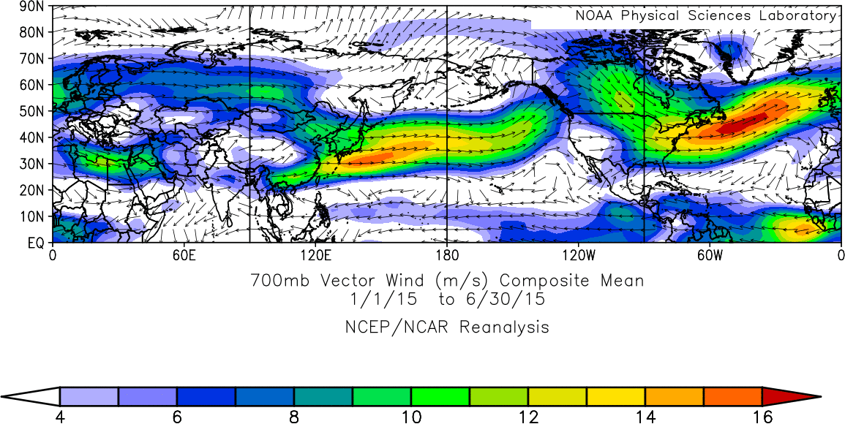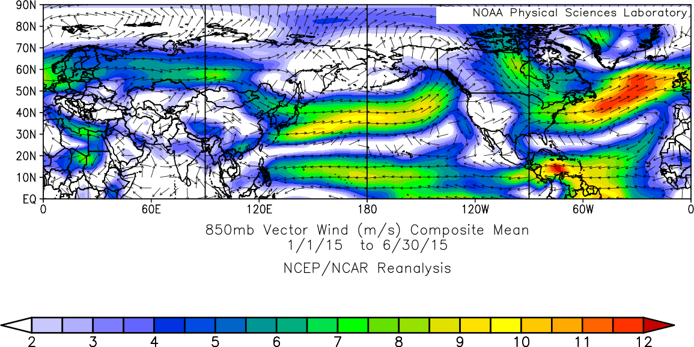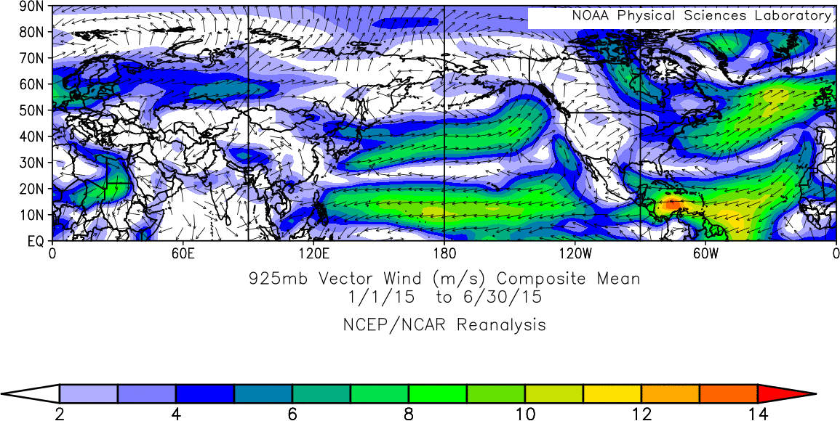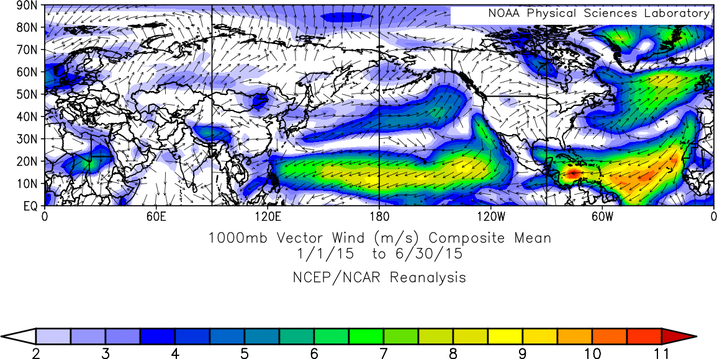

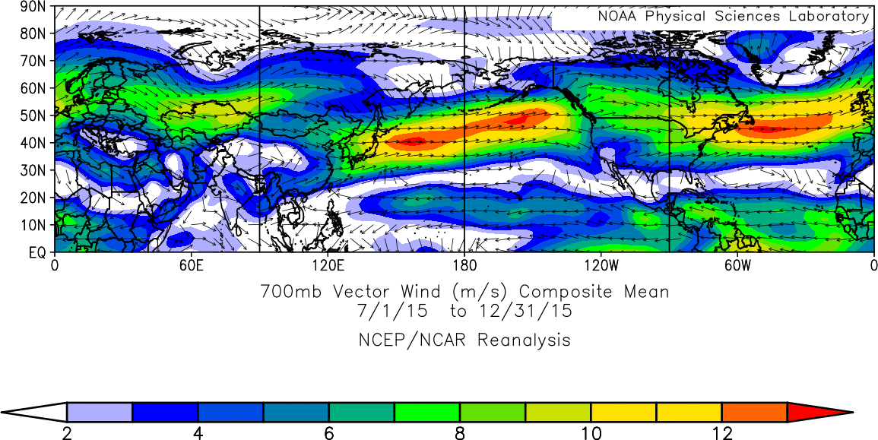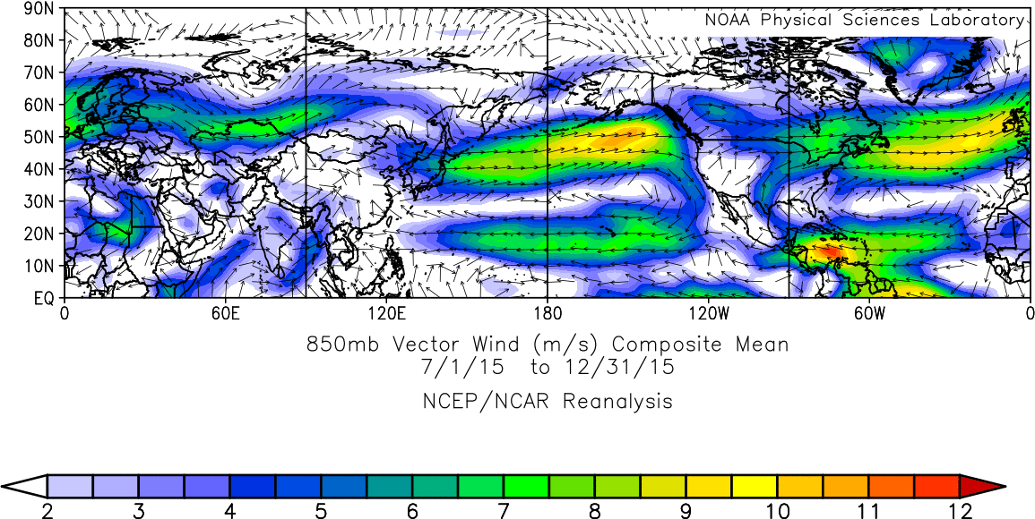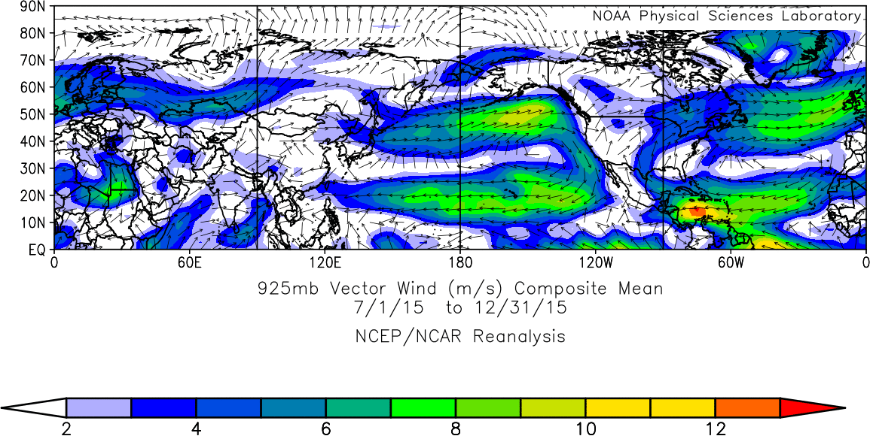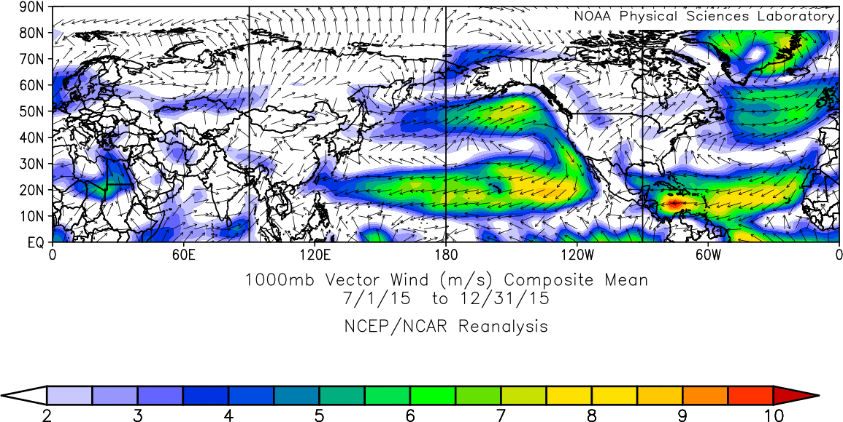
References
1 Barkan, E. & Luz, B. High‐precision measurements of ¹⁷O/¹⁶O and ¹⁸O/¹⁶O ratios in CO₂. Rapid communications in mass spectrometry 26, 2733-2738, doi:10.1002/rcm.6400 (2012).
2 Hofmann, M. E., Horváth, B. & Pack, A. Triple oxygen isotope equilibrium fractionation between carbon dioxide and water. Earth and Planetary Science Letters 319, 159-164, doi:10.1016/j.epsl.2011.12.026 (2012).
3 Welp, L. R. et al. Interannual variability in the oxygen isotopes of atmospheric CO₂ driven by El Niño. Nature 477, 579, doi:10.1038/nature10421 (2011).
4 Liang, M.-C., Mahata, S., Laskar, A. H., Thiemens, M. H. & Newman, S. Oxygen isotope anomaly in tropospheric CO₂ and implications for CO₂ residence time in the atmosphere and gross primary productivity. Scientific reports 7, 13180, doi:10.1038/s41598-017-12774-w (2017).
5 Ciais, P. et al. A three‐dimensional synthesis study of δ¹⁸O in atmospheric CO₂: 1. Surface fluxes. Journal of Geophysical Research: Atmospheres 102, 5857-5872 (1997).
6 Cuntz, M., Ciais, P., Hoffmann, G. & Knorr, W. A comprehensive global three‐dimensional model of δ¹⁸O in atmospheric CO₂: 1. Validation of surface processes. Journal of Geophysical Research: Atmospheres 108 (2003).
7 Francey, R. J. & Tans, P. P. Latitudinal variation in oxygen-18 of atmospheric CO₂. Nature 327, 495 (1987).
8 Stern, L. A., Amundson, R. & Baisden, W. T. Influence of soils on oxygen isotope ratio of atmospheric CO₂. Global Biogeochemical Cycles 15, 753-759, doi:Doi 10.1029/2000gb001373 (2001).
9 Wingate, L. et al. The impact of soil microorganisms on the global budget of δ¹⁸O in atmospheric CO₂. Proceedings of the National Academy of Sciences 106, 22411-22415, doi:10.1073/pnas.0905210106 (2009).
10 Farquhar, G. D. et al. Vegetation effects on the isotope composition of oxygen in atmospheric CO₂. Nature 363, 439 (1993).
11 Gillon, J. & Yakir, D. Influence of carbonic anhydrase activity in terrestrial vegetation on the ¹⁸O content of atmospheric CO₂. Science 291, 2584-2587, doi:10.1126/science.1056374 (2001).
12 Landais, A., Barkan, E., Yakir, D. & Luz, B. The triple isotopic composition of oxygen in leaf water. Geochimica et cosmochimica acta 70, 4105-4115, doi:10.1016/j.gca.2006.06.1545 (2006).
13 Dai, A. Recent climatology, variability, and trends in global surface humidity. Journal of Climate 19, 3589-3606, doi:Doi 10.1175/Jcli3816.1 (2006).
14 Lal, D. Characteristics of global tropospheric mixing based on man‐made C¹⁴, H³, and Sr⁹⁰. Journal of Geophysical Research 71, 2865-2874, doi:DOI 10.1029/JZ071i012p02865 (1966).
15 Jacob, D. J., Prather, M. J., Wofsy, S. C. & McElroy, M. B. Atmospheric distribution of ⁸⁵Kr simulated with a general circulation model. Journal of Geophysical Research: Atmospheres 92, 6614-6626 (1987).
16 Lawrence, D. M. et al. Parameterization improvements and functional and structural advances in version 4 of the Community Land Model. Journal of Advances in Modeling Earth Systems 3, doi:Artn M03001
10.1029/2011ms000045 (2011).
17 Stocker, T. F. et al. (Cambridge University Press Cambridge, 2013).
18 Piao, S. et al. Evaluation of terrestrial carbon cycle models for their response to climate variability and to CO₂ trends. Global change biology 19, 2117-2132, doi:10.1111/gcb.12187 (2013).
19 Hoag, K., Still, C., Fung, I. & Boering, K. Triple oxygen isotope composition of tropospheric carbon dioxide as a tracer of terrestrial gross carbon fluxes. Geophysical Research Letters 32, doi:Artn L02802
10.1029/2004gl021011 (2005).
20 Škerlak, B., Sprenger, M. & Wernli, H. A global climatology of stratosphere-troposphere exchange using the ERA-Interim data set from 1979 to 2011. Atmospheric Chemistry and Physics 14, 913-937 (2014).
21 Holton, J. R. et al. Stratosphere‐troposphere exchange. Reviews of geophysics 33, 403-439, doi:Doi 10.1029/95rg02097 (1995).
22 Hofmann, M. et al. Atmospheric measurements of Δ¹⁷O in CO₂ in Göttingen, Germany reveal a seasonal cycle driven by biospheric uptake. Geochimica et Cosmochimica Acta 199, 143-163 (2017).
23 Pearcy, R. & Ehleringer, J. Comparative ecophysiology of C₃ and C₄ plants. Plant, Cell & Environment 7, 1-13 (1984).
24 Cousins, A. B., Badger, M. R. & von Caemmerer, S. C₄ photosynthetic isotope exchange in NAD-ME-and NADP-ME-type grasses. Journal of Experimental Botany 59, 1695-1703 (2008).
25 Luz, B., Barkan, E., Bender, M. L., Thiemens, M. H. & Boering, K. A. Triple-isotope composition of atmospheric oxygen as a tracer of biosphere productivity. Nature 400, 547, doi:Doi 10.1038/22987 (1999).
26 Luz, B. & Barkan, E. Proper estimation of marine gross O₂ production with ¹⁷O/¹⁶O and ¹⁸O/¹⁶O ratios of dissolved O₂. Geophysical research letters 38 (2011).
27 Liang, M. C., Blake, G. A. & Yung, Y. L. Seasonal cycle of C¹⁶O¹⁶O, C¹⁶O¹⁷O, and C¹⁶O¹⁸O in the middle atmosphere: Implications for mesospheric dynamics and biogeochemical sources and sinks of CO₂. Journal of Geophysical Research: Atmospheres 113 (2008).
28 Field, C. B., Behrenfeld, M. J., Randerson, J. T. & Falkowski, P. Primary production of the biosphere: integrating terrestrial and oceanic components. science 281, 237-240, doi:10.1126/science.281.5374.237 (1998).
29 Mahata, S., Bhattacharya, S. & Liang, M. C. An improved method of high‐precision determination of Δ¹⁷O of CO₂ by catalyzed exchange with O₂ using hot platinum. Rapid Communications in Mass Spectrometry 30, 119-131 (2016).
30 Barkan, E., Musan, I. & Luz, B. High‐precision measurements of δ¹⁷O and ¹⁷O_{excess} of NBS19 and NBS18. Rapid Communications in Mass Spectrometry 29, 2219-2224 (2015).
31 Liang, M.-C. & Mahata, S. Oxygen anomaly in near surface carbon dioxide reveals deep stratospheric intrusion. Scientific reports 5, 11352, doi:10.1038/srep11352 (2015).

