Supplemental Table 1:

Table 1: Data collection and Refinement Statistics
Resolution range | 69.92- 2.69 (2.79 - 2.69)
Space group | C 1 2 1
Unit cell | 114.82, 48.41, 139.84 90, 90, 90,
Total reflections | 42346 (3533)
Unique reflections | 21228 (1773)
Multiplicity | 2.0 (2.0)
Completeness (%) | 97.54 (83.55)
Mean I/sigma(I) | 2.16 (0.57)
Wilson B-factor | 74.42
R-merge | 0.1147 (0.5649)
R-meas | 0.1622 (0.7989)
R-pim | 0.1147 (0.5649)
CC1/2 | 0.99 (0.395)
CC* | 0.997 (0.752)
Reflections used in refinement | 21226 (1773)
Reflections used for R-free | 1035 (95)
R-work | 0.2528 (0.3943)
R-free | 0.2937 (0.4384)
CC(work) | 0.843 (0.480)
CC(free) | 0.825 (0.394)
Number of non-hydrogen atoms | 4941
macromolecules | 4882
ligands | 21
solvent | 38
Protein residues | 350
RMS(bonds) | 0.007
RMS(angles) | 0.92
Ramachandran favored (%) | 95.95
Ramachandran allowed (%) | 4.05
Ramachandran outliers (%) | 0
Rotamer outliers (%) | 0.00
Clashscore | 9.53
Average B-factor | 91.81
macromolecules | 71.28
ligands | 83.52
solvent | 65.19

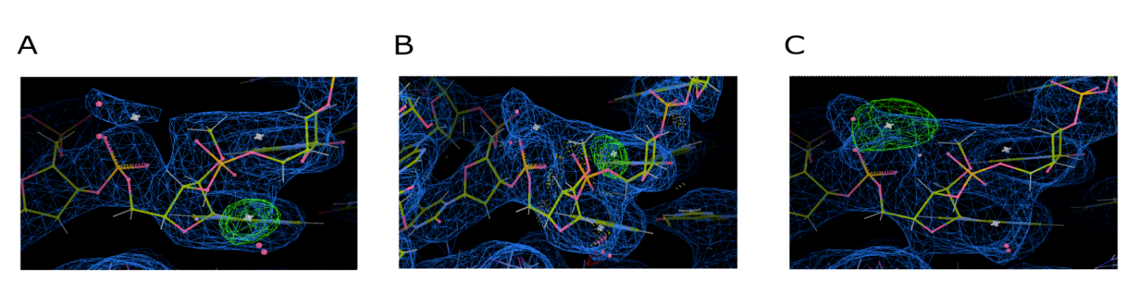
Supplemental Figure 1:

Supplemental Figure 1: Replacement of active site magnesium ions with sodium. Active site magnesium was replaced one by one with sodium and then run through a subsequent round of refinement. The positive peaks indicate the need for more electron density indicating that magnesium is appropriate at these sites. The replacements move from M1-3 (A-C respectively). FoFc σ= 4.0, 2FoFc σ= 1.0

Supplemental Figure 2:

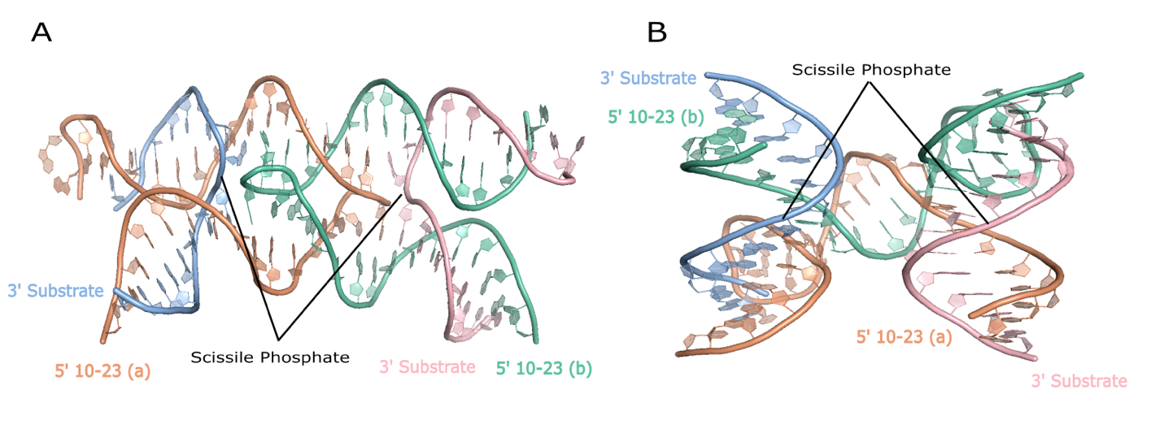
Supplemental Figure 2: Comparison to past 10-23 crystal structure. (A) current 10-23 DNAzyme crystal structure that showcases cis-binding of DNAzyme to substrate and a bend in the substrate strand at the catalytic core. (B) Past crystal structure of the 10-23 DNAzyme with trans-binding of the catalytic core to substrate and a linear substrate with no bending at the scissile phosphate.

