Supplementary Table 1 Data collection and refinement statistics
 | N49K_Na | N49K_Ca | L176Q^{NK}_Na | L176Q^{NK}_Ca | L176G^{NK}_Na | L176G^{NK}_Ca
PDB entry | 8H9O | 8H9W | 8H9X | 8H9Y | 8HA1 | 8HA2
Wavelength (Å) | 1.00
Resolution range(Å) | 29.2-3.3 (3.4-3.3) | 29.8-2.7 (2.8-2.7) | 28.8-3.4 (3.5-3.4) | 29.3-3.4 (3.5-3.4) | 29.7-3.5 (3.6-3.5) | 29.6-3.3 (3.4-3.3)
Space group | I 4 2 2
Unit cell (Å) | 127.8 127.8 200.9  90  90  90 | 128.0 128.0 202.1  90  90  90 | 127.3 127.3 202.8  90  90  90 | 127.9 127.9 201.9  90  90  90 | 126.9 126.9 201.8  90  90  90 | 127.1 127.1 200.6  90  90  90
Total reflections | 185745 (18472) | 613930 (60014) | 985401 (96603) | 1056926 (102926) | 427936 (43203) | 509789 (51498)
Unique reflections | 12883 (1260) | 23425 (1270) | 11812 (449) | 11874 (446) | 10747 (728) | 12718 (472)
Multiplicity | 14.4 (14.7) | 26.2 (26.2) | 83.4 (83.3) | 89.0 (89.7) | 39.8 (40.8) | 40.1 (41.8)
Completeness (%) | 99.66 (99.92) | 94.81 (55.41) | 91.84 (38.71) | 92.05 (38.85) | 96.59 (68.68) | 92.63 (38.31)
Mean I/sigma(I) | 24.82 (3.50) | 24.01 (1.44) | 14.08 (1.13) | 17.87 (1.18) | 20.78 (1.43) | 19.61 (1.54)
R_{merge} | 0.0670 (0.8552) | 0.0894 (2.63) | 0.8998 (20.46) | 0.5776 (8.902) | 0.183 (3.537) | 0.252 (3.206)
R_{pim} | 0.0186 (0.2298) | 0.0181 (0.5217) | 0.0988 (2.247) | 0.0612 (0.9409) | 0.0296 (0.5582) | 0.0403 (0.4995)
CC1/2 | 1 (0.945) | 0.999 (0.883) | 0.999 (0.701) | 0.999 (0.826) | 1 (0.56) | 1 (0.839)
R_{work} | 0.255 (0.300) | 0.250 (0.329) | 0.259 (0.324) | 0.249 (0.268) | 0.291 (0.462) | 0.262 (0.346)
R_{free} | 0.272 (0.260) | 0.264 (0.331) | 0.280 (0.406) | 0.261 (0.361) | 0.297 (0.490) | 0.284 (0.364)
Non-hydrogen atoms No. | 2376 | 2304 | 2298 | 2339 | 2301 | 2260
Macromolecules | 1842 | 1816 | 1813 | 1856 | 1815 | 1778
ligands | 517 | 470 | 472 | 472 | 472 | 472
solvent | 17 | 18 | 13 | 11 | 14 | 10
Protein residues | 225 | 222 | 222 | 228 | 223 | 218
RMS (bonds) | 0.012 | 0.009 | 0.012 | 0.010 | 0.004 | 0.010
RMS (angles) | 1.45 | 1.02 | 1.46 | 1.09 | 0.64 | 1.08
Ramachandran favoured (%) | 96.38 | 98.62 | 99.08 | 98.23 | 98.63 | 98.13
Ramachandran allowed (%) | 3.62 | 1.38 | 0.92 | 1.77 | 1.37 | 1.87
Ramachandran outliers (%) | 0.00 | 0.00 | 0.00 | 0.00 | 0.00 | 0.00
Average B-factor | 111.53 | 94.21 | 69.11 | 67.60 | 155.29 | 91.62
Macromolecules | 105.92 | 87.72 | 64.71 | 59.35 | 149.17 | 86.62
ligands | 132.49 | 120.09 | 86.53 | 100.70 | 179.65 | 111.18

Supplementary Table 2 The condition of molecular dynamics simulation
Figure legends
 | WT  no ECC |  | WT |  | L176Q |  | L176G |  | L176N |  | L176A
Sodium ion (mM) | 100 | 100 | 100 | 100 | 100 | 100 | 100 | 100 | 100 | 100 | 100 | 100
Calcium ion (mM) | - | 40 | - | 40 | - | 40 | - | 40 | - | 40 | - | 40
Calculation time (μsec) | 1.2 | 1.2 | 1.2 | 2.0 | 1.2 | 2.4 | 1.2 | 1.6 | 1.2 | 1.6 | 1.2 | 3.2
Sodium ions | 25 | 25 | 25 | 25 | 25 | 25 | 25 | 25 | 25 | 25 | 25 | 25
Calcium ions | - | 10 | - | 10 | - | 10 | - | 10 | - | 10 | - | 10
Chloride ions | 13 | 33 | 9 | 29 | 9 | 29 | 9 | 29 | 9 | 29 | 9 | 29
Water molecules | 13684 | 13684 | 13684 | 13684 | 13684 | 13684 | 13684 | 13684 | 13684 | 13684 | 13684 | 13684
Number of lipids | 210 | 210 | 210 | 210 | 210 | 210 | 210 | 210 | 210 | 210 | 210 | 210
No. of sodium ion permeation per 100nsec | 10.29 | 1.54 | 11.38 | 10.53 | 12.17 | 6.81 | 11.71 | 5.23 | 13.29 | 6.19 | 9.88 | 3.98
Standard deviation of permeation | 1.062 | 0.48 | 0.84 | 1.63 | 2.85 | 2.56 | 2.79 | 2.53 | 1.46 | 0.71 | 1.33 | 1.67
No. of calcium ion permeation per 100nsec | - | 0.08 | - | 1.28 | - | 0.69 | - | 1.20 | - | 1.56 | - | 0.66
Standard  deviation of permeation | - | 0.12 | - | 0.69 | - | 0.16 | - | 0.61 | - | 0.60 | - | 0.34

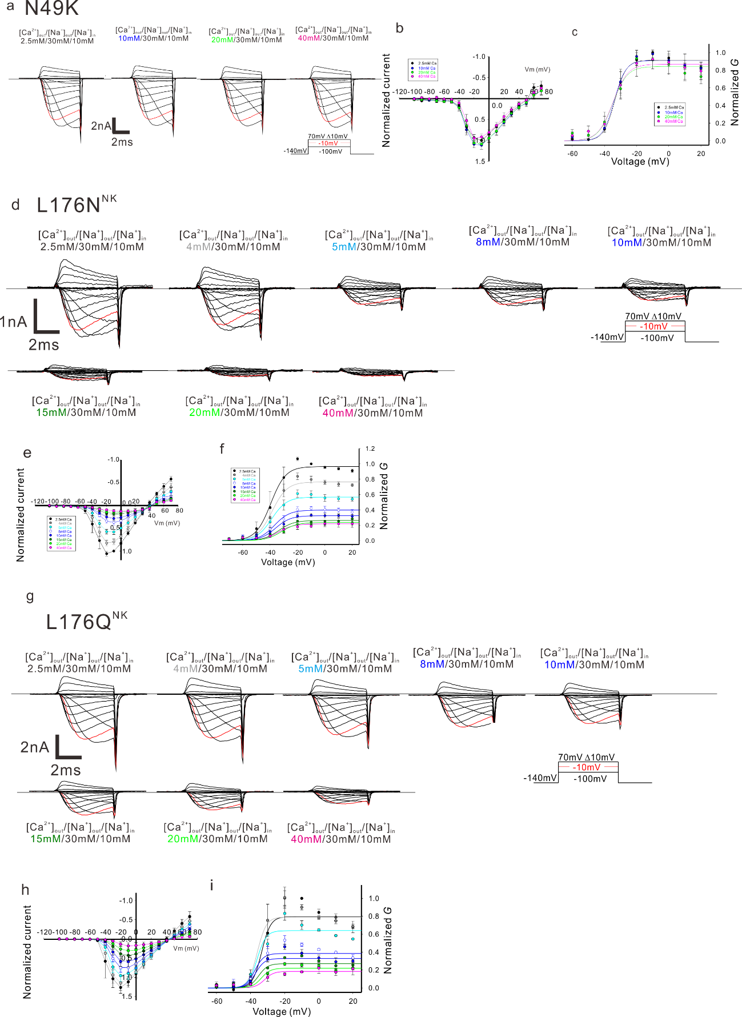Supplementary Figure 1. The current trace, peak current, and tail current of NavAb N49K, L176N^{NK}, and L176Q^{NK} mutants
a). Representative current traces to obtain the peak current and the deactivation tail current to evaluate the current-voltage relationship and the voltage-dependent activation of NavAb N49K mutant. b). Current-voltage relationships of NavAb N49K mutant measured under various extracellular Ca²⁺ concentration (n = 6). All values were normalized by the peak current generated by -10mV stimulation pulse under 2.5 mM extracellular Ca²⁺ condition. c). Normalized G curve of NavAb N49K mutant derived from the tail currents in various extracellular Ca²⁺ concentrations (n = 6). All values were normalized by the tail current generated by -10mV stimulation pulse under 2.5 mM extracellular Ca²⁺ condition. d) Representative current traces to obtain the peak current and the deactivation tail current to evaluate the current-voltage relationship and the voltage-dependent activation of NavAb L176N^{NK} mutant. e). Current-voltage relationships of NavAb L176N^{NK} mutant measured under various extracellular Ca²⁺ concentration (n = 5). All values were normalized by the peak current generated by -10mV stimulation pulse under 2.5 mM extracellular Ca²⁺ condition. f). Normalized G curve of NavAb L176N^{NK} mutant derived from the tail currents in various extracellular Ca²⁺ concentrations (n = 5). All values were normalized by the tail current generated by -10mV stimulation pulse under 2.5 mM extracellular Ca²⁺ condition. g) Representative current traces to obtain the peak current and the deactivation tail current to evaluate the current-voltage relationship and the voltage-dependent activation of NavAb L176Q^{NK} mutant. h). Current-voltage relationships of NavAb L176Q^{NK} mutant measured under various extracellular Ca²⁺ concentration (n = 3). All values were normalized by the peak current generated by -10mV stimulation pulse under 2.5 mM extracellular Ca²⁺ condition. i). Normalized G curve of NavAb L176Q^{NK} mutant derived from the tail currents in various extracellular Ca²⁺ concentrations (n = 3). All values were normalized by the tail current generated by -10mV stimulation pulse under 2.5 mM extracellular Ca²⁺ condition.

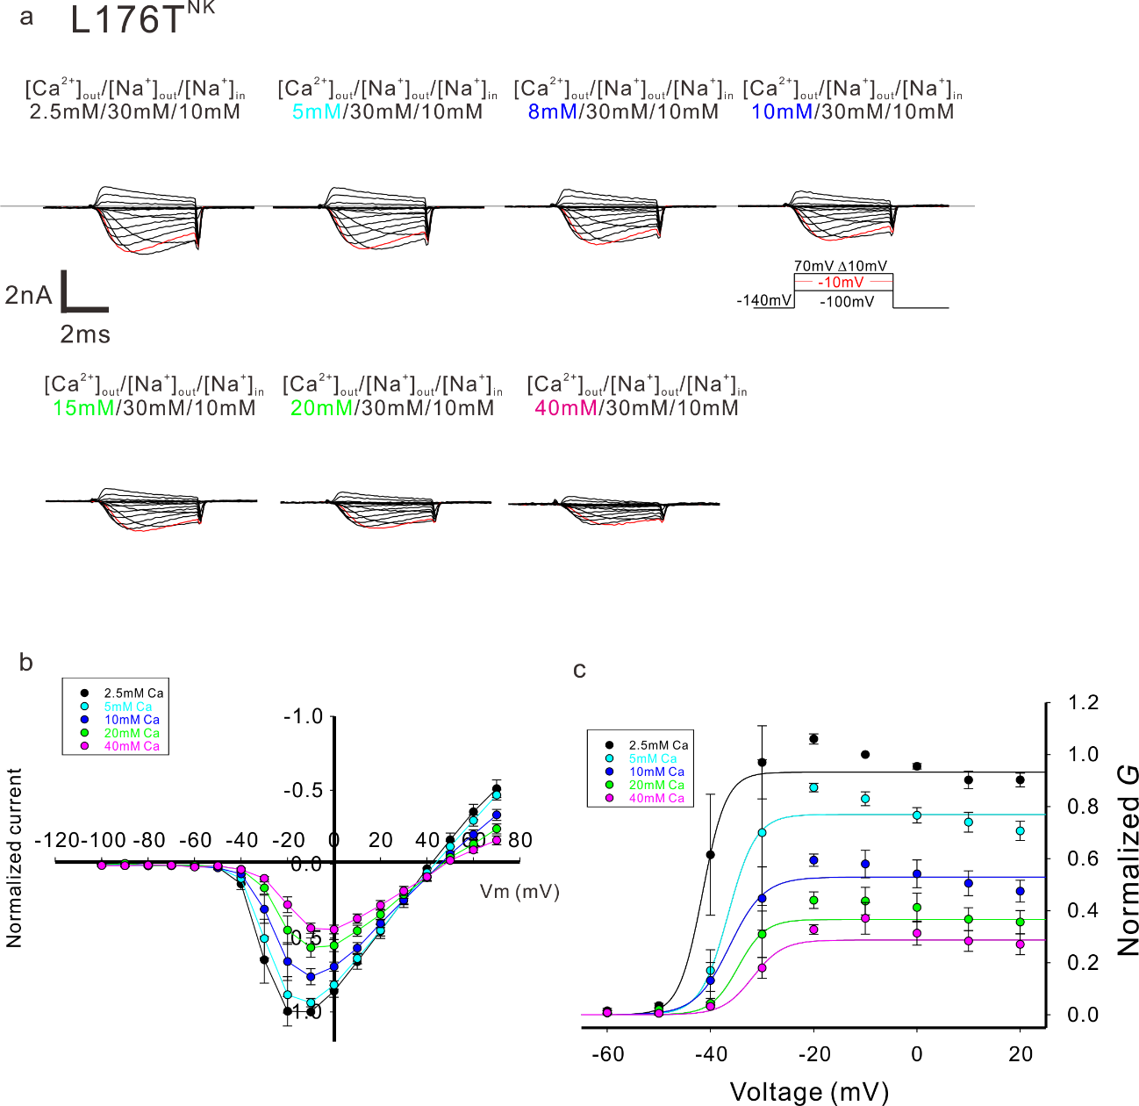
Supplementary Figure 2. The current trace, peak current, and tail current of NavAb L176T^{NK} mutant
a) Representative current traces to obtain the peak current and the deactivation tail current to evaluate the current-voltage relationship and the voltage-dependent activation of NavAb L176T^{NK} mutant. b). Current-voltage relationships of NavAb L176T^{NK} mutant measured under various extracellular Ca²⁺ concentration (n = 4). All values were normalized by the peak current generated by -10mV stimulation pulse under 2.5 mM extracellular Ca²⁺ condition. c). Normalized G curve of NavAb L176T^{NK} mutant derived from the tail currents in various extracellular Ca²⁺ concentrations (n = 4). All values were normalized by the tail current generated by -10mV stimulation pulse under 2.5 mM extracellular Ca²⁺ condition.

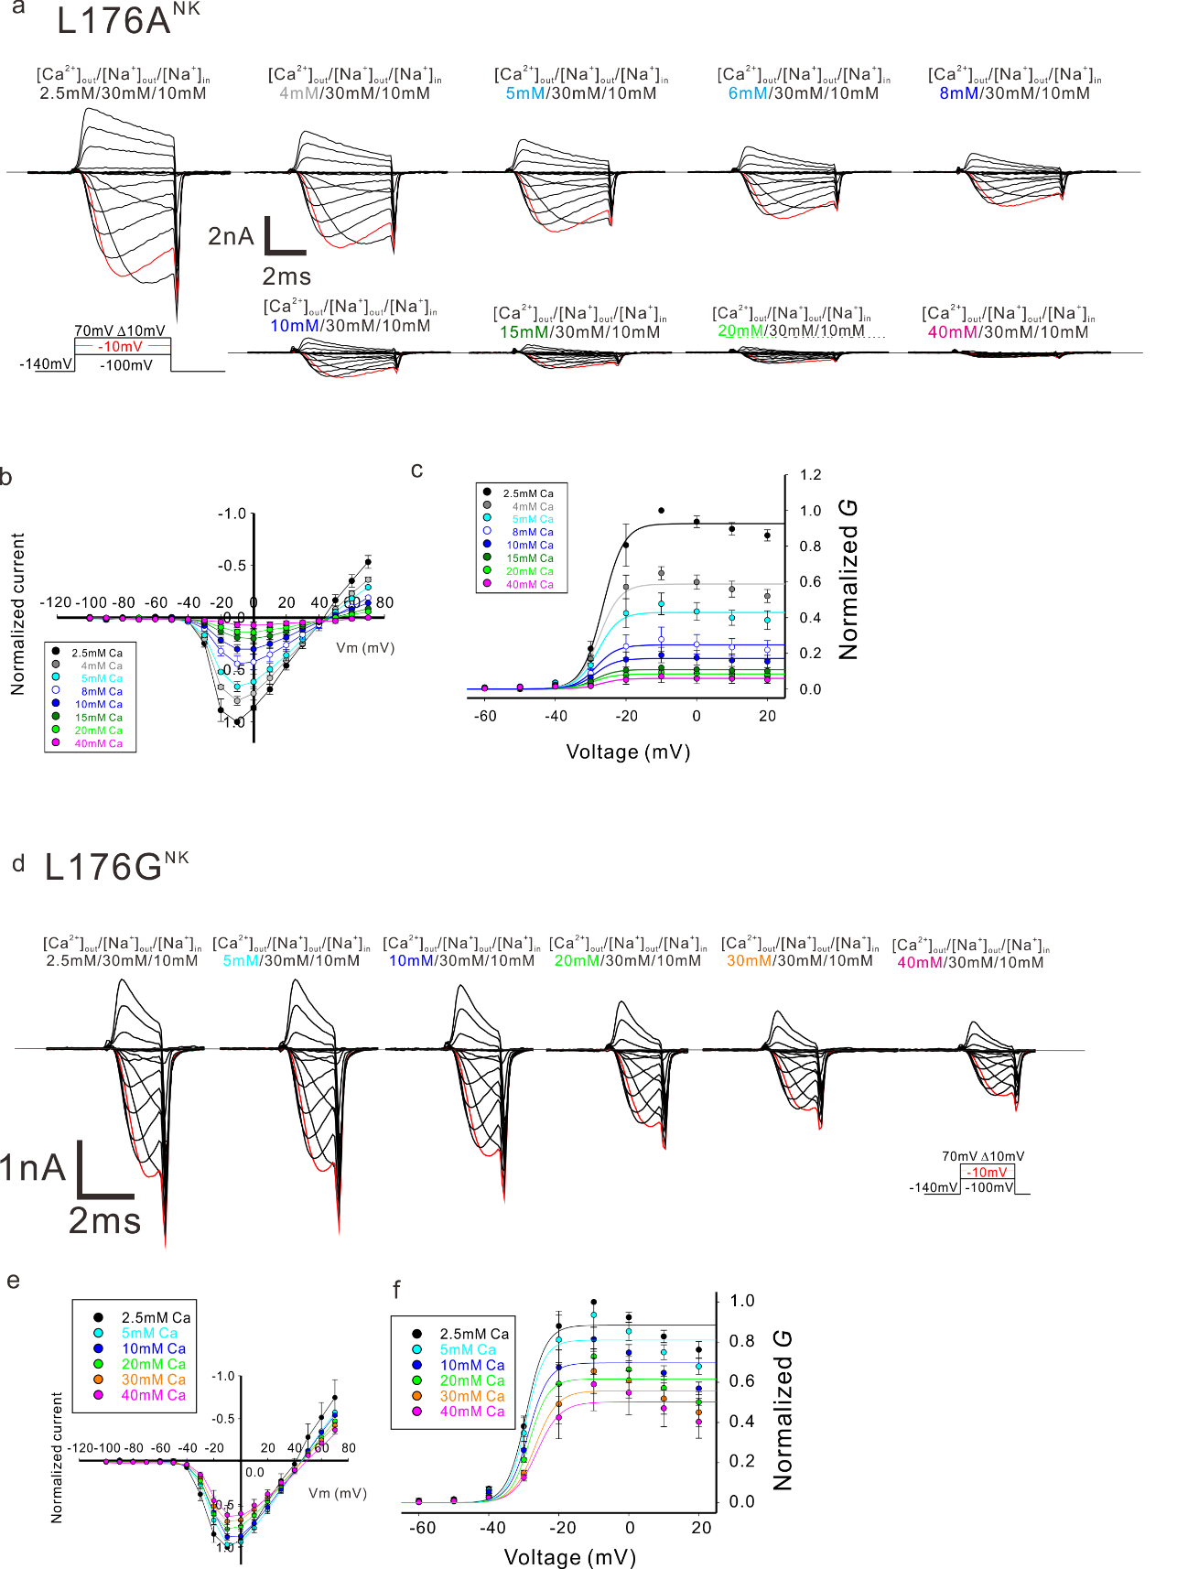
Supplementary Figure 3. The current trace, peak current, and tail current of NavAb L176A^{NK} and L176G^{NK} mutants
a). Representative current traces to obtain the peak current and the deactivation tail current to evaluate the current-voltage relationship and the voltage-dependent activation of NavAb L176A^{NK} mutant. b). Current-voltage relationships of NavAb L176A^{NK} mutant measured under various extracellular Ca²⁺ concentration (n = 3). All values were normalized by the peak current generated by -10mV stimulation pulse under 2.5 mM extracellular Ca²⁺ condition. c). Normalized G curve of NavAb L176A^{NK} mutant derived from the tail currents in various extracellular Ca²⁺ concentrations (n = 3). All values were normalized by the tail current generated by -10mV stimulation pulse under 2.5 mM extracellular Ca²⁺ condition. d). Representative current traces to obtain the peak current and the deactivation tail current to evaluate the current-voltage relationship and the voltage-dependent activation of NavAb L176G^{NK} mutant. e). Current-voltage relationships of NavAb L176G^{NK} mutant measured under various extracellular Ca²⁺ concentration (n = 4). All values were normalized by the peak current generated by -10mV stimulation pulse under 2.5 mM extracellular Ca²⁺ condition. f). Normalized G curve of NavAb L176G^{NK} mutant derived from the tail currents in various extracellular Ca²⁺ concentrations (n = 4). All values were normalized by the tail current generated by -10mV stimulation pulse under 2.5 mM extracellular Ca²⁺ condition.

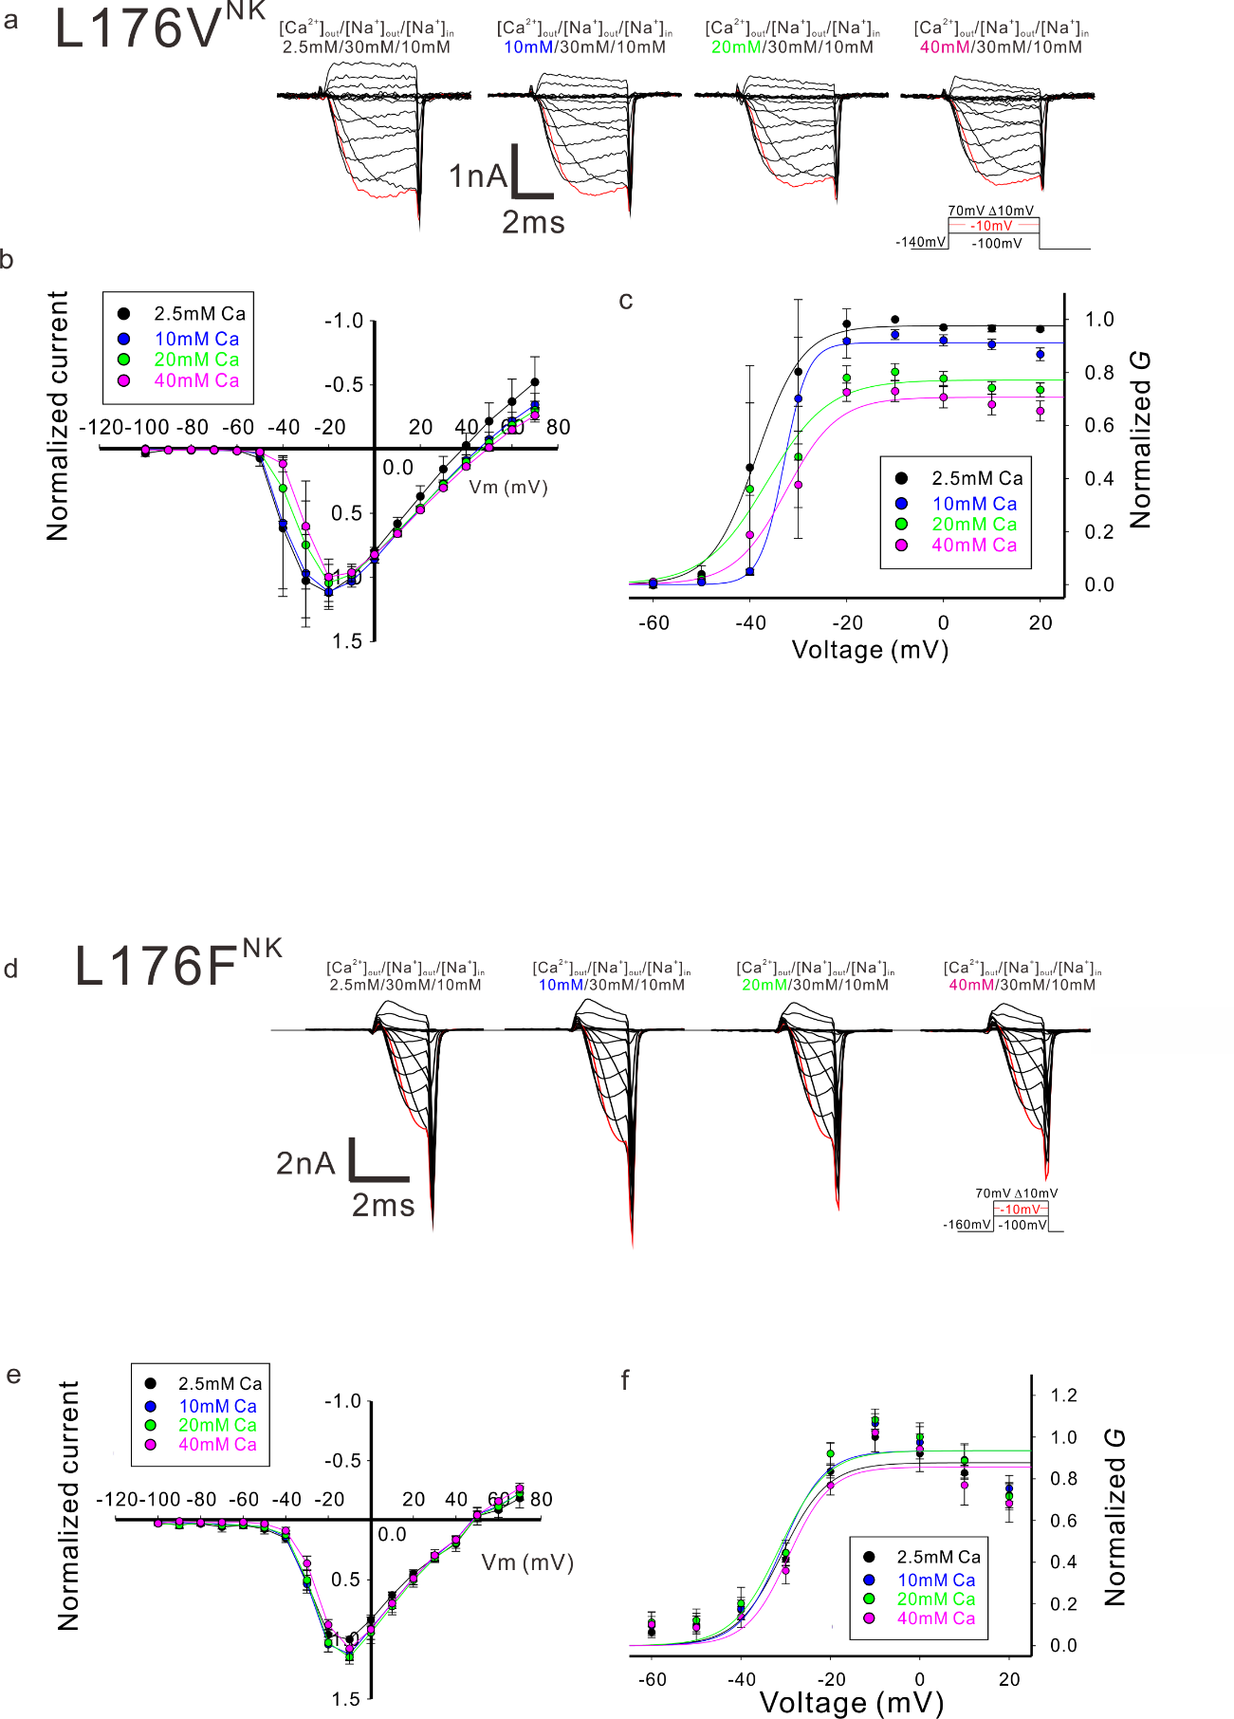
Supplementary Figure 4. The current trace, peak current, and tail current of NavAb L176V^{NK} and L176F^{NK} mutants
a). Representative current traces of NavAb L176V^{NK} mutant generated by -10 mV stimulation pulses in various extracellular Ca²⁺ concentration solutions. b). Current-voltage relationships of NavAb L176V^{NK} mutant measured under various extracellular Ca²⁺ concentration (n = 3). All values were normalized by the peak current generated by -10mV stimulation pulse under 2.5 mM extracellular Ca²⁺ condition. c). Normalized G curve of NavAb L176V^{NK} mutant derived from the tail currents in various extracellular Ca²⁺ concentrations (n = 3). All values were normalized by the tail current generated by -10mV stimulation pulse under 2.5 mM extracellular Ca²⁺ condition. d). Representative current traces of NavAb L176F^{NK} mutant generated by -10 mV stimulation pulses in various extracellular Ca²⁺ concentration solutions. e). Current-voltage relationships of NavAb L176F^{NK} mutant measured under various extracellular Ca²⁺ concentration (n = 5). All values were normalized by the peak current generated by -10mV stimulation pulse under 2.5 mM extracellular Ca²⁺ condition. f). Normalized G curve of NavAb L176F^{NK} mutant derived from the tail currents in various extracellular Ca²⁺ concentrations (n = 6). All values were normalized by the tail current generated by -10mV stimulation pulse under 2.5 mM extracellular Ca²⁺ condition.

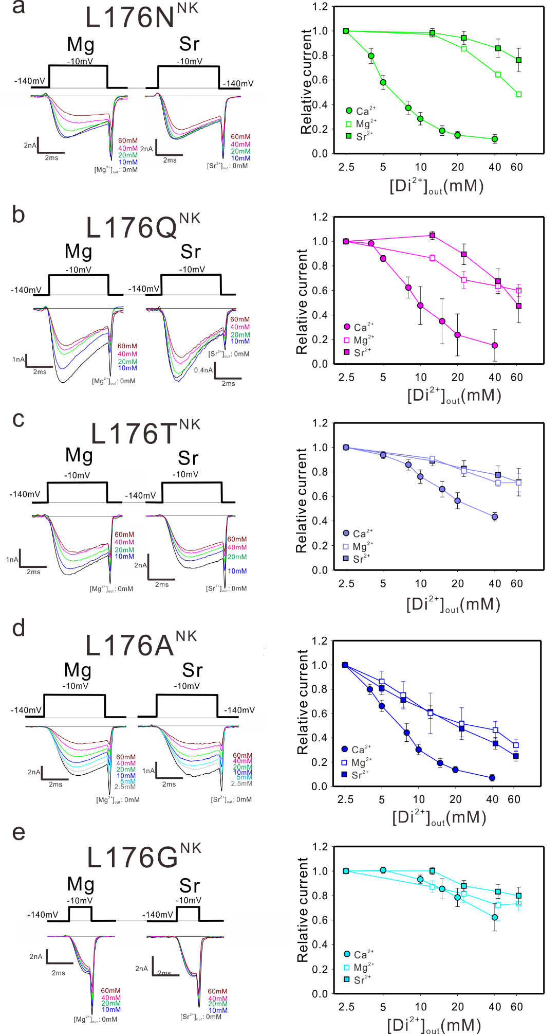
Supplementary Figure 5. The blocking effect of magnesium and strontium ion
a-e). Left: Representative current traces of NavAb L176N^{NK}, L176Q^{NK}, L176T^{NK}, L176A^{NK}, and L176G^{NK} mutant generated by -10 mV stimulation pulses in various extracellular magnesium and strontium concentration solutions, respectively. Right: Relative current generated by -10 mV stimulation pulses in various extracellular Ca²⁺, Mg²⁺ and Sr²⁺ concentration. All values were normalized by the tail current generated by -10mV stimulation pulse under 2.5 mM extracellular Ca²⁺ condition.
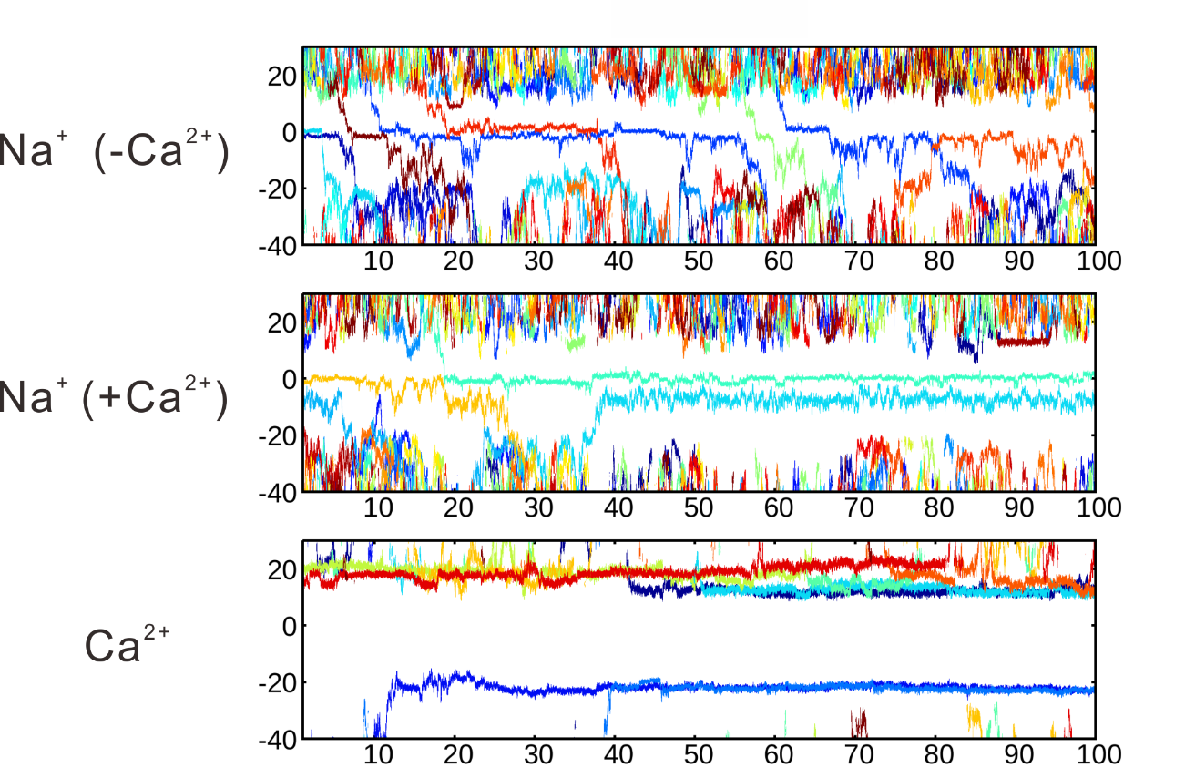
Supplementary Figure 6. The ionic trajectories of the NavAb wild-type channel calculated in MD simulations without the electronic continuum correction.
The trajectories of repeated ion permeation across the pore are shown along the z-axis as a function of time (t). Z-axis values correspond to that in Fig. 4a.

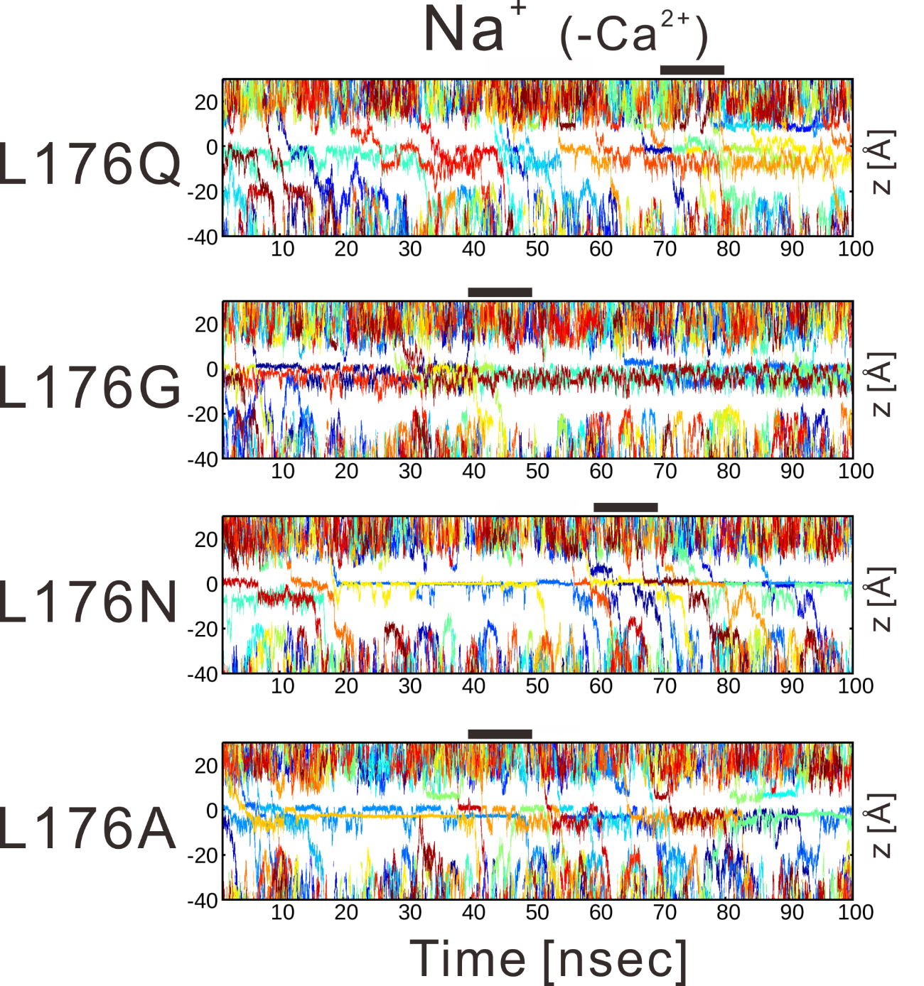
Supplementary Figure 7. The sodium ion trajectories of NavAb L176Q, L176G, L176N, and L176A mutants without calcium ions calculated in MD simulations.
The trajectories of repeated ion permeation across the pore are shown along the z-axis as a function of time (t). The black bars indicate the time period used for evaluating water concentration in Sup. Fig11. Z-axis values correspond to that in Fig. 4a.

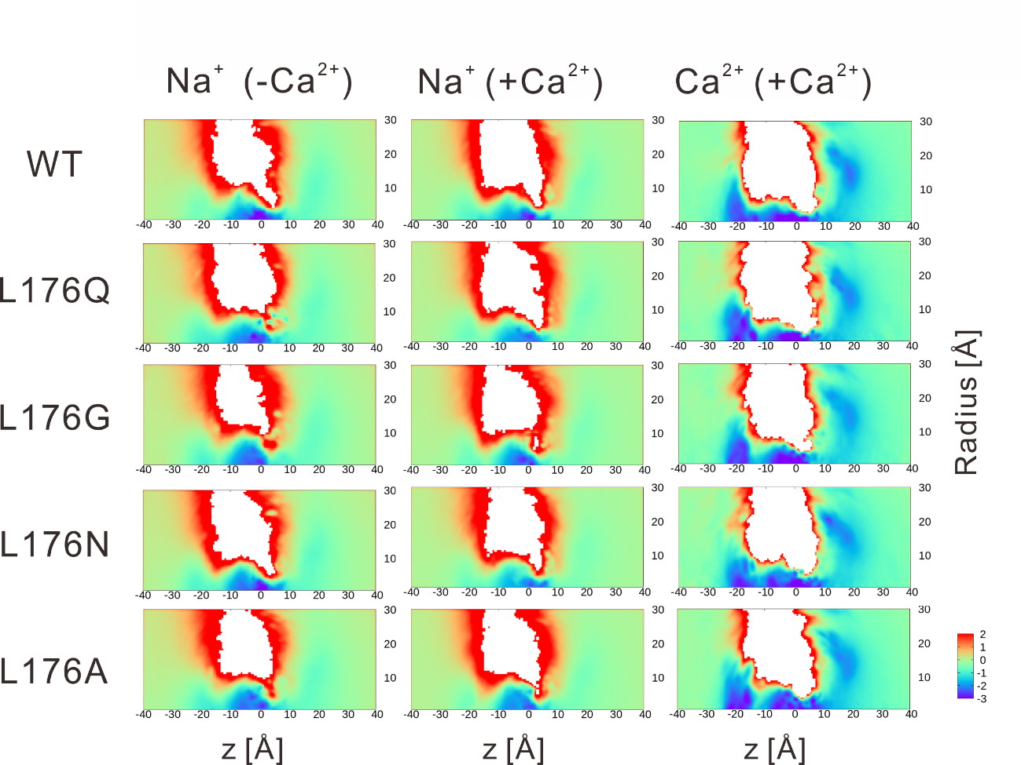
Supplementary Figure 8. Two-dimensional free energy landscape of the ions in each mutant.

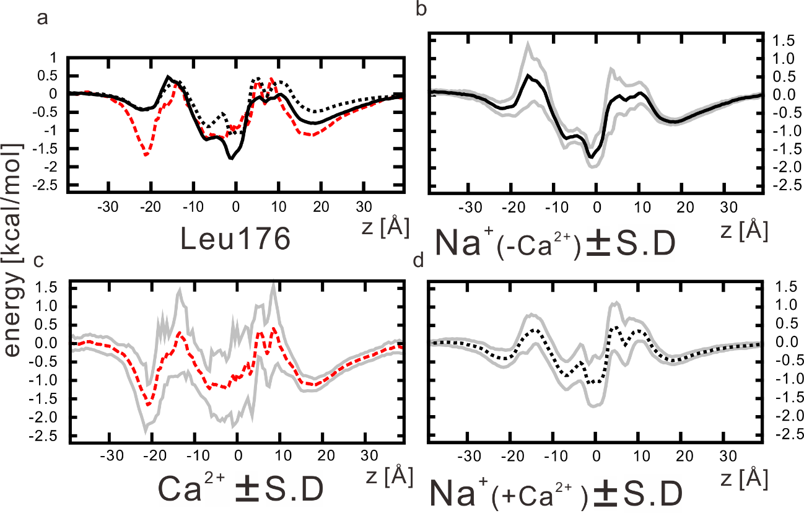
Supplementary Figure 9. The one-dimensional landscape of the free energy in the whole system with the standard deviation. a) The one-dimensional landscape of the ionic free energy of NavAb wild-type channel among periodic repeats. Black and dashed-black lines indicated the free energy of sodium ions in calcium-free conditions and calcium conditions, respectively. Dashed-red line indicates the free energy of calcium ions in calcium conditions. b-d) The one-dimensional landscape of the free energy in the whole system with the standard deviation. Black, dashed-black, and dashed-red lines indicated the averaged free energy of each 100-nsec simulation of sodium ions in calcium-free conditions (b) and calcium conditions (c), and calcium ions (d), respectively. Gray lines indicated the value of the averaged free energy ± stander deviation.

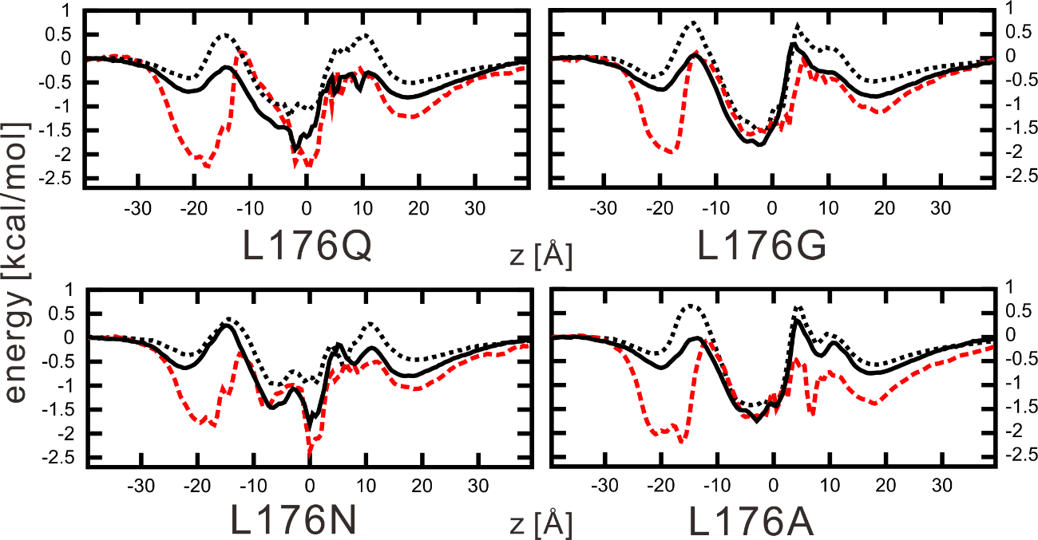
Supplementary Figure 10. The one-dimensional landscape of the ionic free energy of NavAb mutant channels among periodic repeats. Black and dashed black lines indicated the free energy of sodium ions in calcium-free conditions and calcium conditions, respectively. Dashed-red line indicates the free energy of calcium ions in calcium conditions.

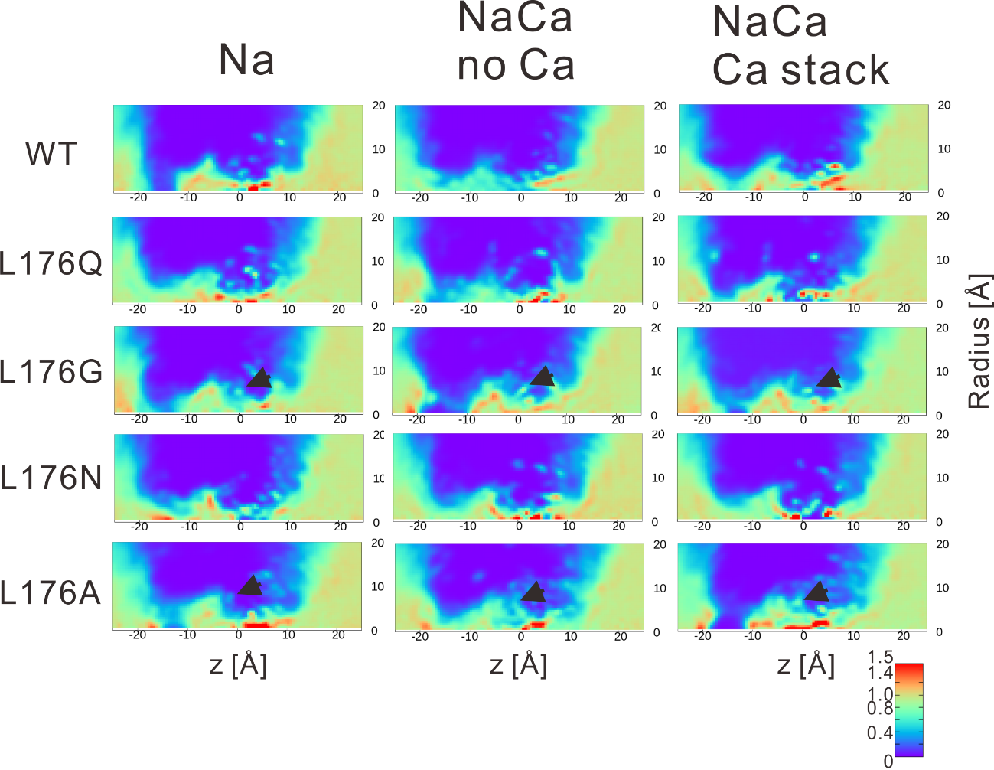
Supplementary Figure 11. The two-dimensional landscape of the water concentration in each mutant and ionic condition. The black arrows indicate water in the extra cavity.

