Plant and Soil
Effects of Mikania sesquiterpene lactones on soil microbes

Hanxia Yu¹, Johannes J. Le Roux², Mengxin Zhao^{3*}, Weihua Li^{1*}
¹Guangdong Provincial Key Laboratory of Biotechnology for Plant Development, Guangzhou Key laboratory of Subtropical Biodiversity and Biomonitoring, School of Life Sciences, South China Normal University, Guangzhou 510631, China
²Department of Biological Sciences, Macquarie University, New South Wales 2109, Australia
³State Key Laboratory for Biology of Plant Diseases and Insect Pests, Institute of Plant Protection, Chinese Academy of Agricultural Sciences, Beijing, China，100193
* Corresponding authors: Email addresses: zhaomengxin@caas.cn; whli@scnu.edu.cn

ORCID

Weihua Li: https://orcid.org/0000-0001-6707-2592

Johannes J. Le Roux: https://orcid.org/0000-0001-7911-9810

Supplementary Information

Table S1 Precursor/product ion pairs and parameters for multiple reaction monitoring (MRM) of compounds.
Compounds | Retention time  (min) | Molecular ions  (m z-1) | MRM transition  (precursor→product) | Cone voltage  (V) | Collision energy  (eV)
1 | 1.89 | 273.05 | 273.1→185.1ª | 26.0 | 10.0
1 | 1.89 | 273.05 | 273.1→229.1 | 26.0 | 8.0
2 | 2.65 | 275.06 | 275.1→187.1ª | 30.0 | 10.0
2 | 2.65 | 275.06 | 275.1→231.2 | 30.0 | 8.0
3 | 1.82 | 291.06 | 291.1→219.1 | 28.0 | 18.0
3 | 1.82 | 291.06 | 291.1→247.1ª | 28.0 | 8.0
4 | 2.56 | 333.10 | 333.1→229.1ª | 24.0 | 14.0
4 | 2.56 | 333.10 | 333.1→273.1 | 24.0 | 6.0
5 | 2.66 | 335.12 | 335.1→187.16 | 26.0 | 16.0
5 | 2.66 | 335.12 | 335.1→275.13ª | 26.0 | 8.0
ª Transition used for quantitation.

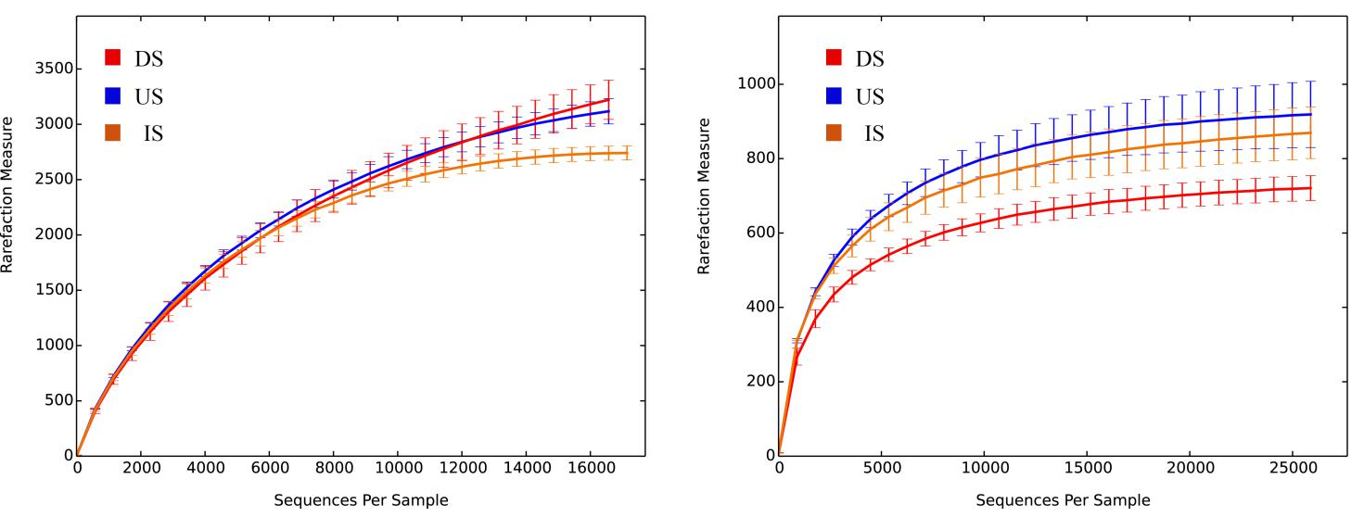
Bacteria Fungi
Fig. S1 Rarefaction curves of the number of bacterial (left) and fungal (right) OTUs in three soils (n=3 for each soil type). IS - the invaded soil; US - the uninvaded soil; DS - the uninvaded soil with dihydromikanolide (Dih) addition.

