Supplementary Materials

Health Burden and Economic Impacts Attributed to PM_{2.5} and O₃ in China from 2010 to 2050 under Different Representative Concentration Pathway Scenarios

Yiyi Wang¹, Jianlin Hu^{1, *}, Jia Zhu¹, Jingyi Li¹, Momei Qin¹, Hong Liao¹, Kai Chen^{2,3}, Meng Wang^{4,5,6,*}

^{*1}Jiangsu Collaborative Innovation Center of Atmospheric Environment and Equipment Technology, Jiangsu Key Laboratory of Atmospheric Environment Monitoring and Pollution Control, Nanjing University of Information Science & Technology, 219 Ningliu Road, Nanjing 210044, China
² Department of Environmental Health Sciences, Yale School of Public Health, 60 College Street, New Haven, CT, 06520-8034, USA
³ Yale Center on Climate Change and Health, Yale School of Public Health, 60 College Street, New Haven, CT, 06520-8034, USA
⁴ Department of Epidemiology and Environmental Health, School of Public Health and Health Professions, University at Buffalo, Buffalo, NY, USA
⁵ RENEW Institute, University at Buffalo, Buffalo, NY, USA
⁶ Department of Environmental and Occupational Health Sciences, School of Public Health, University of Washington, Seattle, WA, USA

*Corresponding authors:
Jianlin Hu, Email: jianlinhu@nuist.edu.cn. Phone: +86-25-58731504
Meng Wang, Email: mwang54@buffalo.edu. Phone: +01-716-8292975
First author:
Yiyi Wang, Email: wangyiyi_11@126.com
Other authors:
Jia Zhu, Email: jiazhu@nuist.edu.cn
Jingyi Li, Email: jingyili@nuist.edu.cn
Momei Qin, Email: momei.qin@nuist.edu.cn
Hong Liao, Email: hongliao@nuist.edu.cn
Kai Chen, Email: kai.chen@yale.edu
Table S1 Life expectancy at exact age from 2010 to 2050
Age group | 2010 | 2020 | 2030 | 2040 | 2050
0 | 75.14 | 77.47 | 79.13 | 80.74 | 82.28
1-4 | 75.07 | 77.13 | 78.63 | 80.14 | 81.61
5-9 | 71.22 | 73.24 | 74.72 | 76.20 | 77.67
10-14 | 66.35 | 68.33 | 69.79 | 71.26 | 72.72
15-19 | 61.43 | 63.40 | 64.85 | 66.31 | 67.76
20-24 | 56.55 | 58.49 | 59.93 | 61.37 | 62.81
25-29 | 51.69 | 53.62 | 55.03 | 56.46 | 57.88
30-34 | 46.87 | 48.77 | 50.16 | 51.57 | 52.98
35-39 | 42.08 | 43.94 | 45.31 | 46.70 | 48.08
40-44 | 37.31 | 39.14 | 40.49 | 41.85 | 43.21
45-49 | 32.59 | 34.39 | 35.70 | 37.04 | 38.38
50-54 | 27.96 | 29.70 | 30.99 | 32.29 | 33.60
55-59 | 23.47 | 25.15 | 26.39 | 27.66 | 28.93
60-64 | 19.19 | 20.78 | 21.96 | 23.17 | 24.38
65-69 | 15.29 | 16.74 | 17.83 | 18.94 | 20.07
70-74 | 11.85 | 13.13 | 14.09 | 15.07 | 16.07
75-79 | 9.05 | 10.12 | 10.90 | 11.70 | 12.53
80-84 | 6.87 | 7.71 | 8.28 | 8.88 | 9.51
85-90 | 5.12 | 5.75 | 6.14 | 6.56 | 7.00
90-95 | 3.90 | 4.38 | 4.60 | 4.86 | 5.14
95-100 | 3.07 | 3.42 | 3.53 | 3.66 | 3.81
100+ | 2.65 | 2.90 | 2.90 | 2.92 | 2.95

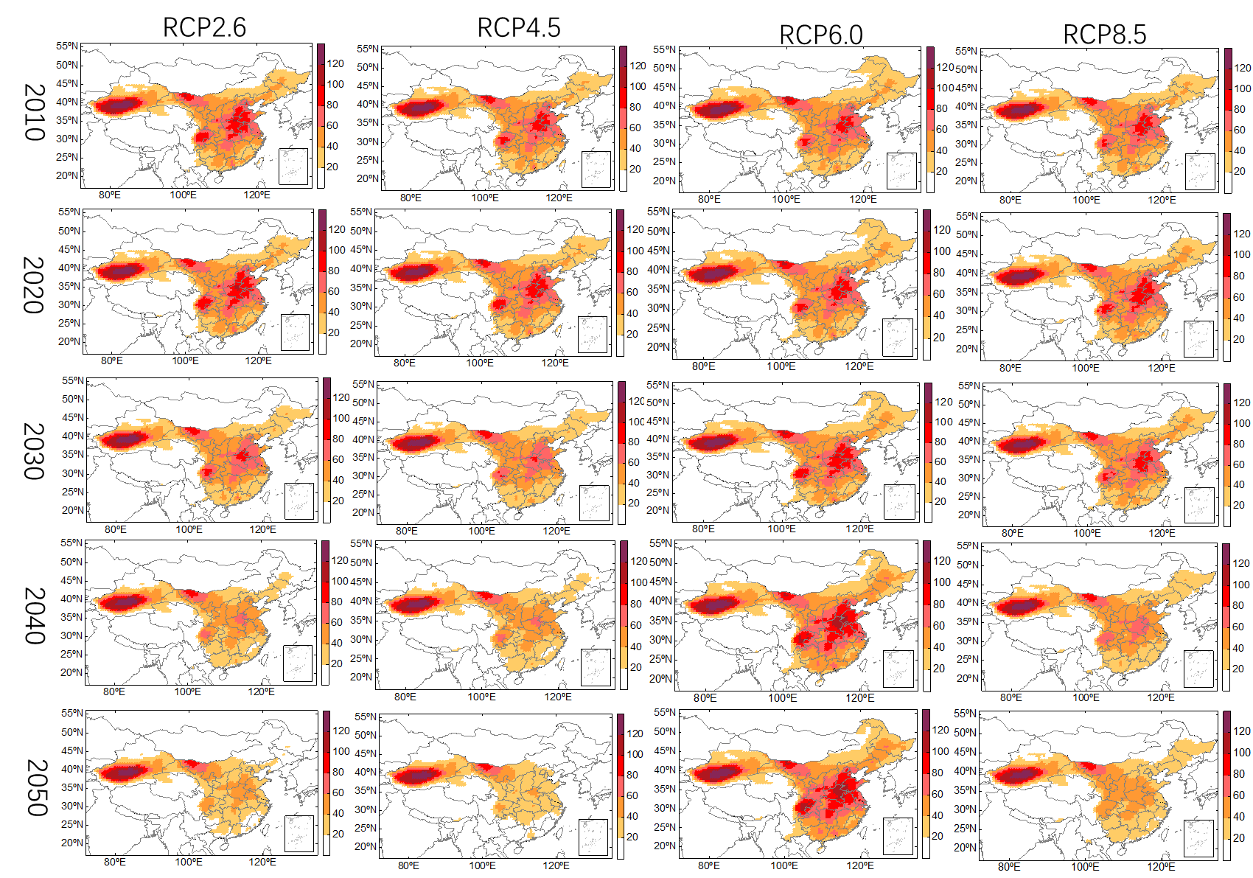
Figure S1 Projected spatial distributions of changes in ambient PM_{2.5} exposures from 2010-2050 under RCPs (μg/m³)

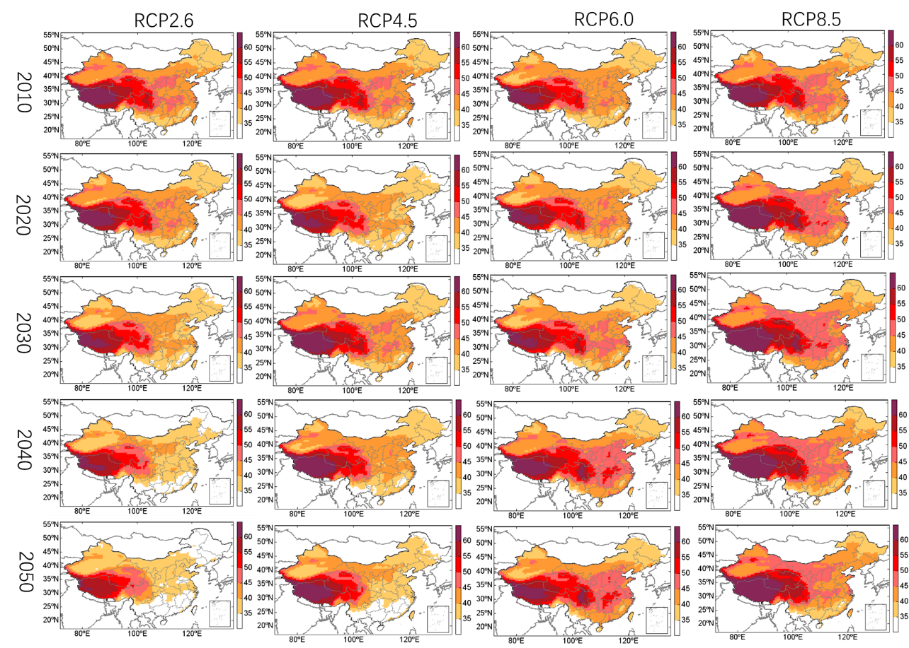
Figure S2 Projected spatial distributions of changes in ambient O3 exposures from 2010-2050 under RCPs (ppb).
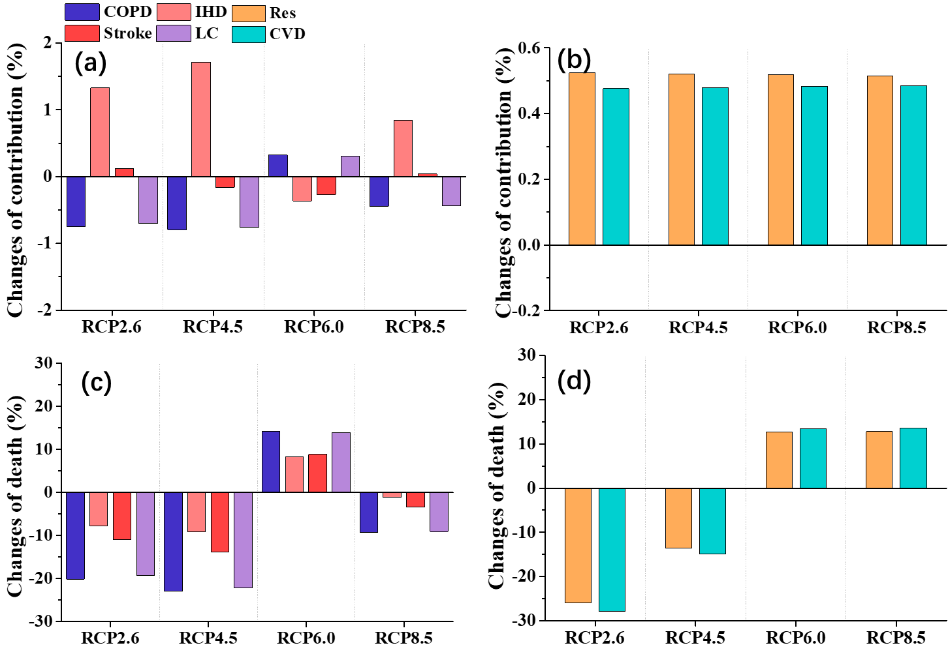
Figure S3 Changes in contribution (a) and mortality (b) of specific diseases (Chronic obstructive pulmonary disease (COPD), Ischemic heart disease (IHD), stroke and Lung cancer (LC)) related to PM_{2.5}. Changes in contribution (c) and mortality (d) of Cardiovascular (CVD) and respiratory related to O₃.

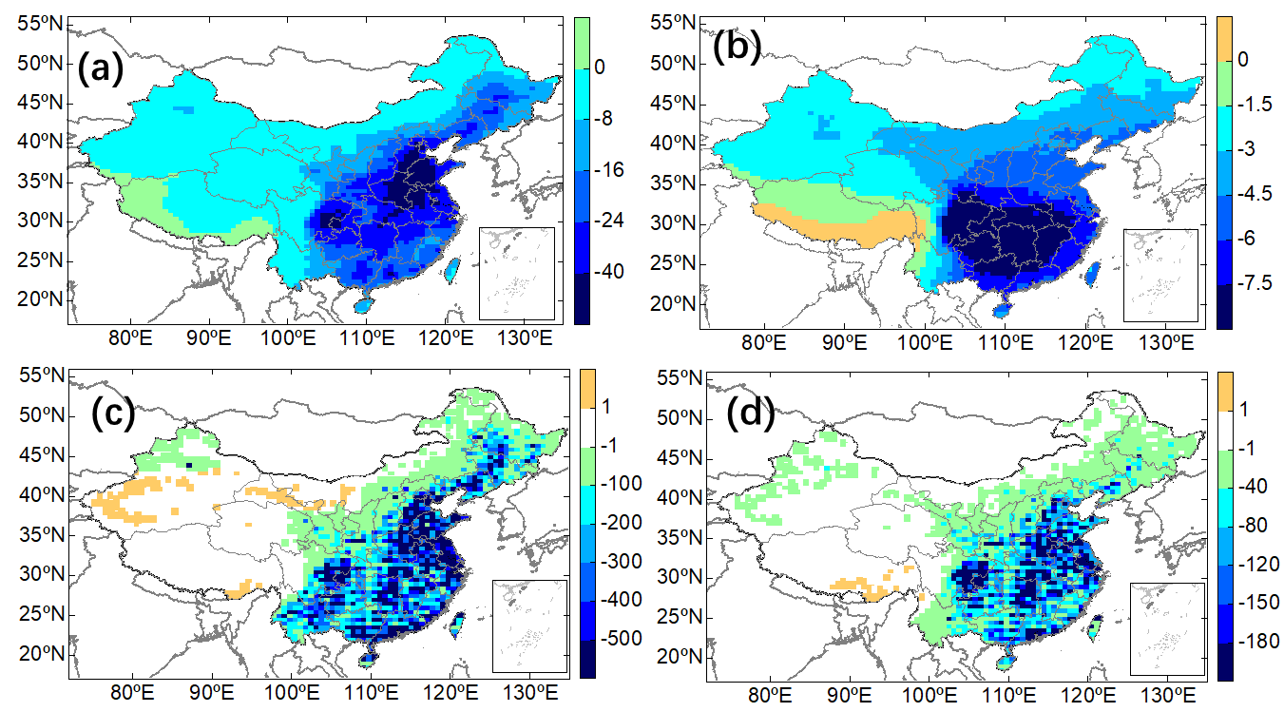
Figure S4 Changes in PM_{2.5} (a) and O₃ (b) concentrations (a-b) and premature deaths (c-d) from 2010 to 2050 under RCP4.5 scenario. Warm colors indicate an increase in pollutant concentration or the number of deaths, while cool colors are the opposite.

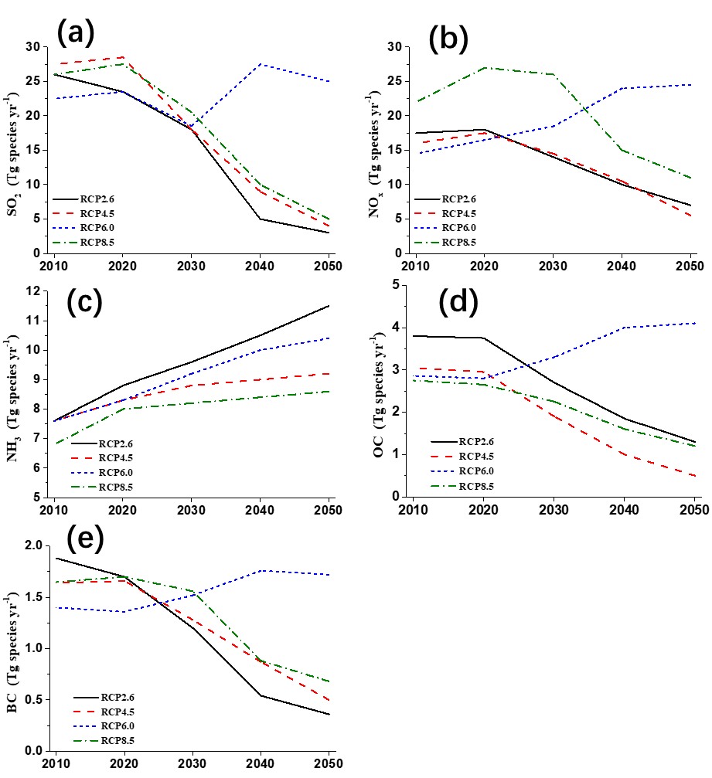
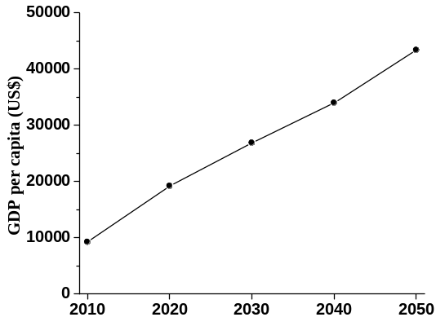
Figure S5 Emissions of (a) SO₂, (b) NOx, (c) NH₃, (d) OC and (e) BC in China from 2010 to 2050 under four RCP scenarios.
Figure S6 Projection of China's GDP per capita at purchasing power parity (PPP) from 2010 to 2050

