Table 3. Docking poses of the ligands with the antioxidative enzymes. Amino acids were shown by three-letter code followed by the numbers showing their position in proteins. Hem in CAT enzyme is shown by stick style in black color. Dexamethasone, NADPH and FADH are shown by space fill (CPK) style in green, purple and yellow color respectively. In SOD1 enzyme the Zn and Cu were shown by spheres in maroon and gray color respectively.
Receptors | Dexamethasone docked with receptors | Residues involved in the reactions
CAT | 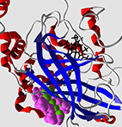 | Arg203, His305, Leu451, Phe198, Phe446, Pro151, Pro304, Ser201, Trp303, Tyr2015, Val302, Val450
GPX4 | 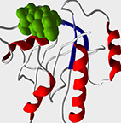 | Asn137, Lys48, Lys135, Met156, Pro155, Trp136
GR | 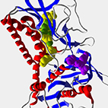 | Ala155, Ala342, Asn294, Asp331, Cys58, Glu50, Gly157, Gly158, Gly27, Gly28, Gly29, Gly31, Gly32, Gly330, Gly55, Gly56, His52, Ile26, Leu338, Lys53, Ser30, Ser51, Thr156, Thr57, Val329, Val49
SOD | 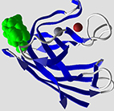 | Arg143, Arg69, Asn65, Glu133, Gly61, His120, His48, His63, His71, His80, Lys136, Lys70, Pro62, Thr135, Thr137, Zn

