Catalyst-free one-pot three-component synthesis of 2-iminothiazoles from nitroepoxides
Elham Badali,ª Azim Ziyaei Halimehjani,*^{,a,b} Azizollah Habibiª
ª Faculty of Chemistry, Kharazmi University, 49 Mofateh St., 15719-14911, Tehran, Iran,
E-mail: ziyaei@khu.ac.ir
^{b} Department of Chemistry, Sharif University of Technology, P.O.Box 11155-9516, Tehran, Iran.

Contents Pages Experimental section (general procedure, characterization data and copies of
¹H and ¹³C NMR spectra for all products 2-30
Crystal data for compound 4p 31

Experimental section
General. All chemicals and solvents were obtained from commercial sources and used as received. The ¹H and ¹³C NMR spectra of products were recorded on a Bruker AMX 300 MHz spectrometers referenced to internal Me₄Si at 0.00 ppm. Reaction monitoring was carried out by thin-layer chromatography using TLC silica gel 60 F254 plates. HRMS (High Resolution Mass Spectra) was measured on a THERMO SCIENTIFIC Advantage and a THERMO SCIENTIFIC Exactive instrument equipped with an APCI source in the positive-ion mode. Mass analysis was performed using Agilent Technology (HP); 5973 Network Mass Selective Detector equipped with an EI mode and ionization energy of 70eV. The temperatures of the electronic-impact ion source and MS quadrupole were 230 ᵒC. IR spectra's were recorded on a Perkin-Elmer Spectrum RXI FT-IR Spectrometer. Nitroepoxides were prepared according to the literature procedures.
General procedure for the synthesis of 4a-s
In a test tube equipped with magnetic stirrer bar, an isothiocyanate (1.0 mmol, 1 equiv), an amine (1.2 equiv) and THF (4 mL) were mixed for 1h at room temperature. Progress of the reaction was monitored by TLC. After complete consumption of the isothiocyanate, the reaction temperature was decreased to 10-15 ᵒC and a nitroepoxide ( 1 equiv) was added and the mixture was stirred at 10-15 ᵒC for 6h. The solvent was removed under reduced pressure to afford yellow viscous oil. Purification was carried out by recrystallization in a minimum amount of MeOH or by column chromatography using silicagel and n-hexane/EtOAc (7/3) (for compounds 4f, 4h, and 4i).
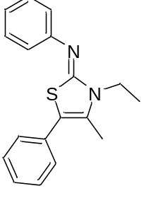N-(3-ethyl-4-methyl-5-phenylthiazol-2(3H)-ylidene)aniline (4a): Yellowish powder (89%); mp 96-97 ºC; ¹H NMR (300 MHz, Chloroform-d) δ 7.36-7.34 (m, 7H), 7.25 – 6.94 (m, 3H), 4.10 (q, J = 6.8 Hz, 2H), 2.29 (s, 3H), 1.43 (t, J = 7.0 Hz, 3H) ppm; ¹³C NMR (75 MHz, CDCl₃) δ 158.9, 151.0, 132.5, 130.0, 129.4, 128.8, 128.6, 127.2, 123.1, 121.8, 109.2, 39.9, 13.7, 12.5 ppm; EI-MS m/z (%): 294 (M⁺,100), 266, 190, 147, 105, 77; IR (KBr) ν_{max} (cm⁻¹): 696, 705, 777, 827, 1057, 1204, 1328, 1395, 1585, 1620.
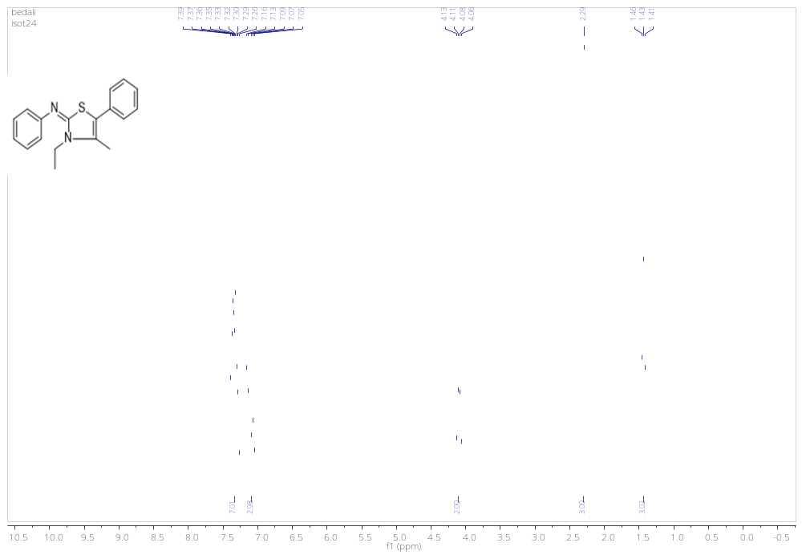
Figure 1. ¹H NMR spectra for 4a
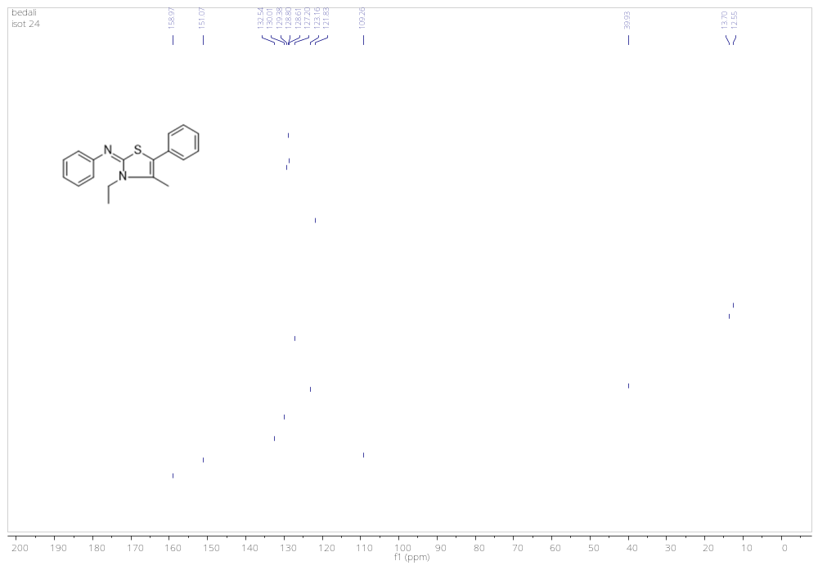
Figure 2. ¹³C NMR spectra for 4a

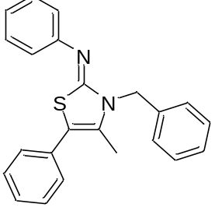3-benzyl-4-methyl-5-phenylthiazol-2(3H)-ylidene)aniline (4b): White powder (81%); mp 105-106 °C; ¹H NMR (300 MHz, Chloroform-d) δ 7.44 – 7.28 (m, 12H), 7.24 – 6.99 (m, 3H), 5.36 (s, 2H), 2.19 (s, 3H) ppm; ¹³C NMR (75 MHz, CDCl₃) δ 158.5, 153.1, 136.8, 132.1, 130.6, 129.4, 128.7, 128.7, 128.7, 128.6, 127.4, 126.7, 123.4, 121.8, 109.8, 48.0, 12.8 ppm; EI-MS m/z (%): 356 (M⁺), 265, 167 (100), 147, 115, 91, 65; IR (KBr) ν_{max} (cm⁻¹): 694, 758, 923, 1073, 1186, 1329, 1392, 1488, 1576, 1614.
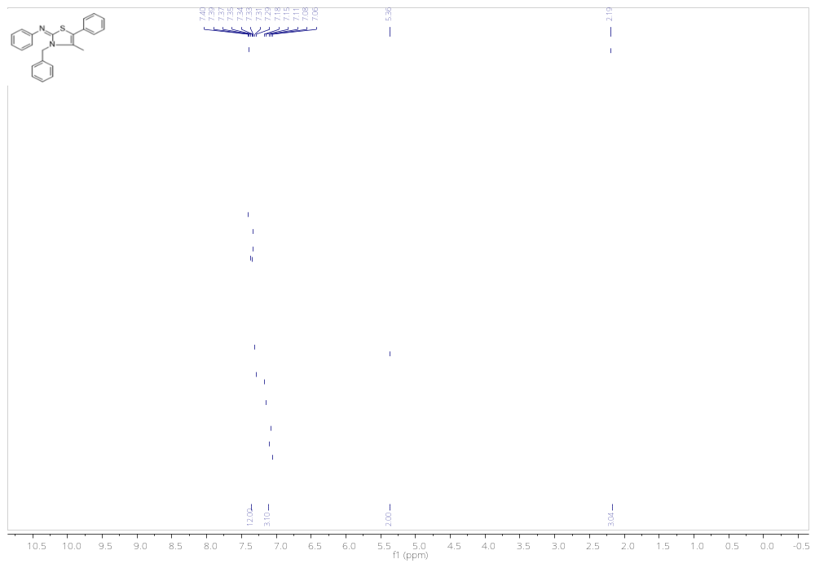
Figure 3. ¹H NMR spectra for 4b
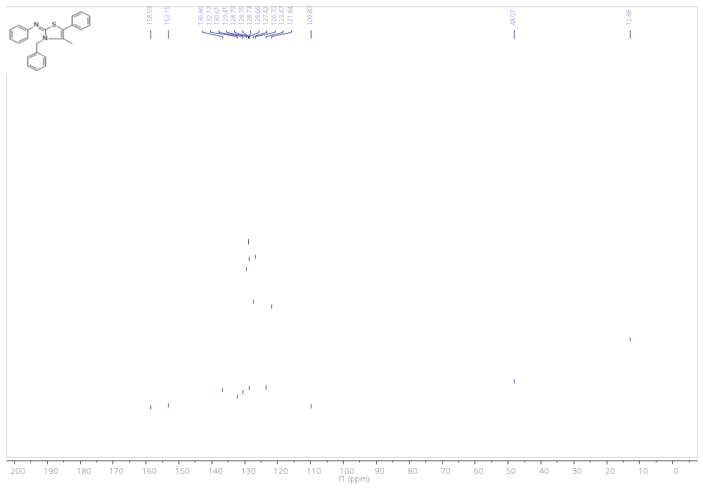
Figure 4. ¹³C NMR spectra for 4b

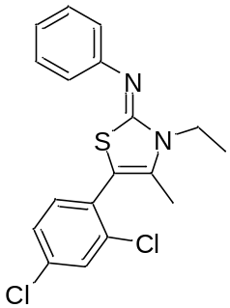
N-(5-(2,4-dichlorophenyl)-3-ethyl-4-methylthiazol-2(3H)-ylidene)anilin (4c): White powder (89%); mp 99-100 ºC; ¹H NMR (300 MHz, Chloroform-d) δ 7.47 (s, 1H), 7.34 (t, J = 7.8 Hz, 2H), 7.27 (d, J = 7.4 Hz, 2H), 7.11 (d, J = 7.5 Hz, 2H), 7.04 (t, J = 7.3 Hz, 1H), 4.03 (q, J = 7.0 Hz, 2H), 2.04 (s, 3H), 1.41 (t, J = 7.1 Hz, 3H) ppm; ; ¹³C NMR (75 MHz, CDCl₃) δ 158.2, 151.6, 135.8, 134.6, 133.6, 132.3, 129.8, 129.7, 129.3, 127.1, 122.8, 121.5, 103.5, 39.7, 13.6, 12.7 ppm; HRMS (ESI) calcd for C₁₈H₁₆Cl₂N₂S (M+H)⁺ 363.0489, found: 363.0484; IR (KBr) ν_{max} (cm⁻¹): 694, 759, 870, 1100, 1201, 1323, 1403, 1473, 1563, 1576,1626.
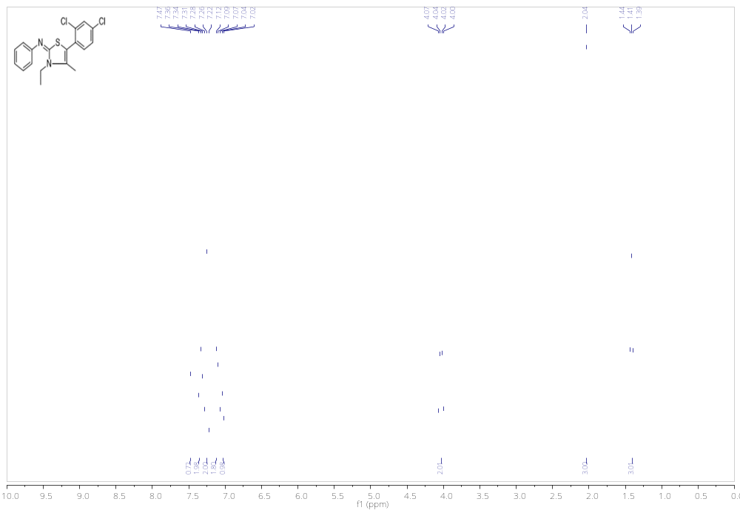Figure 5. ¹H NMR spectra for 4c
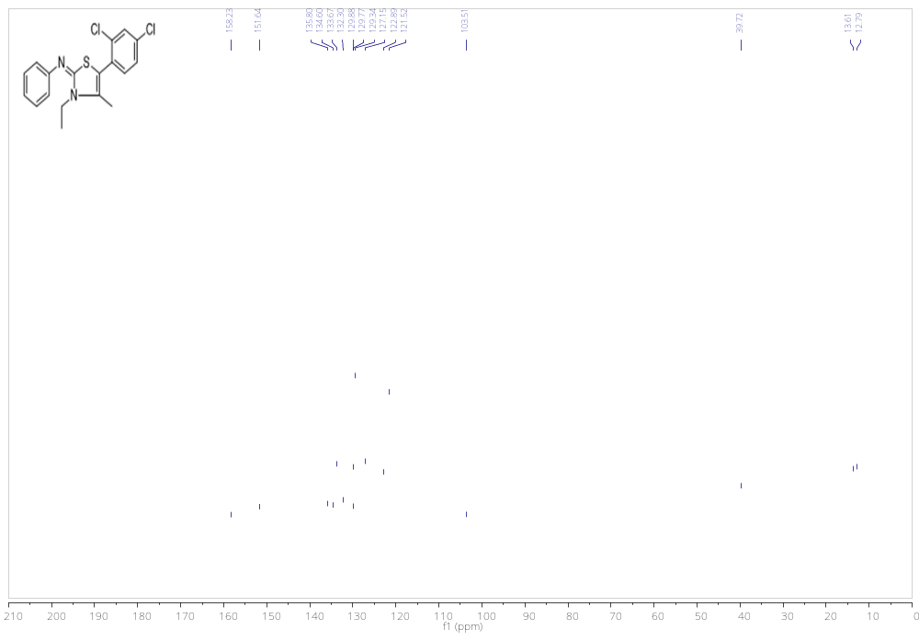
Figure 6. ¹³C NMR spectra for 4c

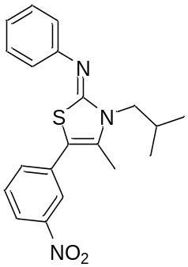N-(3-isobutyl-4-methyl-5-(3-nitrophenyl)thiazol-2(3H)-ylidene)aniline (4d): Yellow powder (84%); mp 102-103 ºC; ¹H NMR (300 MHz, Chloroform-d) δ 8.20 – 8.13 (m, 1H), 8.14 – 8.03 (m, 1H), 7.61 (d, J = 7.8 Hz, 1H), 7.52 (t, J = 7.9 Hz, 1H), 7.36 (t, J = 7.8 Hz, 2H), 7.11 – 7.03 (m, 3H), 3.81 (d, J = 7.5 Hz, 2H), 2.41 (m, 1H), 2.29 (s, 3H), 1.06 (d, J = 6.7 Hz, 6H) ppm; ¹³C NMR (75 MHz, DMSO-d₆) δ 157.1, 151.0, 148.0, 134.6, 133.9, 133.8, 130.4, 129.5, 122.9, 122.4, 121.6, 121.1, 104.6, 51.1, 27.1, 19.9, 12.9 ppm; HRMS (ESI) calcd for C₂₀H₂₁N₃O₂S (M+H)⁺ 368.1433, found: 368.1427; IR (KBr) ν_{max} (cm⁻¹): 696, 733, 764, 894, 1063, 1201, 1346, 1396, 1523, 1611.

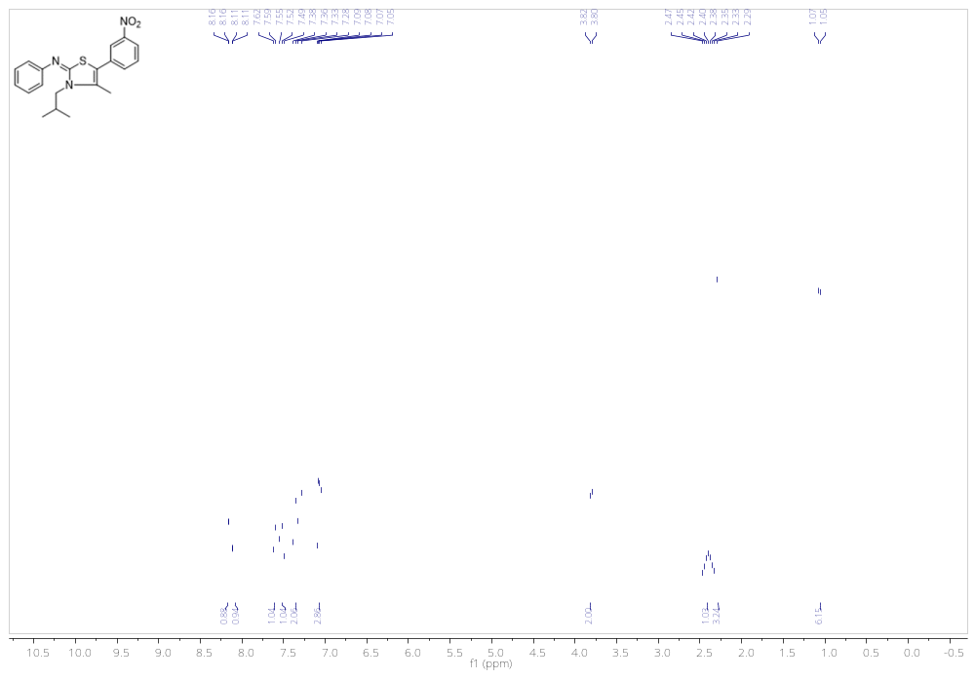
Figure 7. ¹H NMR spectra for 4d

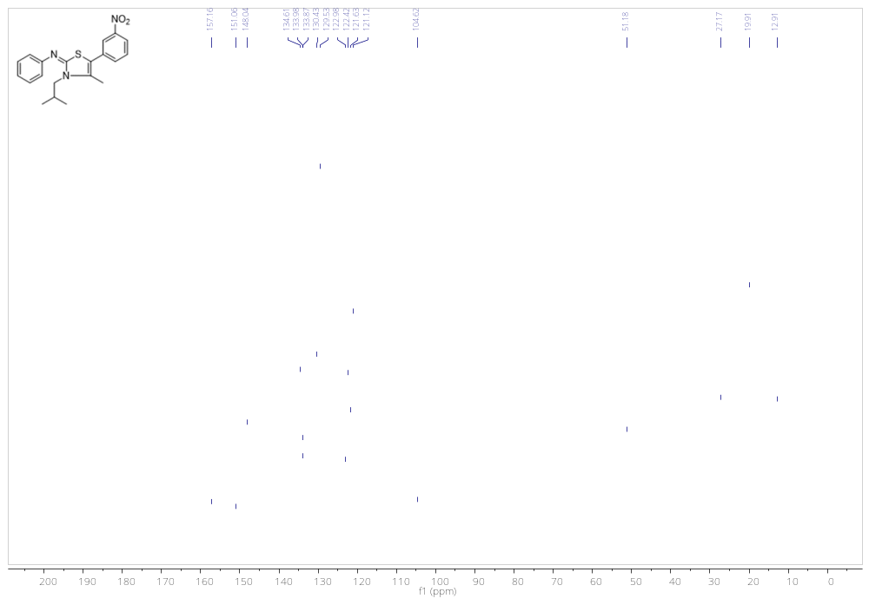
Figure 8. ¹³C NMR spectra for 4d

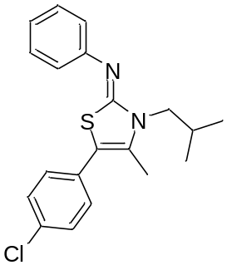N-(5-(4-chlorophenyl)-3-isobutyl-4-methylthiazol-2(3H)-ylidene)aniline (4e): Yellow powder (81%); mp 87-89 ºC; ¹H NMR (300 MHz, Chloroform-d) δ 7.44 – 7.13 (m, 7H), 7.07 (d, J = 7.7 Hz, 2H), 3.78 (d, J = 7.6 Hz, 2H), 2.39 (m, 1H), 2.22 (s, 3H), 1.04 (d, J = 6.7 Hz, 6H) ppm; ¹³C NMR (75 MHz, DMSO-d₆) δ 157.1, 151.6, 132.1, 131.5, 131.2, 130.0, 129.4, 128.7, 122.6, 121.0, 105.5, 51.0, 27.1, 19.9, 12.8 ppm; HRMS (ESI) calcd for C₂₀H₂₁ClN₂S (M+H)⁺ 357.1192, found: 357.1186; IR (KBr) ν_{max} (cm⁻¹): 689, 766, 837, 1013, 1091, 1200, 1392, 1489, 1577.

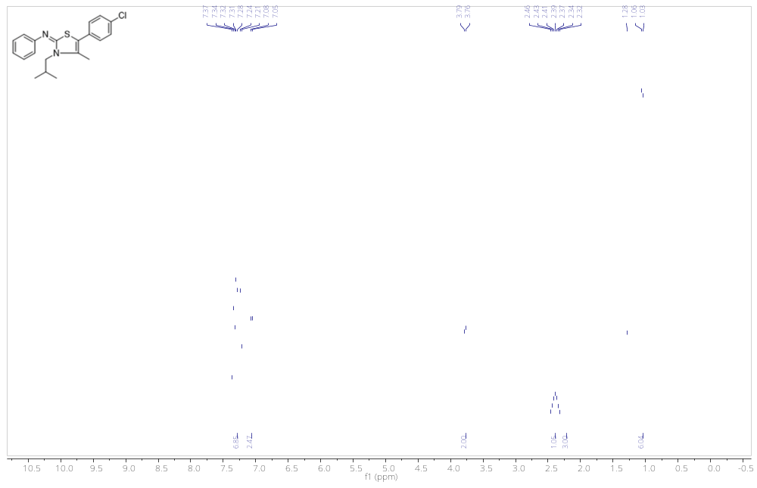
Figure 9. ¹H NMR spectra for 4e
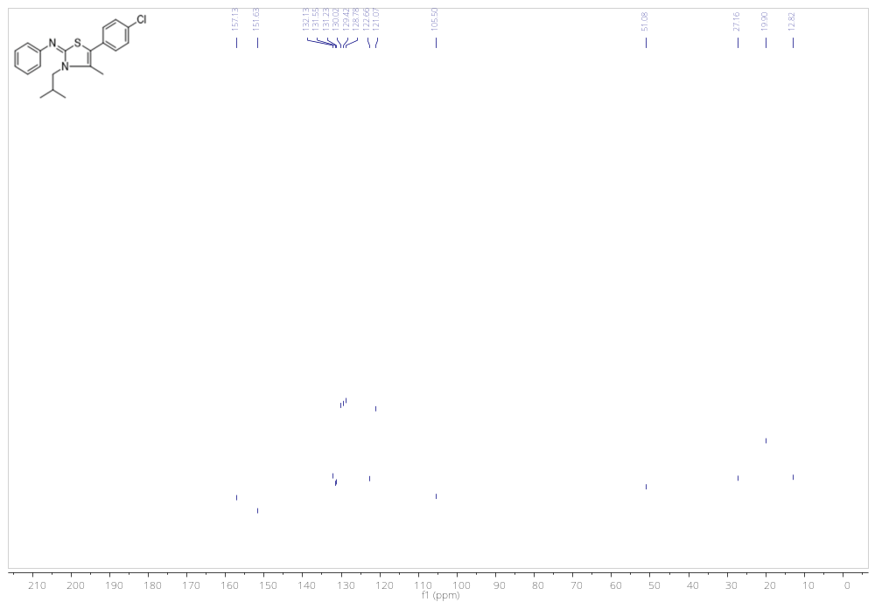
Figure 10. ¹³C NMR spectra for 4e

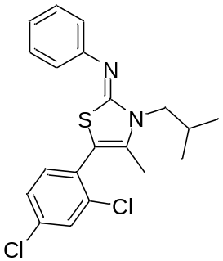N-(5-(2,4-dichlorophenyl)-3-isobutyl-4-methylthiazol-2(3H)-ylidene)aniline (4f): Yellow viscous oil (72%); ¹H NMR (300 MHz, DMSO-d₆) δ 7.71 (s, 1H), 7.44 (s, 2H), 7.28 (t, J = 7.8 Hz, 2H), 6.96 (dd, J = 17.1, 7.5 Hz, 3H), 3.72 (d, J = 7.4 Hz, 2H), 2.29 (m, 1H), 1.98 (s, 3H), 0.94 (d, J = 6.7 Hz, 6H) ppm; ¹³C NMR (75 MHz, DMSO-d₆) δ 157.4, 151.3, 135.0, 134.4, 133.9, 133.8, 129.6, 129.4, 129.3, 127.7, 122.6, 121.0, 101.9, 51.1, 26.8 19.8, 12.9 ppm; EI-MS m/z (%): 390 (M⁺), 334, 193, 173, 149, 111, 85, 71, 57 (100); IR (KBr) ν_{max} (cm⁻¹) 695, 766, 1073, 1101, 1200, 1323, 1398, 1471, 1584, 1608.

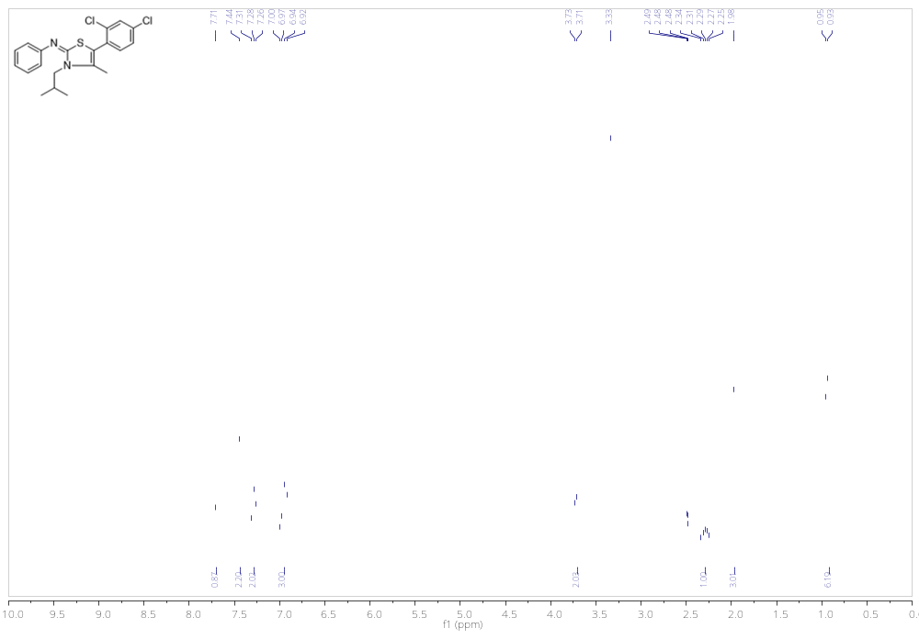
Figure 11. ¹H NMR spectra for 4f

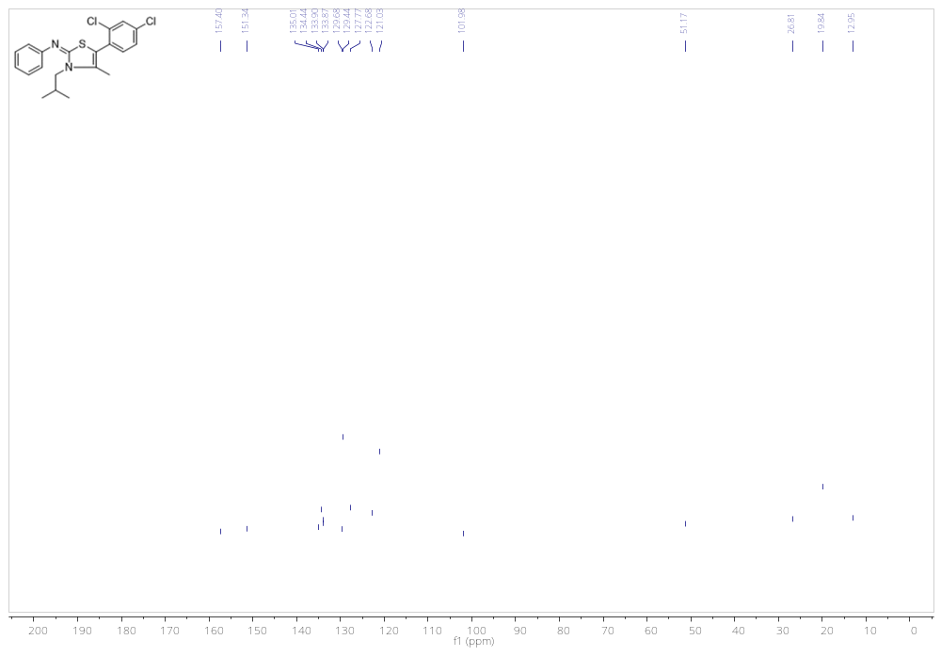
Figure 12. ¹³C NMR spectra for 4f

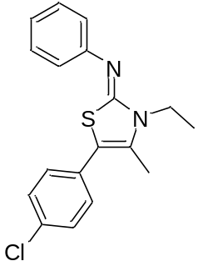N-(5-(4-chlorophenyl)-3-ethyl-4-methylthiazol-2(3H)-ylidene)aniline (4g): White powder (89%); mp147-149 ºC; ¹H NMR (300 MHz, DMSO-d₆) δ 7.45 (d, J = 8.4 Hz, 2H), 7.36-7.32 (m, 4H), 7.09-7.05 (m, 3H), 4.02 (q, J = 6.7 Hz, 2H), 2.27 (s, 3H), 1.29 (t, J = 6.9 Hz, 3H) ppm; ¹³C NMR (75 MHz, DMSO-d₆) δ (ppm): 157.9, 151.8, 132.7, 131.3, 130.3, 129.9, 129.4, 128.7, 122.9, 121.5, 107.2, 39.9, 13.6, 12.5 ppm; HRMS (ESI) calcd for C₁₈H₁₇ClN₂S (M+H)⁺ 329.0879, found: 329.0874; IR (KBr) ν_{max} (cm⁻¹): 698, 775, 836, 904, 1090, 1394, 1486, 1583, 1620.

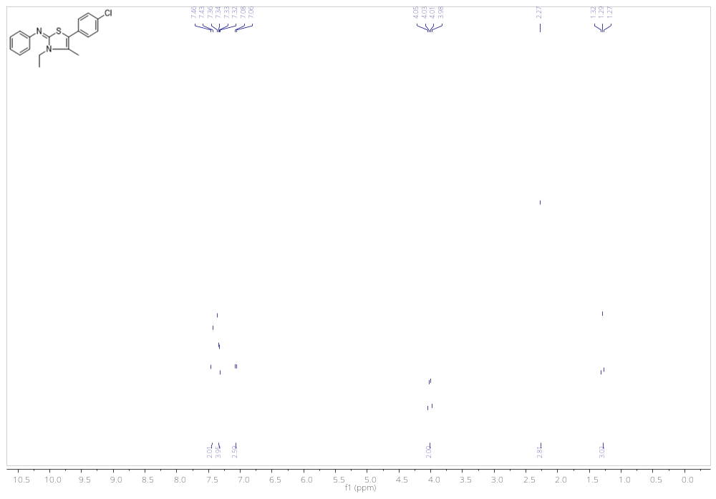
Figure 13. ¹H NMR spectra for 4g

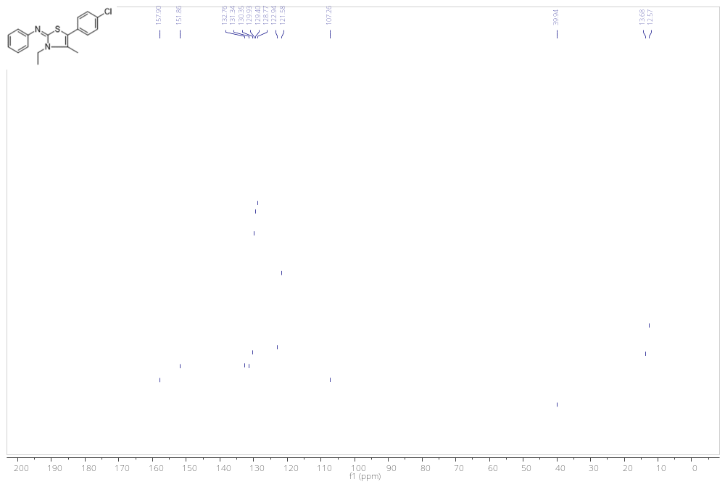
Figure 14. ¹³C NMR spectra for 4g

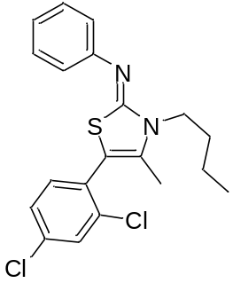N-(3-butyl-5-(2,4-dichlorophenyl)-4-methylthiazol-2(3H)-ylidene)aniline (4h):Yellow viscous oil (74%); ¹H NMR (300 MHz, DMSO-d₆) δ 7.68(s, 1H), 7.45-7.42 (m, 2H), 7.28 (t, J = 7.7 Hz, 2H), 6.99-6.49 (m, 3H), 3.89 (t, J = 7.4 Hz, 2H), 2.00 (s, 3H), 1.71-1.67 ( m, 2H), 1.38-1.33 (m, 2H), 0.93 (t, J = 7.30 Hz , 3H) ppm; ¹³C NMR (75 MHz, DMSO-d6) δ 157.0, 151.1, 134.9, 134.3, 133.8, 133.5, 129.6, 129.4, 129.3, 127.7, 122.6, 121.0, 102.0, 44.1, 29.7, 19.5, 13.7, 12.5 ppm; EI-MS m/z (%):335 (M-C₄H₉), 215, 189, 173, 149, 135, 119, 103, 91, 77, 57, 41 (100); IR (KBr) ν_{max} (cm⁻¹): 696, 765, 1072, 1101, 1196, 1328, 1398, 1472, 1584, 1607.

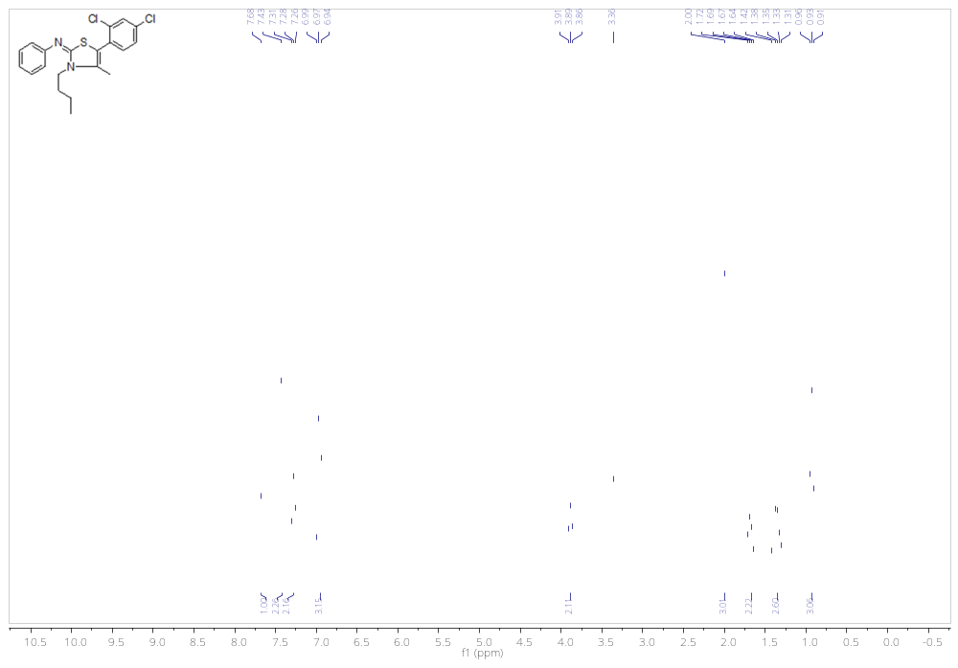
Figure 15. ¹H NMR spectra for 4h

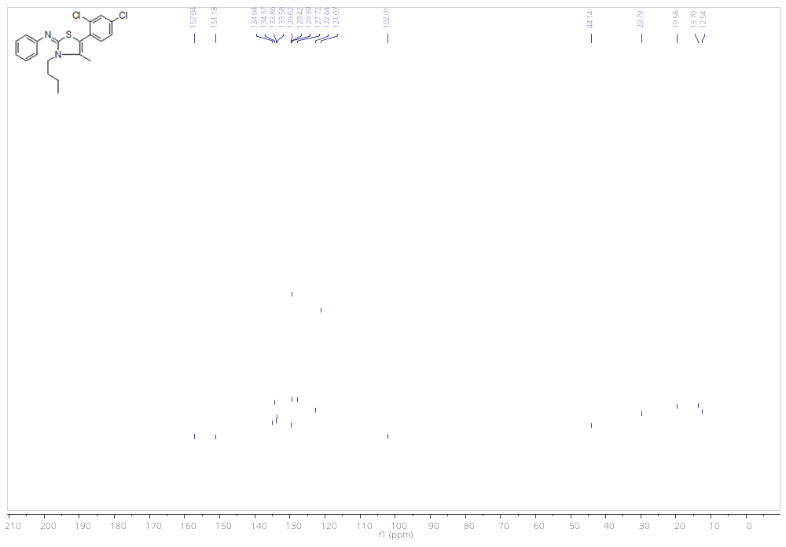
Figure 16. ¹³C NMR spectra for 4h

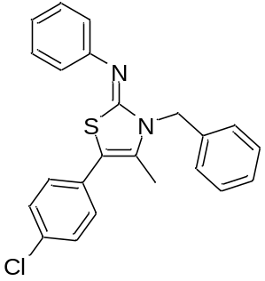N-(3-benzyl-5-(4-chlorophenyl)-4-methylthiazol-2(3H)-ylidene)aniline (4i): Yellow viscous oil (73%); ¹H NMR (300 MHz, Chloroform-d) δ 7.41 – 7.29 (m, 9H), 7.28 – 7.21 (m, 2H), 7.18 – 7.05 (m, 3H), 5.28 (s, 2H), 2.14 (s, 3H) ppm; ¹³C NMR (75 MHz, CDCl₃) δ 158.5, 151.2, 137.0, 132.8, 131.0, 130.7, 129.8, 129.3, 128.7, 128.6, 127.3, 126.6, 123.0, 121.4, 107.5, 47.6, 12.8 ppm; EI-MS m/z (%):390 (M⁺), 299, 167 (100), 139, 91, 65, 43; IR (KBr) ν_{max} (cm⁻¹): 696, 767, 838, 1091, 1391, 1489, 1575, 1610.

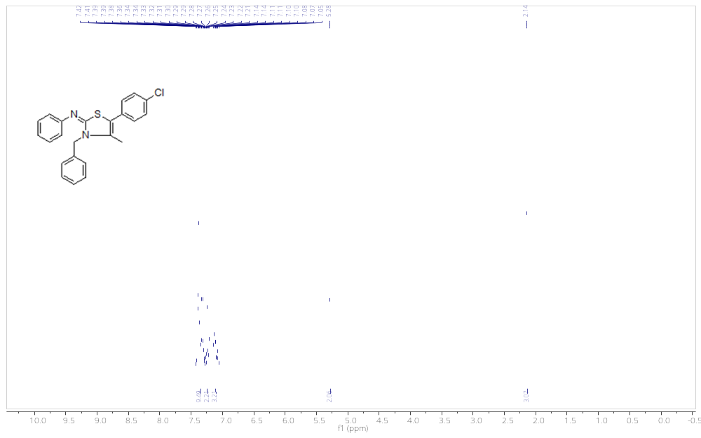
Figure 17. ¹H NMR spectra for 4i
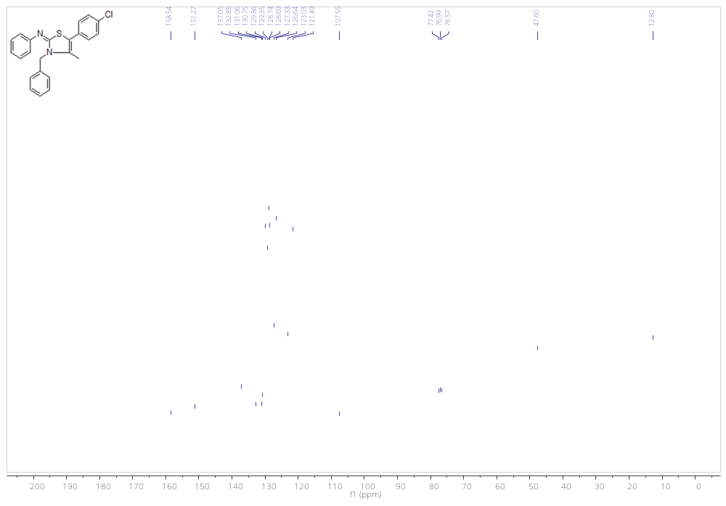
Figure 18. ¹³C NMR spectra for 4i

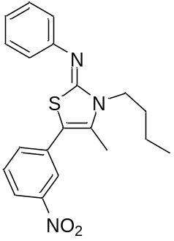N-(3-butyl-4-methyl-5-(3-nitrophenyl)thiazol-2(3H)-ylidene)aniline (4j): Yellow viscous oil (72%); ¹H NMR (300 MHz, DMSO-d₆) δ 8.06 (d, J = 8.1 Hz, 1H), 8.01 (s, 1H), 7.71 (d, J = 7.8 Hz, 1H), 7.62 (t, J = 7.9 Hz, 1H), 7.30 (t, J = 7.8 Hz, 2H), 6.98 (t, J = 9.3 Hz, 3H), 3.99 – 3.81 (m, 2H), 2.27 (s, 3H), 1.68 (dd, J = 15.9, 8.8 Hz, 2H), 1.37 (h, J = 7.3 Hz, 2H), 0.93 (t, J = 7.3 Hz, 3H) ppm; ¹³C NMR (75 MHz, DMSO-d₆) δ 156.4, 151.0, 147.9, 134.4, 133.9, 133.4, 130.3, 129.4, 122.8, 122.2, 121.5, 121.1, 104.5, 44.1, 29.8, 19.6, 13.6, 12.4 ppm; EI-MS m/z (%):367 (M⁺), 311 (100), 275, 235, 189, 150, 119, 93, 76, 57, 43; IR (KBr) ν_{max} (cm⁻¹): 697, 736, 767, 1196, 1347, 1528, 1580, 1616.

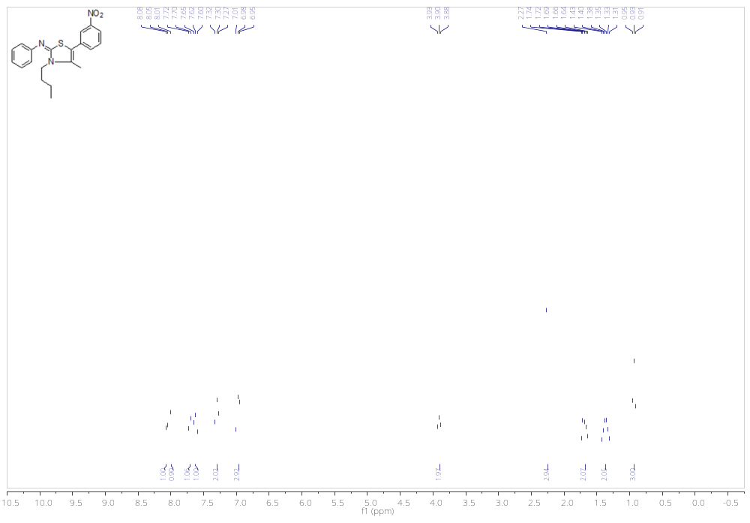
Figure 19. ¹H NMR spectra for 4j

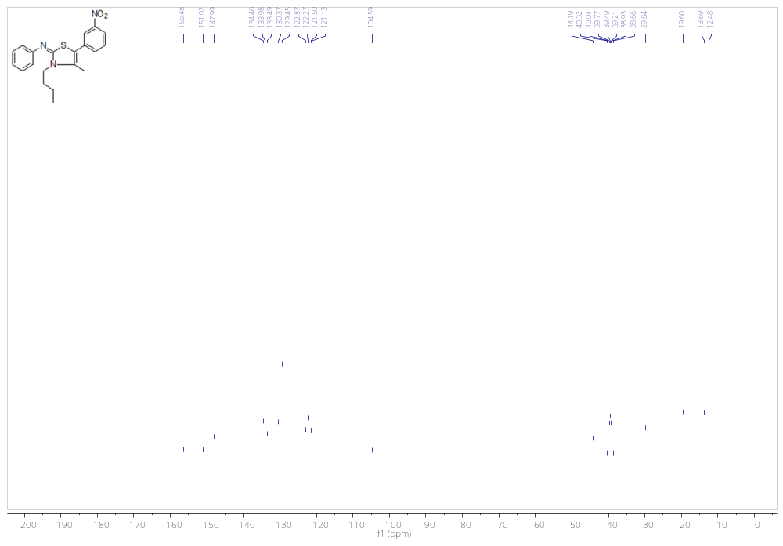
Figure 20. ¹³C NMR spectra for 4j

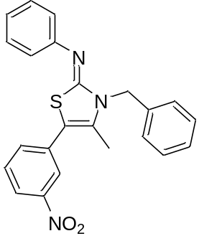N-(3-benzyl-4-methyl-5-(3-nitrophenyl)thiazol-2(3H)-ylidene)aniline (4k): Orange powder (81%); mp 97-98 ºC; ¹H NMR (300 MHz, DMSO-d₆) δ 8.11 (dd, J = 7.8, 1.7 Hz, 1H), 8.06 (t, J = 1.9 Hz, 1H), 7.79 (d, J = 8.0 Hz, 1H), 7.66 (t, J = 8.0 Hz, 1H), 7.42 – 7.28 (m, 7H), 7.07 – 6.94 (m, 3H), 5.28 (s, 2H), 2.21 (s, 3H) ppm; ¹³C NMR (75 MHz, CDCl₃) δ 157.2, 150.5, 148.0, 137.0, 134.6, 133.6, 133.6, 130.4, 129.5, 128.7, 127.3, 126.6, 123.1, 122.4, 121.8, 121.1, 105.1, 47.2, 12.6 ppm; HRMS (ESI) calcd for C₂₃H₁₉N₃O₂S (M+H)⁺ 402.1276, found 402.1271; IR (KBr) ν_{max} (cm⁻¹): 697, 736, 750, 1073, 1184, 1343, 1390, 1558, 1615.

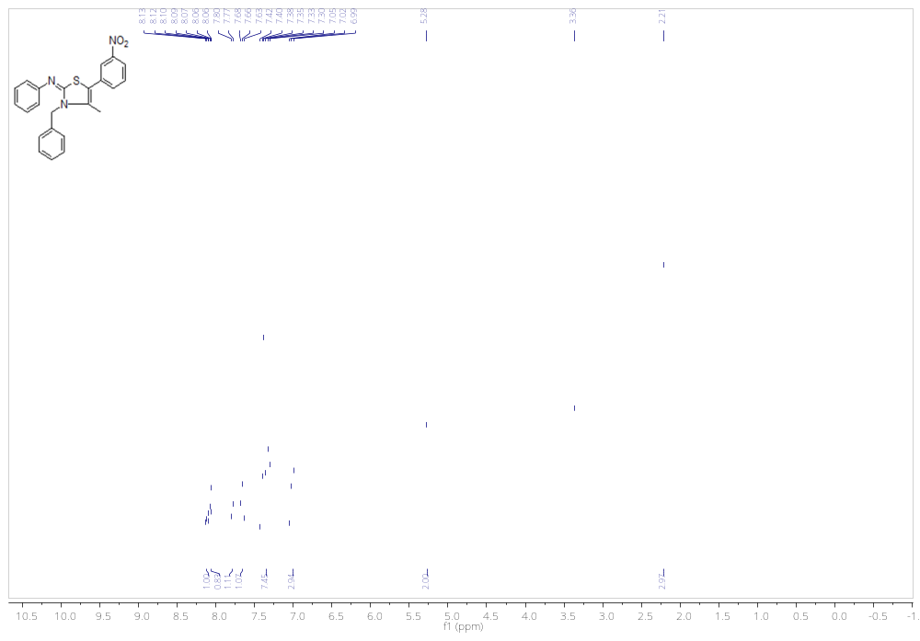
Figure 21. ¹H NMR spectra for 4k
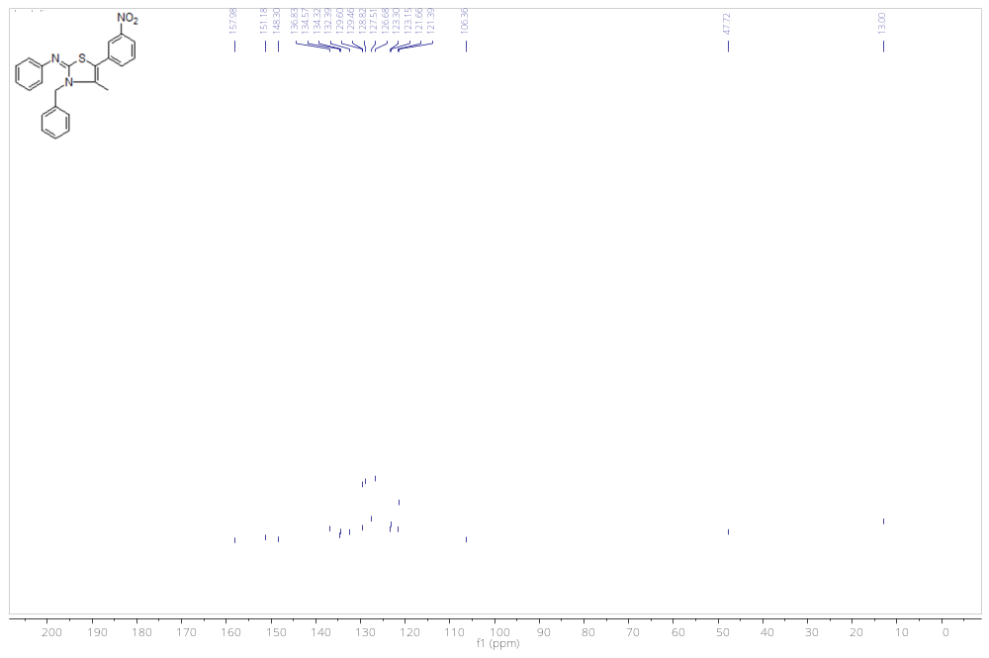
Figure 22. ¹³C NMR spectra for 4k

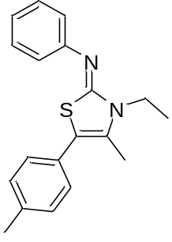N-(3-ethyl-4-methyl-5-(p-tolyl)thiazol-2(3H)-ylidene)aniline (4l): White powder (85%); mp 145-147 ºC; ¹H NMR (300 MHz, DMSO-d₆) δ 7.34 (t, J = 7.8 Hz, 2H), 7.23 – 6.98 (m, 7H), 4.03 (q, J = 7.0 Hz, 2H), 2.36 (s, 3H), 2.25 (s, 3H), 1.40 (t, J = 7.1 Hz, 3H) ppm; ¹³C NMR (75 MHz, CDCl₃) δ (ppm): 158.2, 152.0, 136.8, 129.8, 129.3, 129.2, 128.6, 122.6, 121.6, 109.9, 108.5, 39.7, 21.1, 13.6, 12.5 ppm; HRMS (ESI) Calcd for C₁₉H₂₀N₂S (M+H)⁺ 309.1425, found 309.1420; IR (KBr) ν_{max} (cm⁻¹): 698, 777, 823, 1058, 1200, 1329, 1395, 1583, 1621.

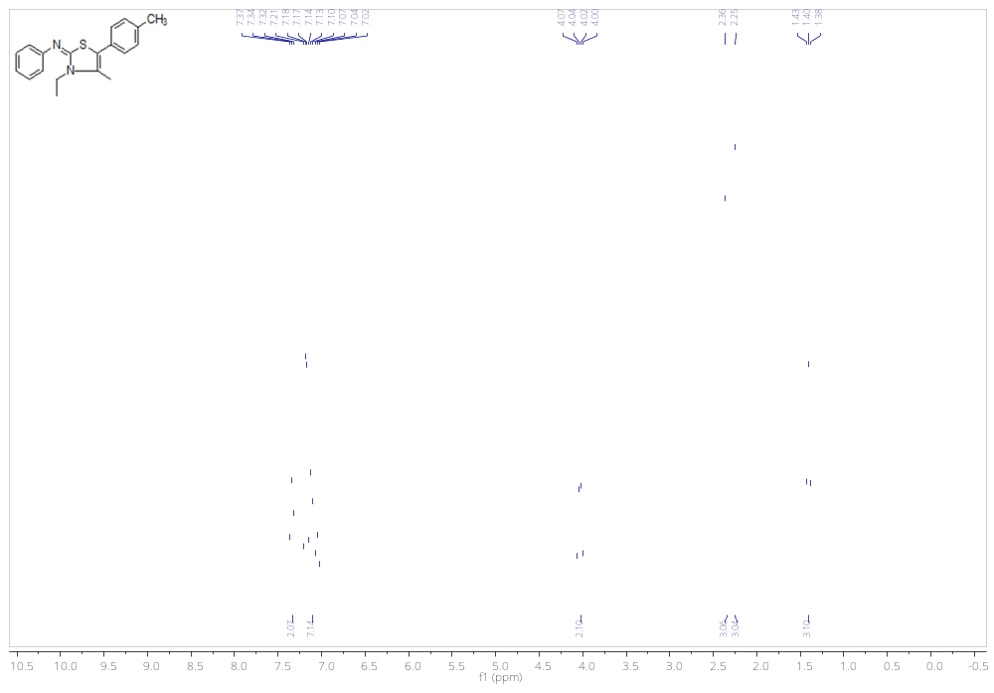
Figure 23. ¹H NMR spectra for 4l

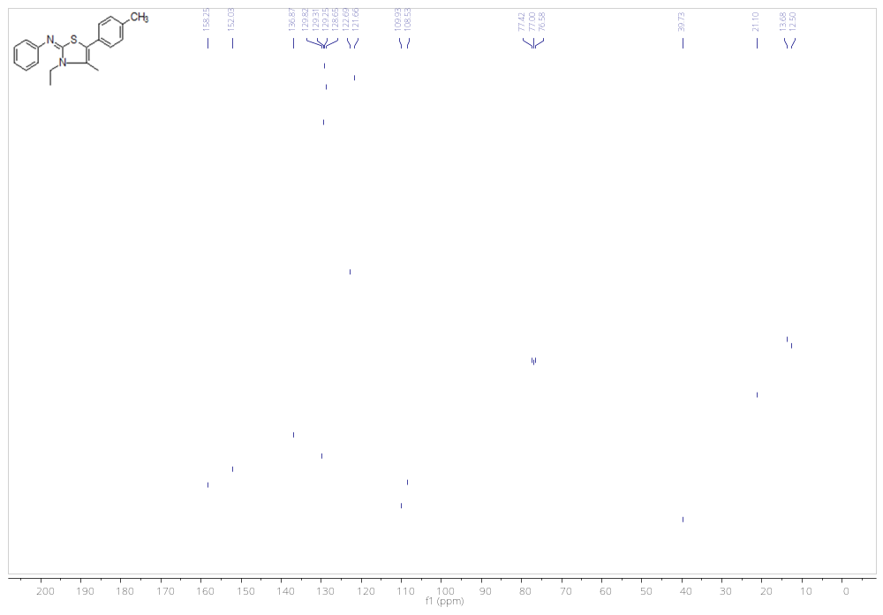
Figure 24. ¹³C NMR spectra for 4l

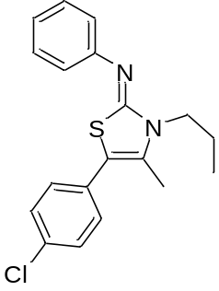N-(5-(4-chlorophenyl)-4-methyl-3-propylthiazol-2(3H)-ylidene)aniline (4m): White powder (84%); mp 100-101 ºC; ¹H NMR (300 MHz, CDCl₃) δ 7.36-7.27 (m, 7H), 7.22-7.04 (m, 2H), 3.91 (t, J = 7.7 Hz, 2H), 2.22 (s, 3H), 1.92-1.79 (m, 2H), 1.04 (t, J = 7.4 Hz, 3H) ppm; ¹³C NMR (75 MHz, CDCl₃) δ 158.1, 151.9, 132.7, 131.3, 130.5, 129.94, 129.4, 128.7, 122.9, 121.5, 107.2, 46.3, 21.6, 12.7, 11.3 ppm; HRMS (ESI) calcd for C₁₉H₁₉ClN₂S (M+H)⁺ 343.1036, found 343.1030; IR (KBr) ν_{max} (cm⁻¹): 697, 779, 1090, 1198, 1326, 1486, 1583, 1620.

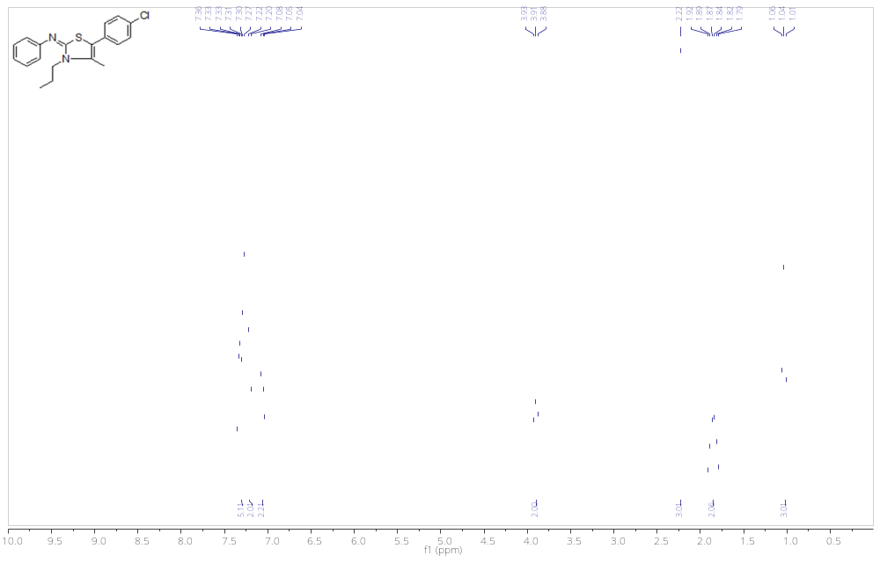
Figure 25. ¹H NMR spectra for 4m
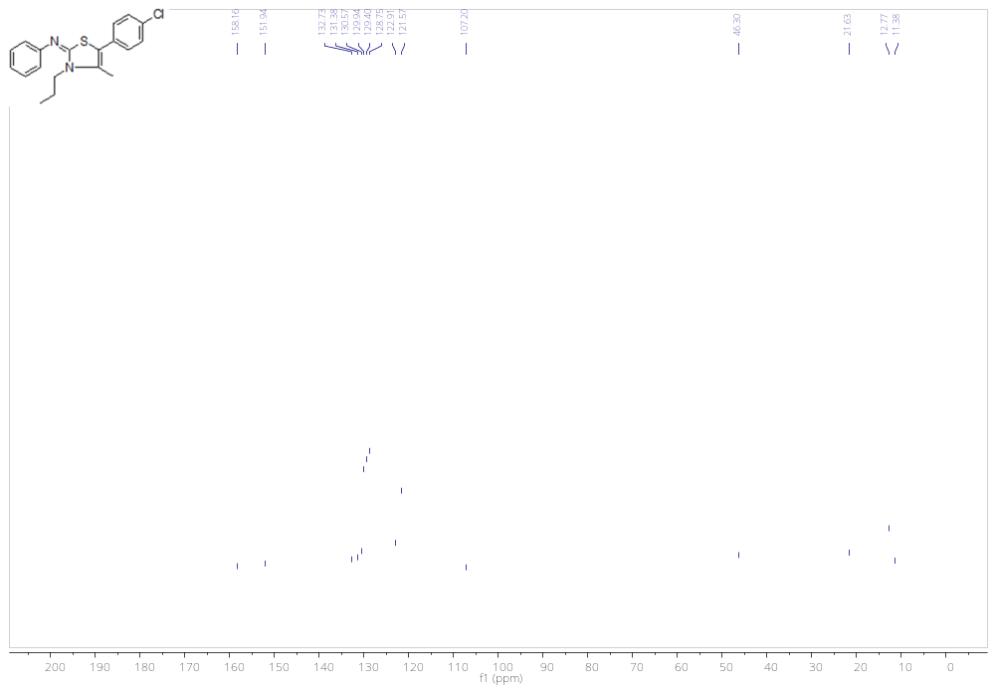
Figure 26. ¹³C NMR spectra for 4m

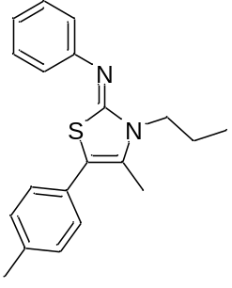N-(4-methyl-3-propyl-5-(p-tolyl)thiazol-2(3H)-ylidene)aniline (4n): White powder (85%), mp 109-110 ºC; ¹H NMR (300 MHz, Chloroform-d) δ 7.35 (t, J = 7.8 Hz, 2H), 7.23 – 7.13 (m, 4H), 7.10 (d, J = 8.1 Hz, 2H), 7.05 (t, J = 7.3 Hz, 1H), 3.92 (t, J = 7.69 Hz, 2H), 2.37 (s, 3H), 2.25 (s, 3H), 1.88-1.86 (m, 2H), 1.06 (t, J = 7.4 Hz, 3H) ppm; ¹³C NMR (75 MHz, CDCl₃) δ 158.5, 152.1, 136.8, 129.8, 129.5, 129.3, 129.2, 128.6, 122.6, 121.6, 108.4, 46.2, 21.6, 21.1, 12.7, 11.3 ppm; EI-MS m/z (%): 322 (M⁺), 307, 280 (100), 230, 204, 150, 135, 115, 91, 69, 41; IR (KBr) ν_{max} (cm⁻¹): 697, 778, 820, 1197, 1326, 1486, 1583, 1621.

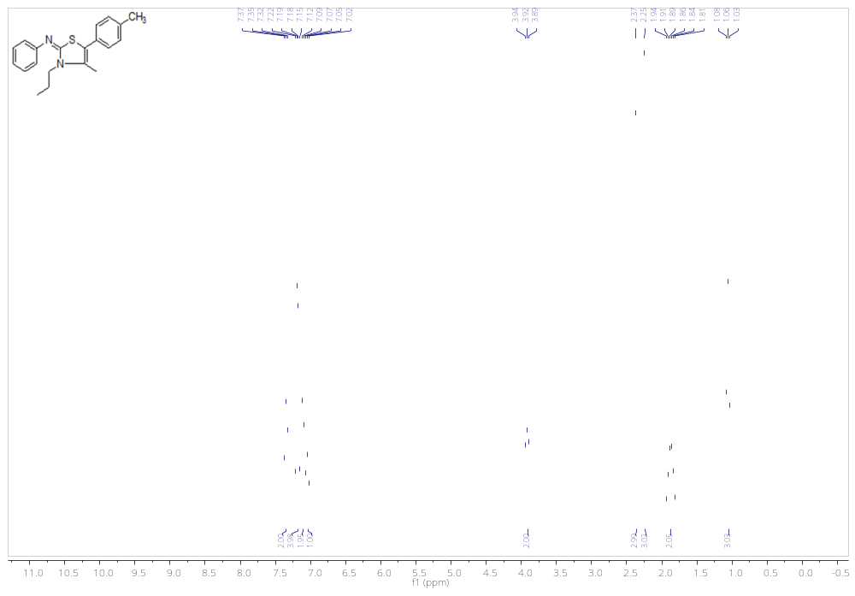

Figure 27. ¹H NMR spectra for 4n

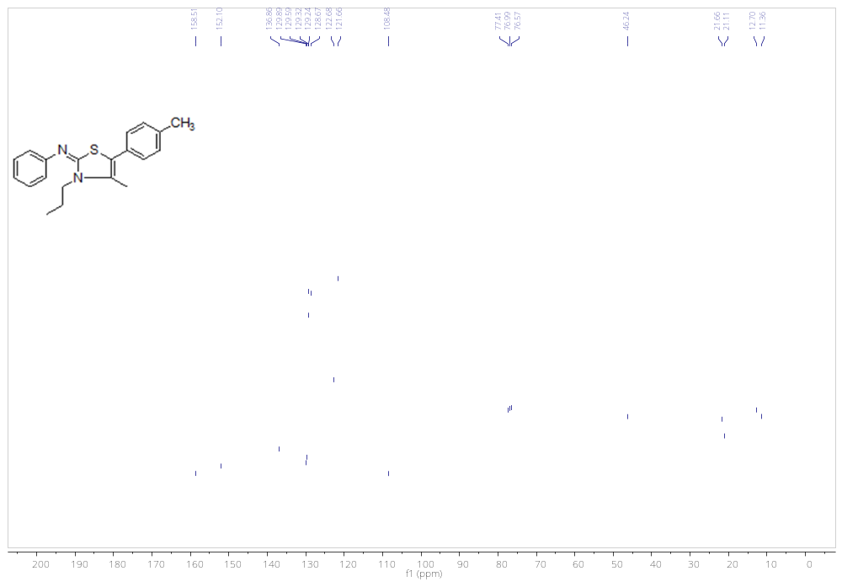
Figure 28. ¹³C NMR spectra for 4n

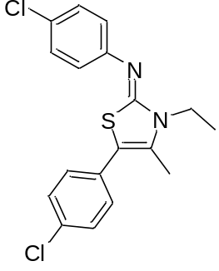4-chloro-N-(5-(4-chlorophenyl)-3-ethyl-4-methylthiazol-2(3H)-ylidene)aniline (4o): White powder (88%); mp 120-121 ºC; ¹H NMR (300 MHz, CDCl₃) δ 7.34-7.27 (m, 4H), 7.22 (d, J = 8.6 Hz, 2H), 7.03 (d, J = 8.6 Hz, 2H), 4.01 (q, J = 7.1 Hz, 2H), 2.23 (s, 3H), 1.38 (t, J = 7.1 Hz, 3H) ppm; ¹³C NMR (75 MHz, CDCl₃) δ 158.5, 150.3, 132.9, 131.1, 130.4, 129.9, 129.3, 128.8, 127.6, 122.9, 107.4, 39.7, 13.6, 12.5 ppm; HRMS (ESI) calcd for C₁₈H₁₆Cl₂N₂S (M+H)⁺ 363.0489, found 363.0484; IR (KBr) ν_{max} (cm⁻¹): 694, 759, 870, 1100, 1201, 1323, 1403, 1473, 1563, 1576, 1626.
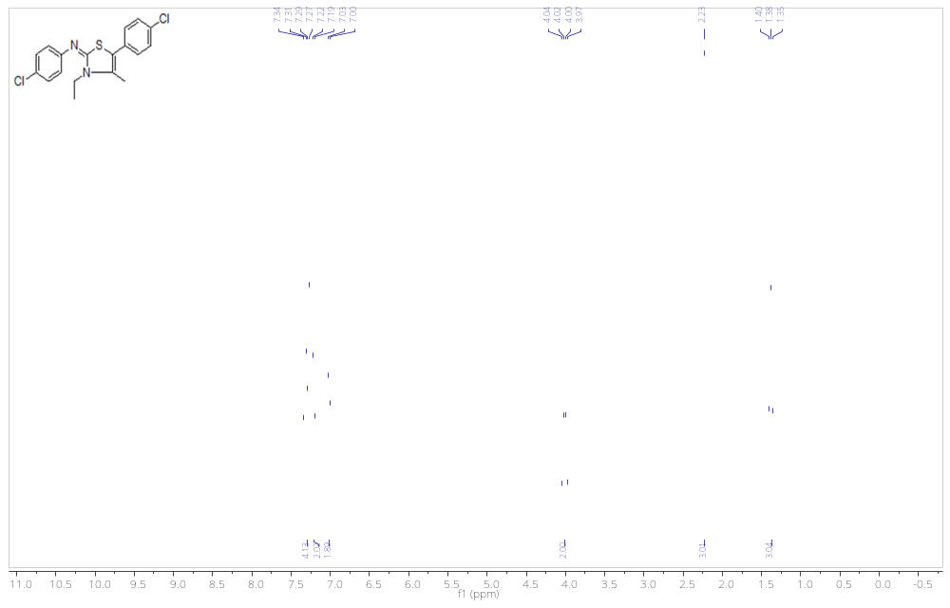
Figure 29. ¹H NMR spectra for 4o
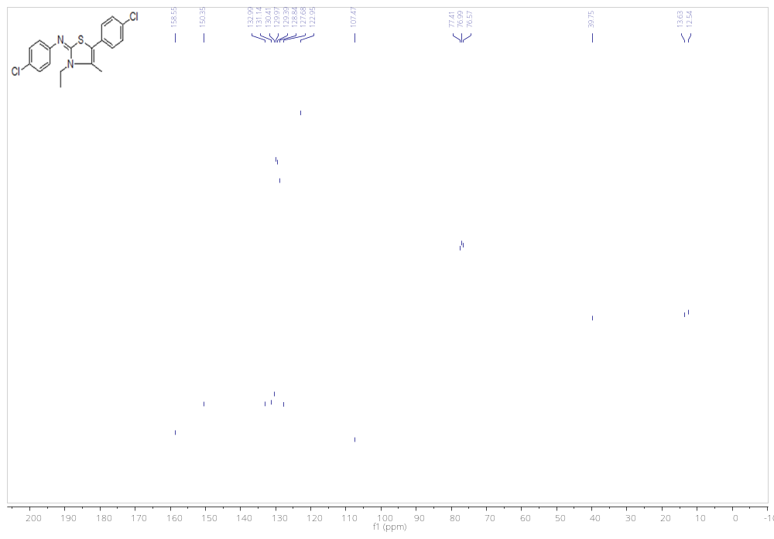
Figure 30. ¹³C NMR spectra for 4o

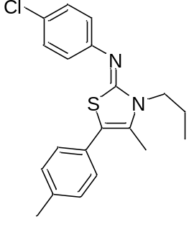4-chloro-N-(4-methyl-3-propyl-5-(p-tolyl)thiazol-2(3H)-ylidene)aniline (4p): White powder (86%); mp 78-79 ºC; ¹H NMR (300 MHz, CDCl₃) δ 7.29-7.27 (d, J = 8.6 Hz, 2H), 7.21-7.15 (m, 4H), 7.05-7.00 (m, 2H), 3.90 (t, J = 6.7 Hz, 2H), 2.37 (s, 3H), 2.25 (s, 3H), 1.91-1.79 (m, 2H), 1.04 (t, J = 7.4 Hz, 3H) ppm; ¹³C NMR (75 MHz, CDCl₃) δ 158.8, 150.6, 137.0, 129.6, 129.6, 129.3, 128.7, 127.4, 123.0, 109.9, 108.7, 46.3, 21.6, 21.1, 12.7, 11.3 ppm; HRMS (ESI) calcd for C₂₀H₂₁ClN₂S 357.1192, found 357.1187; IR (KBr) ν_{max} (cm⁻¹): 813, 848, 1089, 1197, 1326, 1392, 1482, 1580, 15.99, 1617.

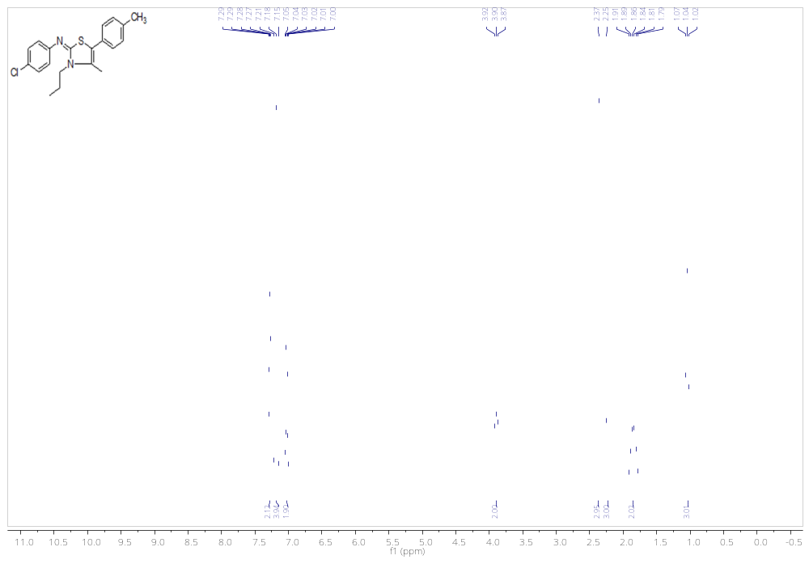
Figure 31. ¹H NMR spectra for 4p

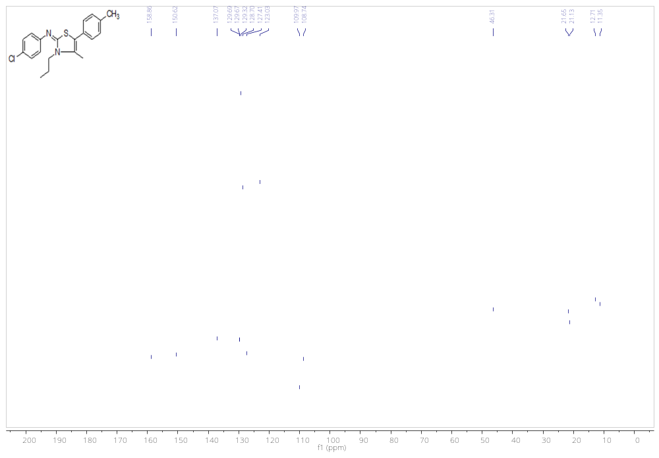
Figure 32. ¹³C NMR spectra for 4p

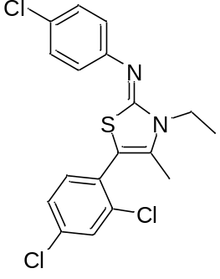4-chloro-N-(5-(2,4-dichlorophenyl)-3-ethyl-4-methylthiazol-2(3H)-ylidene)aniline (4q): White powder (88%); mp 97-98 ºC; ¹H NMR (300 MHz, Chloroform-d) δ 7.47 (t, J = 1.0 Hz, 1H), 7.28 (d, J = 2.8 Hz, 1H), 7.27 – 7.22 (m, 3H), 7.08 – 6.99 (m, 2H), 4.01 (q, J = 7.1 Hz, 2H), 2.03 (s, 3H), 1.39 (t, J = 7.1 Hz, 3H) ppm; ¹³C NMR (75 MHz, CDCl₃) δ 158.5, 150.1, 135.8, 134.7, 133.6, 132.4, 129.8, 129.6, 129.3, 127.5, 127.2, 122.8, 103.7, 39.7, 13.5, 12.7 ppm; HRMS (ESI) calcd for C₁₈H₁₅Cl₃N₂S (M+H)⁺ 399.0070, found 399.0065; IR (KBr) ν_{max} (cm⁻¹): 694, 759, 870, 1100, 1201, 1323, 1403, 1473, 1563, 1576,1617.

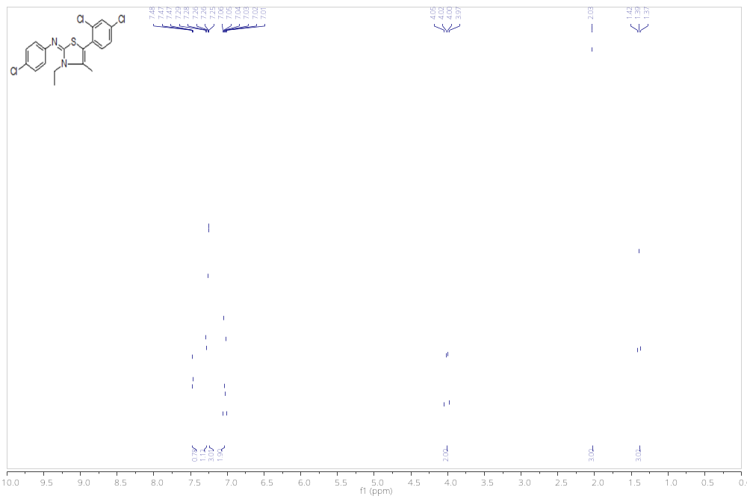
Figure 33. ¹H NMR spectra for 4q
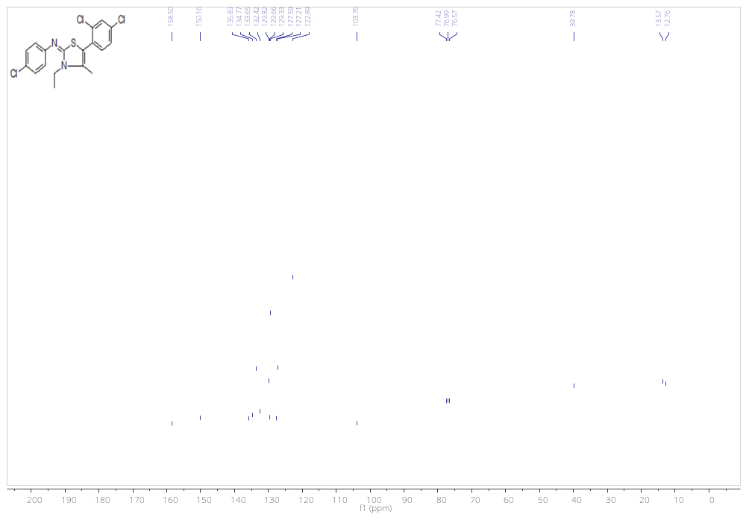
Figure 34. ¹³C NMR spectra for 4q

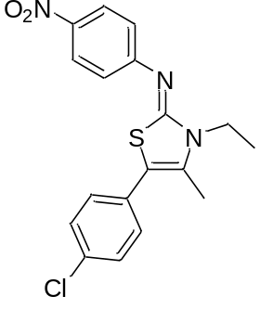N-(5-(4-chlorophenyl)-3-ethyl-4-methylthiazol-2(3H)-ylidene)-4-nitroaniline (4r): Orange powder (93%); mp 142-143 ºC; ¹H NMR (300 MHz, CDCl₃) δ 8.22 (d, J = 8.8 Hz, 2H), 7.39(d, J = 8.4 Hz, 2H), 7.39-7.19 (m, 5H), 4.86 (q, J = 6.90 Hz, 2H), 2.29 (s, 3H), 1.41 (t, J = 6.9 Hz, 3H) ppm; ¹³C NMR (75 MHz, CDCl₃) δ 158.5, 157.5, 142.6, 133.9, 130.9, 130.1, 129.0, 125.5, 123.7, 121.4, 109.1, 40.2, 13.6, 12.5 ppm; HRMS (ESI) calcd for C₁₈H₁₆ClN₃O₂S (M+H)⁺ 374.0730, found 374.0725; IR (KBr) ν_{max} (cm⁻¹): 856, 1109, 1310, 1392, 1489, 1526, 1583, 1612.

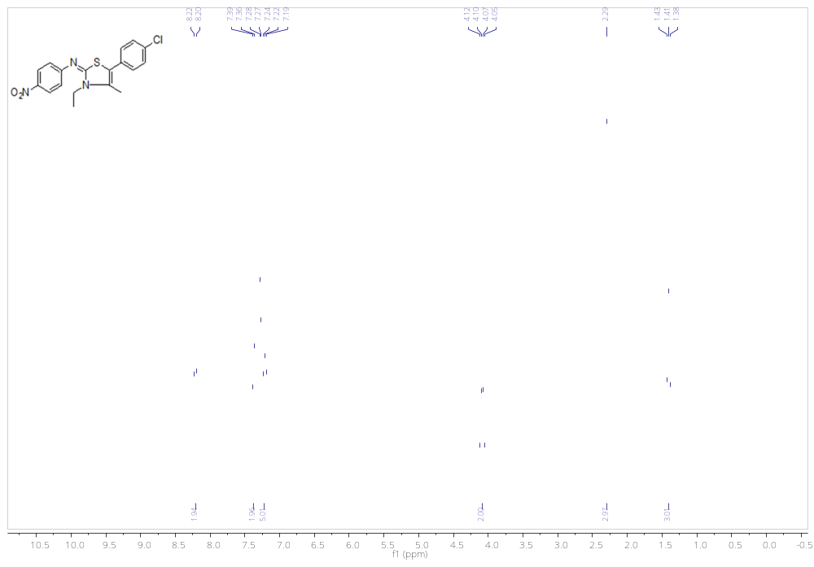
Figure 35. ¹H NMR spectra for 4r

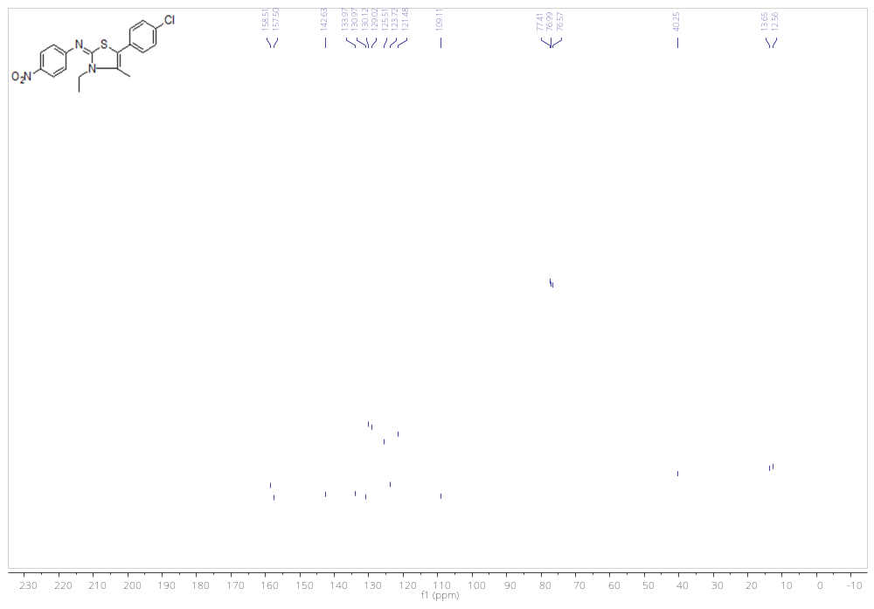
Figure 36. ¹³C NMR spectra for 4r

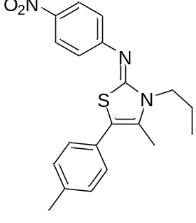N-(4-methyl-3-propyl-5-(p-tolyl)thiazol-2(3H)-ylidene)-4-nitroaniline (4s): Red powder (90%); mp 99 ºC; ¹H NMR (300 MHz, CDCl₃) δ 8.22 (d, J = 8.8 Hz, 2H), 7.28-7.21 (m, 6H), 3.96 (t, J = 7.6 Hz, 2H), 2.38 (s, 3H), 2.28 (s, 3H), 1.92-1.79 (m, 2H), 1.05 (t, J = 7.4 Hz, 3H) ppm; ¹³C NMR (75 MHz, CDCl₃) δ 159.1, 157.5, 141.9, 137.63, 129.8, 129.4, 128.9, 128.8, 125.4, 121.4, 110.1, 46.7, 21.7, 21.1, 12.7, 11.3 ppm; HRMS (ESI) calcd for C₂₀H₂₁N₃O₂S (M+H)⁺ 368.1433, found 368.1427; IR (KBr) ν_{max} (cm⁻¹): 856, 1109, 1318, 1537, 1609.

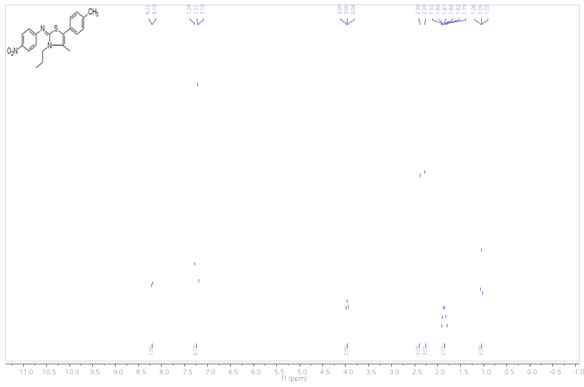
Figure 37. ¹H NMR spectra for 4s
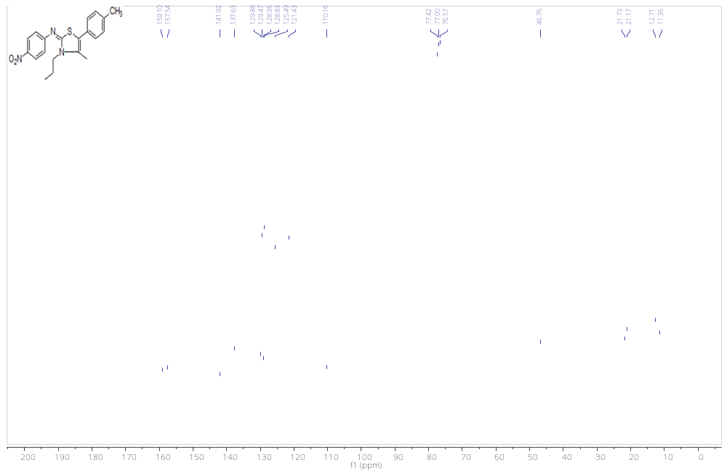
Figure 38. ¹³C NMR spectra for 4s

X-Ray crystallography
Suitable crystals for X-ray crystallography were grown in ethanol by slow evaporation of solvent at room temperature.
X-ray Crystallography
Table 1. Crystal data of compound 4p (CCDC- 217830 )
Empirical formula | C₂₀H₂₁ClN₂S
Formula weight | 356.90
Temperature | 290
Wavelength | 0.71073
Crystal system | orthorhombic
Space group | pbca
Unit cell dimensions | a = 13.808(3) Å α = 90 °  b = 14.504(3) Å β = 90 °  c = 18.506(4) Å γ = 90 °
Volume | 3706.2 (13) Å³
Z | 8
Calculated density | 1.279 Mg/m³
Absorption coefficient | 0.322 mm⁻¹
F(000) | 1504
Crystal size | 0.300 x 0.200 x 0.100 mm³
Theta range for data collection | 2.3 to 25.9 °
Index ranges | -16<=h<=16, -17<=k<=17, -22<=l<=22
Reflections collected | 24481
Independent reflections | 3600 [R(int) = 0.0471]
Data / restraints / parameters | 3600/0/220
Goodness-of-fit on F² | 1.122
Final R indices [I>2σ(l)] | R1 = 0.0449, ωR2 = 0.1075
R indices (all data) | R1 = 0.0471, ωR2 = 0.1090
Largest diff. peak and hole | 0.174 and -0.220 e×Å3

