Single-cell RNA sequencing and molecular docking reveal sinomenine can treat postherpetic neuralgia by regulating the expression of MMP2
Author: Hong li- Zhang1, Yong Zhao2*
1 Department of Gastroenterology, the First Affiliated Hospital of Nanchang University, Jiangxi Institute of Gastroenterology and Hepatology, Jiangxi Clinical Research Center for Gastroenterology, Nanchang, 330006, China
2 Department of Pain Management, the First Affiliated Hospital of Nanchang University
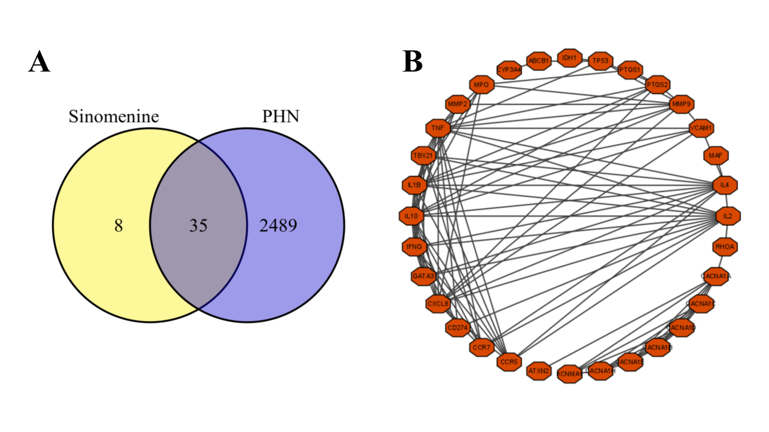
Figure S1. Venn diagram of sinomenine- and PHN-related genes and network relationship map of the intersection genes.
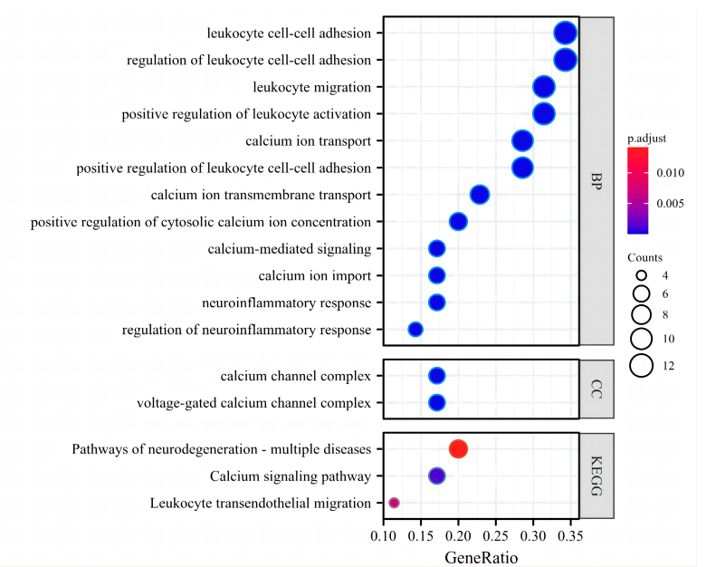
Figure S2. GO functional analysis and KEGG pathway enrichment analysis of the "sinomenine-PHN" intersection genes

Table 1. Hub genes of the "sinomenine-PHN" intersection genes relate protein screened on the PDB website and their ID names
Gene symbol | Description | PBD ID
CACNA1E | Calcium voltage-gated channel subunit alpha1 A | 3DVK
CACNA1C | Calcium voltage-gated channel subunit alpha1 B | 2LQC
CACNA1B | Calcium voltage-gated channel subunit alpha1 C | 2LCM
CACNA1A | Calcium voltage-gated channel subunit alpha1 D | 3DVM
CACNA1D | Calcium voltage-gated channel subunit alpha1 E | 7UHG
TNF | Tumor necrosis factor | 2E7A
IFNG | Interferon-gamma | 6F1E
PTGS1 | Prostaglandin-endoperoxide synthase 1 | 1EBV
IL1B | Interleukin 1 beta | 1T4Q
IL4 | Interleukin 4 | 1IAR
IL10 | Interleukin 10 | 1INR
CXCL8 | C-X-C motif chemokine ligand 8 | 6XMN
KNG1 | Kininogen 1 | 6F27
CCR5 | C-C motif chemokine receptor 5 | 2RRS
CCR7 | C-C motif chemokine receptor 7 | 6QZH

Table 2. Molecular docking results of Hub genes and sinomenine
 | Binding energy(mol/kal) | RMSD✱ | H-Bond distance(Å)
KNG1 | -9.23 | 4.66 | 1.557
CACNA1C | -7.21 | 9.6 | 1.87
CACNA1E | -7.36 | 23.66 | 2.013
IL4 | -6.25 | 12.42 | 1.776
TNF | -6.27 | 28.32 | 1.856
CCR5 | -5.5 | 4.22 | 1.716
CCR7 | -6.54 | 42.9 | 1.721
IL10 | -6.18 | 29.17 | 0
IFNG | -5.69 | 42.63 | 1.856
CACNA1B | -5.39 | 29.16 | 1.842
CACNA1A | -5.97 | 153.49 | 2.018
CXCL8 | -5.26 | 21.6 | 1.977
IL1B | -5.12 | 12.63 | 1.917
CACNA1D | -6.28 | 256.01 | 1.999
PTGS1 | -5.67 | 189.82 | 1.901
✱RMSD: Root Mean Square Deviation

