Supplementary data, Table S1, S2, and Figures S1, 2, 3, and 4

Table S1. Primers used for mPCR to determine the presence of Listeria genus, and serogroup L. monocytogenes in the study (Doumith et al., 2004)

PCR assay | Target Gene | Product Size (bp) | Primer Sequences (5′‐3’)
mPCR1 | ORF2110 | 597 | ORF2110‐F: AGTGGACAATTGATTGGTGAA
 |  |  | ORF2110‐R: CATCCATCCCTTACTTTGGAC
 | ORF2819 | 471 | ORF2819‐F: AGCAAAATGCCAAAACTCGT
 |  |  | ORF2819‐R: CATCACTAAAGCCTCCCATTG
 | Imo1118 | 691 | lmo1118‐F: AGGGGTCTTAAATCCTGGAA
 |  |  | Imo1118‐R: CGGCTTGTTCGGCATACTTA
 | Imo0737 | 906 | lmo0737‐F: AGGGCTTCAAGGACTTACCC
 |  |  | lmo0737‐R: ACGATTTCTGCTTGCCATTC
 | Prs | 370 | prs‐ F: GCTGAAGAGATTGCGAAAGAAG
 |  |  | prs‐R: CAAAGAAACCTTGGATTTGCGG

Table S2. Primers used for mPCR speciation in this study (Ryu et al., 2013)
Species | Gene | Primer | Sequences (5^{i}-3^{i}) | PCR Product Size (bp) | Primer concentration (mM)
Listeria genus | Prs | prs-F | GCTGAAGAGATTGCGAAAGAAG | 370 | 0.2
 |  | prs-R | CAAAGAAACCTTGGATTTGCGG | 370 | 0.2
L. grayi | Oxidoreductase | JOgrayi-F | GCGGATAAAGGTGTTCGGGTCAA | 201 | 0.24
 |  | JOgrayi-R | ATTTGCTATCGTCCGAGGCTAGG | 201 | 0.24
L. innocua | lin0464 | lin0464-F | CGCATTTATCGCCAAAACTC | 749 | 1.2
 |  | lin0464-R | TCGTGACATAGACGCGATTG | 749 | 1.2
L. ivanovii | namA | liv22-228-F | CGAATTCCTTATTCACTTGAGC | 463 | 0.52
 |  | liv22-228-R | GGTGCTGCGAACTTAACTCA | 463 | 0.52
L. monocytogenes | Imo1030 | lmo1030-F | GCTTGTATTCACTTGGATTTGTCTGG | 509 | 0.56
 |  | lmo1030-R | ACCATCCGCATATCTCAGCCAACT | 509 | 0.56
L. seeligeri | lmo033 | lseelin-F | GTACCTGCTGGGAGTACATA | 673 | 0.96
 |  | lseelin-R | CTGTCTCCATATCCGTACAG | 673 | 0.96
L. welshimeri | scrA | lwe1801-F | CGTGGCACAATAGCAATCTG
 |  | lwe1801-R | GACATGCCTGCTGAACTAGA | 281 | 0.96

Table S3. Primer sequences, PCR preparation, and PCR condition used for virulence gene detection in this study
PCR | Target | Product
assay | Gene | Size (bp) | Primer Sequences (5’ 3’) | PCR Preparation | PCR Condition | References
mPCR1 | inlB | 376 | inlB‐F: GATATTGTGCCACTTTCAGGTT | 12.5 μL 2× DreamTaq master mix, | 2 min at 94°C, | Liu et al. (2007)
 |  |  | inlB‐R: CCTCTTTCAGTGGTTGGGTT | 5 μL nuclease-free water, | 35 cycles of 94°C for 30 s,
 | plcA | 1484 | plcA‐F: CTGCTTGAGCGTTCATGTCTCATCCC | 5 μL template DNA, | 55°C for 30 s,
 |  |  | plcA‐R: ATGGGTTTCACTCTCCTTCTAC | 3 μL primer mix for mPCR2 | 72°C for 1 min and
 | hlyA | 456 | hlyA‐F: GTTAATGAACCTACAAGACCTTCC |  | a final extension at 72°C for 10 min.
 |  |  | hlyA‐R: ACCGTTCTCCACCATTCCCA
 | actA | 839 | actA‐F: TCGCCGCGGAAATTAAAAAAAGA
 |  |  | actA‐R: ACGAAGGAACCGGGCTGCTAG
 | iap | 131 | iap‐F: ACAAGCTGCACCTGTTGCAG
 |  |  | iap‐R: TGACAGCGTGTGTAGTAGCA
mPCR2 | inlA | 800 | inlA‐F: ACGAGTAACGGGACAAATGC |  |  | Liu et al. (2007)
 |  |  | inlA‐R: CCCGACAGTGGTGCTAGATT
 | inlC | 517 | inlC‐F: AATTCCCACAGGACACAACC
 |  |  | inlC‐R:CGGGAATGCAATTTTTCACTA
 | inlJ | 238 | inlJ‐F: TGTAACCCCGCTTACACACAGTT
 |  |  | inlJ‐R: AGCGGCTTGGCAGTCTAATA

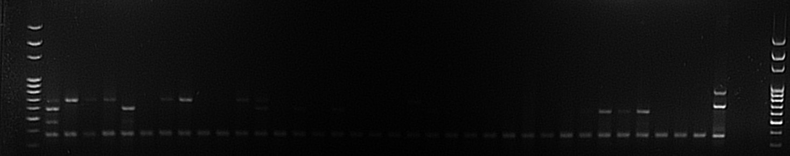
prs

ORF2110
Imo0737
ORF2819 ORF2819

1300
1200
1100
1000
900
700
800
600
300
400
500
L 1 2 3 4 5 6 7 8 9 10 11 12 13 14 15 16 17 18 19 20 21 22 23 24 25 26 27 28 29 P N B L

Figure S1: PCR gel images used to confirm isolates of Listeria spp. with the detection of the
following genes: Prs, ORF2819, ORF2110, and Imo0737. Listeria spp. isolates on 3%
agarose gel. Lane L:100bp DNA ladder, Lanes 1-29, Listeria spp. P: Positive control,
L. monocytogenes. ATCC 19111), N: Negative control, Campylobacter fetus. ATCC 27374),
and B: Blank, Distilled water.

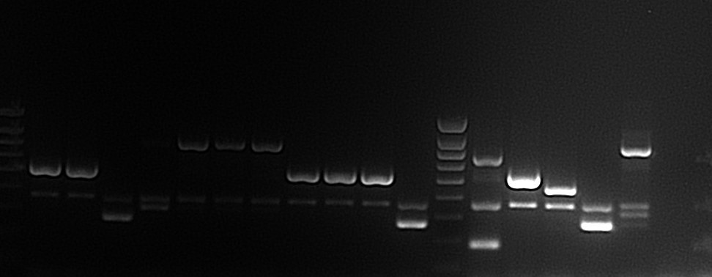
500
600
700
800
900
400
300
200
100
L 1 2 3 4 5 6 7 8 9 10 11 L P1 P2 P3 P4 P5 N B
Figure S2: The images of the multiplex PCR gels used to determine the species of Listeria isolates on 3% agarose gel. Lane L:100bp DNA ladder, Lanes 1; L. monocytogenes, Lane 2; L. monocytogenes, Lane 3; L. welshimeri, Lane 4-7; L. innocua, Lane 8-10; L. monocytogenes, Lane 11; L. welshimeri, P1: Positive control 1, L. grayi ATCC 25401 and L. seeligeri ATCC 35967), P2: Positive control 2. L. monocytogenes ATCC 19111), P3: Positive control 3, L. ivanovii ATCC 19119), P4: Positive control 4, L. welshimeri ATCC 35897), P5: Positive control 5, L. innocua ATCC 33090), N: Negative control, Campylobacter fetus. ATCC 27374) and B: Blank-Distilled water

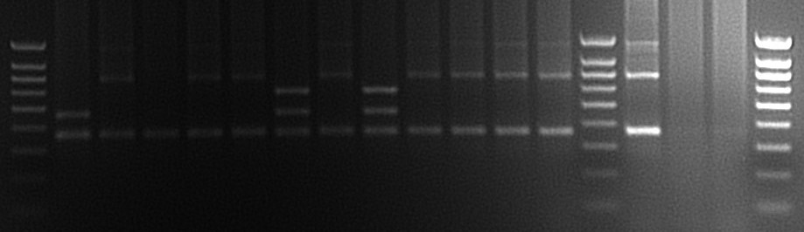
700
900
800
500
600
400
300
100
200
L 1 2 3 4 5 6 7 8 9 10 11 12 L P N B L

Figure S3: The images of the multiplex PCR gels used to determine the serogroups of the isolates of L. monocytogenes with the following genes Prs, ORF2819, ORF2110, and Imo0737 on 3% agarose gel. Lane L:100bp DNA ladder, Lanes 1-12: L. monocytogenes serogroups; P: Positive control, L. monocytogenes. ATCC 19111, N: Negative control, Campylobacter fetus. ATCC27374), and B: Blank-Distilled water

P
N
L
15
14
13
12
11
10
9
8
7
6
5
4
3
2
1
L

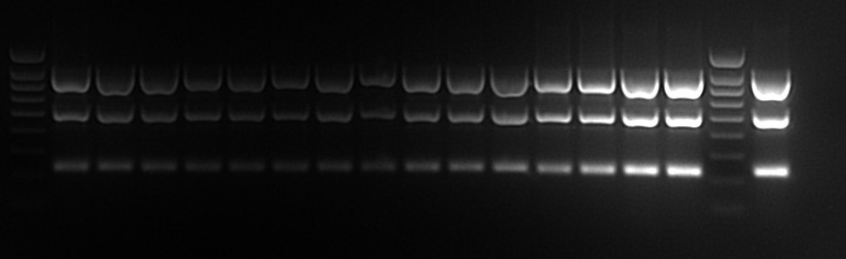
900
inlA

inlC

inlJ

100

Figure S4: Images of PCR gels used to detect the virulence genes (inlA, inlC, and inlJ) of L. monocytogenes isolates on 3% agarose gel. Lane L: 100bp DNA ladder, Lanes 1-15: L. monocytogenes virulence genes, P: Positive control, L. monocytogenes ATCC 19111 Virulence genes, and N: Negative control, Campylobacter fetus. ATCC 27374).

