Supplementary Materials
Methods
Overexpression of HNF4α in UMSCs
HNF4α cDNA was cloned from human umbilical cord MSCs into pHelper 1.0 plasmid. The UMSCs were then infected with lentiviral particles of HNF4α-GFP or GFP (used as a control). Overexpression of HNF4α was confirmed by confocal laser-scanning microscope and Western blotting.
Western blot
Western blotting was performed to analyze the protein expression levels. The cell extracts were isolated from cultured hepatocytes using NE-PER Nuclear and Cytoplasmic Extraction Reagents (Thermo Fisher scientific, Waltham, MA, USA). The primary antibodies against HNF4α (Abcam), and β-actin as control (Sigma-Aldrich) were utilized.
Harvest of conditioned medium
Microcapsules of human hepatocytes, with or without HNF4α-UMSCs or UMSCs were cultured for four days, and the conditioned medium (CM) was harvested and stored at -80 °C.
RNA extraction and real-time PCR
RNA extraction and real-time PCR were performed as described previously.¹⁸ The PCR primers are listed in Table S1. Total liver RNA was extracted using TRIzol (Takara, Tokyo, Japan) reagent according to the manufacturer’s instructions. The cDNA was synthesized with PrimeScript RT reagent Kit (Takara). q-PCR was performed using CFX 96 q-PCR system (BIO-RAD, Hercules, CA, USA). A SYBR RT-PCR kit (Takara) was used for quantitative real-time PCR analysis. The relative expression levels for target gene were normalized by β-actin or GAPDH.

Supplementary figure and table legends
Figure S1: Primary hepatocytes were co-encapsulated with HNF4α-UMSCs at a ratio of 10:1, 5:1, and 2.5:1. Measurement of albumin secretion and urea synthesis in the supernatant of microcapsules in different groups at varied time points.
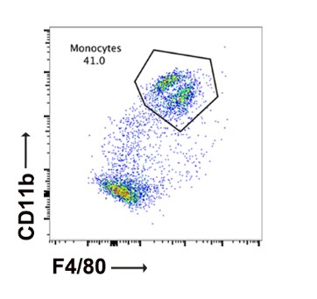
Figure S2: Representative Mφ (CD11b high, F4/80 high) profiles of liver non-granulocytes from liver tissue after 6 h of LPS/D-gal treatment.
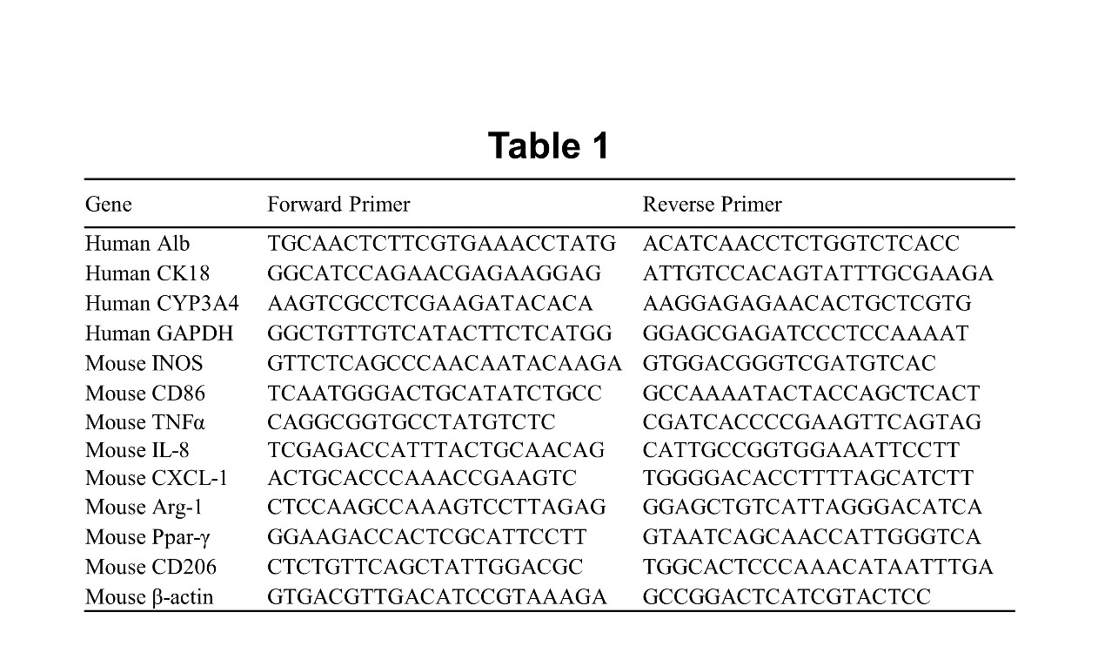
Table S1: The PCR primers used in the study.
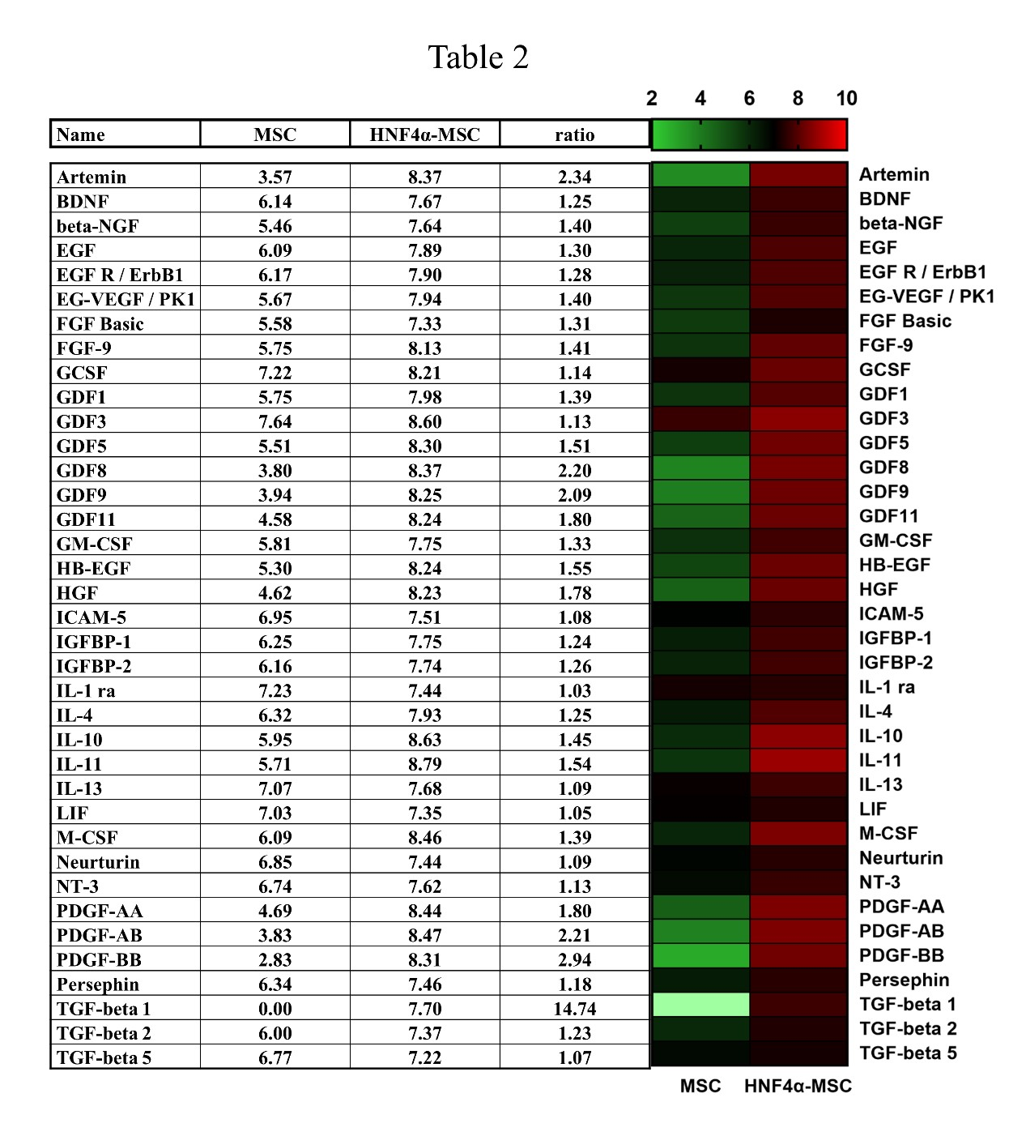
Table S2: The relative intensities of signals were listed in the below table and the list of relative intensities of signals of growth factors in the CMs of HNF4α-UMSCs and UMSCs which are significantly high in HNF4α-UMSCs groups. Heat map is shown in the right panel.

