Supplementary file
Genetic and protein interaction studies reveal pathway synergy between the ciliary dyslexia candidate genes DYX1C1 and DCDC2
Andrea Bieder, Gayathri Chandrasekar, Arpit Wason, Steffen Erkelenz, Jay Gopalakrishnan, Juha Kere and Isabel Tapia-Páez

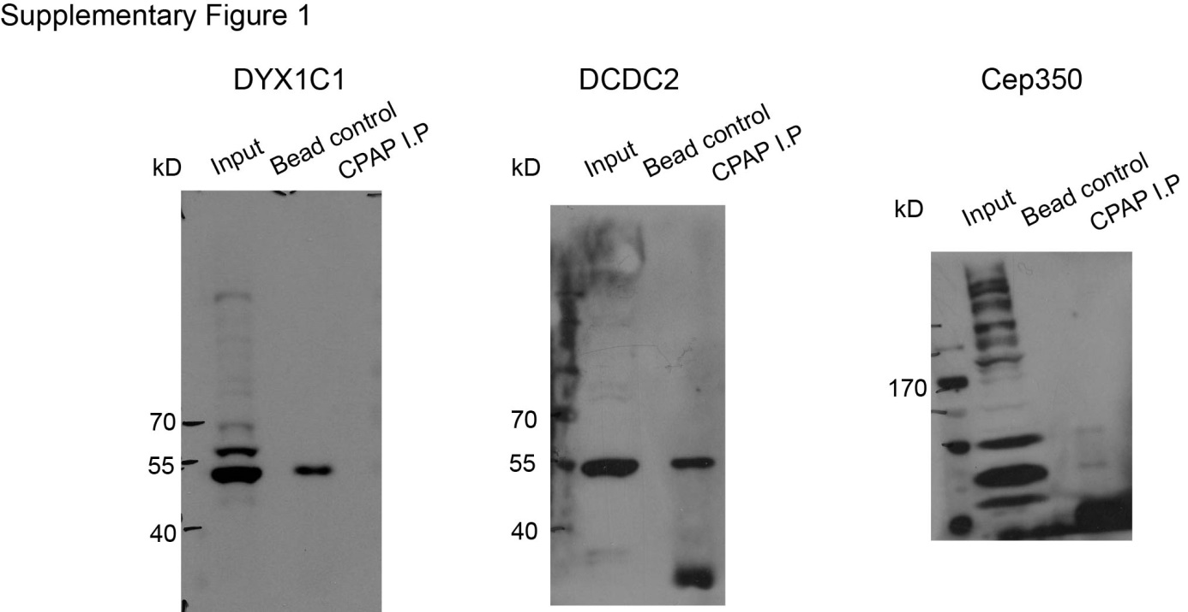

Supplementary Figure 1: Full length blots of immunoprecipitations displayed in Figure 1A.

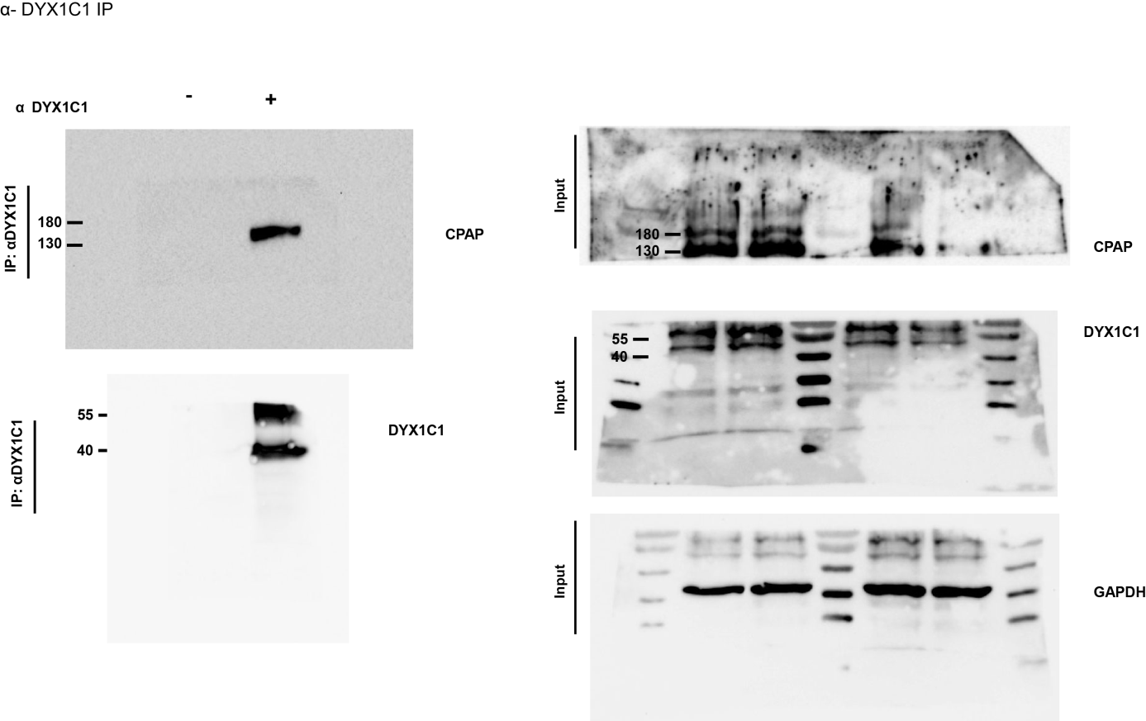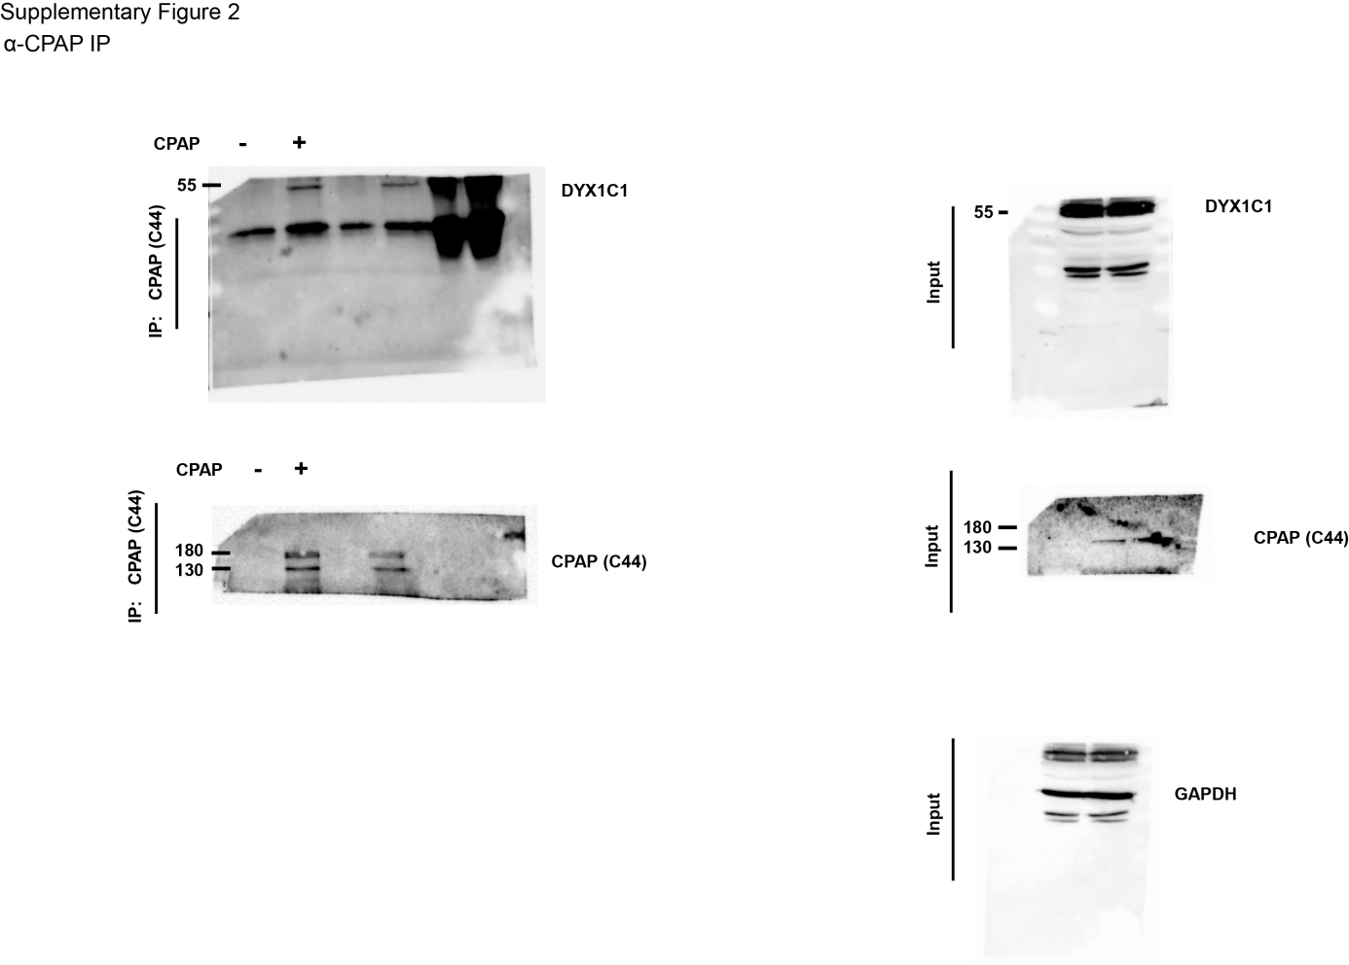

Supplementary Figure 2: Full length blots of immunoprecipitations displayed in Figure 1B.

