Supplementary information

Corresponding author contact information:
William Rapin
Chercheur CNRS
Institut de Recherche en Astrophysique et Planétologie (IRAP, UMR 5277)
Cell. +33769584256
Email william.rapin@irap.omp.eu

Extended Data list:
- Fig. 1: Context of observations in Gale crater, Mars.
- Fig. 2: Larger color image of bedrock with polygonal ridges for context.
- Fig. 3: Local stratigraphic context of the examined section.
- Fig. 4: Polygonal ridges size analysis.
- Table 1: Statistical distribution of polygon sizes.
- Table 2: Chemical composition measured on polygonal ridges and other targets for context.
- Fig. 5: Flux of impacts on Mars through time.
- Fig. 6: APXS data bedrock and diagenetic features.
- Fig. 7: ChemCam images of fine-grained host bedrock.
- Fig. 8: ChemCam images of nodular bedrock.
- Table 3: List of ChemCam points in the examined section.
- Fig. 9: Stratigraphic log of East section.
- Fig. 10: Stratigraphic log of Medium section.
- Fig. 11: Stratigraphic log of West section.

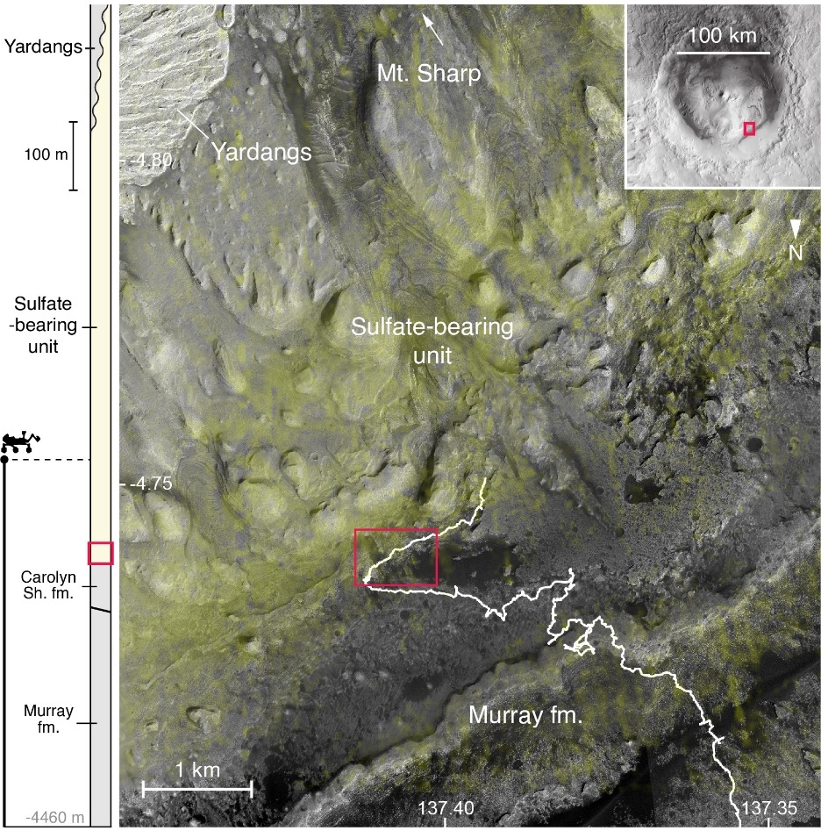
Extended Data Fig. 1: Context of observations in Gale crater, Mars. Stratigraphic context (left) of the lower portion of Mount Sharp and map (right) showing Curiosity rover traverse (white) on the High Resolution Imaging Science Experiment (HiRISE) base map overlaid with Compact Reconnaissance Imaging Spectrometer for Mars (CRISM) S-index, which tracks sulfates (shaded yellow). Red rectangle shows the location of close-up map and detailed stratigraphy (Extended Data Fig. 3b).

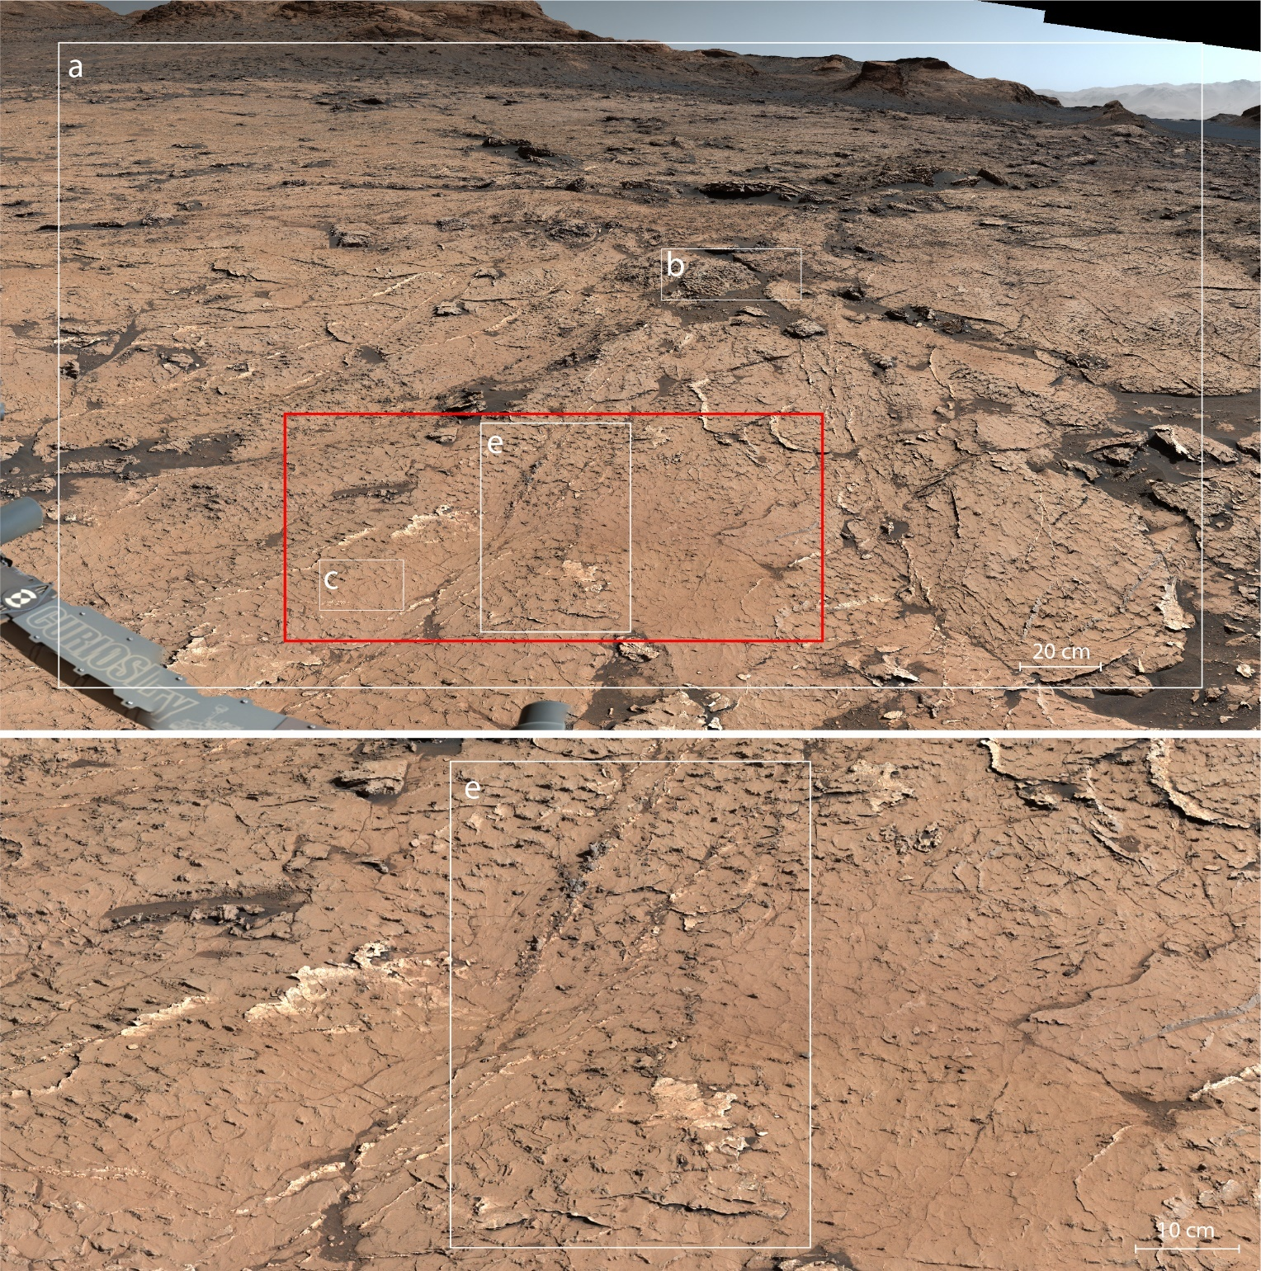
Extended Data Fig. 2: Larger color image of bedrock with polygonal ridges for context. MastCam image (mcam00270) from Fig. 1 (top), with red rectangle the location of close-up view (bottom).

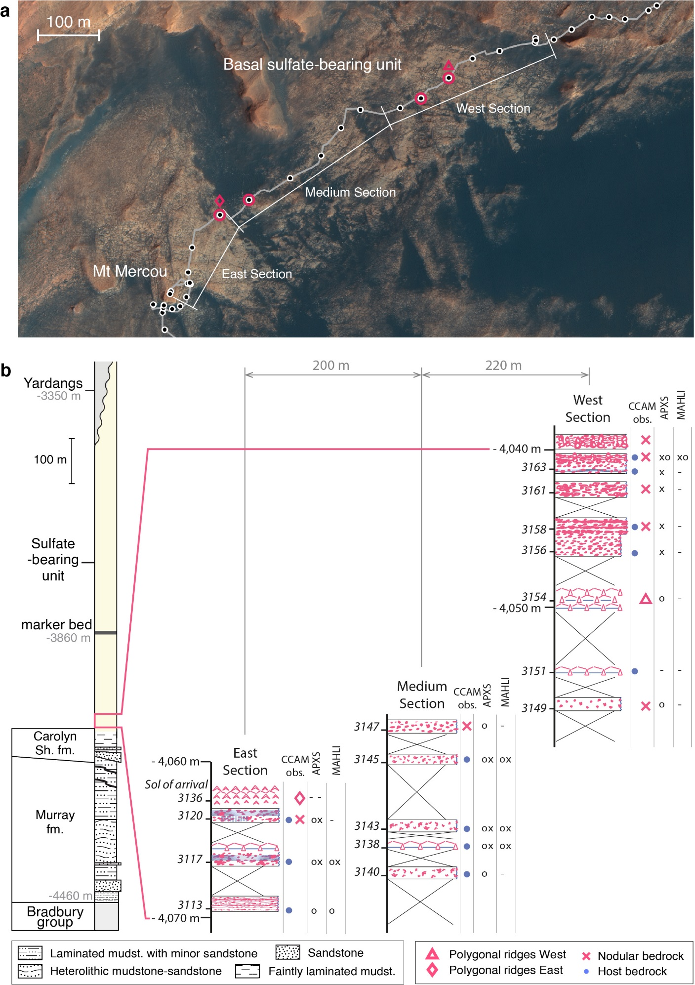
Extended Data Fig. 3: Local stratigraphic context of the examined section. Close-up map of the examined sections along the rover traverse with location of the observed polygonal pattern (red circles) and associated geochemical measurements (red triangle and diamond, see Fig. 2, 3) (a); as well as general stratigraphic column for context with detailed log facies for East (Extended Data Fig. 9), Medium (Extended Data Fig. 10), and West (Extended Data Fig. 11) sections (b). The approximate distance of 200 m and 220 m between the adjacent sections centers is annotated on top (b). Facies are drawn based on available images from Mastcam M34/M100, MAHLI and ChemCam RMI. Nodular features within bedrock interpreted as chemical deposits are highlighted in red, whereas physical sedimentary structures are shown in blue. Sedimentary structures were rarely observed and the host rock of chemical deposits was mostly smooth and featureless. Data from polygonal ridges are represented with diamond and triangle (a and b). Location of ChemCam LIBS observations on bedrock are shown in the “CCAM obs.” column with a red cross where points analyzed chemical deposits and blue dot for host rock. Locations of APXS and MAHLI observations are also highlighted the same way, with a cross for chemical deposits and circle for host bedrock.

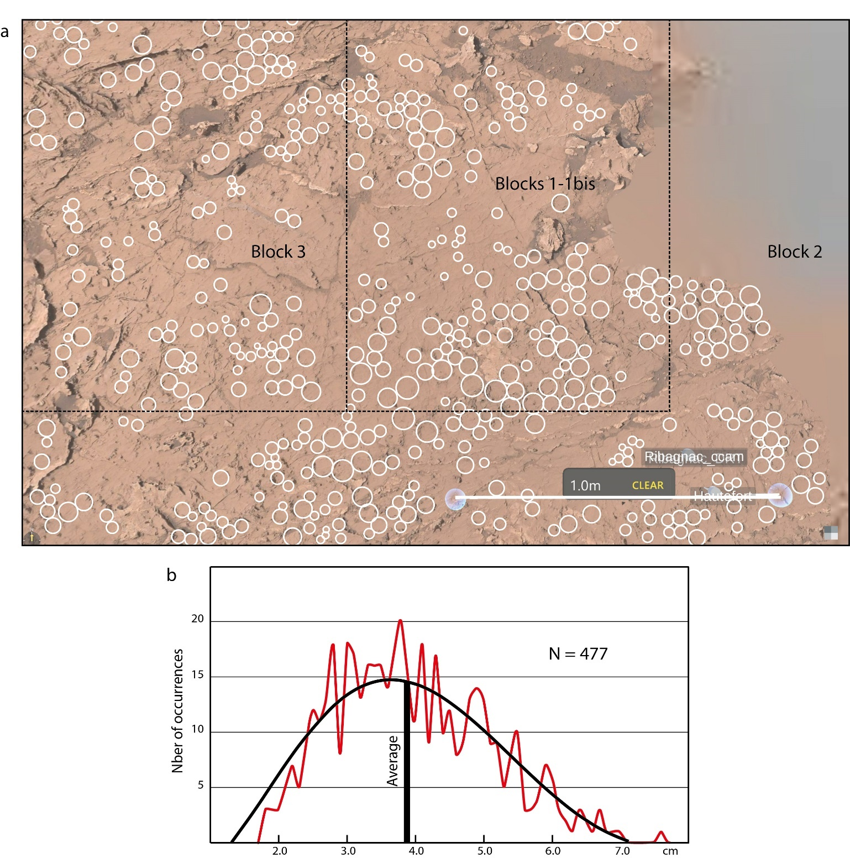
Extended Data Fig. 4: Polygonal ridges size analysis. Top view of bedrock with polygonal ridges generated using Onsight, with circles representing polygon sizes as measured manually on image (a). Statistical distribution of polygon sizes and fit with Poisson probability distribution (b), see Extended Data Table 1.

Extended Data Table 1: Statistical distribution of polygon sizes. Results on polygons size observed in each block (Extended Data Fig. 4). N = Number of measurements; SD = Standard Deviation. "Block 1 bis" is repeated Block 1 by a second operator.
 | Sizes - Circle Diameters (cm)
 | Average | Median | Range | SD
Block 1 (N=168) | 3.98 | 3.85 | [1.82-6.93] | 1.18
Block 1 bis (Op. 2) (N=176) | 3.43 | 3.34 | [1.30-6.70] | 1.20
Block 2 (N=164) | 3.98 | 3.89 | [1.88-6.83] | 1.07
Block 3 (N=145) | 3.71 | 3.56 | [1.73-7.56] | 1.12
Blocks 1+2+3 (N=477) | 3.90 | 3.76 | [1.73-7.56] | 111

Extended Data Table 2: Chemical composition measured on polygonal ridges and other targets for context. Polygonal ridges (i.e. targets Hautefort and Montignac targets), as well average host bedrock composition from ChemCam data, along with APXS data from host bedrock Ribagnac target (Fig. 2c). *APXS also reports compositional data for P2O5, MnO, Cr2O3, Cl, Ni, Zn and Br (see https://pds-geosciences.wustl.edu/msl/msl-m-apxs-4_5-rdr-v1/mslapx_1xxx/data/).
Target | SiO2 | +/- | TiO2 | +/- | Al2O3 | +/- | FeOT | +/- | MgO | +/- | CaO | +/- | Na2O | +/- | K2O | +/- | SO3 | +/- | H2O | +/-
Hautefort #1 | 32.9 | 5.9 | 0.6 | 0.4 | 5.6 | 3.2 | 16.9 | 3.6 | 5.2 | 2.0 | 11.3 | 3.2 | 2.6 | 0.6 | 0.2 | 0.6 | 21.0 | 4.6 | 5.4
Hautefort #2 | 32.6 | 5.9 | 0.6 | 0.4 | 6.1 | 3.3 | 15.3 | 3.4 | 4.6 | 1.9 | 14.4 | 3.6 | 1.1 | 0.6 | 0.3 | 0.6 | 22.9 | 4.4 | 3.2
Hautefort #3 | 44.2 | 5.1 | 0.8 | 0.5 | 8.3 | 3.4 | 18.5 | 3.8 | 4.6 | 1.8 | 8.9 | 2.7 | 1.7 | 0.6 | 0.6 | 0.7 | 7.1 | 5.0 | 2.2
Hautefort #4 | 28.1 | 7.0 | 0.7 | 0.4 | 5.4 | 3.1 | 23.6 | 4.2 | 10.5 | 2.7 | 8.0 | 2.5 | 1.0 | 0.6 | 0.1 | 0.6 | 19.8 | 4.5 | 1.8
Hautefort #5 | 37.0 | 5.9 | 0.8 | 0.5 | 6.7 | 3.3 | 22.5 | 4.1 | 16.7 | 3.5 | 1.0 | 0.9 | 1.5 | 0.6 | 0.2 | 0.6 | 2.3 | 5.2 | 2.9
Montignac #1 | 41.5 | 5.0 | 0.9 | 0.5 | 8.3 | 3.5 | 18.4 | 3.9 | 14.1 | 3.3 | 1.3 | 1.0 | 1.7 | 0.6 | 0.6 | 0.7 | 9.4 | 5.1 | 3.5
Montignac #2 | 42.1 | 5.0 | 0.8 | 0.5 | 8.2 | 3.5 | 16.4 | 3.7 | 14.8 | 3.4 | 1.2 | 0.9 | 1.6 | 0.6 | 0.6 | 0.7 | 10.0 | 5.1 | 4.0
Montignac #3 | 39.1 | 5.1 | 0.8 | 0.5 | 8.0 | 3.5 | 17.6 | 3.9 | 13.5 | 3.3 | 3.0 | 1.3 | 1.4 | 0.6 | 0.3 | 0.6 | 9.7 | 5.0 | 6.0
Montignac #4 | 41.1 | 5.1 | 0.8 | 0.5 | 8.4 | 3.5 | 19.5 | 4.0 | 10.7 | 2.8 | 5.5 | 1.9 | 1.6 | 0.6 | 0.6 | 0.7 | 8.9 | 5.0 | 2.4
Montignac #5 | 40.8 | 5.1 | 0.8 | 0.5 | 7.8 | 3.4 | 19.4 | 4.0 | 12.7 | 3.1 | 2.9 | 1.2 | 1.5 | 0.6 | 0.5 | 0.7 | 9.5 | 5.0 | 3.5
Avg. bedrock | 47.0 |  | 0.9 |  | 10.2 |  | 19.4 |  | 5.9 |  | 4.4 |  | 2.3 |  | 0.7 |  | 5.4 |  | 1.8
APXS Ribagnac* | 50.1 | 0.8 | 1.1 | 0.1 | 8.9 | 0.3 | 20.6 | 0.3 | 5.0 | 0.3 | 3.1 | 0.1 | 2.3 | 0.2 | 0.8 | 0.0 | 4.9 | 0.2 | - | -

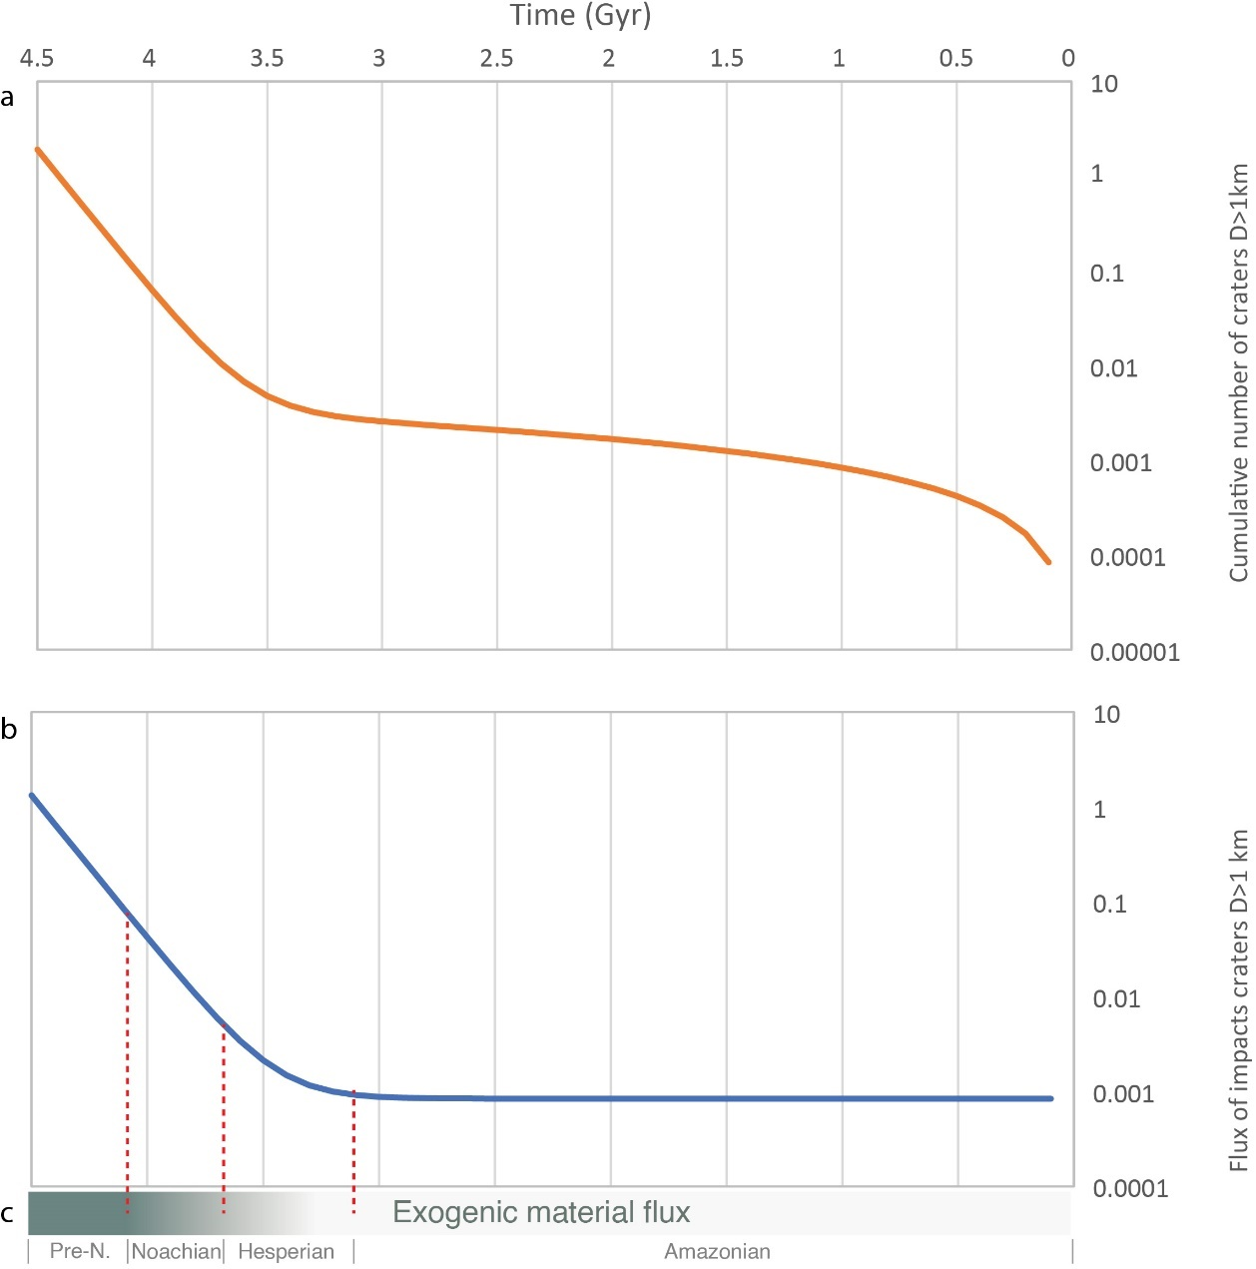
Extended Data Fig. 5: Flux of impacts on Mars through time. Curves representing the impact rate chronology on Mars based on cumulative density of craters with D>1 km per unit area (a). This model is based on the equation from the crater chronology ^{40,41} giving the cumulative number of craters larger than 1 km as N(1) = 5.44×10⁻¹⁴[exp(6.93 T) − 1] + 8.38× 10⁻⁴ T. The derivative of this function gives the flux of impact craters larger than 1 km over time (b) is given by the equation: N’(1) = 3.77×10⁻¹³[exp(6.93 T) − 1] + 8.38× 10⁻⁴ T. This curve presents a strong decrease in intensity of cratering with time which can be used as a proxy for extra-terrestrial material accretion with time. The link between the flux of impact craters of a given size and the accretion flux of the planet is then shown as a gradient bar (c) that is represented on Fig. 4 in the main text.

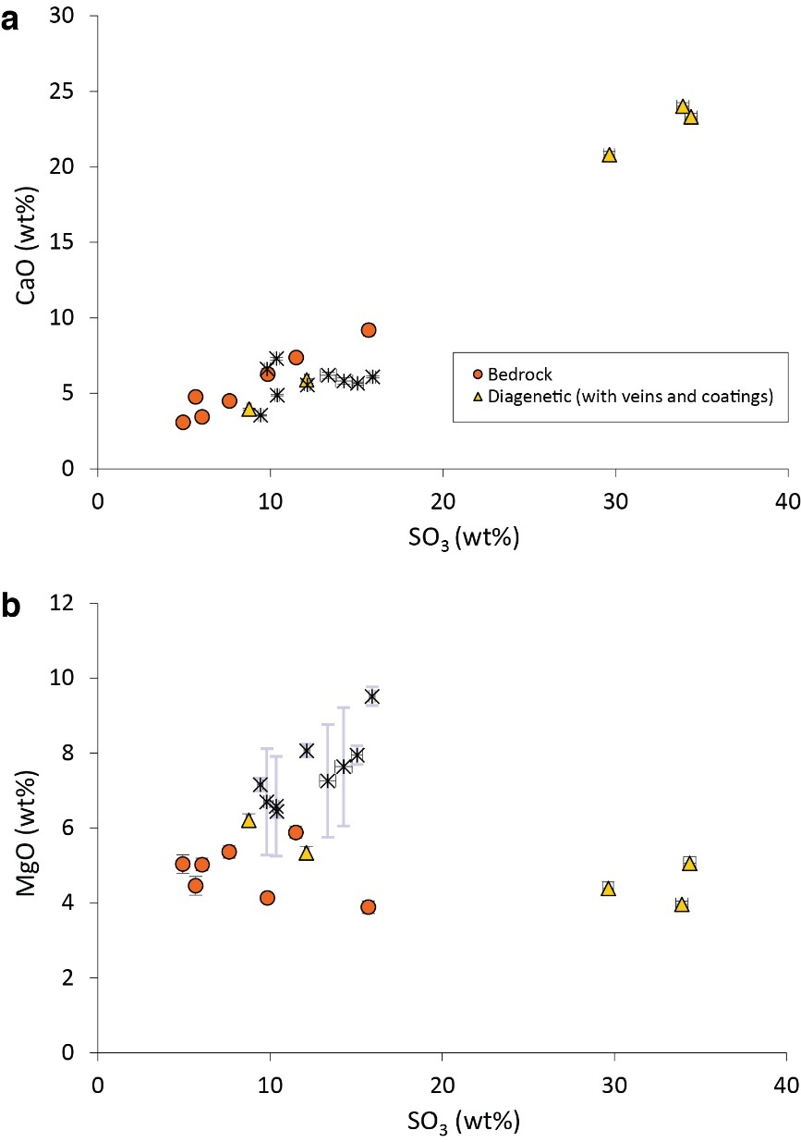
Extended Data Fig. 6: APXS data bedrock and diagenetic features. CaO (a) and MgO (b) versus SO₃ content for bedrock and diagenetic features in the investigated section. The data only includes relatively clean, dust-free targets. List of target names for bedrock: Gourdon, Bardou_DRT, Ribagnac_DRT, Chenaud_DRT, Monpazier, Plaisance_DRT, Monsec_DRT. For veins/coating: Terrasson_Lavilledieu, Festalemps_DRT, Quinsac, Biras, Pezuls. For resistant bedrock: Gardonne_DRT, Simeyrols, Rouffignac, Bosset, Bosset_offset, Nabirat, Sarlande, Salagnac, Le_Bugue.
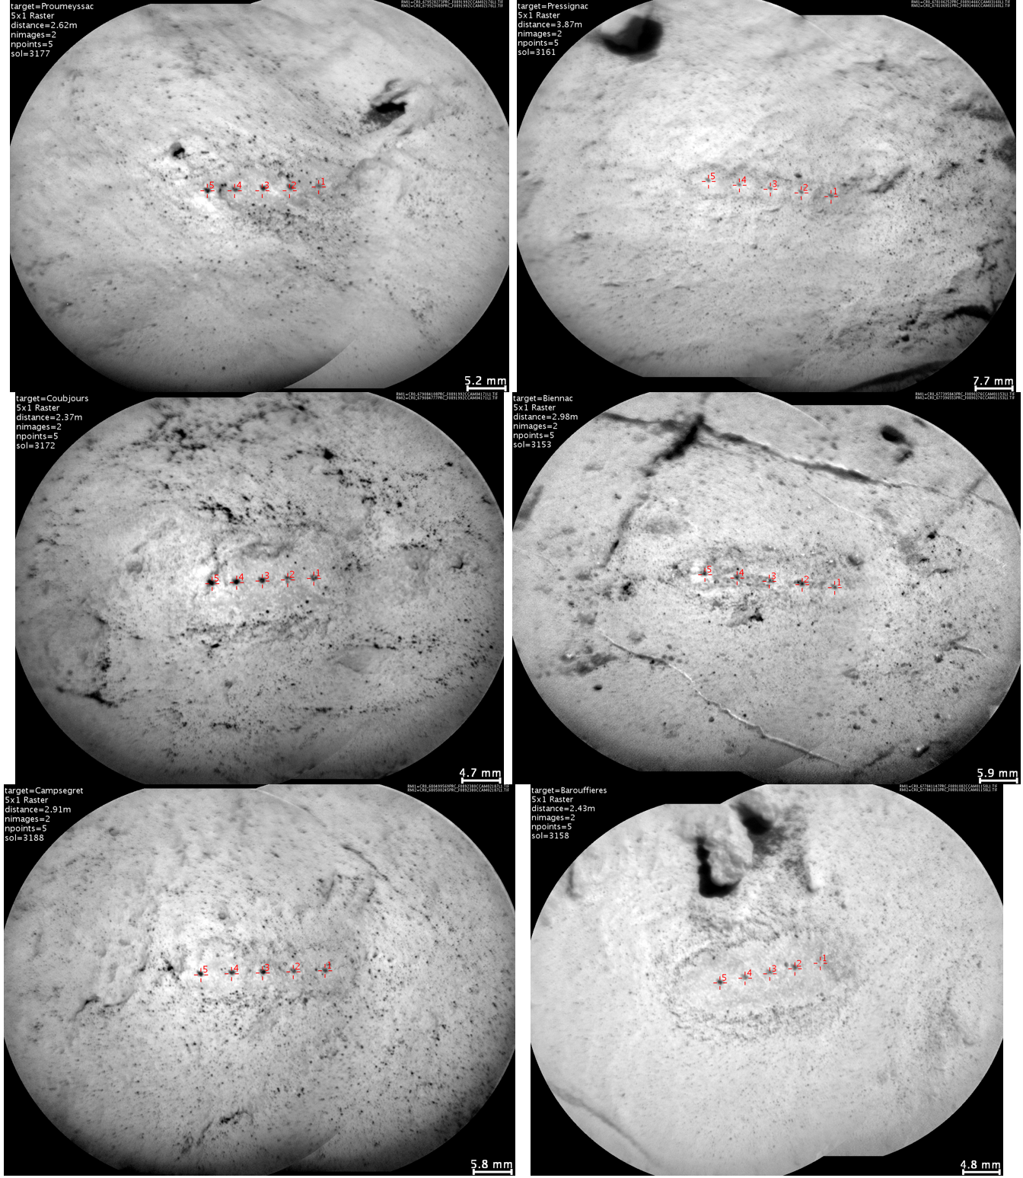
Extended Data Fig. 7: ChemCam images of fine-grained host bedrock. The bedrock matrix typically composed of a light-colored smooth-textured mudstone.
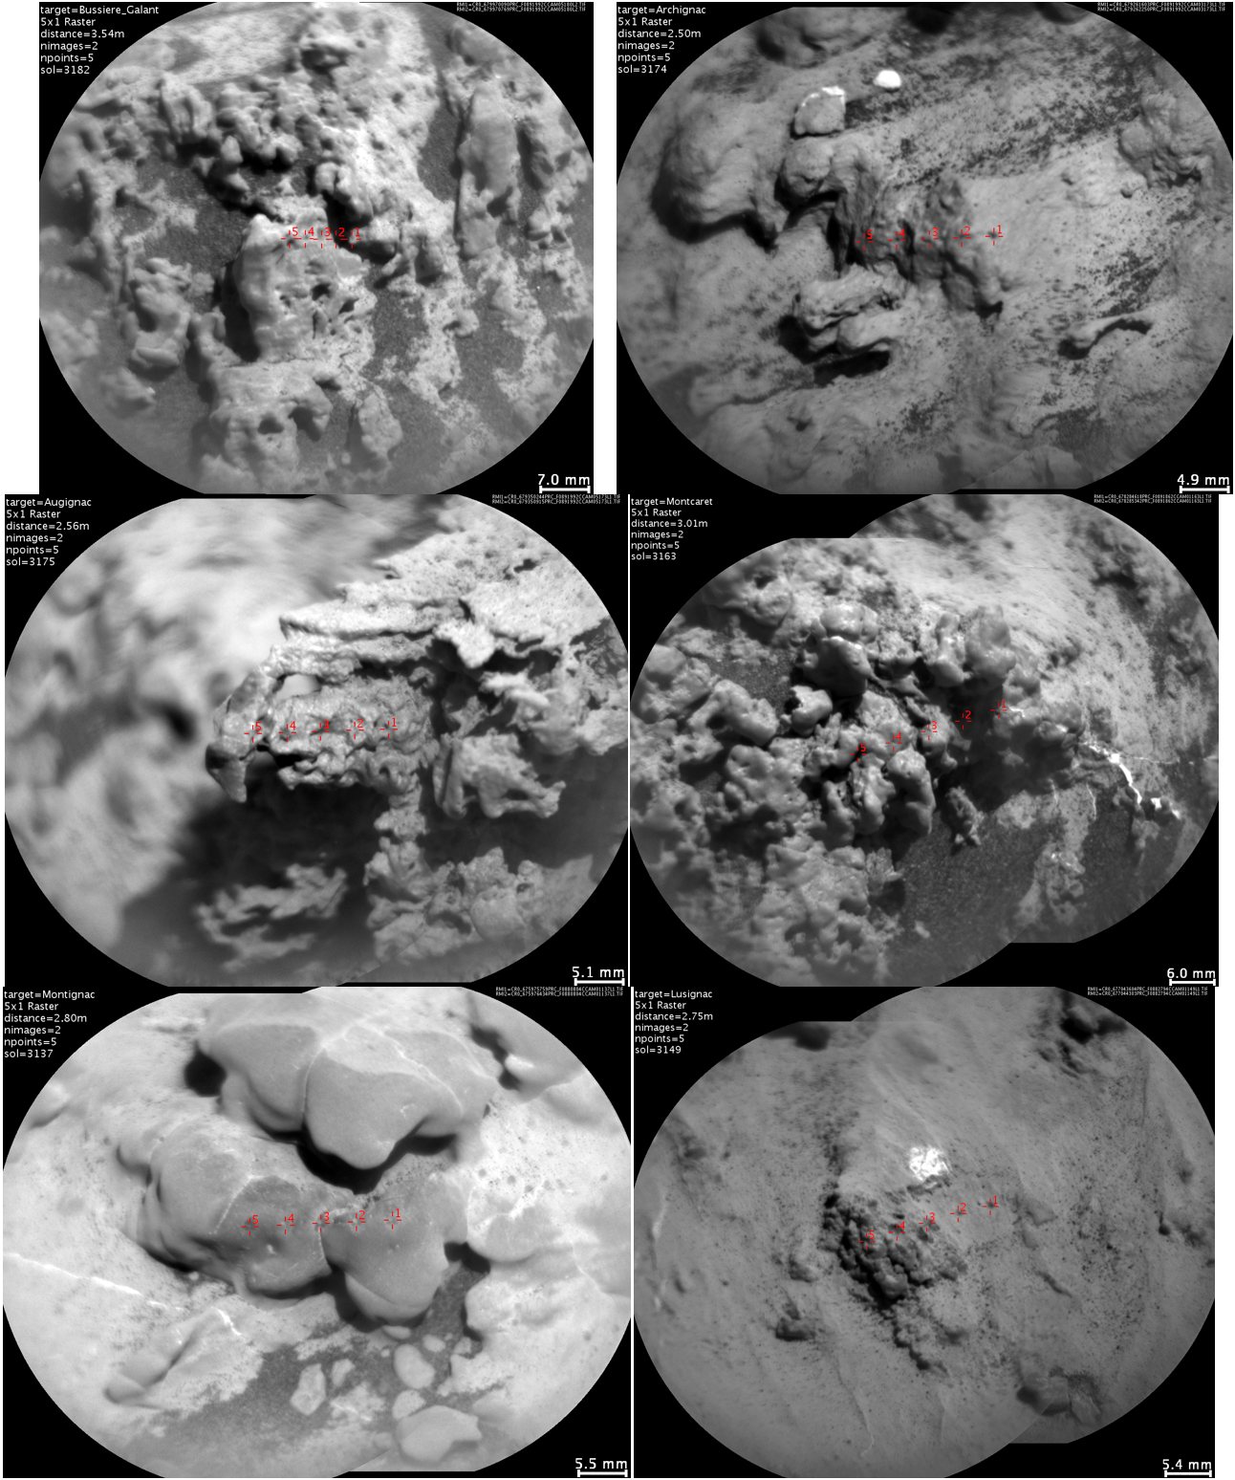
Extended Data Fig. 8: ChemCam images of nodular bedrock. Salt-bearing concretions are widespread and abundant in the examined section.
Extended Data Table 3: List of ChemCam points in the examined section. Targets are classified as either host bedrock or nodular bedrock.
Host bedrock target | Sol | Point #
Monsec_ccam | 3119 | 1, 2, 3, 4, 5
Millevaches | 3122 | 1, 2
La_Donzelle | 3124 | 1, 2, 3, 4, 5
Bourgnac | 3126 | 1, 2, 3
Fossemagne_ccam | 3136 | 1, 3, 4, 5
Lamourette | 3139 | 1, 2, 3, 4, 5
Vayres | 3142 | 1, 2, 3, 4
Sarlande | 3145 | 1, 2, 3, 4, 5
Lacropte | 3146 | 1, 2, 3, 4, 5
Lusignac | 3149 | 1, 2
Biennac | 3153 | 1, 2, 3, 4, 5
Barouffieres | 3158 | 1, 2, 3, 4, 5
La_Lizonne | 3160 | 3, 4, 5
Pressignac | 3161 | 1, 2, 3, 4, 5
aegis_post_3164a | 3164 | 4, 5
Chourgnac | 3165 | 1, 2, 3, 4, 5
aegis_post_3166a | 3166 | 1, 2, 3, 4, 5
Pontours_ccam | 3167 | 1, 2, 3, 4
Dournazac | 3169 | 1, 2, 3, 4
Coubjours | 3172 | 1, 2, 3, 4, 5
Pontours_ccam_drill_hole_3173 | 3173 | 1, 2, 3, 4
Archignac | 3174 | 1
Proumeyssac | 3177 | 1, 2, 3, 4, 5
La_Bastide | 3178 | 4, 5
La_Jemaye | 3180 | 1, 2, 3, 4, 5
Ponteyraud | 3181 | 2, 3

Nodular bedrock target | Sol | Point #
Millevaches | 3122 | 3, 4, 5
Lusignac | 3149 | 3, 4, 5
Salignac_Eyvigues | 3151 | 1, 2, 3
La_Lizonne | 3160 | 1, 2
Montcaret | 3163 | 1, 3, 4, 5
Archignac | 3174 | 2, 3, 4, 5
Augignac | 3175 | 1, 2, 3, 4, 5
Berbiguieres | 3176 | 1, 2, 3, 4, 5
Belcayre | 3179 | 1, 2, 3, 4, 5
Ponteyraud | 3181 | 4, 5
Bussiere_Galant | 3182 | 1, 3, 4, 5

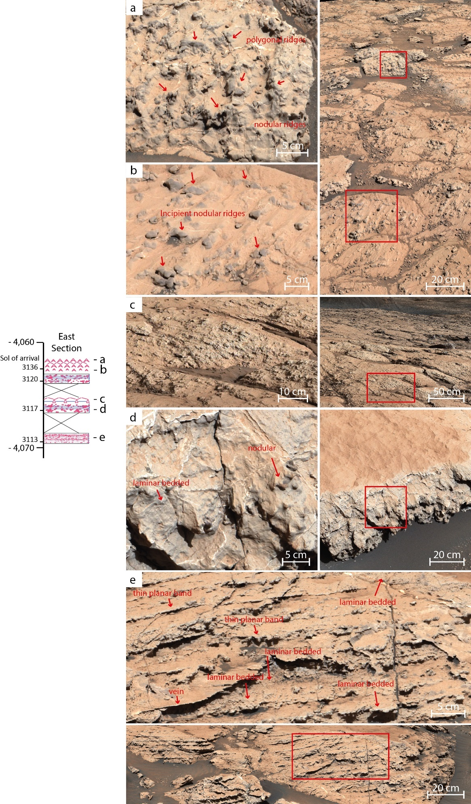
Extended Data Fig. 9: Stratigraphic log of East section. Lumped nodules forming polygonal ridges (a, sol 3137 Montaut). Lumped nodules forming incipient ridges (b, sol 3137 Montignac). Incipient polygonal ridges observed within nodular bedrock (c, sol 3117 drive_direction). Laminated bedrock with variably coalescent nodular texture (d, sol 3119 allas_les_mines). Aligned, variably coalescent micro-nodules within laminar bedded facies (e, sol 3112 garreloup).

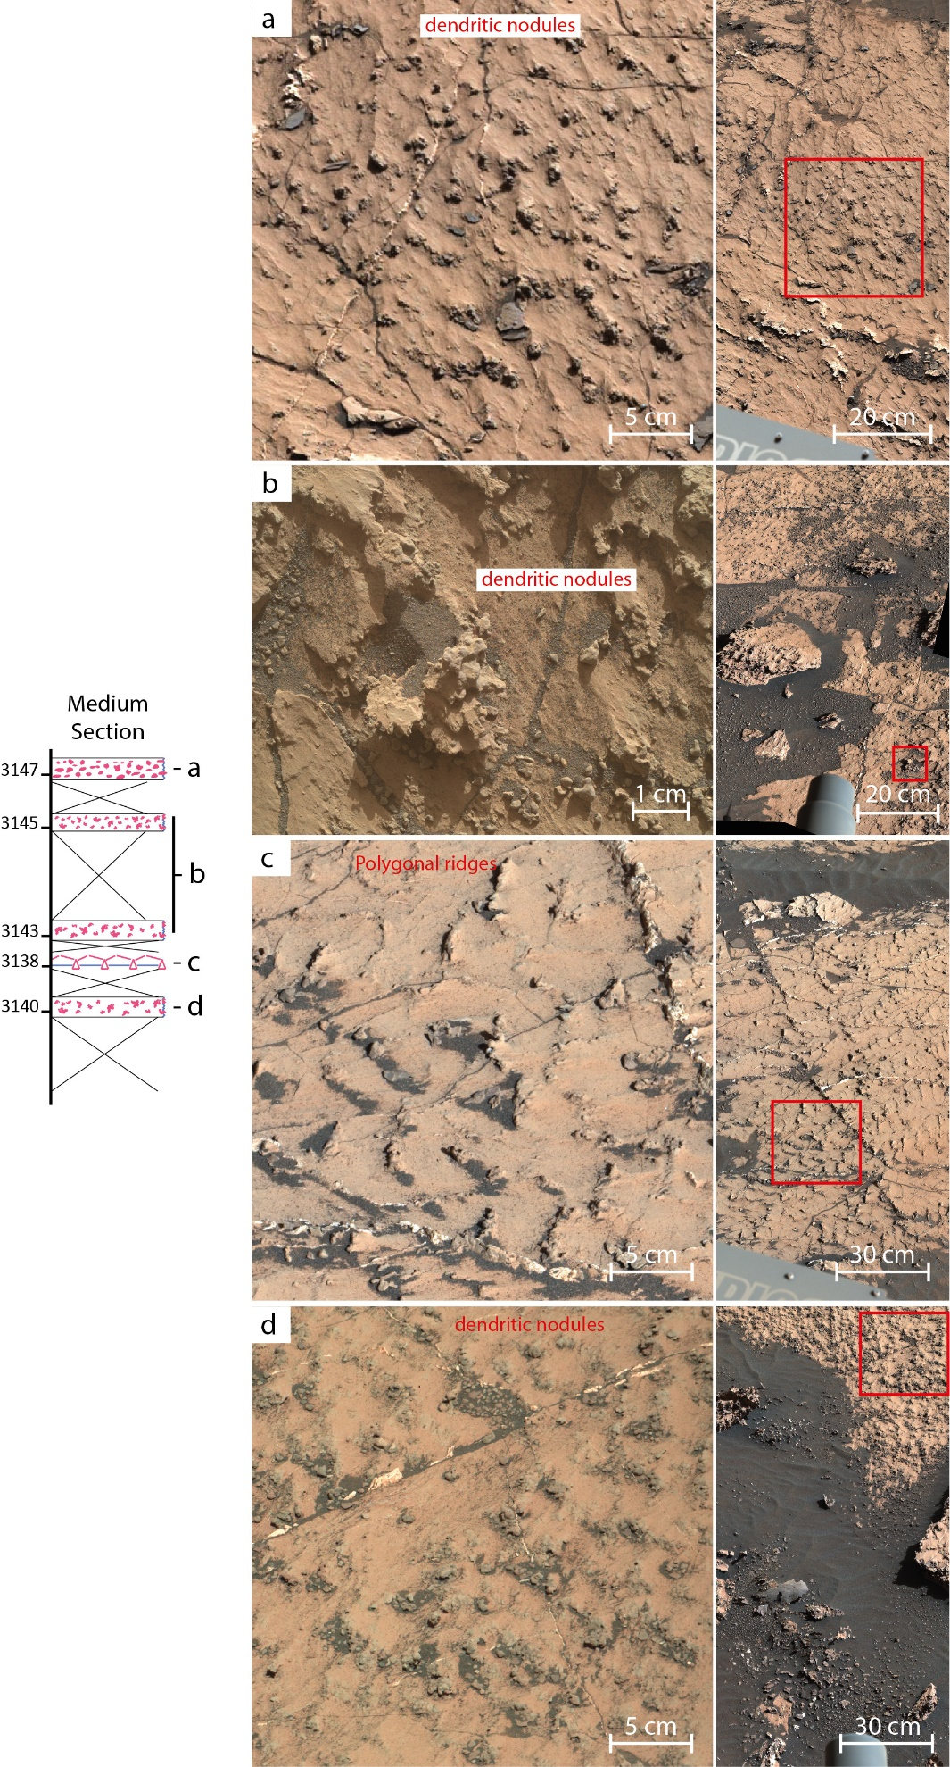
Extended Data Fig. 10: Stratigraphic log of Medium section. Bedrock with evenly distributed dendritic nodules (a, sol 3147 workspace). Close-up image of a dendritic nodule showing jagged, multifaceted, multi-centimeter texture (b, MAHLI target Nabirat 25 cm standoff). Incipient polygonal nodular ridges (c, sol 3139 workspace). Dendritic nodules (d, MastCam on Vayres).

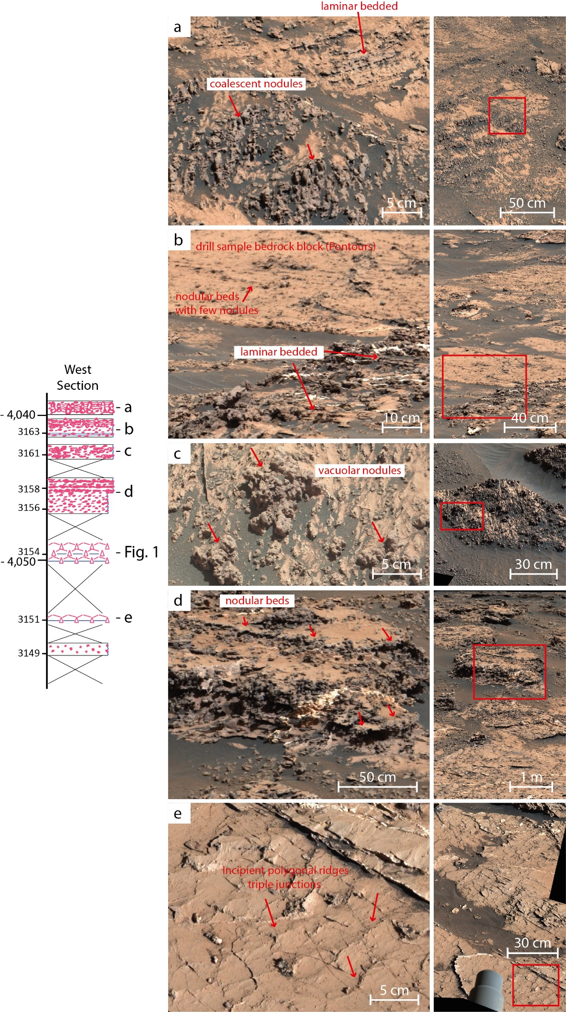
Extended Data Fig. 8west: Stratigraphic log of West section. Partially coalescent nodules and laminar bedded facies (a, sol 3170 Organized_nodules). Nodular bedrock and laminar bedded facies adjascent to smooth or laminated bedrock at Pontours location (b, sol 3163 drill_area_context). Large, polymorphic vacuolar nodules (c, sol 3161 workspace_extension). Coalescent nodules aligned in decimeter thick planar beds (d, sol 3158 diagenetic_transition). Incipient polygonal ridges showing triple junction (e, sol 3151 workspace).

