Supporting Information

Star-Polymer Unimolecular Micelles for Brain Specific Delivery of Anticancer Drug

Mehak Malhotra,† Meenakshi Pardasani,‡ Priyadharshini Srikanth,‡ Nixon M. Abraham,*^{‡1} Manickam Jayakannan*†,
†Department of Chemistry, ‡ Laboratory of Neural Circuits and Behaviour (LNCB), Department of Biology, Indian Institute of Science Education and Research (IISER Pune), Dr. Homi Bhabha Road, Pune 411008, Maharashtra, INDIA.

Table of content
- Synthesis of Star and Linear Macroinitiators and Block copolymers
- Self-assembly and Photophysical Studies
- Drug Encapsulation and Release Kinetics
- Cell Viability Assay
- Melt reactor set-up
- Synthetic scheme of t-BECL monomer
- ROP of star macroinitiators and block copolymers
- Stack plot of ¹H-NMR of S-60, SB-60
- Stack plot of ¹H-NMR of S-110, SB-100
- Stack plot of ¹H-NMR of S-35, SB-35
- GPC Chromatogram of star polymers
- TGA and DSC of star polymers
- SAXS analysis of star polymer SB-60
- CMC plots of star block copolymers
- DLS histograms of star block nascent and DOX-loaded nano-scaffolds
- Cell Viability of SB-60 in WT-MEF
- Live cell CLSM images of free DOX and SB-60 DOX NPs in WT-MEF
- Plots of cytokine analysis and hemolysis assay
- Weigt of the Organs
- H&E representative images (40 X)
- H&E representative images (10 X)
- Representative CLSM images of free DOX and SB-60+DOX uptake in brain, heart, kidney, liver, and spleen tissue (63 X and 10 X)
- CLSM images of SB-60+DOX uptake in different parts of the brain (10 X)

Experimental Methods
Materials: Cis, trans-1,4-cyclohexanediol, potassium t-butoxide, tertiary butyl acrylate, pyridinium chlorochromate (PCC), molecular sieves (4Å), m-chloroperbenzoic acid (m-CPBA), dipentaerythritol, tin(II) 2-ethylhexanoate (Sn(oct)₂), caprolactone (CL), pyrene, horse-liver esterase, α-Chymotrypsin, 3-(4,5-dimethylthiazol-2-yl)-2,5-diphenyltetrazolium bromide (MTT), DAPI, paraformaldehyde, hematoxylin, eosin, sodium azide, trizma base, EDTA, SDS and heparin were acquired from Sigma Aldrich. Doxorubicin hydrochloride was purchased from Alfa Aesar. All the salts were purchased locally (Rankem chemicals). Wild-type mouse embryonic fibroblast cells (WT-MEF) and breast cancer cells (MCF 7) were maintained in DMEM (phenol red free medium: Gibco) containing 10 % (v/v) fetal bovine serum (FBS) and 1 % (v/v) penicillin–streptomycin at 37 °C under a 5 % CO₂ humidified atmosphere. Cells were trypsinised using 0.05 % trypsin (Gibco) and seeded in 96 well (Eppendorf) or 4-well live cell chamber (Labtek) (as per experiment) flat bottomed plastic plates for all assays. Lysotracker Red DND-99 (1 mM) was procured from Thermo Fisher Scientific. Acetonitrile (ACN), methanol, hexane, diethyl ether, trifluoroacetic acid (TFA) and DMSO solvents were all HPLC grade. The optimal cutting temperature (OCT) medium was purchased from Leica (14020108926). DPX mountant and p-Xylene were procured from Thermo Fisher Scientific. Thiopentone injections (Thiosol sodium) was bought from Neon laboratories (50mg/kg). The primary antibody, i.e., Chicken anti-MAP-2 Antibody (ab92434), NeuN (ABN91, Chemicon) and GFAP (Z0334, Dako) was procured from Abcam and the secondary antibody (Goat anti-chicken alexa fluor 647) was obtained from Jackson ImmunoResearch. Vectashield (Vector labs H-1000) was used as the mounting medium for the MAP 2 antibody staining protocol. The cytokine analysis kit used was purchased from BD Life sciences (BD Cytometric Bead array Mouse Th1/Th2/Th17 Cytokine kit). Poly-D-lysine used for coating the coverslips was obtained from Sigma (P0899-10MG). Hanks balanced Salt solution was obtained from HiMedia (TL1010-500ML). 0.25% Trypsin-EDTA was purchased from Invitrogen (25200056). Neurobasal medium (10888022), B27 supplement 50X (17504-044)) and L-Glutamine 200 Mm (25030-081) used for primary neuronal culture were purchased from Invitrogen. The female balb/c, C57B1/6 male mice and C57/B6J mice pups were obtained from the IISER Animal House facility, National Facility for Gene function in Health and Disease (NFGFHD).
Methods: Jeol 400 MHz spectrophotometer was used for recording NMR samples in CDCl₃, CD₃OD and (CD₃)₂SO solvent using TMS as the standard. Gel Permeation Chromatography (GPC, also referred to as Size Exclusion Chromatography) data acquisition was carried out by a Viscotek VE 1122 pump, Viscotek VE 3580 RI, 3210 UV-Vis and Light scattering detectors. Samples for GPC were prepared in HPLC tetrahydrofuran (THF) and executed from method files obtained after calibration using polystyrene standards. The Perkin-Elmer thermal analyzer STA 6000 model was used to determine the polymer’s thermal stability at 10 °C/min heating rate under nitrogen atmosphere. Thermal properties of polymers were analyzed using a TA Q20 differential scanning calorimeter (DSC), wherein the polymers were first heated to melt in order to remove any pre-thermal history and then subsequent heating-cooling cycles were recorded at 10 °C/min under inert conditions to generate the respective thermograms. Perkin-Elmer Lambda 45 UV-Visible Spectrophotometer was used for the absorption studies. Emission spectra for determining the Critical Micelle Concentration (CMC) were recorded using a SPEX Fluorolog HORIBA JOBIN VYON fluorescence spectrophotometer. A 450 W Xe lamp serves as the source of excitation at room temperature. Pyrene was used as the fluorophore, which has excitation maxima at 337 nm. The emission spectrum gives five distinct vibronic levels, amongst which the intensity of levels I₁ and I₃ are known to be extremely sensitive of the hydrophobic environment. As a result, pyrene when encapsulated within a micelle will give different I₁ and I₃ values. The ratio of I₁/I₃ v/s logC is plotted in order to determine the critical aggregate concentration (CAC), which stays constant in a unimolecular micelle. Dynamic light scattering (DLS) was performed using Nano ZS-90 setup (Malvern instruments). DLS utilizes a 633 nm laser as the light source, and the detector collects the scattered light at 90° angle. This gives information about the correlation function [g²(t)], from which the diffusion coefficient (D) is calculated using cumulant method and further the diameter of the particle is determined using the Stokes-Einstein equation. The experiment was performed thrice with independent amphiphilic solutions to yield reproducible data. SAXS was caried out on the Nanoviewer instrument (made in Rigaku, Japan) that is calibrated with silver behenate. It comprises of a rotating anode X-ray source Micromax 007 of 40 kV and 30 mA, HyPix 3000 photon-counting detector and an X-ray collimator system (3-pin hole with an evacuated beam path). FE-SEM analysis requires the sample to be drop casted on silicon wafer and the experiment was done on a Zeiss Ultra Plus scanning electron microscope. Polymer solutions were drop casted on mica plates for carrying out atomic force microscopic (AFM) analysis using Agilent instruments. HR-TEM samples were prepared by drop-casting the dialyzed polymer solutions on copper TEM grids and the images were recorded using Jeol JEM2200FS 200 KeV systems. Again the reproducibility of the data was confirmed using three independent polymer solutions. The cell viability determination was done by measuring the absorbance of the formazan crystals on a microplate reader (Varioskan Flash). Confocal microscopic analysis for the cellular uptake study was done using Leica SP8 microscope. The tissue samples were embedded in the tissue freezing medium (Leica) and sectioned using a cryotome. Confocal microscopic analysis of the DAPI stained tissue sections was done using Leica SP8 microscope. H&E-stained tissue sections were imaged using the bright field microscope (Carl Zeiss) for histological analyses. Biodistribution assay to determine the amount of DOX in the tissue and plasma samples was performed on the microplate reader (Varioskan Flash) in triplicates. Cytokine Analysis was carried out on the BD Celesta Flow Cytometer at the BD Biosciences FACS facility at IISER, Pune. Cell Lysis buffer (200 mL), used for the dissolution of the tissue samples, was prepared from 2 mL of 1 M Tris-HCl (pH = 8), 0.4 mL of 0.5 M EDTA and 2 mL of 10 % SDS in 150 mL distilled water (volume made up to 200 mL). The in vivo and whole-organ imaging was carried out using the In vivo imaging system (IVIS) Spectrum, Perkin Elmer. The experiment was performed at λ_{exc} = 745 nm and λ_{em} = 820 nm, exposure time = 1 s, binning = 4, f-stop = 2, field of view = 24.
Synthesis of S-Y Macroinitiator (MI): A specially designed melt reactor set up with an overhead stirrer and was employed in order to carry out ring opening polymerization over a multi-arm initiator (6-arm). The polymerization protocol of ε-caprolactone using dipentaerythritol as the initiator and tin (II) 2-Ethylhexanoate [Sn(Oct)₂] as the catalyst, which generates the active initiator in situ, has been explained here for the S-60 MI. The degree of polymerization was varied by controlling the [Monomer]/[Initiator] ([M]/[I]) ratio. The catalyst equivalents were calculated such that for every equivalent of the initiator, three equivalents of the catalyst were fed to the reactor. Dipentaerythritol (37.2 mg, 0.1462 mmol) and the catalyst Sn(Oct)₂ (177.7 mg, 0.4386 mmol) were weighed in a flame dried tailor-made schlenk tube followed by addition of the caprolactone monomer (1.0 g, 8.7719 mmol). The schlenk tube was evacuated under high vacuum (0.01 mbar) prior to the start of the polymerization for 45 mins. The polymerization reaction was continued at 110 °C under neat conditions for 8 h with constant overhead stirring set at 130 rpm. The polymer was dissolved in acetonitrile (HPLC) and precipitated in cold methanol. The precipitation was repeated thrice in order to obtain highly pure polymer. Yield = 0.85 g (85 %). ¹H NMR (400 MHz, CDCl₃) δ ppm: 4.05 (t, 2.00 H), 3.64 (t, 0.19 H), 3.38 (s, 0.06 H), 2.30 (t, 1.99 H), 1.64 (m, 4.04 H), 1.37 (m, 2.03 H). ¹³C NMR (100 MHz, CDCl₃) δ ppm: 173.6, 64.2, 62.6, 34.1, 32.3, 28.3, 25.5, 24.6. FT-IR (cm⁻¹): 2953.57, 2869.63, 1728.41, 1644.79, 1459.08, 1418.07, 1392.87, 1366.46, 1277.23, 1235.36, 1187.44, 1162.94, 1065.67, 1037.24, 964.50, 927.11, 846.51, 743.08, 564.83, 520.43.
S-110 MI: Dipentaerythritol (18.6 mg, 0.0731 mmol), Sn(Oct)₂ (88.8 mg, 0.2193 mmol), caprolactone (1.0 g, 8.7719 mmol). The polymerization was carried out for 8 h at 110 °C. Yield = 0.75 g (75 %). ¹H NMR (400 MHz, CDCl₃) δ ppm: 4.05 (t, 2.00 H), 3.63 (t, 0.11 H), 3.38 (s, 0.04 H), 2.29 (t, 2.00 H), 1.64 (m, 4.00 H), 1.37 (m, 2.00 H). ¹³C NMR (100 MHz, CDCl₃) δ ppm: 173.6, 64.2, 62.7, 34.2, 32.4, 28.4, 25.6, 24.6. FT-IR (cm⁻¹): 2952.19, 2868.82, 1728.69, 1459.78, 1418.77, 1391.53, 1363.48, 1275.02, 1234.41, 1162.74, 1066.93, 1039.11, 965.35, 929.70, 847.71, 740.46, 561.76, 514.61.
S-35 MI: Dipentaerythritol (74.4 mg, 0.292 mmol), Sn(Oct)₂ (355.4 mg, 0.8772 mmol), caprolactone (1.0 g, 8.7719 mmol). The polymerization was carried out for 6 h at 110 °C. Yield = 0.7 g (70 %). ¹H NMR (400 MHz, CDCl₃) δ ppm: 4.05 (t, 2.00 H), 3.63 (t, 0.34 H), 3.36 (s, 0.11 H), 2.30 (t, 1.98 H), 1.64 (m, 3.99 H), 1.37 (m, 2.00 H). ¹³C NMR (100 MHz, CDCl₃) δ ppm: 173.7, 64.2, 62.7, 34.2, 32.4, 28.4, 25.6, 24.6. FT-IR (cm⁻¹): 2952.36, 2868.90, 1728.53, 1459.75, 1419.32, 1363.71, 1233.85, 1161.63, 1066.32, 1039.20, 965.21, 929.68, 847.76, 740.19, 564.54, 514.34.
L-60 MI: Triethyleneglycol monomethylether (23 mg, 0.14 mmol), Sn(Oct)₂ (28.4 mg, 0.0701 mmol), caprolactone (1.12 g, 9.8245 mmol). The polymerization was carried out for 8 h at 110 °C. Yield = 0.80 g (71 %). ¹H NMR (400 MHz, CDCl₃) δ ppm: 4.05 (t, 2.00 H), 3.65 (t, 0.20 H), 3.37 (s, 0.05 H), 2.30 (t, 2.00 H), 1.64 (m, 4.08 H), 1.37 (m, 2.03 H). ¹³C NMR (100 MHz, CDCl₃) δ ppm: 173.6, 64.2, 62.7, 34.2, 28.4, 25.6, 24.6. FT-IR (cm⁻¹): 2952.99, 2869.31, 1728.64, 1459.65, 1419.16, 1364.04, 1275.63, 1234.61, 1162.68, 1066.55, 1038.73, 964.93, 929.28, 847.53, 741.08, 561.14, 516.07.
Synthesis of star-shaped block copolymers SB-X: The typical synthetic protocol for the block copolymer has been outlined here for SB-60. The purified S-60 polymer served as the macro-initiator for polymerization of tertiary butyl ester substituted caprolactone monomer (t-BECL). The melt reactor was charged with the S-60 MI (307.5 mg, 0.0419 mmol) and Sn(Oct)₂ (51.03 mg, 0.126 mmol) in a 1:3 ratio followed by the addition of the t-BECL monomer (650 mg, 2.5194 mmol). The schlenk tube was evacuated under high vacuum (0.01 mbar) prior to the start of the polymerization for 45 mins and the reaction was continued for 12 h at 130 °C with constant overhead stirring set at 130 rpm. The polymer was dissolved in minimum amount of acetonitrile and precipitated in cold 20 % hexane/diethyl ether. This precipitation was repeated thrice in order to obtain polymer in high purity. Yield = 0.6 g (63 %). ¹H NMR (400 MHz, CDCl₃) δ ppm: 4.12 (m, 2.00 H), 4.05 (t, 2.00 H), 3.64 (m, 2.19 H), 3.43 (m, 0.97 H), 3.38 (s, 0.06 H), 2.43 (t, 2.00 H), 2.36 (t, 2.01 H), 2.29 (t, 2.01 H), 1.84 (m, 1.98 H), 1.77 (m, 1.98 H), 1.64 (m, 4.00 H), 1.44 (s, 8.45 H), 1.37 (m, 2.03 H). ¹³C NMR (100 MHz, CDCl₃) δ ppm: 173.6, 173.5, 170.9, 80.6, 75.5, 64.8, 64.2, 61.2, 36.5, 36.3, 34.1, 32.9, 29.7, 28.9, 28.3, 28.1, 25.5, 24.6. FT-IR (cm⁻¹): 2954.68, 1727.50, 1457.89, 1418.25, 1392.41, 1366.87, 1254.04, 1158.22, 1102.28, 1064.60, 964.60, 928.40, 845.68, 752.09, 559.84, 512.86.
SB-100 block copolymer: S-110 MI (309.9 mg, 0.0242 mmol), Sn(Oct)₂ (29.4 mg, 0.0726 mmol), t-BECL monomer (750 mg, 2.9069 mmol). The polymerization was carried out for 12 h at 130 °C. Yield = 0.7 g (66 %). ¹H NMR (400 MHz, CDCl₃) δ ppm: 4.12 (m, 1.86 H), 4.05 (t, 2.00 H), 3.64 (m, 1.96 H), 3.43 (m, 0.93 H), 3.38 (s, 0.04 H), 2.43 (t, 1.84 H), 2.36 (t, 1.91 H), 2.30 (t, 2.00 H), 1.85 (m, 1.90 H), 1.77 (m, 1.90 H), 1.64 (m, 4.00 H), 1.44 (s, 8.75 H), 1.37 (m, 2.02 H). ¹³C NMR (100 MHz, CDCl₃) δ ppm: 173.7, 173.6, 170.9, 80.7, 75.5, 64.9, 64.2, 61.3, 36.5, 36.4, 34.2, 33.0, 29.8, 29.0, 28.4, 28.2, 25.6, 24.6. FT-IR (cm⁻¹): 2955.32, 1726.52, 1457.53, 1366.52, 1253.48, 1159.15, 1101.68, 1064.58, 964.63, 929.05, 845.47, 752.03, 554.74, 515.39.
SB-35 block copolymer: S-35 MI (281.9 mg, 0.0664 mmol), Sn(Oct)₂ (80.8 mg, 0.1993 mmol), t-BECL monomer (600 mg, 2.3256 mmol). The polymerization was carried out for 12 h at 130 °C. Yield = 0.55 g (62 %). ¹H NMR (400 MHz, CDCl₃) δ ppm: 4.13 (m, 2.01 H), 4.05 (t, 2.00 H), 3.65 (m, 2.34 H), 3.43 (m, 0.99 H), 3.37 (s, 0.11 H), 2.43 (t, 2.02 H), 2.37 (t, 1.99 H), 2.30 (t, 1.98 H), 1.85 (m, 2.06 H), 1.78 (m, 2.00 H), 1.64 (m, 4.06 H), 1.44 (s, 9.02 H), 1.37 (m, 2.04 H). ¹³C NMR (100 MHz, CDCl₃) δ ppm: 173.6, 173.5, 170.9, 80.7, 75.5, 64.9, 64.2, 61.3, 36.5, 36.4, 34.2, 33.0, 29.8, 29.0, 28.4, 28.2, 25.6, 24.6. FT-IR (cm⁻¹): 2955.84, 2926.20, 1727.04, 1458.18, 1366.74, 1253.88, 1159.58, 1101.96, 1064.45, 963.83, 928.45, 845.80, 751.71, 565.11, 517.31.
LB-60 block copolymer: L-60 MI (294.1 mg, 0.0419 mmol), Sn(Oct)₂ (8.5 mg, 0.0209 mmol), t-BECL monomer (650 mg, 2.5194 mmol). The polymerization was carried out for 12 h at 130 °C. Yield = 0.65 g (69 %). ¹H NMR (400 MHz, CDCl₃) δ ppm: 4.13 (m, 1.67 H), 4.05 (t, 2.00 H), 3.65 (m, 1.87 H), 3.44 (m, 0.80 H), 3.38 (s, 0.05 H), 2.43 (t, 1.67 H), 2.37 (t, 1.64 H), 2.30 (t, 2.06 H), 1.85 (m, 1.75 H), 1.78 (m, 1.75 H), 1.64 (m, 4.06 H), 1.44 (s, 7.49 H), 1.37 (m, 2.02 H). ¹³C NMR (100 MHz, CDCl₃) δ ppm: 173.6, 173.5, 170.9, 80.6, 75.5, 64.8, 64.2, 61.2, 36.5, 34.1, 32.9, 29.7, 28.9, 28.4, 28.1, 25.5, 24.6. FT-IR (cm⁻¹): 2955.55, 2923.18, 1727.32, 1644.59, 1457.86, 1418.50, 1367.34, 1280.78, 1254.76, 1161.16, 1065.58, 965.05, 928.19, 845.62, 749.67, 563.10.
Synthesis of star-shaped homopolymer SH-60: To the flame dried melt reactor set up, the dipentaerythritol initiator (16.43 mg, 0.0646 mmol) and Sn(Oct)₂ catalyst (78.51 mg, 0.1938 mmol) were added in a 1:3 ratio. This was followed by the addition of the tertiary butyl ester substituted caprolactone monomer (1 g, 3.876 mmol) such that the [M]/[I] ratio was maintained as 60. The reactor was evacuated under high vacuum (0.01 mbar) for 45 mins and the reaction was then continued at 130 °C for 8 h with constant overhead stirring set at 130 rpm. The polymer was dissolved in acetonitrile (1.5 mL) and precipitated in cold hexane. This was repeated thrice to yield high purity polymer. Yield = 0.8 g (80 %). ¹H NMR (400 MHz, CDCl₃) δ ppm: 4.13 (m, 2.00 H), 3.64 (m, 2.19 H), 3.43 (m, 1.07 H), 2.43 (t, 2.03 H), 2.36 (t, 2.03 H), 1.84 (m, 2.18 H), 1.77 (m, 2.19 H), 1.44 (s, 9.05 H).
Synthesis of star-shaped random copolymer SR-60: The random copolymer synthesis outlined here is for SR-60 polymer, wherein the feed for both the monomers CL and t-BECL was kept as 60. Herein, the 6-arm dipentaerythritol initiator (11.15 mg, 0.0439 mmol) was added to the schlenk tube along with the catalyst Sn(Oct)₂ (53.3 mg, 0.1315 mmol) maintaining their molar ratio as 1:3 followed by addition of the two monomers CL (300 mg, 2.6315 mmol) and t-BECL (679 mg, 2.6315 mmol) simultaneously. The tube was evacuated under high vacuum (0.01 mbar) before the start of the polymerization for 45 mins. The polymerization was continued at 130 °C for 12 h with constant overhead stirring set at 130 rpm. The polymer was dissolved in acetonitrile (2.5 mL) and precipitated in cold 20 % hexane/diethyl ether. This was repeated thrice to result in high purity polymer. Yield = 0.65 g (66 %). ¹H NMR (400 MHz, CDCl₃) δ ppm: 4.13 (m, 2.01 H), 4.05 (t, 2.00 H), 3.64 (m, 2.20 H), 3.43 (m, 1.09 H), 2.43 (t, 2.01 H), 2.37 (t, 2.01 H), 2.30 (t, 2.01 H), 1.85 (m, 2.03 H), 1.78 (m, 2.04 H), 1.64 (m, 4.26 H), 1.44 (s, 9.02 H), 1.38 (m, 2.00 H).
Synthesis of the carboxylic acid substituted star-block copolymers SB-X: Deprotection of the tertiary butyl group in the polymer SB-60 (214 mg) was carried out using trifluoroacetic acid (TFA) at 0 °C for 30 min. TFA (2.0 mL) was added slowly along the sides of the round bottom flask containing the polymer solution (in DCM) and the reaction was continued at 0 °C for 30 min with constant stirring. TFA was removed by repeated washings with DCM and then the polymer was dissolved in DCM followed by precipitation in cold 20 % hexane/diethyl ether. The solution was vortexed at 1000 rpm and then the supernatant solution was decanted. This procedure was repeated thrice in order to ensure the complete removal of TFA. Yield = 150 mg (82 %). ¹H NMR (400 MHz, (CD₃)₂SO) δ ppm: 4.03 (m, 2.01 H), 3.98 (t, 2.00 H), 3.55 (m, 2.18 H), 2.39 (t, 2.01 H), 2.31 (t, 1.97 H), 2.27 (t, 2.01 H), 1.70 (m, 3.99 H), 1.54 (m, 4.06 H), 1.29 (m, 2.02 H). ¹³C NMR (100 MHz, (CD₃)₂SO) δ ppm: 173.3, 173.1, 75.3, 64.7, 63.9, 61.2, 35.4, 33.8, 32.8, 29.7, 29.1, 28.3, 25.3, 24.5. FT-IR (cm⁻¹): 2253.15, 2126.47, 1727.73, 1657.83, 1550.29, 1226.44, 1048.82, 1023.57, 1000.01, 822.81, 760.38, 617.53, 512.85.
SB-100 block copolymer: SB-100 butyl ester substituted polymer (150 mg), TFA (1.5 mL). Yield = 100 mg (78 %). ¹H NMR (400 MHz, CD₃OD) δ ppm: 4.15 (m, 1.86 H), 4.06 (t, 2.00 H), 3.69 (m, 1.96 H), 3.49 (m, 0.92 H), 2.50 (t, 1.87 H), 2.40 (t, 1.83 H), 2.32 (t, 2.02 H), 1.86 (m, 1.83 H), 1.79 (m, 1.84 H), 1.63 (m, 4.02 H), 1.38 (m, 2.03 H). ¹³C NMR (100 MHz, CD₃OD) δ ppm: 173.6, 173.5, 75.5, 64.9, 64.2, 61.3, 35.4, 33.9, 33.0, 29.7, 29.0, 28.3, 25.6, 24.6. FT-IR (cm⁻¹): 2251.29, 2124.31, 1726.87, 1656.91, 1514.46, 1050.43, 1024.08, 1002.39, 821.67, 758.95, 617.52.
SB-35 block copolymer: SB-100 butyl ester substituted polymer (105 mg), TFA (1.0 mL). Yield = 76 mg (85 %). ¹H NMR (400 MHz, (CD₃)₂SO) δ ppm: 4.04 (m, 2.00 H), 3.98 (t, 2.00 H), 3.56 (m, 2.36 H), 2.39 (t, 2.06 H), 2.32 (t, 2.07 H), 2.27 (t, 2.04 H), 1.69 (m, 4.01 H), 1.54 (m, 4.01 H), 1.29 (m, 1.98 H). ¹³C NMR (100 MHz, (CD₃)₂SO) δ ppm: 173.4, 173.2, 75.5, 64.7, 64.0, 61.1, 35.4, 33.8, 32.8, 29.7, 29.1, 28.3, 25.3, 24.5. FT-IR (cm⁻¹): 2251.24, 2124.63, 1725.97, 1657.18, 1514.26, 1201.78, 1050.55, 1023.98, 1002.54, 821.61, 758.84, 618.29.
LB-60 block copolymer: LB-60 butyl ester substituted polymer (220 mg), TFA (2.0 mL). Yield = 130 mg (70 %). ¹H NMR (400 MHz, (CD₃)₂SO) δ ppm: 4.04 (m, 1.68 H), 3.98 (t, 2.00 H), 3.56 (m, 1.87 H), 2.39 (t, 1.74 H), 2.32 (t, 1.65 H), 2.26 (t, 2.03 H), 1.69 (m, 3.38 H), 1.52 (m, 3.99 H), 1.28 (m, 2.02 H). ¹³C NMR (100 MHz, (CD₃)₂SO) δ ppm: 173.4, 173.2, 75.3, 64.7, 63.9, 61.2, 35.4, 33.8, 32.8, 29.7, 29.1, 28.3, 25.3, 24.5. FT-IR (cm⁻¹): 2253.01, 2126.38, 1656.71, 1515.18, 1049.08, 1023.53, 1000.23, 822.67, 760.13, 616.11, 520.82.
The star homopolymer SH-60 and star random copolymer SR-60 were deprotected using trifluoroacetic acid employing the same protocol as mentioned before and characterized using ¹H NMR to ascertain the disappearance of the t-butyl peak at 1.44 ppm.
Self-assembly of copolymers: The polymer SB-60 (0.5 mg) was dissolved in 0.8 mL DMSO and this solution was then added dropwise to 4.2 mL milli-Q water with constant stirring for 4 h at 25 °C. The solution was then transferred to a semi-permeable membrane of MWCO = 3.5 kD and dialyzed against milli-Q water for 24 h. The water was replenished at regular intervals in order to substantiate the removal of DMSO. Similar protocol for self-assembly was adapted for all the carboxylic acid substituted star and linear block copolymers.
Photophysical studies: The self-assembled star and linear block copolymer micelles were subjected to the critical micelle concentration (CMC) study using pyrene as the probe employing fluorescence spectroscopy. Herein, a pyrene stock was prepared in acetone (HPLC) and 1 mL of this stock was added to each sample vial such that the final pyrene concentration turned out to 0.6 µM (for 3 mL of the sample). The solvent was evaporated completely followed by addition of different concentrations of polymer dialyzed solutions ranging from 10⁻⁶ mg/mL to 0.5 mg/mL maintaining the overall volume to 3ml. These sample vials were then sonicated for 3 h followed by equilibration at room temperature for 12 h. Prior to acquiring the samples, all the vials were purged with nitrogen in order to eliminate all the dissolved oxygen. The fluorescence measurements were carried out by exciting the pyrene molecule at 337 nm and the emission was collected at 347-500 nm. The I₁ and I₃ vibronic levels were monitored, and these values helped determine the CMC for all the dialyzed solutions.
Drug Encapsulation in the Copolymer Scaffolds: Typical encapsulation procedure is given for the star-block polymer. SB-60 (0.5 mg) and DOX (0.2 mg, DOX.HCl pre-treated with triethylamine) were dissolved in 0.8 mL DMSO followed by dropwise addition of the cocktail to 4.2 mL water with continuous stirring for 4 h. The dialysis was carried out in a dialysis tube of MWCO = 3.5 kD against large amount of milli-Q water for 48 h. At regular intervals the water was changed in order to facilitate the removal of un-encapsulated DOX and DMSO.
The drug loading efficiency (DLE) and drug loading content (DLC) were determined by UV-Visible spectroscopy using the following equations:
DLE (%) = {weight of drug in micelles/weight of drug in feed} X 100%
DLC (%) = {weight of drug in micelles/weight of drug-loaded nanoparticles} X 100%
In vitro DOX Release kinetics: The star-block copolymers comprise of a complete polyester backbone that is known to cleave in the presence of enzymes in the lysosomal compartment rendering these nano-assemblies enzyme-responsive. This investigation was carried out by incubating SB-60+DOX nano-assemblies with two lysosomal enzymes, i.e., horse-liver esterase (10U) and α-Chymotrypsin (8U). The enzyme containing DOX solutions were taken in a dialysis tube of MWCO = 1 kD and this tube was then immersed in 4 ml of 1X PBS (pH = 7.4) maintained at 37 °C with constant stirring. In another control setup, the dialyzed solution was taken alone in the tube and exposed to pH = 7.4 (1X PBS) at 37 °C. The nanoparticle degradation was monitored in terms of the amount of DOX released from the tube into the outside 1X PBS solution and these values were determined using absorbance spectroscopy at various time points up to 48 h. Comparing these values with the amount of DOX inside the dialysis tube at time t = 0 h, resulted in the cumulative drug release values.
Cumulative release (%) = C_{n} × V₀/m × 100
where C_{n} represents the amount of DOX in the n^{th} sample, V₀ is the total volume of 1X PBS in the container, and m is the total amount of DOX loaded in nanoparticles taken inside the dialysis tube.
Cell Viability Assay (MTT Assay): The biocompatibility of the star block copolymers along with their DOX loaded nano-formulations was investigated via the cell viability assay in wild type mouse embryonic fibroblast cell lines (WT-MEF) employing the tetrazolium salt, 3-(4,5-dimethylthiazol-2-yl)-2,5-diphenyl tetrazolium bromide (MTT). In a typical experiment, 10³ cells were seeded in each well of a 96-well plate (Eppendorf) in 100 μL of complete DMEM containing 1 % penicillin streptomycin and 10 % FBS (fetal bovine serum). The cells were incubated at 37 °C in a 5 % CO₂ humidified atmosphere for 16 h allowing the cells to adhere following which media aspiration was carried out from each well. The desired concentrations of the nascent polymers, free DOX and the DOX loaded nano-scaffolds were then added to each of the wells for the cell treatment and all of these were done in triplicates. For each of these experiments, there was a control without any compound containing only the complete DMEM and the cells were then incubated at conditions mentioned before for 72 h. At the end of the incubation, the compound containing media was replaced with a freshly prepared MTT solution (0.5 mg/mL) in complete DMEM followed by 4 h incubation at 37 °C, 5% CO₂. The mitochondrial dehydrogenase enzyme present in the viable cells reduces the tetrazolium salt into formazan crystals, whose purple colour gives the readout for number of viable cells. At the end of 4 h, the MTT containing media was aspirated and the purple formazan crystals were dissolved in 100 µL DMSO; the plate was then subjected to absorbance measurements at 570 nm using the Varioskan flash microplate reader. The absorbance values from the sample treated wells were compared with the control wells considering the control value to be 100 % and thus, the cell viability % was determined for all the samples as mean ± SEM.

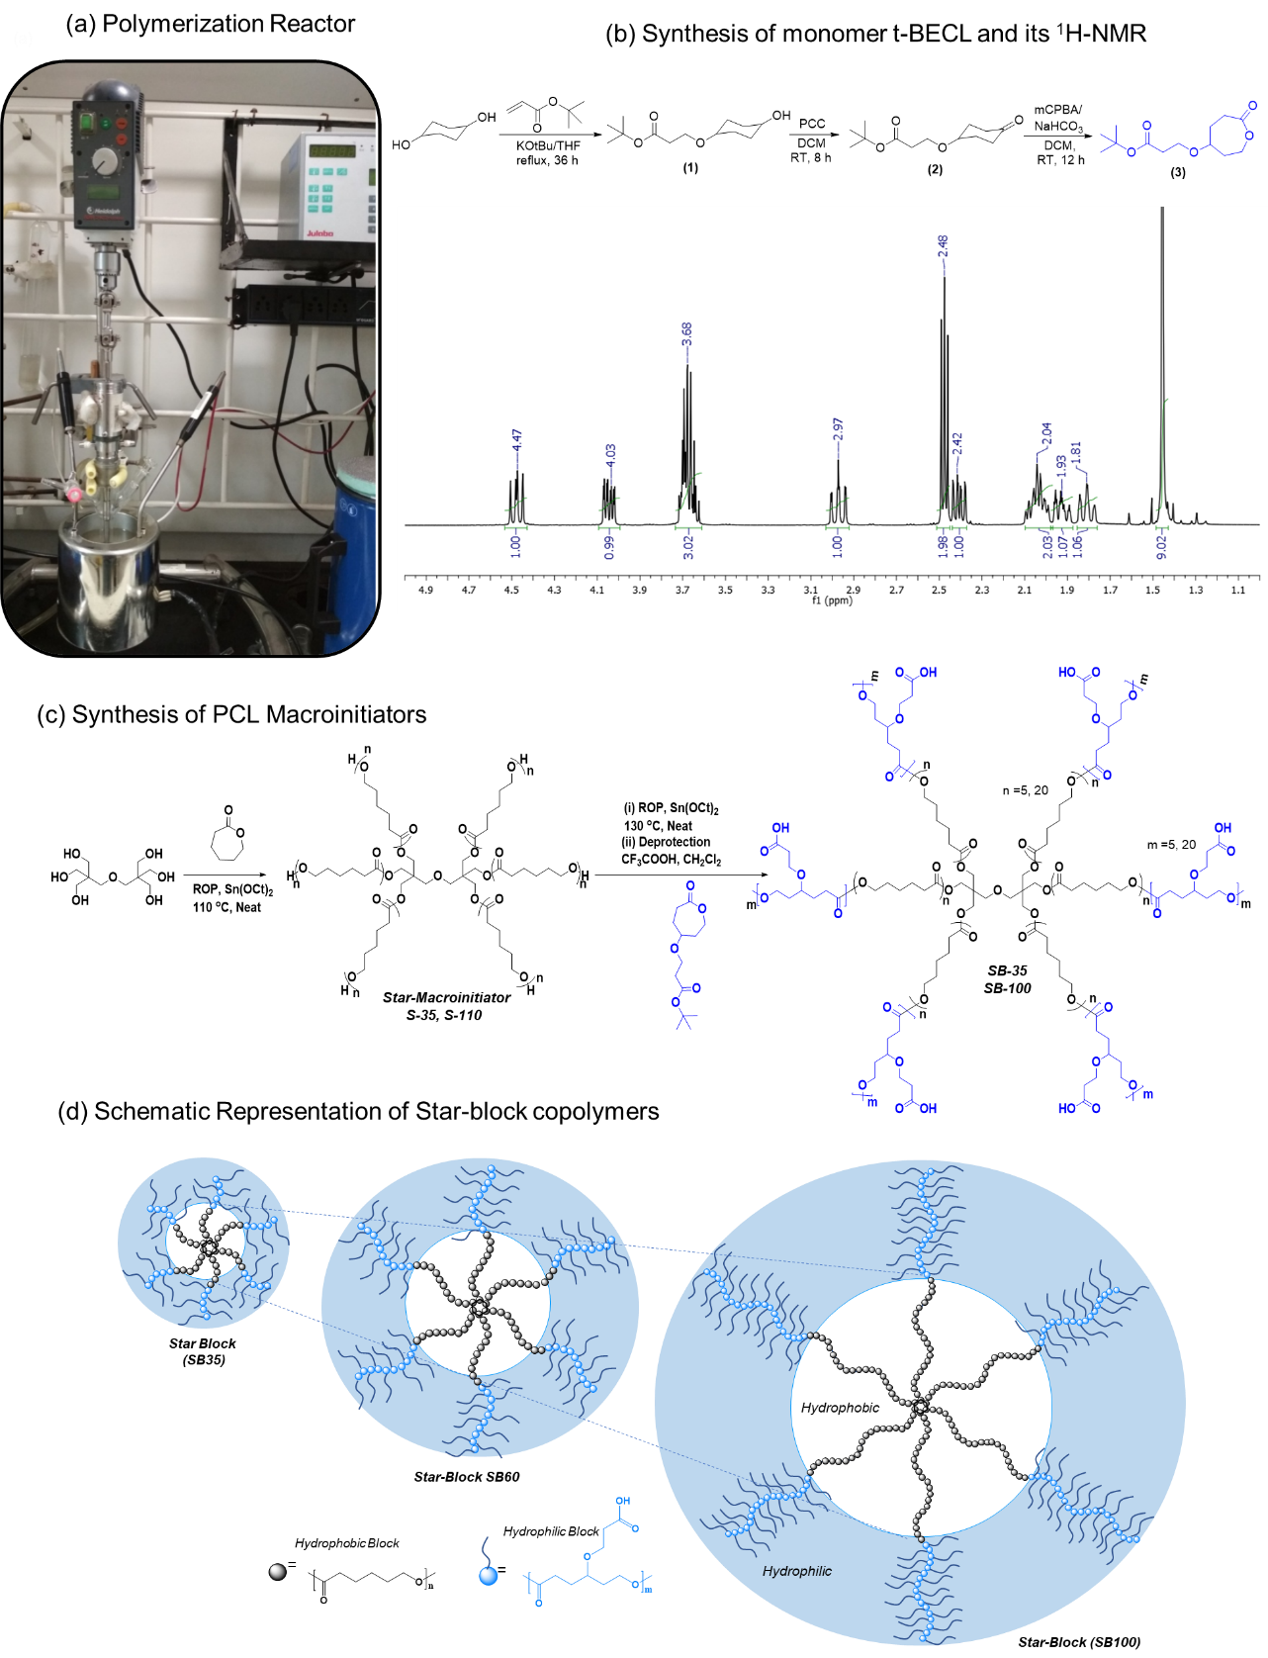
Figure S1: (a) In-house specially designed melt reactor set-up with an overhead stirrer for ring opening polymerization methodology. (b) Multi-step synthetic scheme of the tertiary butyl ester substituted caprolactone monomer (t-BECL) and its ¹H-NMR in CDCl₃. (c) Ring opening polymerization of the star macroinitiators S-35, S-110 and block copolymers SB-35, SB-100. (d) Schematic presentation of core-shell star-block copolymers SB-35, SB-60 and SB-100

Figure S2: (a) ¹H NMR stack plot of S-60, SB-60 and carboxylic substituted SB-60 in CDCl₃ and (CD₃)₂SO. (b) ¹H NMR stack plot of S-110, SB-100 and carboxylic substituted SB-100 in CDCl₃ and CD₃OD. The spectra are plotted up to 4.70 ppm for simplicity.

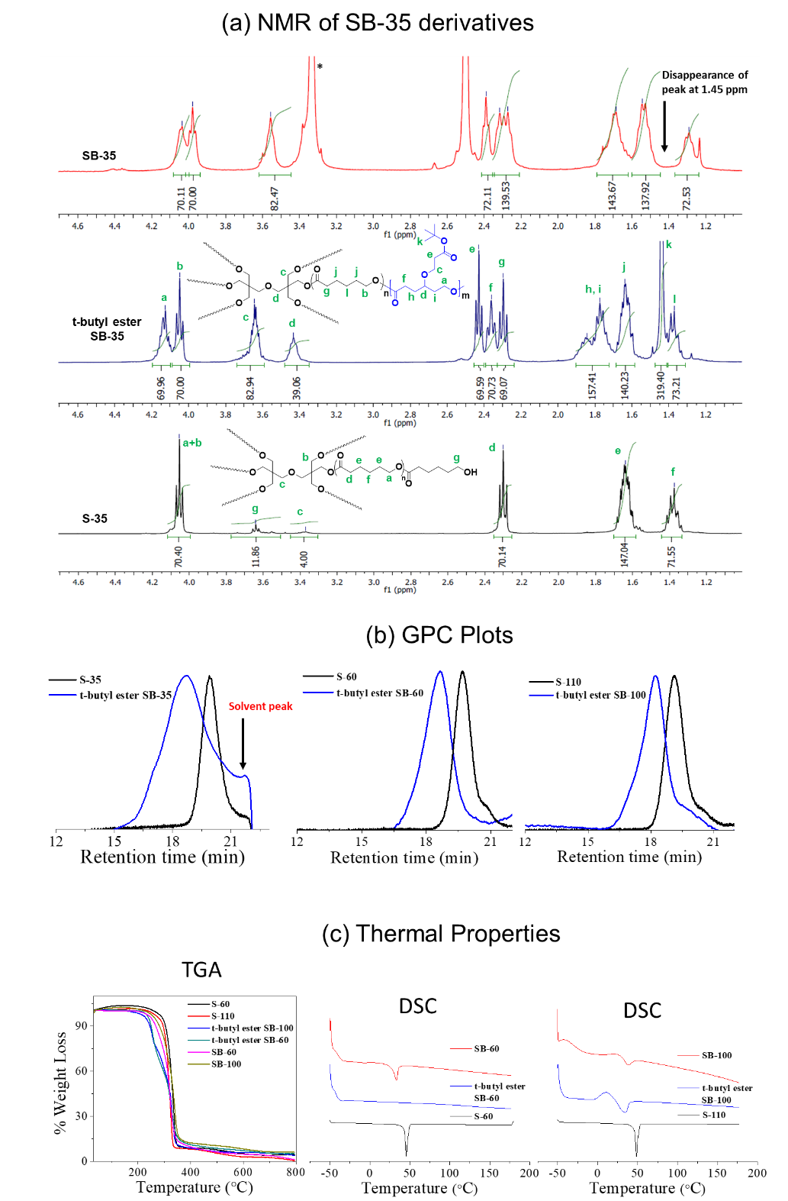

Figure S3: ¹H NMR stack plot of S-35, SB-35 and carboxylic substituted SB-35 in CDCl₃ and (CD₃)₂SO. The spectra are plotted up to 4.70 ppm for simplicity. (b) Gel permeation chromatogram of t-butyl ester substituted star block copolymers alongwith their respective macroinitiators. (c) Thermogravimetric Analysis (TGA) plot and Differential Scanning Calorimetry (DSC) thermograms of star macroinitiators and block copolymers (heating cycle).
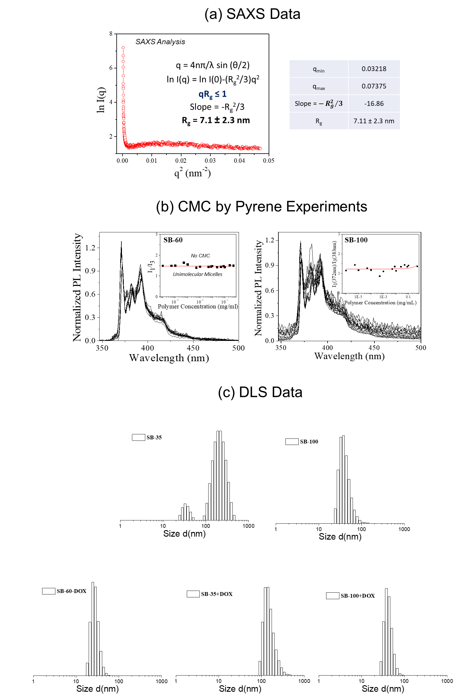

Figure S4: (a) Small Angle X-ray Scattering (SAXS) analysis and determination of radius of gyration (R_{g}) for the star block copolymer SB-60. (b) Critical Micelle Conccentration (CMC) plots of SB-60 and SB-100 polymers. (c) DLS histograms of star block copolymer nascent and DOX-loaded nano-scaffolds.
Important points for Figures S1 to S4 Analysis

Note: ¹H NMR stack plot of SB-60 star-block copolymer and the macroinitiator S-60 is shown here. In order to determine the degree of polymerization (X_{n}), the integration of the peak intensities from the initiator were compared to those of the polymer backbone in ¹H-NMR. As can be seen in lowest panel corresponding to the S-60 macroinitiator, the chain end terminal protons appeared at 3.64 ppm corresponding to the 12 protons adjacent to the hydroxyl group. The peak at 3.39 ppm represents the 4 ether protons of the dipentaerythritol initiator. The newly formed ester peaks in the polycaprolactone part were found to appear at 4.06 ppm and 2.30 ppm. The dipentaerythritol initiator 12 protons next to the ester also appear at 4.06 ppm together with the polycaprolactone peak. The terminal protons at 3.64 ppm were chosen as the reference peak and given an integration of 12, corresponding to which the integration of the PCL part at 4.06 ppm was determined and hence, comparing the intensities of the aforementioned peaks gave the incorporated degree of polymerization (X_{n}). For feed [M]/[I] = 60 in the star macroinitiator: the actual incorporation as determined from the ¹H-NMR was 64 ± 3 repeating units confirming the statistical distribution of 10-11 units per arm. To estimate the degree of polymerization in star-block copolymer; the appearance of new peak corresponding to t-butyl ester PCL was compared with macroinitiator PCL units. In case of the polymer SB-60 (second panel), additional peaks corresponding to the BECL part were seen when compared to the S-60 NMR, wherein the new ester peaks appeared at 4.13 ppm and 2.37 ppm reiterating the formation of the star-block copolymer. Since the S-60 macroinitiator was employed to yield the star-block copolymer, hence comparing the intensities of the two ester peaks at 4.06 ppm (PCL part) and 4.13 ppm (BECL part) gave us the number of repeating units for the BECL unit. The number average degree of polymerization (X_{n}) for the t-butyl ester PCL block was estimated to be 64 ± 3 (for feed [M]/[MI] = 60) indicating the formation of average 10-11 substituted PCL units per arm. The deprotection of the t-butyl group into carboxylic acid was confirmed via the disappearance of the 1.45 ppm peak, as can be seen in the top panel corresponding to carboxylic substituted SB-60.

Note: In all the following figures, the carboxylic acid substituted star block copolymers will be referred to as SB-35, SB-60 and SB-100.

Note: The carboxylic acid substituted star block polymers were characterized using ¹H NMR. The integartion of all the respective peaks was maintained followed by deprotection using TFA and thus, the structural integrity of the polymer backcone was unperturbed. These polymers are only soluble in Methanol and DMSO, hence, their GPC chromatograms could not be recorded due to the unavailability of a GPC system with the aforementioned mobile phases.

Note: Differential scanning calorimetry (DSC) thermograms exhibited both S-60 and S-110 macroinitiators as semi-crystalline having melting transitions at 45.6 °C and 48.6 °C, respectively. The star-block copolymer SB-60 was found to be sluggish to crystallize and the polymer displayed only glass transition (T_{g}) at -42.5 °C. On the other hand, the SB-100 polymer exhibited a cold crystallization peak at 10.5 °C followed by a melting transition at 34.4 °C. The carboxylic acid substituted star-block copolymers SB-60 and SB-100 exhibited semi-crystalline behaviour wherein both the glass transition as well as the melting transitions were observed.

Note: The scattering intensity, I is determined as a function of the scattering vector “q” and according to the Guinier approximation, the value of I depends on the Radius of gyration R_{g} as per the equation given above. The Guinier approximation focusses on the lower q values of the SAXS scattering curve and the plot of ln I(q) vs q² is what is referred to as the Guinier plot, whose slope gives us the value of R_{g} (under the condition that qR_{g} ≤ 1).

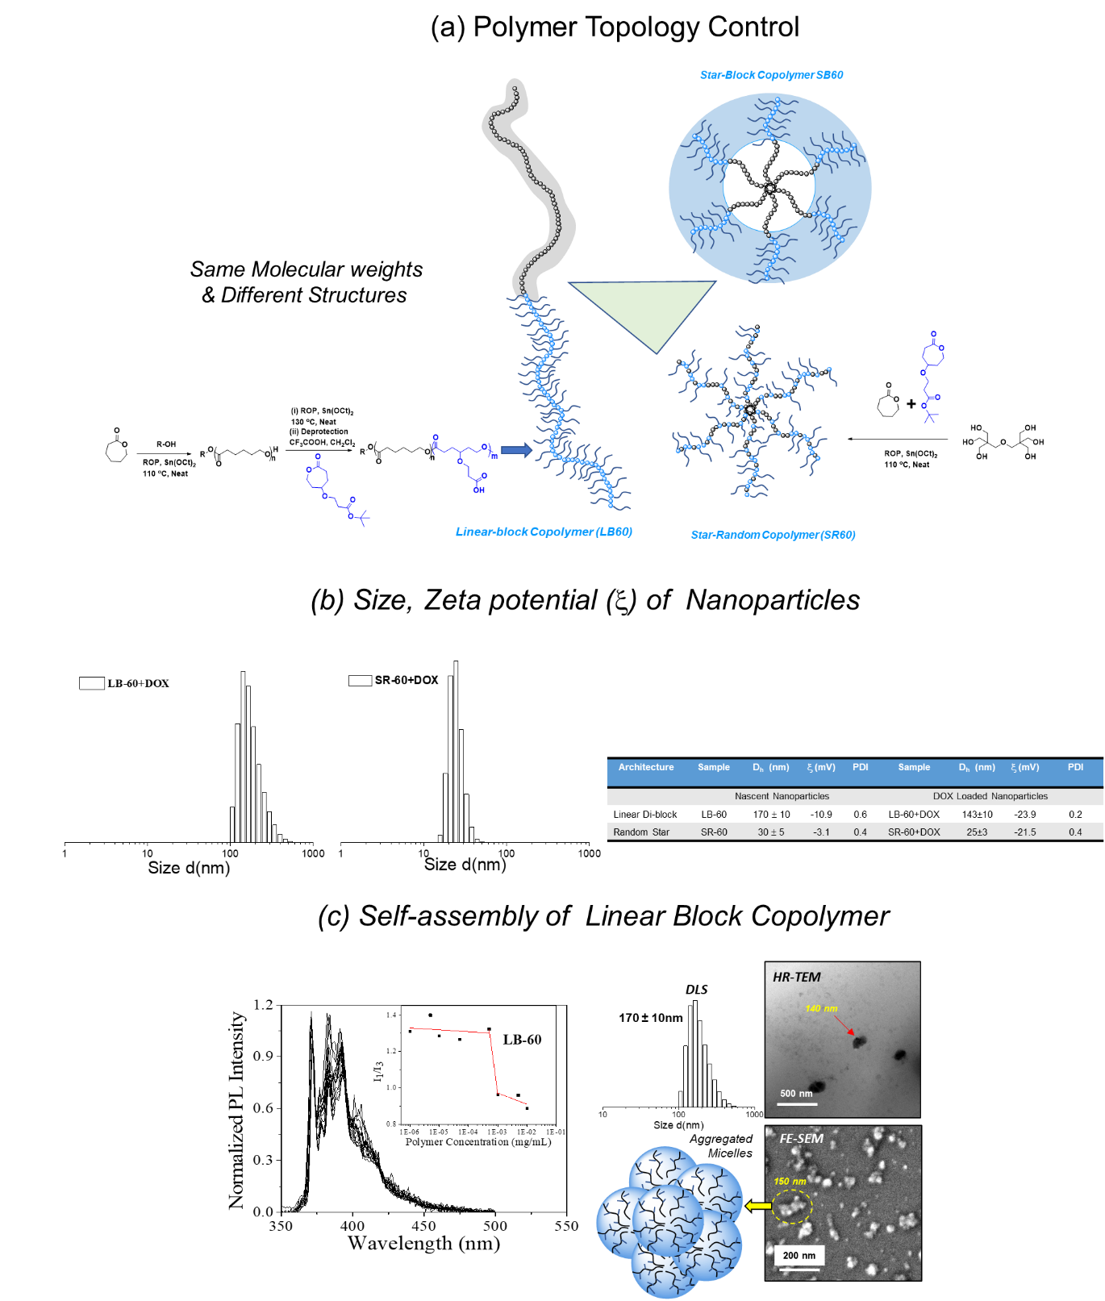
Figure S5: (a) Polymer topology control in the PCL block copolymers. All the polymers have identical molecular weights with 60 PCL units and 60 carboxylic PCL units. (b) Size, Zeta potential and other details of the nascent and DOX loaded liner di-block LB-60 and star random copolymer SR-60. (c) CMC deterimination of LB-60, DLS, FE-SEM and HR-TEM images of linera di-block exhibiting aggregated micelles.
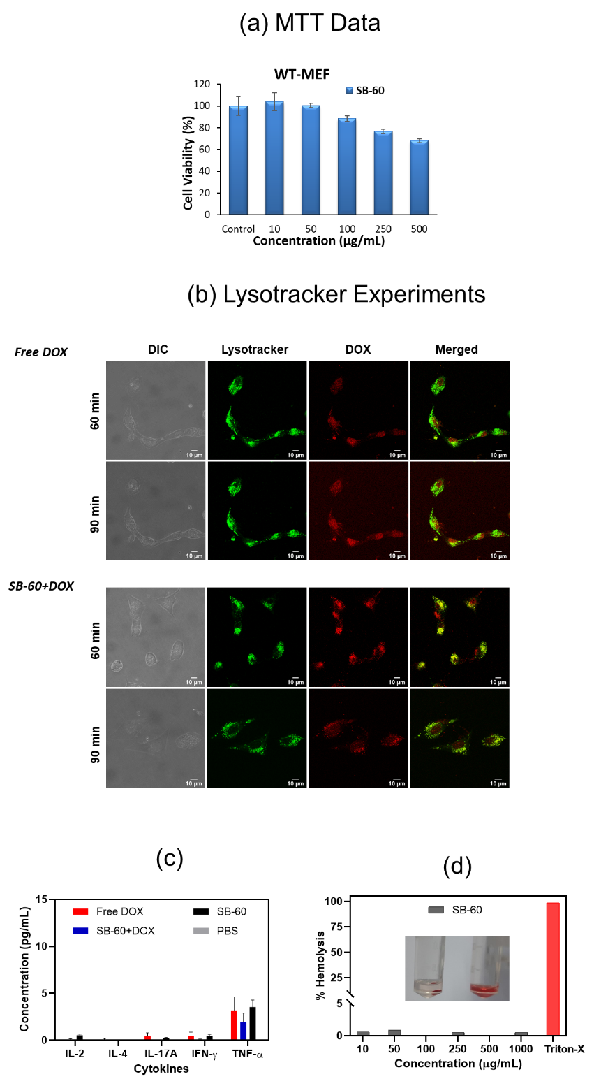

Figure S6: (a) MTT plot depicting the cytocompatibility of the star block copolymer SB-60 upto a concentration of 500 µg/mL. (b) Representative CLSM images depicting live cell uptake of free DOX and SB-60+DOX at different time points 60 and 90 min in WT-MEF cells. (c) Concentration of the cytokines IL-2, IL-4, IL-17A, IFN-ɣ and TNF-α in the plasma samples of all the 19 mice. (d) Plot of % Hemolysis vs. polymer concentration for the star block copolymer SB-60. Triton-X served as the positive control.

Table ST1: Weight of the Organs

Organ | Free DOX (g) |  |  | SB-60+DOX (g) |  |  | LB-60+DOX (g)
 | I | II | III | I | II | III | I | II | III
Brain | 0.3558 | 0.2969 | 0.3136 | 0.3737 | 0.3029 | 0.2536 | 0.3118 | 0.3437 | 0.21
Heart | 0.1266 | 0.1356 | 0.1217 | 0.1468 | 0.1138 | 0.1643 | 0.1291 | 0.1350 | 0.1106
Kidney1 | 0.1478 | 0.1440 | 0.1405 | 0.1553 | 0.1499 | 0.1146 | 0.1286 | 0.1612 | 0.1244
Kidney2 | 0.1472 | 0.0930 | 0.1526 | 0.1426 | 0.1388 | 0.1395 | 0.1362 | 0.1838 | 0.1282
Liver | 1.0208 | 0.7490 | 1.0915 | 1.1159 | 0.9448 | 1.05 | 0.9323 | 1.0447 | 0.9342
Spleen | 0.0962 | 0.1025 | 0.0999 | 0.1069 | 0.0942 | 0.1246 | 0.1104 | 0.1232 | 0.1104

Figure S7: Representative images (40X and 10X) of H&E-stained tissue samples. Scale bar = 20 µm and 50 µm, respectively

Figure S8: Representative CLSM images (63 X and 10X) depicting the uptake of free DOX and SB-60+DOX for the brain, heart, kidney, liver, and spleen tissue.

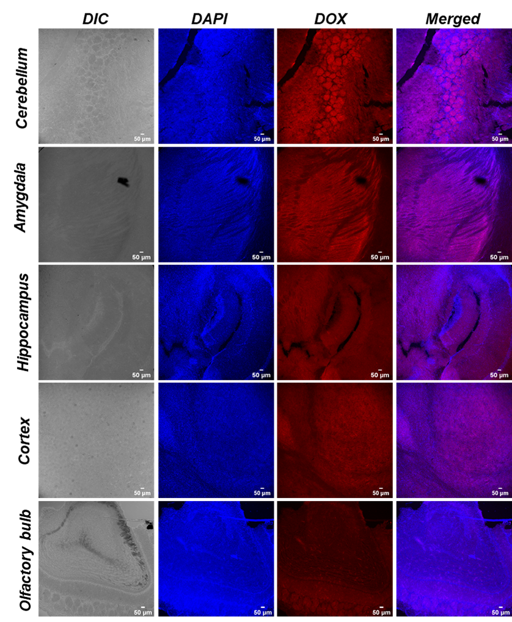

Figure S9: Representative CLSM image (10 X) depicting the uptake of the unimolecular micelle SB-60+DOX across different parts of the brain (scale bar = 50 μm)

Corresponding Authors: jayakannan@iiserpune.ac.in; nabraham@iiserpune.ac.in

