Supplementary Figure 1: Factors associated with risk of developing AF
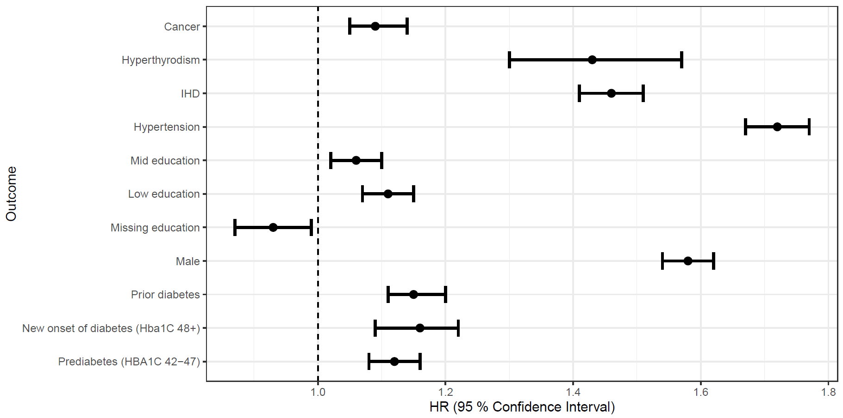

Supplementary Figure 2: Risk of Stroke (A), cardiovascular death (B) and all-cause mortality (C) according to HbA1c status. Based on a 75-year old woman with a low level of education ischemic heart disease and eGFR<60

A)
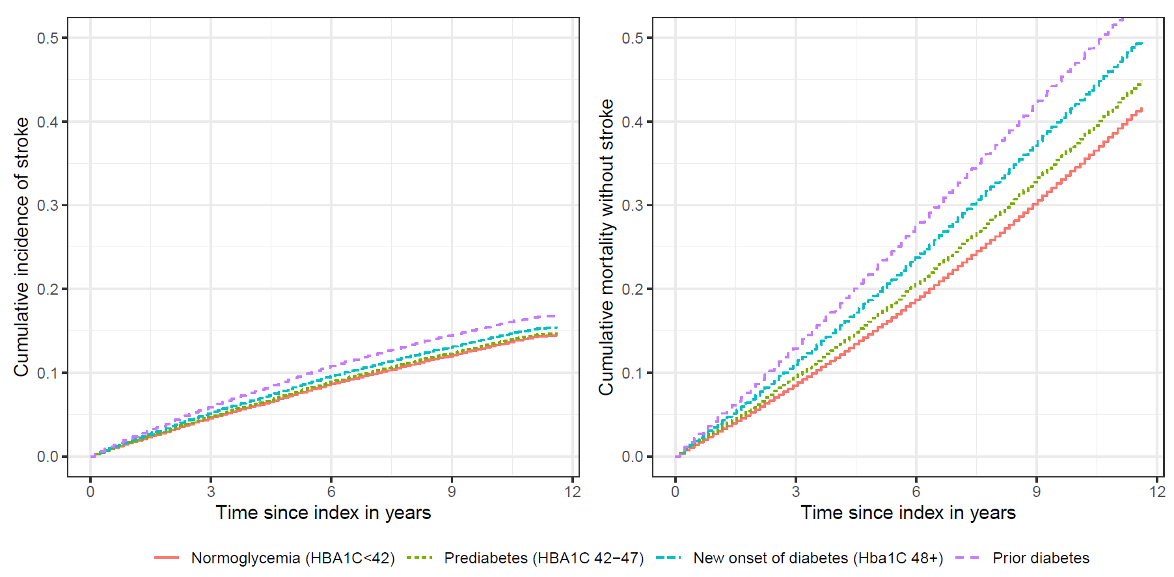
B)
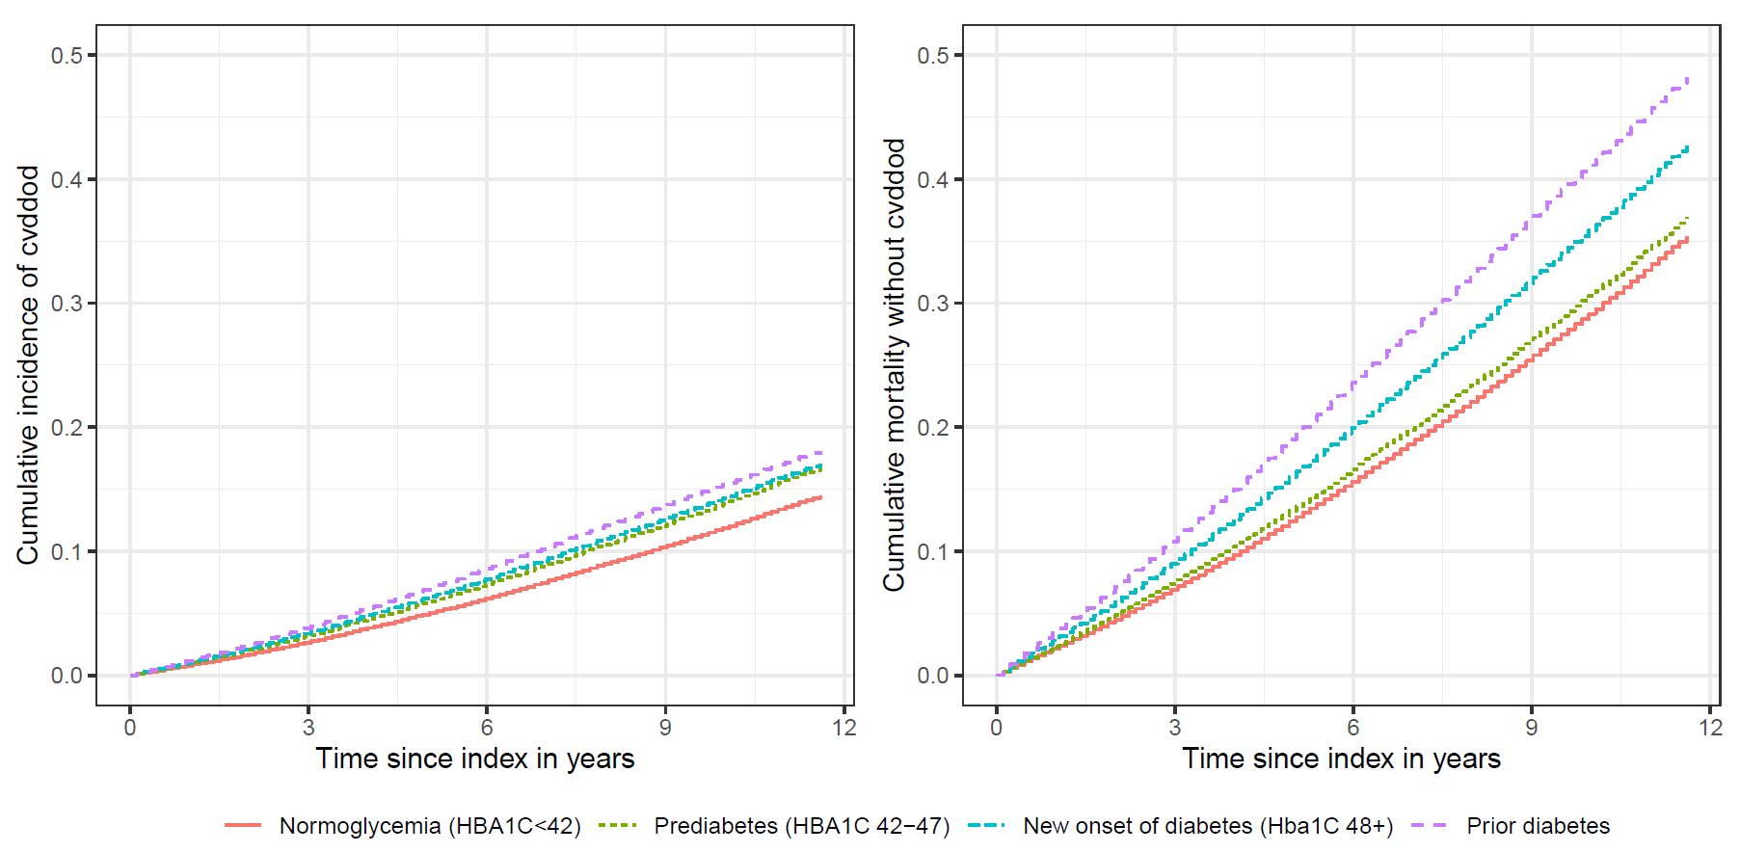

C)
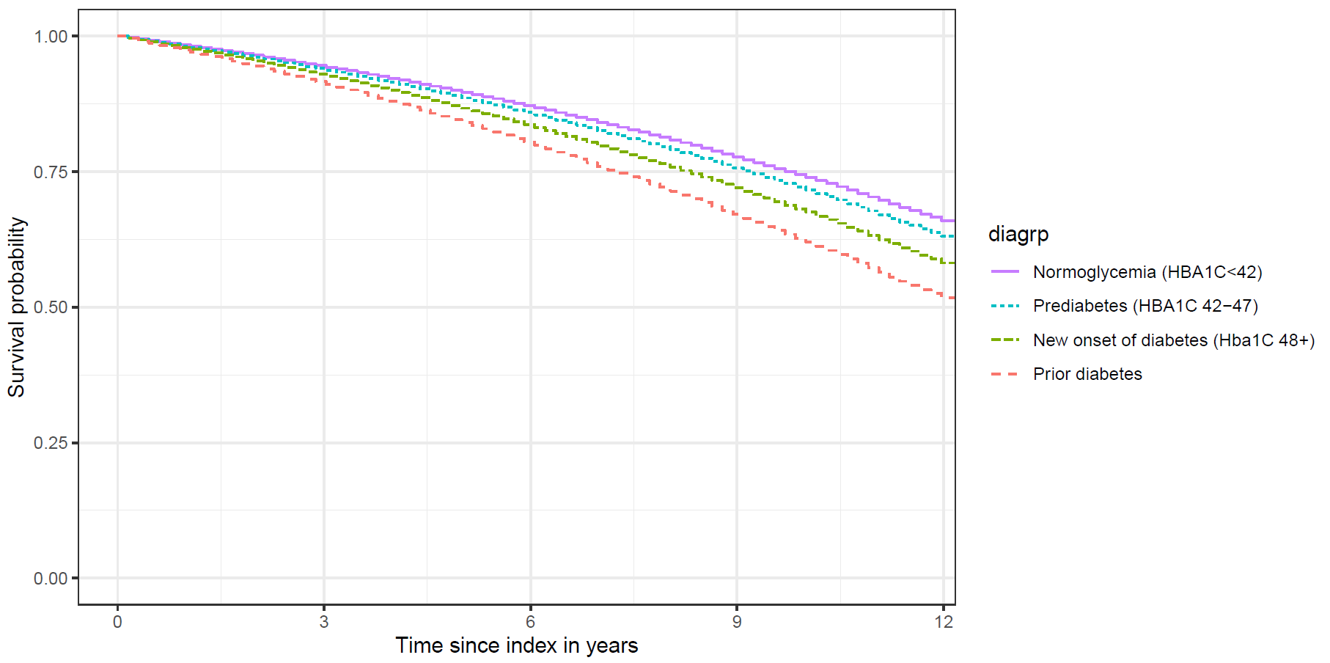

Supplementary Table 1: Diagnosis- and procedure codes for events and comorbidities of interest
Diseases
Heart failure | I11.0, I13.0, I13.2, I42, I50
Renal disease | N03, N04, N17-N19, R34, I12, I13
Hypertension | I10-I15
Stroke | I60-I61, I63-I64
Diabetes mellitus | E10-E14
Ischemic heart disease | I20-I25
Atrial fibrillation | I48
Myocardial infarction | I21, I22
Cancer | C00-C99
COPD | J42, J44
Peripheral artery disease | I70-79
Hyperthyroidism | E05
Cardiovascular death | I00-I15, I21-I52, I60-I99
Procedures
CABG | KFNA-KFNE
PCI | KFNG
* CABG = coronary artery bypass graft, PCI = percutaneous coronary intervention, COPD= chronic obstructive pulmonary disease

Supplementary Table 2: Drug exposure variables (from 6 months prior to index)

ATC | Name
A10A | Insulins
A10B | Blood glucose lowering
B01A | Antiplatelets, any
C10AA | Statins
C02 | Antihypertensives
C03 | Diuretics
C07 | Beta blocking agents
C08 | Calcium channel blockers
C09 | Ace-inhibitors

