Supplementary File

Table S1. Summary statistics of the 17 independent SNPs associated with birth length at P<1×10⁻⁵ used in the three ethnic populations
SNP | CHR | Position | Nearest gene | EA/Non-EA | EAF | Beta | SE | P-value
rs1576672 | 1 | 87695013 | LMO4 | C/T | 0.49 | 0.050 | 0.010 | 1.4×10⁻⁶
rs11205277 | 1 | 148159496 | SF3B4 | G/A | 0.41 | -0.040 | 0.010 | 8.0×10⁻⁶
rs905938 | 1 | 153258013 | DCST2 | C/T | 0.25 | -0.050 | 0.010 | 2.6×10⁻⁷
rs740746 | 10 | 115782777 | ADRB1 | G/A | 0.32 | 0.040 | 0.010 | 5.2×10⁻⁶
rs1042725 | 12 | 64644614 | HMGA2 | T/C | 0.46 | 0.040 | 0.010 | 6.7×10⁻⁷
rs12967139 | 18 | 57138211 | CDH20 | G/A | 0.32 | 0.050 | 0.010 | 1.8×10⁻⁶
rs10185378 | 2 | 206013401 | PARD3B | T/C | 0.06 | 0.090 | 0.020 | 8.5×10⁻⁶
rs16985662 | 22 | 36956224 | TMEM184B | G/A | 0.16 | -0.060 | 0.010 | 8.1×10⁻⁶
rs10483213 | 22 | 40669471 | CENOM | A/G | 0.10 | -0.060 | 0.010 | 8.8×10⁻⁶
rs6798189 | 3 | 124578002 | ADCY5 | A/G | 0.19 | 0.050 | 0.010 | 1.4×10⁻⁶
rs724577 | 4 | 17602508 | LCORL | A/C | 0.29 | 0.050 | 0.010 | 4.5×10⁻⁸
rs2904185 | 4 | 89358856 | PPM1K | T/C | 0.41 | 0.040 | 0.010 | 8.3×10⁻⁶
rs13146972 | 4 | 145789142 | HHIP | T/C | 0.41 | 0.040 | 0.010 | 4.4×10⁻⁶
rs6570507 | 6 | 142721265 | GPR126 | A/G | 0.32 | -0.050 | 0.010 | 3.6×10⁻⁷
rs13229771 | 7 | 92369727 | CDK6 | C/T | 0.11 | 0.070 | 0.010 | 2.8×10⁻⁶
rs12545524 | 8 | 96974821 | GDF6 | G/A | 0.15 | -0.080 | 0.010 | 1.5×10⁻⁸
rs1984119 | 9 | 97408582 | PTCH1 | C/T | 0.27 | 0.050 | 0.010 | 3.2×10⁻⁷
Note: CHR: Chromosome; EA: Effect Allele; EAF: Effect Allele Frequency; SE: Standard Error. The selected SNPs were matched against the UK Biobank genotypes, and 17 SNPs were finally retained for birth length.

Table S2. Summary statistics of the 8 independent SNPs associated with birth length at P<1×10⁻⁵ in the European sibling cohort
SNP | CHR | Position | Nearest gene | EA/Non-EA | EAF | Beta | SE | P-value
rs1576672 | 1 | 87695013 | LMO4 | C/T | 0.49 | 0.050 | 0.010 | 1.4×10⁻⁶
rs905938 | 1 | 153258013 | DCST2 | C/T | 0.25 | -0.050 | 0.010 | 2.6×10⁻⁷
rs1042725 | 12 | 64644614 | HMGA2 | T/C | 0.46 | 0.040 | 0.010 | 6.7×10⁻⁷
rs12967139 | 18 | 57138211 | CDH20 | G/A | 0.32 | 0.050 | 0.010 | 1.8×10⁻⁶
rs10185378 | 2 | 206013401 | PARD3B | T/C | 0.06 | 0.090 | 0.020 | 8.5×10⁻⁶
rs6798189 | 3 | 124578002 | ADCY5 | A/G | 0.19 | 0.050 | 0.010 | 1.4×10⁻⁶
rs724577 | 4 | 17602508 | LCORL | A/C | 0.29 | 0.050 | 0.010 | 4.5×10⁻⁸
rs12545524 | 8 | 96974821 | GDF6 | G/A | 0.15 | -0.080 | 0.010 | 1.5×10⁻⁸
Note: CHR: Chromosome; EA: Effect Allele; EAF: Effect Allele Frequency; SE: Standard Error. We matched the selected SNPs against the UK Biobank genotypes, ultimately retaining 8 SNPs for birth length.

Table S3. Summary statistics of the 41 independent SNPs associated with BMI in childhood at P<5×10⁻⁶ in the three ethnic populations
SNP | CHR | Position | Nearest gene | EA/Non-EA | EAF | Beta | SE | P-value
rs2590942 | 1 | 72657869 | NEGR1 | G/T | 0.82 | 0.06 | 0.01 | 3.88×10⁻⁹
rs12041852 | 1 | 74776088 | TNNI3K | G/A | 0.46 | 0.053 | 0.008 | 1.77×10⁻¹⁰
rs11165675 | 1 | 96812556 | PTBP2 | A/G | 0.27 | -0.041 | 0.009 | 1.67×10⁻⁶
rs7550711 | 1 | 109884409 | GPR61 | T/C | 0.04 | 0.12 | 0.021 | 1.50×10⁻⁸
rs543874 | 1 | 176156103 | SEC16B | G/A | 0.20 | 0.082 | 0.01 | 2.38×10⁻¹⁷
rs633143 | 1 | 179716108 | CACNA1E | T/C | 0.14 | -0.048 | 0.01 | 3.81×10⁻⁶
rs12096993 | 1 | 217931859 | SLC30A10 | T/C | 0.27 | -0.058 | 0.013 | 3.47×10⁻⁶
rs1247117 | 10 | 120418792 | C10orf46 | G/A | 0.11 | 0.058 | 0.013 | 3.47×10⁻⁶
rs17309930 | 11 | 27705069 | BDNF | A/C | 0.21 | 0.053 | 0.01 | 2.47×10⁻⁸
rs6580706 | 12 | 47959818 | TUBA1C | C/G | 0.34 | 0.058 | 0.01 | 1.83×10⁻⁸
rs7132908 | 12 | 48549415 | FAIM2 | A/G | 0.39 | 0.077 | 0.009 | 4.99×10⁻¹⁹
rs12429545 | 13 | 53000207 | OLFM4 | A/G | 0.13 | 0.075 | 0.011 | 3.66×10⁻¹¹
rs10151686 | 14 | 29536217 | PRKD1 | A/G | 0.04 | 0.107 | 0.022 | 1.50×10⁻⁶
rs8046312 | 16 | 19886835 | GPR139 | C/A | 0.81 | 0.067 | 0.011 | 4.06×10⁻¹⁰
rs1421085 | 16 | 52358455 | FTO | C/T | 0.41 | 0.073 | 0.008 | 3.20×10⁻¹⁹
rs11079830 | 17 | 44037629 | HOXB6 | G/A | 0.58 | -0.044 | 0.009 | 4.43×10⁻⁷
rs12457682 | 18 | 7216505 | LAMA1 | C/A | 0.23 | -0.057 | 0.012 | 3.40×10⁻⁶
rs8092620 | 18 | 41433991 | SLC14A2 | G/T | 0.48 | 0.039 | 0.008 | 3.31×10⁻⁶
rs8084077 | 18 | 49532928 | DCC | C/T | 0.73 | 0.041 | 0.009 | 3.47×10⁻⁶
rs8092503 | 18 | 50630485 | RAB27B | G/A | 0.27 | 0.047 | 0.009 | 8.55×10⁻⁸
rs6567160 | 18 | 55980115 | MC4R | C/T | 0.23 | 0.065 | 0.009 | 4.06×10⁻¹²
rs3845265 | 18 | 63690108 | DSEL | A/G | 0.71 | 0.044 | 0.009 | 8.86×10⁻⁷
rs4854349 | 2 | 637861 | TMEM18 | T/C | 0.83 | 0.097 | 0.01 | 6.00×10⁻²¹
rs11676272 | 2 | 24995042 | ADCY3 | G/A | 0.46 | 0.077 | 0.008 | 8.55×10⁻²³
rs1838856 | 2 | 113822060 | PAX8 | A/C | 0.46 | 0.044 | 0.009 | 1.85×10⁻⁶
rs13387838 | 2 | 206989692 | ADAM23 | A/G | 0.04 | 0.151 | 0.027 | 2.40×10⁻⁸
rs214821 | 20 | 2258291 | TGM3 | T/C | 0.02 | 1.627 | 0.35 | 3.38×10⁻⁶
rs188584 | 3 | 62675007 | CADPS | A/C | 0.77 | 0.046 | 0.01 | 3.23×10⁻⁶
rs10866069 | 3 | 64366964 | ADAMTS9 | T/C | 0.17 | 0.055 | 0.012 | 3.05×10⁻⁶
rs13130484 | 4 | 44870448 | GNPDA2 | T/C | 0.44 | 0.051 | 0.008 | 8.94×10⁻¹¹
rs13107325 | 4 | 103407732 | SLC39A8 | T/C | 0.07 | 0.102 | 0.018 | 1.19×10⁻⁸
rs2968990 | 4 | 131098524 | C4orf33 | C/T | 0.37 | 0.042 | 0.009 | 1.67×10⁻⁶
rs1573972 | 4 | 171559399 | AADAT | C/T | 0.19 | 0.087 | 0.019 | 3.78×10⁻⁶
rs25832 | 5 | 66211438 | LOC375449 | G/A | 0.71 | 0.044 | 0.009 | 2.41×10⁻⁶
rs4569924 | 5 | 153520218 | GALNT10 | T/C | 0.43 | 0.04 | 0.008 | 4.06×10⁻⁷
rs987237 | 6 | 50911009 | TFAP2B | G/A | 0.19 | 0.071 | 0.01 | 3.81×10⁻¹³
rs6971577 | 7 | 140350204 | MRPS33 | G/C | 0.78 | 0.051 | 0.01 | 1.17×10⁻⁶
rs13253111 | 8 | 28117893 | ELP3 | G/A | 0.57 | 0.049 | 0.008 | 4.13×10⁻⁹
rs4870949 | 8 | 126704776 | TRIB1 | T/C | 0.07 | 1.817 | 0.289 | 3.13×10⁻¹⁰
rs7869969 | 9 | 95257268 | FAM120A | G/A | 0.33 | -0.041 | 0.008 | 1.43×10⁻⁶
rs3829849 | 9 | 128430621 | LMX1B | T/C | 0.36 | 0.038 | 0.008 | 1.46×10⁻⁶
Note: CHR: Chromosome; EA: Effect Allele; EAF: Effect Allele Frequency; SE: Standard Error. The selected SNPs were matched against the UK Biobank genotypes, and 41 SNPs were eventually obtained for BMI.

Table S4. Summary statistics of the 18 independent SNPs associated with BMI in childhood at P<5×10⁻⁶ in the European sibling cohort
SNP | CHR | Position | Nearest gene | EA/Non-EA | EAF | Beta | SE | P-value
rs2590942 | 1 | 72657869 | NEGR1 | G/T | 0.82 | 0.06 | 0.01 | 3.88×10⁻⁹
rs7550711 | 1 | 109884409 | GPR61 | T/C | 0.04 | 0.12 | 0.021 | 1.50×10⁻⁸
rs543874 | 1 | 176156103 | SEC16B | G/A | 0.20 | 0.082 | 0.01 | 2.38×10⁻¹⁷
rs12096993 | 1 | 217931859 | SLC30A10 | T/C | 0.27 | -0.058 | 0.013 | 3.47×10⁻⁶
rs17309930 | 11 | 27705069 | BDNF | A/C | 0.21 | 0.053 | 0.01 | 2.47×10⁻⁸
rs7132908 | 12 | 48549415 | FAIM2 | A/G | 0.39 | 0.077 | 0.009 | 4.99×10⁻¹⁹
rs8084077 | 18 | 49532928 | DCC | C/T | 0.73 | 0.041 | 0.009 | 3.47×10⁻⁶
rs6567160 | 18 | 55980115 | MC4R | C/T | 0.23 | 0.065 | 0.009 | 4.06×10⁻¹²
rs1838856 | 2 | 113822060 | PAX8 | A/C | 0.46 | 0.044 | 0.009 | 1.85×10⁻⁶
rs13387838 | 2 | 206989692 | ADAM23 | A/G | 0.04 | 0.151 | 0.027 | 2.40×10⁻⁸
rs214821 | 20 | 2258291 | TGM3 | T/C | 0.02 | 1.627 | 0.35 | 3.38×10⁻⁶
rs188584 | 3 | 62675007 | CADPS | A/C | 0.77 | 0.046 | 0.01 | 3.23×10⁻⁶
rs13130484 | 4 | 44870448 | GNPDA2 | T/C | 0.44 | 0.051 | 0.008 | 8.94×10⁻¹¹
rs13107325 | 4 | 103407732 | SLC39A8 | T/C | 0.07 | 0.102 | 0.018 | 1.19×10⁻⁸
rs25832 | 5 | 66211438 | LOC375449 | G/A | 0.71 | 0.044 | 0.009 | 2.41×10⁻⁶
rs987237 | 6 | 50911009 | TFAP2B | G/A | 0.19 | 0.071 | 0.01 | 3.81×10⁻¹³
rs6971577 | 7 | 140350204 | MRPS33 | G/C | 0.78 | 0.051 | 0.01 | 1.17×10⁻⁶
rs4870949 | 8 | 126704776 | TRIB1 | T/C | 0.07 | 1.817 | 0.289 | 3.13×10⁻¹⁰
Note: CHR: Chromosome; EA: Effect Allele; EAF: Effect Allele Frequency; SE: Standard Error. We matched the selected SNPs against the UK Biobank genotypes, ultimately retaining 18 SNPs for BMI.

Table S5. Effect sizes of maternal smoking during pregnancy on offspring height or body size at age 10 before and after considering GRS in the three ethnic populations and European sibling cohort
 | β (se, P) without GRS | β (se, P) with GRS
European cohort ª | 0.143 (0.011, 5.16×10⁻⁴²) | 0.143 (0.011, 5.25×10⁻⁴²)
European cohort ^{b} | 0.281 (0.011, 1.52×10⁻¹³²) | 0.281 (0.011, 2.32×10⁻¹³²)
South Asian cohort ª | 0.396 (0.170, 0.020) | 0.401(0.170, 0.018)
South Asian cohort ^{b} | 0.076 (0.234, 0.746) | 0.079 (0.234, 0.737)
African cohort ª | 0.262 (0.157, 0.095) | 0.261(0.157, 0.096)
African cohort ^{b} | 0.388 (0.172, 0.024) | 0.384 (0.172, 0.026)
European sibling cohort ª | 0.119 (0.039, 2.10×10⁻³) | 0.119 (0.039, 2.10×10⁻³)
European sibling cohort ^{b} | 0.308 (0.050, 7.31×10⁻¹⁰) | 0.306 (0.050, 1.07×10⁻⁹)
Note: a: the effect of smoking during pregnancy on offspring height at age ten; b: the effect of smoking during pregnancy on offspring body size at age ten.

Table S6. Effect sizes of covariates on offspring height or body size at ten years old after controlling for GRS in the European population
 | β (se, P) for height | β (se, P) for body size
maternal smoking | 0.143 (0.011, 5.25×10⁻⁴²) | 0.281 (0.011, 2.32×10⁻¹³²)
birthweight | -0.437 (0.010, <0.001) | 0.180 (0.011, 3.91×10⁻⁶³)
breastfeeding | -0.075 (0.012, 1.05×10⁻¹⁰) | -0.171 (0.013, 7.47×10⁻⁴²)
income | -0.006 (0.010, 0.561) | -0.025 (0.011, 0.022)
gender | -0.064 (0.010, 1.75×10⁻¹⁰) | -0.280 (0.011, 4.83×10⁻¹⁴²)
GRS | 0.057 (0.039, 0.139) | 0.120 (0.009, 9.23×10⁻³⁷)

Table S7. Effect sizes of covariates on offspring height or body size at ten years old after controlling for GRS in the European sibling cohort
 | β (se, P) for height | β (se, P) for body size
maternal smoking | 0.119 (0.039, 2.10×10⁻³) | 0.306 (0.050, 1.07×10⁻⁹)
birthweight | -0.482 (0.034, <0.001) | 0.264 (0.041, 8.59×10⁻¹¹)
breastfeeding | -0.054 (0.041, 0.190) | -0.060 (0.053, 0.259)
income | 0.043 (0.032, 0.181) | 0.039 (0.040, 0.324)
gender | -0.047 (0.032, 0.144) | -0.372 (0.041, <0.001)
birth order | 0.116 (0.028, 4.23×10⁻⁵) | 0.241 (0.034, 2.28×10⁻¹²)
GRS | -0.121 (0.179, 0.499) | 0.091 (0.040, 0.023)

Table S8. Association between GRS and height or body size without adjusting for potential confounders in the three populations
population | β (se, P) for height | β (se, P) for body size
European | 0.056 (0.039, 0.146) | 0.119 (0.009, 1.38×10⁻³⁶)
South Asian | -0.216 (0.315, 0.493) | 0.154 (0.081, 0.058)
African | -0.435 (0.332,0.190) | 0.468 (0.190, 0.014)

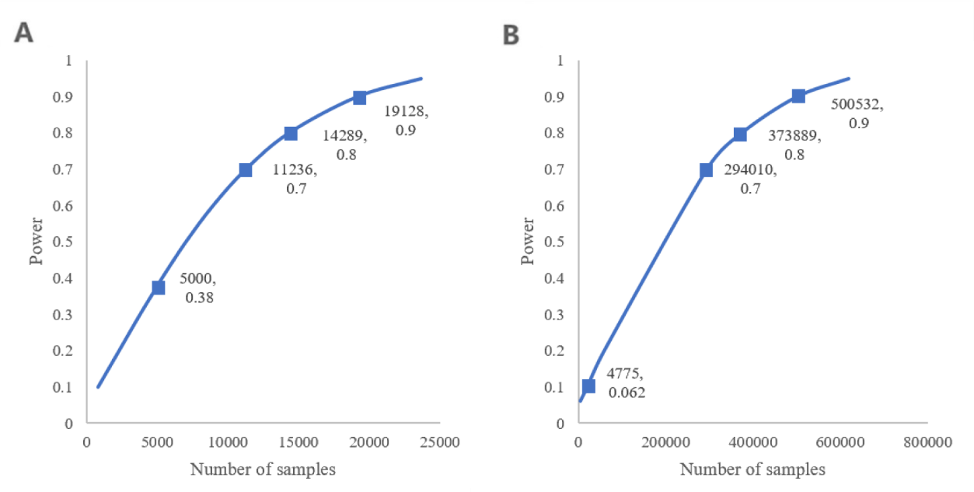

Figure S1. Expected power and sample size in the African population for height (A) and South Asian for body size (B). For each pair of numbers labeled in the figure, the former indicated the number of samples and the latter indicated the power under this setting.
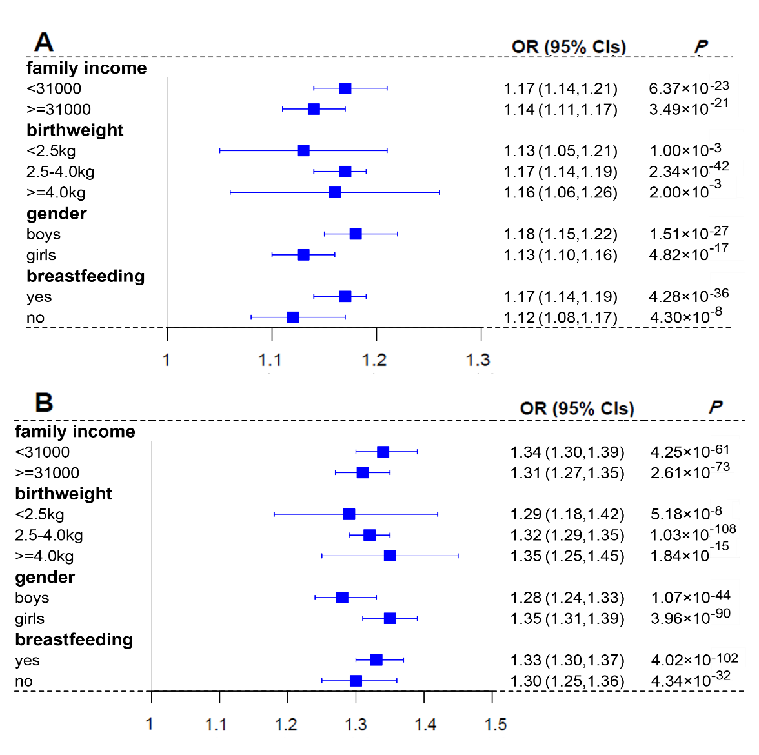

Figure S2. Forest plot of the effect of smoking during pregnancy on (A) height and (B) body size of offspring at age ten after stratified by each covariate.

