Supporting Information

Microwave assisted ultrafast immobilization of CuO nanostructures in paper matrices for antimicrobial applications
Sudiksha Aggrawalª, Debabrata Pradhan^{b}, and Paritosh Mohantyª*
ªFunctional Materials Laboratory, Department of Chemistry, Indian Institute of Technology Roorkee, Roorkee - 247667, Uttarakhand, India
^{b}Materials Science Centre, IIT Kharagpur, West Bengal-721302, INDIA
*E-mail: paritosh75@gmail.com, pm@cy.iitr.ac.in Tel: +91-1332-284859
1. Immobilization of CuO nanostructures in paper matrices using copper (I) bromide as precursor
Copper (I) bromide has been used as copper oxide precursor for the immobilization of copper oxide nanostructures in the paper matrices using microwave assisted method. Different reactions were carried out by varying reaction parameters such as temperature and time. Typically, 1.6 g of cellulose fibers in accordance with 80 GSM paper matrices, were dispersed in 50 mL of DI water. In a different beaker, in 50 mL of DI water 0.64 g of copper (I) bromide calculated as per 20 wt.% of CuO content, was dissolved completely. It was then transferred to the cellulose dispersion followed by dropwise addition of 40 mL 0.2 M NaOH solution with continuous stirring at RT for 15 min. The volume of the reaction mixture was made upto 140 mL by the addition of DI water. The complete reaction mixture was then transferred to 250 mL round bottom flask and microwave treatment was given at varying temperature from 50-80 ºC, time from 30-60 min and designated as CP1-CP3 (Table S1). After the completion of reaction, cellulose fibers were washed several times with ethanol and DI water to remove excess of bases and unreacted reagents. The cellulose fibers were allowed to dry at RT. Further, the cellulose fibers were re-dispersed and employed for Handsheet preparation. The mild reaction conditions was chosen so that fibers remain intact. Moreover, in an open vessel microwave system, it is not possible to carry out reaction above 80 ºC using water as a solvent. The colour of the copper bromide solution was blue and after adding it in the cellulose suspension, it also turned to sky blue colour. But the color of the copper oxide is red or brown, but even after carrying out the reaction for 1h at 80 ºC, the color of the cellulose fibers remain sky blue and it was not converted into the copper oxide at this mild reaction condition. Therefore, this series was not proceeded further.
2. Immobilization of CuO nanostructures in paper matrices using copper (II) acetate as precursor
Copper (II) acetate was also used as precursor for the immobilization of CuO nanostructures in the paper matrices using the similar procedure as discussed above. Different reactions were carried out by varying reaction parameters such as temperature and time, and designated as CP4-CP6 (Table S1). The exact similar procedure was followed except that 0.8 g copper (II) acetate was dissolved in 50 mL DI water, to keep the content of CuO in paper as 20 wt. %. Here, the change of colour from sky blue to brown was observed, when the reaction was carried out at 80 ºC for 30 min and 60 min. Although, there was no formation of CuO when reaction was carried out at 50 ºC even for 60 min. In order to achieve ultrafast immobilization of CuO nanostructures in the paper matrices, other precursors were also tried using microwave assisted method.
3. Immobilization of CuO nanostructures in paper matrices using copper (II) sulphate as precursor
Copper (II) sulphate was used as precursor for the immobilization of CuO nanostructures in the paper matrices using microwave assisted procedure as discussed above. The only deviation from the above described procedure is that here, 0.996 g of copper (II) sulphate is dissolved in water and the samples prepared were designated as CP7-CP9 (Table S1). Herein, the color of the cellulose fibers have been converted to brown at very mild reaction temperature of 50 ºC and ultrafast reaction time of 5 min only. This ultrafast immobilization of CuO nanostructures in the paper matrices have been extended further and series of samples have been synthesized by varying the CuO content from 5-30 % in the paper matrices. Five specimens have been synthesized with 5, 10, 15, 20 and 30 wt. % of CuO in the paper matrices and designated as 5CuOP, 10CuOP, 15CuOP, 20CuOP and 30CuOP, respectively. Details of chemicals added are summarized in Table S2.

Table S1. Composition of reagents and microwave parameters for the immobilization of CuO nanostructures in paper matrices.
S. N. | Sample ID's | Precursor | Salt (g) | Temp  (ᵒC) | Time  (min) | Power  (W)
1. | CP1 | Copper (I) bromide | 0.64 | 80 | 60 | 300
2. | CP2 | Copper (I) bromide | 0.64 | 80 | 60 | 300
3. | CP3 | Copper (I) bromide | 0.64 | 50 | 60 | 300
4. | CP4 | Copper (II) acetate | 0.8 | 80 | 60 | 300
5. | CP5 | Copper (II) acetate | 0.8 | 80 | 30 | 300
6. | CP6 | Copper (II) acetate | 0.8 | 50 | 60 | 300
7. | CP7 | Copper (II) sulphate | 0.996 | 80 | 30 | 300
8. | CP8 | Copper (II) sulphate | 0.996 | 50 | 30 | 300
9. | CP9 | Copper (II) sulphate | 0.996 | 50 | 5 | 300

Table S2. Composition details of the precursors added in the synthesis of CuO immobilized paper matrices using copper sulphate as precursor.
S. No. | Sample Id | Cupric sulphate  (M) | NaOH  (M)
1. | BP | Nil | Nil
2. | 5CuOP | 0.2 | 0.1
3. | 10CuOP | 0.4 | 0.2
4. | 15CuOP | 0.6 | 0.2
5. | 20CuOP | 0.8 | 0.2
6. | 30CuOP | 1.2 | 0.4

Table S3. Retention of CuO nanostructures in paper matrices estimated by combustion test and TGA analysis.

Sample ID | Mass remaining (%)
 | Combustion | TGA in Ar
5CuOP | 5 | 5.17
10CuOP | 7.98 | 8.19
15CuOP | 12.5 | 11.14
20CuOP | 12.2 | 12.4
30CuOP | 17.7 | 14.5

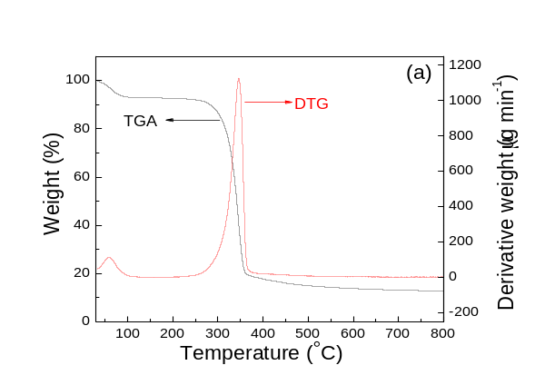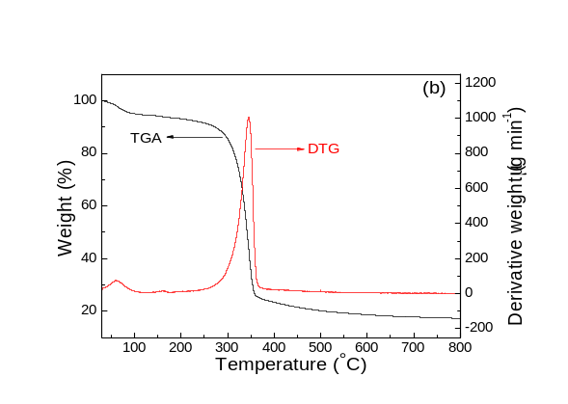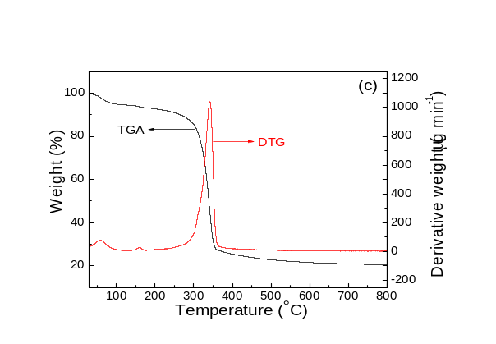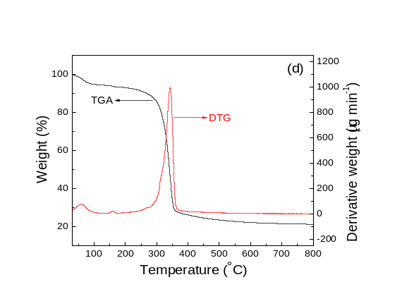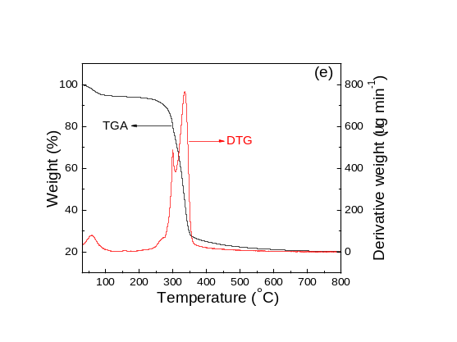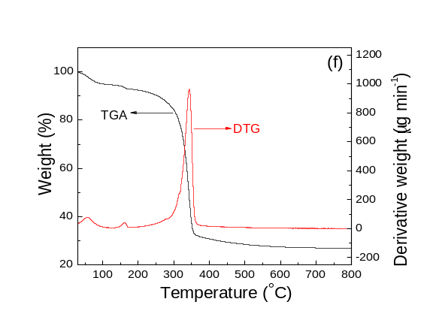
Figure S1. DTG curves of: (a) P, (b) 5CuOP, (c) 10CuOP, (d) 15CuOP, (e) 20CuOP and (f) 30CuOP.

Table S4. Percent reduction and log reduction values in growth of E. coli after 2h of visible light exposure.
S. No. | Sample Id | CFU | % Reduction | Log Reduction
1. | P | 2.8×10⁷ | No reduction | 0
2. | 5CuOP | 1.5×10⁷ | 40 | 0.33
3. | 10CuOP | 1.4×10⁷ | 50 | 0.29
4. | 15CuOP | 7.5×10 | 95 | 4.577
5. | 20CuOP | 2 | 99.99 | 7.14
6. | 30CuOP | 0 | 99.9999 | 7.44

