Effects of biochar combined with MgO desulfurization waste residue on nitrogen conversion and odour emission in chicken manure composting
Yuwan Pang^{a,c,d,e}, Feng Zhen ^{b}, Dehan Wang^{c}, Zifeng Luo^{c}, Jianfeng Huang^{a,d,e}*, Yanli Zhang ^{f}
ª Institute of Agricultural Resources and Environment, Guangdong Academy of Agricultural Sciences, Guangzhou 510640, China
^{b} Guangzhou Institute of Energy Conversion, Chinese Academy of Sciences, Guangzhou 510640, PR China
^{c} College of Natural Resources and Environment, South China Agricultural University, Guangzhou 510642, China
^{d} Guangdong Key Laboratory of Nutrient Cycling and Farmland Conservation, Guangzhou, 510640, China
^{e} Maoming Branch, Guangdong Laboratory for Lingnan Modern Agriculture, Maoming 525000, China
^{f} College of Life Science and Technology, Mudanjiang Normal University, Mudanjiang, 157011, China

We would like to submit our manuscript entitled “Effects of biochar combined with MgO desulfurization waste residue on nitrogen conversion and odour emission in chicken manure composting” for publication in ENVIRONMENTAL SCIENCE AND POLLUTION RESEARCH.
*Corresponding author E-mail address: hjf20051675@126.com.

SUPPLEMENTARY MATERIAL
Table SM1 Physical-Chemical properties of composting material
Raw material | Moisture content | Organic matter | Total N | Total P | Total K
Chicken manure | 67.21 | 61.35 | 3.42 | 2.36 | 3.81
Mushroom residue | 18.57 | 83.24 | 1.44 | 1.57 | 1.07

Table SM2 The physical and chemical properties of the MDWR
pH | Moisture (%) | MgSO₃  (%) | MgSO₄  (%) | Hg  (mg·kg⁻¹) | As  (mg·kg⁻¹) | Cd  (mg·kg⁻¹) | Pb  (mg·kg⁻¹) | Cr  (mg·kg⁻¹)
8.74 | 17.81 | 35.7 | 8.54 | 0.023 | 1.21 | -- | 4.83 | 7.14

Table SM3 Productive rate of citrus-branchs-biochar and the contents of main elements
Treatments | C₃₂₅ | Unit
Productive rate | 39.82±1.44 | %
Total Nitrogen | 10.46±0.44 | g/kg
Total Phosphorus | 3.39±0.50 | g/kg
Total Potassium | 10.92±0.62 | g/kg
pH value | 8.51±0.02ef | -
SSA | 1.17 | m²/g
SPV | 0.00121 | cm³/g
APS | 125.79 | Å
Note: Values followed by different lowercase letters in same column represent significant differences (P< 0.05).

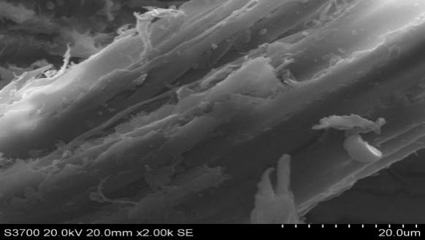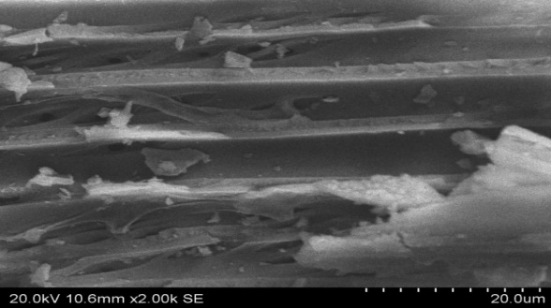
Fig. SM1 SEM photo of citrus-braches-biochar

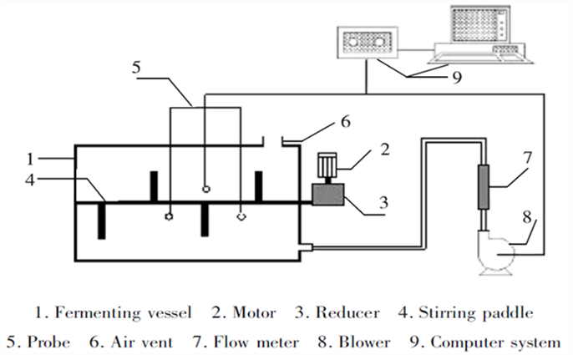
Fig. SM2 Schematic diagram of the composting bioreactor

Table SM4 Element contents of the SEM sites
Element | C | N | O | Mg | P | K | Fe | Cu | Total
wt% | 16.82 | 4.24 | 45.83 | 14.97 | 16.03 | 1.2 | 0.04 | 0.87 | 100
Atomic percentage | 24.37 | 5.27 | 49.86 | 10.71 | 9.01 | 0.53 | 0.01 | 0.24 | 100

