Supporting Information

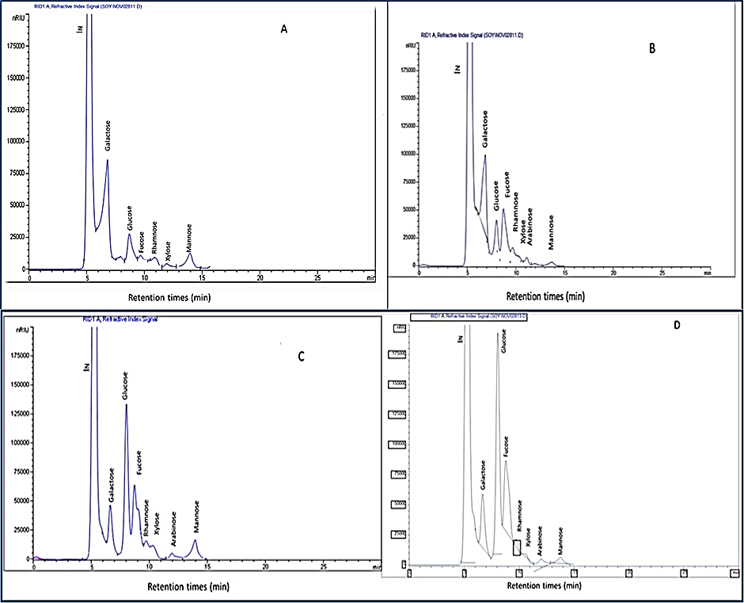
Figure SI1. (A-D): HPLC chromatograms of monosaccharaides of N. Oculata extracts from acid hydrolysis (A, B) and acid enzyme hydrolysis (C, D), respectively.

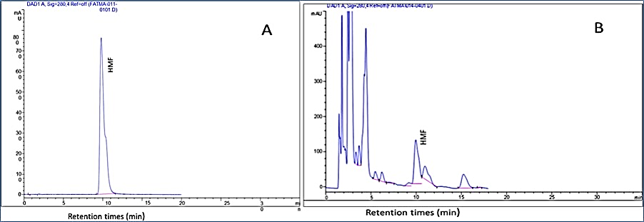

Figure SI2. HPLC chromatograms of hydroxyl methyl furfural (HMF): (A) standard and (B) sample of N. Oculata extracts from acid enzyme hydrolysis.

