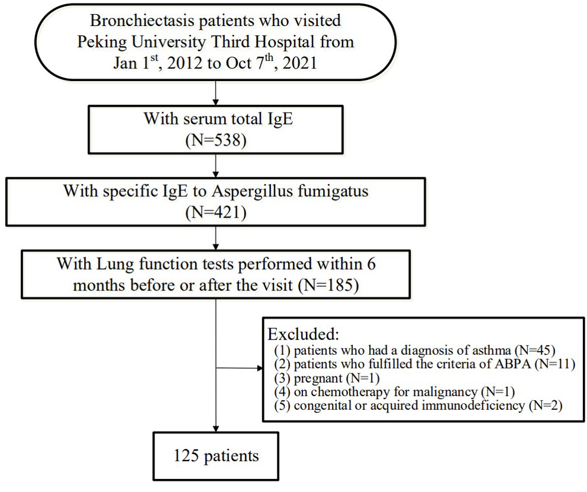
Supplementary Figure 1. Flowchart of the enrollment of patients.

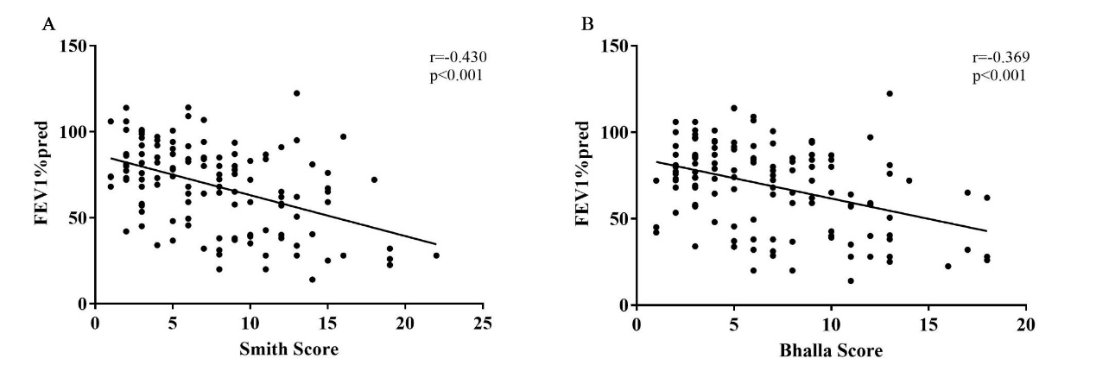
Supplementary Figure 2. Relationship between FEV1%pred and radiological feature of bronchiectasis (A. Smith score; B. Bhalla score).

Supplementary Table 1. Demographic, clinical, laboratory and radiological features according to blood eosinophil counts (300 cell/ul)
 | Eosinophil＜300 cell/ul | Eosinophil≥300 cell/ul | P value
No. patients (total n=125) | n=103, 82.4% | n=22, 17.6%
Male/Female | 1.15:1 (55:48) | 1:2.14 (7:15) | 0.066
Age (mean ± SD, years) | 61.95±14.301 | 64.32±13.318 | 0.477
BMI (mean ± SD, kg/m2) | 22.60±3.131 | 23.70±3.069 | 0.139
Ever-smoker (n, %) | 24/102, 23.5% | 12/22, 54.5% | 0.013
Smoke Index (median, IQR) | 450 (220, 800) | 600 (400, 800) | 0.533
Respiratory symptoms (n, %)
Cough | 101/103, 98.1% | 19/22, 86.4% | 0.011
Sputum | 100/103, 97.1% | 18/22, 81.8% | 0.005
Hemoptysis | 39/103, 37.9% | 3/22, 13.6% | 0.029
Dyspnea | 42/103, 40.8% | 13/22, 59.1% | 0.116
Blood test
WBC (10⁹/l, median, IQR) | 6.35 (5.00, 7.88) | 6.74 (5.44,7 .70) | 0.470
HB (g/l, median, IQR) | 132.1±16.05 | 133.5±25.96 | 0.752
Neutrophil (10⁹/l, median, IQR) | 3.93 (3.00, 5.05) | 4.31 (2.97, 5.02) | 0.920
Total IgE (KU/L, median, IQR) | 40.6 (17.7, 102.0) | 102.3 (32.4, 550.0) | 0.021
Total IgE > 60KU/L (n, %) | 40/103, 38.8% | 14/22, 63.6% | 0.033
Positive specific IgE to Aspergillus fumigatus (n, %) | 3/103, 2.9% | 0/22, 0% | 0.418
Chest HRCT
Number of lobes involved (n, %) | 4 (2, 5) | 4 (3, 6) | 0.116
≥ 3 lobes involved (n, %) | 70/103, 68.0% | 17/22, 77.3% | 0.389
Bilateral involvement (n, %) | 73/103, 69.9% | 14/22, 63.6% | 0.565
Lobes involved (n, %)
Upper lobes | 61/103, 59.2% | 15/22, 68.2% | 0.435
Middle/ lingula lobe | 82/103, 79.6% | 21/22, 95.5% | 0.077
Lower lobes | 97/103, 94.2% | 20/22, 90.9% | 0.570
Smith score (median, IQR) | 7 (3, 10) | 8 (5.0, 12.0) | 0.218
Bhalla score (median, IQR) | 6 (3, 10) | 8 (5.0, 10.0) | 0.144
Bronchiectasis type (n, %)
Cylindrical | 16/103, 15.5% | 5/22, 22.7% | 0.413
Cystic and/or mixed | 87/103, 84.5% | 17/22, 77.3% | 0.413
Mucus plugs | 18/103, 17.5% | 3/22, 13.6% | 0.662
Lung function
FEV1 % predicted (%, median, IQR) | 73.0(45.5, 86.7) | 73.1 (62.0, 90.0) | 0.659
FEV1/FVC (%, median, IQR) | 71.0(55.2, 77.0) | 72.6(64.0, 80.0) | 0.662
RV/TLC (mean ± SD, years) | 50.1±13.33 | 51.0±11.05 | 0.095
BMI: Body Mass Index; WBC: white blood count; HB: hemoglobin; HRCT: high resolution computerized tomography; FEV1: forced expiratory volume in first second; FVC: forced vital capacity; RV: residual volume; TLC: total lung capacity; bold: P values＜0.05.

