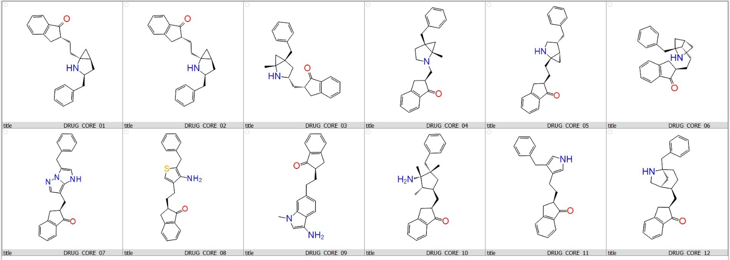
Table 1. Structures of Active Ligand Library Against Acetylcholinesterase (AchE) receptor.

Sl No. | Compound | Binding Energy  (Kcal/mol) | Sl No. | compound | Binding energy (Kcal/mol)
01 | DRUG CORE 01 | -11.9 | 07 | DRUG CORE 07 | -12.0
02 | DRUG CORE 02 | -12.0 | 08 | DRUG CORE 08 | -11.3
03 | DRUG CORE 03 | -11.6 | 09 | DRUG CORE 09 | -11.5
04 | DRUG CORE 04 | -11.6 | 10 | DRUG CORE 10 | -11.2
05 | DRUG CORE 05 | -11.8 | 11 | DRUG CORE 11 | -10.7
06 | DRUG CORE 06 | -11.3 | 12 | DRUG CORE 12 | -13.2

Table 2. LIGAND LIBRARY DOCKING SCORE Acetylcholinesterase (AchE) receptor]

Sl. No. | structure | Binding Energy (Kcal/mol) | TPSA | ESOL Solubility (mg/ml) | BBB permeable
01 | 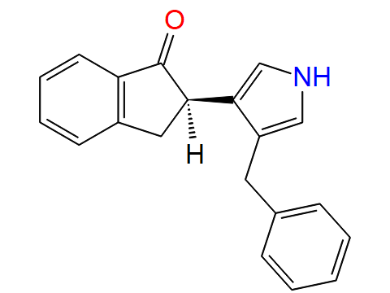 | -6.7 | 32.86 | 0.00792 | Yes
02 | 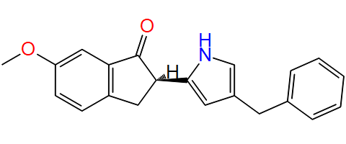 | -11.2 | 42.09 | 0.0073 | Yes
03 | 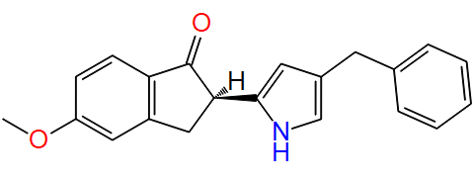 | -7.3 | 42.09 | 0.0073 | Yes
04 | 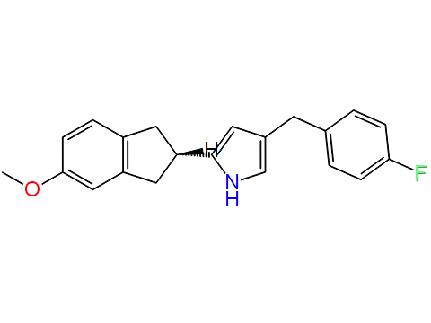 | -7 | 25.02 | 0.00253 | Yes
05 | 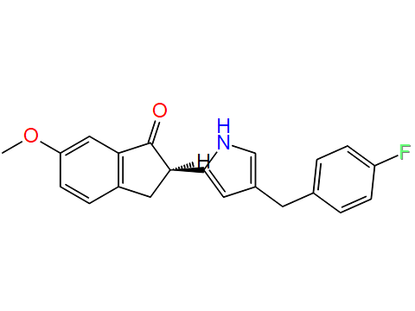 | -11.6 | 42.09 | 0.00542 | Yes
06 | 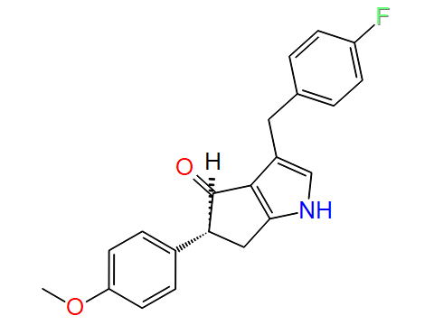 | -11.1 | 42.09 | 0.00542 | Yes
07 | 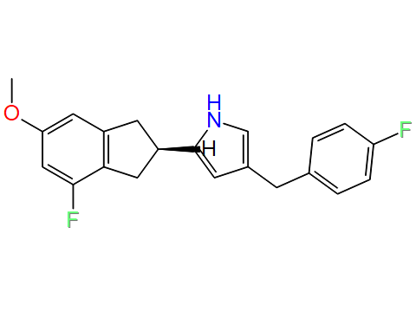 | -11.9 | 25.02 | 0.00187 | Yes
08 | 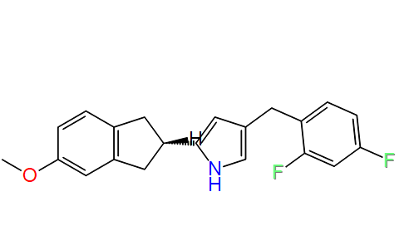 | -11.4 | 25.02 | 0.00187 | Yes
09 | 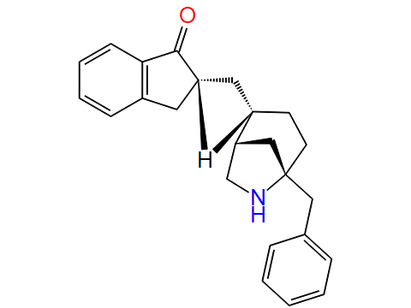 | -13.1 | 29.1 | 0.00381 | Yes
10 | 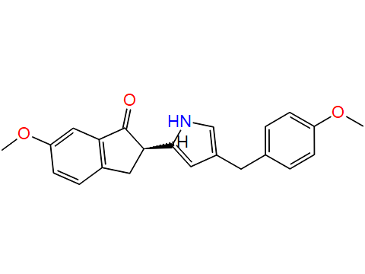 | -11 | 51.32 | 0.00694 | Yes
11 | 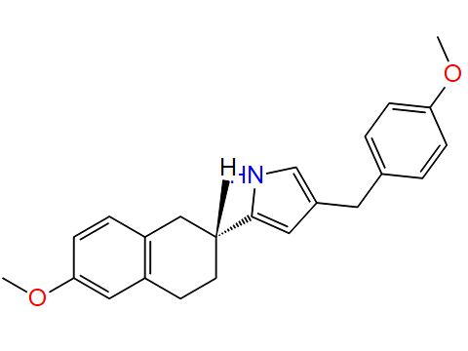 | -11.2 | 34.25 | 0.00172 | Yes
12 | 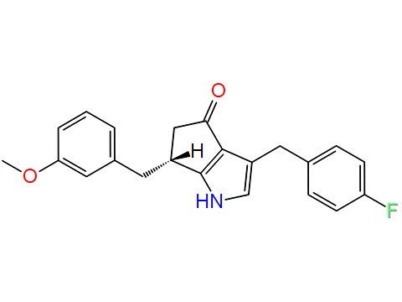 | -11.3 | 42.09 | 0.00523 | Yes
13 | 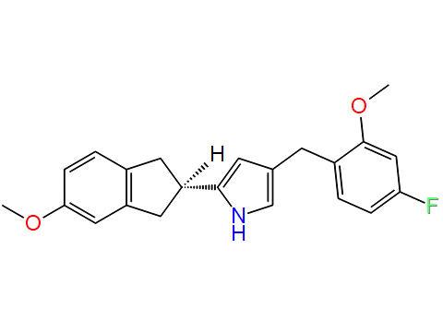 | -11.3 | 34.25 | 0.0024 | Yes
14 | 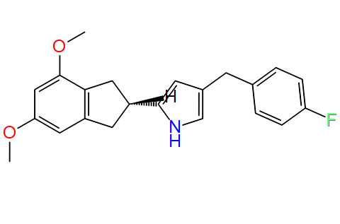 | -11.3 | 34.25 | 0.0024 | Yes
15 | 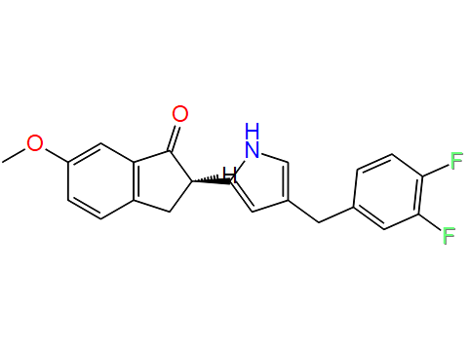 | -11.3 | 42.09 | 0.00399 | Yes
16 | 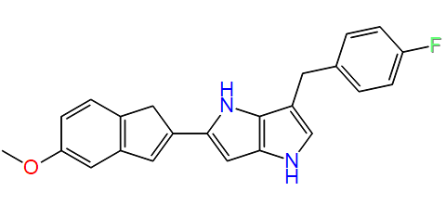 | -11.9 | 40.81 | 0.00128 | Yes
17 | 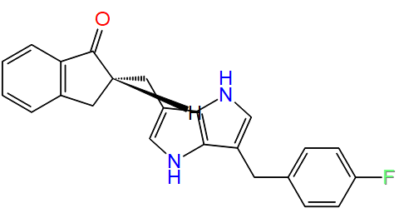 | -7.4 | 48.65 | 0.00182 | Yes
18 | 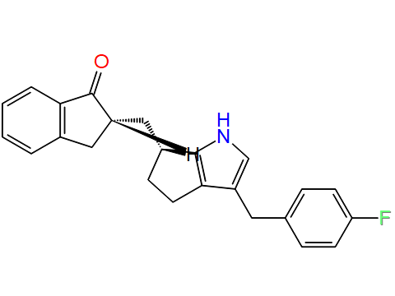 | -12.2 | 32.86 | 0.00129 | Yes
19 | 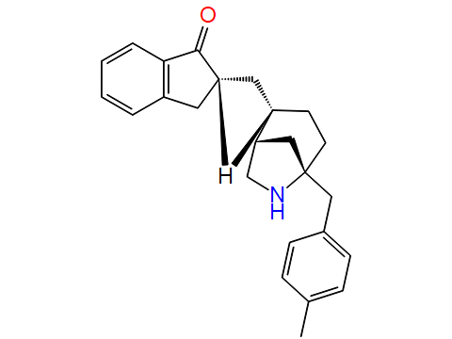 | -12.9 | 29.1 | 0.00195 | Yes
20 | 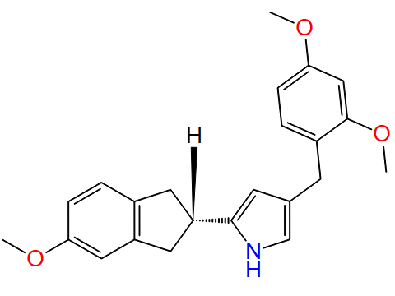 | -8 | 43.48 | 0.00307 | Yes
21 |  | -10.8 | 43.48 | 0.00307 | Yes
22 | 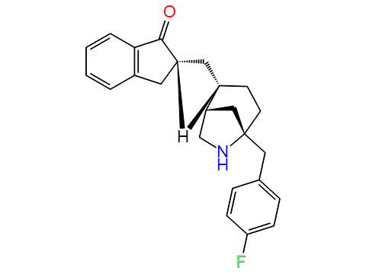 | -11 | 29.1 | 0.00276 | Yes
23 | 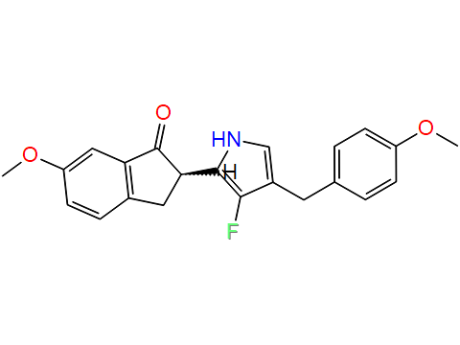 | -13.2 | 51.32 | 0.00509 | Yes
24 | 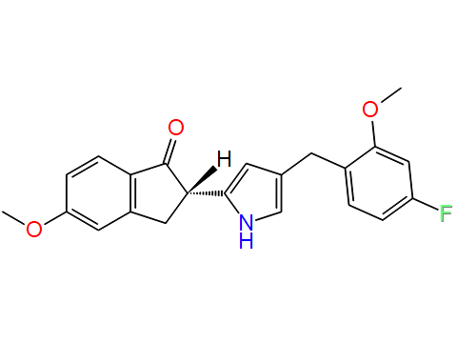 | -8.9 | 51.32 | 0.00509 | Yes
25 | 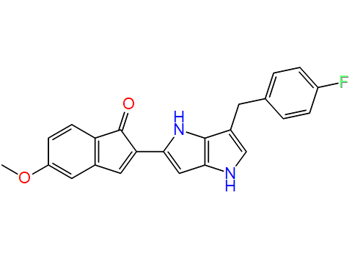 | -11.9 | 57.88 | 0.00182 | Yes
26 | 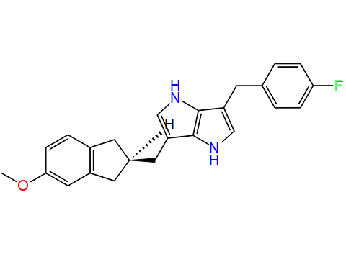 | -8 | 40.81 | 0.00062 | Yes
27 | 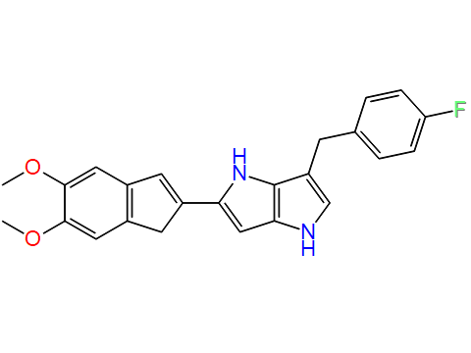 | -7.8 | 50.04 | 0.0012 | Yes
28 | 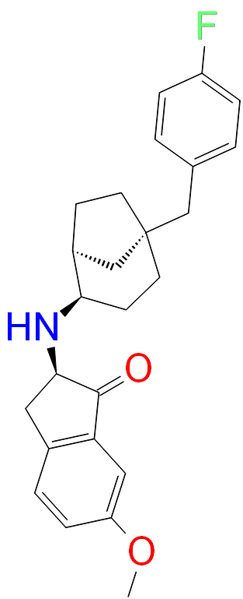 | -12 | 38.33 | 0.00093 | Yes
29 | 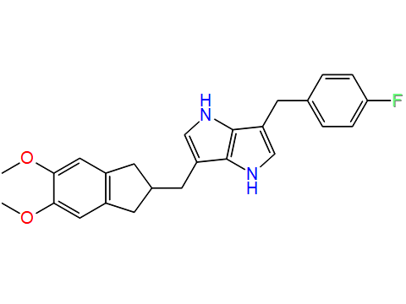 | -12.4 | 50.04 | 0.000575 | Yes

Table 3. The binding energy of the optimized lead compounds with the Active site of the Acetylcholinesterase Enzyme was computed using PyRx software.

