Appendix 1: Pictures of alien fish species in the Karun River Basin, Iran. Photo credit: M. Zare Shahraki.

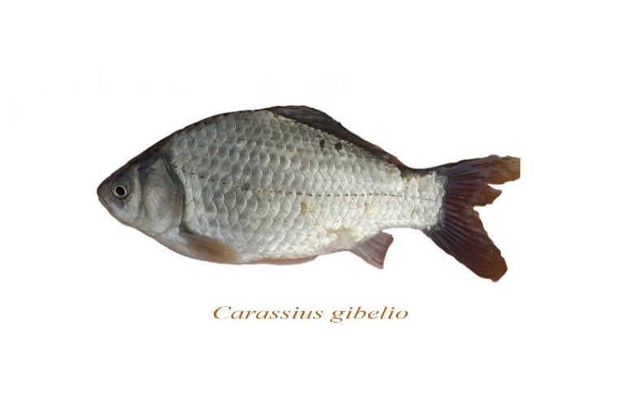
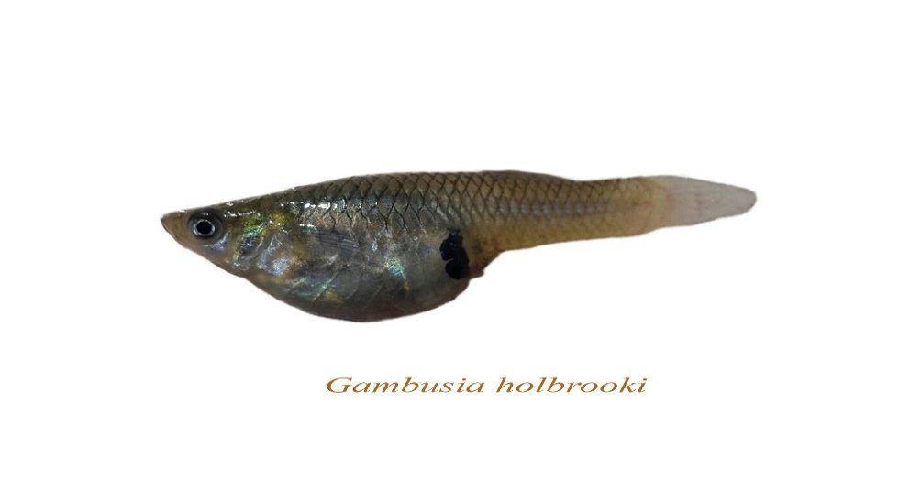
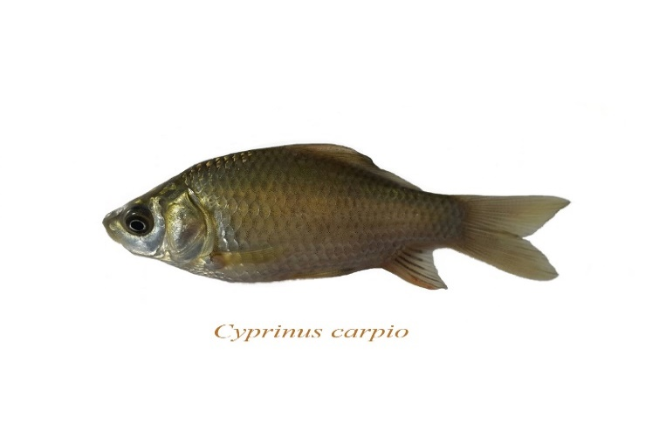
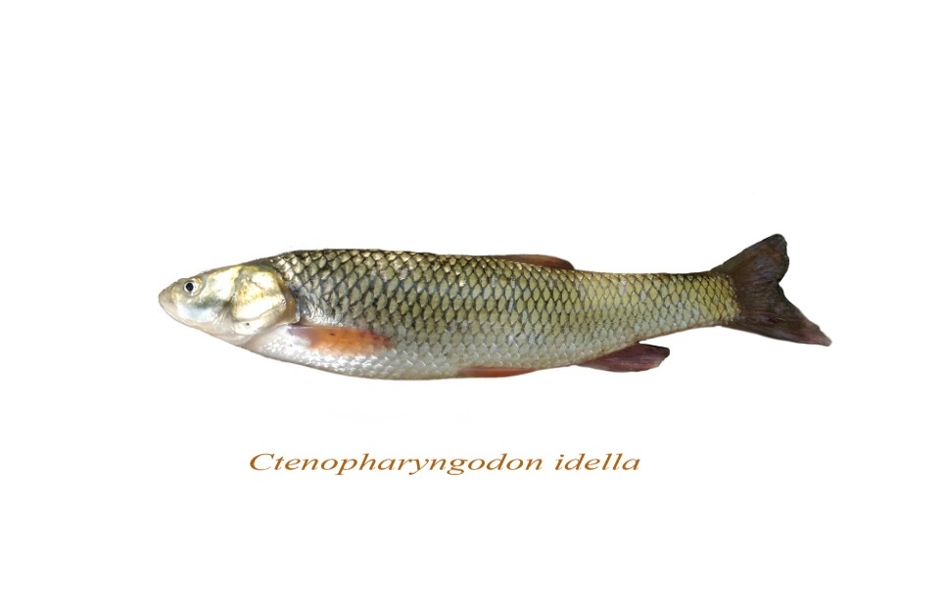
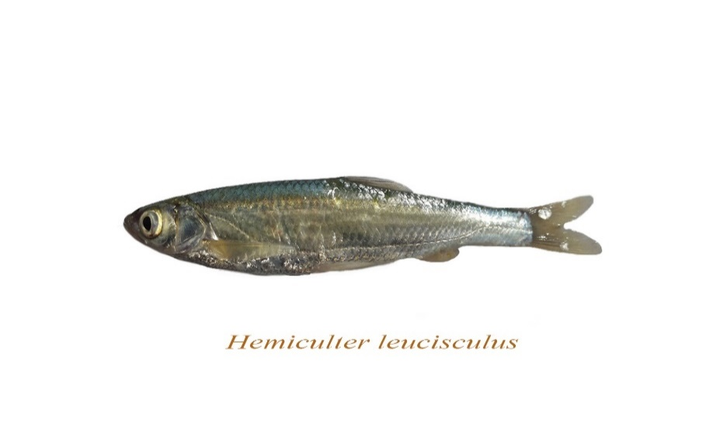
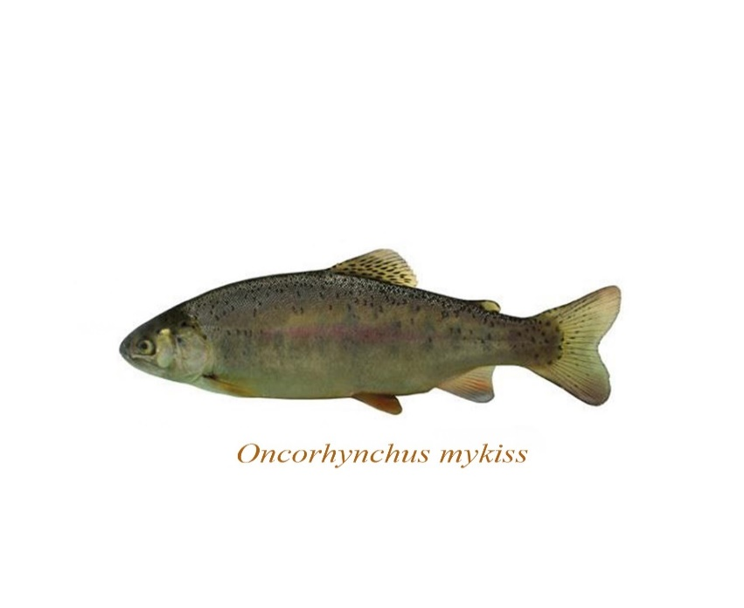
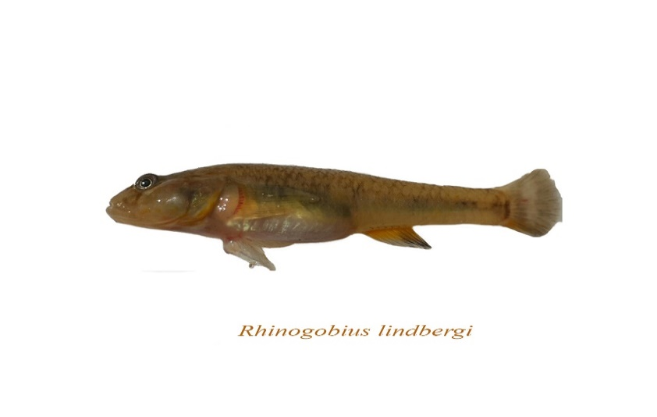
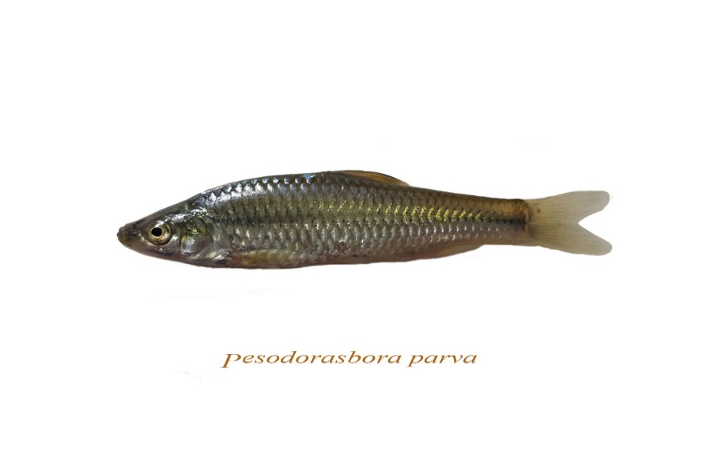
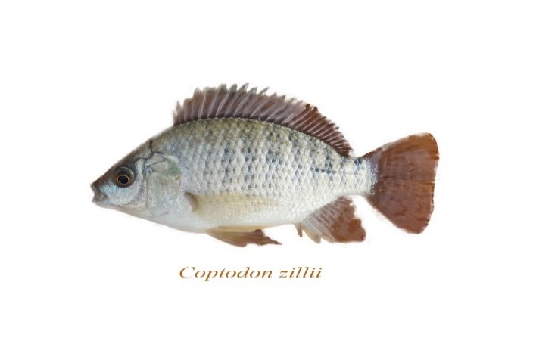
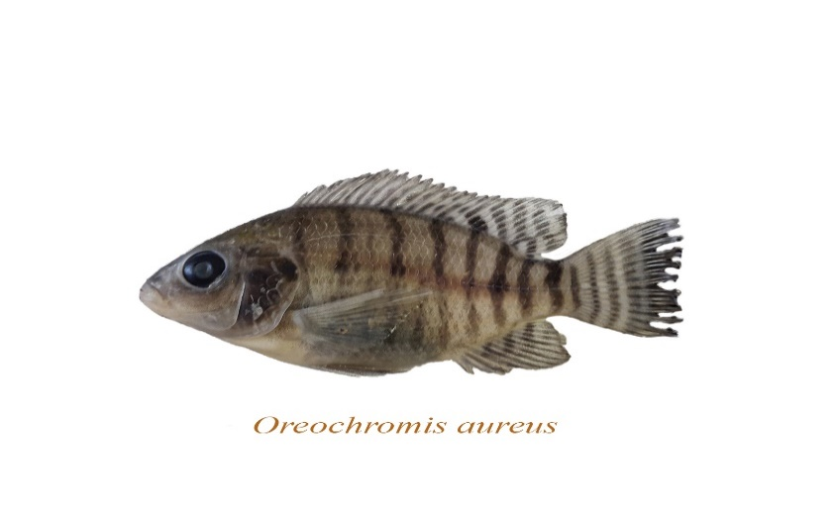
Carassius gibelio
Cyprinus carpio
Oreochromis aureus
Coptodon zillii
Rhinogobius lindbergi
Pseudorasbora parva
Oncorhynchus mykiss
Ctenopharyngodon idella
Hemiculter leucisculus
Gambusia holbrooki

