Supplementary Information

Development of eye phantoms for mimicking the structural deformation of the human cornea accompanied with intraocular pressure alteration

Han Saem Cho¹ and Sae Chae Jeoung¹ *
¹Advanced Instrumentation Institute, Korea Research Institute of Standards and Science, Daejeon, 34113, Korea
* Correspondence e-mail: scjeoung@kriss.re.kr

Supplementary Figure S1. The method to estimate CCT and CRC from OCT images

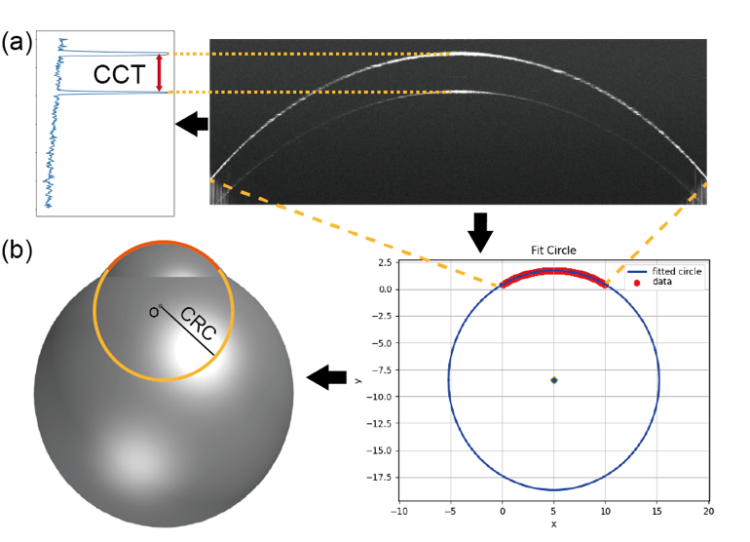

The anterior and posterior surfaces of the cornea, from the OCT image, were extracted by using the edge detection algorithm. The CCT was estimated by dividing the distance between the two surfaces at the apex of the cornea by 1.4, the refractive index of PDMS (a). CRC was estimated by fitting the anterior surfaces with a circular function (b). These methods were developed with Python programming.

Supplementary Figure S2. Mechanical model for the cornea of the eye phantoms
- The linear elastic stress–strain relations on the cornea part of the phantoms led us to obtain expressions with not only circumferential stress and strain but also important mechanical characteristics. We can consider the corneal part of the phantom as a thin spherical shell, and the force balance equation can be written with the corneal radius of curvature (CRC) and central corneal thickness (CCT) as follows ¹² :
$IOP×π×{CRC}^{2}=σ_{C}×2π×CRC×CCT$ (Σ1)
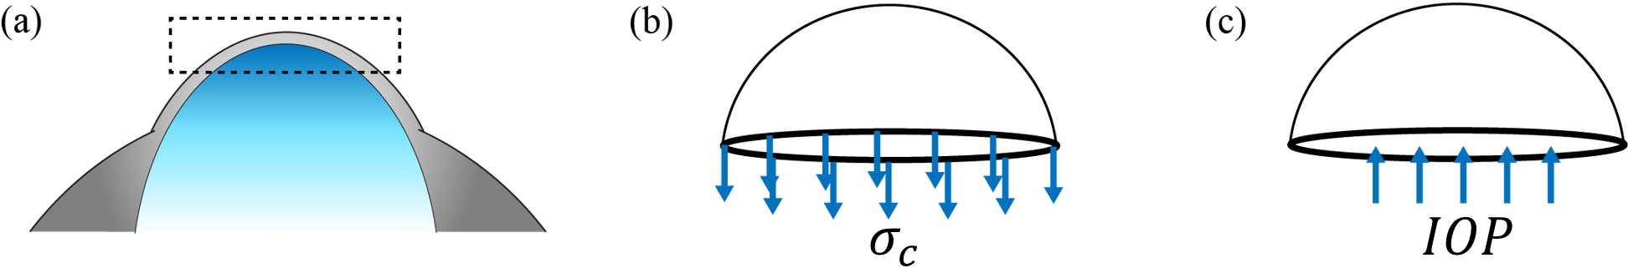
(a) Cross-sectional diagram of the cornea part of the eyeball phantom. The free body diagram of the cornea consists of two different forces: (b) circumferential stress and (c) intraocular pressure (IOP). These forces should be equilibrated to maintain the structure of the eyeball by changing the applied forces.
From equation (S1) the circumferential stress $σ_{c}$ can be described with the measurable variables of the corneal characteristics in the eye phantom.
$σ_{c}=\frac{IOP×CRC}{2×CCT}$ (Σ2)
The thin-walled pressure vessel model has been generally regarded as a reasonable approximation for the analysis of the mechanical response of the cornea accompanied by changes in IOP ³. In this model, the cornea should be considered as an elastic and isotropic spherical shell. In this model, the measured variable with changing IOP is the apical increments at the center of the cornea. The values were used to calculate the circumferential strain ε_{c},
$ε_{c}=\frac{δr}{r}$ (Σ3)
where $r$ and $δr$ are the mid-radius of the thin-shell and its increment accompanied by increasing the internal pressure and IOP, respectively.
Supplementary Figure S3. The diagram for the expansion of the thin spherical shell accompanied with applying IOP
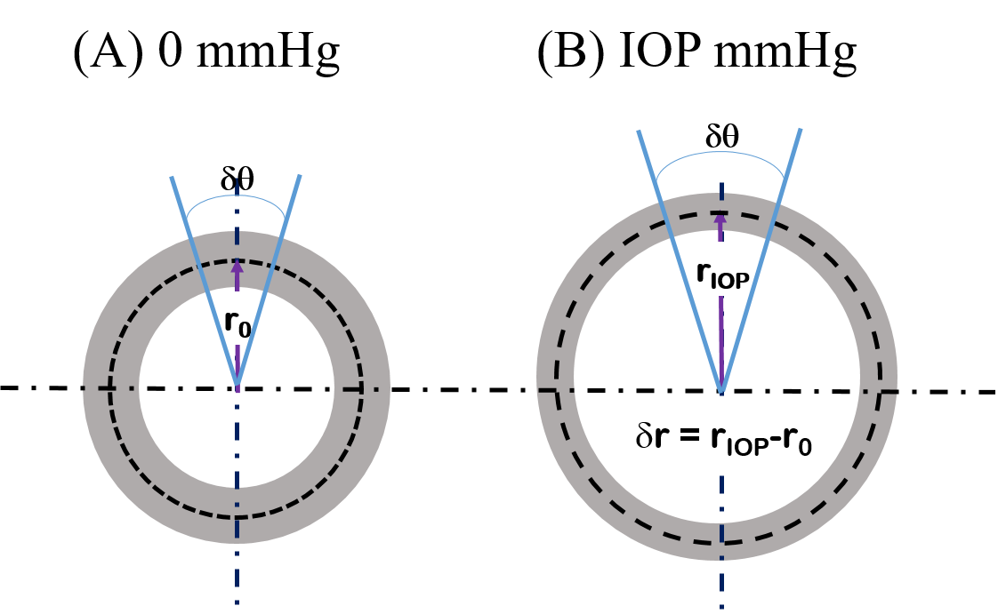

δr is the increment of the mid-radius of the spherical shell. For a reasonable approximation, the material is isotropic and its wall thickness is much smaller than the mid-radius. Also, the strains caused by the internal pressure change should be small.
However, the shape of the cornea in our phantom is not purely spherical. In addition, the center of the corneal curvature should be moved when the phantom expands radially with an increase in IOP. Furthermore, the central cornea is subjected to out-of-plane strain changes. In our experiments with some of the full eyeball phantom and all of the fixed-cornea eye phantoms, we observed that the CRC decreased with increasing IOP accompanied by a rise in the corneal apex. This means that the aforementioned model could not be applied to the analysis of the mechanical properties of our eye phantoms.
It is necessary to derive another formula for the strains, which is applicable to our eye phantoms. The tangential (or circumferential) strain accounts for the in-plane strain of the corneal surface of the phantom because the stress in the thin wall of the pressurized eyeball phantoms is the one of in-plane stress.
Supplementary Figure S4. The diagram for the in-plane expansion of the element at the top of the cornea.

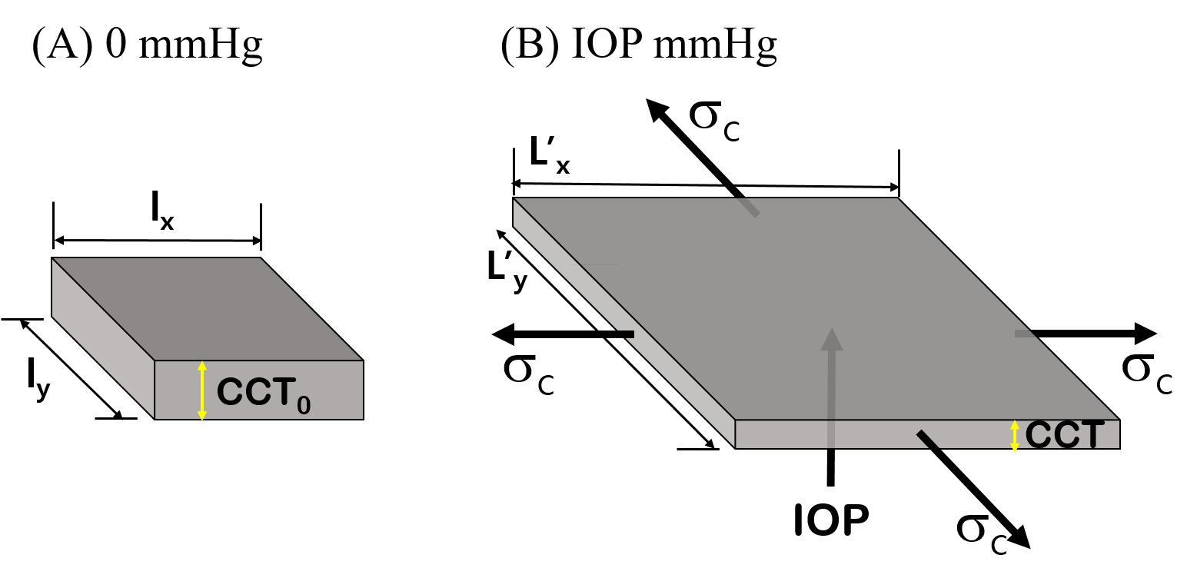
An isotropic linearly elastic material subject to the internal pressure (IOP), which is acting to the bottom of the cornea element. The element shown in (A) is unstrained and that shown in (B) is deformed by tangential stress, σ_{t}.
PDMS could be considered as isotropic if the deformation was small. When the cornea is inflated, as depicted in Fig. S3, the circumferential strain ε_{c} can be expressed as follows:
$ε_{c}=\frac{{L'}_{x}-l_{x}}{l_{x}}=\frac{{L'}_{y}-l_{y}}{l_{y}}$ (Σ4)
Assuming that $l_{x}=l_{y}$ and ${L'}_{x}={L'}_{y}$, the relative volume change $\frac{∆V}{V}$ can be written with Poisson’s ratio ¹,
$\frac{∆V}{V}= \frac{L_{x}^{' 2}×CCT-l_{x}^{ 2}×{CCT}_{0}}{l_{x}^{ 2}×{CCT}_{0}}={\left(1+\frac{L_{x}^{'}-l_{x}}{l_{x}}\right)}^{1-2ν}-1$ (Σ5)
If the Poisson ratio ($ν$) is approximately 0.4 ~0.5, the strain is less than 0.1, and the relative volume changes are less than 2.0 %. Now, we can safely suppose that
$l_{x}^{ 2}×{CCT}_{0}≈L_{x}^{' 2}×CCT$ (Σ6)
By combining the Eqn. S4 and S6, the in-plane strain at the corneal apex can be expressed in terms of CCT.
$ε_{c}=\frac{{L'}_{x}-l_{x}}{l_{x}}=\frac{{L'}_{y}-l_{y}}{l_{y}}≅{\left(\frac{{CCT}_{0}}{CCT}\right)}^{1/2}-1$ (Σ7)
The above relation between the circumferential strain and the CCT has been derived with an approximation of little but clearly occurring volume changes due to deformation. However, the error caused by the approximation could not deteriorate the accuracy of the analysis unless the strain was higher than 10 %.
If the radial stress σ_{r}, which is equal to the IOP, is smaller than the circumferential stress $σ_{C}$, from Hooke’s law, we can describe the in-plane modulus, $\frac{E}{(1-ν)}$
$\frac{E}{(1-ν)}≈ \frac{σ_{c}}{ε_{c}}$ (Σ8)
where E and ν are Young’s modulus and Poisson’s ratio, respectively.
The stress-strain plot shown in Eq. S8 results in the in-plane modulus, which includes Young’s modulus and Poisson’s ratio of the cornea part of the phantoms. If then, we can discuss how the mechanical characteristics of the phantoms are similar to those of the human subject in more detail.

Supplementary references

1. Hibbeler, R. C. Mechanics of Materials. (Pearson Prentice Hall, 2011).
2. Kelly, P. Solid Mechanics Lecture notes. Department of Engineering Science (University of Auckland: NZ, 2012).
3. Elsheikh, A. et al. Assessment of Corneal Biomechanical Properties and Their Variation with Age. Curr. Eye Res. 32, 11–19 (2007).

