Supporting information
Mechanosensitive non-equilibrium supramolecular polymerization in closed chemical systems
Xianhua Lang^{1#}, Yingjie Huang^{1#}, Lirong He¹, Yixi Wang², Udayabhaskararao Thumu², Zonglin Chu³, Wilhelm T. S. Huck⁴, Hui Zhao¹*
¹School of Chemical Engineering, State Key Lab of Polymer Materials Engineering, Sichuan University, Chengdu 610065, China.
²Institute of Fundamental and Frontier Sciences, University of Electronic Science and Technology of China, Chengdu 610054, China.
³College of Chemistry and Chemical Engineering, Hunan University, Changsha 410082, China.
⁴Institute for Molecules and Materials, Radboud University, Nijmegen, The Netherlands.
*Corresponding author:
Email:zhaohuichem@scu.edu.cn
#These authors contributed equally: Xianhua Lang and Yingjie Huang

Table of Contents
Experimental Procedures 3
1. Materials 3
2. Instruments. 3
3. Synthesis of compounds 4
6. Supramolecular polymerization via charge transfer and amphiphilic interaction. 7
7. Redox kinetics of C₁₂-MV²⁺ investigated by UV-vis measurements. 9
8. Redox kinetics of C₁₂-MV²⁺ investigated by ¹H-NMR spectra. 10
9. Redox kinetics of C₁₂-MV²⁺ investigated by EPR measurements. 11
10. The dissipative performance can be activated again by introducing fresh air in a closed system. 11
11. C₁₂-MV²⁺ / PN dissipation states at different times. 12
12. Dissipation states of C₁₂-MV²⁺/PN induced by phenyl lactate chirality at different times. 13
13. Fluorescence quantum yields 15
14. Redox kinetics of C₁₂-MV²⁺/PN investigated by EPR measurements. 16
15. Fluorescence of PN could be quenched by the CT interaction with C₁₂-MV²⁺. 17
16. Redox kinetics of MV²⁺/PN investigated by fluorescence spectroscopy. 18
17. The fluorescence of PN is absorbed by MV²⁺. 19
18. Redox kinetics of MV²⁺ investigated by discoloration. 20
19. Redox kinetics of MV²⁺ investigated by UV-vis measurements. 21
20. Redox kinetics of MV²⁺/PN investigated by UV-vis measurements. 22
21. Ultrasound-induced patterning of MV²⁺ and C₁₂-MV²⁺. 23
22. Ultrasound-induced patterning of MV²⁺/PN. 26
23. Ultrasound-induced patterning of C₁₂-MV²⁺/PN. 28
24. Ultrasound-induced patterning in different molds. 29
25. NMR spectrum. 30
26. Supplementary Video List. 35
Reference 36

Experimental Procedures
- Materials
All chemicals were purchased from Bide Chemical Technology Co., Ltd. and used directly without further purification.
- Instruments.
Nuclear magnetic resonance (NMR) spectroscopy. NMR spectra were recorded on a JNM-ECZ400S/L1 400 MHz NMR spectrometer. Deuterated dimethyl sulfoxide (DMSO-d₆), deuterated chloroform (CDCl₃), and deuterium oxide (D₂O) were used as solvents.
UV-vis spectroscopy. UV absorbance spectra was performed by a SHIMADZU UV1900 UV spectrophotometer.
Fluorescence spectroscopy. Fluorescence spectra were recorded on a HITACHI F-4700 fluorescence spectrophotometer. Excitation wavelength: 320 nm, Slit width: 1nm or 2.5nm, (ex/em): 5/10 nm.
Surface tension. Surface tension was measured using QBZY automatic surface tension meter
Viscosity. The viscosity is measured by Ubbelohde viscometer. The diameter of the capillary is 0.9-1.0 mm. And the viscosity of the solutions was confirmed based on equation (1).
$η=\frac{πρghr^{4}}{8LV}t$ (1)
η---viscosity; r---capillary radius; L---capillary length; V---capillary volume; g---gravitational acceleration; ρ---solution density; t---liquid flow time through the capillary.
Electron paramagnetic resonance. EPR spectra were obtained using MS-5000X spectrometer.
Transmission Electron Microscope (TEM). TEM images were recorded on JEOL JEM F200 at 200 kV. The samples were dried under high vacuum for 30 min before TEM test.
Circular Dichroism (CD). The CD spectra were recorded in a Jasco J-810 circular dichroism spectrometer at RT. Spectra were collected at a scan rate of 200 nm•S⁻¹ and 2 nm bandwidth with three-times scans for averaging.
Ultrasonic Cleaner. Ultrasonically induced patterning is done by placing the molds into the ultrasound Cleaner of Shanghai Jingqi Instrument Co. Model SB-120DT3L. Power 120w. Frequency 40kHz.
Patterned molds. Round PTFE mold with 7cm diameter and 0.5 cm depth. Positive triangle mold side length 6.7 cm. Square mold side length 6.1 cm.

- Synthesis of compounds
(1) Synthesis of 1-dodecyl-[4,4'-bipyridin]-1-ium.
Scheme 1
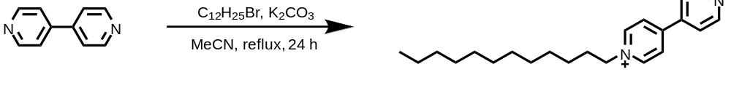
1
In a 200 mL round-bottom flask, 2,2'-Dipyridyl (2.35 g, 15 mmol) and 1-Bromododecane (16.5 mmol, 1.1 eq) were dissolved in 40 mL of MeCN. And then Potassium carbonate (20 mmol) was added to above mixture. The mixture was stirred at 85 ºC for 24 h under N₂ atmosphere. After removing all the solids by filtration, the solvent was removed by evaporation. The white solid was obtained after washing with dichloromethane and acetonitrile, and dried in a vacuum oven at 40 ºC for 24 h (4.2 g, 70% yield). ¹H NMR (400 MHz, DMSO-d₆) δ 9.27 (d, 2H), 8.87 (d, 2H), 8.65 (d, 2H), 8.06 (d, 2H), 4.65 (t, 2H), 1.96 (s, 2H), 1.24 (d, 18H), 0.80 (m, 3H). ¹³C NMR (101 MHz, DMSO-d₆) δ 152.76, 151.51, 145.85, 141.42, 125.93, 122.47, 60.91, 31.80, 31.25, 29.52, 29.43, 29.31, 29.22, 28.94, 25.93, 22.60, 14.46.
Synthesis of 1-dodecyl-1'-methyl-[4,4'-bipyridine]-1,1'-diium (C₁₂-MV²⁺).
Scheme 2
In a 200 mL round-bottom flask, compound 1 (4 g, 9.8 mmol) and CH₃I (27 mmol, 3 eq) were dissolved in 60 mL of MeCN, then the solution was refluxed for 24 h under N₂. The solution was evaporated. After washing with dichloromethane and acetonitrile, the pure C₁₂-MV²⁺ was obtained as a red solid by drying in a vacuum oven at 40 ºC for 48 h (4.87 g, 91% yield). ¹H NMR (400 MHz, DMSO-d₆) δ 9.40 (d, 2H), 9.29 (s, 2H), 8.79 (dd, 4H), 4.70 (t, 2H), 4.45 (s, 3H), 1.98 (s, 2H), 1.25 (m, 18H), 0.80 (m, 3H). ¹³C NMR (101 MHz, DMSO-d₆) δ 149.07, 148.73, 147.11, 146.25, 61.43, 48.64, 31.81, 31.29, 29.52, 29.46, 29.34, 29.22, 28.95, 25.95, 22.61, 14.49.

(2) Synthesis of 1-methyl-1'-octyl-[4,4'-bipyridine]-1,1'-diium (C₈-MV²⁺).
Scheme 2
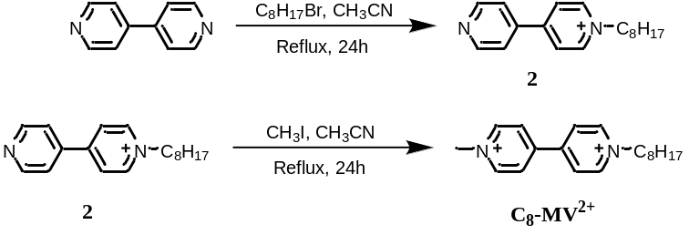
The process of C₈-MV²⁺ synthesis is similar to the preparation of C₁₂-MV²⁺.
Component 2: White solid，¹H NMR (400 MHz, DMSO-d₆) δ 9.33 (d, J = 6.4 Hz, 2H), 8.96 – 8.81 (m, 2H), 8.69 (d, J = 6.6 Hz, 2H), 8.17 – 8.02 (m, 2H), 4.70 (t, J = 7.5 Hz, 2H), 1.97 (p, J = 7.0 Hz, 2H), 1.48 – 1.15 (m, 11H), 0.96 – 0.77 (m, 3H).
C₈-MV²⁺：Red solid，¹H NMR (400 MHz, DMSO-d₆) δ 9.47 – 9.35 (m, 2H), 9.34 – 9.18 (m, 2H), 8.91 – 8.63 (m, 4H), 4.71 (t, J = 7.4 Hz, 2H), 4.46 (s, 3H), 1.98 (h, J = 7.4, 6.8 Hz, 2H), 1.40 – 1.14 (m, 10H), 0.92 – 0.79 (m, 3H).

(3) Synthesis of 1-hexadecyl-1'-methyl-[4,4'-bipyridine]-1,1'-diium (C₁₆-MV²⁺).
Scheme 3
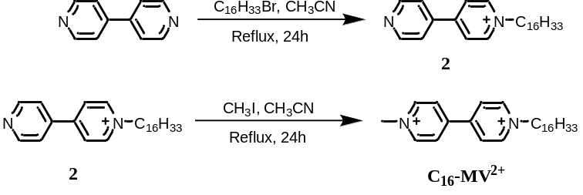
The synthesis process of C₁₆-MV²⁺ is similar to the preparation process of C₁₂-MV²⁺.
Compound 3: White solid，¹H NMR (400 MHz, DMSO-d₆) δ 9.42 – 9.14 (m, 2H), 8.96 – 8.78 (m, 2H), 8.66 (d, J = 6.8 Hz, 2H), 8.15 – 7.96 (m, 2H), 4.65 (t, J = 7.4 Hz, 2H), 1.97 (q, J = 7.3 Hz, 2H), 1.49 – 1.10 (m, 27H), 0.85 (t, J = 6.7 Hz, 3H).
C₁₆-MV²⁺: Red solid，¹H NMR (400 MHz, DMSO-d₆) δ 9.41 (d, J = 6.8 Hz, 2H), 9.31 (d, J = 6.8 Hz, 2H), 8.80 (dd, J = 10.5, 6.8 Hz, 4H), 4.70 (t, J = 7.4 Hz, 2H), 4.45 (s, 3H), 1.98 (s, 2H), 1.24 (s, 26H), 0.85 (t, J = 6.8 Hz, 3H).

(4) Synthesis of 1,1'-dimethyl-[4,4'-bipyridine]-1,1'-diium (MV²⁺).
Scheme 4
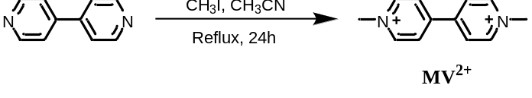
The synthesis process of MV²⁺ is similar to the preparation process of C₁₂-MV²⁺.
MV²⁺: Purple solid, ¹H NMR (400 MHz, D₂O) δ 8.96 (d, J = 7.0 Hz, 1H), 8.45 (d, J = 7.0 Hz, 1H), 4.41 (s, 1H). ¹³C NMR (101 MHz, D₂O) δ 149.86, 146.42, 126.92, 48.68.

- The influence of viologen derivatives on supramolecular self-assembly.
Firstly, we investigated the influence of viologen derivatives on supramolecular self-assembly. The results showed that when amphiphilic molecules with long hydrophobic polar chains (C₁₂-MV²⁺ or C₁₆-MV²⁺) were dissolved in water containing PN, the self-assembly could be obtained due to charge transfer (CT) interaction and amphipathic interaction. Inhere, C₁₂-MV²⁺ with better water solubility was used for further studies.

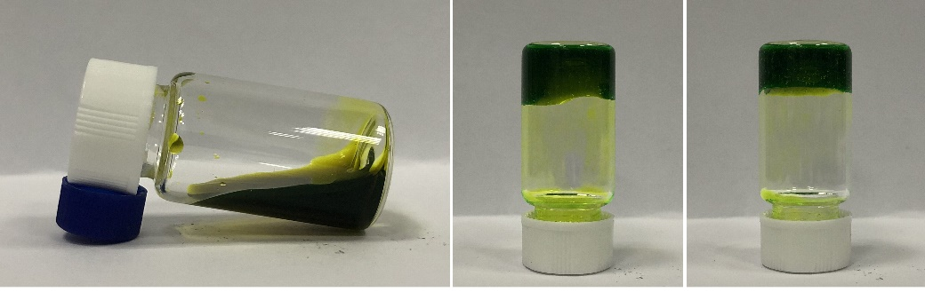
C₈-MV²⁺/PN C₁₂-MV²⁺/PN C₁₆-MV²⁺/PN
Figure S1. Images of viologen derivatives (10 mM) and PN (10 mM) in the aqueous solutions.

- The influence of pH on supramolecular self-assembly.
The influence of pH on supramolecular self-assembly was investigated by viscosity measurements. The results indicated that when the pH of the solutions was 12, the solutions containing C₁₂-MV²⁺ (10 mM) and PN (10 mM) exhibited the highest viscosity. Therefore, all subsequent measurements were carried out in the buffer (pH = 12).
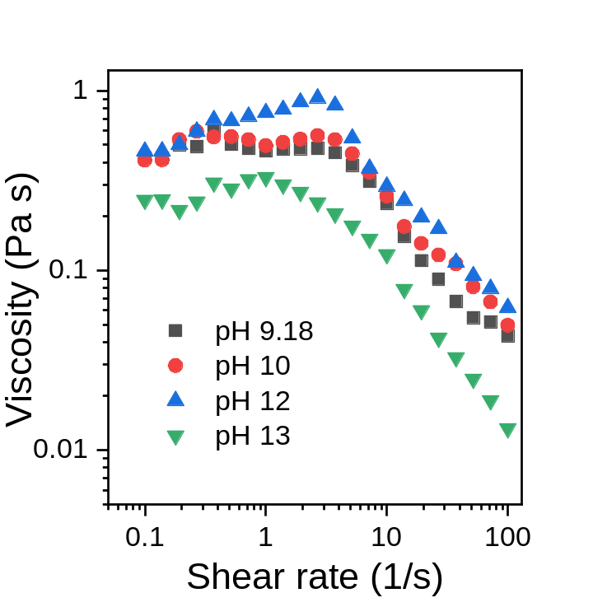
Figure S2. Viscosity changes by varying the pH of solutions (10 mM C₁₂-MV²⁺, 10 mM PN).
- Supramolecular polymerization via charge transfer and amphiphilic interaction.
The amphipathic molecule contains hydrophilic methyl viologen as acceptor and attached a hydrophobic nonpolar C₁₂ chain. Amphipathic C₁₂-MV²⁺ is soluble in water containing PN, a series of self-assemblies can be obtained due to CT and amphipathic interaction. To investigate the self-assembly morphology of supramolecular polymers, firstly, we performed viscosity studies on C₁₂-MV²⁺/PN samples where the ratio of incoming PN to C₁₂-MV²⁺ varied from 0 to 2. The solution viscosity showed a gradually improved with the increase of PN content, especially when [PN] > 0.5 eq, there is a sudden change in viscosity (Figure S3b). We believe this change is due to the transformation in assembly morphology. And more, the viscosity slowly decreased when [PN] > 1 eq, which could be attributed to hydrophilic PN improve the solubility of assembly in water (Figure S3c).
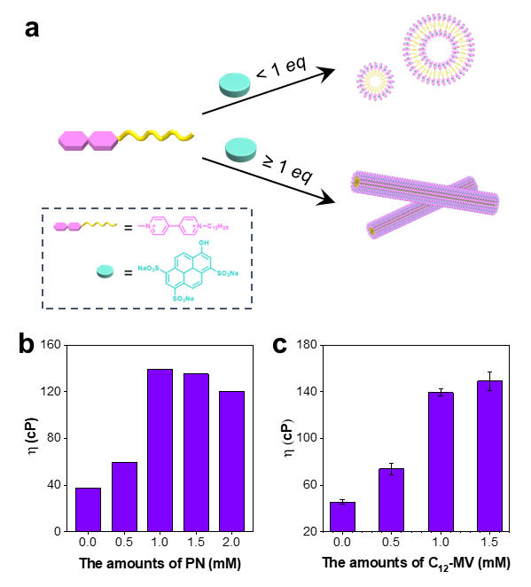
Figure S3. (a) Schematic representation of the ratio (C₁₂-MV²⁺/PN) dependent variation in self-assembly process for a specific morphology. (b) Viscosity changes depict the conformational switching by varying the equivalents of PN (0–2 equiv of PN against 1 mM C₁₂-MV²⁺). (c) Viscosity changes depicting the conformational switching by varying the equivalents of (0 equiv, 0.5 equiv, 1 equiv, and 1.5 equiv of C₁₂-MV²⁺ against 1 mM PN).
Furthermore, to investigate the structural control in this supramolecular self-assembly, TEM experiment also clearly proved that the assembly is in line with our previous assumption (Figure S4). In the absence of PN, the solution containing C₁₂-MV²⁺ (1 mM) cannot be observed any self-assembly, its Critical micelle concentration (CMC) is around 3.2 mM confirmed by surface tensile measurements (Figure S5). After adding 0.5 eq PN, TEM indicated the self-assembly of C₁₂-MV²⁺/VN into vesicles with an average diameter of 300 nm. And more interestingly, in the presence of 1 mM PN, supramolecular polymer could be obtained under the same C₁₂-MV²⁺ concentration as before (Figure S4). The above results suggest that supramolecular polymer of C₁₂-MV²⁺/PN is a structure control polymerization.
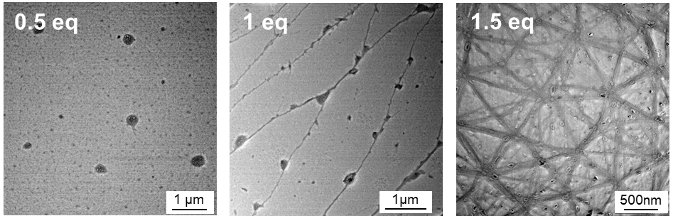
Figure S4. Respective TEM images show the transformation from micelles to fiber collected at 0.5 equiv, 1 equiv, and 1.5 equiv of PN against C₁₂-MV²⁺ (1 mM).

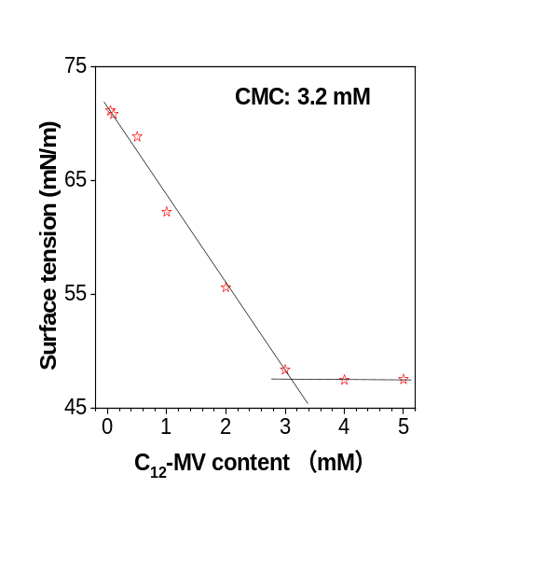
Figure S5. The surface tension of different C₁₂-MV²⁺ content in water

- Redox kinetics of C₁₂-MV²⁺ investigated by UV-vis measurements.
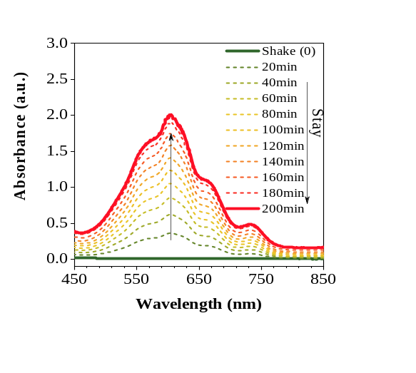
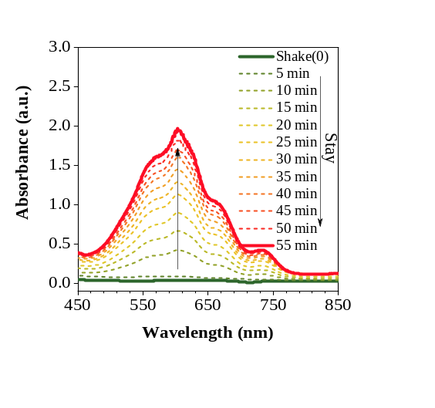
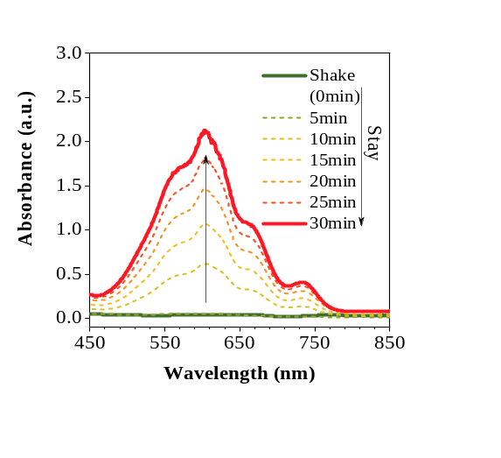
Figure S6. Time-dependent UV-vis measurements showing the transient existence of C₁₂-MV^{•+}, [C₁₂-MV²⁺] = 3 mM, with different content of N₂H₄•H₂O (5% v/v, 10% v/v, 20% v/v).
- Redox kinetics of C₁₂-MV²⁺ investigated by ¹H-NMR spectra.
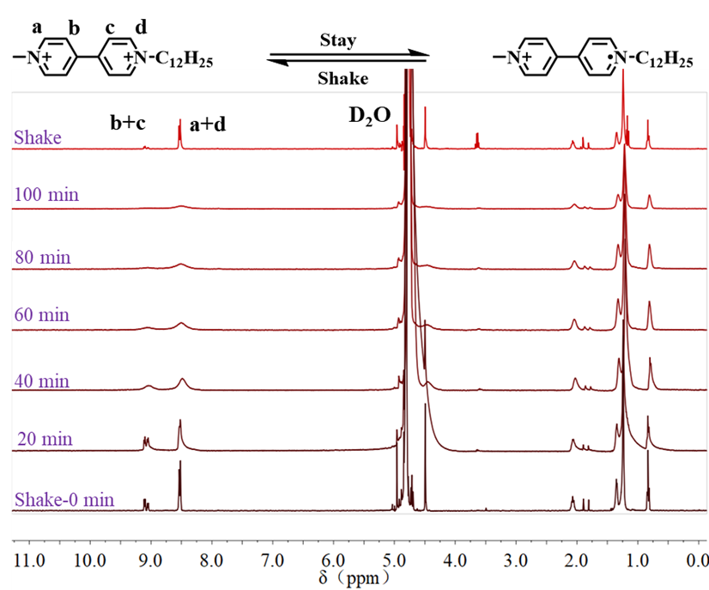
Figure S7. Time-dependent ¹H-NMR spectra of C₁₂-MV²⁺ and N₂H₄•H₂O at 25 ºC.

- Redox kinetics of C₁₂-MV²⁺ investigated by EPR measurements.
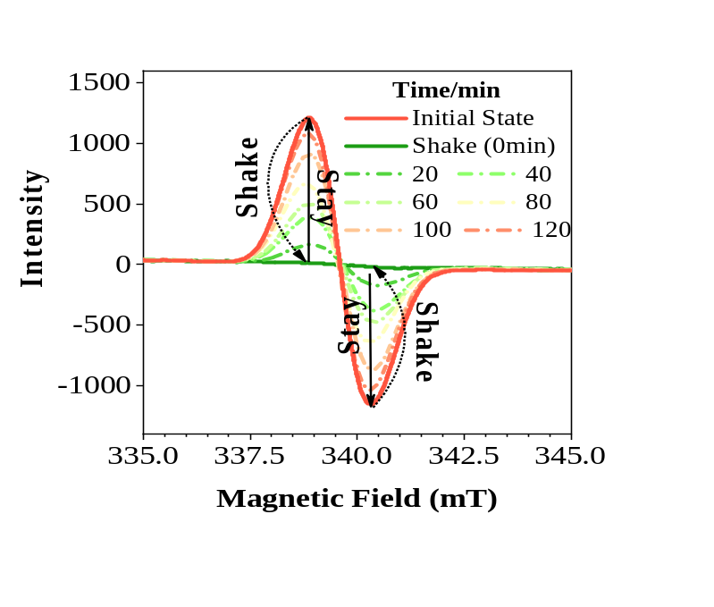
Figure S8. Time-dependent EPR measurements showing the transient existence of C₁₂-MV^{•+}, [C₁₂-MV²⁺] = 3 mM.

- The dissipative performance can be activated again by introducing fresh air in a closed system.
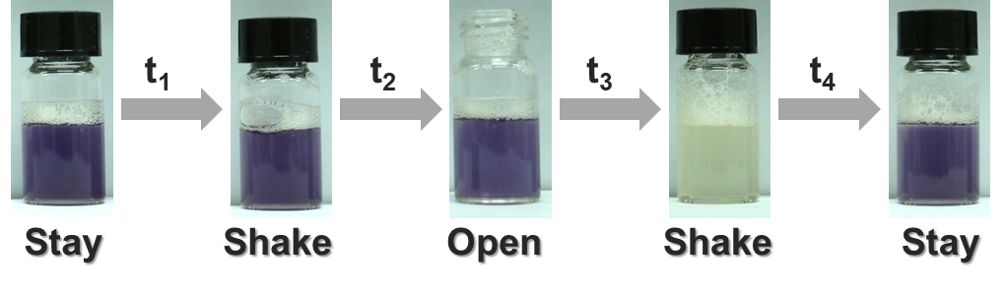
Figure S9. Visualization of discoloration activated again by introducing fresh air in a closed system.

- C₁₂-MV²⁺ / PN dissipation states at different times.
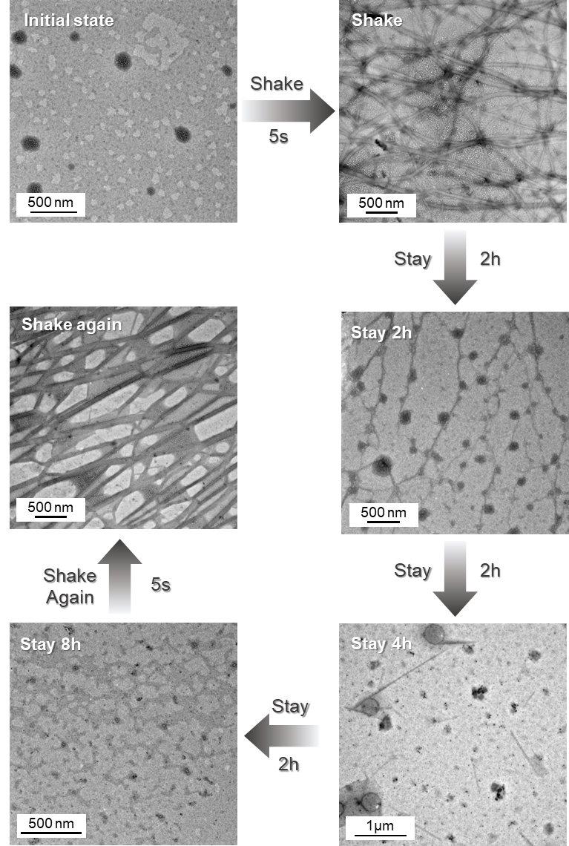
Figure S10. C₁₂-MV²⁺ / PN dissipation states at different times.

- Dissipation states of C₁₂-MV²⁺/PN induced by phenyl lactate chirality at different times.

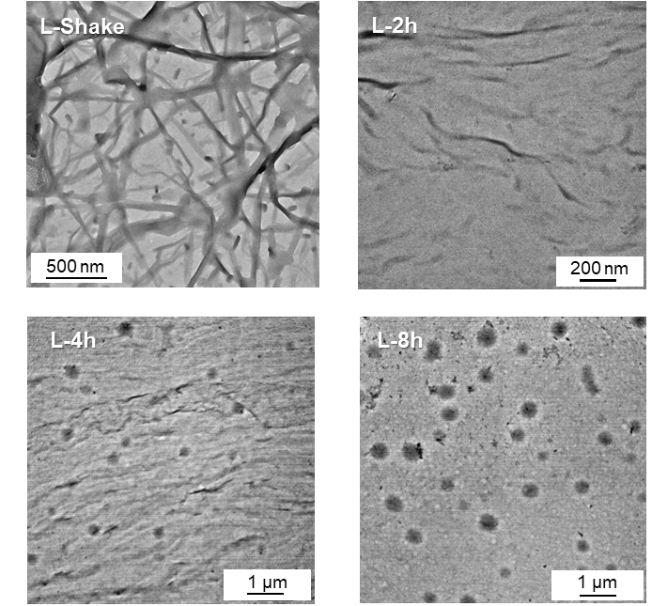
Figure S11. Dissipation states of C₁₂-MV²⁺/PN induced by phenyl lactate chirality at different times.

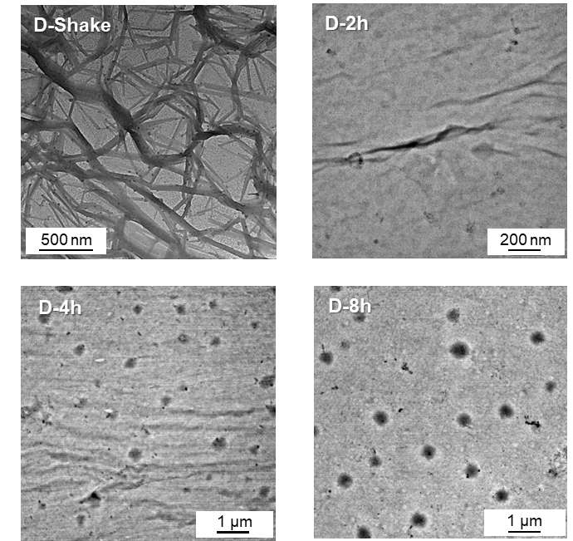
Figure S12. Dissipation states of C₁₂-MV²⁺/PN induced by phenyl lactate chirality at different times.

- Fluorescence quantum yields
$$ϕ_{f}=\frac{N_{em}\left(λ_{ex}\right)}{N_{abs}\left(λ_{ex}\right)}$$

The fluorescence quantum yield, $ϕ_{f}$, is the ratio of the number of emitted photons $N_{em}\left(λ_{ex}\right)$to the number of absorbed photons $N_{abs}\left(λ_{ex}\right)$.
Here the fluorescence quantum yield of the solution system before and after C₁₂-MV redox was calculated by comparing the absorption peak area of PN in the UV spectrum and the emission peak area in the fluorescence spectrum with the fluorescence quantum yield of PN itself 0.56¹.
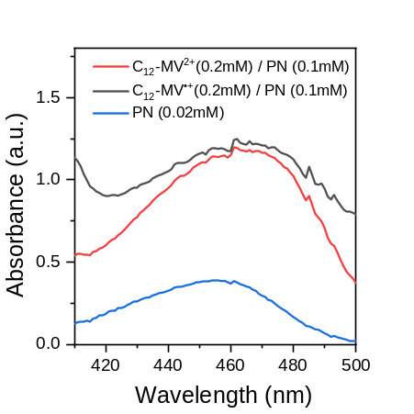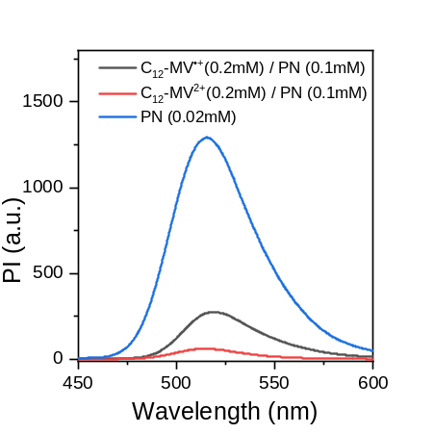
Figure S13. UV absorption spectra of the C₁₂-MV²⁺/PN system before and after oxidation and PN (left). Fluorescence spectra of the C₁₂-MV²⁺/PN system before and after oxidation and PN (right).

Table S1. Calculation of fluorescence quantum yields
 | S_{FL} | S_{UV} | S_{FL} / S_{UV} | φ_{f} of PN | Coefficient | φ_{f}
PN | 70264.3 | 7.4 | 9498.29 | 0.56 | 5.90E-05 | -
C₁₂-MV^{+•}/PN | 8663.5 | 35.8 | 242.00 | - | - | 0.0143
C₁₂-MV²⁺/PN | 1588.4 | 32.1 | 49.48 | - | - | 0.0029
S_{FL} : Fluorescence peak area; S_{UV} :UV peak area of PN.

- Redox kinetics of C₁₂-MV²⁺/PN investigated by EPR measurements.
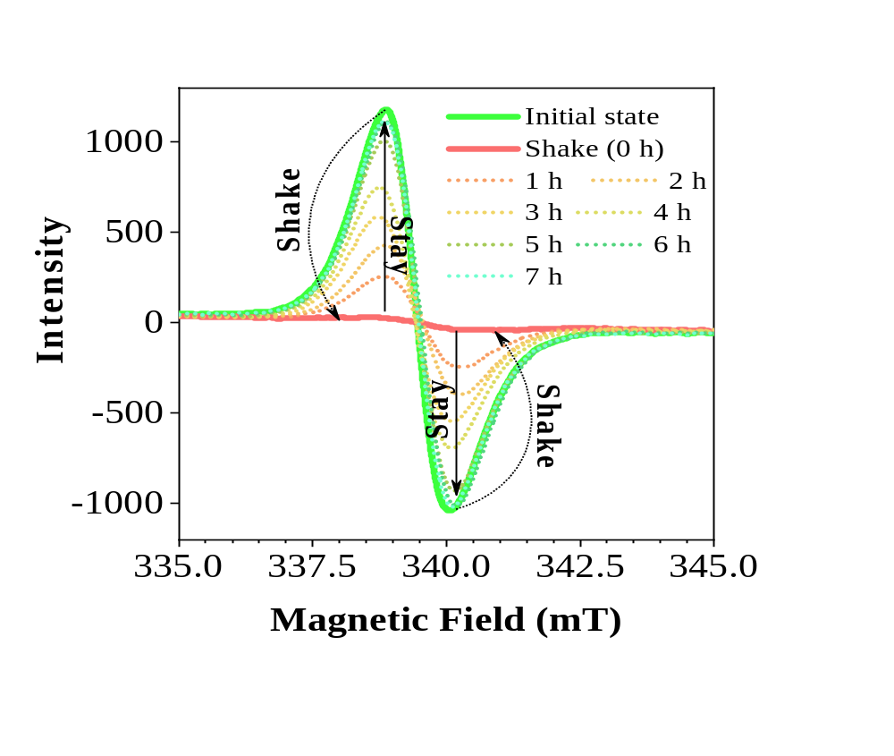
Figure S14. Time-dependent EPR measurements show the transient existence of C₁₂-MV^{•+}, [C₁₂-MV²⁺] = 3 mM, [PN] = 3 mM.

- Fluorescence of PN could be quenched by the CT interaction with C₁₂-MV²⁺.
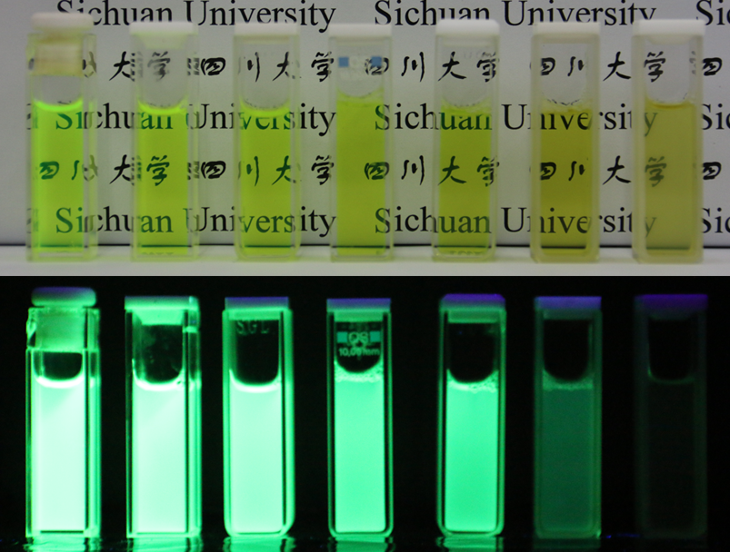
Figure S15. Images (upon) and fluorescence images (down) of a solution of PN (0.1 mM) upon addition of increasing concentrations of C₁₂-MV²⁺ aqueous solution (0−5 eq). [C₁₂-MV²⁺] = 3 mM, pH = 12.

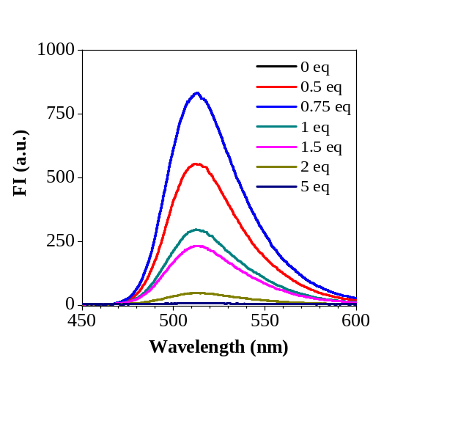
Figure S16. Fluorescence spectra of a solution of PN (0.1 mM) upon addition of increasing concentrations of C₁₂-MV²⁺ aqueous solution (0−5 eq).

- Redox kinetics of MV²⁺/PN investigated by fluorescence spectroscopy.
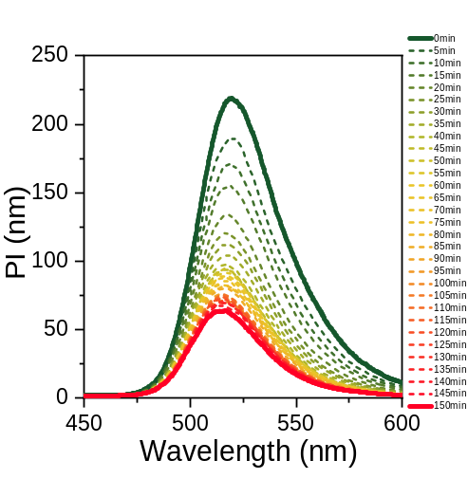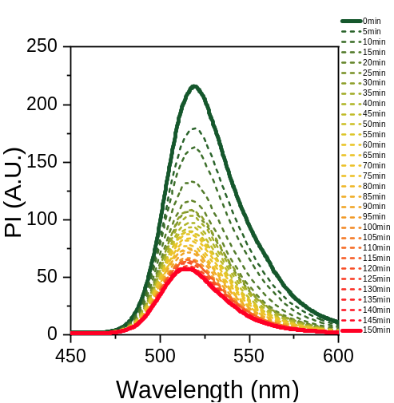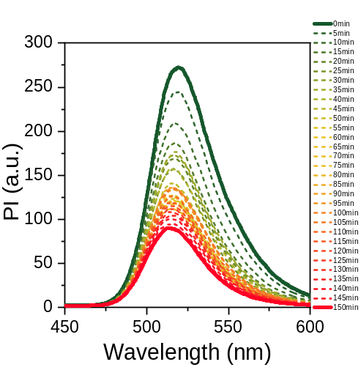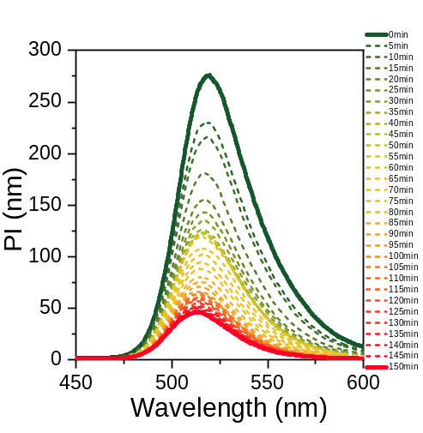
0 PEG
1% PEG
2.5% PEG
5% PEG
Figure S17. Time-dependent fluorescence spectroscopy, [MV²⁺] = 2 mM, [PN] = 0.2 mM, N₂H₄•H₂O (20% v/v), with different content of PEG (10kDa).

- The fluorescence of PN is absorbed by MV²⁺.
The quenching of PN fluorescence is due to the energy transfer between MV^{•+} and PN. The enhanced fluorescence induced by shake is due to the energy transfer between MV²⁺ and PN was decreased.

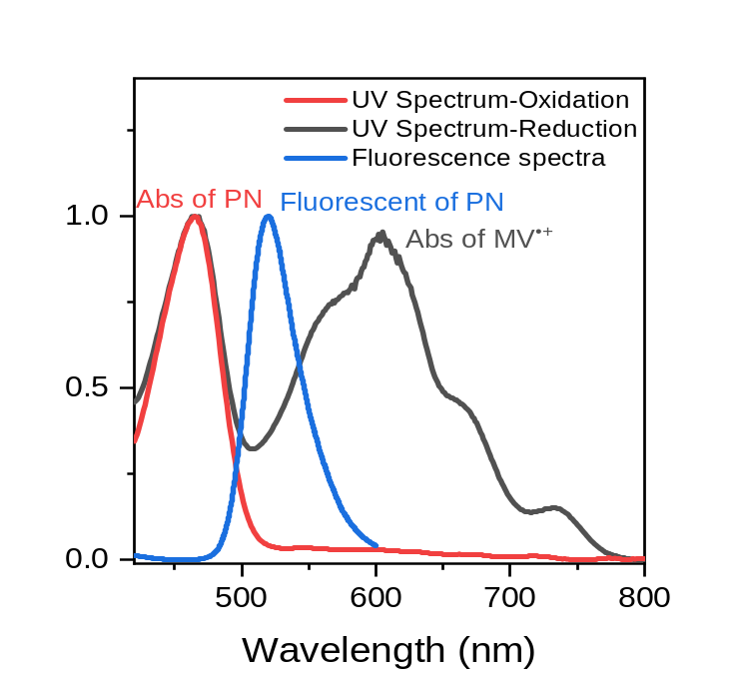
Figure S18. UV-vis spectra of MV²⁺ and MV^{•+}; Fluorescence spectra of PN.

- Redox kinetics of MV²⁺ investigated by discoloration.
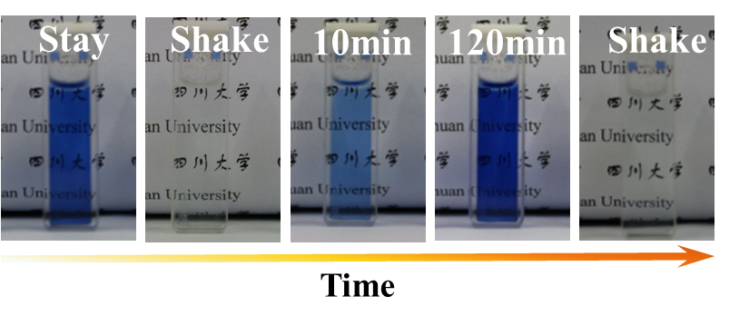
Figure S19. Photographs of shake power discoloration over time indicating reversible redox reaction of MV²⁺ by adding N₂H₄•H₂O, [MV²⁺] = 3 mM, N₂H₄•H₂O (20% v/v), buffer (pH=12).

- Redox kinetics of MV²⁺ investigated by UV-vis measurements.
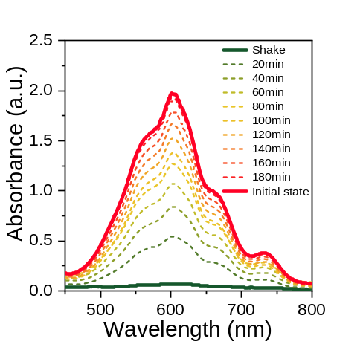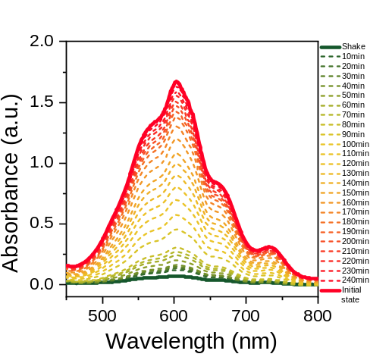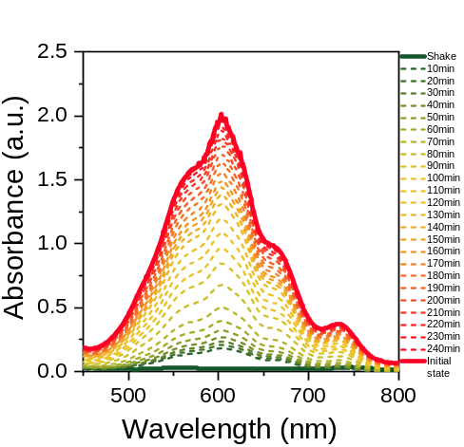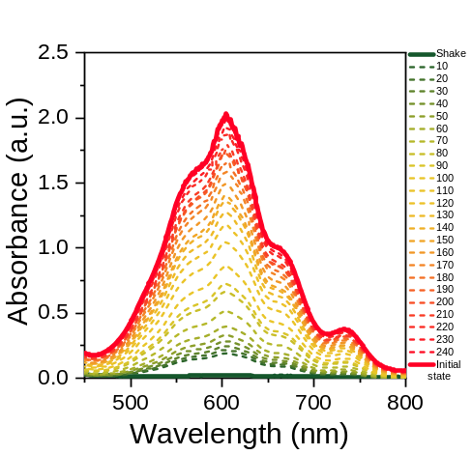
0 PEG
1% PEG
2.5% PEG
5% PEG
Figure S20. Time-dependent UV-vis measurements showing the transient existence of MV^{•+}, [MV²⁺] = 3 mM, N₂H₄•H₂O (20% v/v), with different content of PEG (10kDa).

- Redox kinetics of MV²⁺/PN investigated by UV-vis measurements.
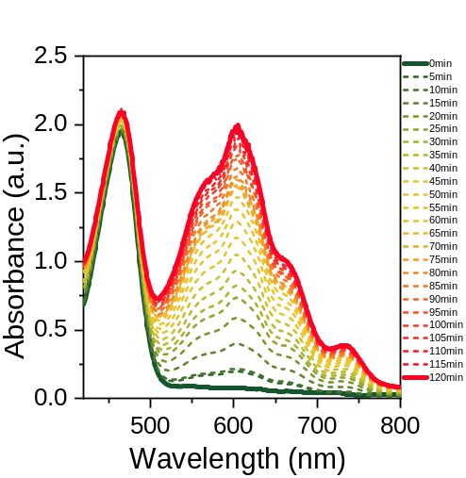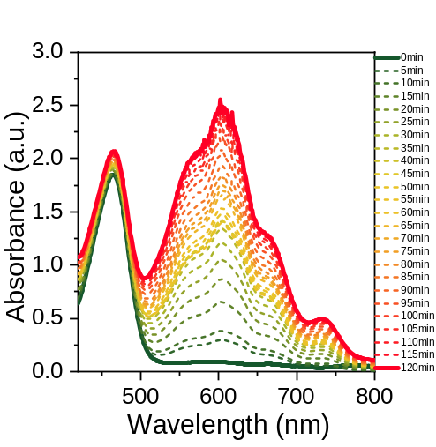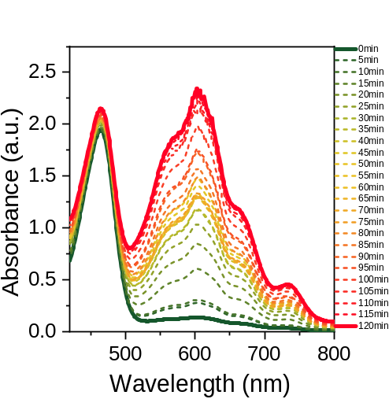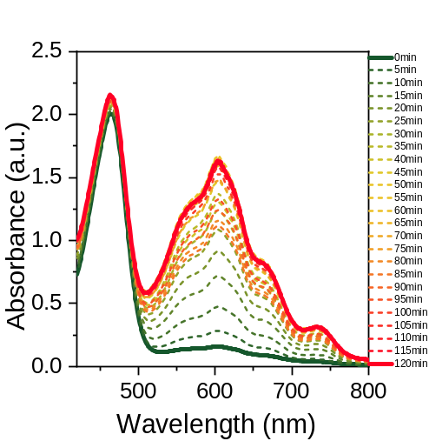
0 PEG
1% PEG
2.5% PEG
5% PEG
Figure S21. Time-dependent UV-vis measurements showing the transient existence of MV^{•+}, [MV²⁺] = 2 mM, [PN] = 0.2 mM, N₂H₄•H₂O (20% v/v), with different content of PEG (10kDa).

- Ultrasound-induced patterning of MV²⁺ and C₁₂-MV²⁺.
We observed that oxygen entered the system with a fixed flow direction for directional oxidation during sonication, but after a little staying, instead of showing a flow line of oxygen entry, a pattern of snowflake spots appeared. We consider this because the viscosity of the system is so weak, which makes the flow line discontinuous. Therefore, a series of streamlined patterns were obtained by adding different levels of PEG (10 kDa) into the solution to increase the viscosity of the system. When the PEG concentration reached 5%, a complete heart-shaped streamline pattern was shown.

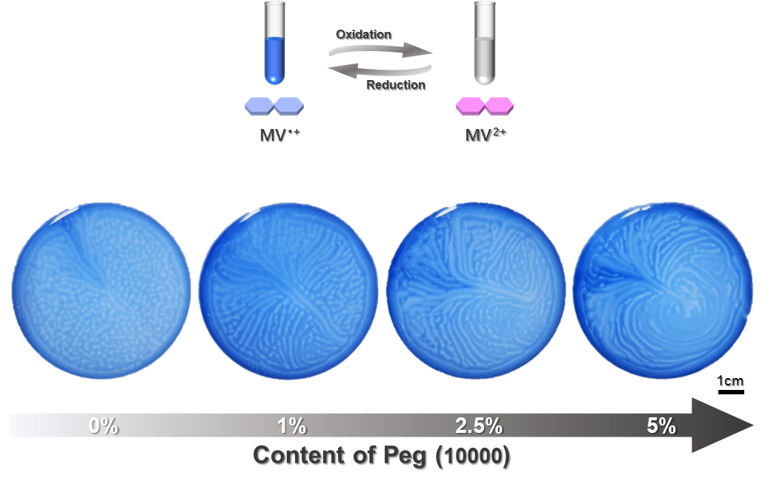
Figure S22. Ultrasound-induced patterning of MV²⁺ (5 mM) with different content of PEG (10 kDa). N₂H₄•H₂O (20% v/v). Obtained by sonication for 150 s and stay for 60 s.

Compared to MV²⁺, C₁₂-MV²⁺ itself has surface activity, which increases the viscosity of the system and decreases the surface tension of the system, so the direction of oxygen inflow can be observed without additional PEG addition. Because different concentrations of C₁₂-MV²⁺ have different effects on the surface tension of the system, we observed different sizes of the cardioid flow lines, which decrease with the decrease of surface tension (Figure S23 and S24).

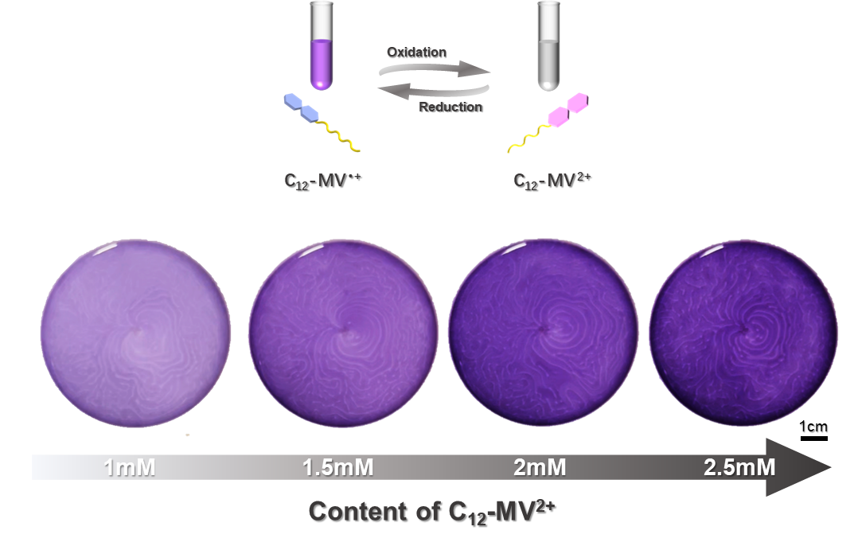
Figure S23. Ultrasound-induced patterning of different content of C₁₂-MV²⁺. N₂H₄•H₂O (20% v/v). Obtained by sonication for 150 s and stay for 60 s.

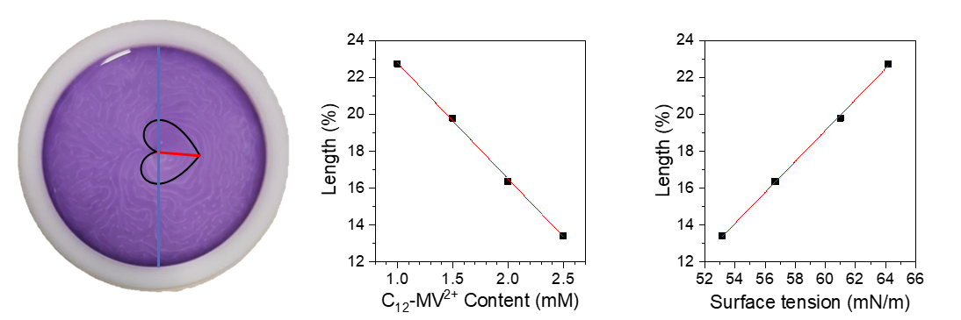
Figure S24. Variation of relative size of heart pattern with concentration and surface tension. Relative size is calculated as the ratio of the midline to the diameter.

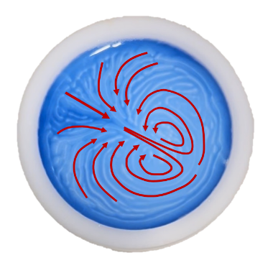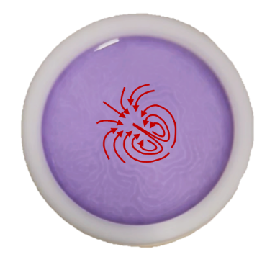
Figure S25. The direction of ultrasound-induced O₂ diffusion.

- Ultrasound-induced patterning of MV²⁺/PN.
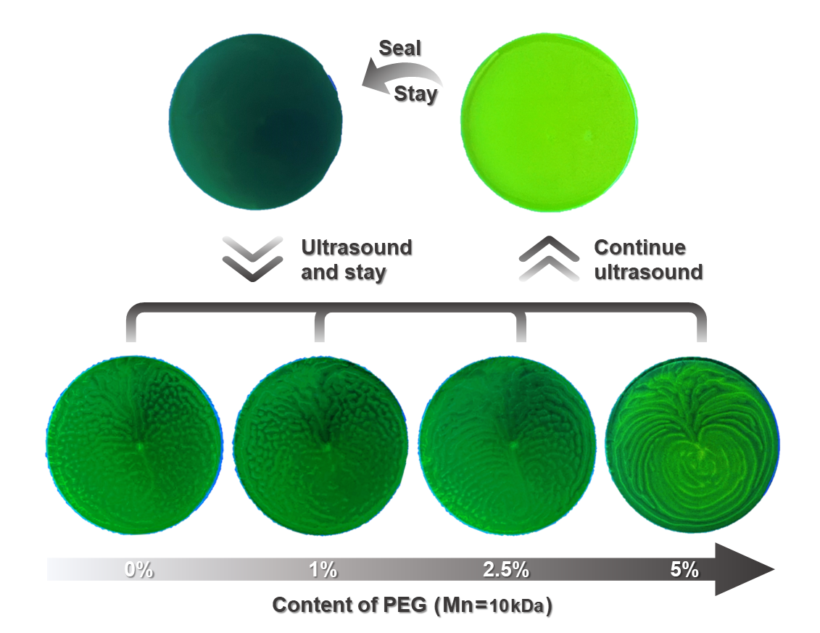
Figure S26. Ultrasound-induced patterns for MV²⁺/PN in buffer containing different contents of PEG, under 365 nm UV light. Obtained by sonication for 150 s and stay for 60 s.

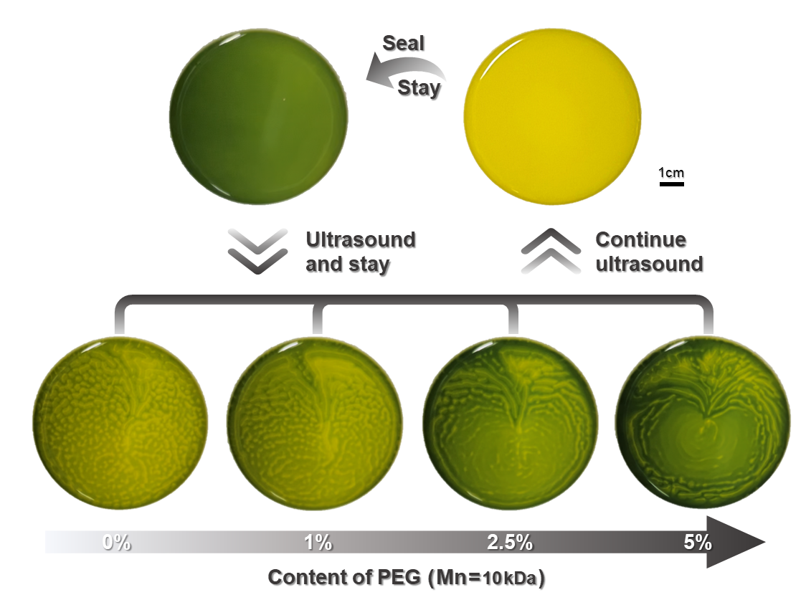
Figure S27. Ultrasound-induced patterns for MV²⁺/PN in buffer containing different contents of PEG, under daylight. Obtained by sonication for 150 s and stay for 60 s.

- Ultrasound-induced patterning of C₁₂-MV²⁺/PN.
Due to the high viscosity of the C₁₂-MV²⁺/PN supramolecular system, the force of ultrasound is not sufficient to disperse the reduced C₁₂-MV^{•+} again and it is difficult to form patterns. There is no effective pattern not only in visible light or UV light.
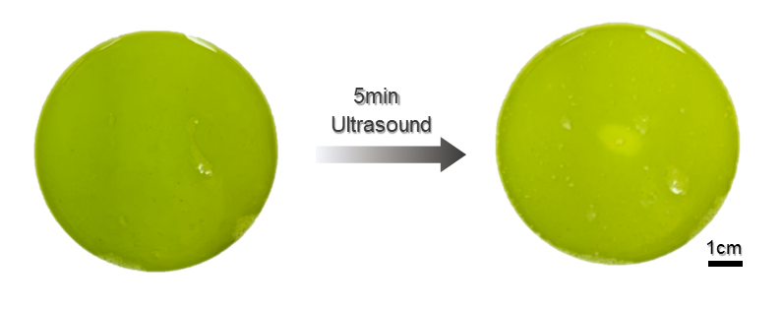
Figure S28. Ultrasound-guided patterns for C₁₂-MV²⁺ (1mM) / PN (1mM) in buffer, under daylight. N₂H₄•H₂O (20% v/v). Some of the bright spots are the bubbles.

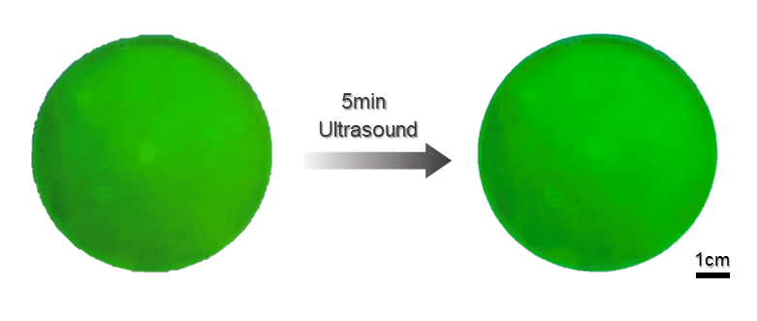
Figure S29. Ultrasound-guided patterns for C₁₂-MV²⁺ (1mM) / PN (1mM) in buffer, under 365 nm UV light. N₂H₄•H₂O (20% v/v). Some of the bright spots are the bubbles.

- Ultrasound-induced patterning in different molds.
For different shapes of molds (triangular and square), local diffusion processes of ultrasonically induced oxygen entry can be observed, but without an overall large-scale regular patterning relative to circular molds.

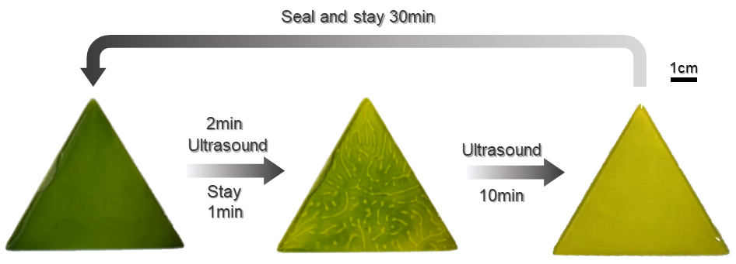
Figure S30. Ultrasonically induced patterning of MV²⁺/PN in a triangular mold containing PEG (5%) in buffer under daylight. Obtained by sonication for 150 s and stay for 60 s.

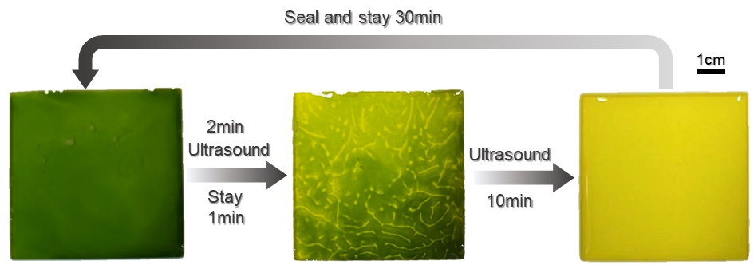
Figure S31. Ultrasonically induced patterning of MV²⁺/PN in a square mold containing PEG (5%) in buffer under daylight. Obtained by sonication for 150 s and stay for 60 s.

- NMR spectrum.
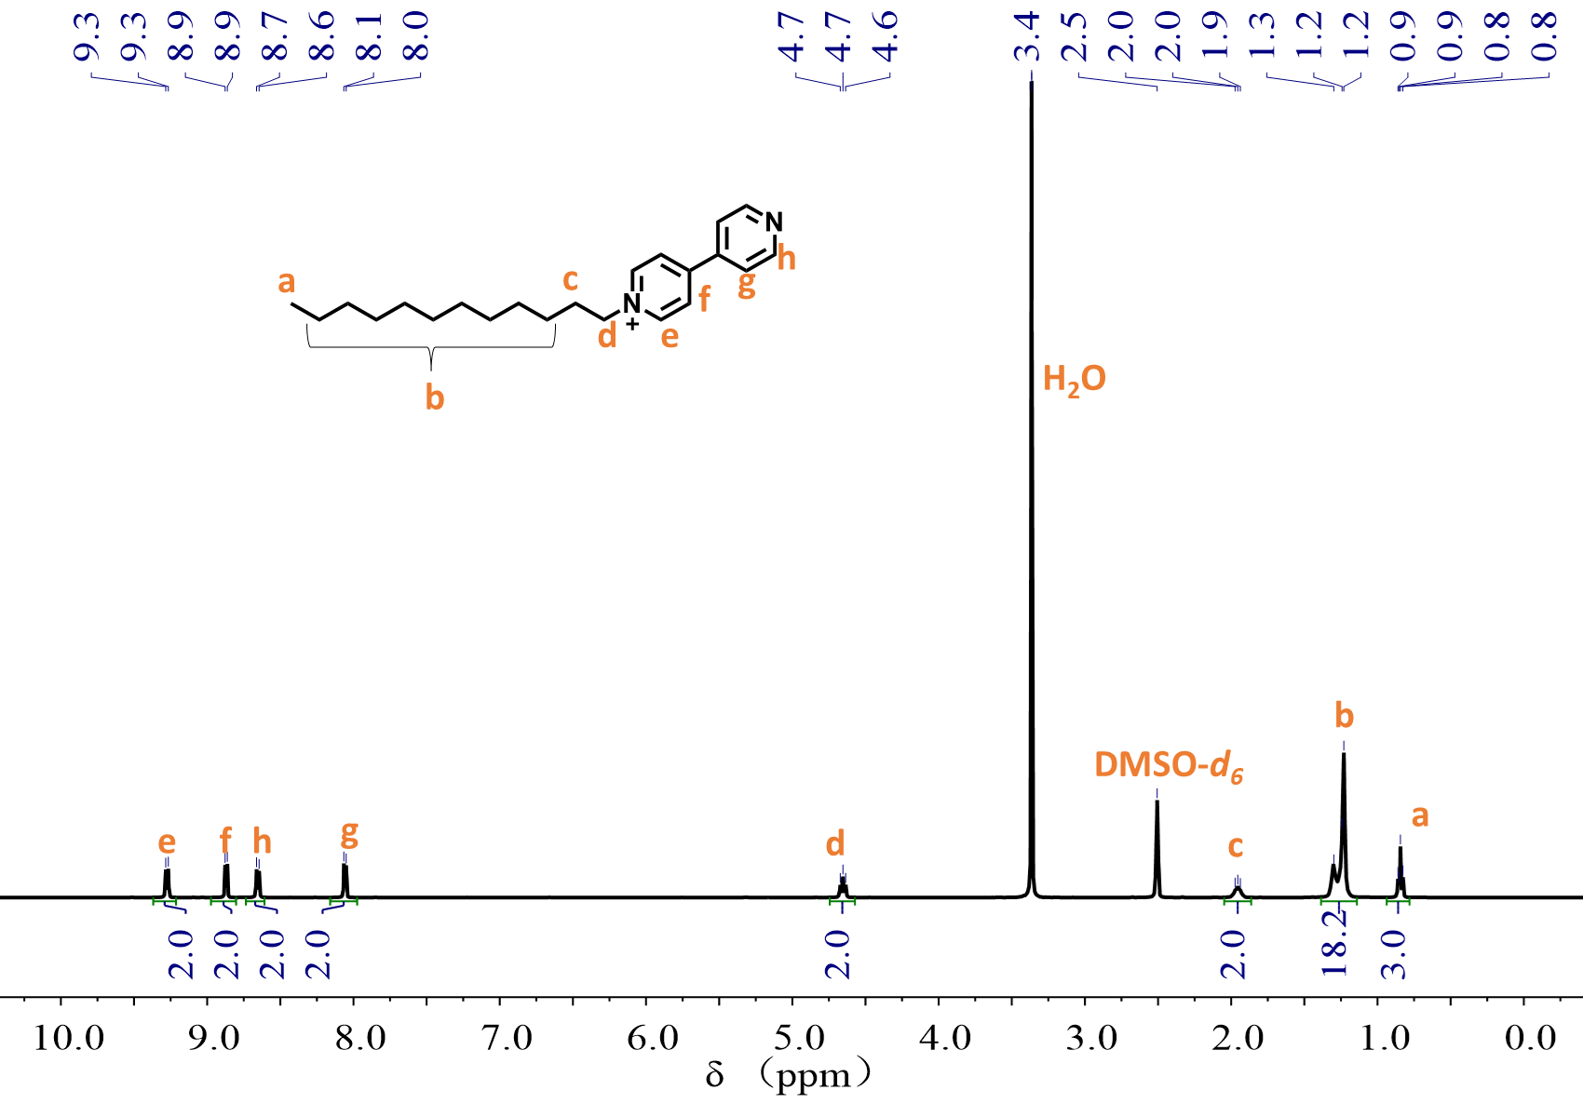
Figure S32 ¹H-NMR spectrum of 1-dodecyl-[4,4'-bipyridin]-1-ium in DMSO-d₆ (400 MHz).

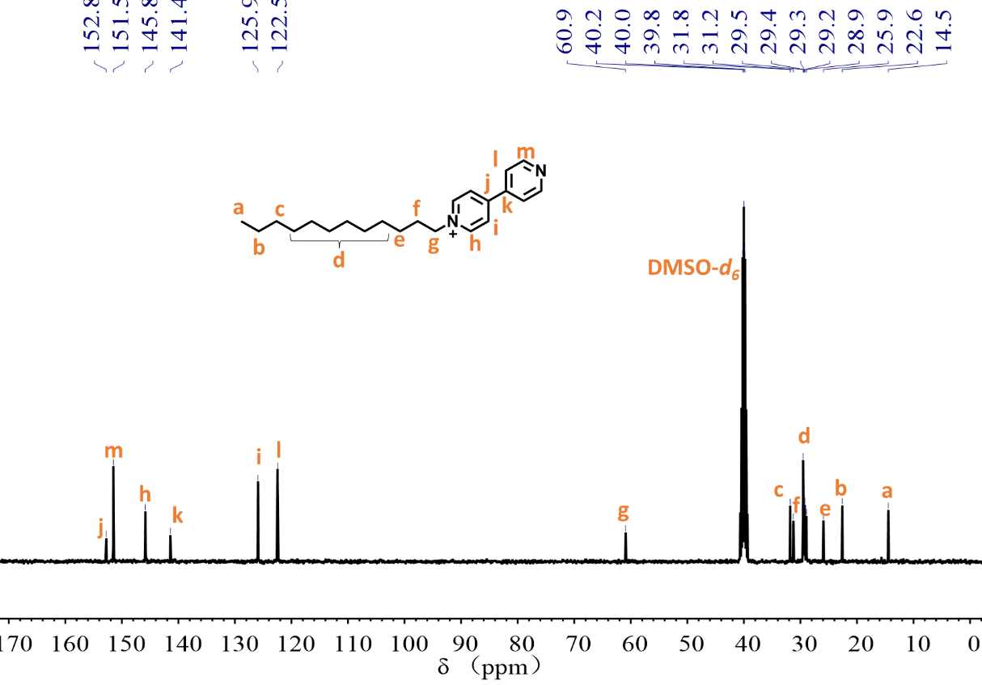
Figure S33 ¹³C-NMR spectrum of 1-dodecyl-[4,4'-bipyridin]-1-ium in DMSO-d₆.

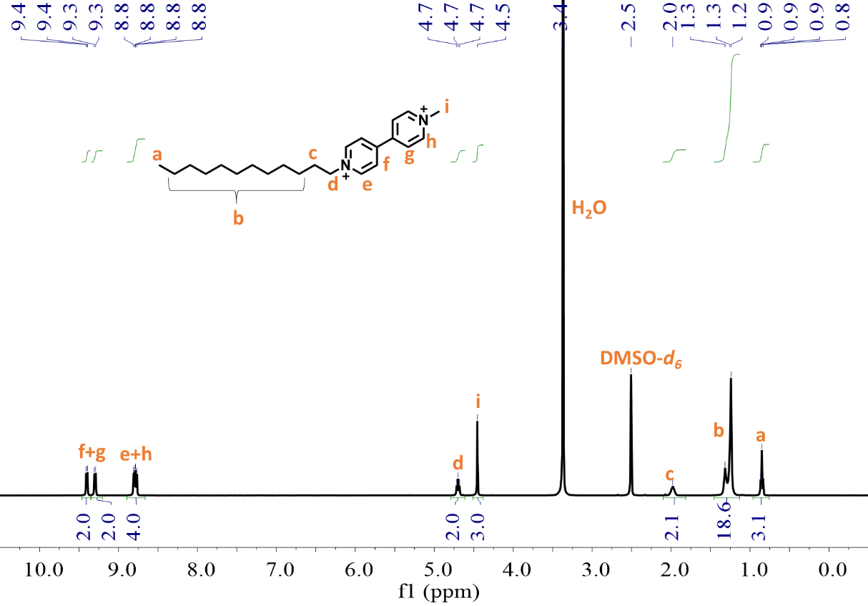
Figure S34. ¹H-NMR spectrum of C₁₂-MV²⁺ in DMSO-d₆ (400 MHz).

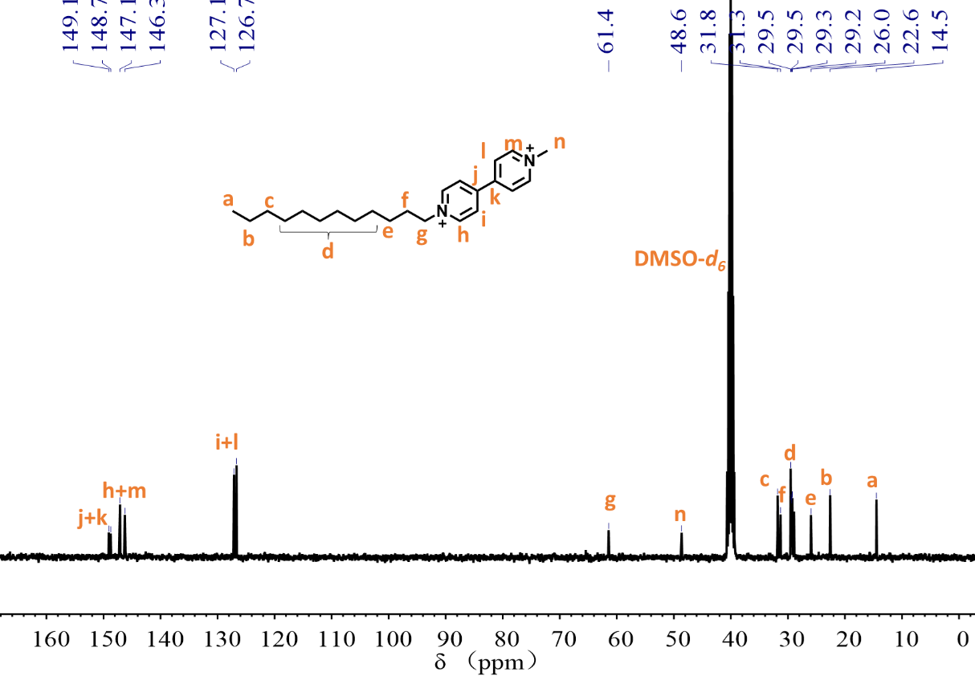
Figure S35. ¹³C-NMR spectrum of C₁₂-MV²⁺ in DMSO-d₆.

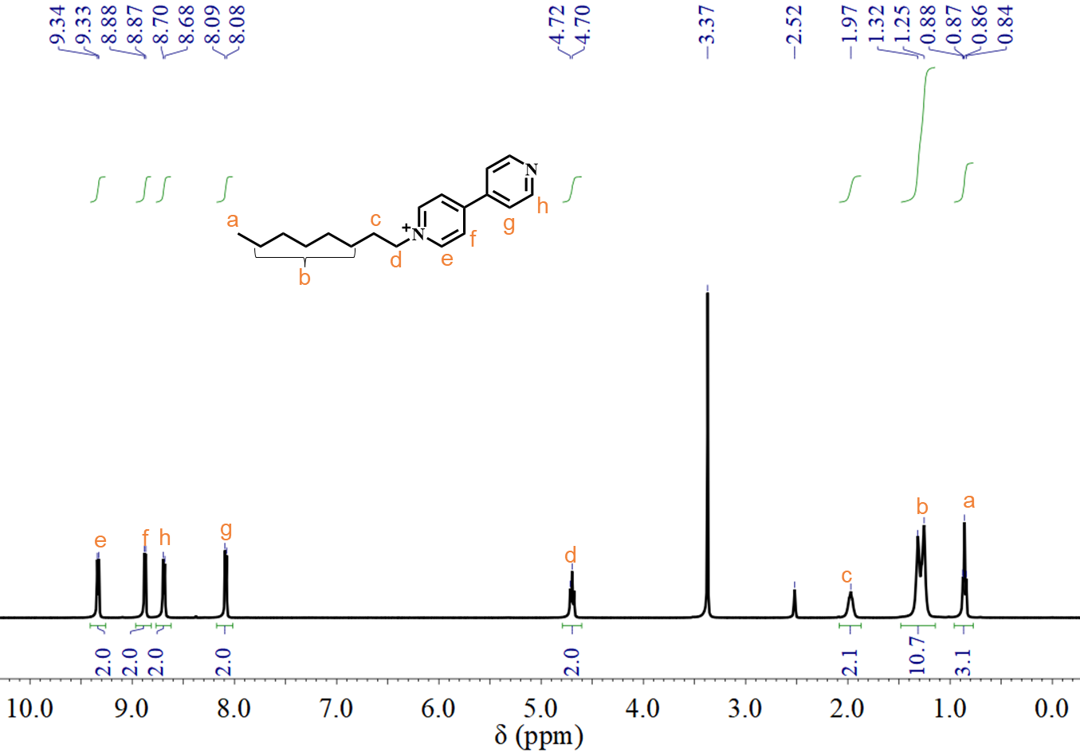
Figure S36. ¹H-NMR spectrum of 2 in DMSO-d₆ (400 MHz).

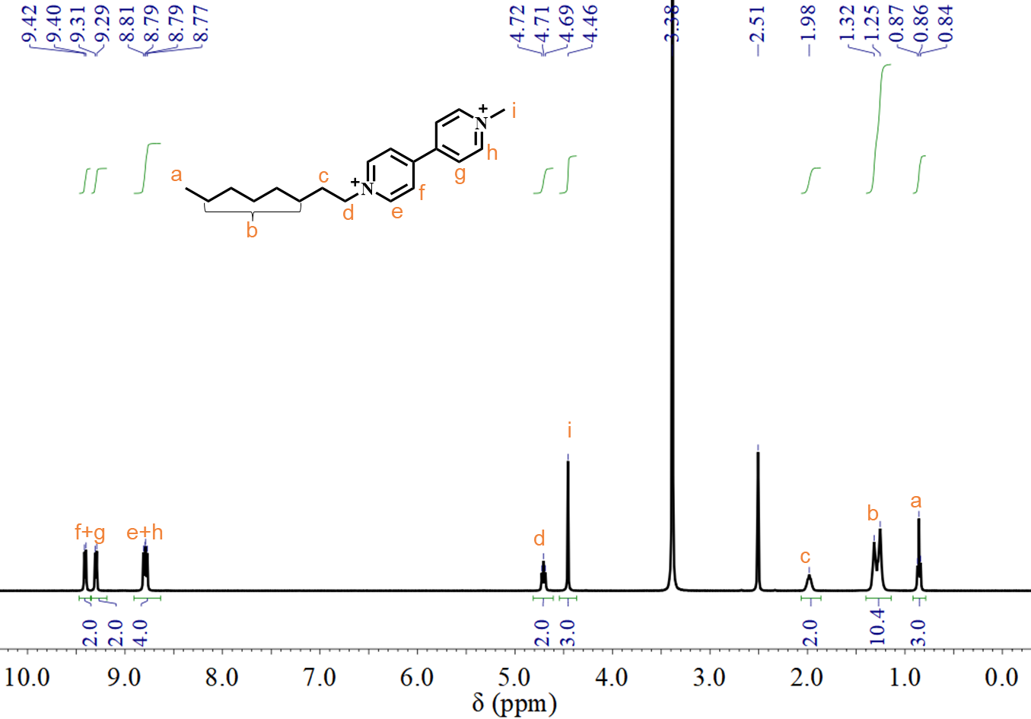
Figure S37. ¹H-NMR spectrum of C₈-MV²⁺ in DMSO-d₆ (400 MHz).

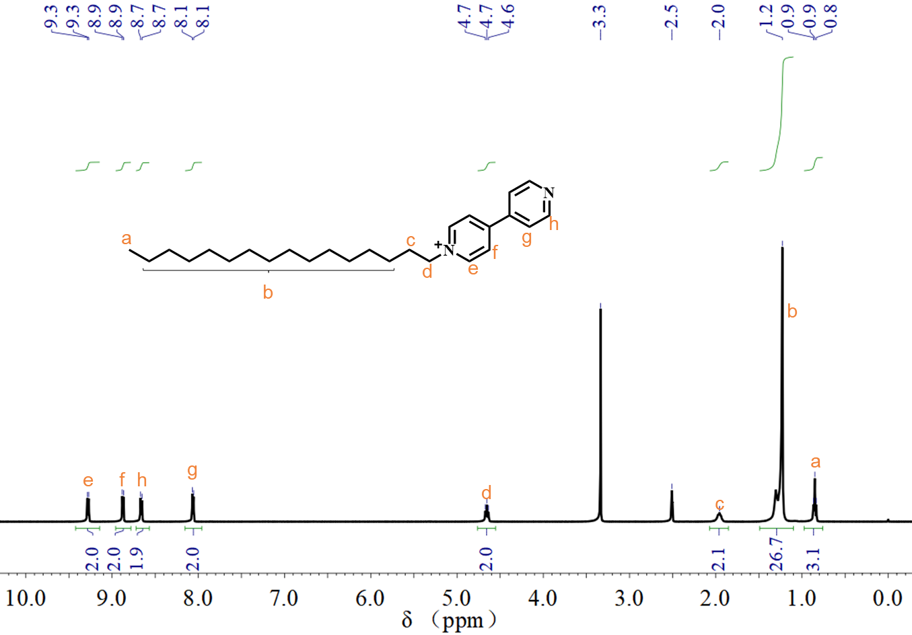
Figure S38. ¹H-NMR spectrum of 3 in DMSO-d₆ (400 MHz).

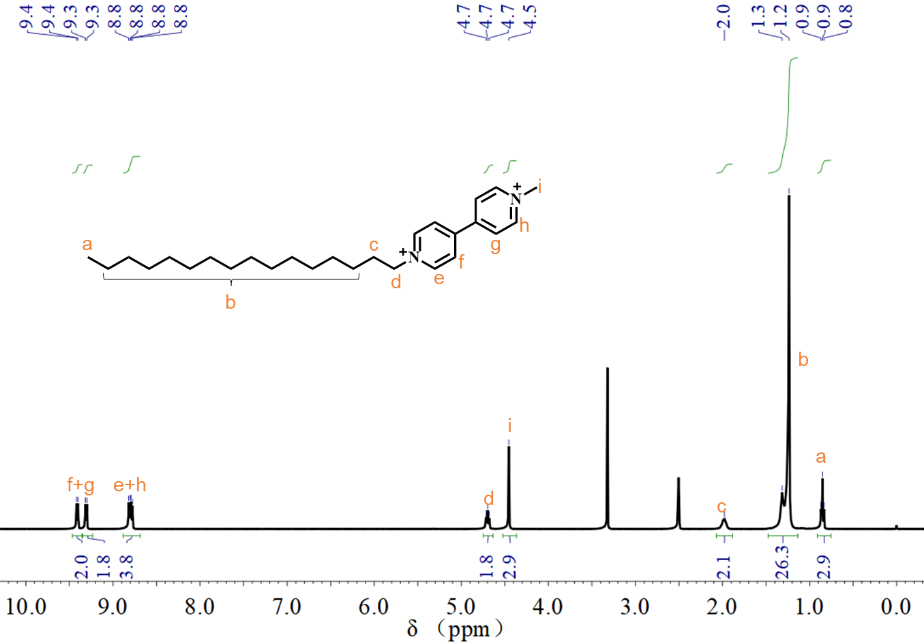
Figure S39. ¹H-NMR spectrum of C₁₆-MV²⁺ in DMSO-d₆ (400 MHz).

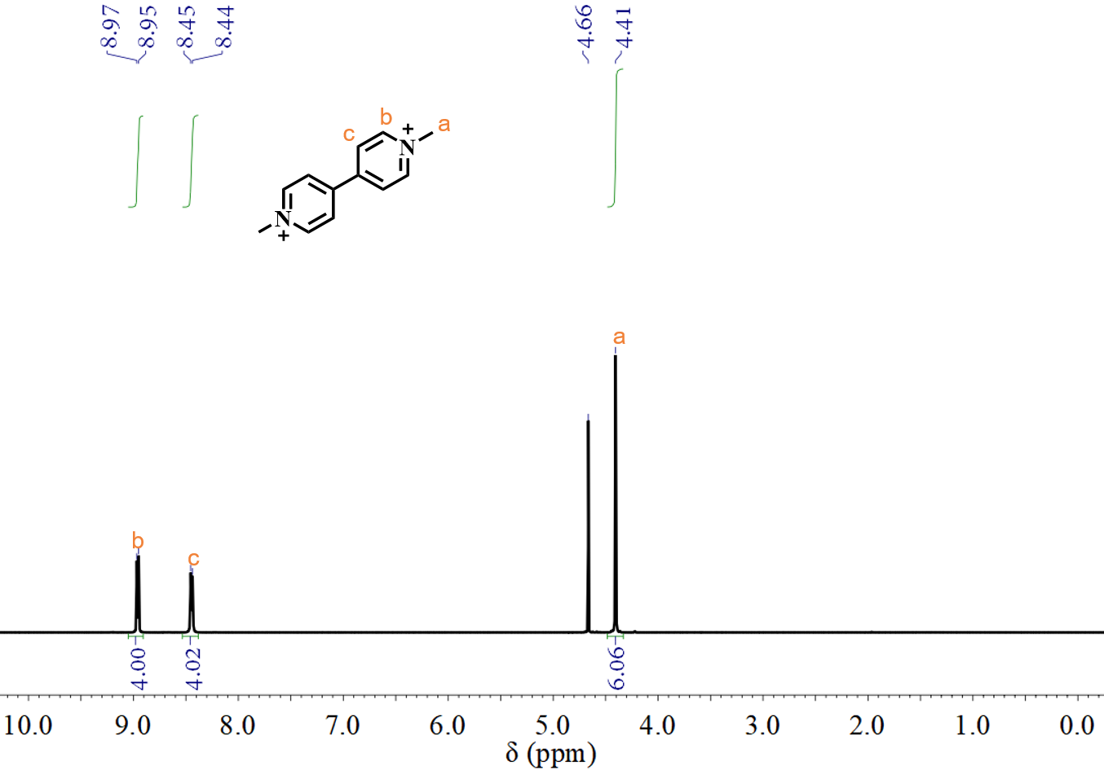
Figure S40. ¹H-NMR spectrum of MV²⁺ in D₂O- (400 MHz).

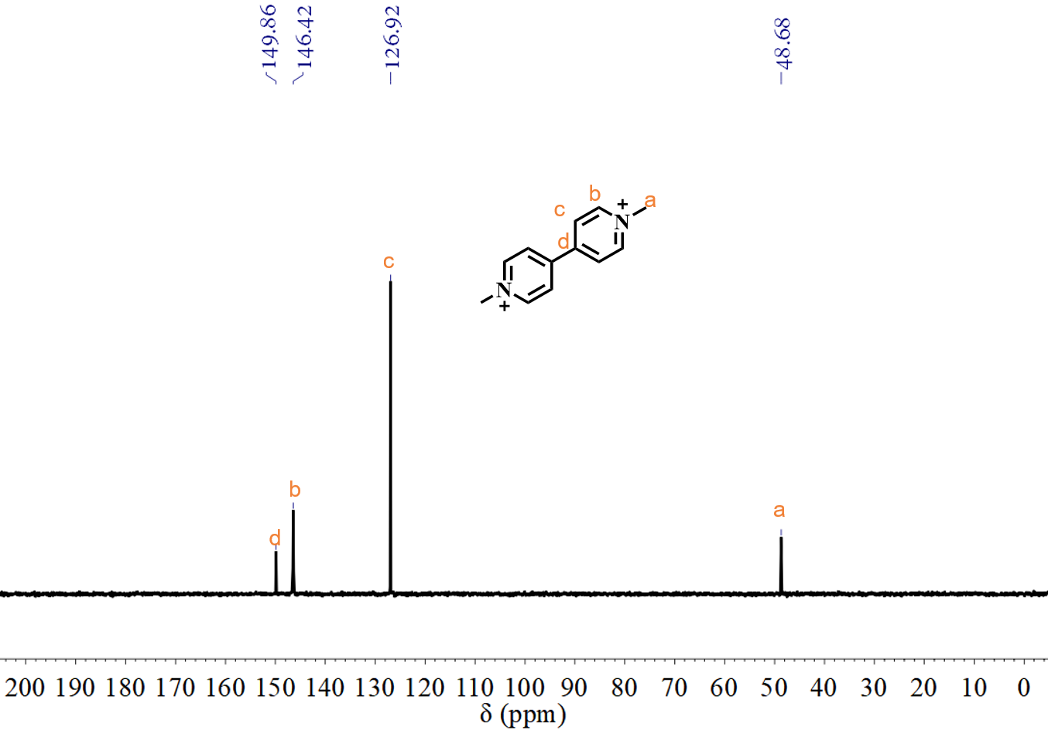
Figure S41. ¹²C-NMR spectrum of MV²⁺ in D₂O (400 MHz).

- Supplementary Video List.
Table S2. Supplementary Video List.
Serial number | Element
Supplementary Video 1 | Shaking/staying induced discoloration of C₁₂-MV²⁺
Supplementary Video 2 | Shaking-induced fluorescence quenching of C₁₂- MV²⁺/PN
Supplementary Video 3 | Shaking-induced enhancement of fluorescence emission of MV²⁺/PN
Supplementary Video 4 | Patterning of MV²⁺/PN under ultrasound and staying with 5%PEG under 365nm UV light
Supplementary Video 5 | Patterning of MV²⁺/PN under ultrasound and staying with 5%PEG under daylight
Supplementary Video 6 | Patterning of C₁₂- MV²⁺ (2.5mM) under ultrasound and staying

Reference
1 Oshchepkov, M. & Popov, K. in Desalination and Water Treatment. Ch. Chapter 15, (2018).

