Supplementary Information

Supplementary Table 1. LMMs quantifying population average baselines and monthly change in ALSFRS-RSE, ALSFRS-R and ROADS.
Model | Outcome | Term | Term est. [95% CI] (p-val.) | R2m | R2c.
1 | ALSFRS-RSE | Intercept | 34.346 [31.950, 36.736] (0.000) | 0.013 | 0.98
 |  | Time | -0.475 [-0.627, -0.325] (0.000)
2 | ROADS | Intercept | 84.906 [79.904, 89.896] (0.000) | 0.025 | 0.954
 |  | Time [months] | -1.260 [-1.712, -0.806] (0.000)
3 | ALSFRS-R | Intercept | 31.576 [29.112, 34.039] (0.000) | 0.014 | 0.942
 |  | Time [months] | -0.369 [-0.623, -0.113] (0.007)
4 | (ALSFRS-RSE, ALSFRS-R) | Intercept | 34.422 [32.033, 36.808] (0.000) | 0.046 | 0.957
 |  | Time [months] | -0.473 [-0.702, -0.247] (0.000)
 |  | in-clinic | -2.866 [-3.470, -2.257] (0.000)
 |  | Time [months]:in-clinic | 0.057 [-0.122, 0.234] (0.535)
5 | ALSFRS-RSE | Intercept | 34.597 [31.219, 37.961] (0.000) | 0.013 | 0.981
 |  | Time [months] | -0.595 [-0.805, -0.388] (0.000)
 |  | Modus | -0.484 [-5.241, 4.287] (0.844)
 |  | Time [months]:Modus | 0.236 [-0.054, 0.528] (0.115)
6 | ROADS | Intercept | 85.547 [78.453, 92.583] (0.000) | 0.025 | 0.956
 |  | Time [months] | -1.381 [-2.035, -0.710] (0.000)
 |  | Modus | -1.246 [-11.191, 8.766] (0.808)
 |  | Time [months]:Modus | 0.223 [-0.701, 1.122] (0.632)
ALSFRS-R -- staff-administered amyotrophic lateral sclerosis functional rating scale-revised; ALSFRS-RSE -- self-entry ALSFRS-R; CI -- estimate's confidence interval obtained from LMM estimation; est. -- estimate obtained from LMM estimation; LMM – mixed effects model; Mod. no. -- LMM model number; R2c -- LMM conditional coefficient of determination; R2m -- LMM marginal coefficient of determination; p.-val. -- estimate's p-value obtained from LMM estimation; ROADS -- Rasch-built Overall ALS Disability Scale

Supplementary Table 2. Association between wearable-derived daily PA measures and ALSFRS-RSE total score.
Model | Device | Data | Daily measure | Slope est.* [95% CI] (p-val.) | R2m | R2c
no. | group | set
1 | AG | VDMs | Light activity [minutes] | 0.828 [-1.119, 2.775] (0.178) | 0.006 | 0.975
2 | AG | VDMs | Moderate activity [minutes] | 1.028 [0.254, 1.802] (0.010) | 0.011 | 0.97
3 | AG | VDMs | Vigorous activity [minutes] | 6.009 [3.433, 8.585] (0.002) | 0.226 | 0.976
4 | AG | VDMs | MVPA [minutes] | 1.302 [0.319, 2.285] (0.010) | 0.018 | 0.969
5 | AG | VDMs | Sedentary [minutes] | 0.246 [-0.333, 0.824] (0.400) | 0.001 | 0.972
6 | AG | VDMs | Non-sedentary [minutes] | 2.553 [1.687, 3.420] (0.000) | 0.103 | 0.974
7 | AG | VDMs | Locomotion [minutes] | 3.462 [2.237, 4.687] (0.000) | 0.148 | 0.969
8 | AG | VDMs | Non-locomotion [minutes] | 0.886 [-0.409, 2.181] (0.114) | 0.006 | 0.976
9 | AG | VDMs | Steps | 3.040 [1.950, 4.130] (0.000) | 0.123 | 0.970
10 | AG | VDMs | Calories | 1.543 [0.774, 2.313] (0.000) | 0.032 | 0.973
11 | AG | VDMs | METs | 1.414 [0.744, 2.083] (0.000) | 0.025 | 0.972
12 | AG | VDMs | Total activity counts | 2.778 [1.837, 3.720] (0.000) | 0.116 | 0.976
13 | AG | VDMs | Sleep [minutes] | -0.159 [-3.577, 3.259] (0.831) | 0.000 | 0.970
14 | AG | IDMs | Total activity counts | 2.850 [1.883, 3.817] (0.000) | 0.124 | 0.974
15 | AG | IDMs | Total log(activity counts) | 1.784 [1.028, 2.541] (0.000) | 0.047 | 0.971
16 | AG | IDMs | log(total activity counts) | 3.621 [2.386, 4.857] (0.000) | 0.237 | 0.977
17 | AG | IDMs | Active to sedentary TP | -3.286 [-5.036, -1.536] (0.003) | 0.198 | 0.971
18 | AG | IDMs | Sedentary to active TP | 2.197 [1.293, 3.100] (0.000) | 0.061 | 0.977
19 | AG | IDMs | Non-sedentary [minutes] | 3.082 [2.042, 4.121] (0.000) | 0.134 | 0.977
20 | AG | IDMs | Sedentary [minutes] | -3.082 [-4.121, -2.042] (0.000) | 0.134 | 0.977
21 | M | VDMs | Steps recorded/minute - total | 0.564 [-0.315, 1.443] (0.201) | 0.005 | 0.958
22 | M | VDMs | Steps recorded/minute - 95th perc. | 0.213 [-1.832, 2.258] (0.810) | 0.001 | 0.961
23 | M | VDMs | Steps recorded/minute - mean | 0.854 [-0.431, 2.139] (0.191) | 0.011 | 0.964
24 | M | VDMs | Steps recorded/minute - median | 0.536 [-0.438, 1.511] (0.277) | 0.005 | 0.964
25 | M | VDMs | Time % with 1-15 steps recorded/minute | 1.097 [-0.522, 2.716] (0.159) | 0.018 | 0.964
26 | M | VDMs | Time % with 16-40 steps recorded/minute | 0.993 [0.274, 1.711] (0.007) | 0.016 | 0.960
27 | M | VDMs | Time % with 41+ steps recorded/minute | -0.863 [-3.117, 1.390] (0.363) | 0.012 | 0.961
28 | M | VDMs | Max 60 | 0.923 [0.137, 1.709] (0.022) | 0.011 | 0.964
29 | M | VDMs | Max 20 | 0.731 [-0.252, 1.715] (0.142) | 0.007 | 0.964
30 | M | VDMs | Max 5 | 0.949 [-0.149, 2.048] (0.090) | 0.013 | 0.958
31 | M | VDMs | Max 1 | 1.025 [-0.008, 2.058] (0.052) | 0.017 | 0.957
32 | M | VDMs | Peak performance index | 0.741 [-0.384, 1.866] (0.195) | 0.009 | 0.958
AG -- ActiGraph device; ALSFRS-RSE -- self-entry amyotrophic lateral sclerosis functional rating scale-revised; IDMs -- investigator-derived daily measures; CI -- estimate's confidence interval obtained from LMM estimation; est. -- estimate obtained from LMM estimation; Model no. – model number: ordering index of a LMM fit, assigned to a particular daily measure; R2c -- LMM conditional coefficient of determination; R2m -- LMM marginal coefficient of determination; M -- Modus device; PA – physical activity; VDMs -- vendor-provided daily measures
* Daily measure slopes have been standardized to have zero means and unit standard deviations.

Supplementary Table 3. Association between wearable-derived daily PA measures and ROADS score.
Model | Device | Data | Daily measure | Slope est.* [95% CI] (p-val.) | R2m | R2c
no. | group | set
1 | AG | VDMs | Light activity [minutes] | 1.066 [-4.157, 6.288] (0.663) | 0.002 | 0.977
2 | AG | VDMs | Moderate activity [minutes] | 3.947 [0.214, 7.680] (0.041) | 0.044 | 0.947
3 | AG | VDMs | Vigorous activity [minutes] | 32.32 [-28.05, 92.68] (0.211) | 0.269 | 0.995
4 | AG | VDMs | MVPA [minutes] | 5.074 [0.469, 9.680] (0.035) | 0.077 | 0.944
5 | AG | VDMs | Sedentary [minutes] | -0.954 [-6.155, 4.247] (0.690) | 0.002 | 0.968
6 | AG | VDMs | Non-sedentary [minutes] | 6.202 [1.932, 10.47] (0.009) | 0.145 | 0.969
7 | AG | VDMs | Locomotion [minutes] | 12.04 [4.131, 19.94] (0.007) | 0.346 | 0.963
8 | AG | VDMs | Non-locomotion [minutes] | 1.869 [-3.376, 7.114] (0.447) | 0.006 | 0.978
9 | AG | VDMs | Steps | 17.70 [4.817, 30.59] (0.013) | 0.447 | 0.980
10 | AG | VDMs | Calories | 4.138 [0.053, 8.223] (0.048) | 0.047 | 0.974
11 | AG | VDMs | METs | 4.422 [-0.518, 9.363] (0.072) | 0.049 | 0.973
12 | AG | VDMs | Total activity counts | 4.945 [1.081, 8.809] (0.018) | 0.092 | 0.967
13 | AG | VDMs | Sleep [minutes] | 0.233 [-2.664, 3.130] (0.872) | 0.000 | 0.952
14 | AG | IDMs | Total activity counts | 4.891 [0.899, 8.883] (0.021) | 0.092 | 0.966
15 | AG | IDMs | Total log(activity counts) | 1.720 [-2.231, 5.671] (0.360) | 0.009 | 0.972
16 | AG | IDMs | log(total activity counts) | 5.888 [1.065, 10.71] (0.021) | 0.157 | 0.967
17 | AG | IDMs | Active to sedentary TP | -5.872 [-9.531, -2.214] (0.004) | 0.150 | 0.948
18 | AG | IDMs | Sedentary to active TP | 4.588 [0.128, 9.048] (0.045) | 0.070 | 0.957
19 | AG | IDMs | Non-sedentary [minutes] | 5.235 [1.275, 9.195] (0.014) | 0.101 | 0.969
20 | AG | IDMs | Sedentary [minutes] | -5.235 [-9.195, -1.275] (0.014) | 0.101 | 0.969
21 | M | VDMs | Steps recorded/minute - total | 3.791 [-2.403, 9.985] (0.188) | 0.083 | 0.869
22 | M | VDMs | Steps recorded/minute - 95th perc. | 4.810 [-0.445, 10.07] (0.068) | 0.113 | 0.877
23 | M | VDMs | Steps recorded/minute - mean | 6.167 [0.719, 11.61] (0.030) | 0.195 | 0.883
24 | M | VDMs | Steps recorded/minute - median | 1.445 [-3.753, 6.643] (0.536) | 0.013 | 0.856
25 | M | VDMs | Time % with 1-15 steps recorded/minute | 1.992 [-1.330, 5.314] (0.236) | 0.022 | 0.860
26 | M | VDMs | Time % with 16-40 steps recorded/minute | 5.309 [-1.930, 12.55] (0.126) | 0.125 | 0.907
27 | M | VDMs | Time % with 41+ steps recorded/minute | 0.231 [-9.796, 10.26] (0.943) | 0.000 | 0.893
28 | M | VDMs | Max 60 | 3.609 [-1.051, 8.269] (0.112) | 0.059 | 0.894
29 | M | VDMs | Max 20 | 2.096 [-1.929, 6.121] (0.228) | 0.020 | 0.873
30 | M | VDMs | Max 5 | 4.986 [1.805, 8.167] (0.003) | 0.134 | 0.857
31 | M | VDMs | Max 1 | 6.062 [3.141, 8.984] (0.000) | 0.201 | 0.873
32 | M | VDMs | Peak performance index | 4.298 [-1.822, 10.42] (0.105) | 0.114 | 0.849
AG -- ActiGraph device; IDMs -- investigator-derived daily measures; CI -- estimate's confidence interval obtained from LMM estimation; est. -- estimate obtained from LMM estimation; Model no. -- model number: ordering index of a LMM fit, assigned to a particular daily measure; R2c -- LMM conditional coefficient of determination; R2m -- LMM marginal coefficient of determination; M -- Modus device; PA – physical activity; ROADS -- Rasch-built Overall ALS Disability Scale; VDMs -- vendor-provided daily measures
*Daily measure slopes have been standardized to have zero means and unit standard deviations.

Supplementary Table 4. Average baseline and monthly change in investigator-derived total activity counts across 9 different data collection scenarios
Time span of | No. of | Baseline est. [95% CI] | Baseline est. | Monthly change est. | Monthly change est.
data included | data points |  | % change | [95% CI] (p-val.) | % change
All wD | 2821 | 1362438 [1059453, 1665100] |  | -58631 [-99870, -16735] (0.012)
2wD+2wB | 1480 | 1365618 [1062850, 1668039] | 0.2% | -60004 [-99344, -20021] (0.007) | 2.3%
2wD+4wB | 1030 | 1369841 [1063604, 1675745] | 0.5% | -60904 [-101906, -19606] (0.009) | 3.9%
2wD+6wB | 839 | 1370795 [1067516, 1673669] | 0.6% | -59797 [-100155, -19086] (0.009) | 2.0%
2wD+8wB | 690 | 1378268 [1071597, 1684976] | 1.2% | -50122 [-94237, -4581] (0.038) | -14.5%
1wD+2wB | 982 | 1383447 [1081313, 1685141] | 1.5% | -64690 [-106144, -22614] (0.006) | 10.3%
1wD+4wB | 616 | 1378843 [1074813, 1682415] | 1.2% | -53240 [-96037, -10231] (0.024) | -9.2%
1wD+6wB | 446 | 1362648 [1058805, 1666175] | 0.0% | -73018 [-117645, -27579] (0.005) | 24.5%
1wD+8wB | 357 | 1360927 [1061328, 1660141] | -0.1% | -52865 [-100359, -3977] (0.041) | -9.8%
% change – the percent change in point estimate value as compared with the estimate obtained with the use of all available data ("All wD"); CI -- estimate's confidence interval obtained from LMM estimation; est. -- estimate obtained from LMM estimation; No. -- number; p-val. -- estimate's p-value obtained from LMM estimation; wD -- week(s) of data included in the analysis; wB -- weeks of data withheld from the analysis (“break in wearable data collection")

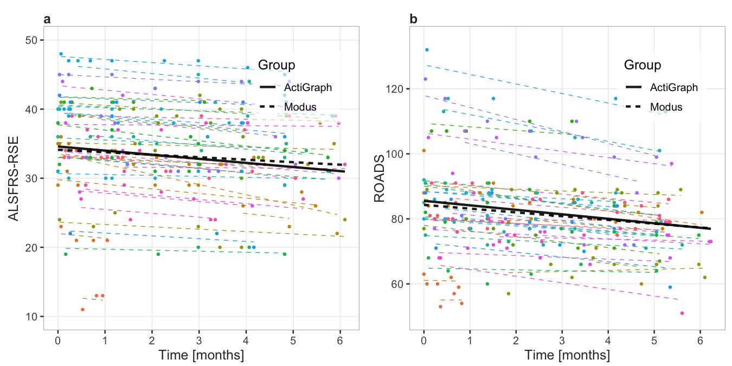
Supplementary Figure 1. Estimated survey baseline and change over time across groups by wearable device (ActiGraph, Modus). a Self-entry Amyotrophic Lateral Sclerosis Functional Rating Scale-Revised (ALSFRS-RSE). b Rasch-built Overall ALS Disability Scale (ROADS). Participants are color coded and the color scheme is maintained across plots: lines represent participant-specific conditional means, points represent observed values. The thick black lines in a, b represent the population mean by wearable device: ActiGraph (solid line), Modus (dashed line).

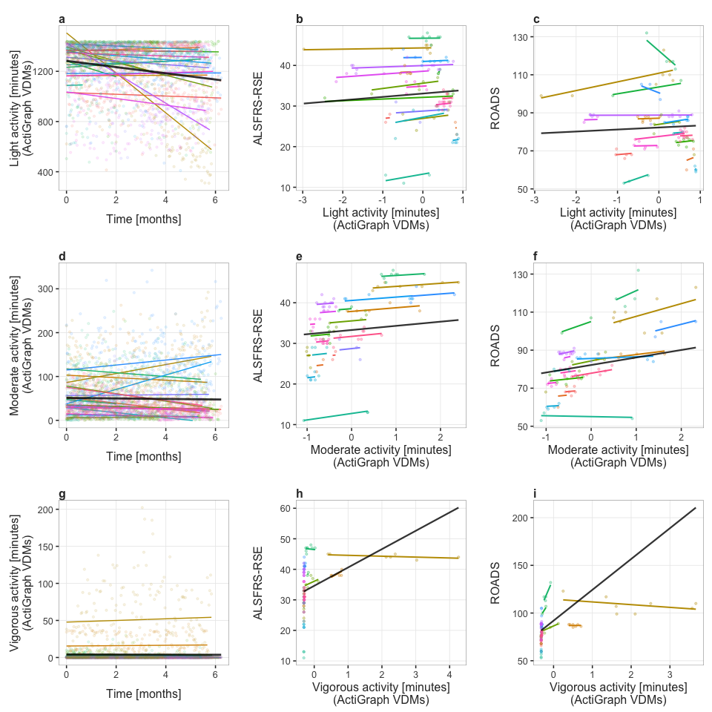 Supplementary Figure 2. Wearable physical activity daily measure change over time and their association with the self-entry amyotrophic lateral sclerosis (ALS) functional rating scale-revised (ALSFRS-RSE) and the Rasch-built Overall ALS disability Scale (ROADS). Three different daily measures are represented in the figure, one per row. Column 1 (a, d, g) - baseline and monthly change in the daily measure. Column 2 (b, e, h) - daily measure association with ALSFRS-RSE total score. Column 3 (c, f, i) - daily measure association with the ROADS total score. The slopes in columns 2 and 3 represent the effect estimates for daily measures, standardized to have 0 means and unit standard deviations. In each plot, colored lines represent participant conditional mean values, and the color scheme is maintained across plots. Black lines represent population mean values.

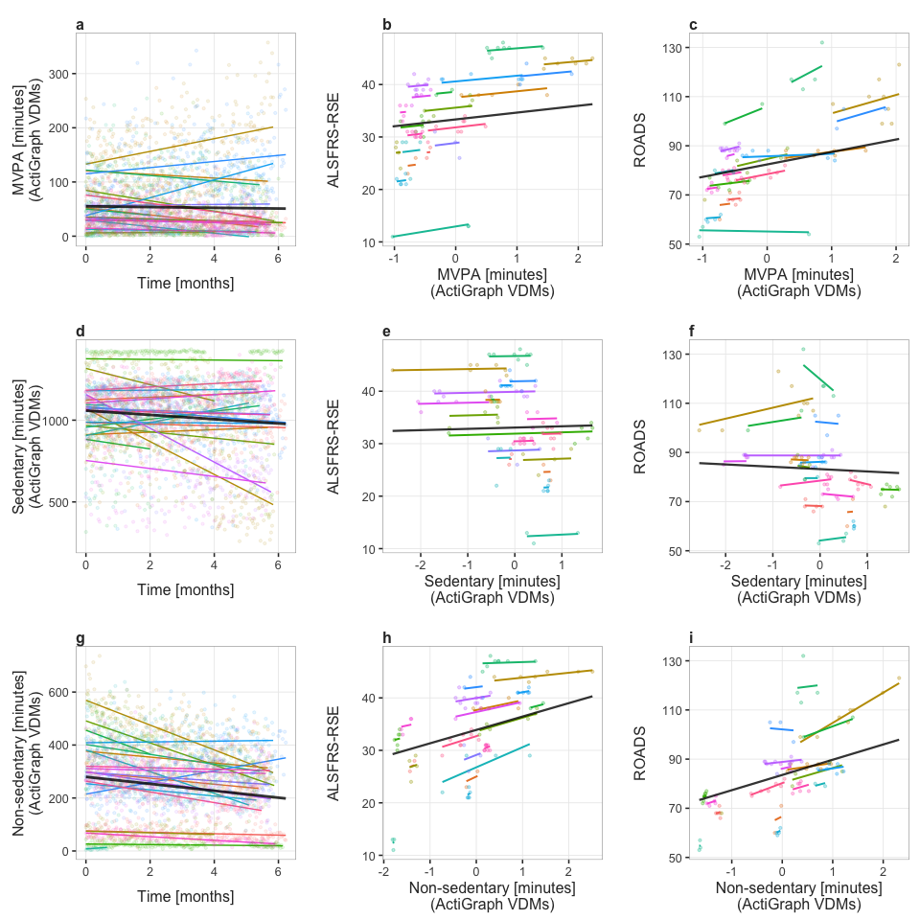 Supplementary Figure 3. Wearable physical activity daily measure change over time and their association with the self-entry amyotrophic lateral sclerosis (ALS) functional rating scale-revised (ALSFRS-RSE) and the Rasch-built Overall ALS disability Scale (ROADS). Three different daily measures are represented in the figure, one per row. Column 1 (a, d, g) - baseline and monthly change in the daily measure. Column 2 (b, e, h) - daily measure association with ALSFRS-RSE total score. Column 3 (c, f, i) - daily measure association with the ROADS total score. The slopes in columns 2 and 3 represent the effect estimates for daily measures, standardized to have 0 means and unit standard deviations. In each plot, colored lines represent participant conditional mean values, and the color scheme is maintained across plots. Black lines represent population mean values.

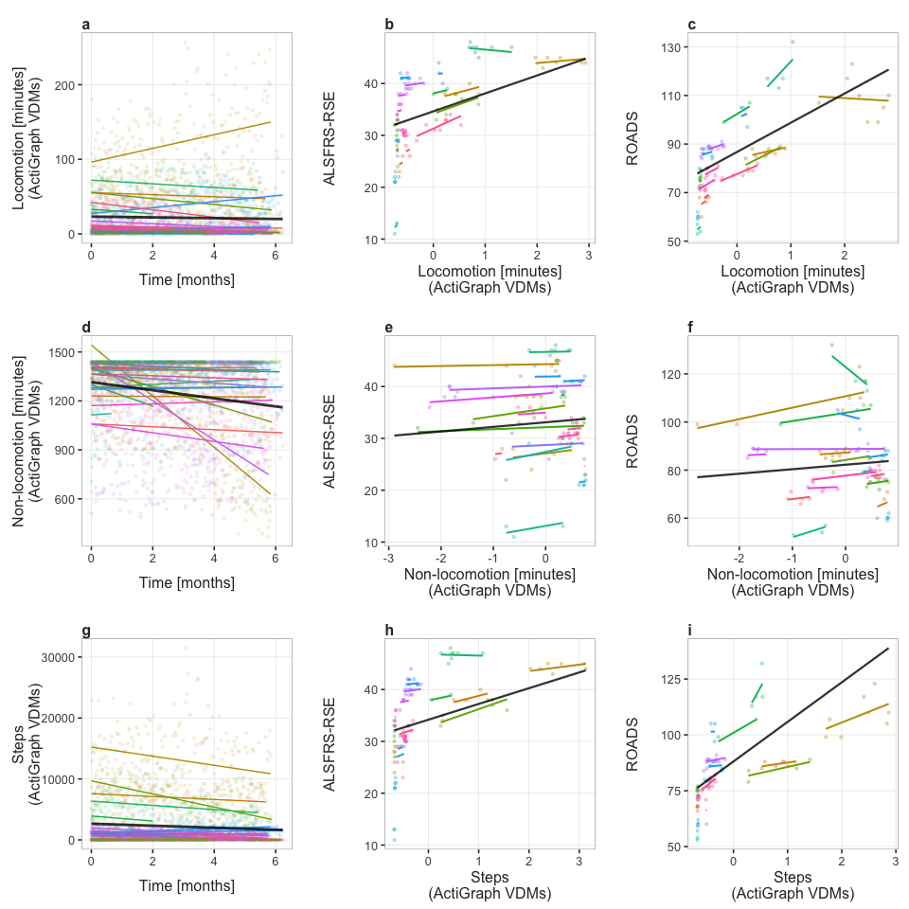 Supplementary Figure 4. Wearable physical activity daily measure change over time and their association with the self-entry amyotrophic lateral sclerosis (ALS) functional rating scale-revised (ALSFRS-RSE) and the Rasch-built Overall ALS disability Scale (ROADS). Three different daily measures are represented in the figure, one per row. Column 1 (a, d, g) - baseline and monthly change in the daily measure. Column 2 (b, e, h) - daily measure association with ALSFRS-RSE total score. Column 3 (c, f, i) - daily measure association with the ROADS total score. The slopes in columns 2 and 3 represent the effect estimates for daily measures, standardized to have 0 means and unit standard deviations. In each plot, colored lines represent participant conditional mean values, and the color scheme is maintained across plots. Black lines represent population mean values.

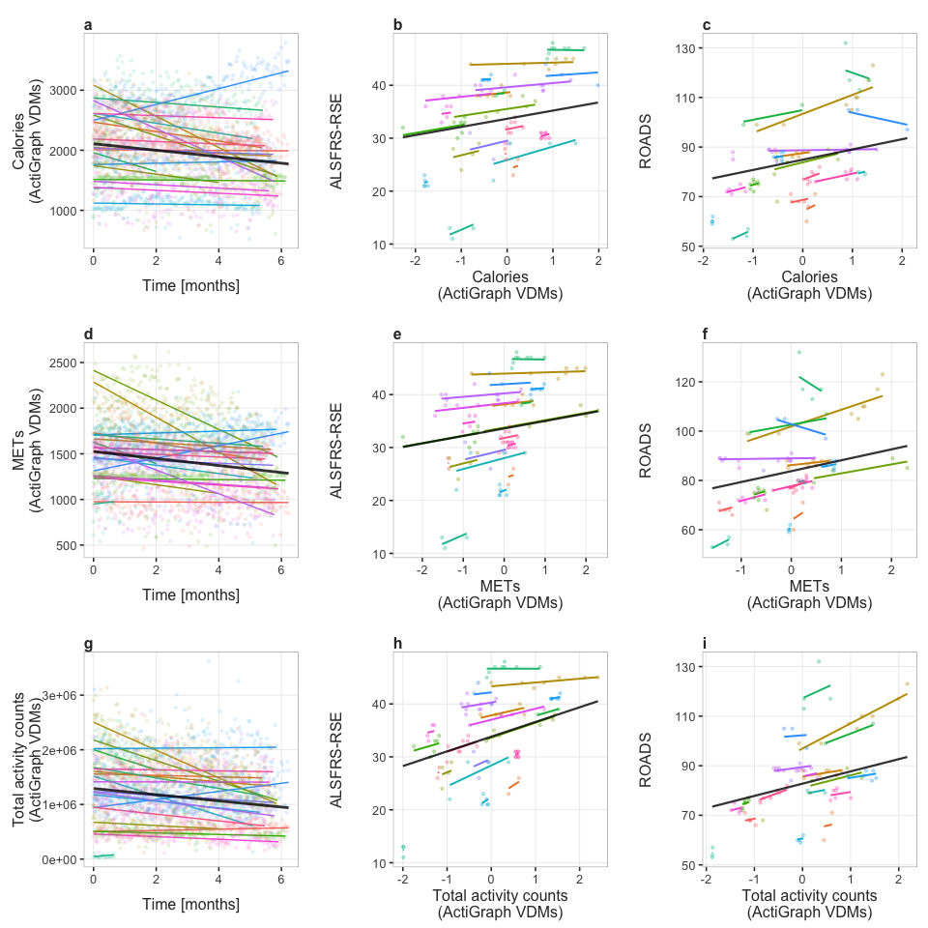 Supplementary Figure 5. Wearable physical activity daily measure change over time and their association with the self-entry amyotrophic lateral sclerosis (ALS) functional rating scale-revised (ALSFRS-RSE) and the Rasch-built Overall ALS disability Scale (ROADS). Three different daily measures are represented in the figure, one per row. Column 1 (a, d, g) - baseline and monthly change in the daily measure. Column 2 (b, e, h) - daily measure association with ALSFRS-RSE total score. Column 3 (c, f, i) - daily measure association with the ROADS total score. The slopes in columns 2 and 3 represent the effect estimates for daily measures, standardized to have 0 means and unit standard deviations. In each plot, colored lines represent participant conditional mean values, and the color scheme is maintained across plots. Black lines represent population mean values.

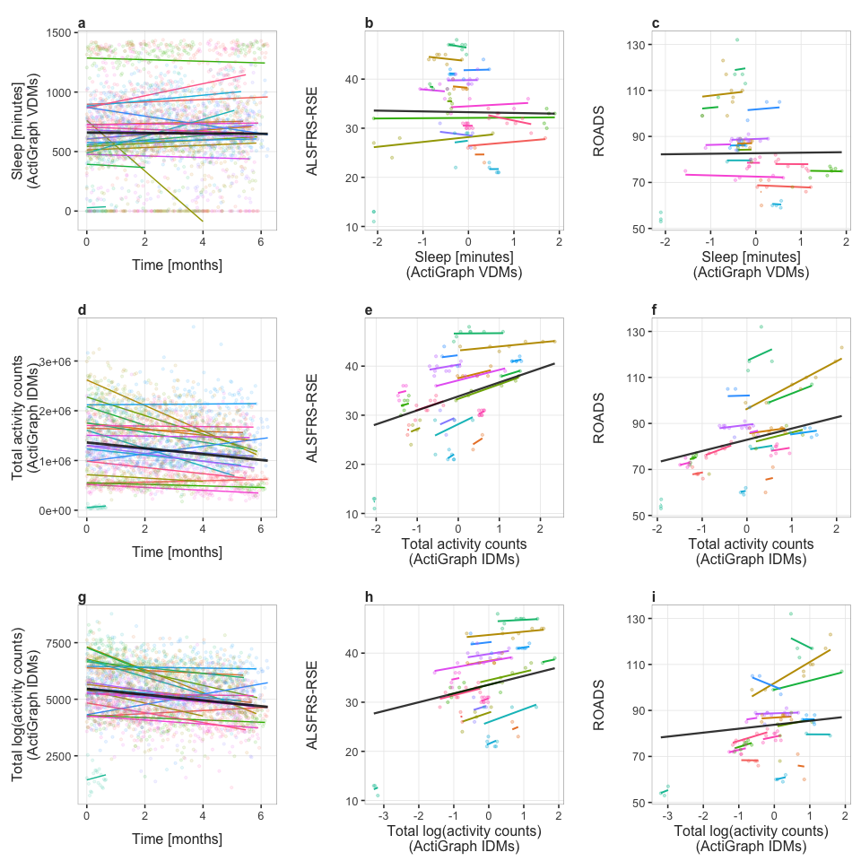 Supplementary Figure 6. Wearable physical activity daily measure change over time and their association with the self-entry amyotrophic lateral sclerosis (ALS) functional rating scale-revised (ALSFRS-RSE) and the Rasch-built Overall ALS disability Scale (ROADS). Three different daily measures are represented in the figure, one per row. Column 1 (a, d, g) - baseline and monthly change in the daily measure. Column 2 (b, e, h) - daily measure association with ALSFRS-RSE total score. Column 3 (c, f, i) - daily measure association with the ROADS total score. The slopes in columns 2 and 3 represent the effect estimates for daily measures, standardized to have 0 means and unit standard deviations. In each plot, colored lines represent participant conditional mean values, and the color scheme is maintained across plots. Black lines represent population mean values.

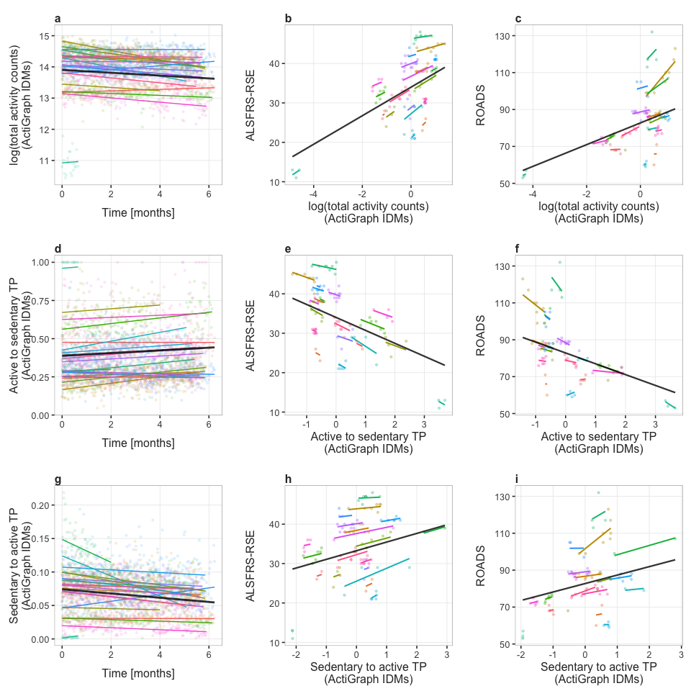 Supplementary Figure 7. Wearable physical activity daily measure change over time and their association with the self-entry amyotrophic lateral sclerosis (ALS) functional rating scale-revised (ALSFRS-RSE) and the Rasch-built Overall ALS disability Scale (ROADS). Three different daily measures are represented in the figure, one per row. Column 1 (a, d, g) - baseline and monthly change in the daily measure. Column 2 (b, e, h) - daily measure association with ALSFRS-RSE total score. Column 3 (c, f, i) - daily measure association with the ROADS total score. The slopes in columns 2 and 3 represent the effect estimates for daily measures, standardized to have 0 means and unit standard deviations. In each plot, colored lines represent participant conditional mean values, and the color scheme is maintained across plots. Black lines represent population mean values.

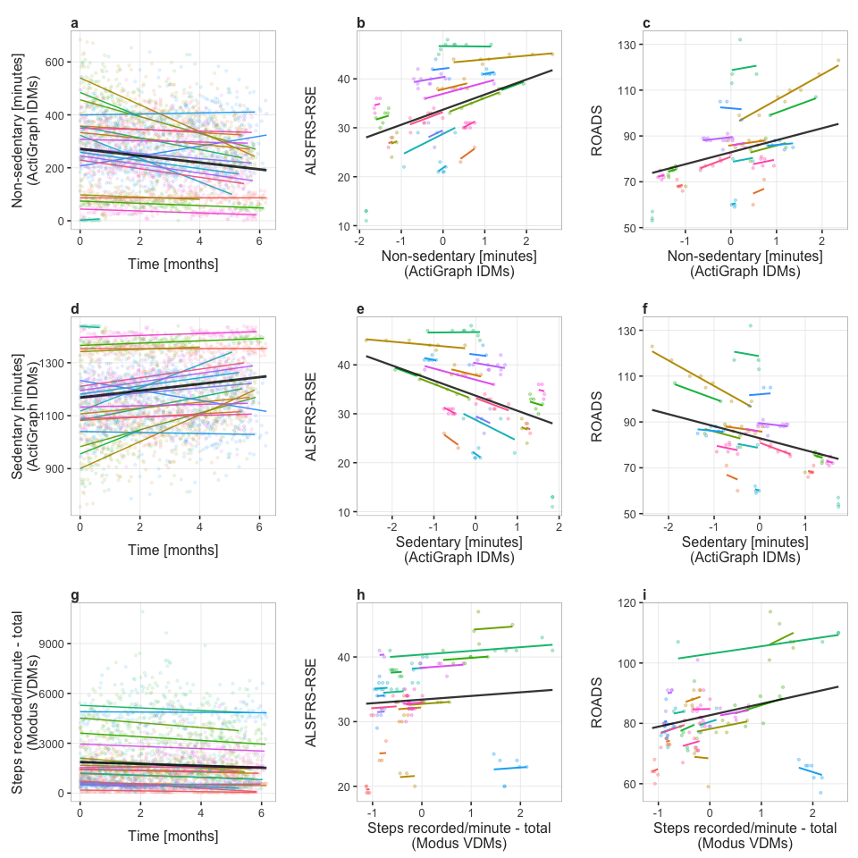 Supplementary Figure 8. Wearable physical activity daily measure change over time and their association with the self-entry amyotrophic lateral sclerosis (ALS) functional rating scale-revised (ALSFRS-RSE) and the Rasch-built Overall ALS disability Scale (ROADS). Three different daily measures are represented in the figure, one per row. Column 1 (a, d, g) - baseline and monthly change in the daily measure. Column 2 (b, e, h) - daily measure association with ALSFRS-RSE total score. Column 3 (c, f, i) - daily measure association with the ROADS total score. The slopes in columns 2 and 3 represent the effect estimates for daily measures, standardized to have 0 means and unit standard deviations. In each plot, colored lines represent participant conditional mean values, and the color scheme is maintained across plots. Black lines represent population mean values.

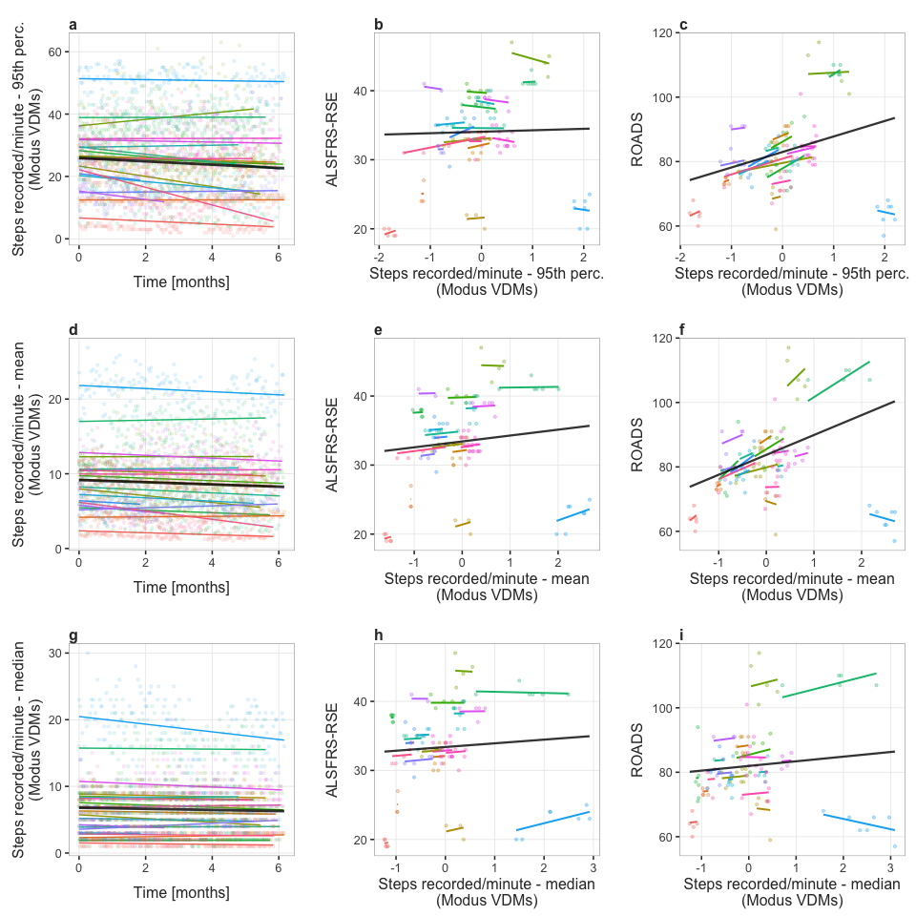 Supplementary Figure 9. Wearable physical activity daily measure change over time and their association with the self-entry amyotrophic lateral sclerosis (ALS) functional rating scale-revised (ALSFRS-RSE) and the Rasch-built Overall ALS disability Scale (ROADS). Three different daily measures are represented in the figure, one per row. Column 1 (a, d, g) - baseline and monthly change in the daily measure. Column 2 (b, e, h) - daily measure association with ALSFRS-RSE total score. Column 3 (c, f, i) - daily measure association with the ROADS total score. The slopes in columns 2 and 3 represent the effect estimates for daily measures, standardized to have 0 means and unit standard deviations. In each plot, colored lines represent participant conditional mean values, and the color scheme is maintained across plots. Black lines represent population mean values.

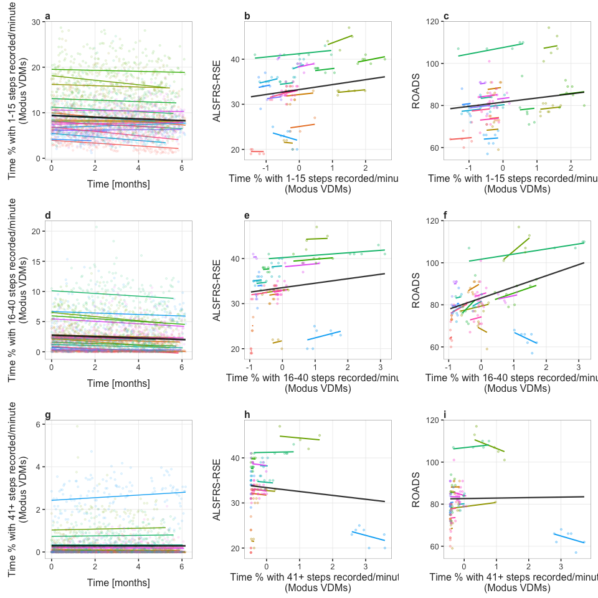 Supplementary Figure 10. Wearable physical activity daily measure change over time and their association with the self-entry amyotrophic lateral sclerosis (ALS) functional rating scale-revised (ALSFRS-RSE) and the Rasch-built Overall ALS disability Scale (ROADS). Three different daily measures are represented in the figure, one per row. Column 1 (a, d, g) - baseline and monthly change in the daily measure. Column 2 (b, e, h) - daily measure association with ALSFRS-RSE total score. Column 3 (c, f, i) - daily measure association with the ROADS total score. The slopes in columns 2 and 3 represent the effect estimates for daily measures, standardized to have 0 means and unit standard deviations. In each plot, colored lines represent participant conditional mean values, and the color scheme is maintained across plots. Black lines represent population mean values.

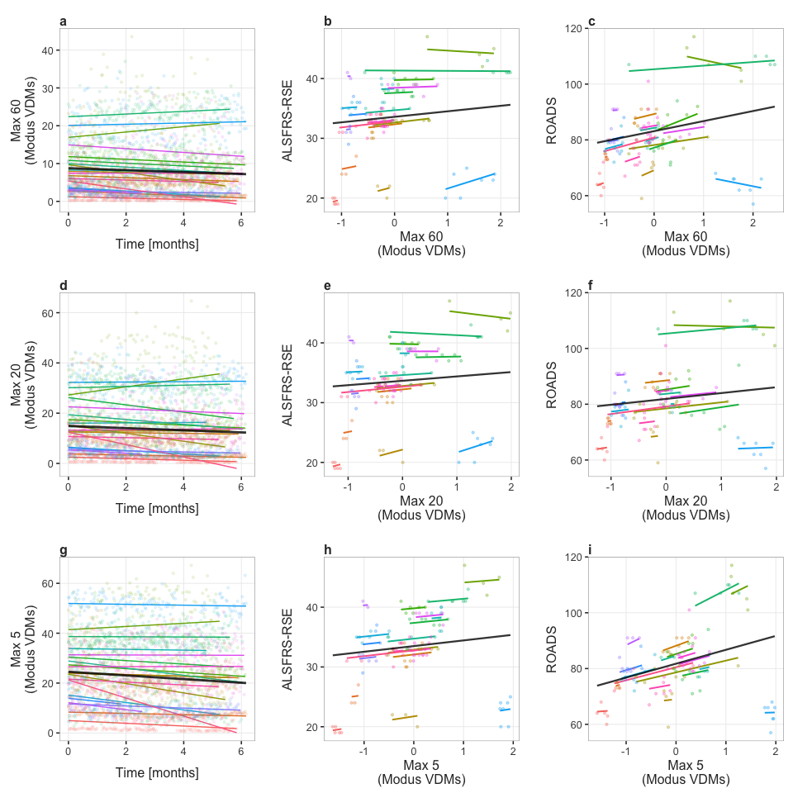 Supplementary Figure 11. Wearable physical activity daily measure change over time and their association with the self-entry amyotrophic lateral sclerosis (ALS) functional rating scale-revised (ALSFRS-RSE) and the Rasch-built Overall ALS disability Scale (ROADS). Three different daily measures are represented in the figure, one per row. Column 1 (a, d, g) - baseline and monthly change in the daily measure. Column 2 (b, e, h) - daily measure association with ALSFRS-RSE total score. Column 3 (c, f, i) - daily measure association with the ROADS total score. The slopes in columns 2 and 3 represent the effect estimates for daily measures, standardized to have 0 means and unit standard deviations. In each plot, colored lines represent participant conditional mean values, and the color scheme is maintained across plots. Black lines represent population mean values.

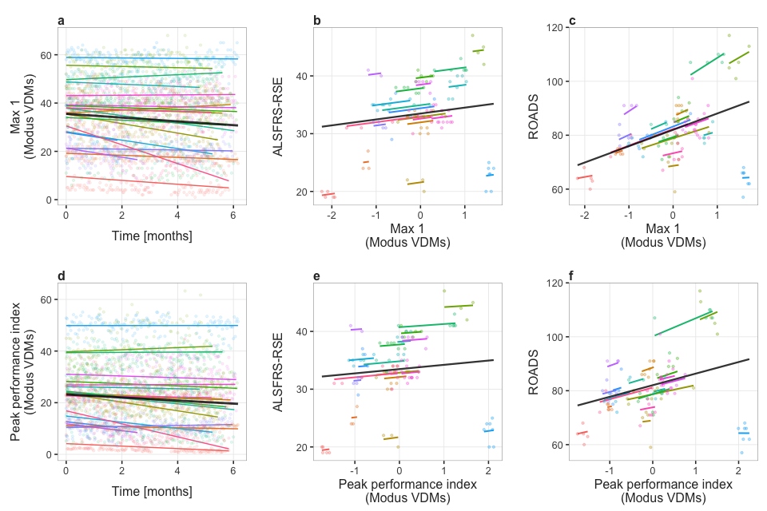 Supplementary Figure 12. Wearable physical activity daily measure change over time and their association with the self-entry amyotrophic lateral sclerosis (ALS) functional rating scale-revised (ALSFRS-RSE) and the Rasch-built Overall ALS disability Scale (ROADS). Two different daily measures are represented in the figure, one per row. Column 1 (a, d) - baseline and monthly change in the daily measure. Column 2 (b, e) - daily measure association with ALSFRS-RSE total score. Column 3 (c, f) - daily measure association with the ROADS total score. The slopes in columns 2 and 3 represent the effect estimates for daily measures, standardized to have 0 means and unit standard deviations. In each plot, colored lines represent participant conditional mean values, and the color scheme is maintained across plots. Black lines represent population mean values.

