Supplementary Information
Copper Nanostructured biohybrid material as broad-spectrum antiviral agent and its application as coating surface material

Noelia Losada-Garcia¹, Angela Vazquez-Calvo², David Ortega-Alarcon³, Olga Abian³⁻⁵, Adrian Velazquez-Campoy³⁻⁵, Pilar Domingo-Calap⁶ , Antonio Alcami² and Jose M. Palomo¹*

¹Instituto de Catálisis y Petroleoquímica (ICP), CSIC, C/ Marie Curie 2. 28049 Madrid, Spain, e-mail: josempalomo@icp.csic.es
²Centro de Biología Molecular Severo Ochoa, Consejo Superior de Investigaciones Científicas (CSIC)-Universidad Autónoma de Madrid (UAM), 28049, Madrid, Spain
³Institute of Biocomputation and Physics of Complex Systems (BIFI), Joint Unit GBsC-CSIC-BIFI, University of Zaragoza, Zaragoza, 50018, Spain.
⁴Fundación Instituto de Investigación Sanitaria de Aragón (IIS Aragón), 50009 Zaragoza, Spain.
⁵CIBERehd, 28029 Madrid, Spain
⁶Instituto de Biología Integrativa de Sistemas, I2SyBio, Universitat de València-CSIC, Valencia, Spain

Additional Methods

Materials
Lipase B from Candida antarctica (CAL-B) solution was purchased from Novozymes (Copenhagen, Denmark). Copper (II) sulphate pentahydrate [Cu₂SO₄ x 5H₂O], hydrogen peroxide (H₂O₂, 33%) and sodium hydroxide (NaOH) were from Panreac (Barcelona, Spain). Sodium phosphate, sodium chloride, benzoquinone, hydroquinone, p-aminophenol and (2,2,6,6-tetramethylpiperidin-1-yl)oxyl (TEMPO) were purchased from Sigma-Aldrich (St. Louis, MO, USA). HPLC grade acetonitrile (ACN), ethanol (EtOH) and 2-propanol were from Scharlab (Barcelona, Spain). Hexadecyltrimethylammonium bromide (CTAB) was from Affymetrix (California, EE.UU). 0.6% didecyldimethylammonium chloride (C₂₂H₄₈ClN) (commercial product Multipurpose Green Forest Disinfectant) and bleach (obtained by diluting commercial bleach (40 g sodium hypochlorite/L) were from commercial store (Madrid, Spain). SARS-CoV-2 (kindly provided by Volker Thiel, Institute of Virology and Immunology, Bern, Switzerland), recombinant Receptor Binding Domain (RBD) was purchased from CerTest Biotec (Zaragoza, Spain, ref. MT-25RBDs1). LB medium was purchased from Formedium (Norfolk, England). FRET peptide substrate was from Biosyntan GmbH (Berlin, Germany). Vero-E6, HuH-7 cells (kindly provided by Isabel Solá and Luis Enjuanes, CNB-CSIC, Madrid, Spain) and HeLa-H1 (kindly provided by Mauricio García-Mateu, CBMSO, Madrid, Spain) were grown in Dulbecco’s modified Eagle’s medium (DMEM; Invitrogen) containing 5% fetal bovine serum (FBS), 2mM L-glutaminie, 100 mg/ml streptomycin and 100 U/ml penicillin, incubated at 37ºC/5%CO2. Virus used were: HCoV-229E, SARS-CoV2 strains MAD6 (were kindly provided by Isabel Solá and Luis Enjuanes, CNB-CSIC, Madrid, Spain) and HRV-14 (was kindly provided by Mauricio García-Mateu, CBMSO, Madrid, Spain). All infectious virus manipulations were performed in our biosafety level 2 (BSL-2) or BSL-3 facilities.

Other equipment
To recover the nanobiohybrids, a Biocen 22 R (Orto-Alresa, Ajalvir, Spain) refrigerated centrifuge was used.
To measure the pAP samples a HPLC pump PU-4180 (JASCO, Tokyo, Japan) was used. Analyses were run at 25 ºC using a RI-4030 refractive Index detector (JASCO, Tokyo, Japan) and a UV-4075 ultraviolet detector (JASCO, Tokyo, Japan).
A synergy HT (BioTek) multimode microplate reader was used for cell viability assays.
Fenton process assay
p-aminophenol (pAP) (1 mg) was dissolved (10 mL) in distilled water and 100 mM of hydrogen peroxide (1%, v/v) were added. To initiate the reaction, 10 mL of this solution were added to a glass bottle containing 130µL of 500ppm solution (3mg) of NanoCu and stirred gently at room temperature on an orbital shaker (320 rpm). At different times samples (100 µL) were taken and the reaction was followed by HPLC. Samples were first centrifuged at 8000 rpm for 5 min and then 50 µL were diluted 20 times in bi-distilled water before injection. HPLC column was C8 Kromasil 150 × 4.6 mm AV-2059. HPLC conditions were: an isocratic mixture of 15% acetonitrile and 85% bi-distilled water, UV detection at 270 nm, and a flow rate of 0.4 mL/min. The possible adsorption of substrate to the catalyst was first tested and without the presence of hydrogen peroxide no reaction was observed and the full area of the substrate was unaltered in the HPLC analysis. Then, the reaction was repeated in the presence of 0.1 mmol of TEMPO (48 mg of polymer-bound TEMPO).

Stability of NanoCu under different conditions
- Stability against contact with different disinfectants
To evaluate the effect of disinfectants on the stability of NanoCu previously adhered to a certain surface, samples of 0.25 g of solid were prepared with 800 µL of ethanol:water 50:50, each of which was added to a Petri dish. Once air dried (1-3 h), 600 µL of each disinfectant was sprayed. The disinfectants used were 0.6% didecyldimethylammonium chloride (C₂₂H₄₈ClN) (commercial product Multipurpose Green Forest Disinfectant), 3% hydrogen peroxide (obtained by diluting a 33% hydrogen peroxide solution), 0.1% bleach (obtained by diluting commercial bleach (40 g sodium hypochlorite/L) in water), 70% and 96% ethanol, 70% isopropanol and 1.75% hexadecyltrimethylammonium bromide (CTAB). After air drying in a Petri dish, the solid was recovered. To verify that there was no change in the chemical species of the sample, they were analysed by X-ray diffraction (XRD).

- Stability against incubation in the presence of additives described as disinfectants
To assess the stability of NanoCu mixed directly with the disinfectant, 5 mg of the material was incubated in 7.5 mL of a solution (0.66 mg/mL) of 0.1% bleach, 70% isopropanol, or CTAB 1.75 %, evaluating its stability after 7 days of incubation. After this incubation time, the solids did not undergo any type of change in colour or morphology, the copper species (demonstrated by X-rays) and the amount of copper (quantitative analysis) being completely preserved. Furthermore, it was confirmed that the catalytic efficiency of the nanoparticles in NanoCu was preserved at 100% after the incubation time (Figure S15B).
Stability under high temperature
Another test performed to evaluate the stability of NanoCu was incubation at high temperature. In this case, the stability of the chemical structure was evaluated by exposing the material for 1 h at 100ºC in water and air, and at 150ºC in an oil bath. The solids after treatment were evaluated by X-ray diffraction. There were no changes in the chemical species of NanoCu, and therefore the coating is stable at high temperature.
Virucidal assay with bacteriophages with NanoCu
To analyze the effect of the NanoCu component in other viruses, four bacteriophages encompassing different viral families and morphological structures were tested. Two phages, f1 and ΦX174, as model phages infecting Escherichia coli, and other two, F30 and F.a.2 infecting Mycobacterium smegmatis. The four bacteriophages belong to different families: phage f1 belongs to the Inoviridae, ΦX174 to Microviridae, F30 to Myoviridae and F.a.2 belongs to the Siphoviridae families. In order to assay the effects of NanoCu, 10 µL of each virus at a concentration between 108 -1010 PFU/mL were added to tubes containing 1 mL of LB (Lysogeny Broth) culture medium supplemented with 5 mM CaCl2 and the NanoCu product (M1: fresh NanoCu, 2: fresh NanoCu + H2O2, 3: 4-month-old NanoCu, M4: 4-month old NanoCu + H2O2) at a final concentration of 1000 µg/mL. For controls, 10 µL of virus was added to LB+CaCl2 culture medium, without NanoCu. Each phage, sample and time condition was performed in triplicate. They were incubated at room temperature and shaked at 1000 rpm for 4h. After the corresponding time, in each case, the virus concentration was calculated by the plaque assay method. For this purpose, the double layer technique with top agar was used. Thus, 200 µL of the corresponding stationary bacterial culture together with 10 µL of each virus were seeded in Petri dishes of LB+CaCl2 medium using LB-Top agar. After incubation at 37 °C for 24h (E. coli) or 48h (M. smegmatis), viral plaques formed were counted and the concentration in PFU/mL was calculated.
Stability of the water paint mix with NanoCu under different conditions
Temperature stability
Regarding the thermal stability of the mixture, tests were carried out by incubating the mixture of paint and NanoCu 10% at different temperatures, 25ºC, 40ºC and 70ºC. On the other hand, another paint sample with 10% NanoCu was kept at 25ºC for one year, analysed by X-ray diffraction (XRD).
Stability of the mixture against commercial disinfectants
The sample (water-based paint mixture with 10% NanoCu) was incubated in a petri dish in the presence of 1mL of different commercial disinfectants such as 0.6% didecyldimethylammonium chloride (C₂₂H₄₈ClN) (commercial product Multipurpose Green Forest Disinfectant), 3% hydrogen peroxide (made by diluting a 33% hydrogen peroxide solution), 0.1% bleach (made by diluting commercial bleach (40 g sodium hypochlorite/L) in water), and 70% ethanol. To evaluate the potential migration of NanoCu from the mixture, the samples were analysed by ICP-OES.
NanoCu application on different surfaces by spraying method
Using a MC360 equipment
For the direct application of NanoCu to different surfaces (surgical mask, 100% cotton fabric, white, black and filter polyester fabric) by means of the electrostatic spraying method with the MC360 equipment from the Microclean company (https://microclean- solutions.com/project/mc-360/) the product was used at a concentration of 5000ppm at a flow rate of 118mL/min. The spraying process was carried out for different times (1-10 sec). Subsequently, hot air drying was performed for 30 s.
Using a spray can
For the direct application of NanoCu on different surfaces (Paper, 100% cotton fabric, white polystyrene fabric, FFP2 mask, surgical mask) a spray was used at a concentration of 1250ppm and 625ppm. The spraying process was carried out for different positions and sprays (9 sprays at 5 cm from the paper horizontally, 9 sprays at 15 cm from the paper horizontally, 9 sprays at 45º paper tilt, 15 sprays at 5-10 cm from the paper vertically, 12 sprays at 20 cm from the paper vertically). Subsequently, hot air drying was performed for 30 s.

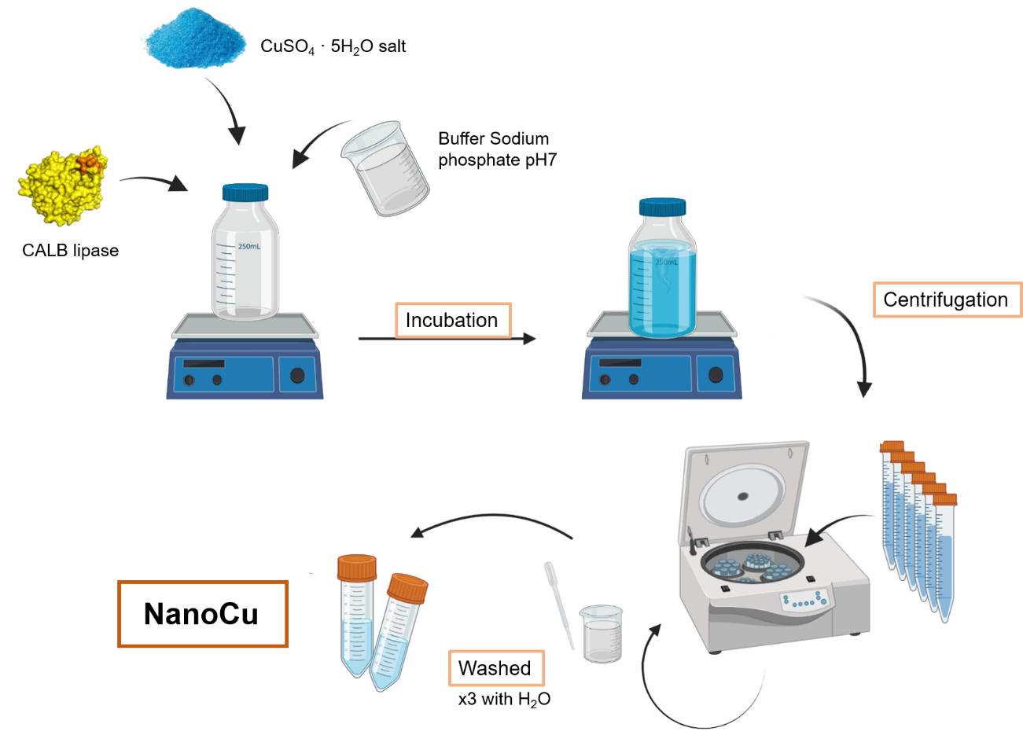
Figure S1. Protocol scheme of NanoCu synthesis.

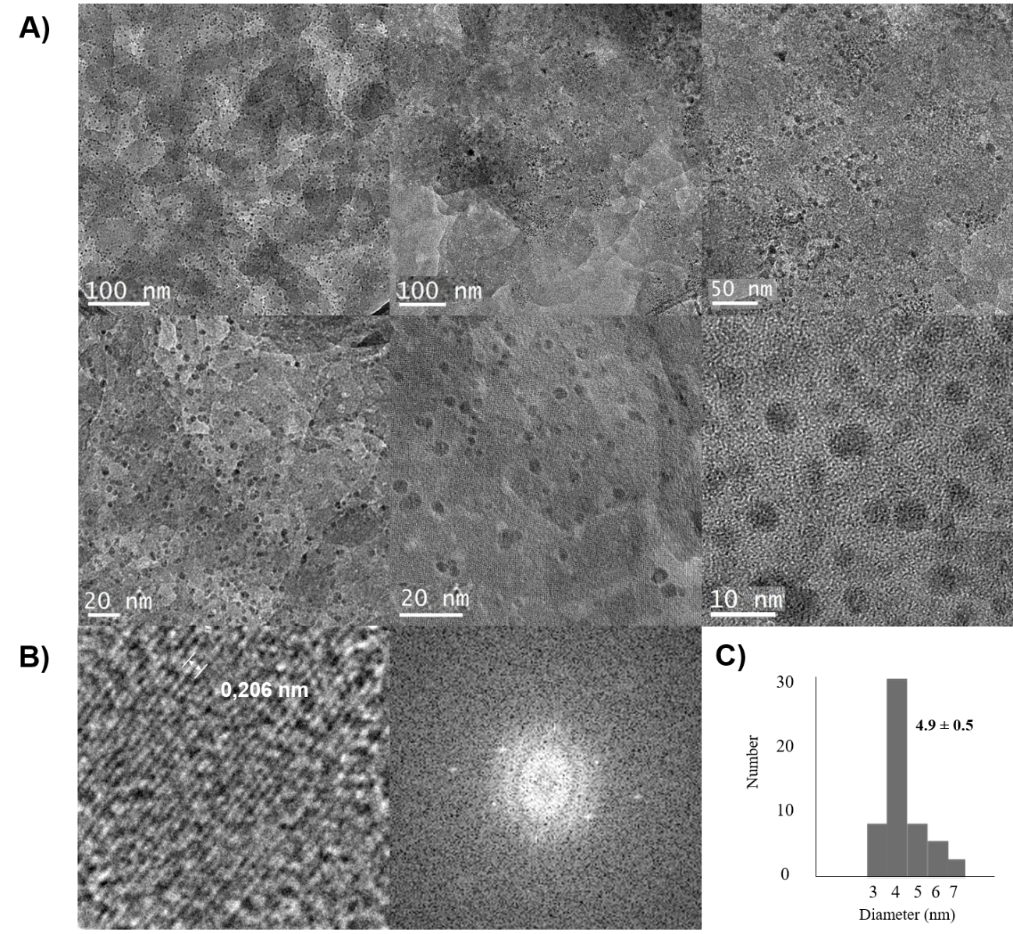

Figure S2. Characterization of NanoCu. A) TEM and HR-TEM images; B) FFT and IFFT analysis; C) Particle size distribution.

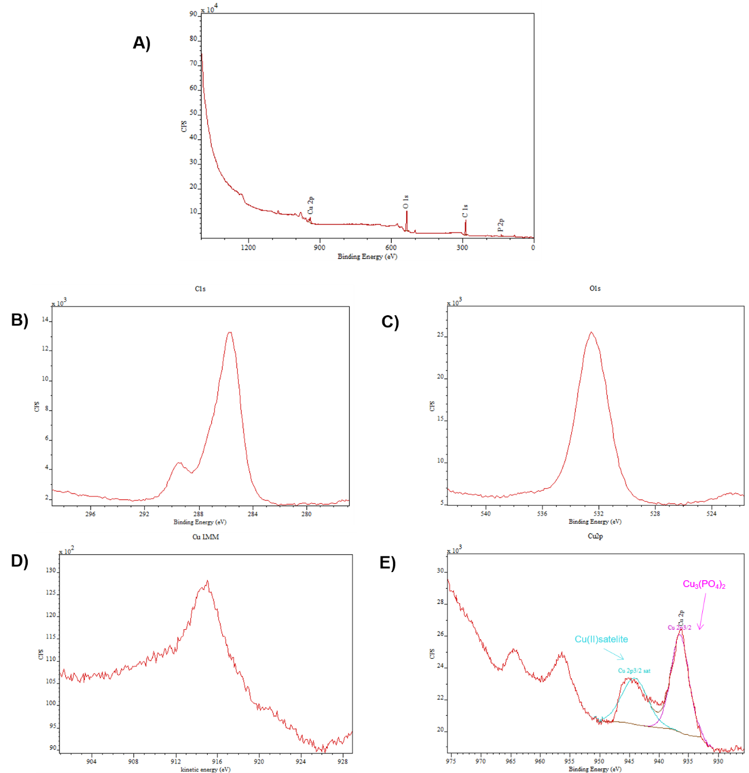
Figure S3. XPS analysis of NanoCu. A) XPS full spectrum. B) XPS spectrum of C1s, C) XPS spectrum of O1s. D) Cu LMM auger spectrum, E) XPS spectrum of Cu2p.

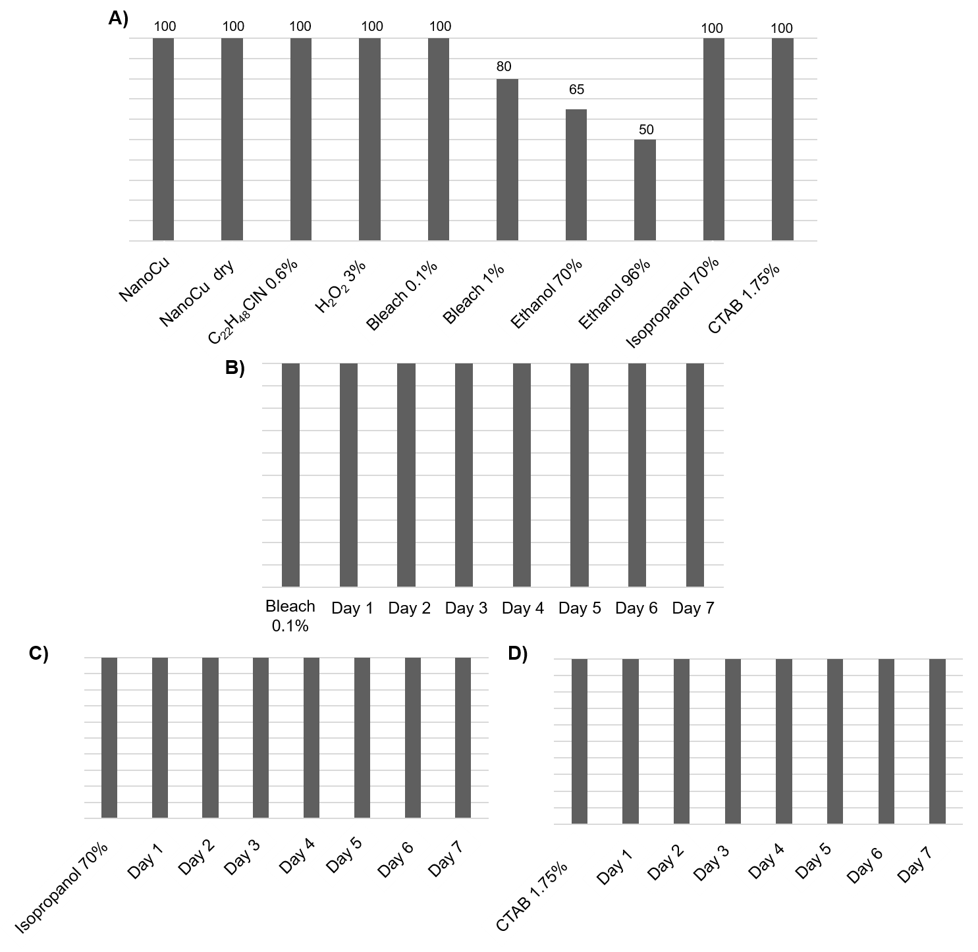
Figure S4. Catalytic efficiency of NanoCu. A) Samples treated with the different disinfectants compared with the fresh material and the material dried under the same conditions. B) NanoCu mixed directly with 0.1% bleach for 7 days. C) NanoCu mixed directly with 70% isopropanol for 7 days. D) NanoCu mixed directly with CTAB (1.75%) for 7 days. Catalytic efficiency was determined using the p-aminophenol oxidation assay. (C₂₂H₄₈CIN empirical formula of didecyldimethylammonium chloride).

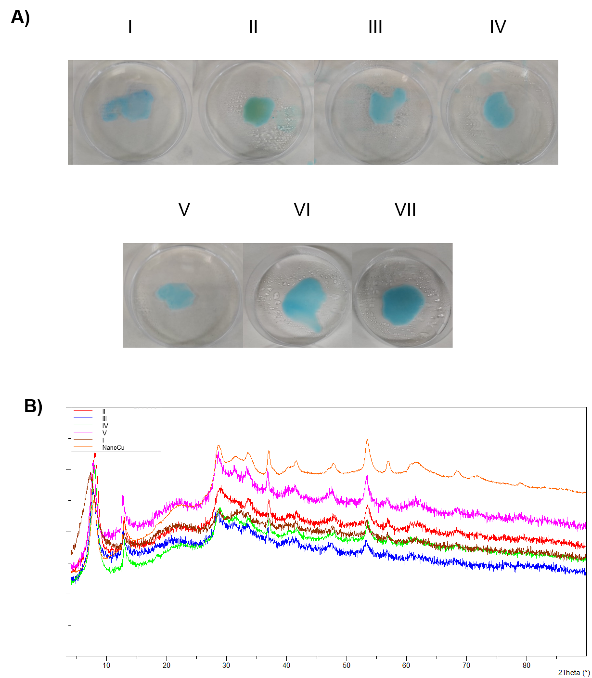
Figure S5. Stability of NanoCu against contact with disinfectants. A) Samples in Petri dishes with the different disinfectants. B) X-ray diffraction spectra (XRD) of the solids after disinfectant application compared to the untreated solid. I) Multipurpose disinfectant (0.6% didecyldimethylammonium chloride); II) 3% H₂O₂; III) 0.1% bleach; IV) 70% ethanol; V) 96% ethanol, VI) 70% isopropanol, VII) 1.75% CTAB.

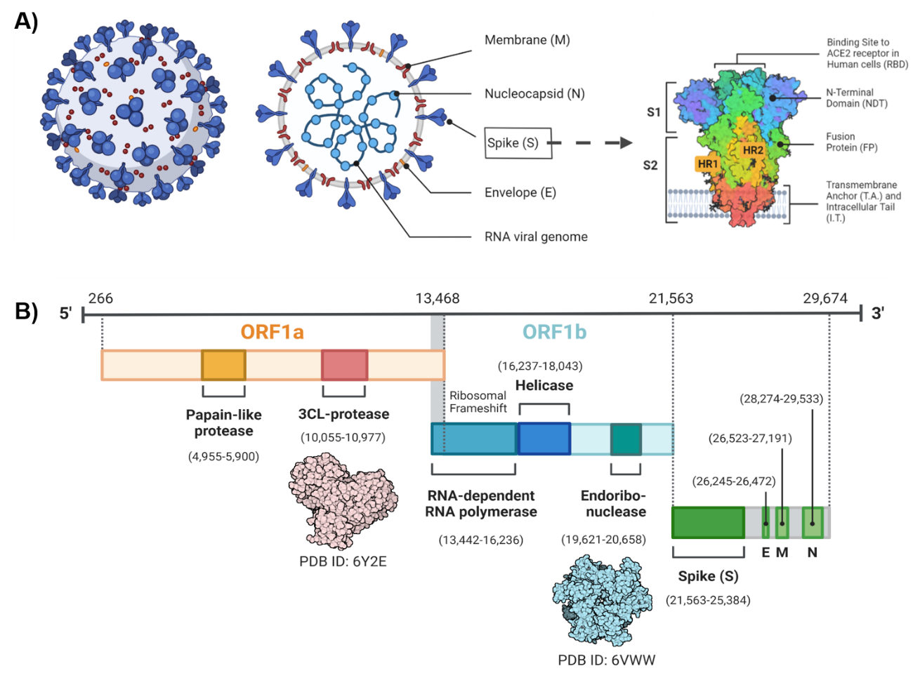
Figure S6. A) Scheme of important functional proteins involved in SARS-CoV-2 and an in-depth look into the structure of Spike Glycoprotein; B) The genomic organization of SARS-CoV-2, which includes ORF1a (yellow), ORF1b (blue), Spike (S), E, M, and N proteins (green).

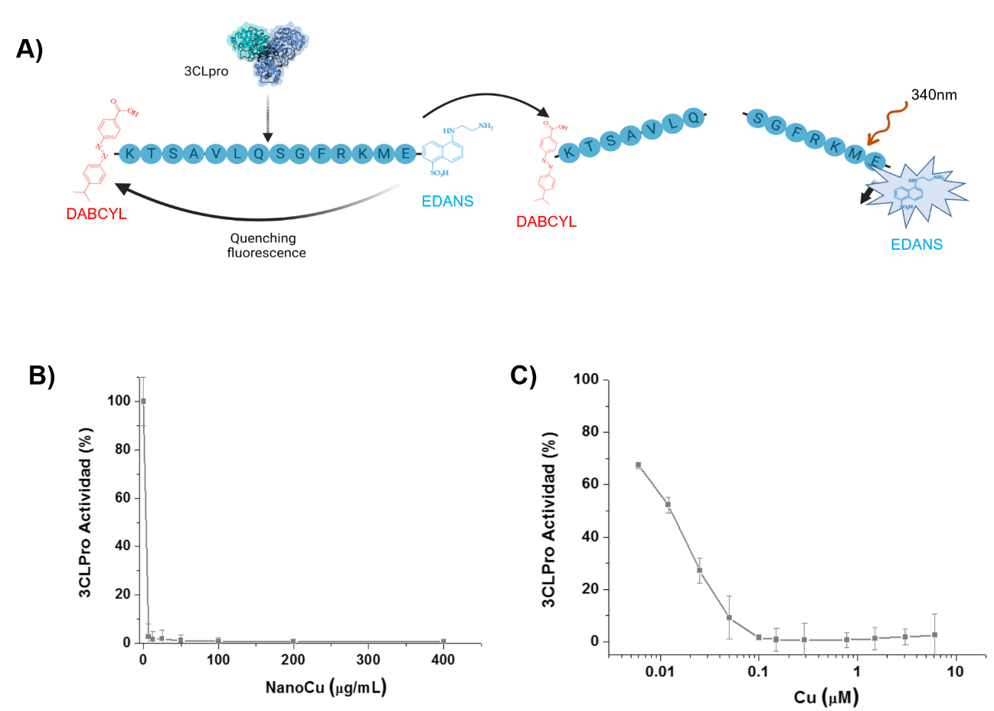
Figure S7. A) Representative scheme of the 3CLpro protein quenching mechanism by fluorescence resonance energy transfer (FRET) cleavage assay with 20 μM peptide substrate (Dabcyl)-KTSAVLQSGFRKME-(Edans)-NH in 100 µL. 0.2 μM 3CLpro in 50 mM sodium phosphate, 150 mM NaCl, at pH 7. FluoDia T70 reader (λ_{excitation}= 340 nm; λ_{emission}= 480 nm).b); B-C) Functional characterization of NanoCu by an activity assay of the SARS-CoV-2 3CLpro protein at increasing concentrations of NanoCu in continuous assay. Data are presented as a function of NanoCu concentration in μg/mL (B) and of Cu contained in NanoCu in μM (C).

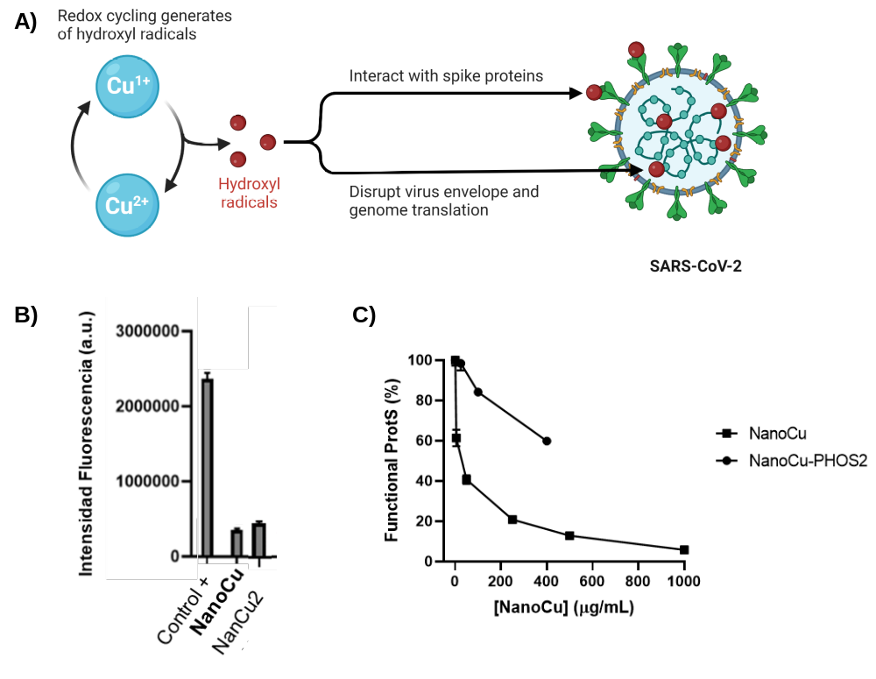
Figure S8. A) Theoretical mechanism of the interaction of CuNPs with SARS-CoV-2 on the Surface. B) Functional characterization of NanoCu and NanoCu2 by an activity assay of the SARS-CoV-2 3CLpro protein in the presence of 30 μg/mL. Control of protein without NanoCu was tested. The value was determined at final point after 20 min. C) Functional characterization of NanoCu and NanoCu2 using a RayBio® COVID-19 Spike-ACE2 binding assay in the presence of increasing concentrations of nanomaterial in μg/mL.

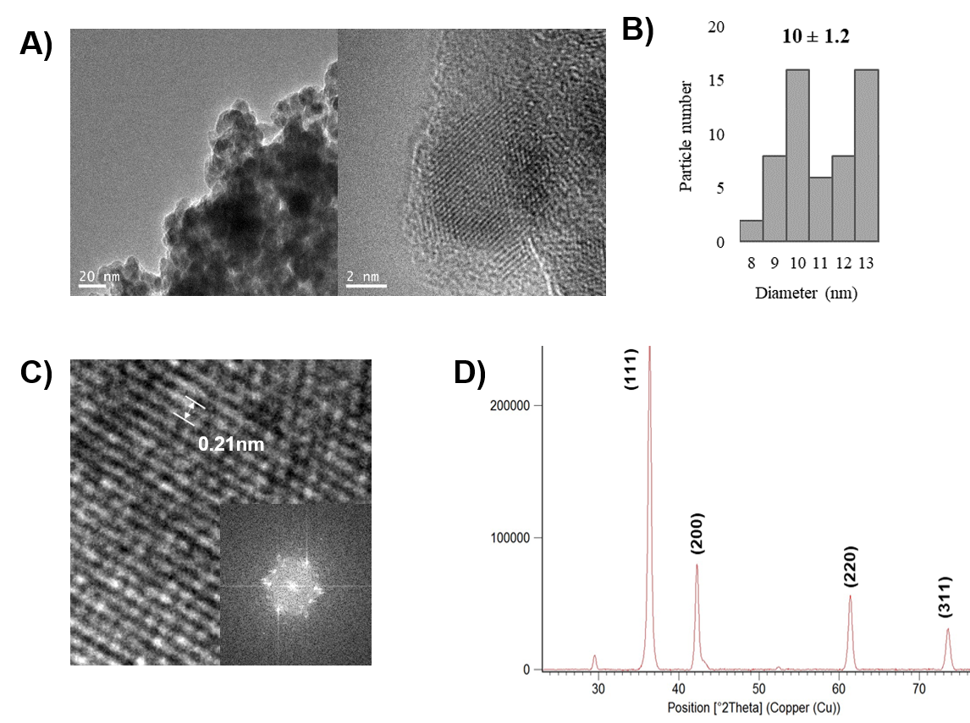
Figure S9. Characterization of NanoCu-2. A) TEM and HR-TEM images; B) Particle size distribution; C) FFT and IFFT analysis; D) XRD spectrum.

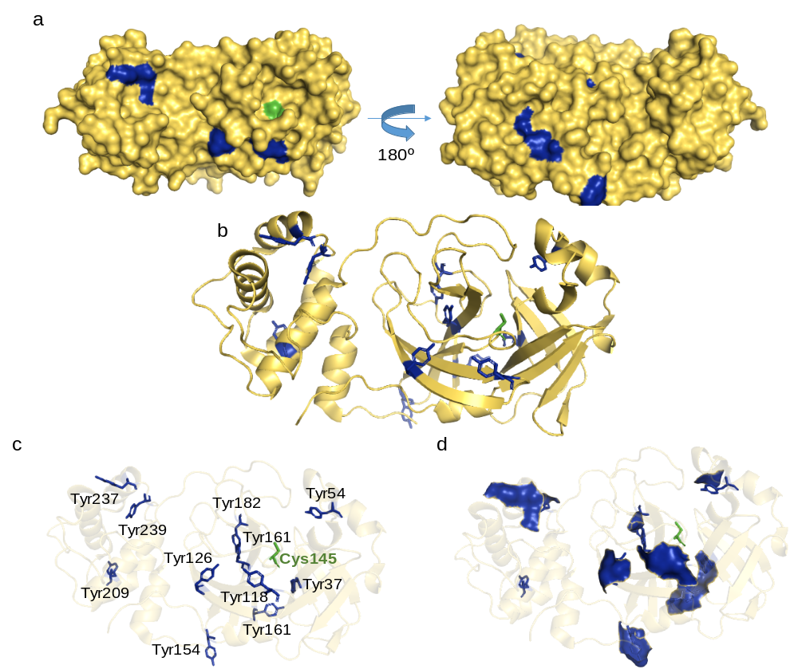

Figure S10. 3CLPro SARSCoV2 crystal structure. A) Surface image B) Cartoon C) Tyrosines marked in blue. Cysteine of active site in gree. D) Surface image of surface tyrosinases.

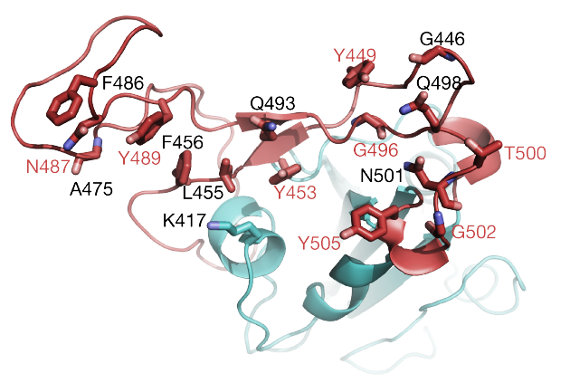

Figure S11. RBD-binding Spike protein with key aminoacids marked. Recently Gln493, Gln498, Asn501, Phe486, Lys417, Phe456 and tyrosines Tyr505, Tyr449, Try489 and Tyr495 have been identified as key residues in the region binding domain (RBD) of the spike protein for the tight binding of SARS-CoV-2 with ACE2, whereas Asn343 and Asn331 are two glycosylated sites in RBD structure.

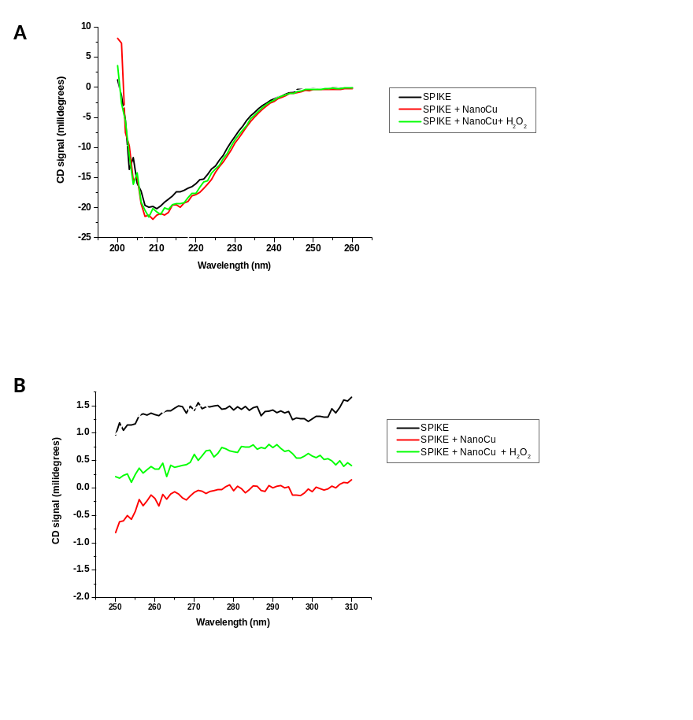
Figure S12. Circular Dichroism analysis of Spike protein in the absence and presence of NanoCu. A) Far-CD spectra. B) Near CD spectra.

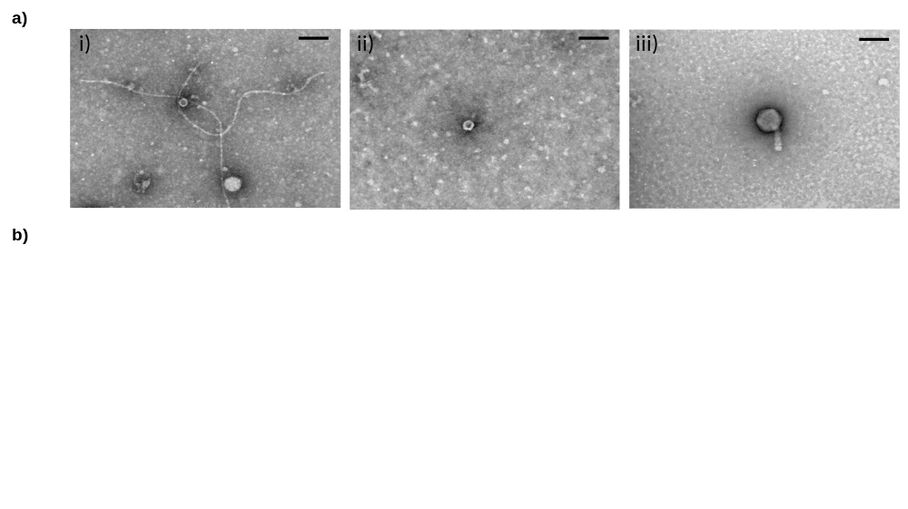

Figure S13. A) Electron micrographs of the bacteriophages f1, ΦX174 and F30. The bacteriophages present different morphological structures. i) Phage f1, Inoviridae, filamentous. ii) Phage ΦX174, Microviridae, small icosahedral, and iii) F30 to Myoviridae, large head and a long, thick, complex, contractile tail. Scale bar: 100nm. B)Virucidal effect of NanoCu and NanoCu + H₂O₂ against bacteriophages f1, ΦX174 and F30. Bacteriophages were incubated 4 hours at a concentration of 1000 μg/mL of NanoCu in presence and absence of H₂0₂, fresh and old NanoCu (after 7 month synthesized). Controls were done in absence of any treatment. All tested samples were done in triplicate. Error bars correspond to the standard error of the media. Unpaired t-test was performed comparing experimental treatments and controls for each bacteriophage: *: p < 0.05.

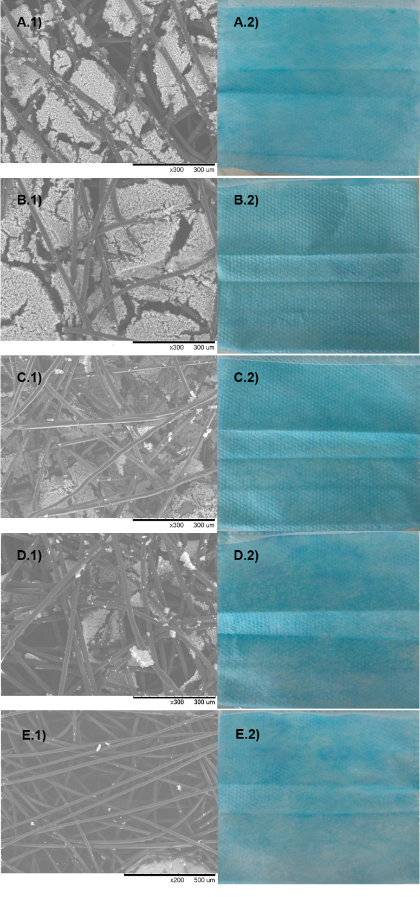
Figure S14. 1) SEM microscopy images of the structure of the surgical mask with the coating with NanoCu in ethanol:water 50:50; 2) Image of the actual mask. A) 1000ppm; B) 750ppm; C) 500ppm; D) 250ppm; E) 125ppm. All samples have been made in 45cm².
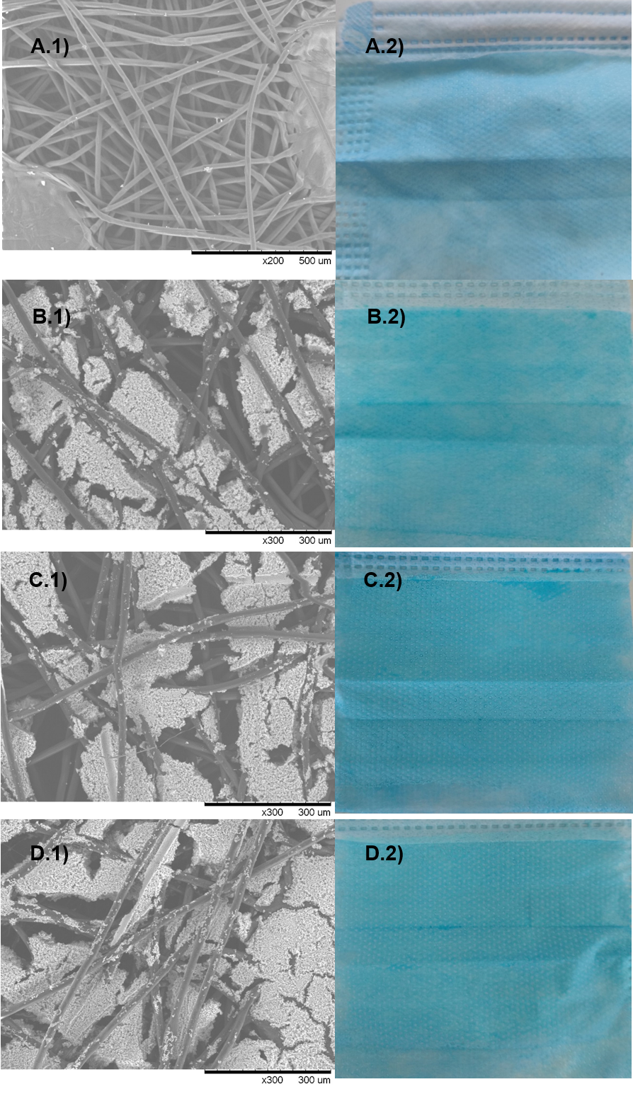
Figure S15. 1) SEM microscopy images of the surgical mask structure. 2) Image of the actual mask. A) Untreated surgical mask; B) Mask with NanoCu in Ethanol:water 50:50; C) Mask with NanoCu in Ethanol:water 70:30; D) Mask with NanoCu in Ethanol:water 80:20. All samples have been made in 45cm² with 1000ppm of NanoCu.
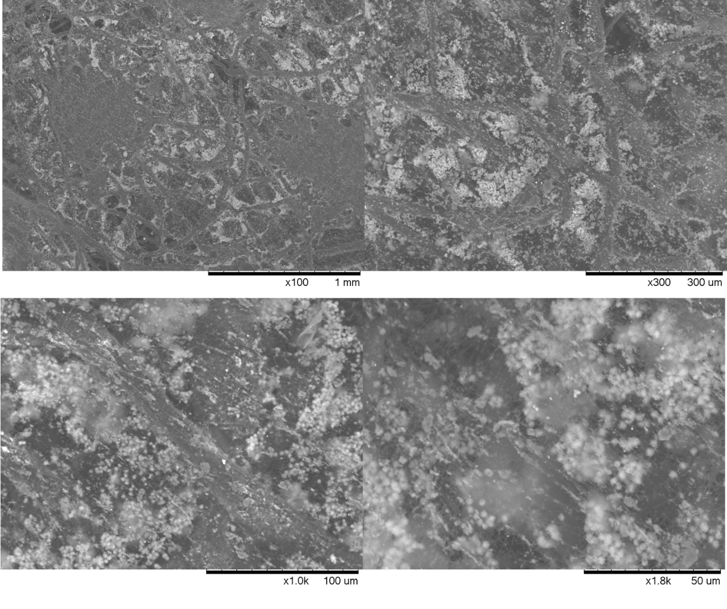
Figure S16. SEM microscopy images of the structure of the FFP2 mask with 250ppm the NanoCu as coating in ethanol:water 50:50.

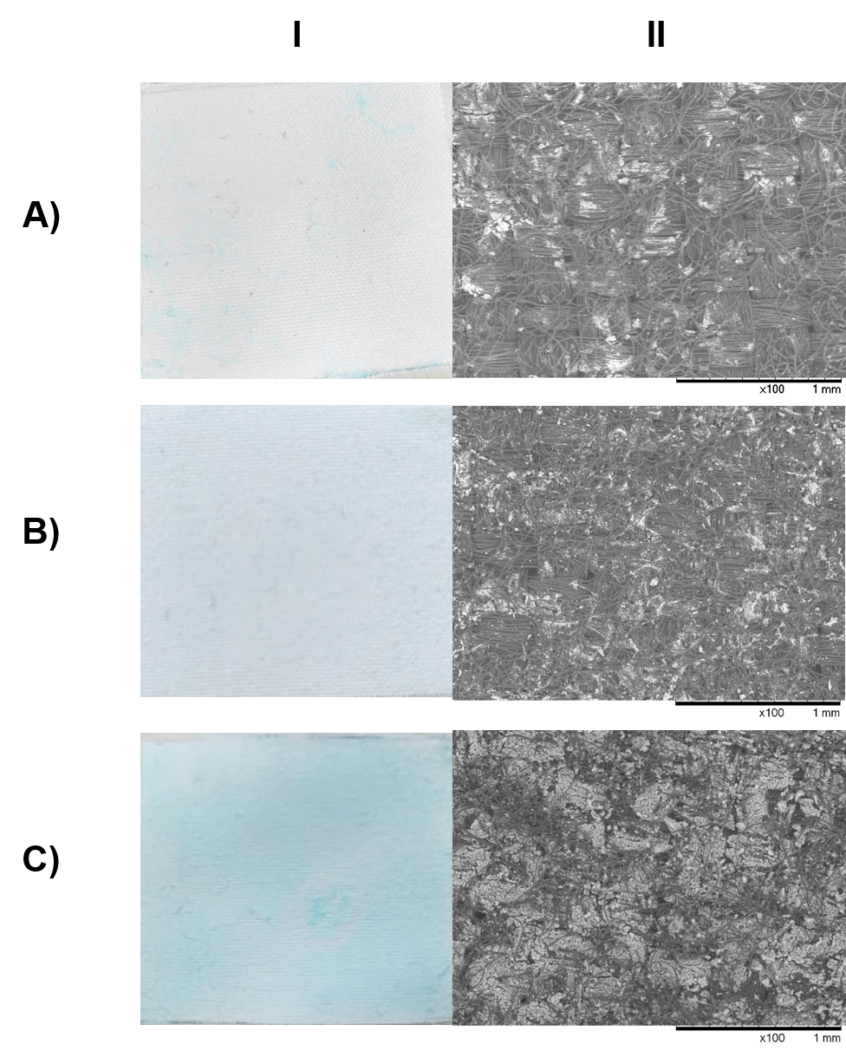
Figure S17. White polystyrene fabric tests: 1) Image of the actual fabric; 2) SEM microscopy images of the structure of the polystyrene fabric with the coating NanoCu in ethanol:water 50:50. A) 125ppm; C) 250ppm. B) 350ppm; All samples have been made in 10.5cm².

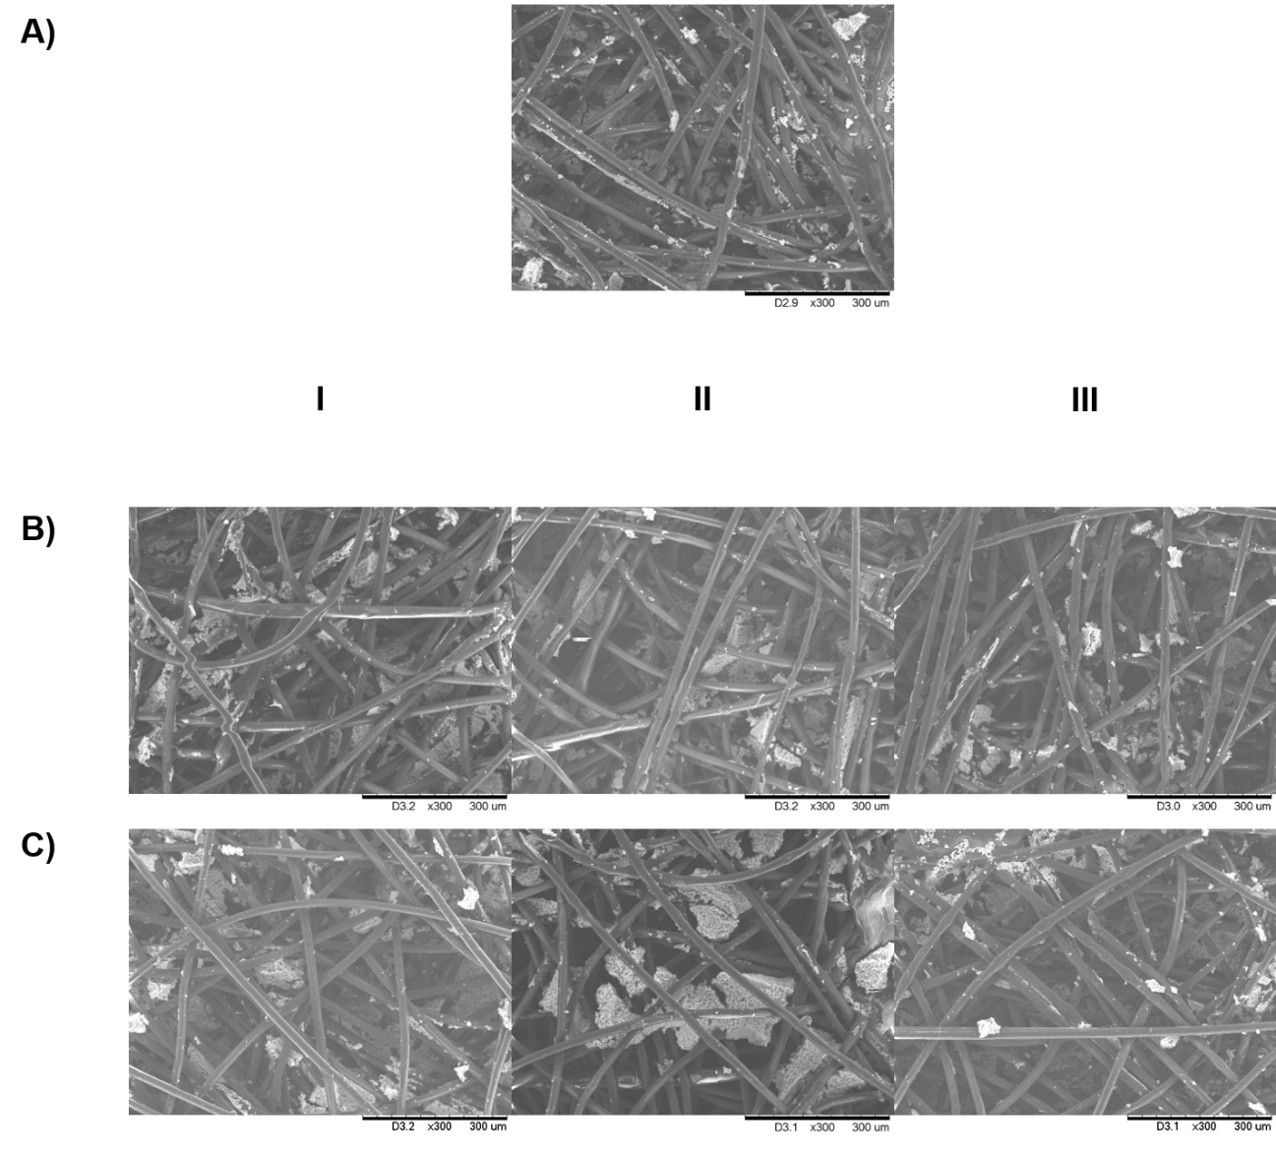
Figure S18. SEM microscopy images of the NanoCu-coated surgical mask against washes (125ppm of NanoCu in ethanol:water 50:50). A) Untreated sample; B) Samples at 40ºC; C) Samples at 60ºC. I) 30 min; II) 60 min; III) 120 min.

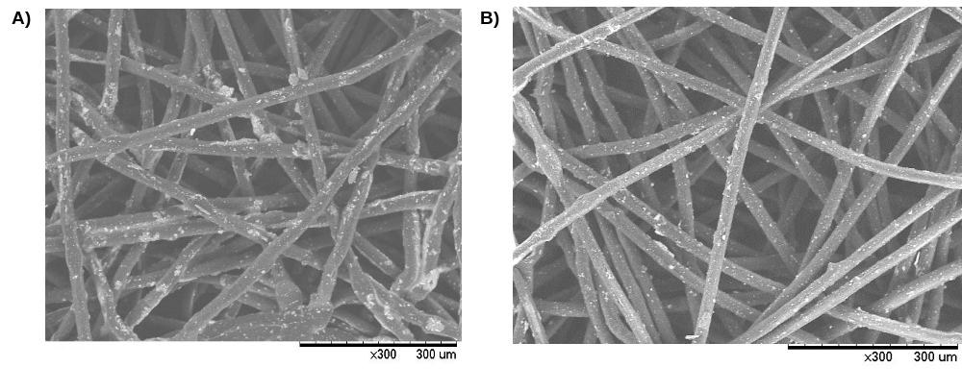
Figure S19. SEM images of the FFP2 mask with NanoCu: A) Initially (No washes); B) After 6 wash cycles.

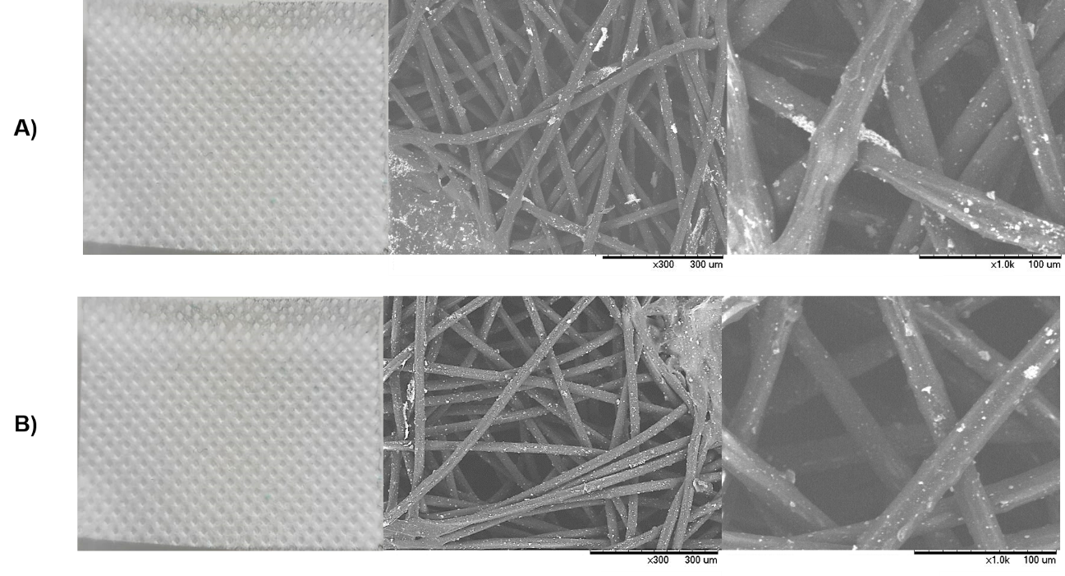
Figure S20. A) SEM images of the filter polystyrene fabric with the immersion method without agitation at a concentration of 625 ppm for 1 min; B) SEM images of the fabric with the immersion method with agitation at a concentration of 1250ppm for 2 min. All samples have been made in 10.5cm².

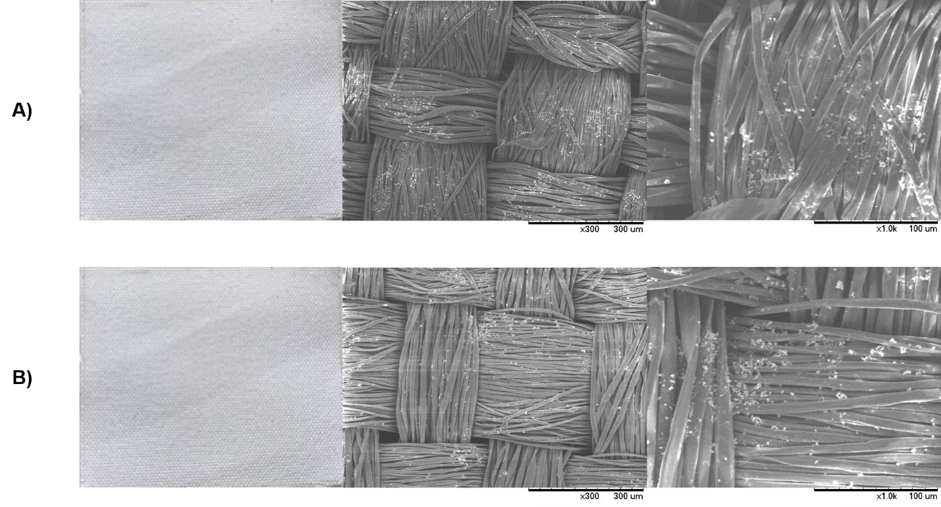

Figure S21. A) SEM images of the white polyester fabric with the immersion method without agitation at a concentration of 625 ppm for 1 min; B) SEM images of the fabric with the immersion method with agitation at a concentration of 1250ppm for 2 min. All samples have been made in 10.5cm².

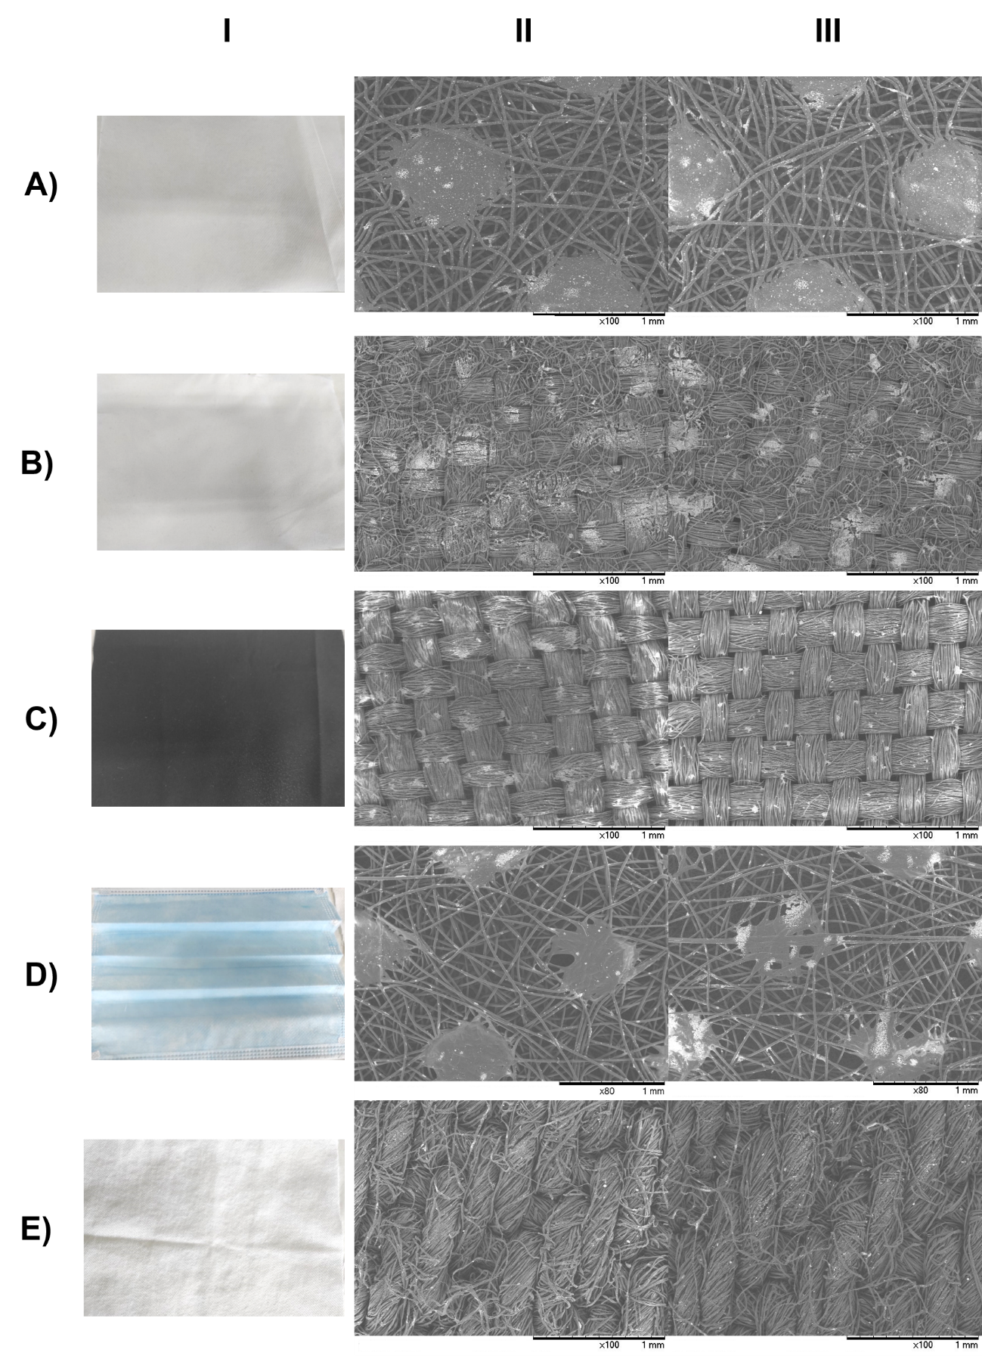
Figure S22. Application of NanoCu by spraying in different positions. I. Real piece of mask and fabrics; II. 9 sprays at 5 cm from the paper horizontally (NanoCu concentration -1250ppm); III. 15 sprays at 5-10 cm from the paper vertically (NanoCu concentration -1250ppm). A) 100% cotton fabric; B) White polystyrene fabric; C) Filter polystyrene fabric; D) Surgical mask.
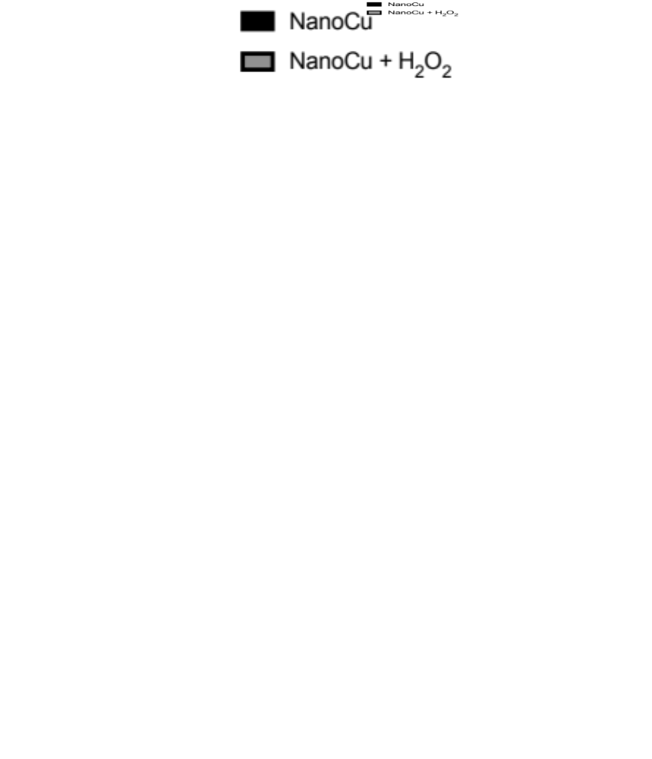

Figure S23. Determination of virucidal activity of cotton fabric with NanoCu + H₂O₂ incorporated against HCoV-229E coronavirus. A volume of 50 µl of viral inoculum were applied to fabric piece and incubated during 120 minutes at room temperature. Then, the recovery virus titer was determined by plaque assay (T1). Then, the fabric was washed with distilled water (a) or water +0.5% H₂O₂ (b) and virucidal assay was repeated (T2). The process was repeated two times more (T3-T4). N = 4 replicates were done, and errors bars correspond to ±SD. Paired Student test analysis were employed for comparing experimental treatments with the control: *: p < 0.05.

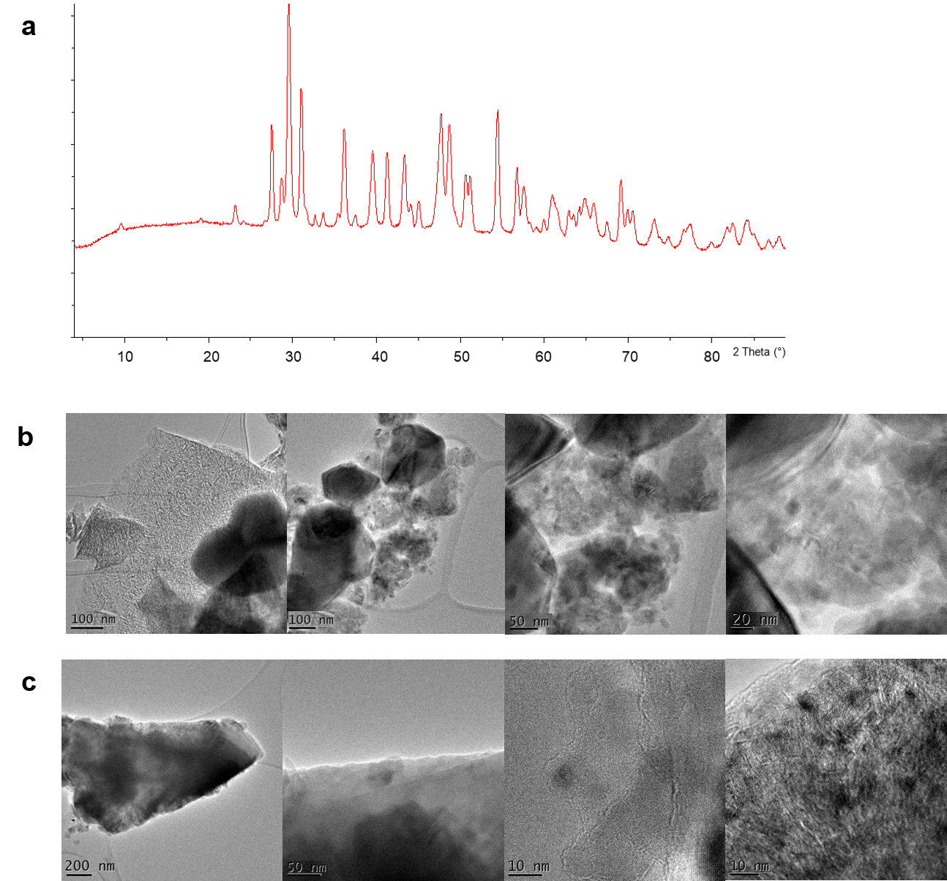

Figure S24. Characterization of the paint samples with NanoCu and the original paint. A) XRD spectrum; B) TEM images of the original paint; C) TEM and HRTEM images of the paint with 50% of NanoCu.

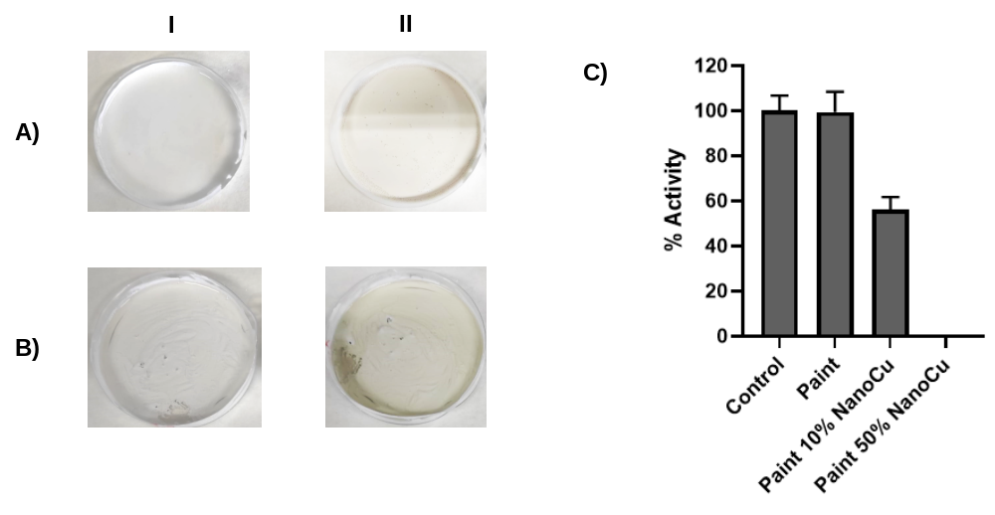
Figure S25. A) pAP assay with NanoCu mix wet Paint (50:50); B) pAP assay with NanoCu mix dry Paint (50:50); I. t:0min; II. t:15min; C) 3CLpro assay.

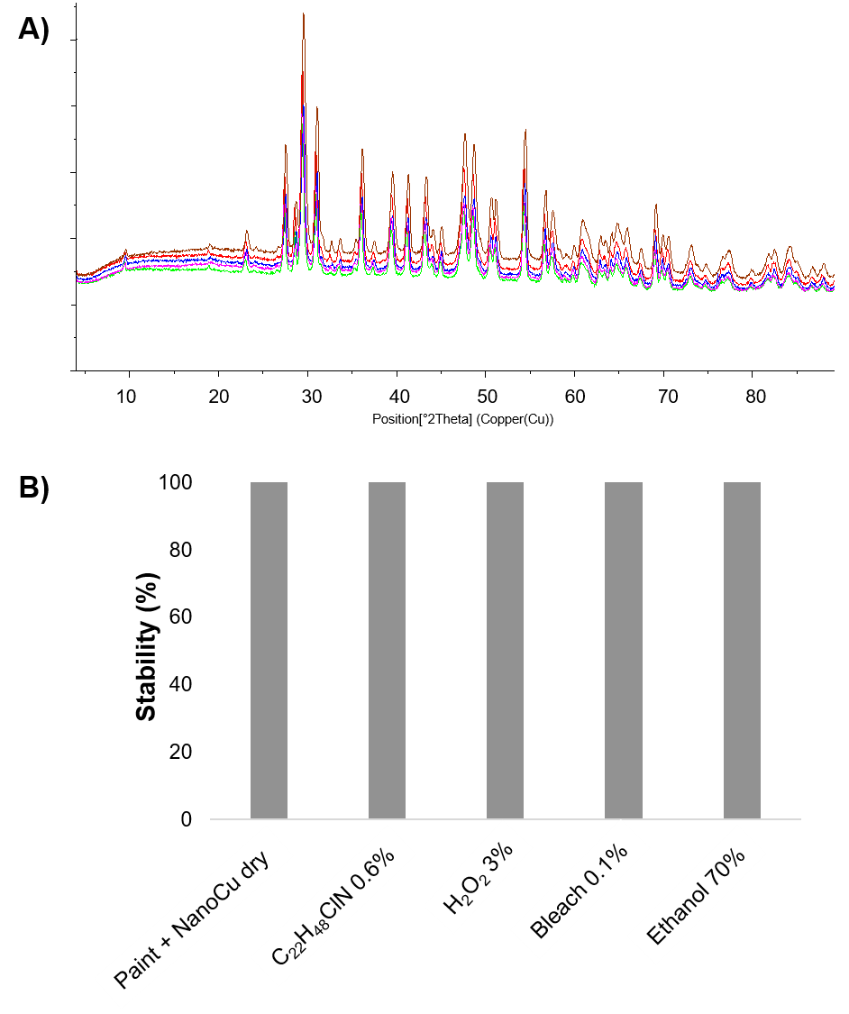
Figure S26. A) X-ray diffraction spectra (XRD) of the solids after disinfectant application compared to the untreated solid. B) Stability of NanoCu in paint against contact with different disinfectants.

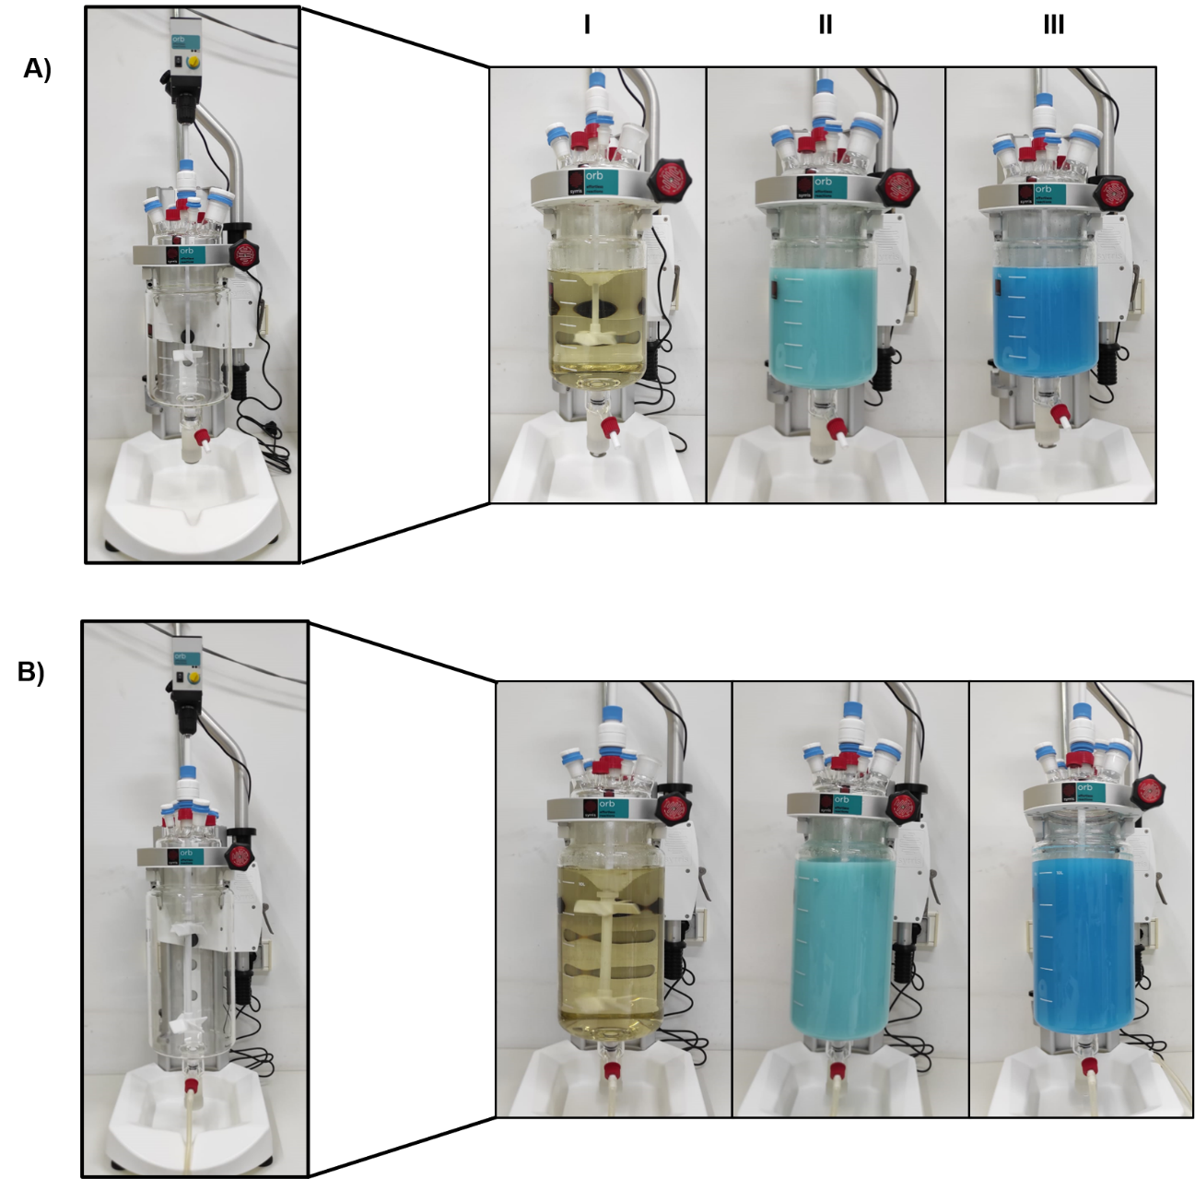

Figure S27. NanoCu scaling process. A) In a 5L reactor; B) In a 10L reactor. I) CALB addition; II) Synthesis at 15min; III) Synthesis at 1h.

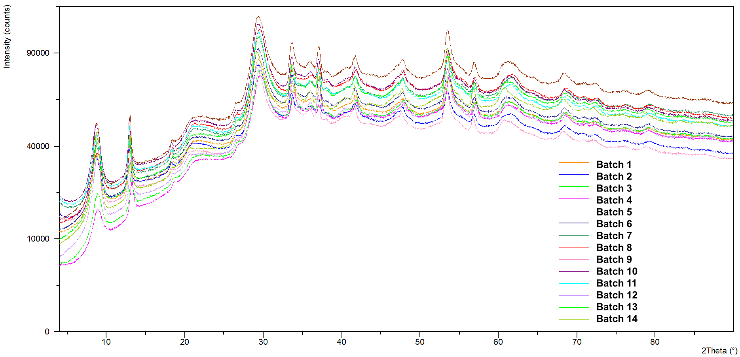

Figure S28. XRD spectra of NanoCu with different batch of production.
Test | Amount of enzyme (mg) | Amount of copper salt  (mg) | Incubation time  (h) | Vessel type | Stirring method | Wash step
Test 1 | 18 | 600 | 17 | Glass bottle closed | Magnet stir | yes
Test 1.1 | 18 | 1200 | 17 | Glass bottle closed | Magnet stir | yes
Test 1.2 | 9 | 600 | 17 | Glass bottle closed | Magnet stir | yes
Test 2 | 18 | 600 | 17 | Glass bottle open | Magnet stir | yes
Test 4 | 18 | 600 | 17 | Glass bottle closed | Blade stir | yes
Test 5 | 18 | 600 | 17 | Glass bottle closed | Magnet stir | No
Test 6* | 18 | 600 | 17 | Glass bottle closed | Magnet stir | No
Test 7 | 18 | 600 | 1-2 | Glass bottle closed | Magnet stir | yes
Test 8 | 18 | 600 | 4 | Glass bottle closed | Magnet stir | yes
Test 9 | 18 | 600 | 8 | Glass bottle closed | Magnet stir | yes
Test 10 | 18 | 600 | 1-2 | Glass bottle open | Blade stir | yes
Test 11 | 18 | 600 | 1-2 | Glass bottle closed | Blade stir | yes
Table S1. Summary of the modification tests of NanoCu protocol.

* Extra step: post-synthesis heating at 70ºC 10min

