Supplement Figures and Tables:
Supplement Fig. 1: 30-day mortality by different indications
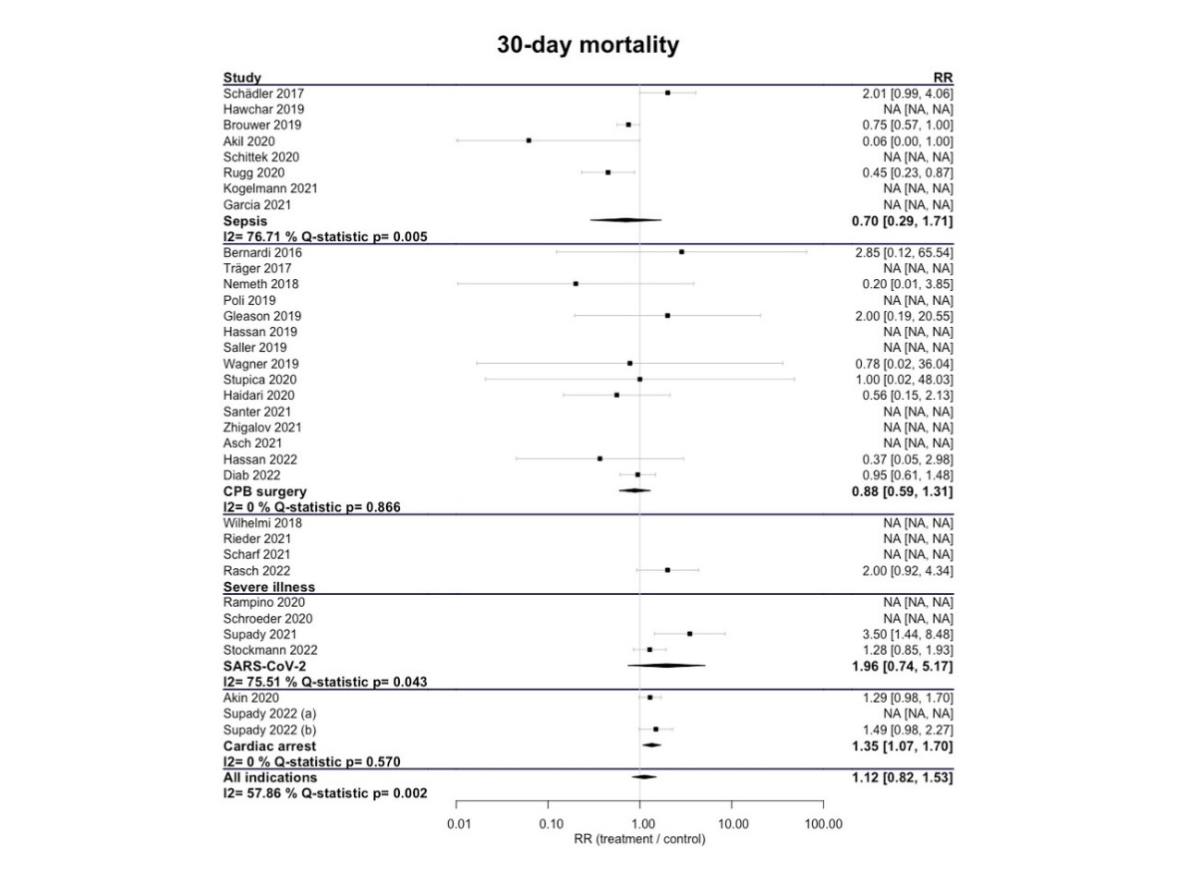

Supplement Fig. 2: In-hospital mortality by different indications
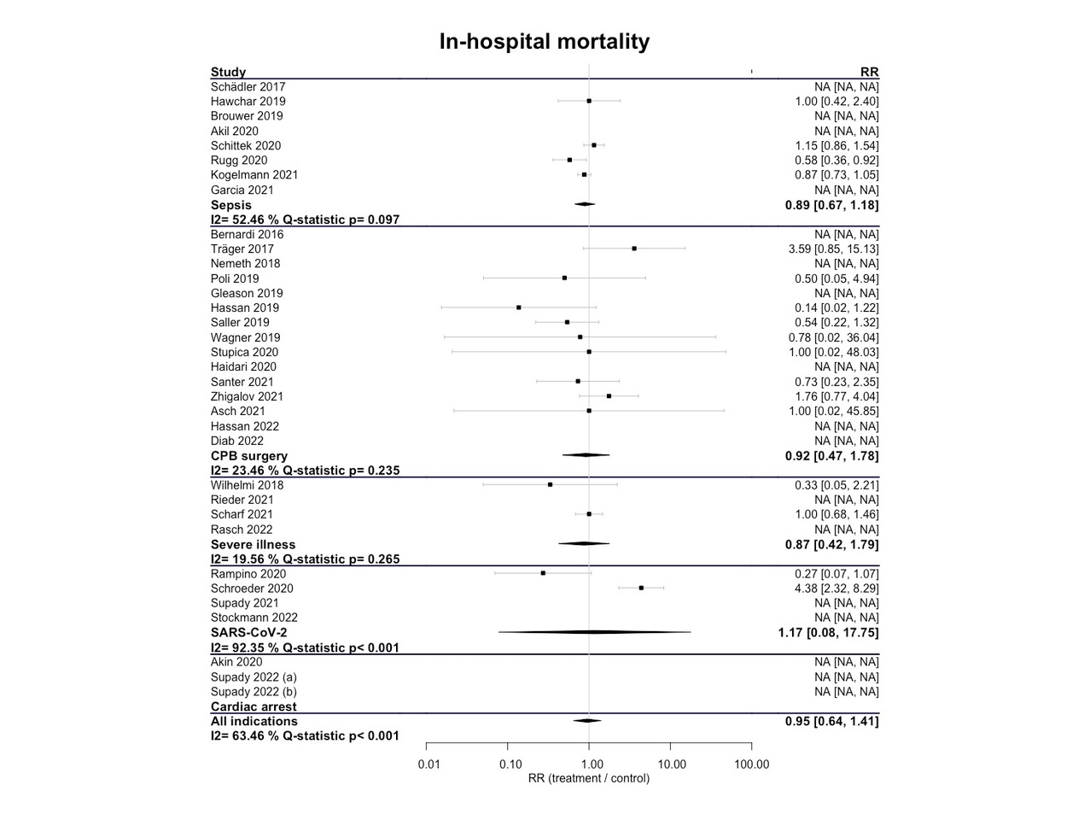

Supplement Fig. 3: ICU mortality by different indications
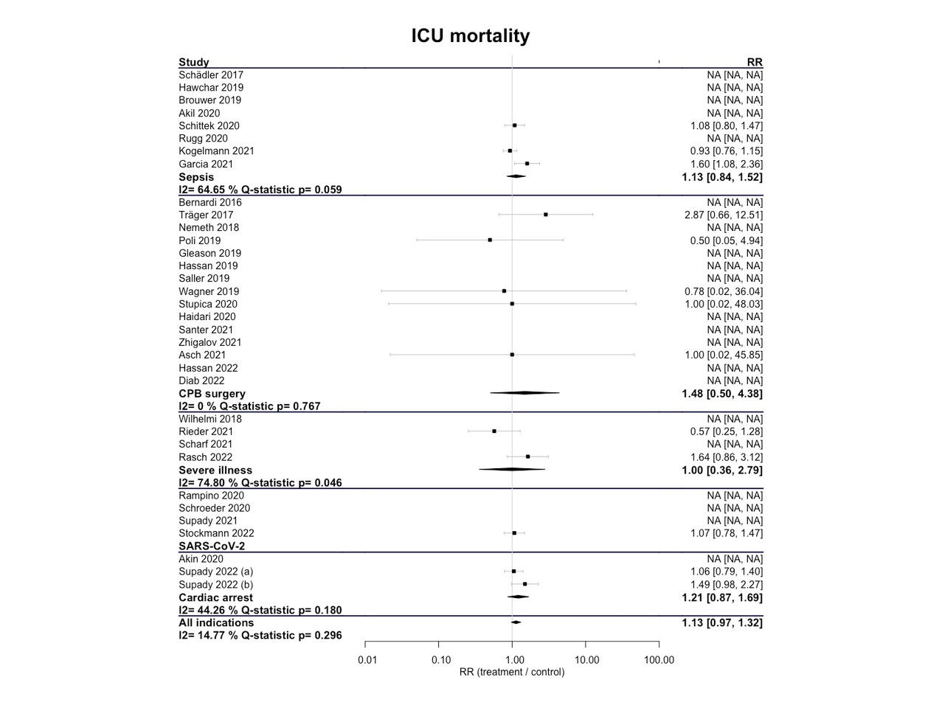

Supplement Fig. 4: Risk of Bias in Non-randomized Studies of Interventions
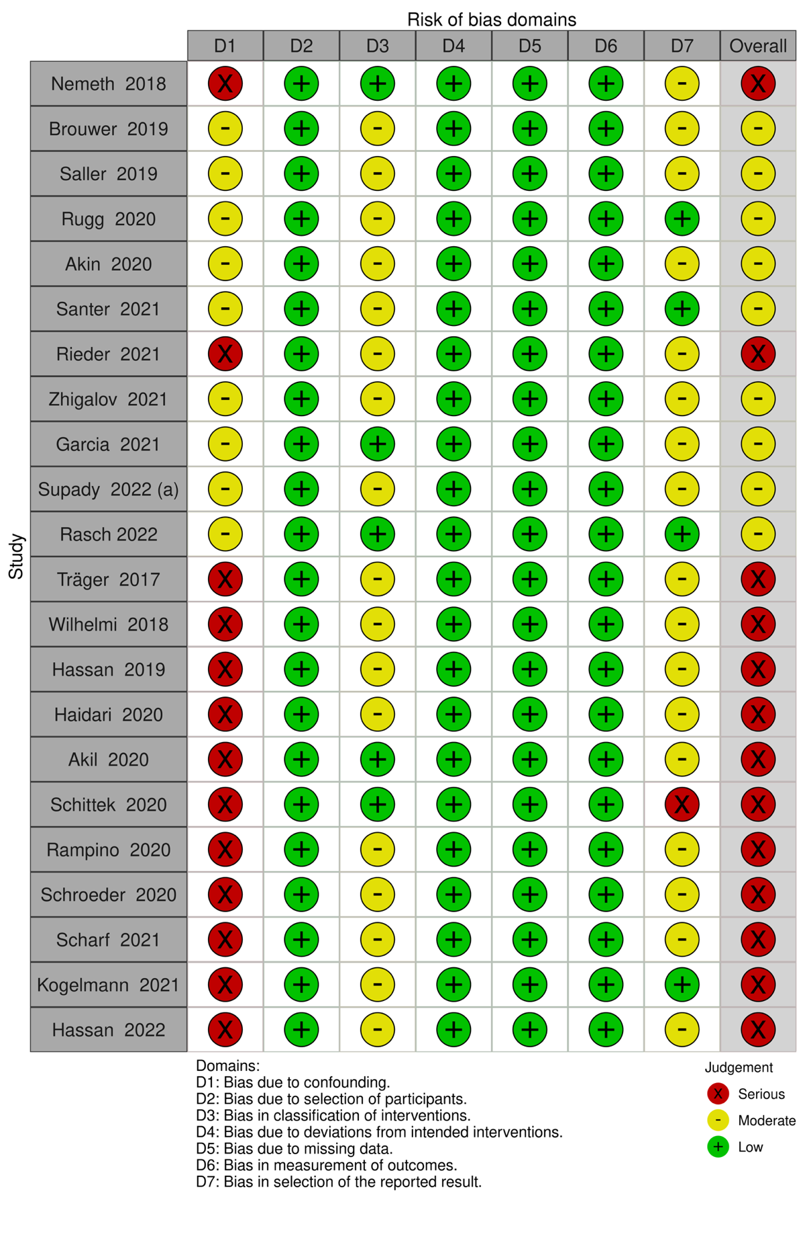

Supplement Fig. 5: Risk of Bias in randomized trials
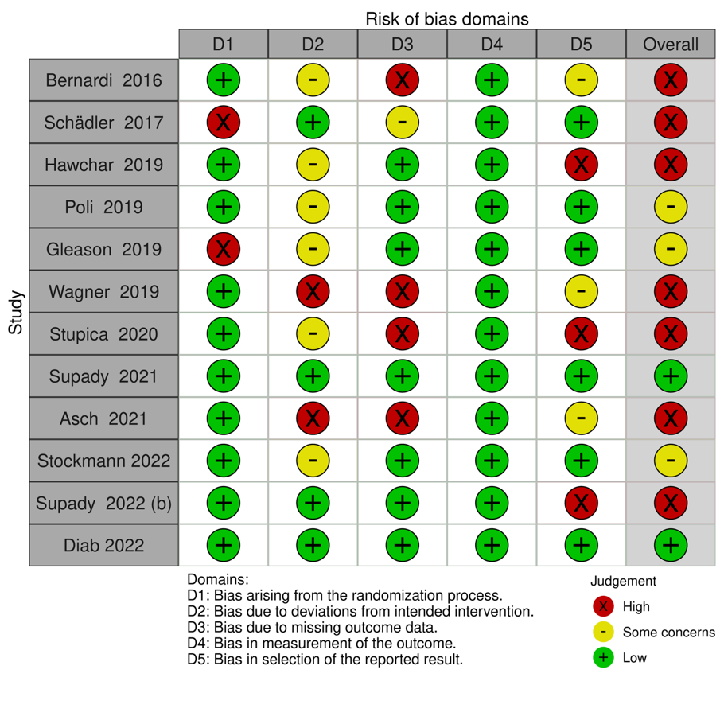

Supplement Fig. 6: Funnel plot for all study designs combined
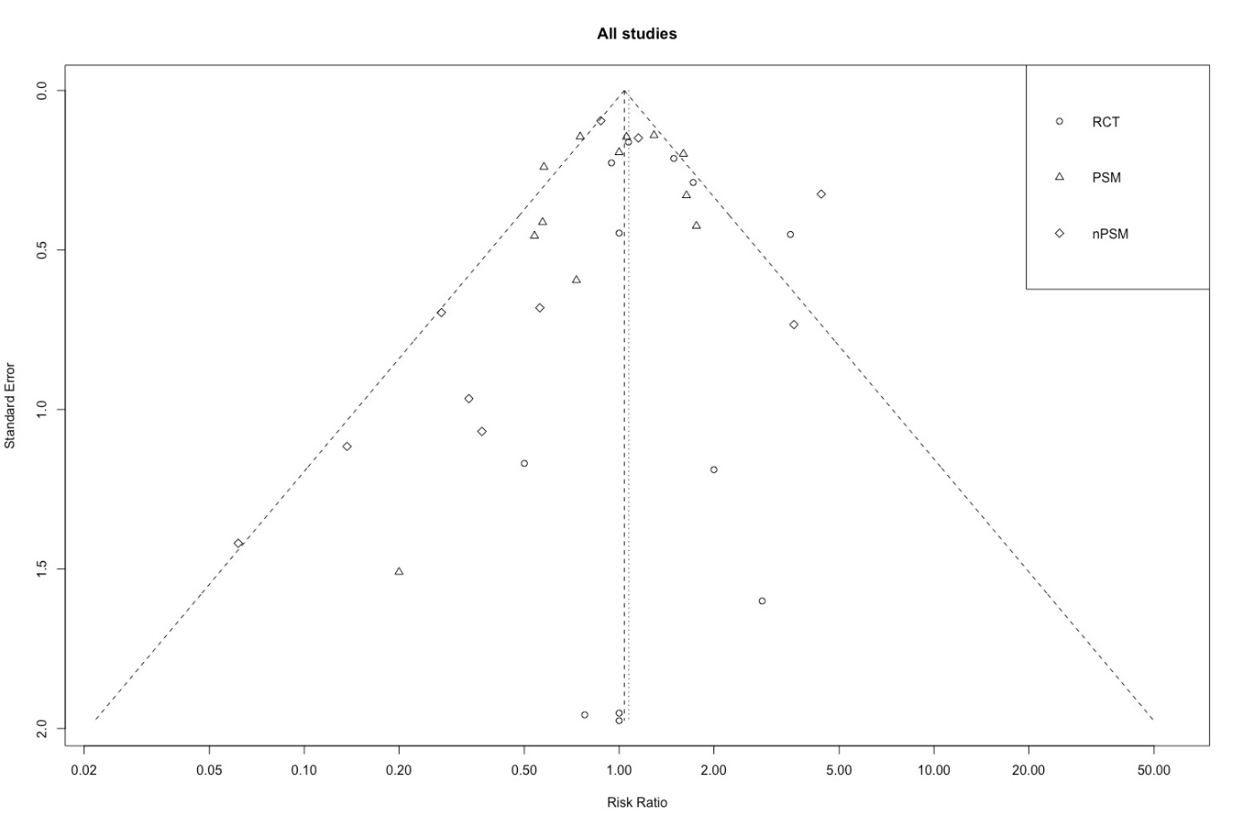

Supplement Fig. 7: Funnel plot for RCT
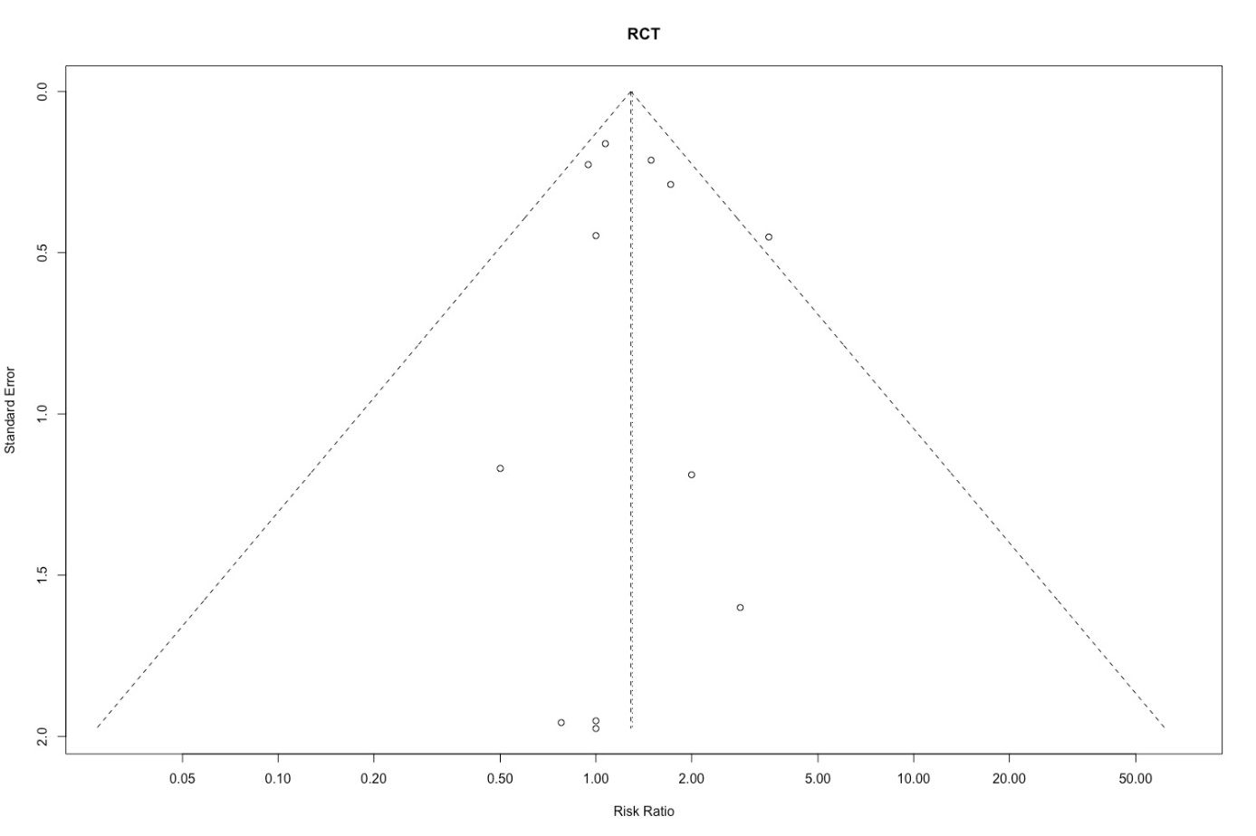

Supplement Fig. 8: Funnel plot for PSM
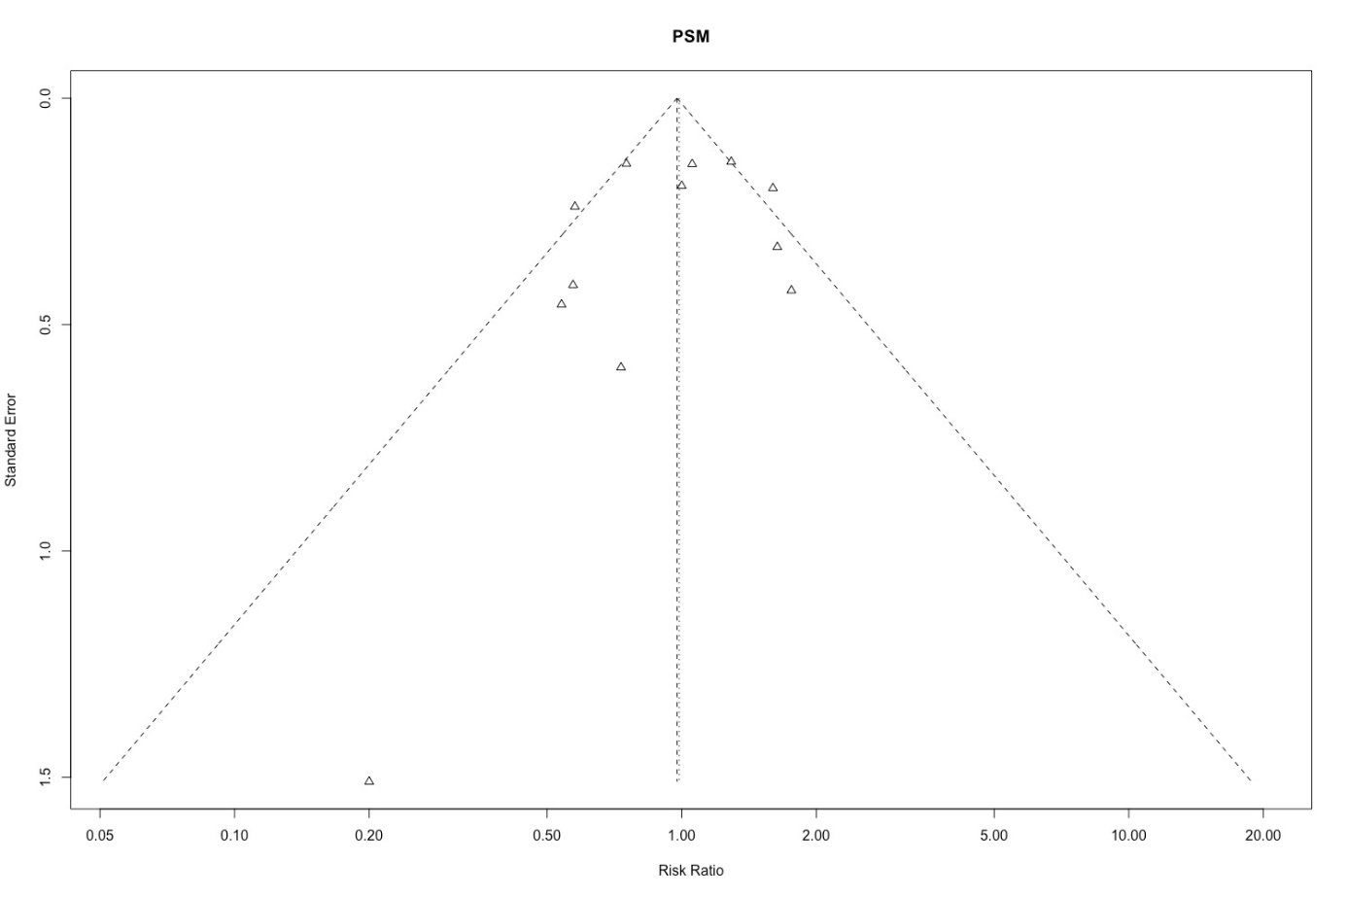

Supplement Fig. 9: Funnel plot for nPSM
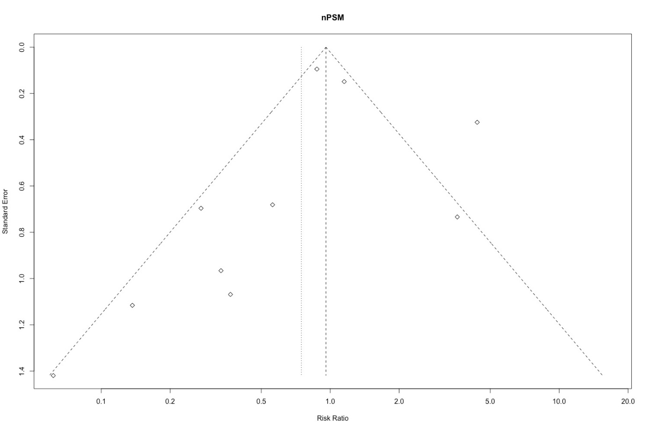

Supplement Tab. 1: Baseline SOFA, SAPS-2, APACHE-2 and EuroScore-2 (difference: treatment group – control group)
 | SOFA |  | SAPS-2 |  | APACHE-2 |  | EuroSCORE-2
 | M±SD | Md [IQR] | M±SD | Md [IQR] | M±SD | Md [IQR] | M±SD | Md [IQR]
Sepsis | 0.06 (± 1.36) | 0.33 [-0.59; 1.24] | -1.44 (± 7.93) | -0.78 [-7.33; 5.78] | -2.84 (± 3.69) | -3.15 [-6.79; 0.49]
CPB surgery | -0.04 (±0.57) | -0.02 [-0.59; 0.55] | -1.21 (± 8,57) | -5.42 [-14.90; 4.06] | -0.82 (± 2.2) | -1.08 [-3.32; 1.16] | 0.15 (± 0.83) | 0.31 [-0.57; 1.20]
Severe illness
SARS-CoV-2
Cardiac arrest | -0.15 (± 1) | -0.20 [-1.25; 0.84] | 1.22 (± 4.1) | 1.12 [-3.26; 5.49]
All indications | -0.14 (± 0.53) | 0.04 [-0.36; 0.44] | -0.71 (± 3.79) | -0.25 [-3.25; 2.75] | -1.52 (± 1,9) | -1.76 [-3.83; 0.31] | 0.15 (± 0.83) | 0.31 [-0.57; 1.20]

Supplement Tab. 2: CRP and PCT before and first reported after treatment (difference: treatment group – control group)
 | CRP (mg/l) before treatment |  | CRP (mg/l) after treatment |  | PCT (ng/ml) before treatment |  | PCT (ng/ml) after treatment
 | M±SD | Md [IQR] | M±SD | Md [IQR] | M±SD | Md [IQR] | M±SD | Md [IQR]
Sepsis | 1.81 (± 35.3) | -1.53 [-34.62, 31.56] | 3.14 (± 76.74) | 10.21 [-77.92; 98.33] | -7.60 (±7.76) | -7.13 [-13.29; -0.97] | 5.09 (± 9.9) | 5.69 [-3.42; 14.80]
CPB surgery | -0.60 (± 1.83) | -0.26 [-1.33; 0.80] | 0.22 (±1.15) 1.37] | -0.02 [-0.90; 0.85] | 0.03 (± 0.03) | 0.04 [0.00; 0.07]
Severe illness |  |  | 46.49 (±49.19) | 43.76 [-13.89; 101.41]
SARS-CoV-2 |  |  | -5.97 (± 43.51) | -5.37 [-53.95; 43.20] | 2.06 (± 1.88) | 0.61 [-1.09; 2.30]
Cardiac arrest |  |  | -92.14 (±245.76) | -95.08 [-324.10; 133.94] | -1.02 (± 2.82) | -1.03 [-3.83; 1.78]
All indications | -0.57 (±1.8) | -0.29 [-1.16; 0.58] | 0.98 (± 2.76) | -0.04 [-1.61; 1.53] | 0.04 (± 0.08) | 0.03 [-0.02; 0.08] | 5.09 (± 9.9) | 5.69 [-3.42; 14.80]
Only the mean differences shown in red was significant at the 0.05 level. Otherwise no statistically significant differences occurred.

Supplement Tab. 3: Lactate and IL-6 before and first reported after treatment (difference: treatment group – control group)
 | Lactat (mmol/l) before CytoSorb |  | Lactat (mmol/l) after CytoSorb |  | IL-6 before CytoSorb |  | IL-6 after CytoSorb
 | M±SD | Md [IQR] | M±SD | Md [IQR] | M±SD | Md [IQR] | M±SD | Md [IQR]
Sepsis | 0.88 (±2.15) | 0.99 [-0.20; 2.18] | 0.29 (± 0.79) | 0.29 [-0.50; 1.09] | 443 (± 520) | -5962.57 [-20364.73; 8439.59] | -100 (±235) | -158.20 [-394.16; 77.76]
CPB surgery | -0.13 (± 0.08) | -0.09 [-0.19; 0.00] | -0.80 (± 1.86) | -0.59 [-2.05; 0.86] | 0.00 (± 0.02) | 0.00 [-0.02; 0.02] | -2 (±51) | -2.55 [-51.61; 46.5]
Severe illness | 2.52 (± 2.93) | 2.36 [-1.08; 5.79] | -0.76 (±2.06) | -0.83 [-3.21; 1.54] | 19818 (±48381) | 5055.28 [1620.73; 8489.84]
SARS-CoV-2 |  |  |  |  | -104 (±427) | -58.57 [-467.34; 350.21]
Cardiac arrest | -0.31 (± 1.81) | -0.67 [-3.09; 1.74] | -1.08 (± 1.44) | -0.68 [-2.23; 0.87] | -226 (± 327) | -275.00 [-620.44; 70.44]
All indications | 0.28 (± 0.42) | 0.34 [-0.13; 0.82] | -0.12 (± 0.48) | -0.02 [-0.40; 0.37] | 0.00 (±0.03) | 0.00 [-0.03; 0.03] | -6 (±49) | -8.16 [-56.37; 40.05]
Only the mean differences shown in red was significant at the 0.05 level. Otherwise no statistically significant differences occurred.

