Supplementary Document

Search Strategy

"PIMSRA"[All Fields] OR (("percutaneous"[All Fields] OR "percutaneously"[All Fields] OR "percutanous"[All Fields]) AND ("intramyocardial"[All Fields] OR "intramyocardially"[All Fields]) AND ("septal"[All Fields] OR "septally"[All Fields] OR "septals"[All Fields]) AND ("radiofrequency ablation"[MeSH Terms] OR ("radiofrequency"[All Fields] AND "ablation"[All Fields]) OR "radiofrequency ablation"[All Fields])) OR ("Liwen"[All Fields] AND ("methods"[MeSH Terms] OR "methods"[All Fields] OR "procedure"[All Fields] OR "methods"[MeSH Subheading] OR "procedures"[All Fields] OR "procedural"[All Fields] OR "procedurally"[All Fields] OR "procedure s"[All Fields])

Single arm study

P – Hypertrophic Cardiomyopathy
I – Intramyocardial Septal Radiofrequency Ablation
C - NA
O – Left Ventricular Outflow Gradient
Interventricular Septum Thickness (Anterior and Posterior)
Left Ventricular Ejection Fraction (LVEF)

Database | Strategy | Articles
Pubmed | "PIMSRA"[All Fields] OR (("percutaneous"[All Fields] OR "percutaneously"[All Fields] OR "percutanous"[All Fields]) AND ("intramyocardial"[All Fields] OR "intramyocardially"[All Fields]) AND ("septal"[All Fields] OR "septally"[All Fields] OR "septals"[All Fields]) AND ("radiofrequency ablation"[MeSH Terms] OR ("radiofrequency"[All Fields] AND "ablation"[All Fields]) OR "radiofrequency ablation"[All Fields])) OR ("Liwen"[All Fields] AND ("methods"[MeSH Terms] OR "methods"[All Fields] OR "procedure"[All Fields] OR "methods"[MeSH Subheading] OR "procedures"[All Fields] OR "procedural"[All Fields] OR "procedurally"[All Fields] OR "procedure s"[All Fields])) | 45
Cochrane CENTRAL | ("PIMSRA" OR "Percutaneous Intramyocardial Septal Radiofrequency Ablation" OR "Liwen procedure") | 1
SCOPUS | TITLE-ABS-KEY ( ( "PIMSRA" OR "Percutaneous Intramyocardial Septal Radiofrequency Ablation" OR "Liwen procedure" ) ) | 13
Embase | ("PIMSRA" OR "Percutaneous Intramyocardial Septal Radiofrequency Ablation" OR "Liwen procedure") | 13

Identification of studies via databases and registers

Additional records identified through other sources (n=4)
Records identified through database searching (n=72)
Pubmed (n=45)
Cochrane Central (n=1)
Embase (n=13)
Scopus (n=13)

Identification

Records after duplicates removed (n=50)

Records screened (n = 50)
Records excluded after title and abstract screening (n= 38)

Screening

Articles excluded after full text screening, with reasons (n=8)
- Case Reports – (n=4)
- Relevant data not provided (n=2)
- Animal study (n=1)

Full text articles assessed for eligibility
(n = 12)

Eligibility
Studies included in qualitative synthesis (n=5)

Studies included in quantitative synthesis (meta- analysis)
(n = 5)

Included

Raw Data

LVOT (Left Ventricular Outflow Tract) Gradient

Study ID | Sample size | Mean SD/Quartiles
Study ID | Sample size | Baseline | 1 month | 3 months | 6 months | 1 year
Qian D 2021 | 30 | 82.45+-30.83 | N/A | N/A | N/A | 11.69+-5.5
Zuo L 2020 | 30 | 95.0 (57.2) | 15.5(22.2) | 13(26) | 12(13.7) | 12.5(14.3)
Liu L 2018 | 15 | 88(66) | 14(8) | 13(6) | 11(6) | N/A
Zhou M 2022 | 200 | 79(53) | N/A | N/A | N/A | 14(24)
Liu LW 2019 | 9 | 83.3±32.4 |  |  | 26.8±19.6

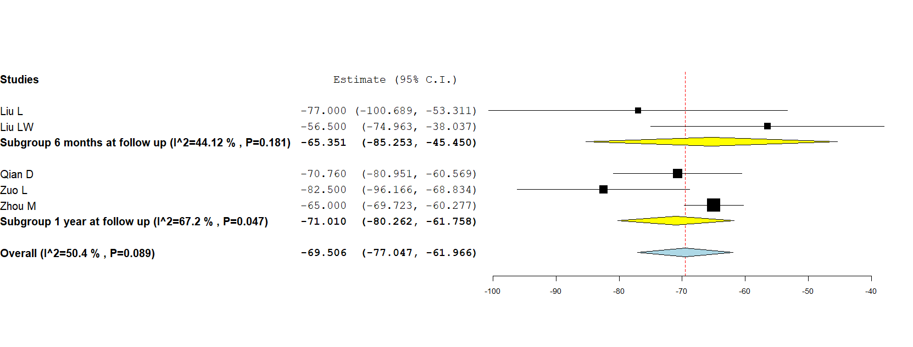

LVEF (Left Ventricular Ejection Fraction)

Study ID | Sample size | Mean SD/Quartiles
Study ID | Sample size | Baseline | 1 month | 3 months | 6 months | 1 year
Qian D 2021 | 30 | 68.95 ± 6.46 | 68.30 ± 6.54% | N/A | N/A | 67.55 ± 6.35%
Zuo L 2020 | 30 | 62.6 ± 5.5 | 62.0 ± 6.9 | 60.2 ± 5.2 | 60.2 ± 3.8 | 59.3 ± 4.2
Liu L 2018 | 15 | N/A | N/A | N/A | N/A | N/A
Zhou M 2022 | 200 | 60.2 (4.7) | N/A | N/A | N/A | 59.2 (3.8)
Liu LW 2019 | 9 | N/A | N/A | N/A | N/A | N/A

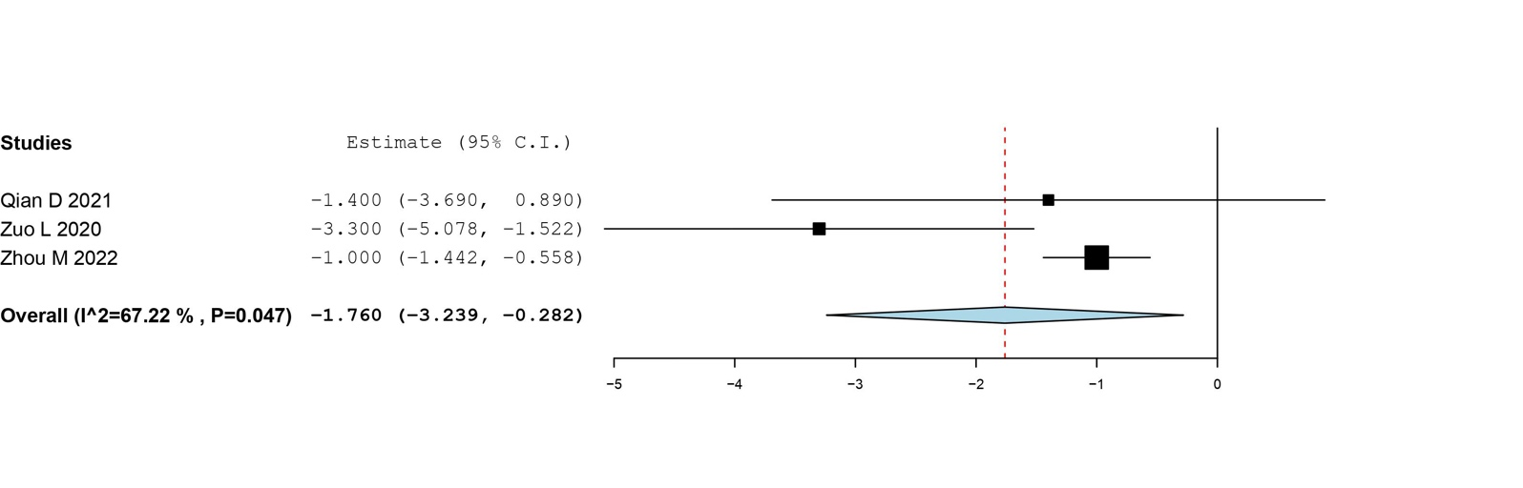

Anterior interventricular septum thickness

Study ID | Sample size | Mean SD/Quartiles
Study ID | Sample size | Baseline | 1 month | 3 months | 6 months | 1 year
Qian D 2021 | 30 | 22.03+-2.55 | N/A | N/A | N/A | 12.78+-1.95
Zuo L 2020 | 30 | 23.3+-4.1 | 19.3+-2.9 | 16.6+-2.5 | 15+-2.7 | 14.4+-2.3
Liu L 2018 | 15 | 25(21) | 20(17) | 16(14) | 14(12) | N/A
Zhou M 2022 | 200 | N/A | N/A | N/A | N/A | N/A
Liu LW 2019 | 9 | 24.7±2.7 |  |  | 13.4±2.0

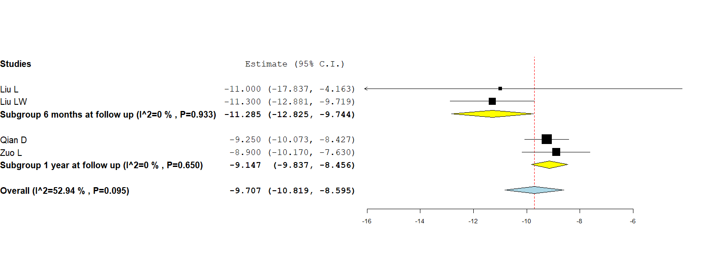

Posterior interventricular septum thickness

Study ID | Sample size | Mean SD/Quartiles
Study ID | Sample size | Baseline | 1 month | 3 months | 6 months | 1 year
Qian D 2021 | 30 | 21.2+-2.36 | N/A | N/A | N/A | 12.2+-2.29
Zuo L 2020 | 30 | 21.8+-4.9 | 18.5+-2.7 | 16+-3 | 14.9+-3 | 14.4+-1.9
Liu L 2018 | 15 | 24(21) | 18(16) | 15(12) | 14(11.5) | N/A
Zhou M 2022 | 200 | N/A | N/A | N/A | N/A | N/A
Liu LW 2019 | 9 | 22.6±3.3 |  |  | 12.3±2.4

