Supplementary information

Supplementary Figure 1. Growth of E.coli on HiChrome UTI agar delivered as per experimental design
Growth of cultured E.coli on HiChrome UTI agar applied using various methods i.e. top streak, bottom streak and bottom drop and over serial dilutions (a). Comparison of CFU/ml obtained from different application methods and using different quantification methods. CFU/ml was significantly different (p<0.05) between all dilutions for both the quantification methods as well as for all methods of application. CFU/ml calculated manually and by OpenCFU were not significantly different (p>0.1).
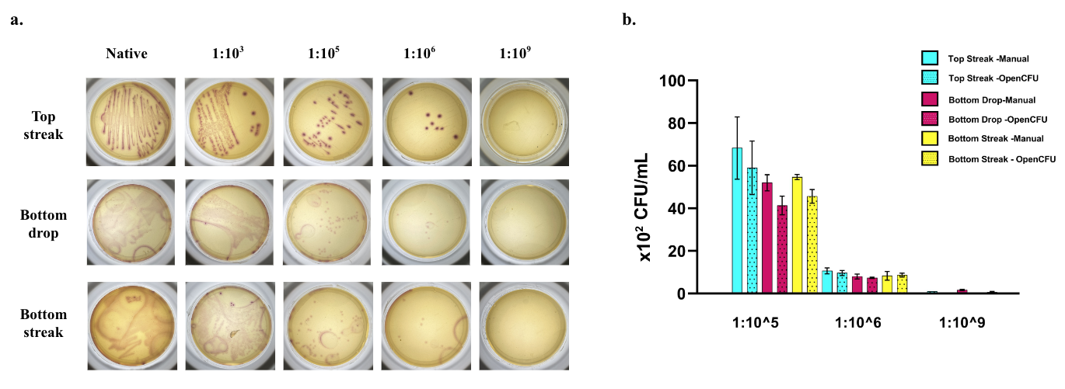

Supplementary Figure 2. Membrane based culture delivery and corresponding growth of E.coli at different temperatures in HiChrome UTI agar
Growth of cultured E.coli on HiChrome agar at 37℃ for 16 hours and at 25℃ for 30 hours with the sample delivered using the membrane (a). Visual comparison of CFU obtained manually for both temperature conditions (b). CFU was significantly different (p<0.05) between all dilutions in which colonies could be counted except between 1:10⁵ and 1:10⁶ at 25℃ (p=0.22). CFU calculated for both conditions were not significantly different in any dilution (p>0.1).

