Figure S5 HR-ESI-MS spectrum of 5, 6-dimethoxy-[1',1:4,1''-terphenyl]-2-ol (1): 14-9

Figure S6 UV spectrum of 5, 6-dimethoxy-[1',1:4,1''-terphenyl]-2-ol (1): 14-9
Figure S7 ¹H NMR spectrum of 5, 6-dimethoxy-[1',1:4,1''-terphenyl]-2-ol (1): 14-9 (CDCl₃, 600 MHz)

Figure S8 ¹³C NMR spectrum of 5, 6-dimethoxy-[1',1:4,1''-terphenyl]-2-ol (1): 14-9 (CDCl₃, 151 MHz)
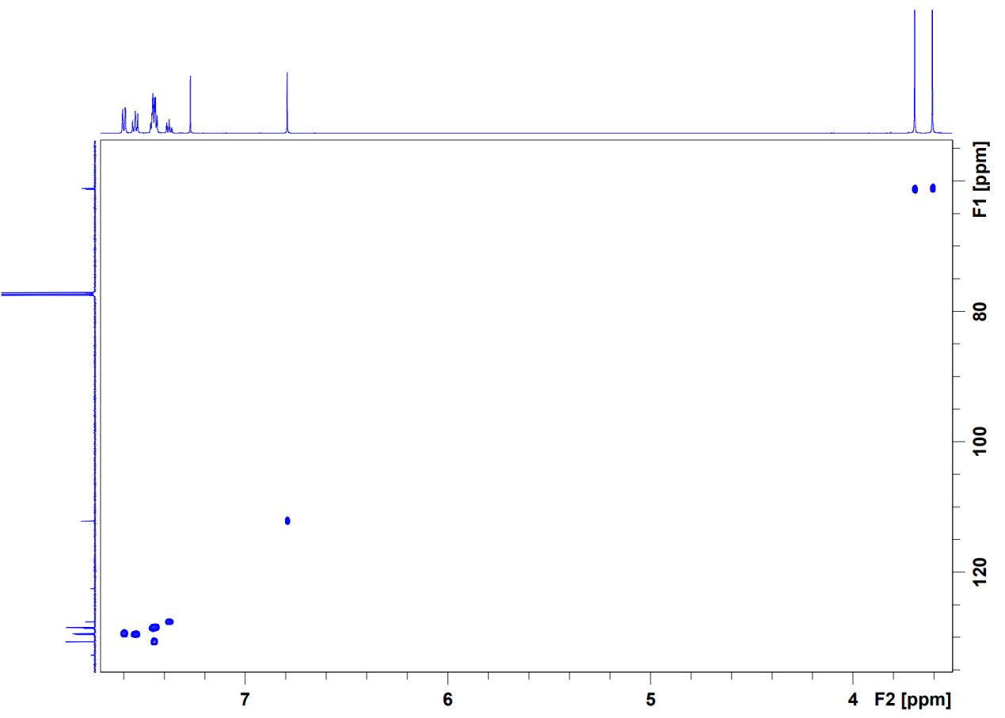
Figure S9 HSQC spectrum of 5, 6-dimethoxy-[1',1:4,1''-terphenyl]-2-ol (1): 14-9 (CDCl₃)

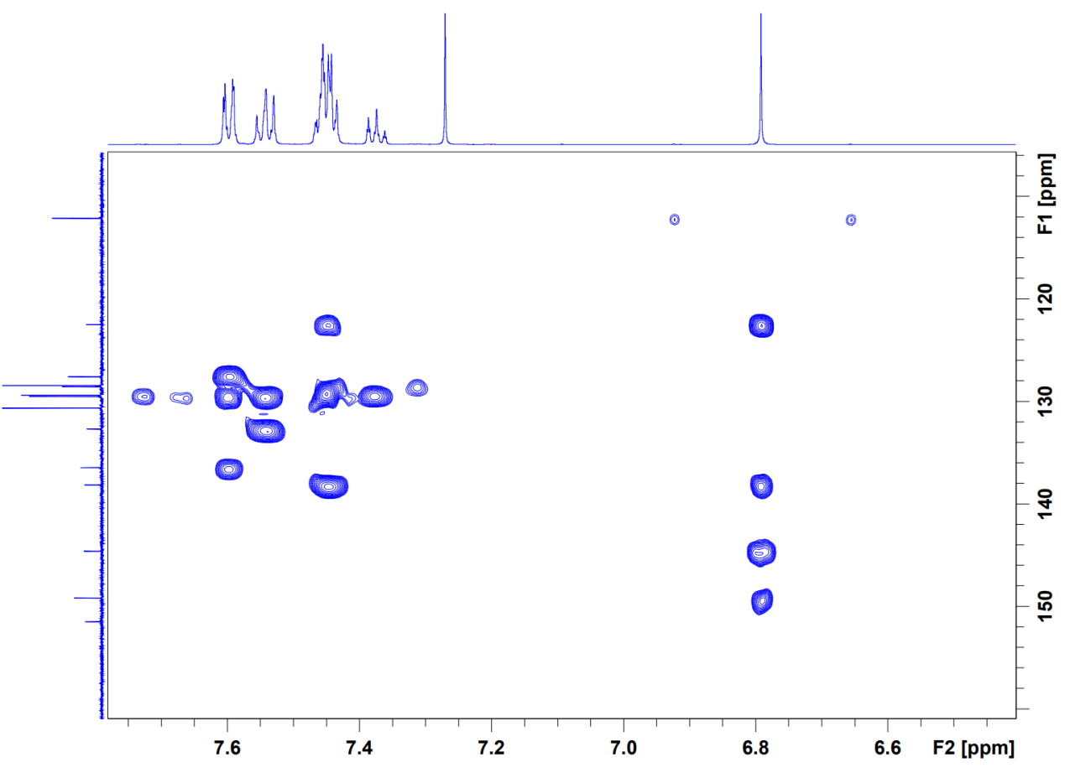
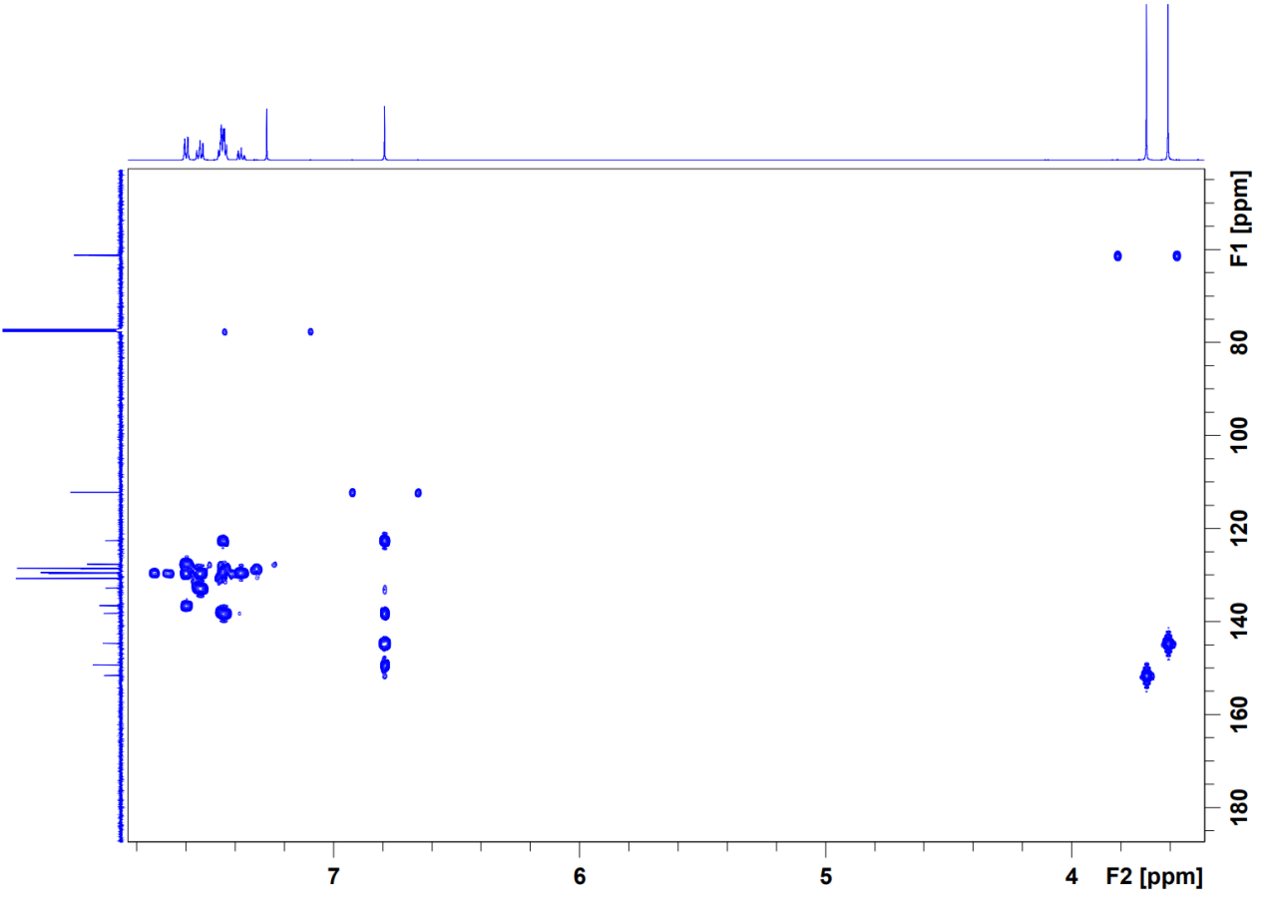
Figure S10 HMBC spectrum of 5, 6-dimethoxy-[1',1:4,1''-terphenyl]-2-ol (1): 14-9 (CDCl₃)
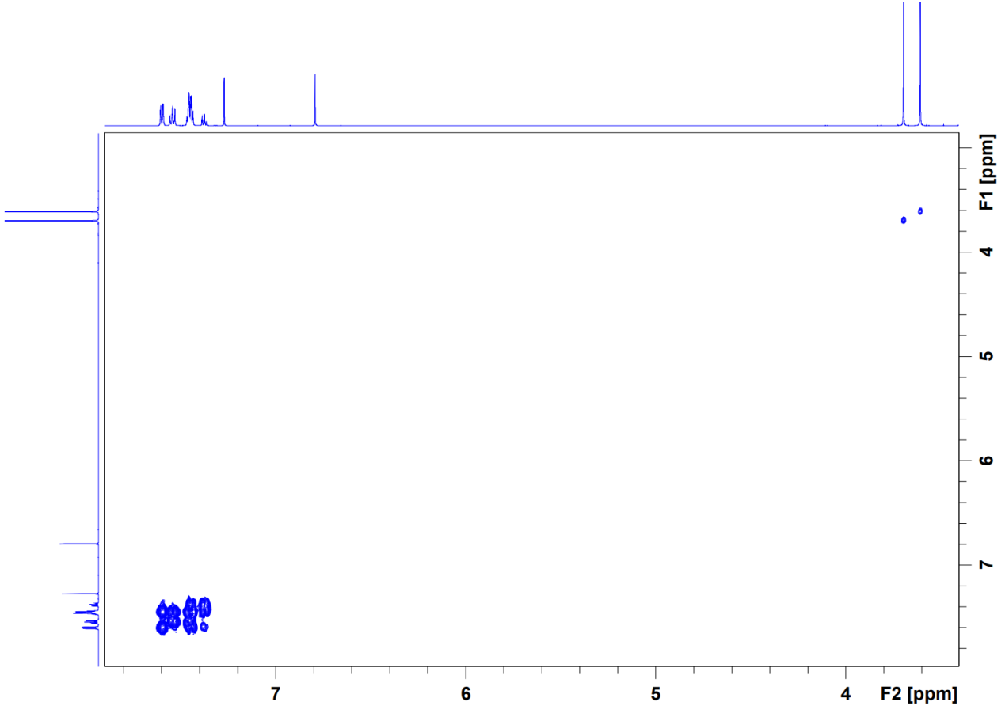
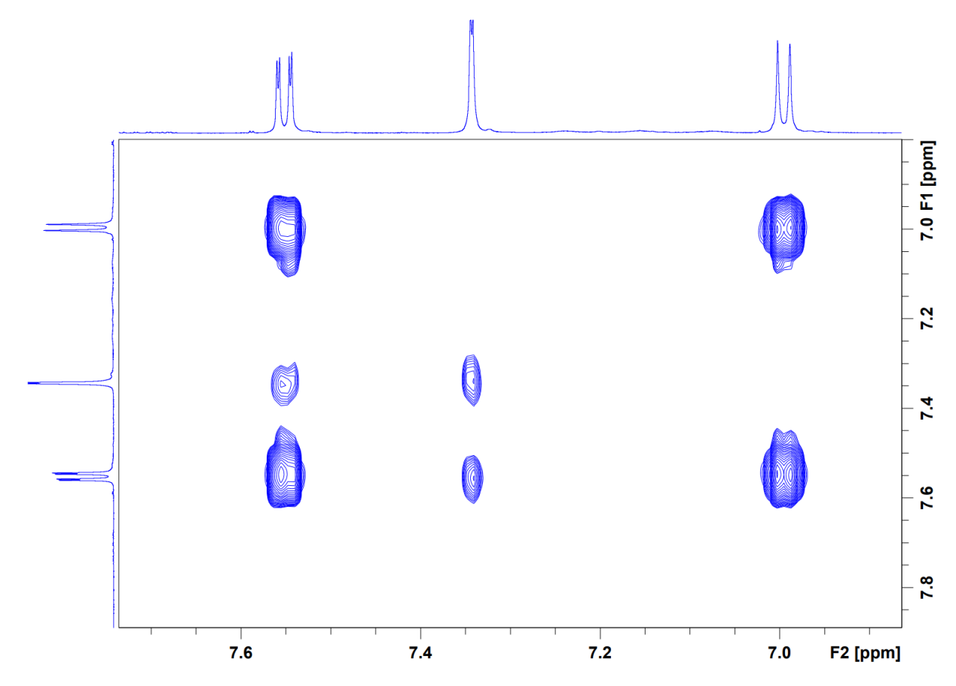
Figure S11 ¹H-¹H COSY spectrum of 5, 6-dimethoxy-[1',1:4,1''-terphenyl]-2-ol (1): 14-9 (CDCl₃)
Figure S12 HR-ESI-MS spectrum of 5-(methoxycarbonyl)-2-methylbenzo[d][1, 3]dioxole-2-carboxylic acid (2): 14-10
Figure S13 UV spectrum of 5-(methoxycarbonyl)-2-methylbenzo[d][1, 3]dioxole-2-carboxylic acid (2): 14-10

Figure S14 ¹H NMR spectrum of 5-(methoxycarbonyl)-2-methylbenzo[d][1, 3]dioxole-2-carboxylic acid (2): 14-10 (DMSO-d₆, 600 MHz)
Figure S15 ¹³C NMR spectrum of 5-(methoxycarbonyl)-2-methylbenzo[d][1, 3]dioxole-2-carboxylic acid (2): 14-10 (DMSO-d₆, 151 MHz)
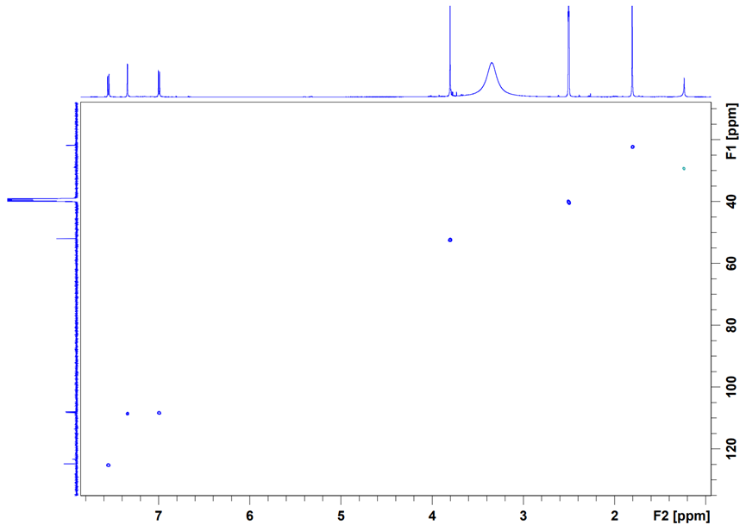
Figure S16 HSQC spectrum of 5-(methoxycarbonyl)-2-methylbenzo[d][1, 3]dioxole-2-carboxylic acid (2): 14-10 (DMSO-d₆)

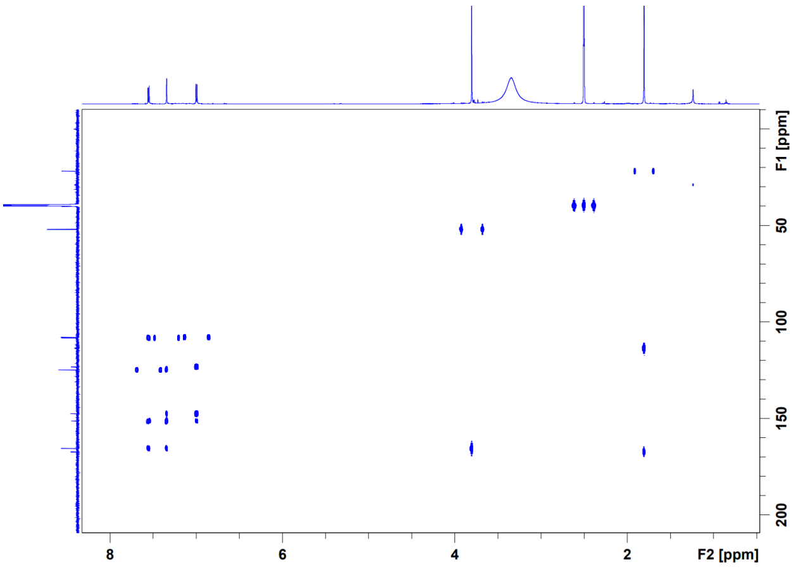
Figure S17 HMBC spectrum of 5-(methoxycarbonyl)-2-methylbenzo[d][1, 3]dioxole-2-carboxylic acid (2): 14-10 (DMSO-d₆)
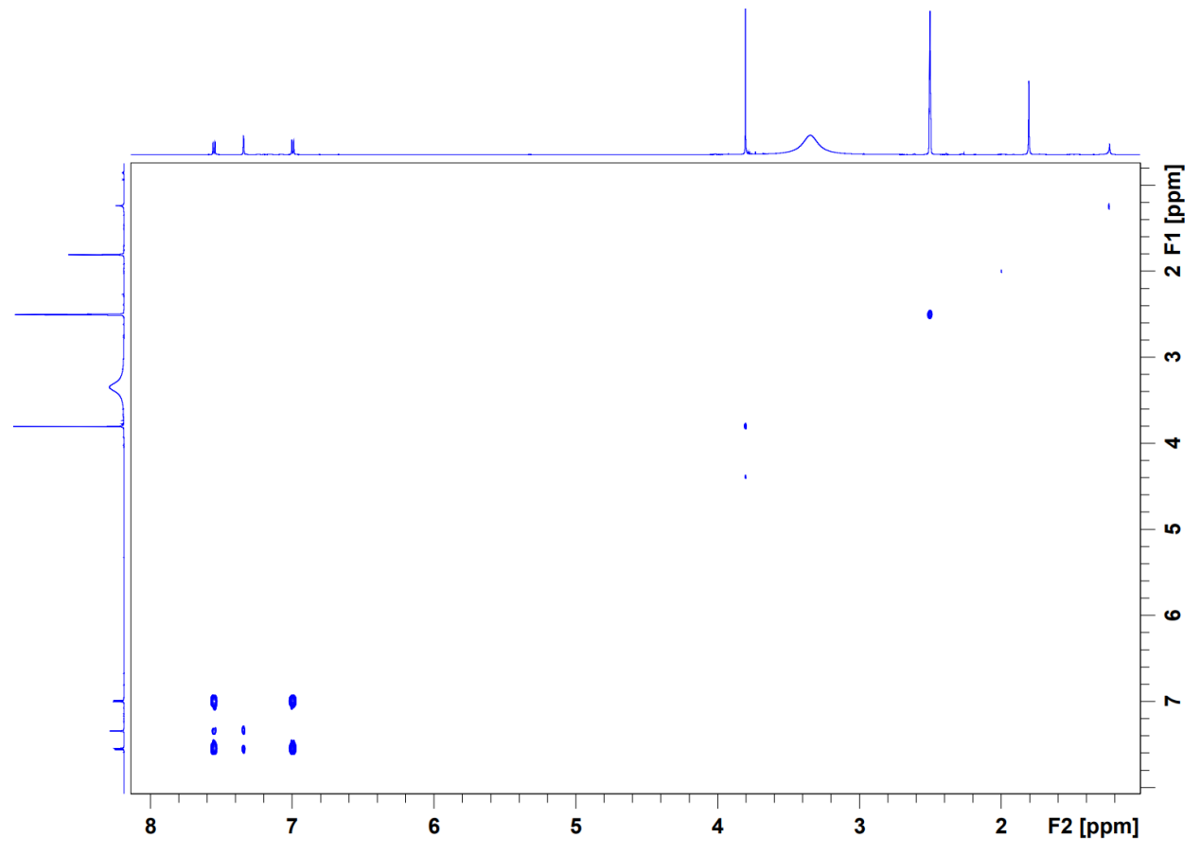
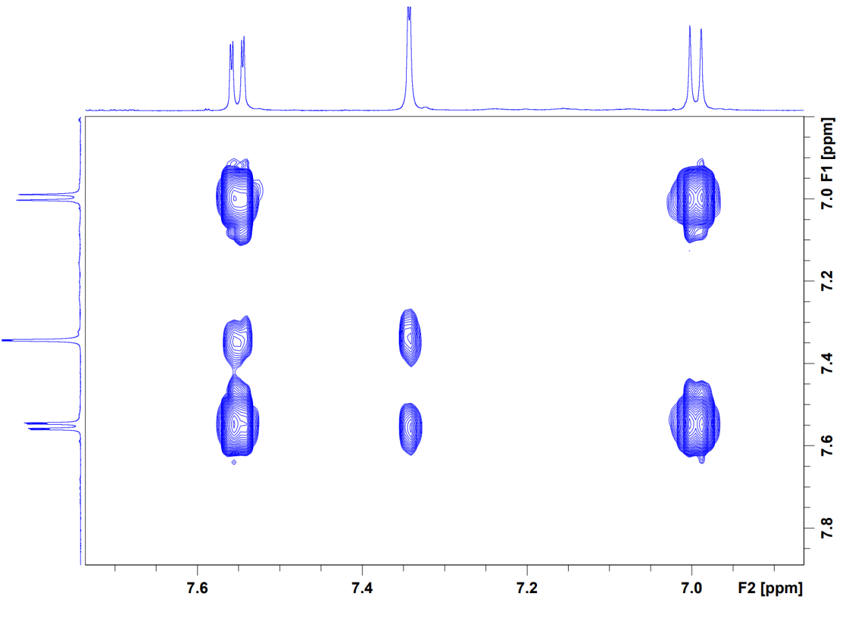
Figure S18 ¹H-¹H COSY spectrum of 5-(methoxycarbonyl)-2-methylbenzo[d][1, 3]dioxole-2-carboxylic acid (2): 14-10 (DMSO-d₆)

Figure S19 HR-ESI-MS spectrum of 3,7-dihydroxy-1,9-dimethyldibenzofuran (3) 14-4
Figure S20 ¹H NMR spectrum of 3,7-dihydroxy-1,9-dimethyldibenzofuran (3) 14-4 (Acetone-d₆, 600 MHz)
Figure S21 ¹³C NMR spectrum of 3,7-dihydroxy-1,9-dimethyldibenzofuran (3) 14-4 (Acetone-d₆, 151 MHz)
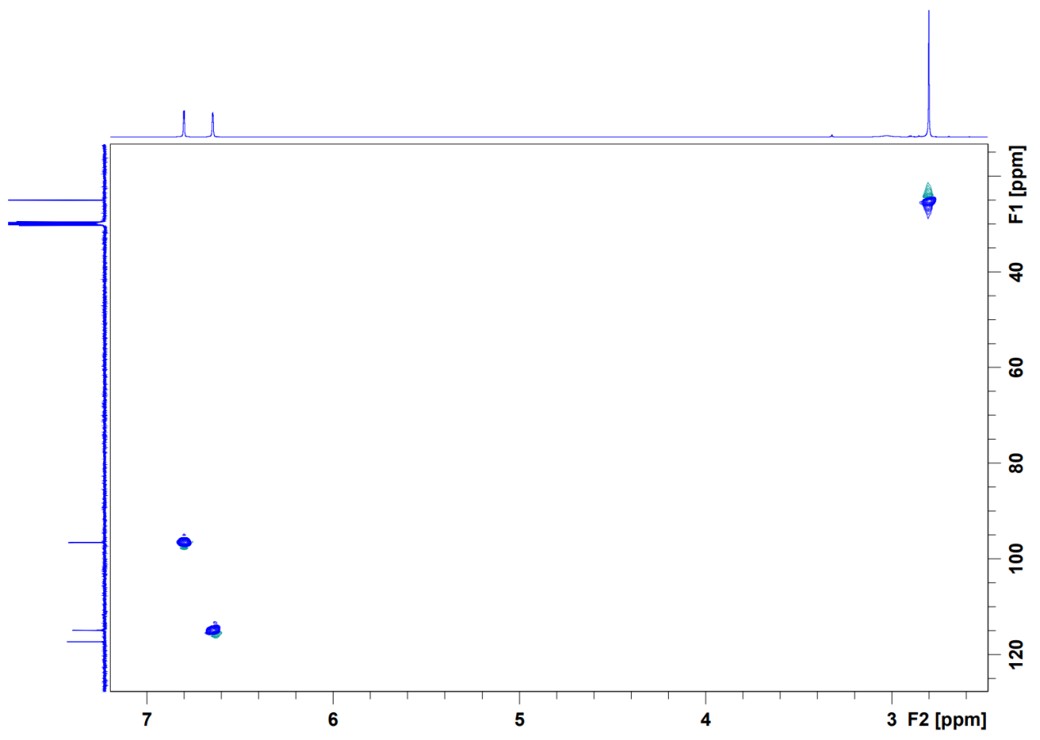
Figure S22 HSQC spectrum of 3,7-dihydroxy-1,9-dimethyldibenzofuran (3) 14-4 (Acetone-d₆)
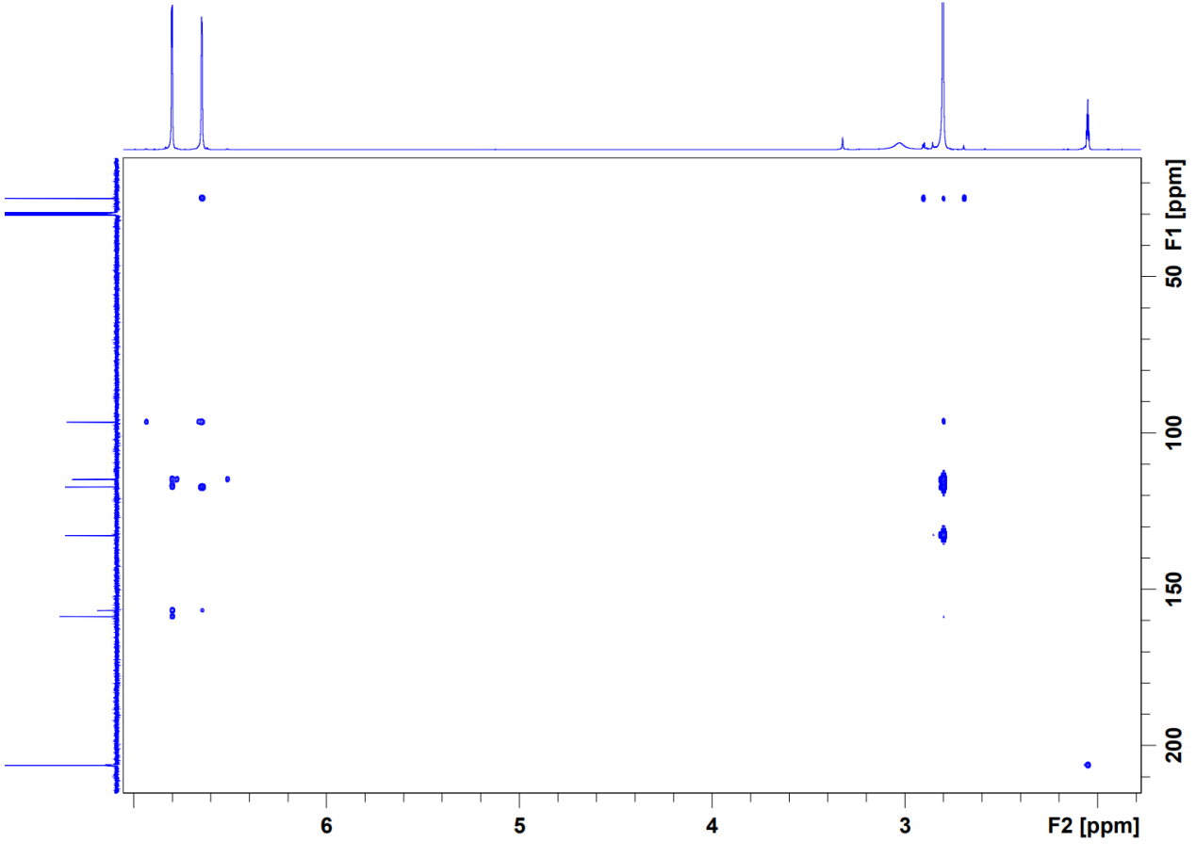
Figure S23 HMBC spectrum of 3,7-dihydroxy-1,9-dimethyldibenzofuran (3) 14-4 (Acetone-d₆)
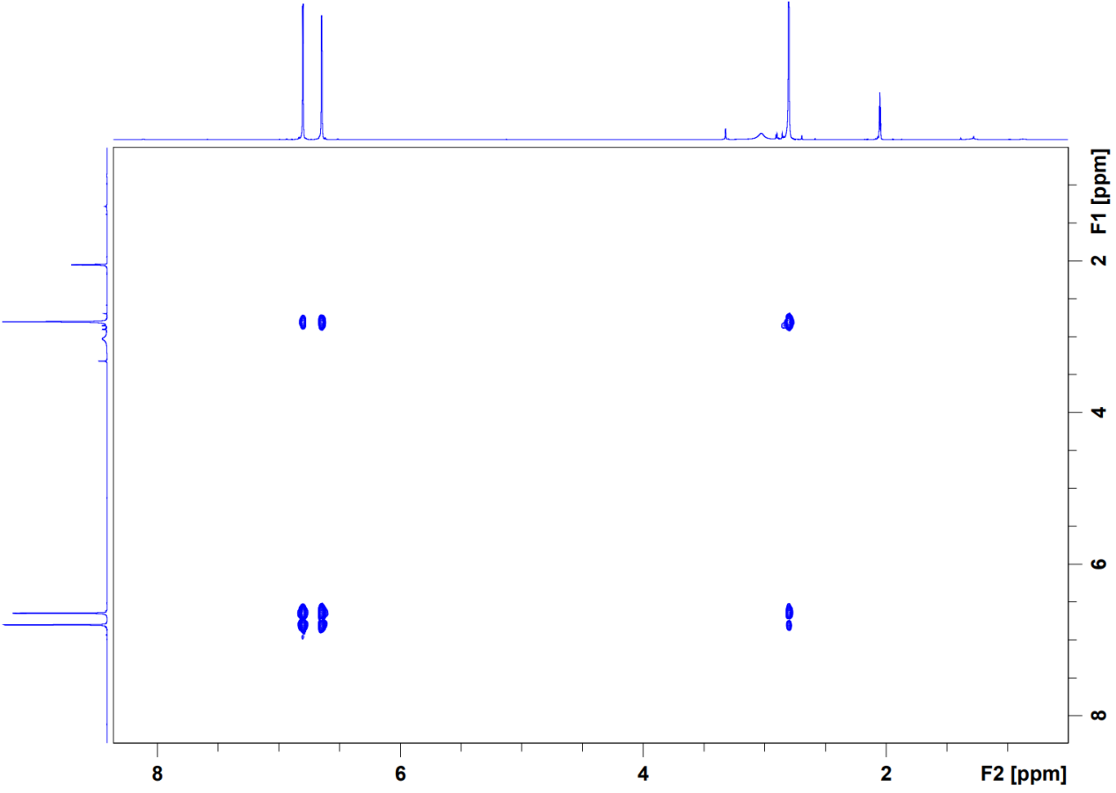
Figure S24 ¹H-¹H COSY spectrum of 3,7-dihydroxy-1,9-dimethyldibenzofuran (3) 14-4 (Acetone-d₆)
Figure S25 ¹H NMR spectrum of Methyl 3-hydroxybenzoate (4) 14-7 (DMSO-d₆, 600 MHz)
Figure S26 ¹³C NMR spectrum of Methyl 3-hydroxybenzoate (4) 14-7 (DMSO-d₆, 151 MHz)
Figure S27 ¹H NMR spectrum of Uracil (5) 14-5 (DMSO-d₆, 600 MHz)
Figure S28 ¹³C NMR spectrum of Uracil (5) 14-5 (DMSO-d₆, 151 MHz)

