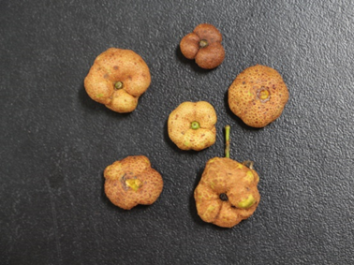 | 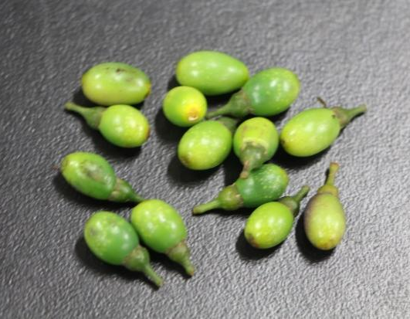
Powdery fruit | Healthy fruit
Figure S1 Physical picture of diseased and healthy fruits of Cinnamomum burmannii

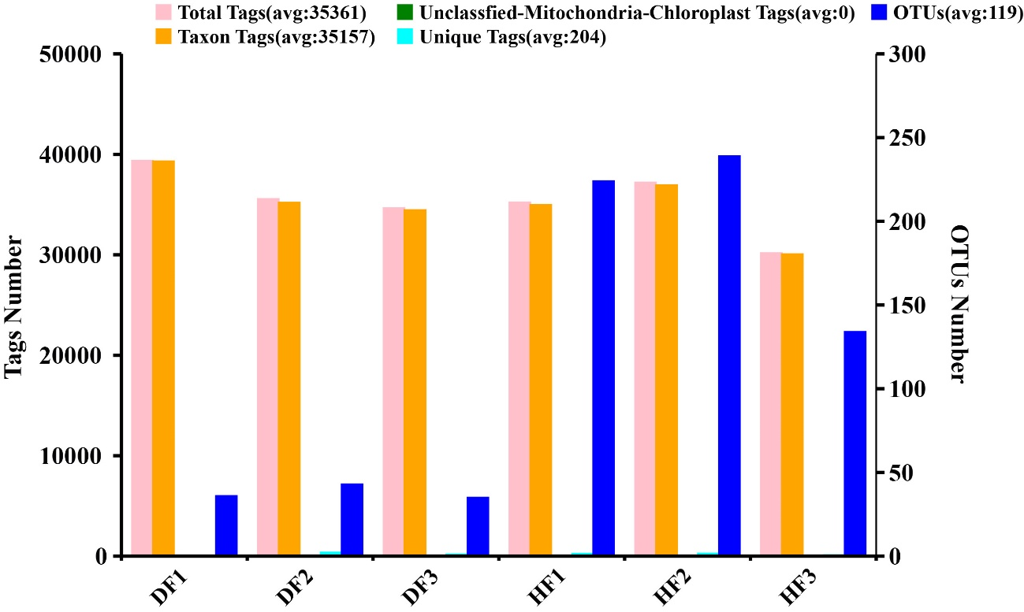
Figure S2 The number of tags and OTUs of fungi in healthy and diseased fruit samples of C. burmannii. Total Tags: the total number of stitching sequences obtained after filtering, Taxon Tags: the number of Tags used to build OTUs and obtain classification information, Unclassfied-Mitochondria-Chloroplast Tags: the number of OTU Tags that cannot be annotated to the boundary level, Unique Tags: the number of Tags with frequency 1 that cannot be clustered into OTUs, OTUs: the number of OTUs finally obtained.

Figure S3 Rarefaction Curve. a is the Chao1 index dilution curve for a single sample, b is the Chao1 index dilution curve between HF and DF groups, c is the Shannon index dilution curve for a single sample, d is the Shannon index dilution curve between HF and DF groups.

Figure S4 Phylogenetic tree for endophytic fungi from C. burmannii based on the rDNA-ITS sequence. a is phylogenetic tree for endophytic fungi of diseased fruit. b is phylogenetic tree for endophytic fungi of healthy fruit.

