Effect of Lithium Administration on Brain Activity Under an Emotion Regulation Paradigm in Healthy Participants: A Functional Magnetic Resonance Imaging Study

Supplementary material
Methods:

Tasks
Emotion Regulation Task (Reinecke et al., 2015)
40 negatively valanced coloured International Affective Picture System (Lang et al., 1997) images portraying characteristic panic- related catastrophic expectations, such as accidents or attacks (mean valence rating of 2.8±1.7, mean arousal ratings of 6.0±2.2 on 9-point Likert scales from 1=unpleasant/low arousal to 9=pleasant/high arousal) were used. Images were presented in eight blocks of five images, each displayed for five seconds and separated by one-second fixation cross. Image blocks were alternated with a baseline block (fixation cross) of thirty seconds, where participants were asked to relax. Starting with a baseline block, there were two experimental conditions: maintain (M), where participants were instructed to passively view the images and naturally experience the emotional state evoked; and reappraise (R), where participants were instructed to downregulate the provoked negative affect through reappraisal, trained prior to the scanning session. Half of the participants per group (placebo/lithium) started with maintain and half with reappraise, with instructions switching midway (four maintain, four reappraise). Instructions were given before the block by presenting the word “maintain” or “suppress” for four seconds. Following each picture block, a 4-point rating scale (1=neutral; 4=negative) was displayed for four seconds and participants had to indicate using a keypad the intensity of the negative affect experienced throughout the block (see Figure 1 for an example trial).
Checkerboard Control Task (Murphy et al., 2009)
The task consisted of two conditions: flash and baseline, with 10 blocks of alternating black and white squares switching at a frequency of eight Hz; and 10 blocks of a fixed-cross, respectively. Each flash block lasted for 16 seconds and each baseline block of 15 seconds. Participants were instructed to lay still while keeping their eyes open and blinking normally.

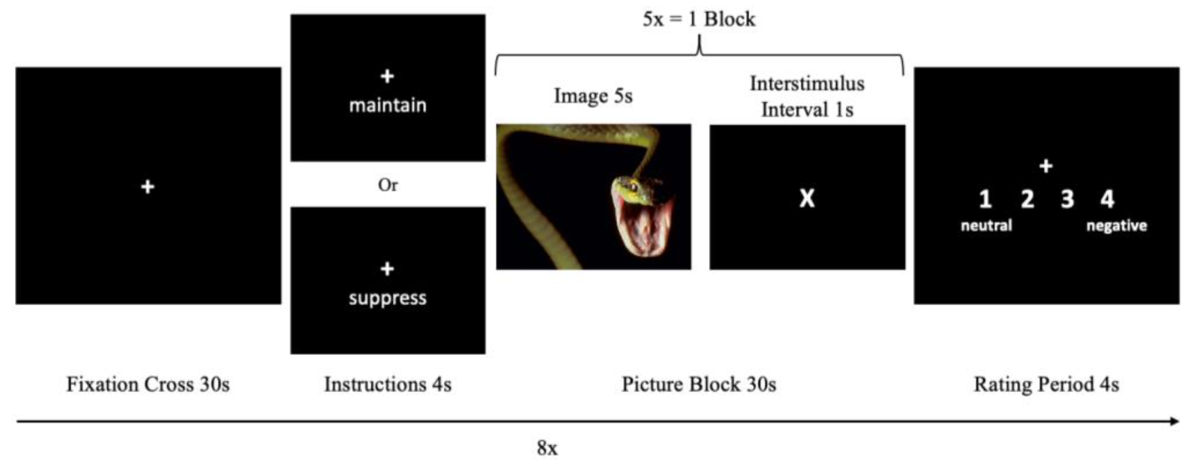Fig. S1 Emotion Regulation Task: Example Trial. The task starts with fixation cross for 30 seconds followed by instructions indicating either suppress or maintain. Picture Block consists of 5 images, 5 seconds each, each separated by 1s interstimulus interval. At block completion, a rating period of 4 seconds takes place

Results

Table S1 – Main effect of the emotion regulation task across groups
 | Brain area | Side | Cluster size (voxels) | MNI max (x, y, z) | z-score | p-value
Task activation (mean across groups, reappraise > maintain) (Z > 3.1, p < 0.05)
Cluster 1 | Paracingulate cortex  ACC, supplemetary motor cortex and dmPFC.  dlPFC, vlPFC and lateral OFC. Insular cortex and frontal operculum, hippocampus, thalamus, cerebellum, lateral occipital cortex and the superior and middle temporal gyrus, supramarginal gyrus and angular gyrus | R+L | 36268 | 14, 20, 58 | 6.88 | <0.001
Cluster 2 | Occipital pole | R+L | 268 | 4, -94, 4 | 4.26 | <0.001
Cluster 3 | Cingulate gyrus | L | 140 | -4, -26, 28 | 4.81 | 0.0015
Cluster 4 | Cingulate gyrus, precuneous cortex, intracalcarine cortex | R | 110 | 0, -42,18 | 3.96 | 0.0068
Cluster 5 | Inferior temporal gyrus, temporal pole | R | 102 | 50, 2, 42 | 3.94 | 0.0104
Task activation (mean across groups, reappraise > maintain) (Z > 2.3, p < 0.05)
Cluster 1 | In addition to regions above: anterior PFC (BA10), posterior CC, amygdala, insular cortex | R+L | 85337 | 50, 2, -42 | 7.13 | <0.001
 | MNI coordinates (x, y, z) refer to the peak of activation within each cluster

Table S2 – Small Volume Correction Significant Increased Activation in Selected Regions of Interest. Z>3.1, p<0.05 Corrected
 | Brain area | Side | Cluster size (voxels) | MNI max (x, y, z) | z-score | p-value
Z > 3.1, p < 0.05
Task activation  Mean across groups  R > M | Amygdala | R | 11 | 26, -6, -18 | 3.92 | 0.0072
 | Amygdala | R | 7 | 22, 0, -24 | 3.68 | 0.0118
 | Amygdala | R | 1 | 26, 0, -20 | 3.20 | 0.0324
 | Amygdala | L | 25 | -26, -6, -16 | 3.80 | 0.0016
 | MTG | R | 170 | 52, -26, -4 | 4.82 | <0.001
 | MTG | L | 339 | -58, -30, 0 | 5.80 | <0.001
Group x Task  (R > M; Lithium > Placebo) | MTG | R | 19 | 52, -32, 6 | 4.33 | 0.0058
Note: MTG, middle temporal gyrus; R > M, reappraisal versus maintain; ROI, region of interest; MNI, Montreal Neurological Institute; R, right; L, left. MNI coordinates (x, y, z) refer to the peak of activation within each cluster

