NCBI Code: C152
Designation: KB
Species: Human
Tissue: mouth
Morphology: Epithelial-like
Description: The KB cell line was derived from an epidermoid carcinoma in the mouth of an adult Caucasian male. It was one of the early successful attempts to isolate and serially propagate a human cell line directly in monolayer culture on glass. The line was isolated in a medium consisting of 90% basal medium (Eagle), and 10% human serum and in the course of 350 subsequent passages has been adapted to 5% calf serum. The KB line has been used extensively in studies of cell nutrition and metabolism, cancer chemotheraphy screening, tumorigenicity and viruses. KB cells have been reported to contain human papilloma virus 18 (HPV-18) sequences.
Culture Medium: EMEM (EBSS) + 1% NEAA + 10% FBS. The cell line was adapted to RPMI 1640 + 10% FBS in NCBI.
Preservation Medium: FBS + 10% DMSO
Subculture Routine: Split confluent cultures 1:3 to 1:10, ie seeding at 1-3 x 10^4 cells/cm^2 using 0.25% trypsin or trypsin/EDTA, 5% CO2, 37°C.
Isoenzymes: LDH, G6PD, NP
Sterility: Tests for mycoplasma, bacteria and fungi were negative.

Passage No: 375
DNA Typing:
CSF1P O: | FG A: | TH0 1: | TPO X: | VW A: | D3S13 58: | D5S8 18: | D7S8 20: | D8S11 79: | D13S3 17: | D16S5 39: | D18S 51: | D21S 11: | AME L:
9,10 | 21 | 7 | 8,12 | 16,18 | 15,18 | 11,12 | 8,12 | 12,13 | 12,14 | 9,10 | 16 | 27,28 | X

ATCC Number: CCL-17
ECACC Number: 94050408
Reference: Proc Soc Exp Biol Med 1955, 89:362; ibid 1956, 91: 361; ibid 1957, 94:661;
Cancer Res 1958, 18:1017; Science 1961, 33:1559.
Karyology: 2n=46, near triploid to hypertriploid cell line
Chromosome Frequency Distribution (Cells /Chromosomes):
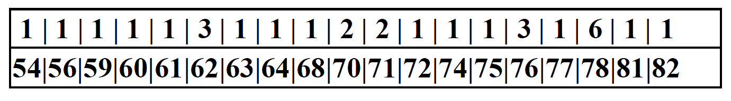
Viability: 100%, 3.5 x 10^6 cells/vial

