Table 1. MS/MS-based characterization of R. sinensis compounds extracted with different solvents
Tentative identification | Chemical formula of [M-H]⁻ | R_{t} (min) | Calculated mass | [M-H]⁻ m/z | MS² ions | Type of extract |  |  | Structure
 |  |  |  |  |  | Ace | MeOH | EtOH | Structure
Chromones
6-Hydroxymethyl eugenitin | C₁₂H₁₁O₅ | 11.80 | 235.0606 | 235 | 235, 232, 220, 207, 190, 164, 148, 137, 83, 79, 73 | + | - | - | 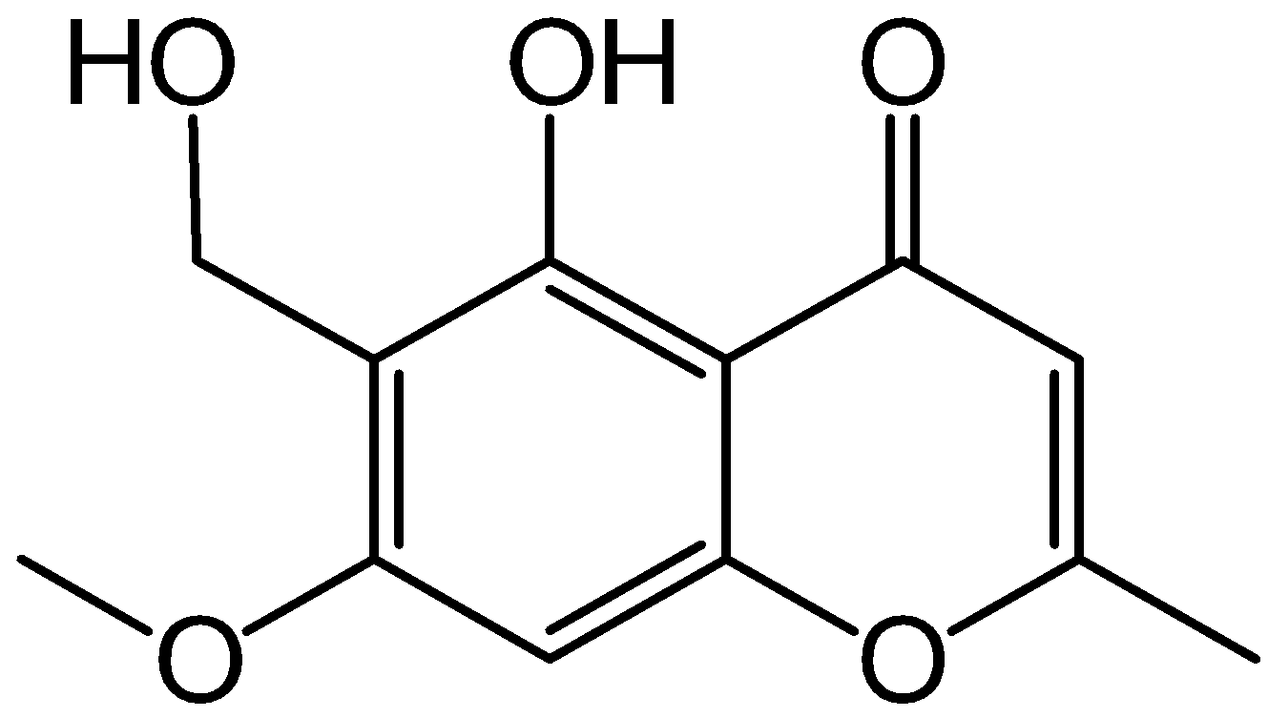
Lepraric acid | C₁₈H₁₇O₈ | 13.10 | 361.0923 | 361 | 235, 220, 207, 191 | + | - | + | 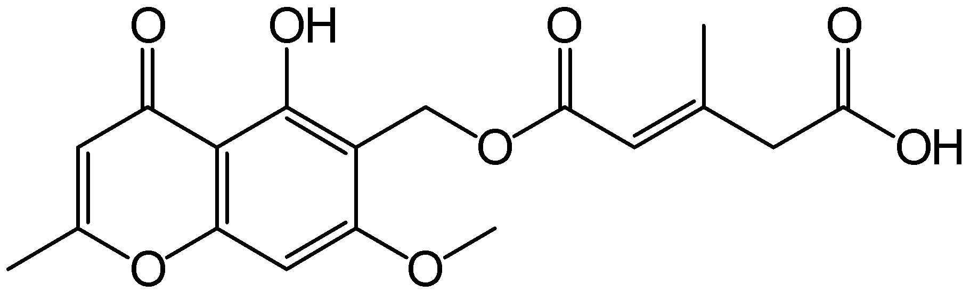
Depsides
Ramalinaic acid | C₁₈H₁₅O₈ | 11.90 | 359.0766 | 359 | 343, 326, 323, 301, 283, 275, 257, 229, 215, 83 | + | - | - | 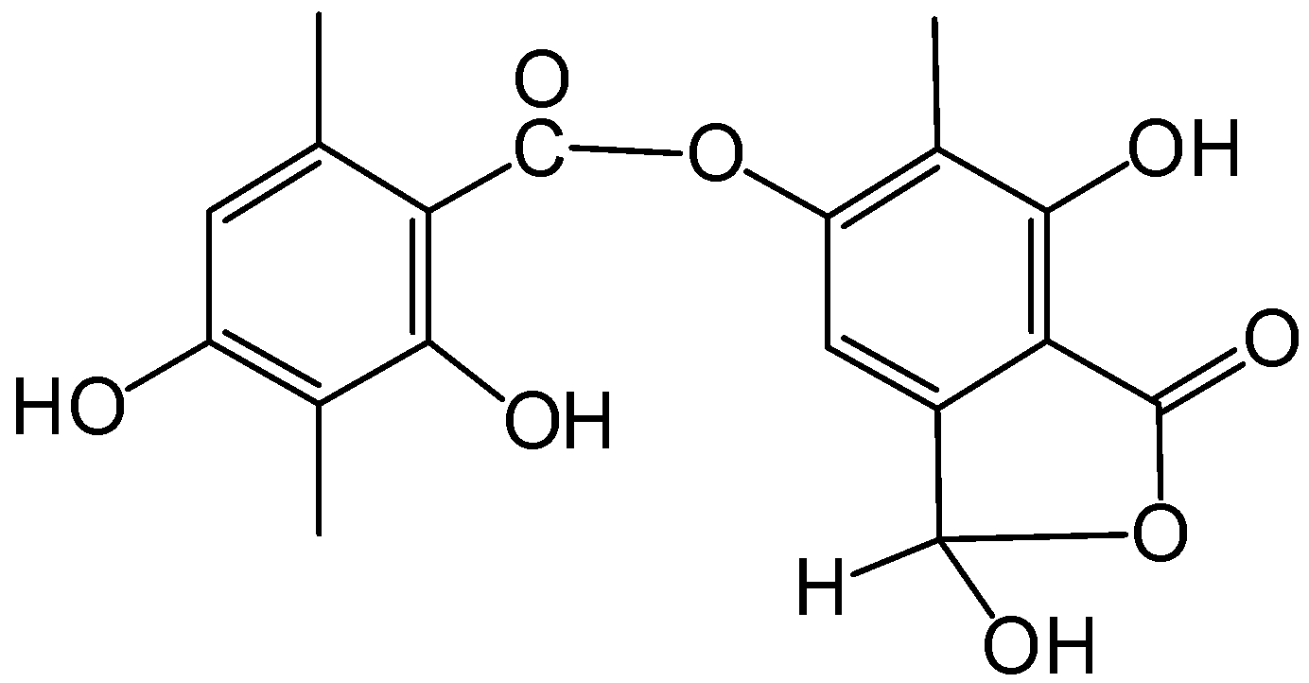
Subsekikaic acid | C₂₀H₂₁O₈ | 15.16 | 389.1236 | 389 | 389, 343, 328, 325, 315, 301, 299, 286, 259, 231, 220, 180, 139, 95, 83 | + | - | - | 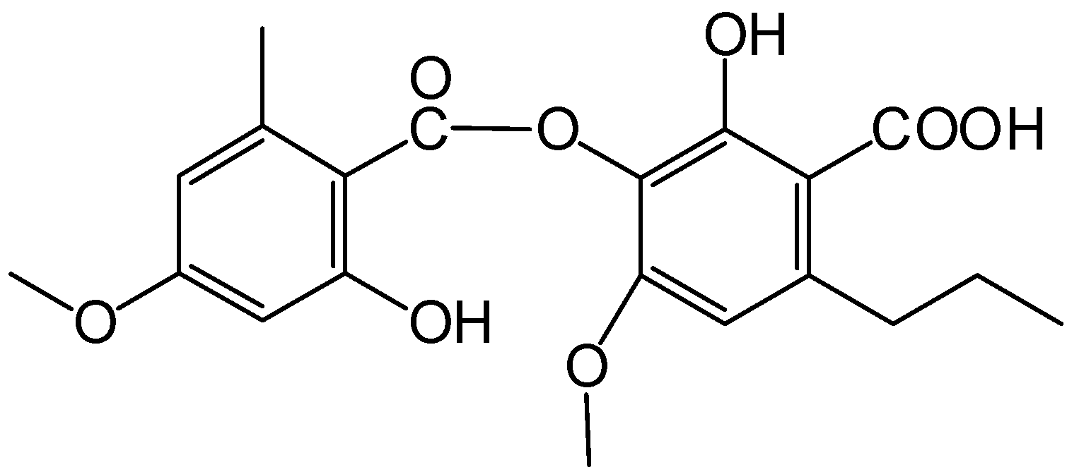
2-O-Methyldivaricatic acid | C₂₂H₂₅O₇ | 12.94 | 401.1600 | 401 | 356, 342, 325, 282, 270, 226, 218, 181, 96, 68 | - | + | - | 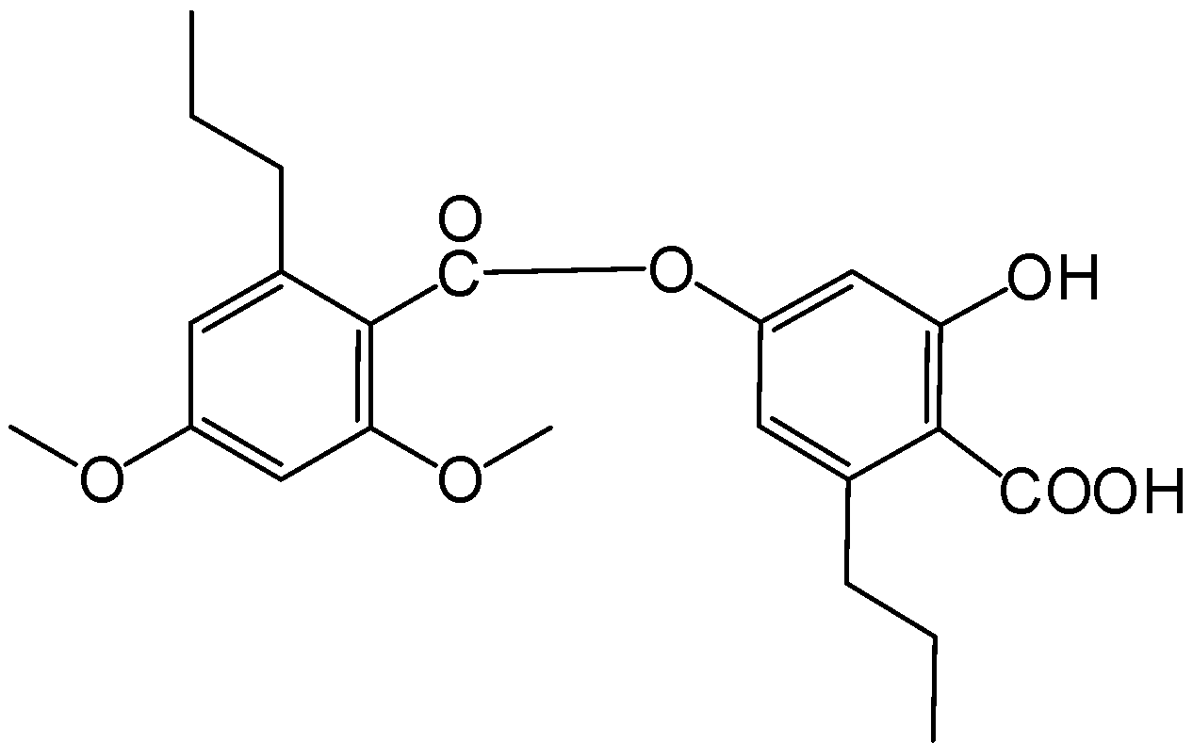
Stenosporic acid | C₂₃H₂₇O₇ | 13.54 | 415.1756 | 415 | 370, 355, 343, 338, 326, 314, 231, 160 | + | + | - | 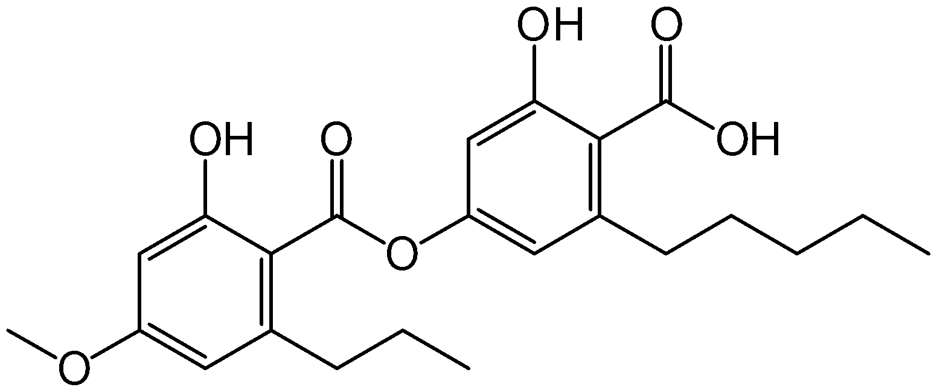
Perlatolic acid | C₂₅H₃₁O₇ | 14.43 | 443.2069 | 443 | 398, 366, 357, 339, 326, 313, 297, 259, 258, 218 | + | - | + | 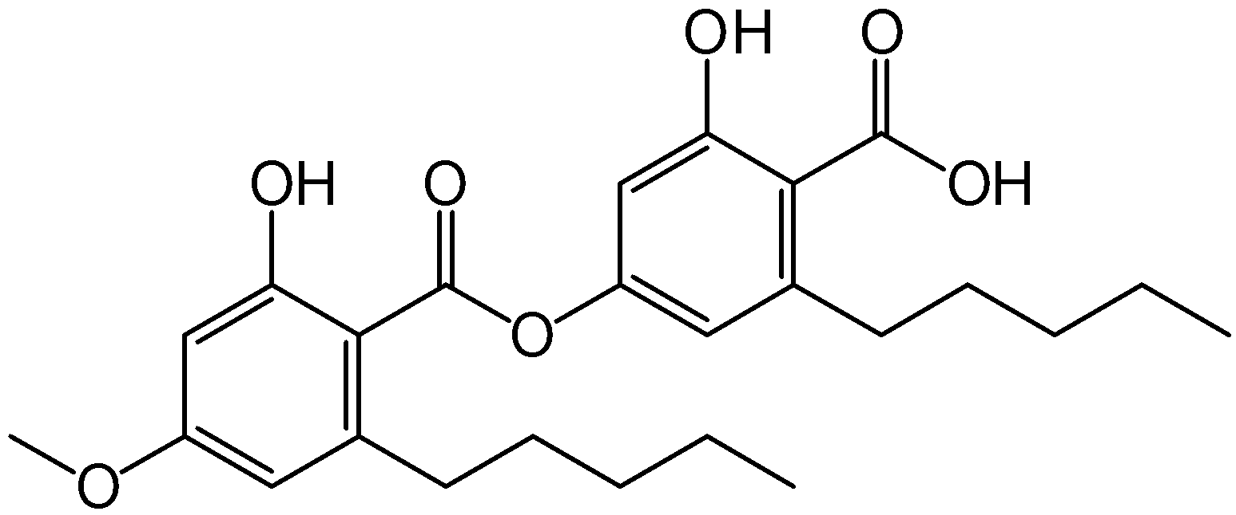
2'-O-Methylperlatolic acid | C₂₆H₃₃O₇ | 15.00 | 457.2226 | 457 | 412, 397, 386, 354, 340, 314, 297, 239, 214, 180, 94 | - | + | - | 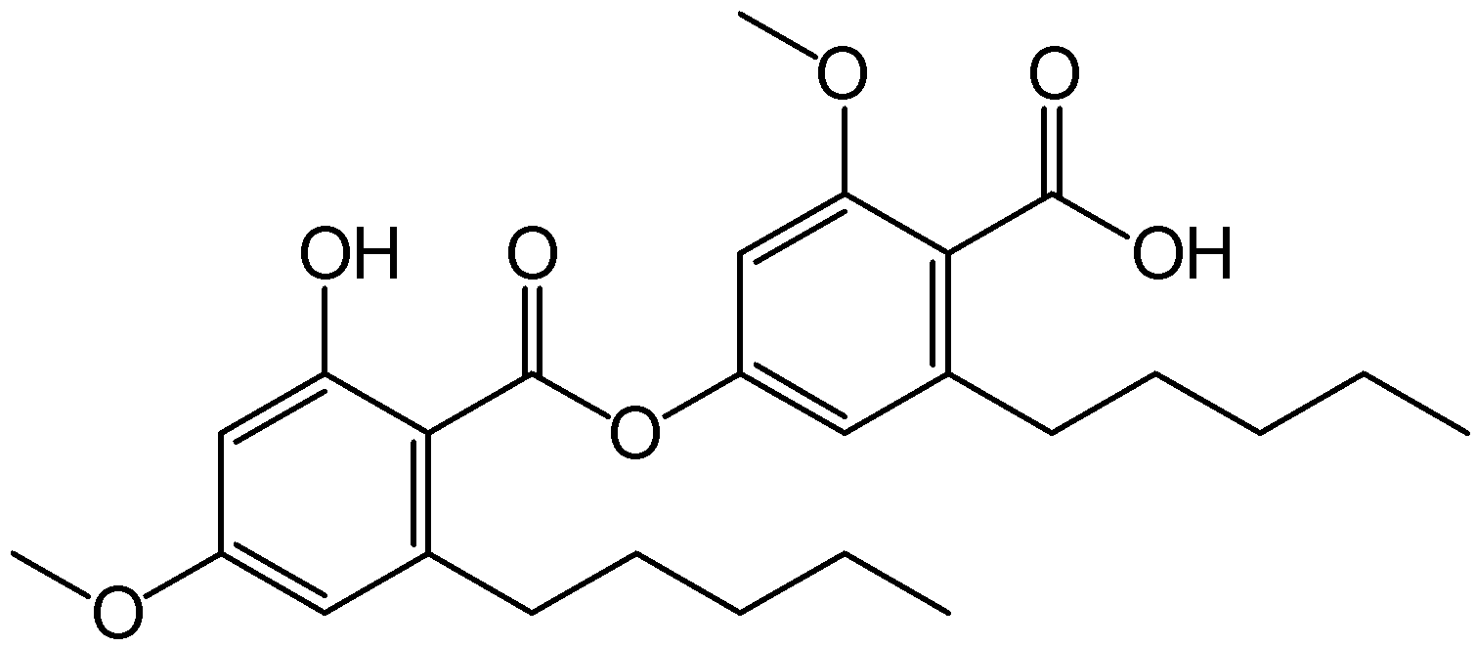
Squamatic acid | 2M-2H+Na | 15.10 | 801.164 | 802 | 412, 391, 389 | - | - | + | 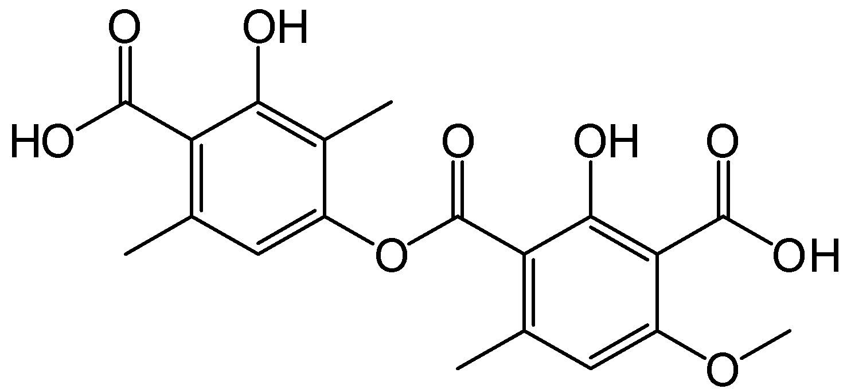

Table 1. MS/MS-based characterization of R. sinensis compounds extracted with different solvents (continued)
Tentative identification | Chemical formula of [M-H]⁻ | R_{t} (min) | Calculated mass | [M-H]⁻ m/z | MS² ions, m/z | Type of extract |  |  | Structure
 |  |  |  |  |  | Ace | MeOH | EtOH | Structure
Dibenzofurans
Isousnic acid |  | 13.58 |  | 342 | 312, 286, 231, 82 | + | - | - | 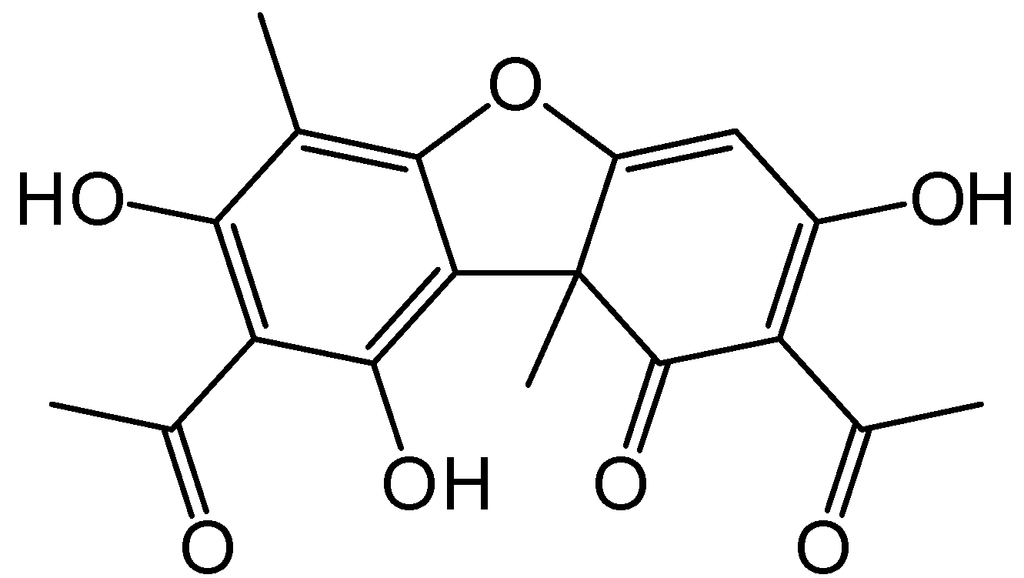
Usnic acid | C₁₈H₁₅O₇ | 15.44 | 343.0817 | 343 | 328, 313, 299, 259, 231, 215, 189, 83 | + | + | + | 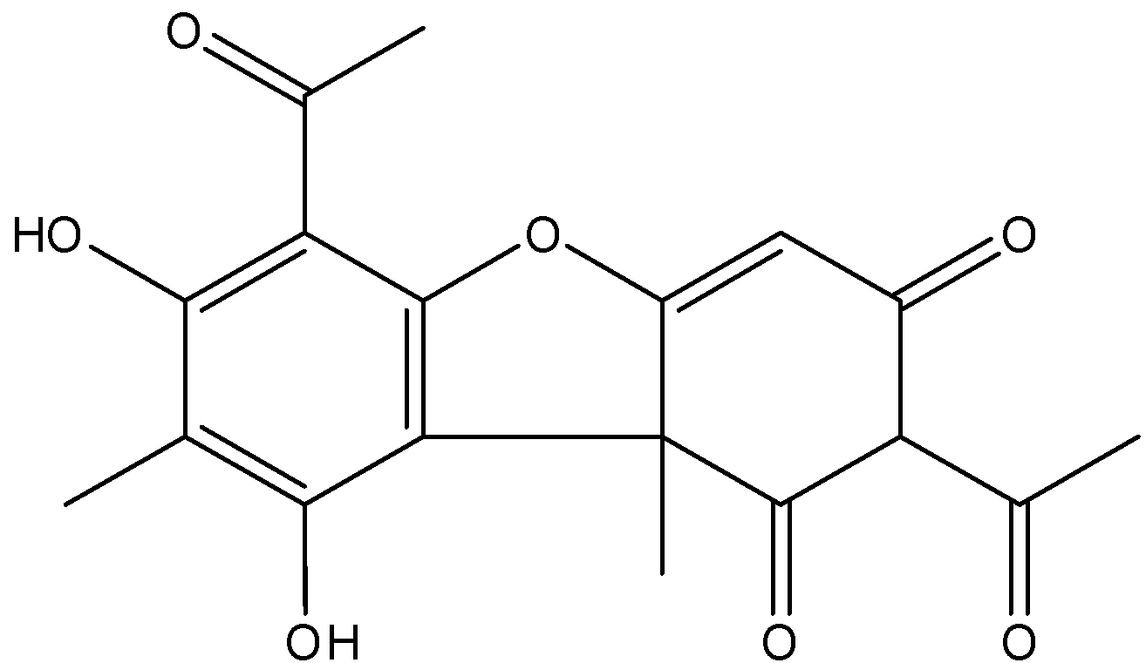
Placodiolic acid | C₁₉H₁₉O₈ | 14.47 | 375.1079 | 375 | 375, 373, 357, 343, 328, 315, 299, 255, 247, 234, 231, 215, 180, 83 | + | - | - | 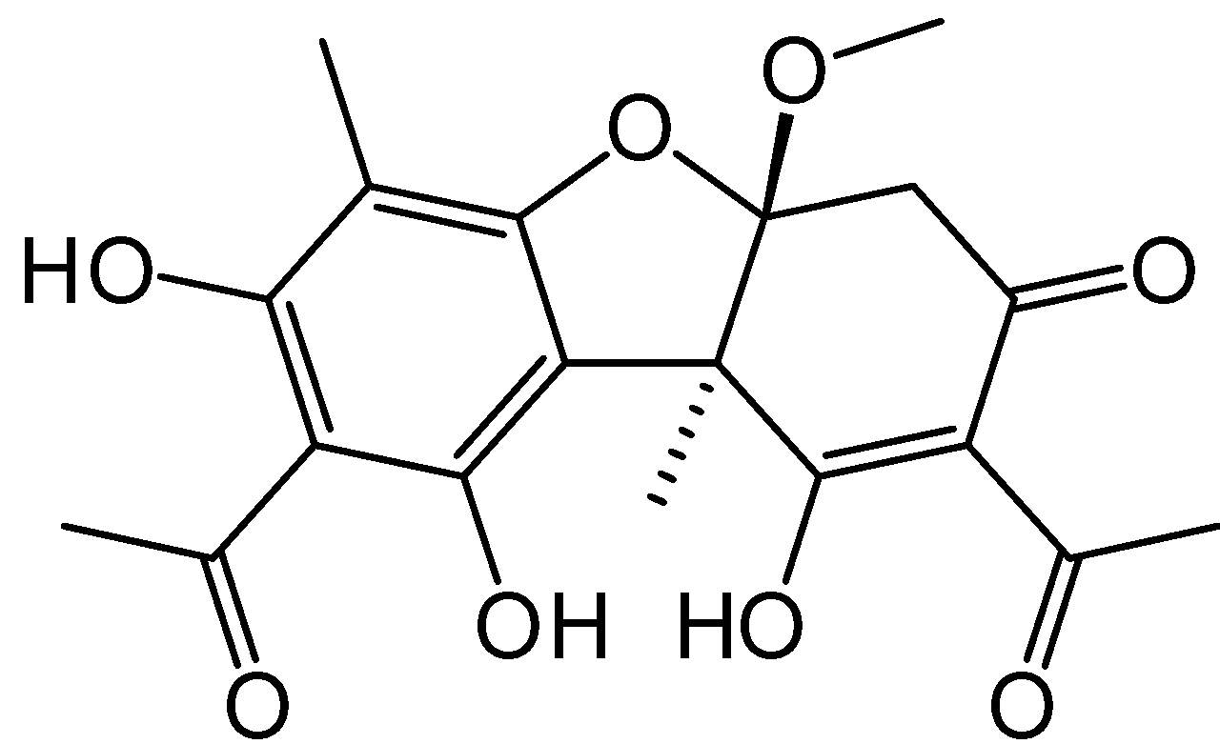
Usnic acid | 2M-2H+Na | 15.42 | 709.153 | 710 | 343, 328 | + | + | +
Pseudoplacodiolic acid | 2M-2H+Na | 14.51 | 773.206 | 774 | 774, 375, 233 | - | + | - | 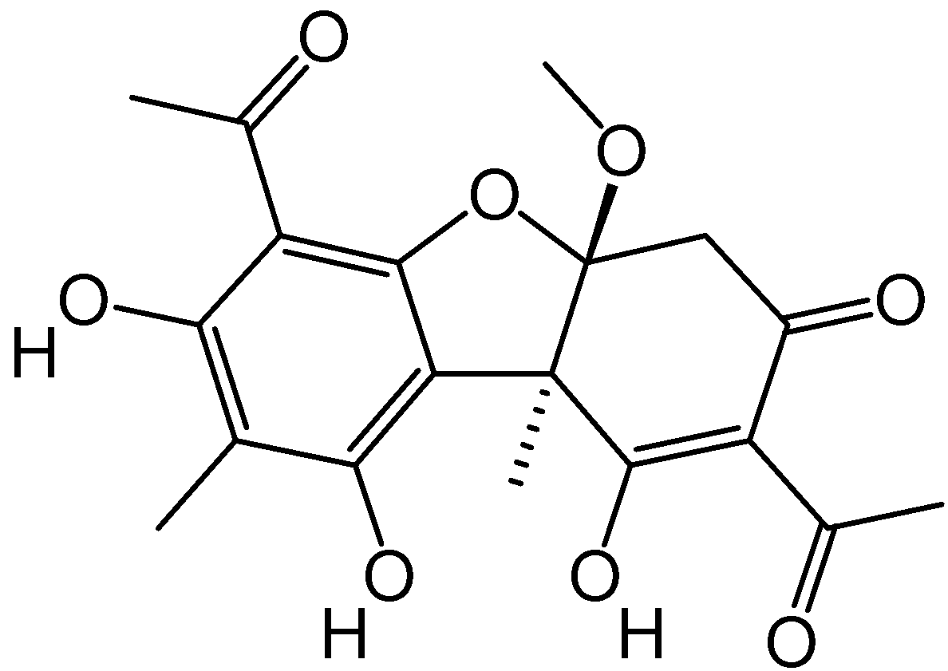
Depsidones
Virensic acid |  | 12.95 |  | 356 | 341, 326, 313, 311, 299, 297, 284, 272, 267, 243, 231, 177, 163, 96, 59 | - | + | - | 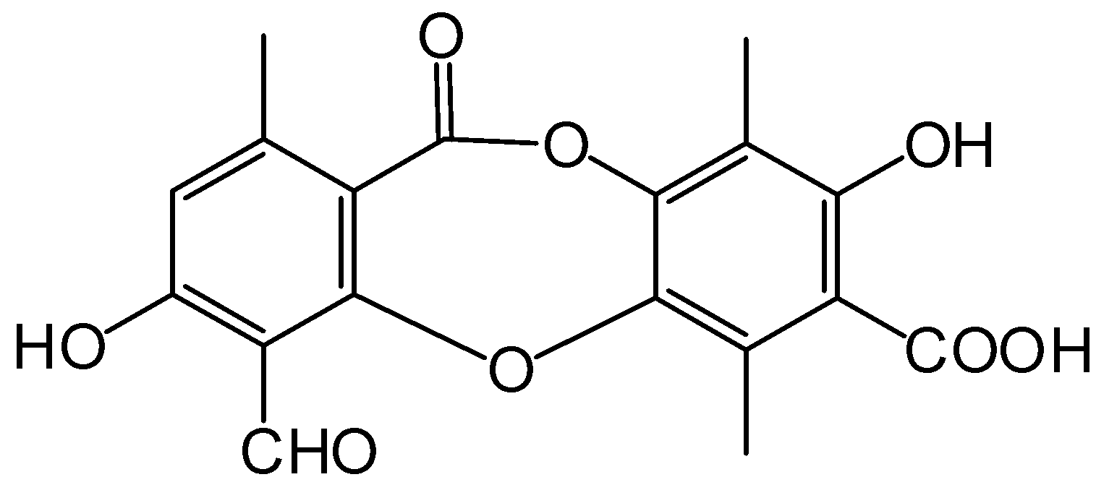
Norstictic acid | C₁₈H₁₁O₉ | 13.49 | 371.0403 | 371 | 369, 340, 338, 326, 323, 313, 309, 299, 231, 216, 207, 110, 79 | - | + | - | 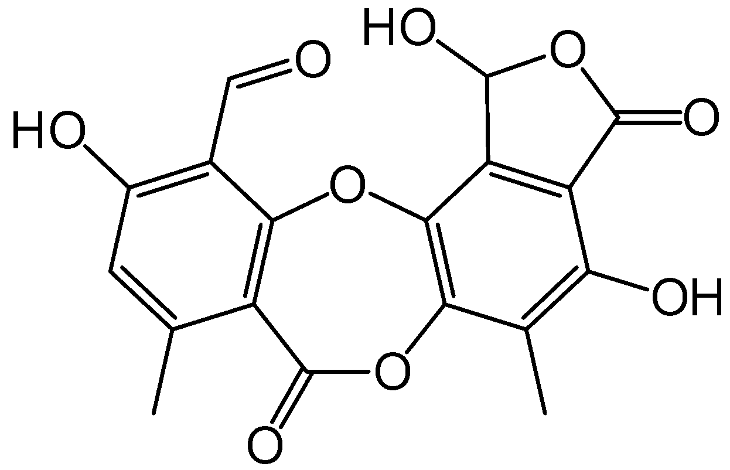
Conprotocetraric acid | C₁₈H₁₆O₉ | 14.47 | 376.0794 | 376 | 343, 328, 315, 301, 299, 291, 286, 283, 271, 259, 256, 244, 231, 227, 196, 187, 180, 95, 82, 55 | - | + | - | 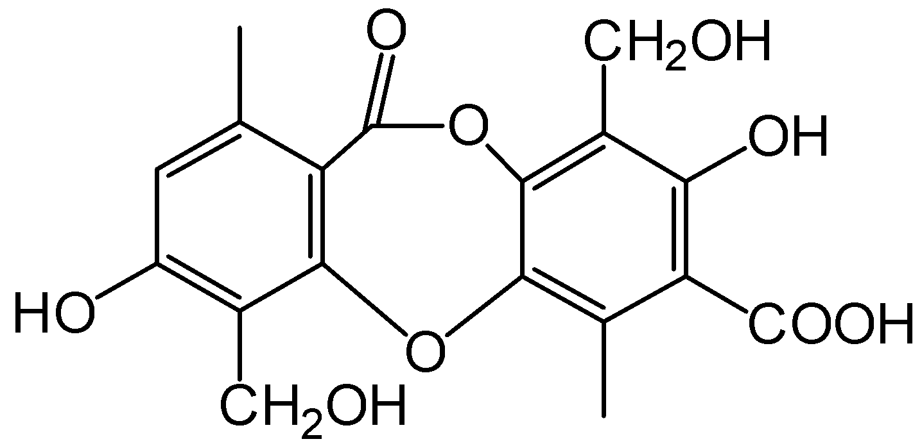

Table 1. MS/MS-based characterization of R. sinensis compounds extracted with different solvents
Tentative identification | Chemical formula of [M-H]⁻ | R_{t} (min) | Calculated mass | [M-H]⁻ m/z | MS² ions, m/z (relative intensity) | Type of extract |  |  | Structure
 |  |  |  |  |  | Ace | MeOH | EtOH | Structure
Depsidones
Methylstictic acid | C₂₀H₁₅O₉ | 11.18 | 399.0716 | 399 | 383, 368, 354, 325, 314, 300, 286, 256, 231, 225, 189, 94 | + | + | + | 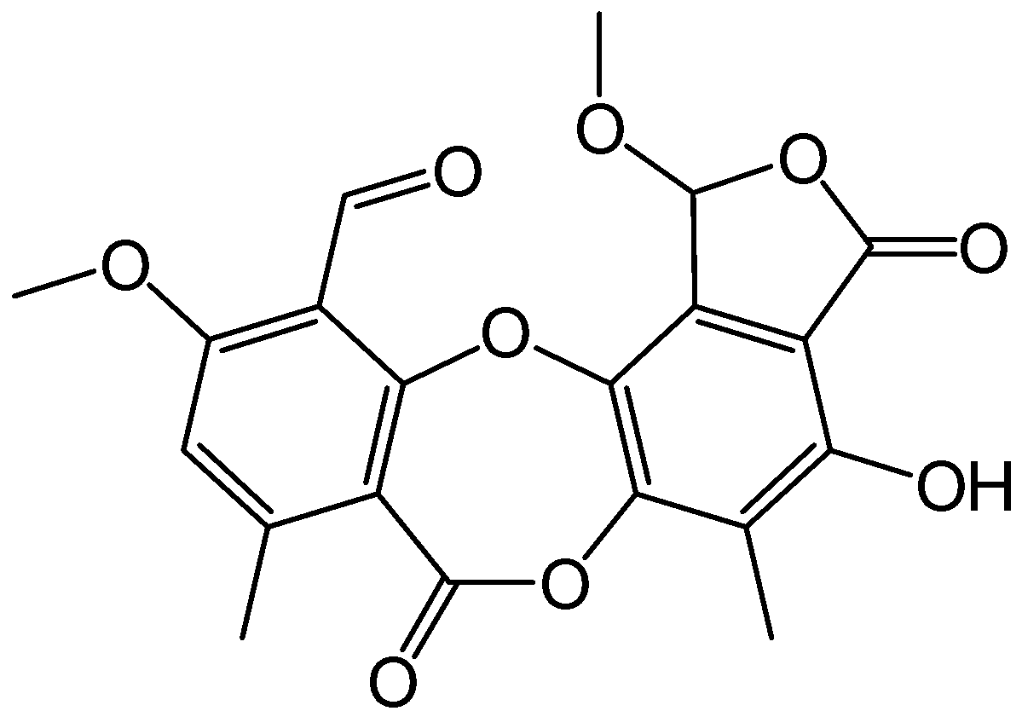
Gangaleoidin | C₁₈H₁₄Cl₂O₇ | 14.99 | 412.0116 | 412 | 395, 354, 326, 312, 310, 299, 164, 151, 136 | - | + | - | 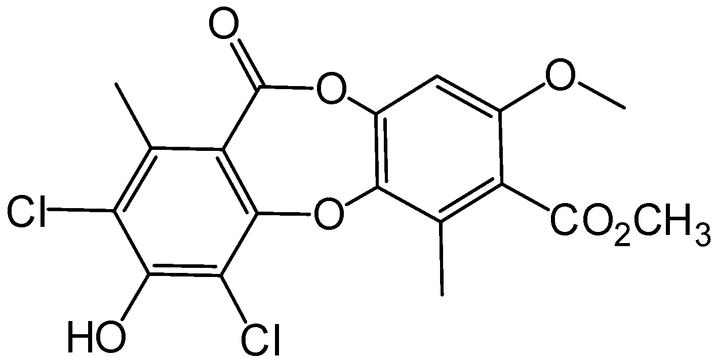
Terpenoids
(-)-ent-Kauran-16α-ol  (Ceruchinol) | C₂₀H₃₃O | 11.06 | 289.2531 | 289 | 288, 260, 231, 182, 117 | - | - | + | 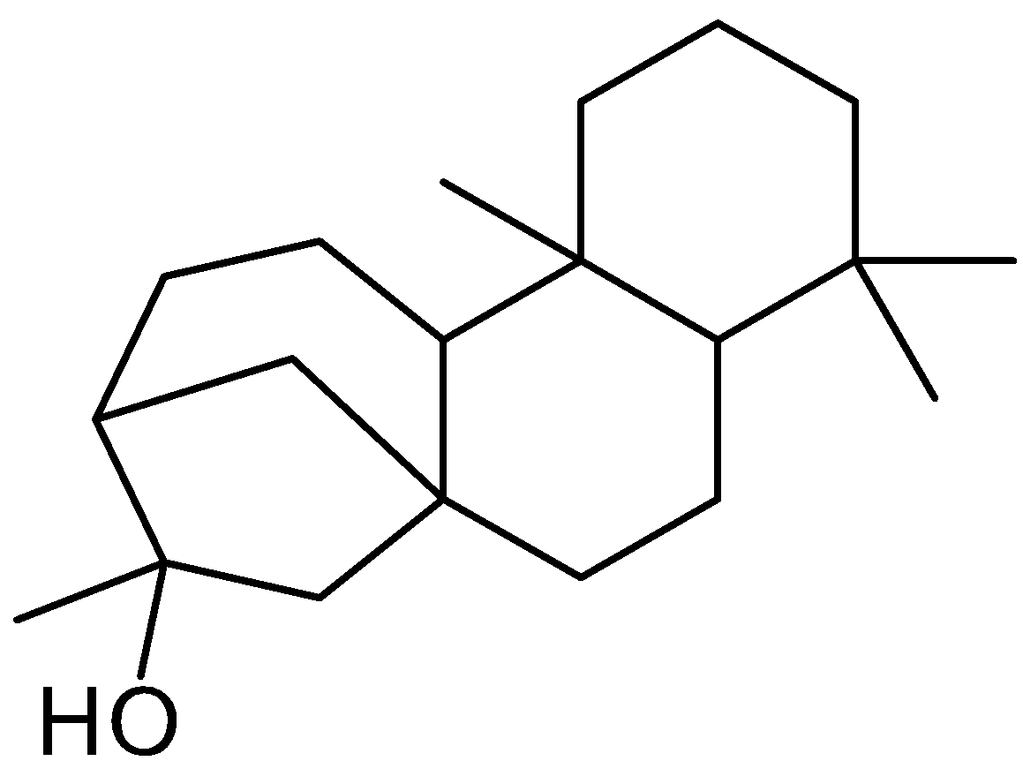
Fatty acids
Nephrosterinic acid | C₁₇H₂₇O₄ | 14.19 | 295.1909 | 295 | 277 (100), 195 (21), 183 (37), 180 (9), 171 (23), 164 (11), 108 (12), 97 (14) | + | + | + | 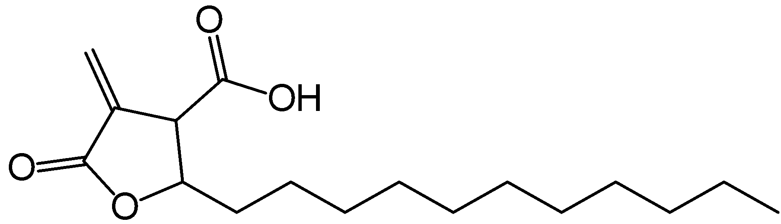
Arachidonic acid | C₂₀H₃₁O₂ | 11.80 | 303.2324 | 304 | 259, 244, 231, 215, 203, 189, 161, 83 | + | - | - | 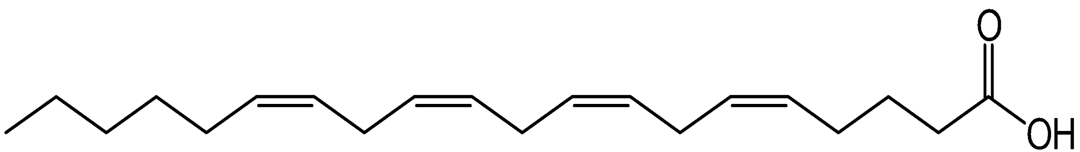
Monocyclic aromatic
Atranol | C₈H₇O₃ | 1.58 | 151.0395 | 151 | 87, 71, 59, 55, 43, 41 | + | + | - | 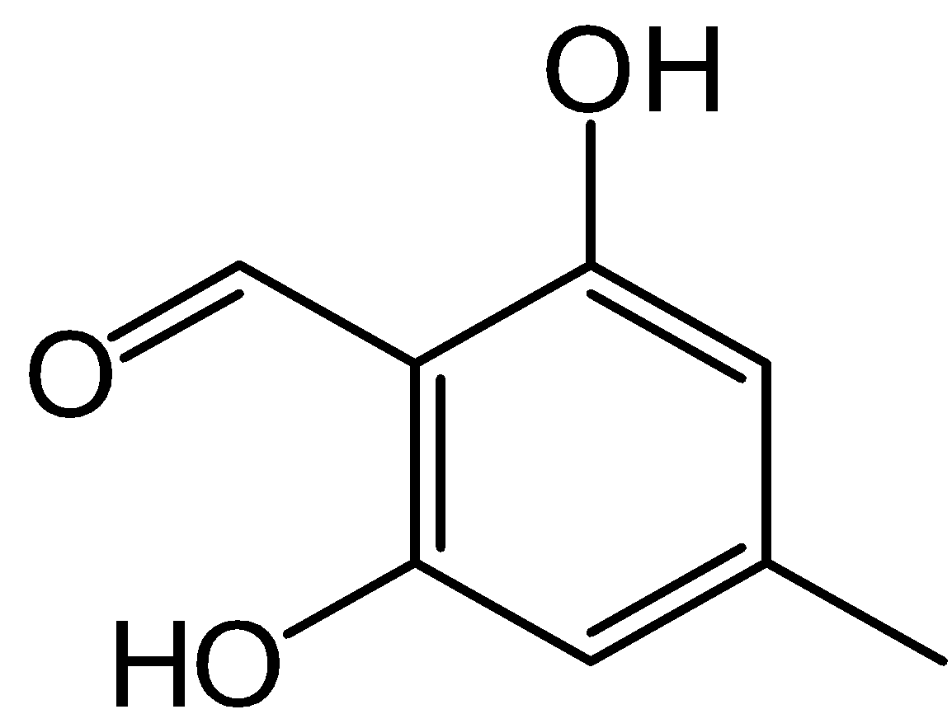
Olivetolic acid | C₁₂H₁₅O₄ | 12.55 | 223.0970 | 223 | 223, 207, 181, 163, 148, 137, 123, 121, 119, 95, 83, 79 | + | - | + | 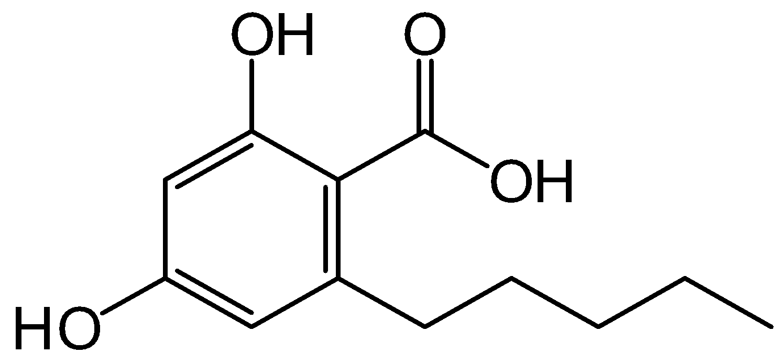
Polyols
meso-Erythritol | C₄H₁₀O₄ | 8.20 | 122.0579 | 121 | 121, 119, 92, 65 | + | - | - | 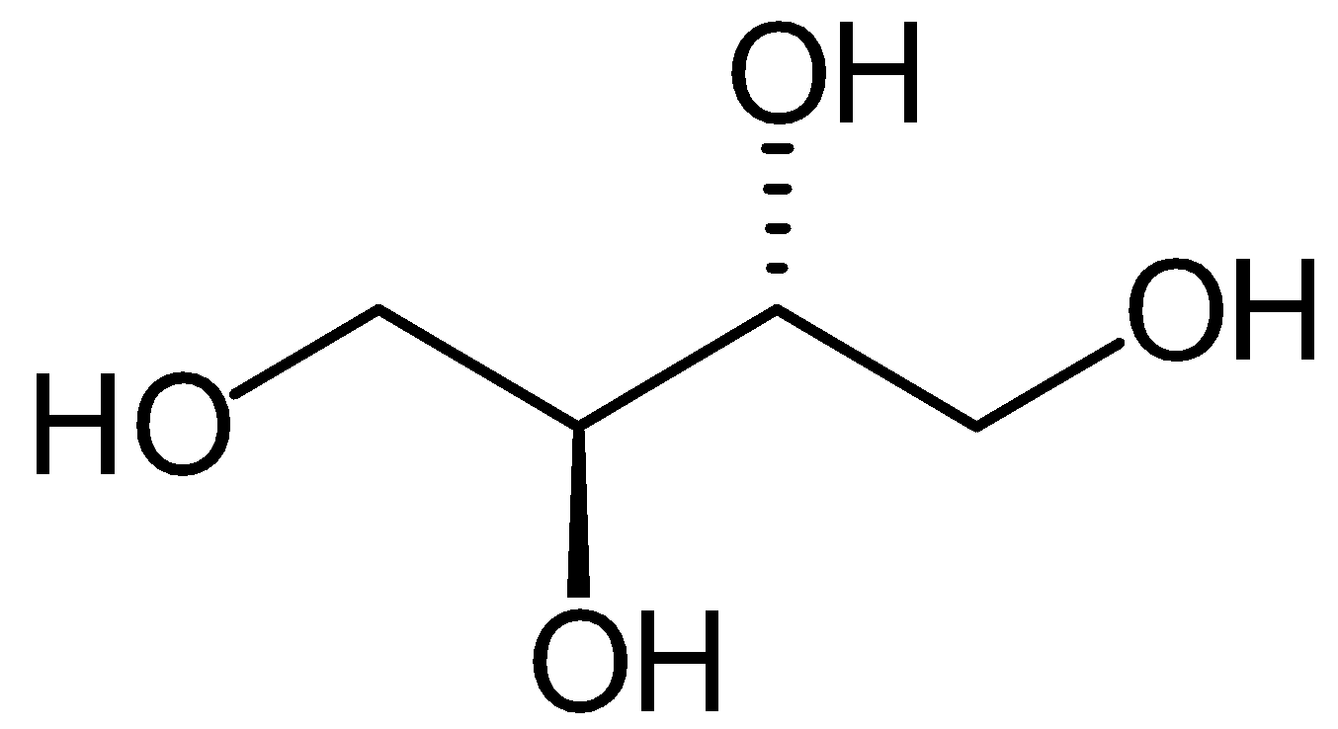

Table 1. MS/MS-based characterization of R. sinensis compounds extracted with different solvents
Tentative identification | Chemical formula of [M-H]⁻ | R_{t} (min) | Calculated mass | [M-H]⁻ m/z | MS² ions  m/z (relative intensity) | Type of extract |  |  | Structure
 |  |  |  |  |  | Ace | MeOH | EtOH | Structure
Pulvinic acid derivatives
Leprapinic acid | C₂₀H₁₆O₆ | 11.97 | 352.094 | 351 | 288, 276, 259, 244, 231, 232, 216, 205, 158, 83, 68 | + | - | - | 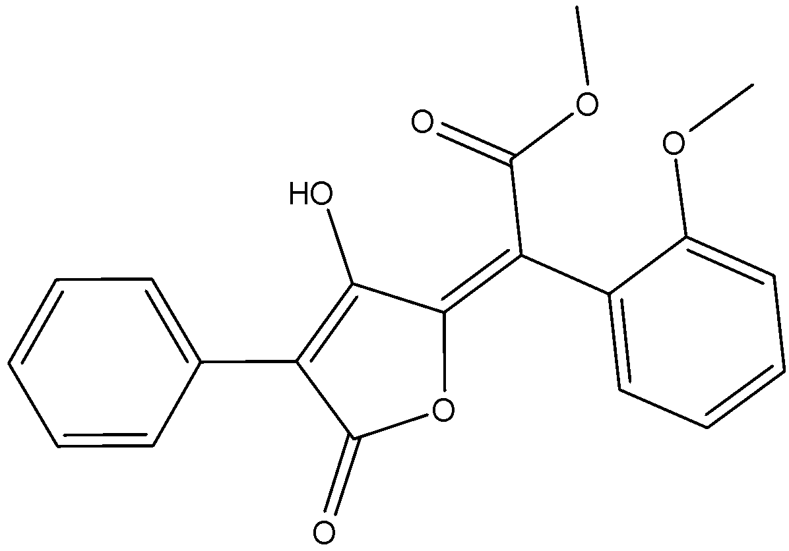
Leprapinic acid | 2M-2H+Na | 8.80 | 725.163 | 725 | 679, 678, 677 | - | + | +
Unknown compounds
Unknown | - | 9.20 | - | 187 | 187, 169, 151, 125, 123, 97, 95, 80, 57 | + | - | +
2-heptyl-4,6-dimethoxy-3-methylbenzoic acid | C₁₇H₂₆O₄ | 10.11 | 294.183 | 293 | 234, 250, 221, 207, 181, 178 | + | - | - | 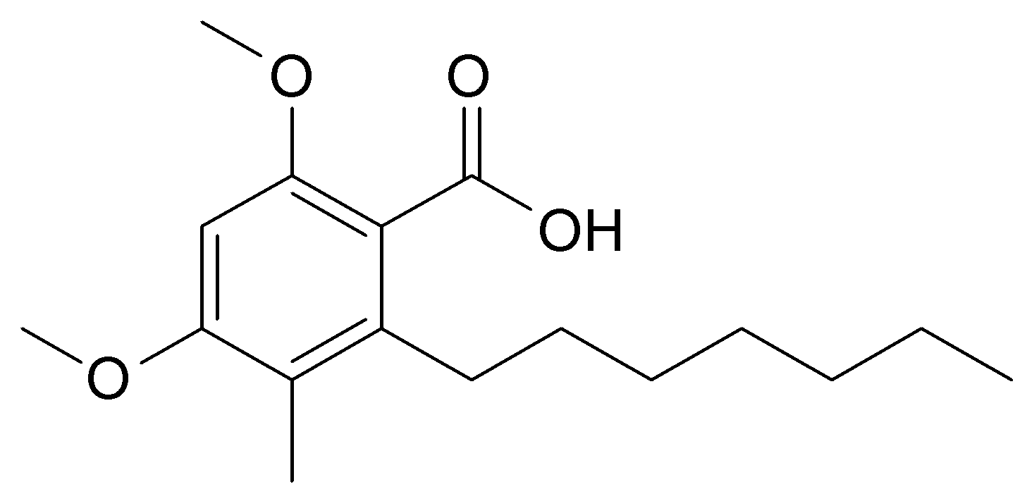
Trihydroxyoctadecenoic acid | C₁₈H₃₄O₅ | 10.72 | 330.240 | 330 | 329, 229, 211, 201, 171, 156, 139, 127 | + | - | -
Unknown | - | 12.00 | - | 360 | 303, 302, 301 | - | + | -
Unknown | - | 14.38 | - | 390 | 389, 387, 371, 369, 273, 201 | + | + | +
Unknown | - | 8.67 | - | 742 |  | - | - | +
Unknown | - | 13.10 | - | 746 | 745, 383, 361, 235 | + | - | +

