RAPACASPASE-9-BASED SUICIDE GENE APPLIED TO THE SAFETY OF IL-1RAP CAR-T CELLS
Lucie Bouquet, Walid Warda, Mathieu Neto Da Rocha, Rim Trad, Clémentine Nicod, Rafik Haderbache, Delphine Genin, Christophe Ferrand, Marina Deschamps

Supplemental Figures and Legends

- Figure S1. Schematic representation of viral constructs.
- Figure S2. Generation of iCasp9-G and iCasp9-A retroviral plasmids.
- Figure S3. Generation of RapaCaspase9 suicide gene plasmids.
- Figure S4. Functional validation of RapaCasp9-G suicide gene, induced by rapamycin produced for research and Rapamune® pill.
- Figure S5. Timing improvement for suicide gene induction in RapaCasp9-expressing GMTCs.

Figure S1

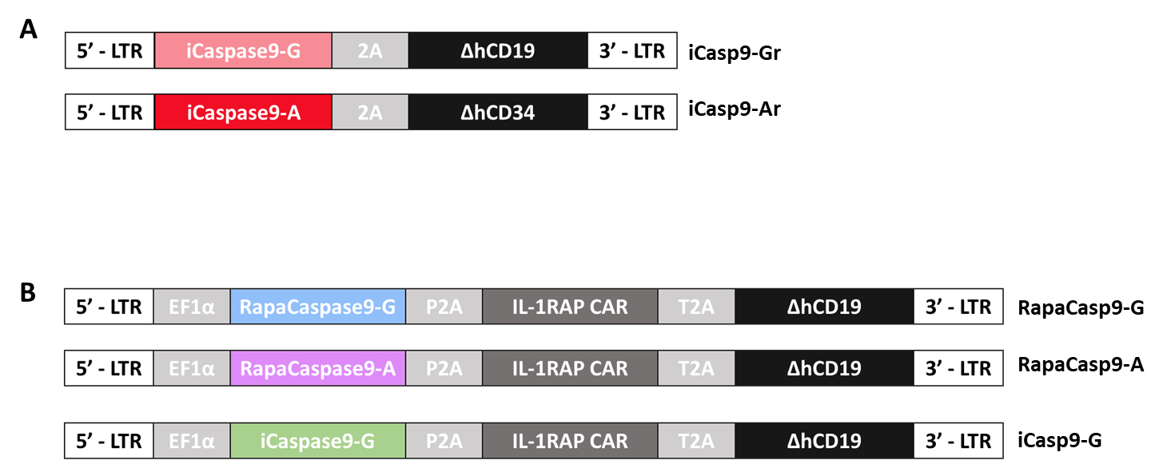

Figure S1. Schematic representation of viral constructs. A. Schematic representation of the retroviral iCaspase9 constructs, including the suicide gene and a ∆CD19. The different sequences are separated with 2a self-cleaving peptides. B. Schematic representation of the lentiviral RapaCaspase9 and iCaspase9 constructs, including an EF1α promoter, the suicide gene, an IL-1RAP chimeric antigen receptor and a ∆CD19. The different sequences are separated with 2a self-cleaving peptides

Figure S2

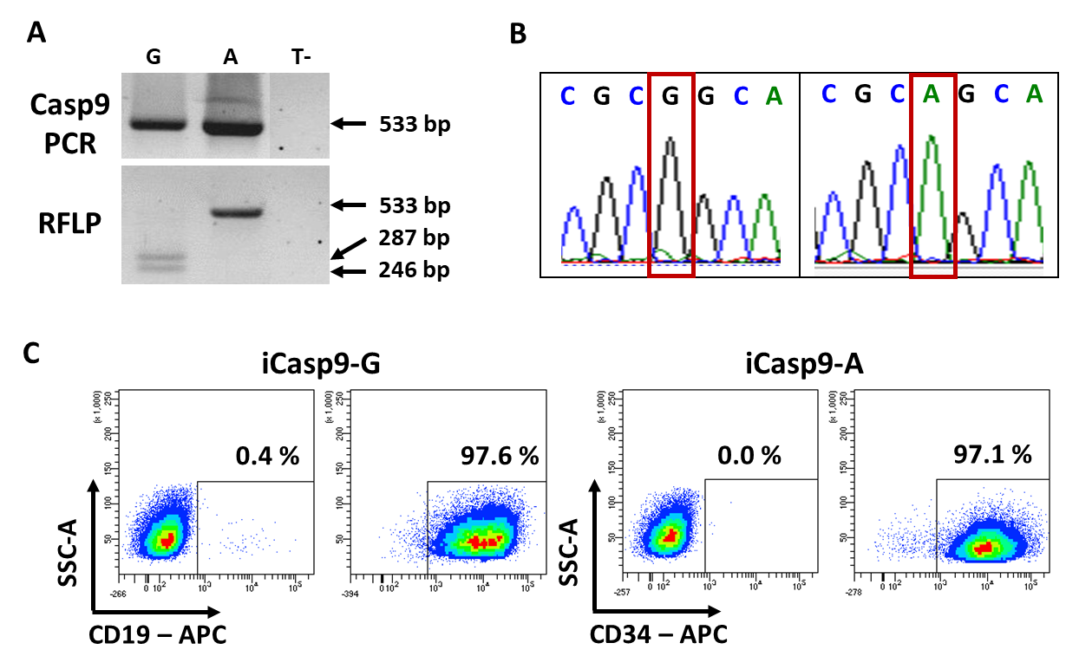

Figure S2. Generation of iCasp9-G and iCasp9-A retroviral plasmids. A. Restriction fragment length polymorphism of retroviral iCaspase9 plasmids targeting the site-directed mutagenesis site. PCR targeting the Casp9 suicide genes was performed, and the PCR products underwent enzymatic restriction with the BstUI enzyme and migration in an agarose gel. The negative control (T-) contained water instead of DNA. B. Validation of the site-directed mutagenesis by Sanger sequencing of the iCaspase9 suicide genes. C. Transfection efficiency of PG13-iCasp9-G and PG13-iCasp9-A after sorting with CD19 or CD34 labeling.

Figure S3

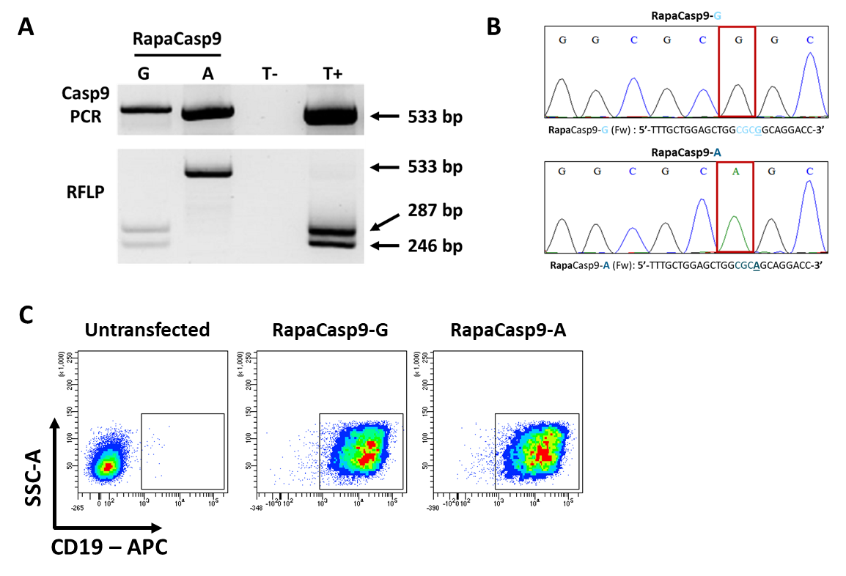

Figure S3. Generation of RapaCaspase9 suicide gene plasmids. A. Restriction fragment length polymorphism of lentiviral RapaCaspase9 plasmids targeting the site-directed mutagenesis site. PCR targeting the Casp9 suicide genes was performed, and the PCR products underwent enzymatic restriction with the BstUI enzyme and migration in an agarose gel. The negative control (T-) contained water instead of DNA, and the positive control (T+) contained a validated plasmid with a G nucleotide. B. Validation of the site-directed mutagenesis by Sanger sequencing of the Casp9 suicide genes. C. Representative dot plots of the transfection efficiency for HEK-293T cells transfected with RapaCasp9-G and RapaCasp9-A lentiviral plasmids.
Figure S4

Figure S4. Functional validation of RapaCasp9-G suicide gene, induced by rapamycin produced for research and Rapamune® pill. Cell death percentages of RapaCasp9-G-expressing GMTCs during 24 and 48 hours after rapamycin exposure. Cells were exposed to 109 nM rapamycin from Sigma-Aldrich (produced for research) or from Rapamune® pill (commercialized rapamycin), and normalized to control cells (DMSO treated). Cell death was evaluated by Annexin-V/7-AAD labeling and gating on CD3⁺/CD19⁺ cells by flow cytometry. Mean ± SD of three independent experiments.

Figure S5

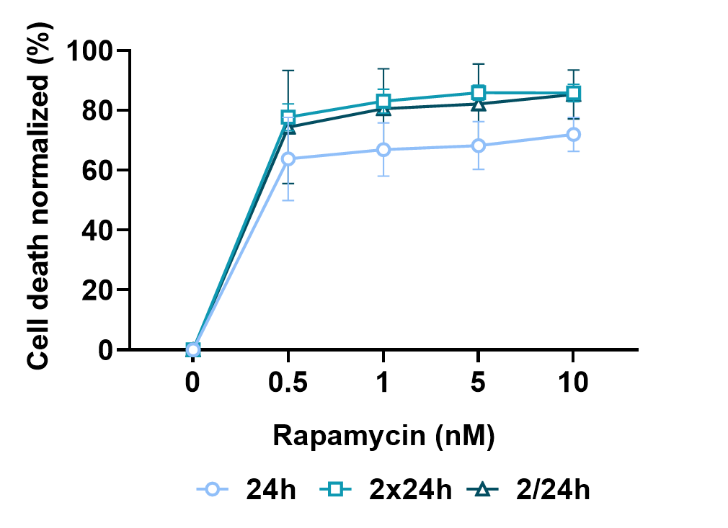

Figure S5. Timing improvement for suicide gene induction in RapaCasp9-expressing GMTCs. Killing curve after exposure to rapamycin at doses ranging from 0.5 nM to 10 nM. RapaCasp9-G-expressing GMTCs were exposed to rapamycin during 24 hours (24h), to two successive doses of rapamycin during 24 hours with cells washing between each dose (2x24h), and two successive half-doses of rapamycin added 24 hours apart (2/24h). Mean ± SD of three independent experiments.

