Supporting Information
Direct Conversion of N-Acetyl-D-glucosamine to value added N- containing aromatic heterocyclic compounds
Samrin S. Shaikh^{1,2}, Chetana R. Patil¹, Nishita Lucas¹, Vivek V. Bokade^{2,3}, Chandrashekhar V. Rode^{1,2}*
Chemical Engineering and Process Development Division, CSIR-National Chemical Laboratory, Dr. Homi Bhaba Road, Pune 411008, India.
*Corresponding author: Email: cv.rode@ncl.res.in
Tel.: +91 (020) 25902349

Experimental procedure for isolated yields
3AF and 3A5AF was purified using column chromatography. A silica column (silica, 10 g) (100-200 mesh) were used. The sample was previously analyzed on SiO₂ TLC plates using a 50 % ethyl acetate/hexanes mixture and the retention factor (Rf) obtained was used as a reference for column. The Rf was 0.14. Samples of the product were combined and extracted using solvent extraction technique (DMSO + H₂O). After evaporating the solvent using the Buchi Rota evaporator at 50 °C until dryness, the dried residue was placed under vacuum. The HRMS data were in agreement with the formulation of C₆H₇NO₂ and C₈H₉NO₃. For three reactions performed under identical conditions, isolated yields were 50 and 21 % respectively.

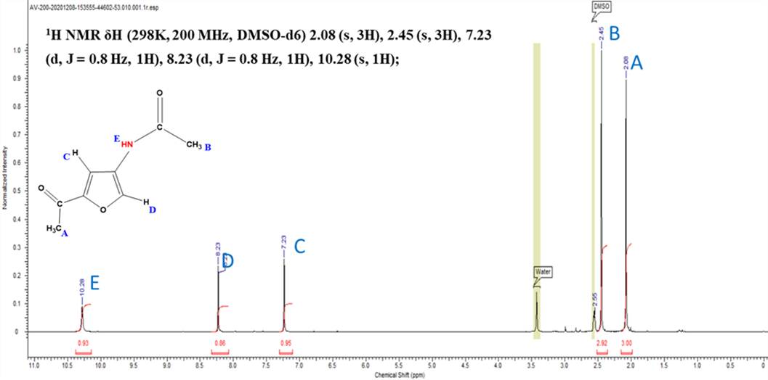
Fig. S-1a: ¹H NMR spectrum of 3A5AF produced from N-acetyl-D-glucosamine [1H NMR δH (298K, 200 MHz, DMSO-d6) 2.08 (s, 3H), 2.45 (s, 3H) 7.23 (d, J = 0.8 Hz, 1H),8.23 (d, J = 0.8 Hz, 1H), 10.28 (s, 1H)]
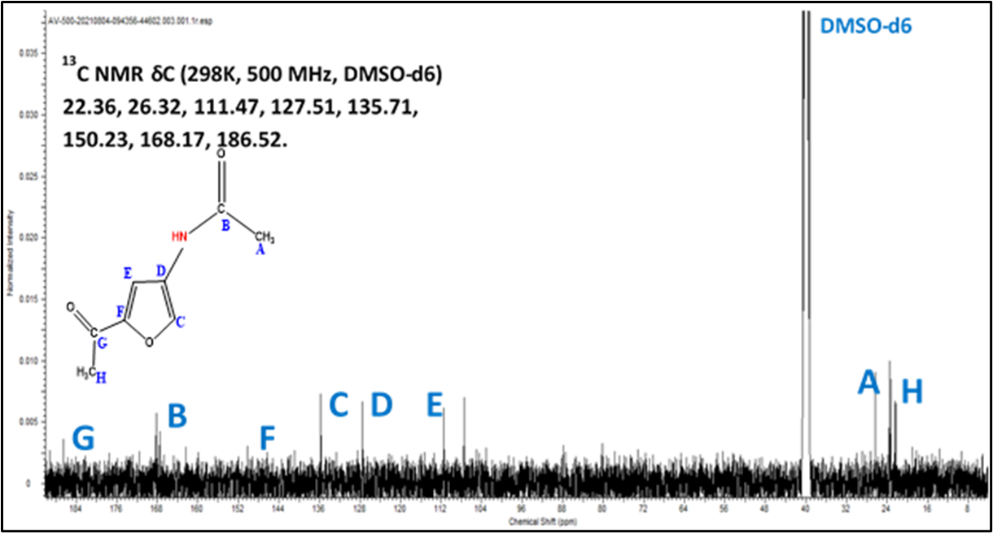
Fig. S-1b: ¹³C NMR spectrum of 3A5AF produced from N-acetyl-D-glucosamine [¹³C NMR δC (298K, 500 MHz, DMSO-d6) 22.36, 26.32, 111.47, 127.51, 135.71, 150.23, 168.17, 186.52]

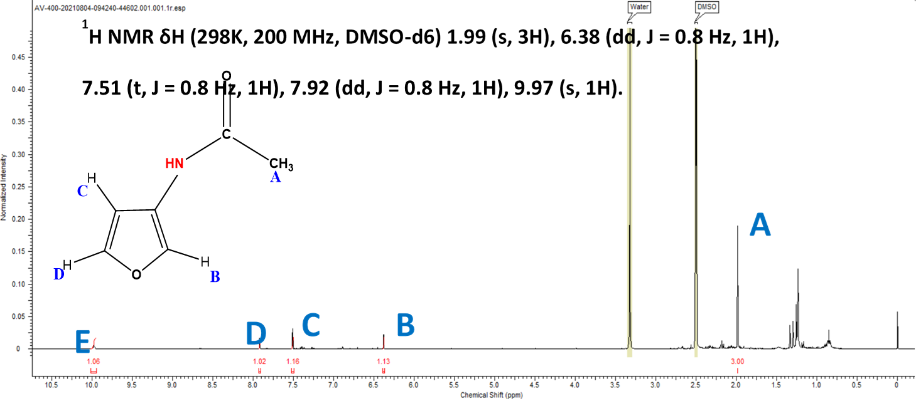
Fig. S-2a: ¹H NMR spectrum of 3AF produced from N-acetyl-D-glucosamine [¹H NMR δH (298K, 200 MHz, DMSO-d6) 1.99 (s, 3H), 6.38 (dd, J = 0.8 Hz, 1H), 7.51 (t, J = 0.8 Hz, 1H), 7.92 (dd, J = 0.8 Hz, 1H), 9.97 (s, 1H)]

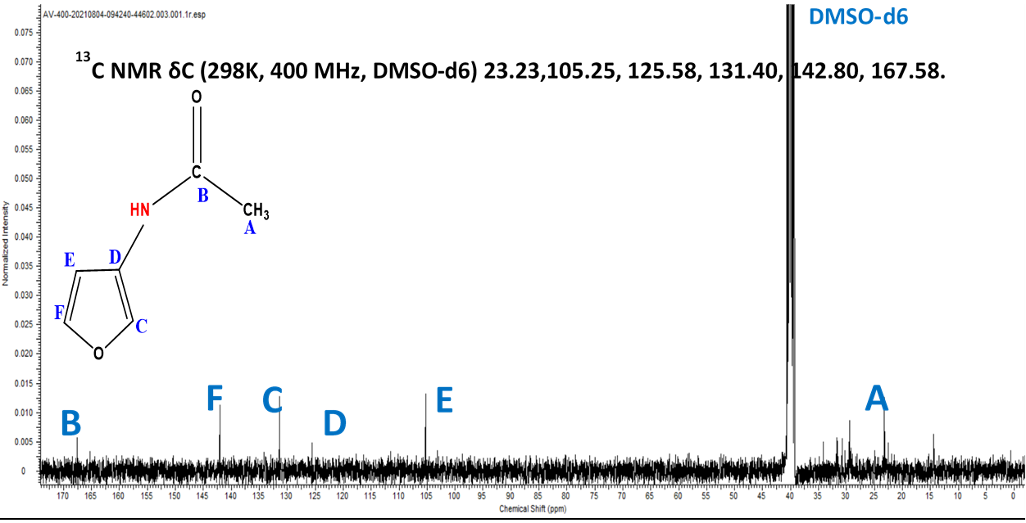
Fig. S-2b: ¹³C NMR spectrum of 3AF produced from N-acetyl-D-glucosamine [¹³C NMR δC (298K, 400 MHz, DMSO-d6) 23.23, 105.25, 125.58, 131.40, 142.80, 167.58]
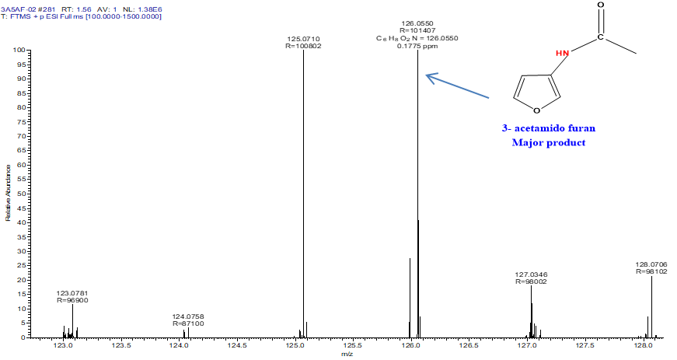
Fig. S-3: HR-MS chromatogram of 3AF produced from N-acetyl-D-glucosamine.

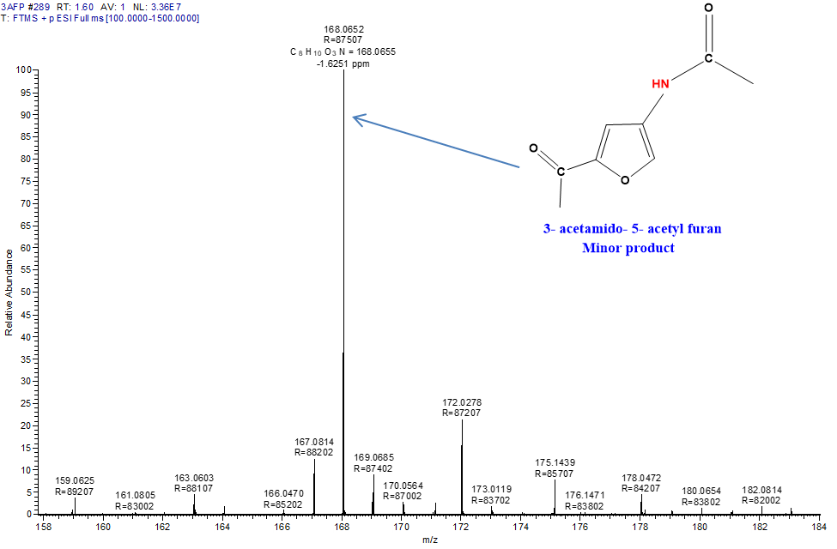

Fig. S-4: HR-MS chromatogram of 3A5AF produced from N-acetyl-D-glucosamine.

Fig.S-5: FTIR plot for N-acetyl-D-glucosamine

Fig.S-6: FTIR plot for 3AF and 3A5AF.

HPLC analysis:

The NAG conversion was quantitatively determined by HPLC analysis on Hiplex-Pb column by keeping 0.5 mL/min flow rate of the prepared mobile phase maintaining column temperature at 80 ºC and total analysis time of 20 minutes.

Fig S-7: Calibration curve of N-acetyl glucosamine (NAG)

Fig.S-8 BET Isotherm for various catalysts.

Fig.S-9 TPD plots for various catalysts.

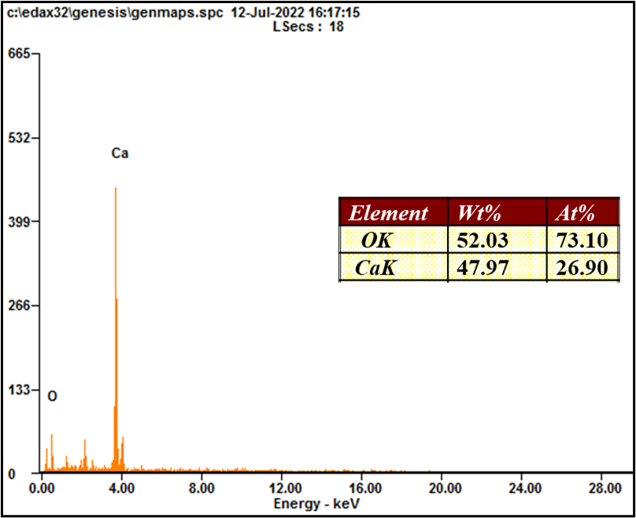
Fig.S-10: EDS for CaO catalyst.

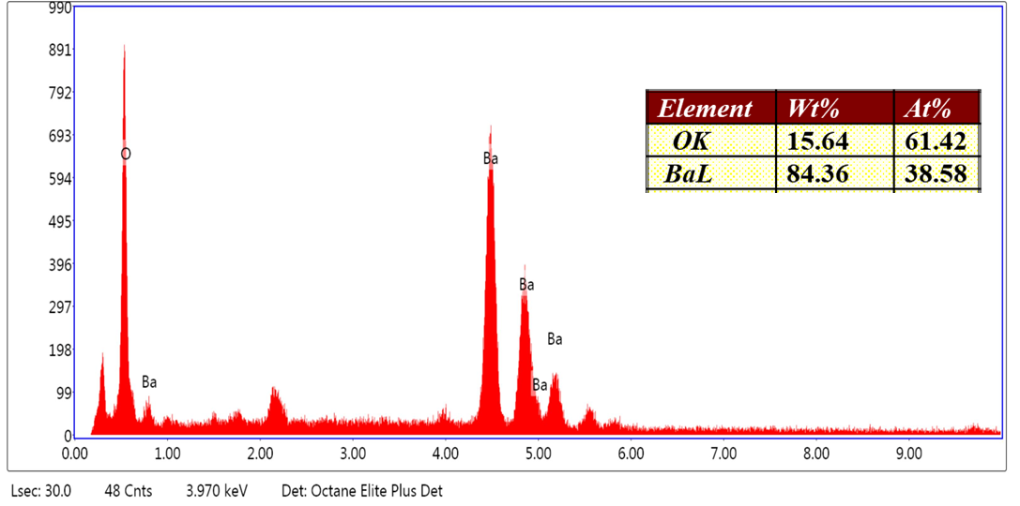
.
Fig.S-11: EDS for BaO catalyst.

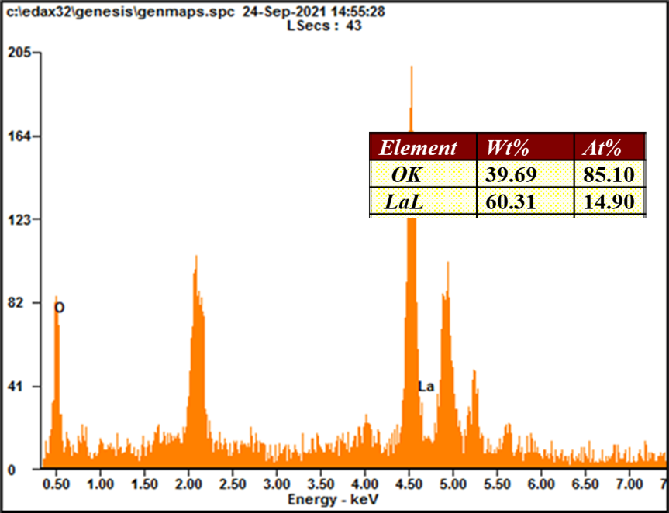

Fig.S-12: EDS for La₂O₃ catalyst.

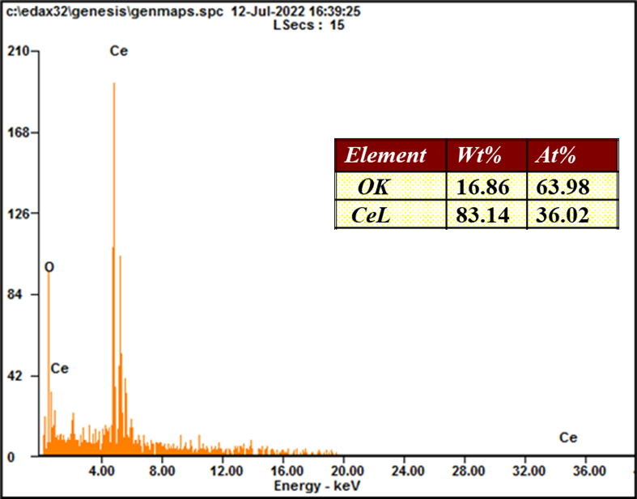

Fig.S-13: EDS for La₂O₃ catalyst.

Fig.S-14: TGA for CaO, BaO, La₂O_{3,} Ce₂O_{3,} ZrO_{2,} Al₂O₃ catalyst.

