Supplementary Materials for

Secondary conformation of MERS-CoV, SARS-CoV and SARS-CoV-2 Spike Proteins revealed by Infrared Vibrational Spectroscopy
Annalisa D’Arco^{1,2}, Marta Di Fabrizio³, Tiziana Mancini², Rosanna Mosetti², Salvatore Macis², Giovanna Tranfo⁴, Giancarlo Della Ventura^{1,5}, Augusto Marcelli^{1,6}, Massimo Petrarca^{7,8}, Stefano Lupi^{2,7,*}

- INFN-LNF, Via E. Fermi 54, 00044 Frascati, Italy.
- Physics Department, University of Rome ‘La Sapienza’, P.le Aldo Moro 5, 00185 Rome, Italy.
- Laboratory of Biological Electron Microscopy, IPHYS, SB, EPFL & Department of Fundamental Microbiology, Faculty of Biology and Medicine, UNIL, Lausanne, Switzerland.
- Department of Occupational and Environmental Medicine, Epidemiology and Hygiene, INAIL, Monte Porzio Catone, 00078 Rome, Italy.
- Science Department, University of Roma Tre, Largo S. L. Murialdo 1, 00146 Rome, Italy
- RICMASS, Via dei Sabelli 119A, 00185 Rome, Italy
- INFN-Section of Rome ‘La Sapienza’, P.le Aldo Moro 2, 00185 Rome, Italy.
- SBAI-Department of Basic and Applied Sciences for Engineering, Physics, University of Rome ‘La Sapienza’, Via Scarpa 16, 00161 Rome, Italy.

*Corresponding author. E.mail: stefano.lupi@roma1.infn.it

This PDF file includes:

Supplementary Text
Figs. S1 and S2
Tables S1 and S2

S1. Comparison of SARS-CoV-2 S1 protein at different concentration
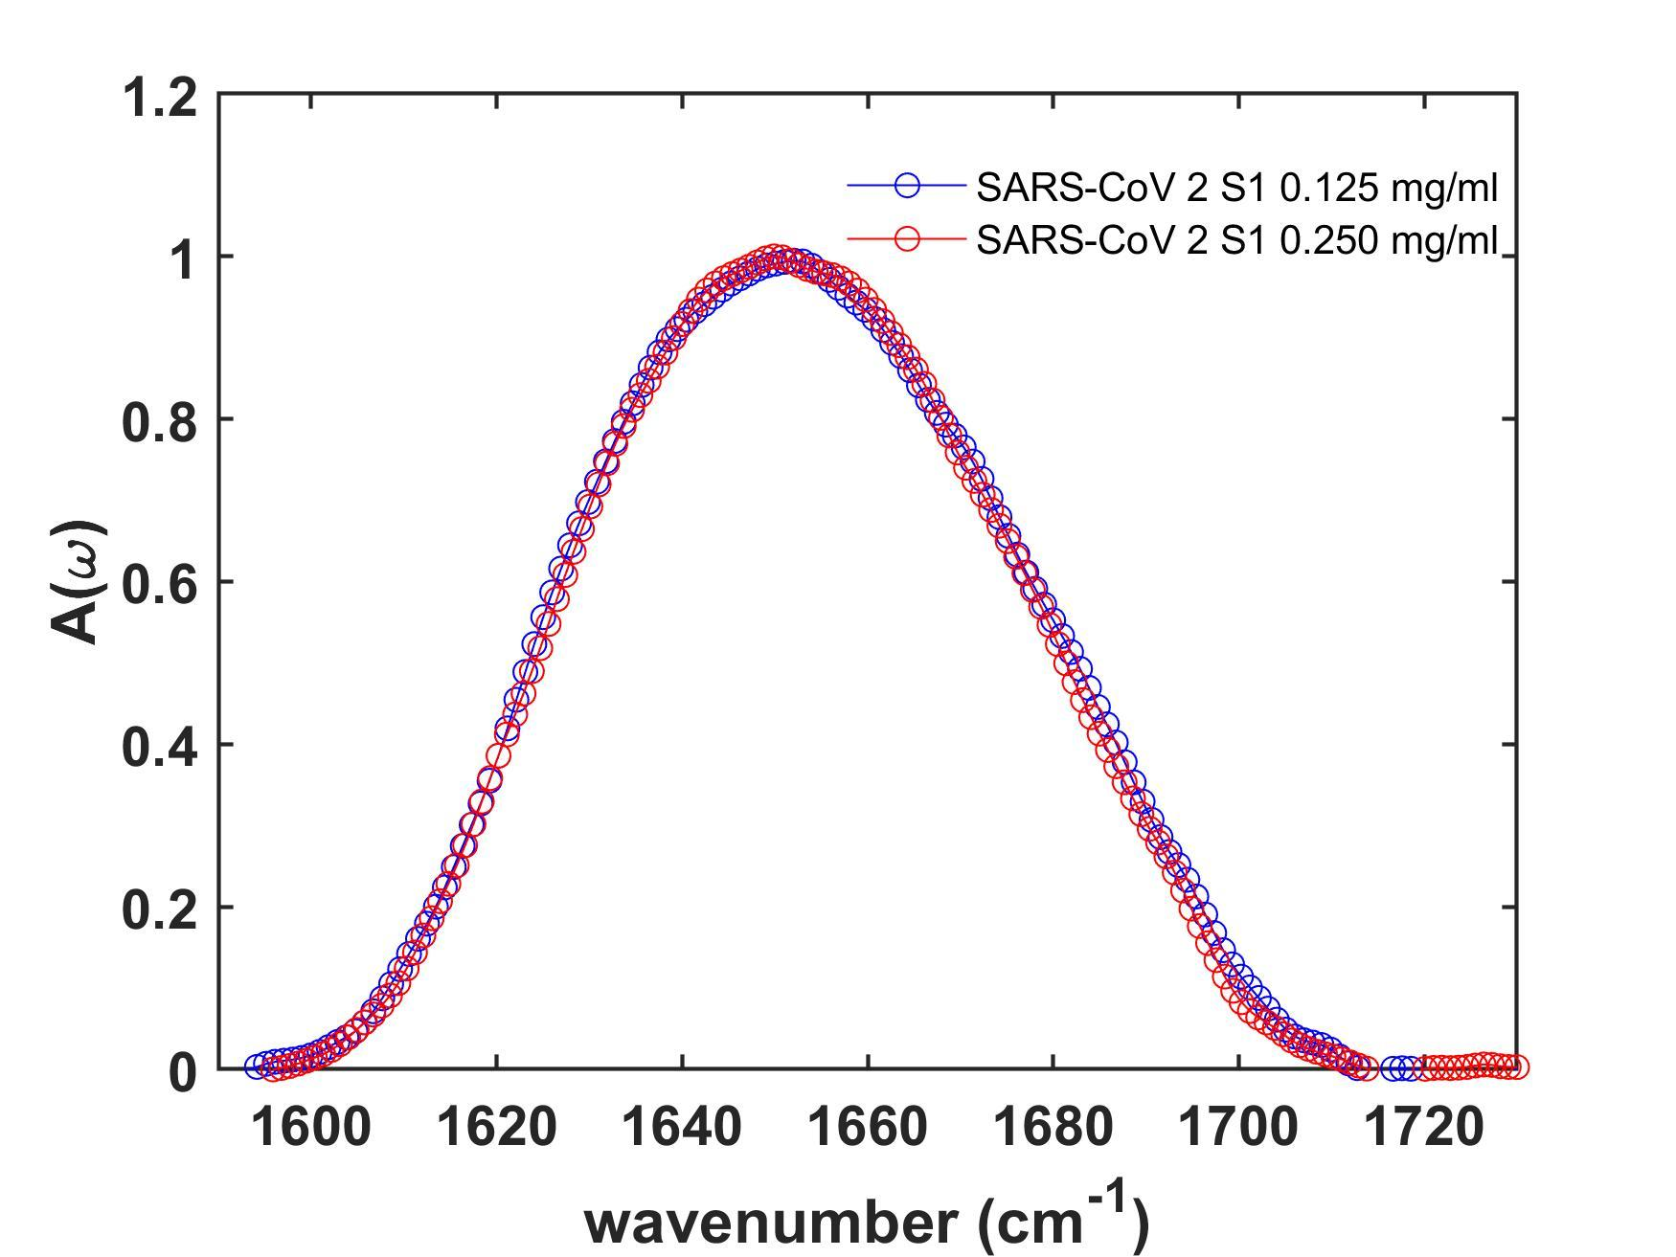
Fig. S1. Comparison of SARS-CoV-2 S1 protein at different concentration. Direct comparison of normalized Amide I SARS-CoV-2 S1 absorption spectra at different concentrations (blue and red circle lines are referred to 0.125mg/ml and 0.250mg/ml, respectively).

S2. Secondary structure assignment for SARS-CoV2 S1 protein vs. pH

Table S1. Secondary structure assignment for SARS-CoV-2 S1 units as function of pH as derived from IR data analysis. The quantitative structural evaluation (α-helix, β-sheet, β-turn and random coils), is based on the fitting gaussian components.

pH 4.55  peak [cm⁻¹] | pH 4.55 Peak Relative Intensity [%] | pH 5.5 Peak [cm⁻¹] | pH 5.5 Peak Relative Intensity [%] | pH 7.4 Peak [cm⁻¹] | pH 7.4 Peak Relative Intensity [%] | pH 8.8 Peak [cm⁻¹] | pH 8.8 Peak Relative Intensity [%] | pH 11.2 Peak [cm⁻¹] | pH 11.2 Peak Relative Intensity [%] | Peaks Assignment
1618 | 15.7 | 1617 | 18.8 | 1619 | 5.2 | 1619 | 11.6 | 1616 | 12.4 | β-sheet intermolecular
1623 | 8.5 | - | - | - | - | - | - | 1625 | 9.1 | β-sheet (anti-parallel)
1628 | 5.2 | 1628 | 14.8 | 1628 | 11.4 | - | - | - | - | β-sheet
- | - | - | - | 1633 | 9.8 | 1633 | 23.6 | 1632 | 12.8 | β-sheet
1636 | 12.6 | 1637 | 10.5 | - | - | - | - | 1638 | 8.3 | β-sheet
- | - | - | - | 1643 | 12.3 | 1643 | 15.1 | - | - | Random coil
1646 | 14.1 | 1646 | 15.4 | - | - | - | - | 1645 | 12.9 | Random coil
1654 | 16.1 | 1653 | 8.4 | 1650 | 13.6 | 1653 | 12.7 | 1653 | 11.4 | α-helix
- | - | 1659 | 6.4 | 1658 | 15.9 | - | - | - | - | α-helix
1662 | 7.0 | - | - | - | - | 1663 | 13.6 | 1661 | 14.1 | α-helix
- | - | - | - | 1666 | 5.6 | - | - | - | - | β-turn
1670 | 12.5 | 1669 | 6.7 | - | - | - | - | 1670 | 6.1 | β-turn
- | - | - | - | 1673 | 6.7 | 1674 | 18.9 | 1676 | 7.3 | β-turn
- | - | 1677 | 8.3 | 1678 | 15.2 | - | - | - | - | β-turn
1686 | 7.6 | - | - | - | - | 1686 | 4.3 | 1686 | 5.5 | β-turn
- |  | 1690 | 2.4 | 1693 | 4.2 | - | - | - | - | β-sheet (anti-parallel)
1699 | 0.7 | 1698 | 0.6 | - | - | - | - | 1700 | 0.2 | β-sheet (anti-parallel)

S3. Glycans
The CoV S glycoproteins are densely decorated by heterogeneous N-linked glycans, that are used by viral fusion proteins as shield to counteract the host immune response (28-35,61). These oligosaccharides increase the global stability of proteins (9-12), participating in S folding (27), and working as recognition sites.
In Figure S2, we report the absorbance spectra of glycoprotein S1 of MERS-CoV (a), SARS-CoV (b) and SARS-CoV-2 (c) in the 900-1180 cm⁻¹ carbohydrates spectral range. Although band overlapping and broadening lead to spectra complexity, some spectral features can be recognized, and collected in Table S2.
Therefore, the vibrations coupled with the stretching vibrations of the COH site groups, and the glycosidic bonds dominate the region of 900-1180 cm⁻¹. Nevertheless, the few intense IR absorbance peaks could be associated with the formation of polymeric chains, and the presence of vibrational bands, attributed to ν(CO) and C-O-C glycosidic linkage, may serve as markers for the glycosylation degree.
Remarkable bands are observed. Their assignments are based on previous studies in literature (29-37,61), Band of the skeletal modes (ring) vibration of glycosidic linkage are observed in the spectral range 900-950 cm⁻¹. The peak near 915cm⁻¹ was observed in the spectra of Glc, Fuc, and Man monomers, instead the presence of 945 cm⁻¹ band may be attributed to Nan monomer contribution. The bands of the ν(CO) mode in COC linkages appear in the spectral regions encompassing from 965-1000cm⁻¹ and 1130-1160 cm⁻¹. The strong contributions are due to the absorption bands at 994 cm⁻¹, and 1035 cm⁻¹. The peak around 990 cm⁻¹ is associated to coupling of in-plane β(CCH), β(CCO) moieties, and was observed in the spectra of Glc, Gal and Fuc monomers. This is accompanied by bands at 926 cm⁻¹ due to the ring and COH bending modes. The intense peak at 1035 cm⁻¹ is a specific spectral feature attributing to Man and Fuc.
The bands located around 1100 cm⁻¹ and 1150 cm⁻¹ are originated from various coupling of stretching and bending vibrations of the CC and CO bonds. In particular, the absorption near 1150 cm⁻¹ in the IR spectra of aqueous solutions of oligosaccharides is exclusively attributed to the v(CO) and glycosidic bond. Appreciable differences are not noticeable between the MERS-CoV and SARS-CoV S1. In SARS-CoV-2 S1, slight shifts are observed to high frequency in the spectral region 1030-1120 cm⁻¹, and a new absorption band appears at 1015 cm⁻¹. They are indicative of different glycan composition, including the oligosaccharide units and mannose content.

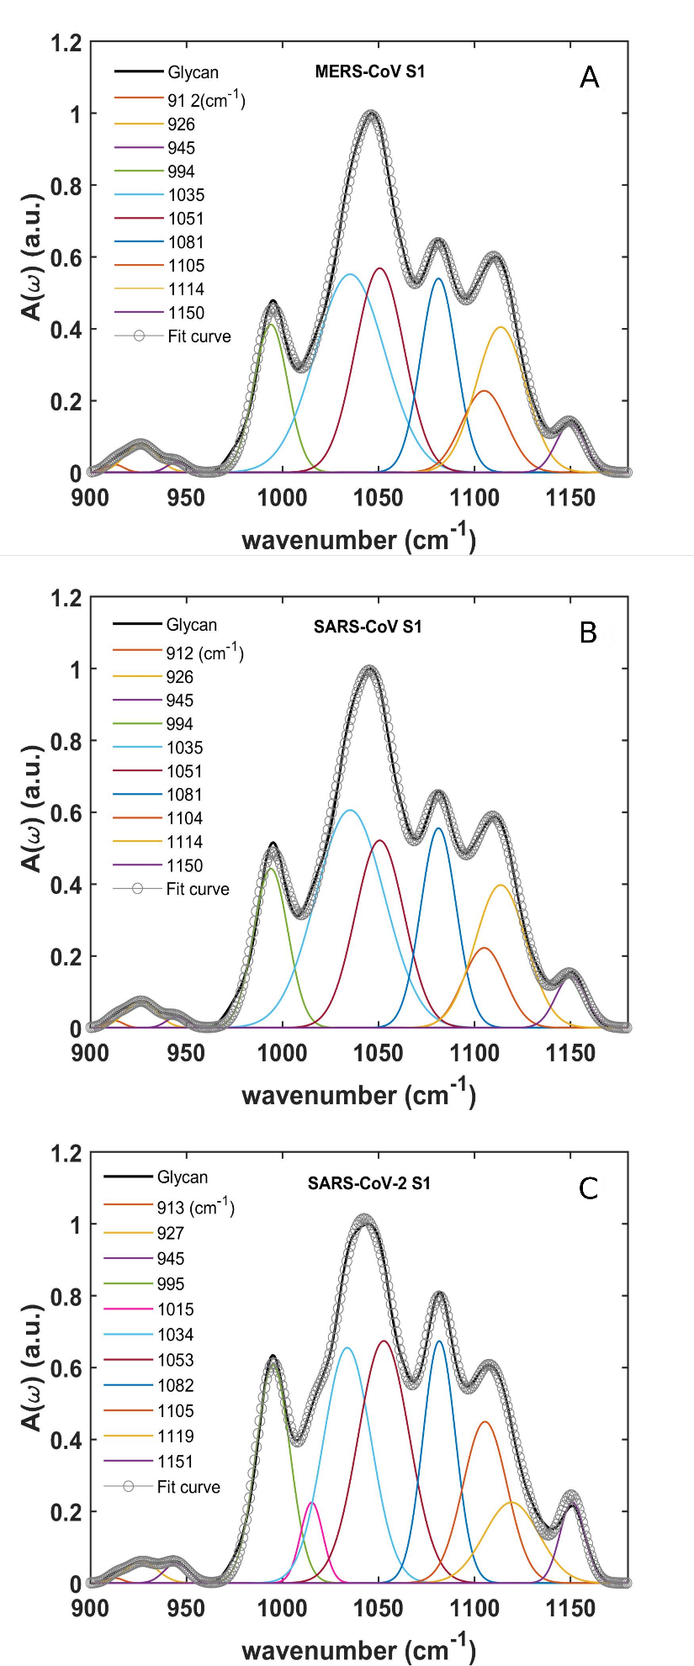
Figure S2. (Absorption spectra of glycan band (900-1180 cm⁻¹). Deconvolution of average spectra in the a) MERS-CoV, b) SARS-CoV and c) SARS-CoV-2 S1 units are reported.)

Table S2. Main IR absorption bands. Deconvoluted carbohydrates band frequencies and assignments.
MERS-CoV S1  Peak  [cm⁻¹] | SARS-CoV S1  Peak  [cm⁻¹] | SARS-CoV-2 S1  Peak  [cm⁻¹] | Peak Assignments
912 | 913 | 913 | Glc, Fuc, Man, ν(CO), ν(CCH), ν(CO) in glycosidic linkage
926 | 926 | 926 | ring modes, ν(CO) in glycosidic linkage
945 | 945 | 945 | Nan, ν(CO) in glycosidic linkage
994 | 994 | 995 | Glc, Gal, Fuc - β(CCH), β(CCO) ν(CO) in glycosidic linkage
 |  | 1015 | Man ν(CC) β(COH)
1035 | 1035 | 1033 | Man,Fuc –COH vibration
1051 | 1051 | 1052 | Man Gal ν(CC) ν(CO) β(COH)
1081 | 1081 | 1082 | Glc β(CH)
1103 | 1104 | 1107 | Glc, Gal ν(CC) ν(CO) β(COH)
1114 | 1114 | 1117 | Man, Fuc
1150 | 1151 | 1150 | Gal Glc, Nan–ν(CC) ν(CO) in glycosidic linkage

