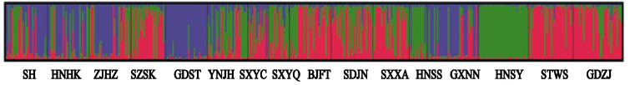
Figure S1 Bayesian cluster analysis using STUCTURE. Graphical representation of the data set for the most likely K (K = 3), where each color corresponds to a suggested cluster and each individual is represented by a vertical bar. The X-axis corresponds to population codes. The Y-axis presents the probability of assignment of an individual to each cluster.

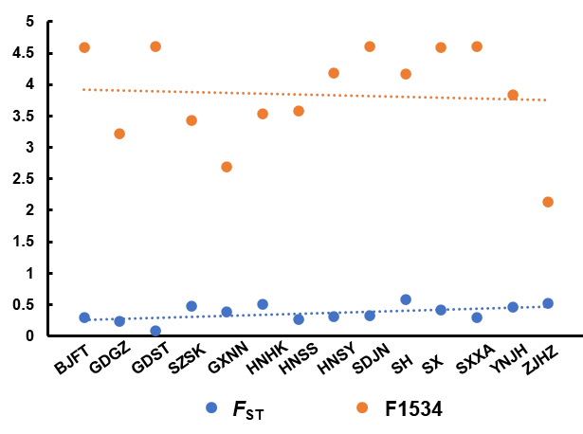
Figure S2. Pearson correlation analysis of F1534 wild-type frequency with F_{ST} within population.

Table S1. Primer sequences of 8 microsatellite loci of Aedes albopictus.
Locus | Primer (5’-3’) | Ta (℃) | GenBank accession number
Alb-di-4 | F：TGGCGACCTATTATACCCGC | 50 | KF146971
Alb-di-4 | R：CAACTCGTTCCTTGACCGTG | 50 | KF146971
Alb-di-6 | F：TCTTCATCTACGCTGTGCTC | 50 | KF146972
Alb-di-6 | R：GACGCCAATCCGACAAAGTC | 50 | KF146972
Alb-tri-6 | F：AGCACGAGTACAGAATGTGC | 50 | KF146974
Alb-tri-6 | R：TGGCCTCCTACCGTTTATCTG | 50 | KF146974
Alb-tri-41 | F：GATCGATTTGGGAGCTTCTG | 50 | KF146983
Alb-tri-41 | R：GAACCTCTTCTCGCTTGGCT | 50 | KF146983
Alb-tri-46 | F：TTCACAACATACGGAATCGC | 50 | KF146975
Alb-tri-46 | R：GGTCCGGTGTAATAGCCTCC | 50 | KF146975
AealbA9 | F：TGGGACAAGAGCTGAAGGAT | 52 | DQ366022
AealbA9 | R：CTCGTTCTCTACTCTCTCCGTT | 52 | DQ366022
AealbB52 | F：GGGTCTAGAAGTAATAGCGATCG | 50 | DQ366024
AealbB52 | R：GCATTCTTTGCTTCTGTTTGC | 50 | DQ366024
AealbF3 | F：CTCGTGAGTACGTTCCGTGA | 53 | DQ366027
AealbF3 | R：AGGGAAACAAGGACTTCATCA | 53 | DQ366027

Table S2. Number of alleles per population at each microsatellite locus.
Populations | Alb-di-4 | Alb-di-6 | Alb-tri-6 | Alb-tri-41 | Alb-tri-46 | AealbA9 | AealbB52 | AealbF3
SH | 5 | 7 | 10 | 6 | 6 | 11 | 3 | 3
HNHK | 3 | 8 | 9 | 7 | 7 | 11 | 3 | 4
ZJHZ | 2 | 9 | 11 | 5 | 8 | 10 | 3 | 3
SZSK | 2 | 8 | 10 | 5 | 7 | 8 | 3 | 4
GDST | 4 | 6 | 5 | 7 | 5 | 5 | 3 | 4
YNJH | 4 | 10 | 9 | 7 | 8 | 10 | 4 | 6
SXYC | 3 | 5 | 8 | 6 | 5 | 7 | 5 | 3
SXYQ | 4 | 4 | 10 | 4 | 6 | 6 | 1 | 2
BJFT | 4 | 5 | 8 | 5 | 6 | 11 | 2 | 3
SDJN | 3 | 8 | 10 | 7 | 8 | 8 | 3 | 3
SXXA | 4 | 7 | 8 | 7 | 8 | 11 | 3 | 4
GDGZ | 5 | 7 | 7 | 5 | 6 | 10 | 2 | 4
HNSS | 5 | 6 | 6 | 4 | 5 | 10 | 3 | 2
GXNN | 5 | 8 | 9 | 5 | 6 | 10 | 3 | 4
HNSY | 4 | 7 | 11 | 6 | 8 | 3 | 1 | 6
STWS | 2 | 6 | 9 | 5 | 6 | 9 | 1 | 6
GDZJ | 3 | 8 | 12 | 8 | 9 | 13 | 2 | 4

Table S3. Average coefficient of ancestry obtained from a STRUCTURE run with K = 3 for 443 individuals of Aedes albopictus from 16 samples collected in China.
Cluster | Population | I (red) | II (green) | III (blue)
I (red) | STWS | 0.797 | 0.171 | 0.032
I (red) | GDZJ | 0.719 | 0.253 | 0.028
I (red) | BJFT | 0.604 | 0.355 | 0.040
I (red) | SZSK | 0.585 | 0.340 | 0.075
I (red) | SXXA | 0.584 | 0.368 | 0.049
I (red) | SDJN | 0.561 | 0.394 | 0.044
I (red) | SXYC | 0.468 | 0.279 | 0.253
II (green) | HNSY | 0.022 | 0.958 | 0.020
II (green) | HNSS | 0.086 | 0.766 | 0.148
II (green) | SXYQ | 0.316 | 0.596 | 0.088
II (green) | YNJH | 0.228 | 0.541 | 0.231
III (blue) | GDST | 0.026 | 0.046 | 0.928
III (blue) | GXNN | 0.173 | 0.171 | 0.655
III (blue) | HNHK | 0.144 | 0.279 | 0.577
III (blue) | SH | 0.241 | 0.263 | 0.495
III (blue) | ZJHZ | 0.284 | 0.236 | 0.481

