Supplementary figure 1. The Sanky plot of clinical indicators and FGPI score.
Supplementary figure 2. The comparison of PART1 expression between metastasis and no metastasis group.
Original images from the HPA database. We provided the reference number.
HPA011315 ACSL3 normal
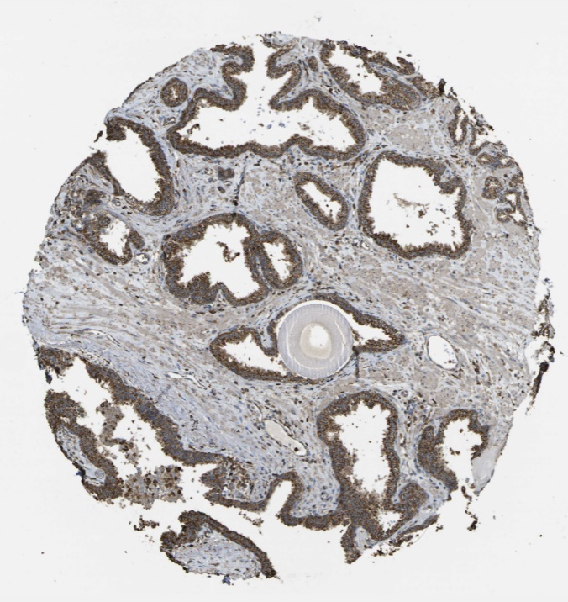
HPA011315 ACSL3 Tumor
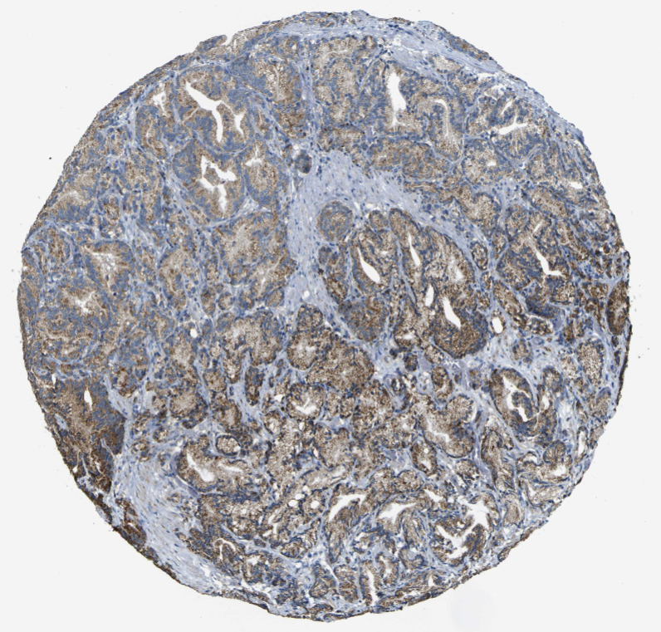

HPA041264 ACTC1 normal
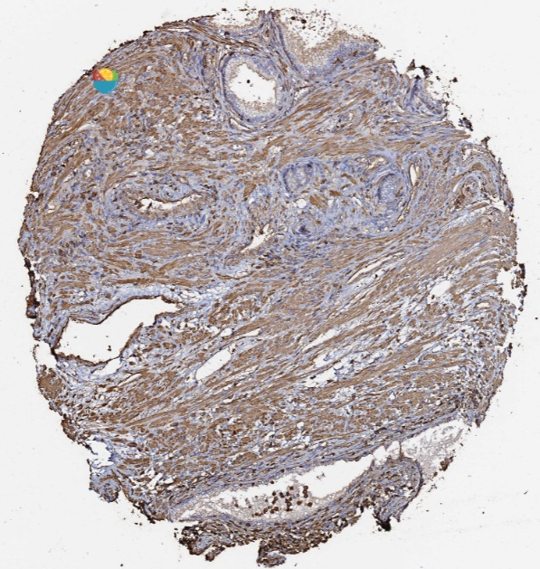
HPA041264 ACTC1 TUMOR
