Cellulose nano-fiber and fly-ash based nanohybrids: a facile and sustainable thermal insulating material
Sourav Senª, Ajit Singhª, Kamalakannan Kailasam^{a*}, Chandan Bera^{a*} and Sangita Roy^{a*}
ªInstitute of Nano Science and Technology (INST), Sector 81, Knowledge City, 140306 Mohali, Punjab, India
*Email: sangita@inst.ac.in
chandan@inst.ac.in
kamal@inst.ac.in
Table of contents
Table S1: Table displaying the surface area and the pore volume of CNF and FA@CNF nanohybrid with different wt% of fly-ash (7, 10 and 15%). This data has been obtained from desorption isotherm by BJH method.
Fig S1: Histogram generated from the corresponding FESEM studies of (a) CNF aerogel and (c) FA@CNF-10% nanohybrid. Graphical analysis representing the number of pores distributed in the (b) CNF and (d) FA@CNF-10% nanohybrid.
Fig S2: FESEM mapping study of the cross-section of FA@CNF nanohybrid (a), FESEM mapping images for Al, Si, Ca, Fe elements on the surface of the nanohybrids respectively, in particular, (b), Al (c), Si (d), Ca (e) and Fe (f).
Fig. S3: (a) Nitrogen adsorption and desorption isotherms, and (b) Use of Barrett−Joyner−Halenda (BJH) method depicting pore size distribution of CNF and FA@CNF nanohybrids with doping of different wt% of fly-ash (7, 10 and 15%).
Fig. S4: FESEM-EDX line scanning analysis for distribution of Si and Al elements along the surface of FA@CNF nanohybrids (a,b) FA@CNF-10% and (c,d) FA@CNF-15%. Bar at count 60 showed a fixed level of Si and Al elements in the all two samples.
Fig. S5: (a) Thermal conductivity measurement of FA@CNF nanohybrids with different wt % of fly-ash (2%, 5% and 12%) using transient hot wire method and (b) Plot of differential thermal conductivity values of the FA@CNF nanohybrids with doping of different wt% of fly-ash.
Table S1: Table displaying the surface area and the pore volume of CNF and FA@CNF nanohybrid with different wt% of fly-ash (7, 10 and 15%). This data has been obtained from desorption isotherm by BJH method.
Sample | Surface Area  S_{BET} (m² g⁻¹) | pore volume  (cm³ g⁻¹)
CNF | 16.033 | 0.049
FA@CNF-7% | 7.642 | 0.034
FA@CNF-10% | 5.313 | 0.023
FA@CNF-15% | 8.103 | 0.044

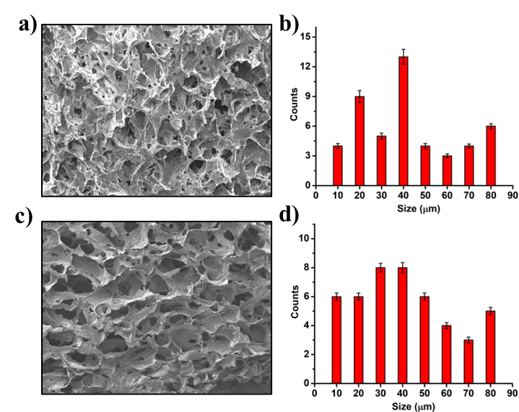
Fig S1: Histogram generated from the corresponding FESEM studies of (a) CNF aerogel and (c) FA@CNF-10% nanohybrid. Graphical analysis representing the number of pores distributed in the (b) CNF and (d) FA@CNF-10% nanohybrid.
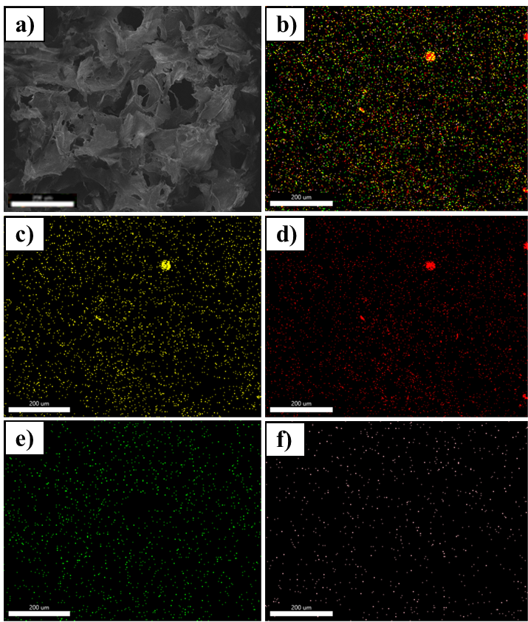
Fig S2: FESEM mapping study of the cross-section of FA@CNF nanohybrid (a), FESEM mapping images for Al, Si, Ca, Fe elements on the surface of the nanohybrids respectively, in particular, (b), Al (c), Si (d), Ca (e) and Fe (f).
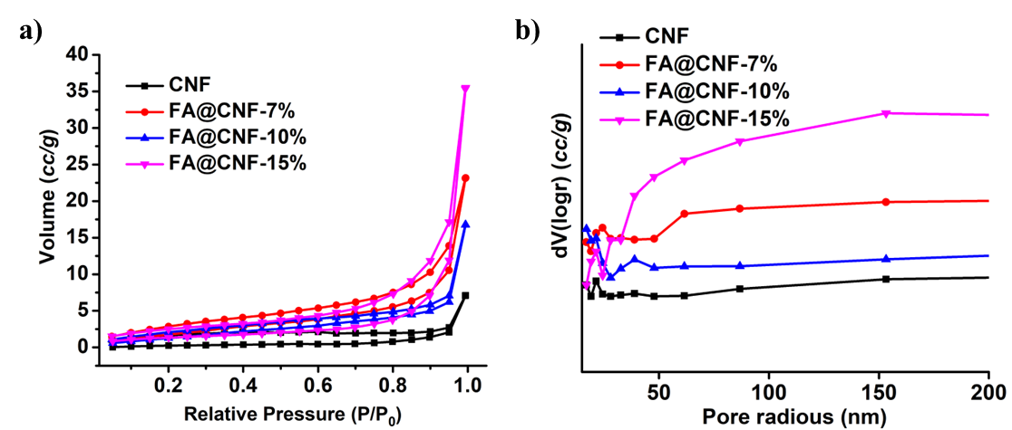
Fig. S3: (a) Nitrogen adsorption and desorption isotherms, and (b) Use of Barrett−Joyner−Halenda (BJH) method depicting pore size distribution of CNF and FA@CNF nanohybrids with doping of different wt% of fly-ash (7, 10 and 15%).

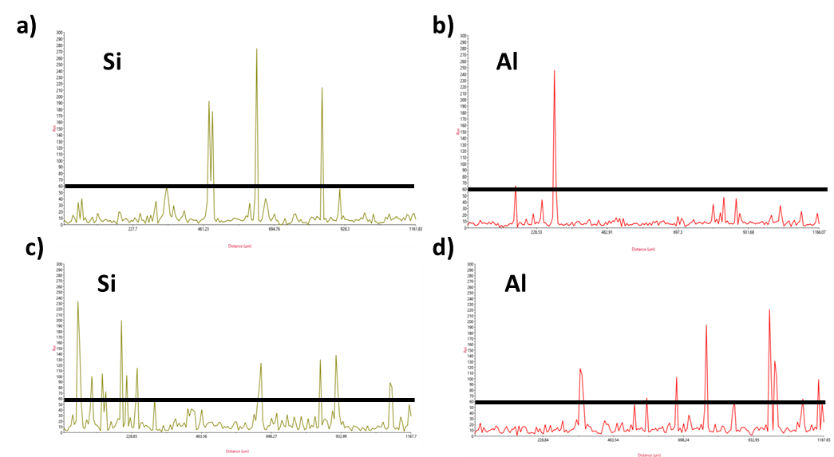
Fig. S4: FESEM-EDX line scanning analysis for distribution of Si and Al elements along the surface of FA@CNF nanohybrids (a,b) FA@CNF-10% and (c,d) FA@CNF-15%. Bar at count 60 showed a fixed level of Si and Al elements in the all two samples.
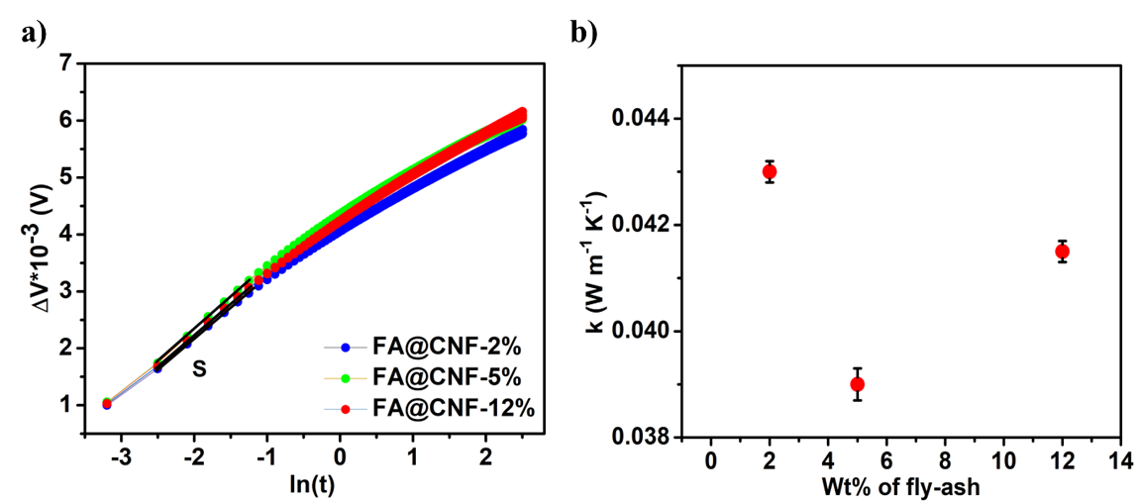
Fig. S5: (a) Thermal conductivity measurement of FA@CNF nanohybrids with different wt % of fly-ash (2%, 5% and 12%) using transient hot wire method and (b) Plot of differential thermal conductivity values of the FA@CNF nanohybrids with doping of different wt% of fly-ash.

