Supplementary Materials

1. Additional information about stimuli
Here we provide the following information:
1.1. A detailed description of how we constructed the discourse scenarios, including details of the cloze norming procedures (see also¹).
1.2. A description of the relationship between the stimuli used in the present study and an overlapping set of stimuli used in a previous ERP study carried out in a different set of participants¹.
1.3. Additional details of how we counterbalanced stimuli across the four conditions, across neuroimaging modality (MEG/EEG, fMRI), and across session order (MEG/EEG first, fMRI first).

1.1. Construction and cloze norming of stimuli
In order to construct the discourse scenarios, we began with a large set of preferentially transitive verbs, and we established their animacy constraints as well as their lexical constraints in minimal contexts by carrying out an offline cloze norming study. On the basis of these norms, we then selected a subset of verbs, which were all of low lexical constraint in minimal contexts. After that, we wrote high constraint and low constraint discourse contexts around each verb. We then carried out a second cloze norming study to verify the discourse lexical constraints of these high constraint and low constraint discourse contexts.
These two cloze norming studies are described below. For both norming studies, participants were recruited through Amazon Mechanical Turk. They were asked to complete each context with the first word that came to mind², and in an extension of the standard cloze procedure, to then provide two additional words that could complete the sentence^{3,4}. Individuals were excluded if (a) their first language was anything other than English, (b) they self-reported any psychiatric or neurological disorders, or (c) they failed to follow instructions (we included “catch” questions that served as attention checks).

Selection of verbs and cloze norming study to assess their animacy constraints and lexical constraints in minimal contexts
We started with a set of 617 transitively-biased verbs. These verbs were taken from a number of different sources, including⁵ and materials from previous studies carried out in our lab^{6,7}. We excluded verbs with a log Hyperspace Analogue to Language (HAL) frequency⁸ of two standard deviations below the mean (based on English Lexicon Project database⁹).
For each verb, we constructed a minimum context ˗ a simple active past-tense sentence stem consisting of a proper name, the verb, and then a determiner (e.g., “Harry explored the…”). For cloze norming, we divided these sentence stems into six lists in order to reduce time demands on any individual. Between 89 and 106 participants (depending on list) who met inclusion criteria provided completions.
We then identified the best completion following each context (i.e. the most common first noun produced across all participants). When identifying this best completion, we collapsed alternate word forms (e.g., singular/plural nouns) but not synonyms or lexical alternatives (e.g. couch/sofa). Based on the animacy of the noun completions, we categorized the verbs as either animate constraining or inanimate constraining. We also tallied the number of participants who produced the best completion in order to calculate the lexical constraint of the verbs in these minimal contexts. We then selected a subset of these verbs (50% animate constraining; 50% inanimate constraining), all with lexical constraints in these minimal contexts of less than 24%. These verbs were used to generate the discourse stimuli as described next.

Construction and cloze norming of the discourse stimuli
We wrote high and low lexical constraint discourse contexts around each verb. Each discourse context consisted of two sentences, and the first few words of a third sentence (an adjunct phrase of 1-4 words, a pronominal subject that referred back to the first two sentences, the verb and a determiner).
We quantified these constraints by carrying out a second cloze norming study. The discourse contexts were pseudorandomly divided into two lists, such that each list contained only one of the two contexts (high constraint or low constraint) associated with each verb. The two lists were then divided into thirds to minimize time demands on any individual participant. Between 51 and 69 participants who met inclusionary criteria provided completions following each context.
Based on these cloze norms, we then selected 150 high constraint discourse contexts and 150 low constraint discourse contexts to create our four conditions. One hundred high constraint expected scenarios were created by pairing 100 high constraint contexts with the nouns with the highest cloze probability for that context. The same 100 high constraint contexts were paired with direct object nouns of low cloze values, but that were still plausible in relation to their contexts, resulting in 100 high constraint unexpected scenarios. We then constructed 150 low constraint unexpected scenarios by pairing unexpected nouns with the low constraint discourse contexts (in 100 of these, the nouns were the same as those used in the high constraint unexpected scenarios). Finally, we created 150 anomalous scenarios by pairing the high constraint discourse contexts with nouns that violated the animacy constraint of the verbs. Thus, in total, there were 500 scenarios: 100 high constraint expected, 100 high constraint unexpected, 150 low constraint unexpected, and 150 anomalous.
Because the anomalous critical words always followed high constraint contexts, we also created 200 anomalous scenarios with low constraint contexts in order to balance the number of scenarios with high constraint and low constraint discourse contexts in each list, as well as to balance the number of scenarios with plausible and anomalous critical nouns. We refer to these low constraint anomalous scenarios as “fillers” because we made the a priori decision to exclude them from analysis (for the reasons described in section 1.2), and from our main counterbalancing scheme (see section 1.3). Of these 200 low constraint anomalous filler scenarios, 150 were created by pairing the 150 low constraint discourse contexts with nouns that violated the animacy constraint of the verbs (in 100 of them, the nouns were the same as those used in the high constraint anomalous scenarios; in 50 of them, the nouns were the same as those used in the low constraint unexpected scenarios). The remaining 50 low constraint anomalous scenarios were created by constructing 50 additional low constraint discourse contexts and pairing them with nouns that violated the animacy constraint of the verbs.
All 700 scenarios were divided into four lists. Each list contained 200 scenarios (150 experimental scenarios and 50 filler low constraint anomalous scenarios). Of the 150 experimental scenarios, 25 were expected, 50 were low constraint unexpected, 25 were high constraint unexpected, and 50 were anomalous. This overall list composition ensured that each participant viewed 50% plausible and 50% anomalous scenarios, and that critical words were just as likely to be plausible following high constraint and low constraint discourse contexts.

1.2. Differences between the stimuli used in the present study and those used in our previous ERP study¹
The stimuli used in present study largely overlapped with these used in our previous ERP study carried out in a different set of participants¹ but we made several changes. Here we describe these changes and explain why they were made.
(a) In our previous ERP study ¹, we had five experimental conditions, each with 20 trials. In the present study, we omitted one of these conditions (low constraint anomalous scenarios) from our analysis and main counterbalancing scheme. This is because our previous ERP study showed that the neural response produced by these low constraint anomalous critical words (the posterior late positivity/P600 effect) was qualitatively similar but smaller in amplitude than the response produced by the high constraint anomalous critical words. We therefore chose to focus the analyses in the present study on the four remaining experimental conditions so that we could increase the number of trials per condition to maximize our power of detecting MEG and fMRI effects. Specifically, by omitting the low constraint anomalous scenarios as an experimental condition, we were able to increase the number of scenarios in the high constraint expected and the high constraint unexpected conditions to 25, and to reduce the number of lists to 4. However, we did include the low constraint anomalous stimuli as fillers to ensure that each participant viewed 50% plausible and 50% anomalous scenarios, and to ensure that the critical words were just as likely to be plausible following high constraint and low constraint contexts (as described above in 1.1).
(b) In our previous ERP study¹, we analyzed 100 core stimuli in which the same critical word was fully counterbalanced across the four original unpredictable conditions (20 trials per condition). We also included 100 additional scenarios, which, in that study were considered filler items. In the present multimodal imaging study, however, we made the a priori decision to combine our original core stimuli with those that we originally classified as filler stimuli to create our four conditions of interest. By doing this, and by excluding the low constraint anomalous scenarios (as described above), we were able to increase the number of trials in some conditions and therefore to maximize power. Thus, each participant read 150 experimental scenarios: 25 expected, 25 high constraint unexpected, 50 low constraint unexpected and 50 anomalous.
(c) In the present study, each participant viewed a different list in each of the two sessions: the MEG/EEG session and the fMRI session. This ensured that no individual participant saw the same critical word in more than one condition across the two sessions. It also reduced the chances of any discourse context being repeated across the two sessions. However, even with this counterbalancing, there would have remained some discourse contexts that repeated across the two sessions. Therefore, to minimize any impact of repetition, we constructed slightly different versions of each list. Specifically, we changed proper names and small details that would have had minimal impact on cloze probability/lexical constraint. For example, we changed the two-sentence context, “Edgar spent all day ignoring the problem with the door. It squeaked whenever he opened it.” to “Jason spent all day ignoring what was wrong with the door. It couldn’t be opened without squeaking.” We paired these slightly altered contexts with critical words from another condition. For any given list, half of the participants saw the original versions of the list in their first session, and the altered version in the second session, and vice-versa for the other half.
Finally, we placed constraints on how these lists were counterbalanced across sessions, as described next.

1.3. Additional details of counterbalancing across conditions, across modality (MEG/EEG and fMRI), and across session order (MEG/EEG first and fMRI first)
We created four lists of stimuli that were rotated across individual participants. In creating these lists, we aimed to partially counterbalance the introductory two sentences, the verbs and/or the critical nouns across selected experimental conditions so that each participant would see these aspects of the scenarios only once but so that, across all participants, they would be seen in more than one condition. To do this, we started with two sets of scenarios. The first set of stimuli were those scenarios that constituted four out of the five conditions that were considered as “experimental” stimuli in our original ERP study¹. The second set of stimuli were based on the stimuli that were classified as “filler” items in our original ERP study, plus an additional set of 25 low constraint anomalous scenarios (some of the fillers in the present study).
The first set of scenarios was used to generate 100 of the 200 scenarios seen in each list — specifically, 25 scenarios in each of the first four sentence types: high constraint expected, low constraint unexpected, high constraint unexpected, and high constraint anomalous. This set constituted 100 scenario quadruplets (four scenarios of each condition that used the same verb). They were rotated across the four lists such that (a) the same adjunct phrase plus verbs in the final sentences were counterbalanced across all four conditions; (b) the same high constraint contexts were counterbalanced across the high constraint expected, high constraint unexpected and the high constraint anomalous scenarios, and (c) the same critical words were counterbalanced across the high constraint unexpected, high constraint anomalous, and the low constraint unexpected scenarios. The second set of scenarios were used to generate the remaining 100 scenarios in each of the four list — specifically, 25 of the high constraint anomalous scenarios, 25 of the low constraint unexpected scenarios, and the 50 low constraint anomalous filler scenarios.
As discussed above, we also counterbalanced list versions across MEG/EEG and fMRI sessions, and we placed constraints on this counterbalancing to ensure that, for any context that partially repeated across sessions, participants always saw the more predictable version before the more unpredictable version. Specifically, (a) if a participant had seen a particular high constraint context paired with an expected critical word in session 1, they would see its (altered) context paired with an unexpected critical word in session 2; (b) if a participant had seen a particular high constraint context paired with an unexpected critical word in session 1, they would see its (altered) context paired with an anomalous critical word in session 2. We also used different comprehension questions in the two sessions.

2. Behavioral results
Below we report the mean accuracy across all 34 participants who took part in the MEG/EEG and/or the fMRI session. For the 29 participants who took part in both MEG/EEG and fMRI sessions, we collapsed their behavioral data across the two sessions.
Participants’ acceptability judgments corresponded to the experimental conditions in 85.5% of trials on average (SD: 6.3%). There was a significant main effect of Scenario Type, F(3,99) = 32.74, P < 0.001. Follow-up pairwise comparisons indicated that participants were most accurate in responding “Yes” to the expected scenarios (Mean: 95.1%; SD: 4.7%), followed by responding “No” to the anomalous scenarios (Mean: 90.1%, SD: 8.8%), and they were least accurate in responding “Yes” to the low constraint unexpected scenarios (Mean: 75.7%, SD: 14.2%) and to the high constraint unexpected scenarios (Mean: 81.5%, SD: 11.2%). In the 29 participants who took part in both the MEG/EEG and fMRI sessions, there was no interaction between Scenario Type and Session Order (MEG/EEG first, fMRI first), F(3,84) = 0.32, P = 0.82, or between Scenario Type and Neuroimaging Modality (MEG/EEG, fMRI), F(3,84) = 1.10, P = 0.35.
On average, 82.4% of the comprehension questions were answered correctly (SD: 10.1%), indicating that participants attended to the context information in the discourse scenarios, rather than simply to the final sentences.

3. Additional discussion about the relationship between the MEG and ERP findings
There were some interesting differences between the MEG and ERP findings, particularly in response to the anomalous words. First, the sensor-level MEG N400 anomaly effect (shown in Figure 2, main manuscript) was larger than the ERP N400 anomaly effect (shown in Figure 1, main manuscript). We suggest that this is because the N400 ERP component evoked by the anomalous critical words was artificially reduced at the scalp surface as a result of its spatiotemporal overlap with the subsequent late posterior positivity/P600 ERP component. The N400 and late posterior positivity/P600 ERP components both have posterior scalp distributions, but because they have opposite polarities, they can cancel each other out at the scalp surface^{10,11}. This type of “component overlap” is less of an issue for MEG for two reasons. First, the values measured by the gradiometer MEG sensors do not carry information about the polarity of the underlying dipoles; that is, evoked MEG responses reflect the overall magnitude of activity, regardless of the direction of the underlying currents. Therefore, unlike ERP responses, there is no cancellation of MEG activity with different polarities. Second, MEG has a better spatial resolution than EEG because magnetic fields are less distorted than electric fields by the conductivities of the skull and scalp. Therefore, evoked MEG responses that originate from spatially distinct underlying sources are less likely than ERP responses to overlap spatially at the scalp surface within the same time window.
Note that this account of component overlap implies that the positive-going ERP response to the anomalous words began within the N400 time window. We suggest that the early onset of this positivity reflected the initial detection of conflict between the anomalous input and the comprehender’s entire communication model, and that this conflict detection was also indexed by the anterior cingulate and the inferior frontal responses to the anomalous words, detected by MEG between 300-500ms. As discussed in the main manuscript, we further suggest that, between 300-500ms, this prefrontal conflict response triggered top-down feedback to the lateral temporal cortex, and between 600-1000ms, it triggered additional activity within the fusiform, prefrontal and parahippocampal cortices. We suggest that this late 600-1000ms neural activity manifest on the scalp surface as the late posterior positivity/P600 ERP component.
A second difference between the MEG and ERP findings was that the late ERP effects between 600-1000ms (both the late frontal positivity and the late posterior positivity/P600 effects) were generally larger than the MEG effects observed within the same late time window. Unlike ERPs (and fMRI), which both index activity originating from both sulci and gyri, MEG is insensitive to radial sources from gyri¹². In addition, in MEG, tangential sources on opposing sides of sulci often cancel out¹³. For both these reasons, MEG is relatively insensitive to activity that stems from extended regions of cortex that cut across multiple gyri and sulci, and that are likely to give rise to robust late positivity ERP effects (as well as robust hemodynamic effects, as discussed in the main manuscript).
The relative insensitivity of MEG to neural effects that manifest as robust positive-going ERP effects has been noted before¹³. For example, MEG is relatively insensitive to the well-known P300 effect¹⁴, to which the late posterior positivity/P600 is thought to be functionally related¹⁵⁻¹⁸. We speculate that positive-going ERP components, like the late positivities described in the present study and the P300, are more likely to stem from radial sources than negative-going components like the N400. It is possible that this neuroanatomical distinction is linked to a functional distinction between negative-going ERP components indexing the initial stages of feedforward activity, and positive-going ERP components indexing retroactive feedback activity^{19,20}.

Supplementary Figures

Supplementary Figure 1. Patches defined on the “fsaverage” FreeSurfer surface²¹ for the purpose of the MEG group-level statistical analysis.
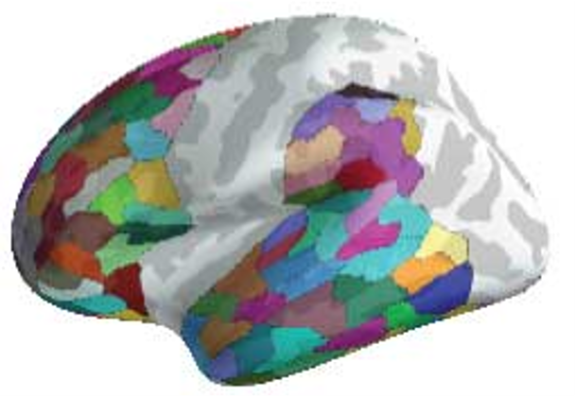
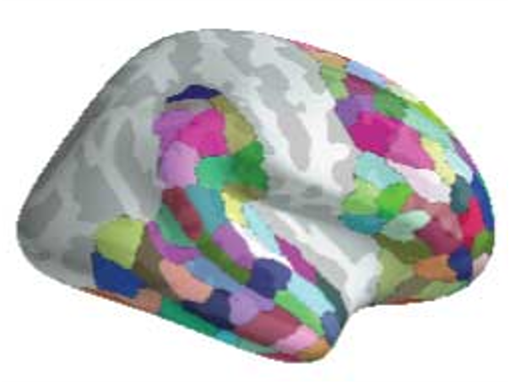
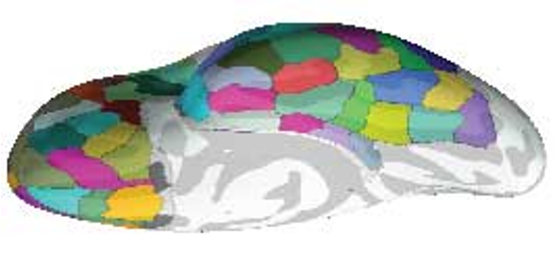
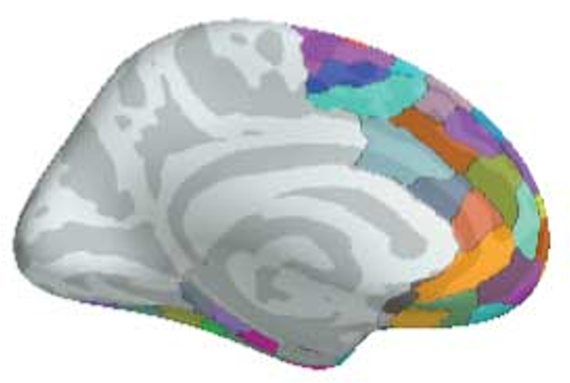
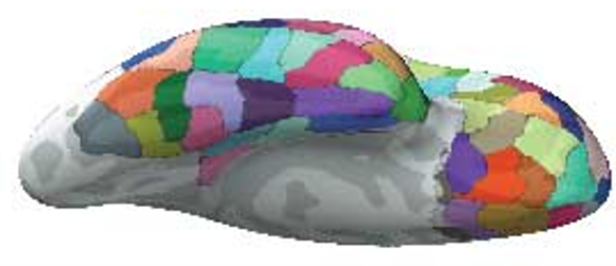
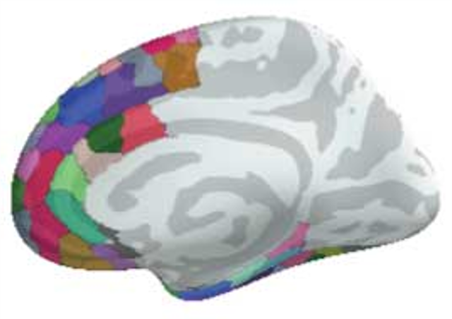
Left hemisphere
Right hemisphere

Supplementary Figure 2. Exploratory analysis of MEG source-level activity over the right hemisphere produced by the low constraint unexpected and the expected critical words.
These patches were used in a spatial cluster-based permutation test to account for multiple comparisons. In total, 140 patches were defined on the left hemisphere within our a priori search area, and 141 patches were defined on the right hemisphere for an exploratory analysis.
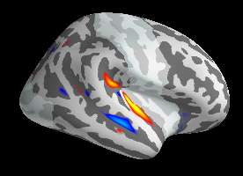
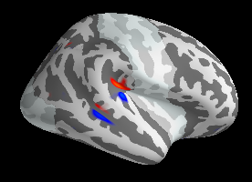
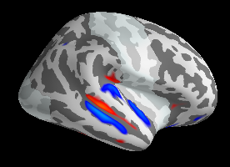
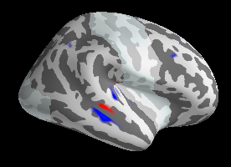
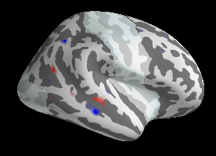
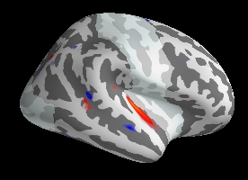
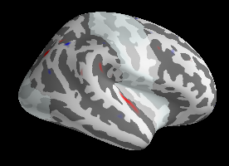
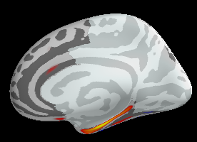
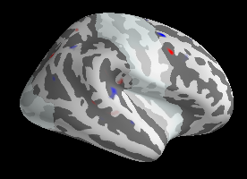
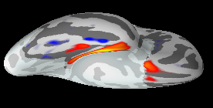
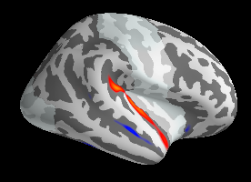
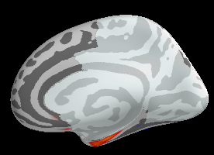
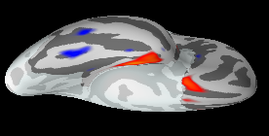
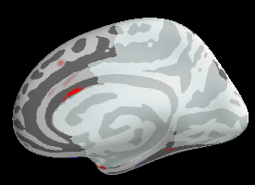
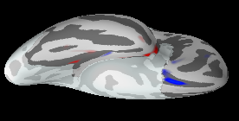
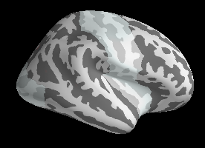
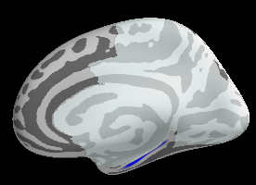
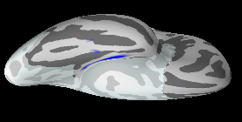
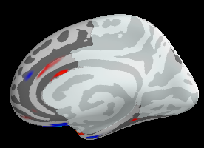
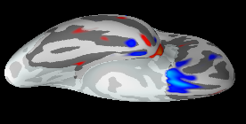
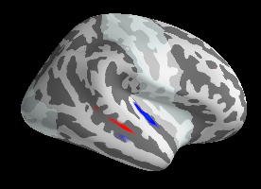
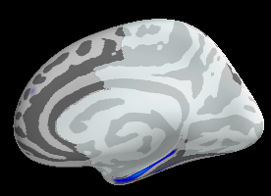
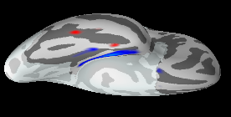
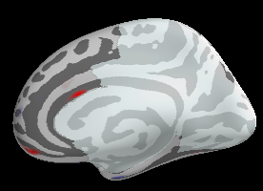
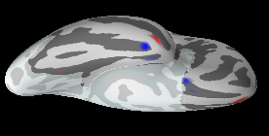
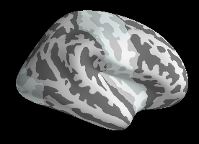
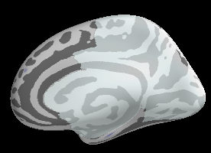
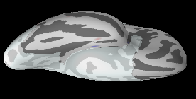
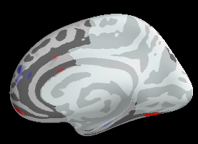
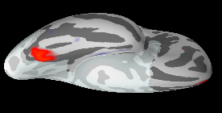
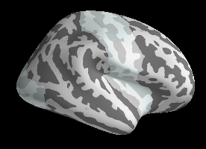
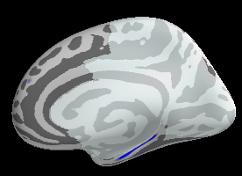
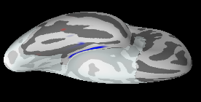
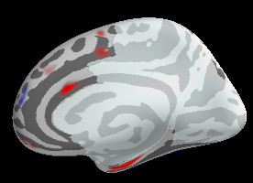
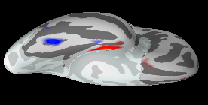
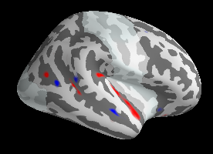
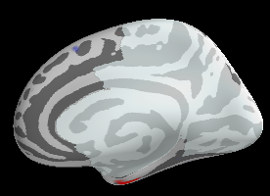
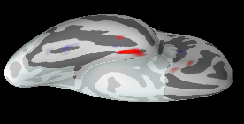
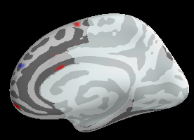
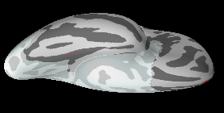
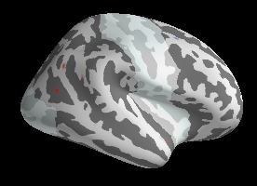
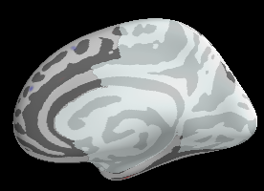
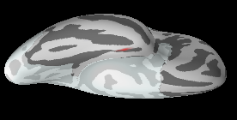
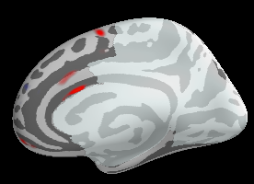
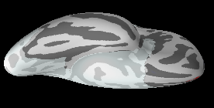
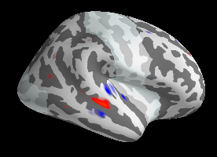
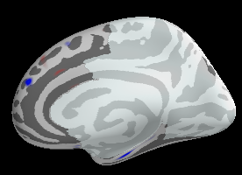
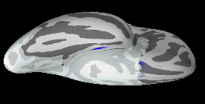
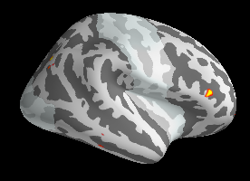
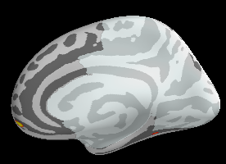
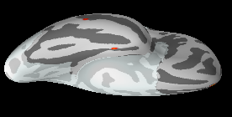
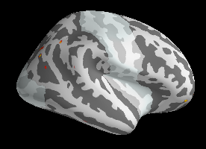
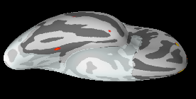
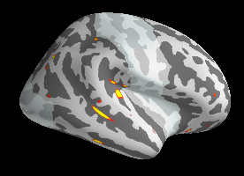
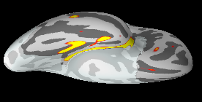


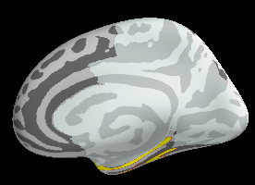
200-300
300-400
400-500
500-600
600-700
700-800
800-900
900-1000
200-300
300-400
400-500
500-600
600-700
700-800
800-900
900-1000
300-500ms
Statistical Contrast:

Low Constraint
Unexpected
versus
Expected
dSPMs: Low Constraint Unexpected
600-800ms
dSPMs: Expected
800-1000ms
1.7
-log10(p)
1.3
(p=0.02)
(p=0.05)
0.15
-0.55
0.55
F-value
-0.15

Supplementary Figure 3. Exploratory analysis of MEG source-level activity over the right hemisphere produced by the high constraint unexpected and the expected critical words.
Top and middle: Signed dSPMs produced by the low constraint unexpected and the expected critical words, shown at 100ms intervals from 200ms until 1000ms. All dSPMs are thresholded at 0.15, with red indicating outgoing dipoles and blue indicating ingoing dipoles. Bottom: Statistical maps contrasting the low constraint unexpected and expected critical words within our three a priori time windows of interest: 300-500ms, 600-800ms, and 800-1000ms. Red circles indicate regions that reached cluster-level significance. Within the 300-500ms time window, the low constraint unexpected critical words evoked significantly more activity than the expected critical words within the right temporal pole. There was also an effect in the right medial temporal cortex, which was driven by dipoles going in opposite directions to the low constraint unexpected critical words (outgoing) and the expected critical words (ingoing). No significant effects were found within the 600-1000ms time window.
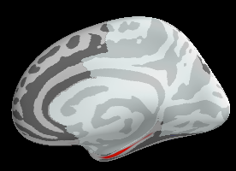
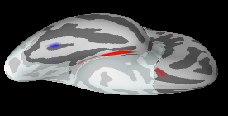
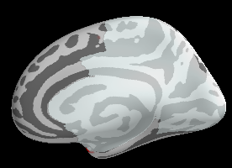
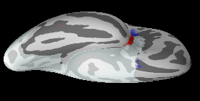
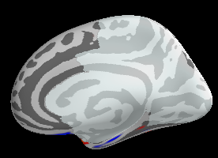
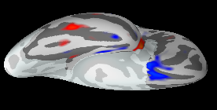
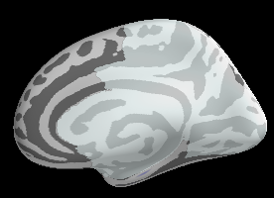
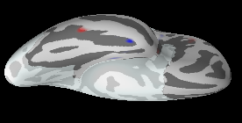
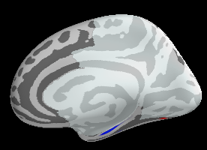
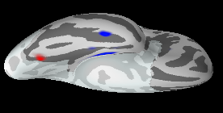
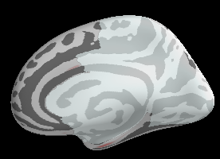
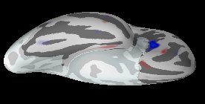
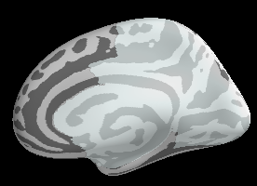
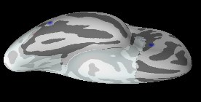
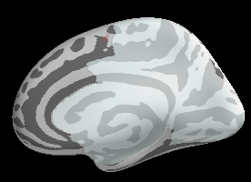
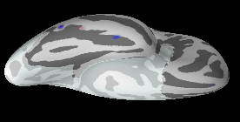
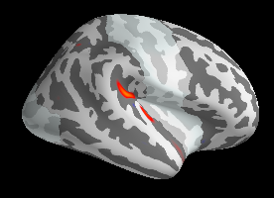
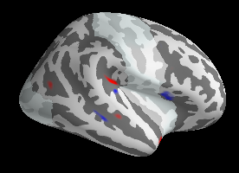
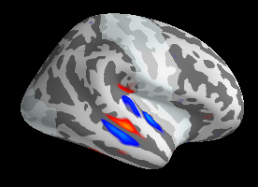
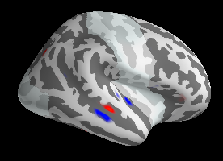
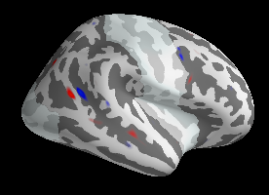
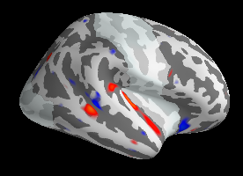
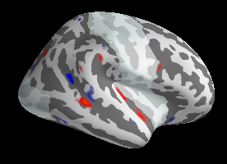
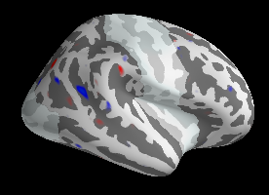
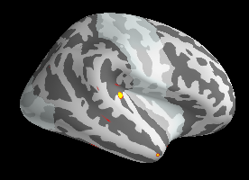
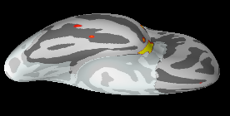

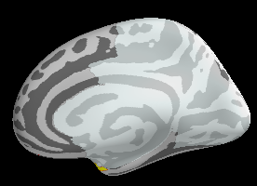
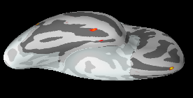
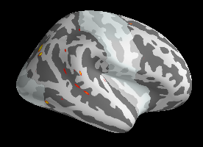
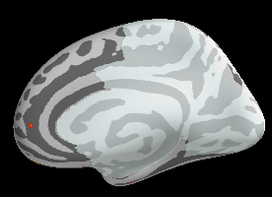
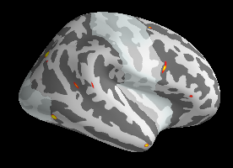
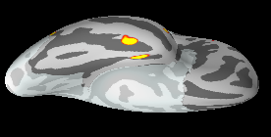
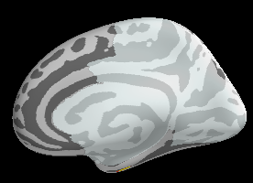
200-300
300-400
400-500
500-600
600-700
700-800
800-900
900-1000
200-300
300-400
400-500
500-600
600-700
dSPMs: High Constraint Unexpected
700-800
800-900
900-1000
dSPMs: Expected
300-500ms
600-800ms
800-1000ms
Statistical Contrast:

High Constraint
Unexpected
versus
Expected
0.15
-0.55
0.55
F-value
-0.15
1.7
-log10(p)
1.3
(p=0.02)
(p=0.05)

Supplementary Figure 4. Exploratory analysis of MEG source-level activity over the right hemisphere produced by the anomalous and the expected critical words.
Top and middle: Signed dSPMs produced by the high constraint unexpected and the expected critical words, shown at 100ms intervals from 200ms until 1000ms. All dSPMs are thresholded at 0.15, with red indicating outgoing dipoles and blue indicating ingoing dipoles. Bottom: Statistical maps contrasting the high constraint unexpected and expected critical words within our three a priori time windows of interest: 300-500ms, 600-800ms, and 800-1000ms. Red circles indicate regions that reached cluster-level significance. Within the 300-500ms time window, the high constraint unexpected critical words evoked significantly more activity than the expected critical words within the right temporal pole. No significant effects were found within the 600-1000ms time window.
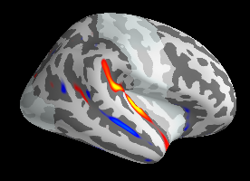
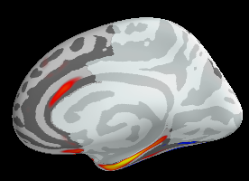
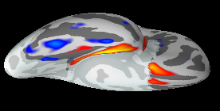
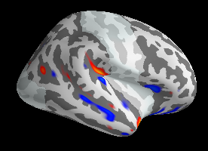
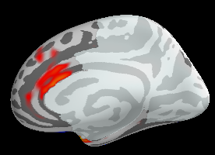
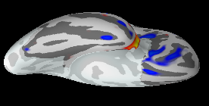
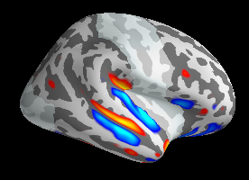
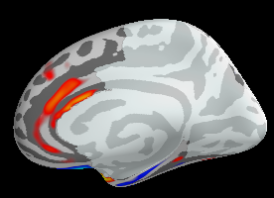
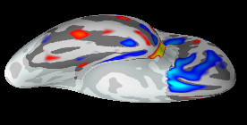
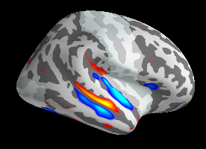
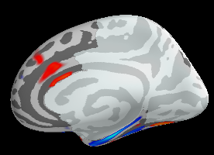
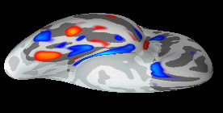
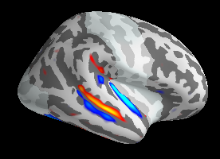
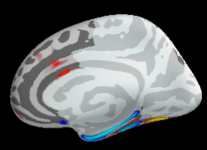
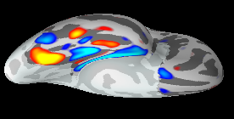
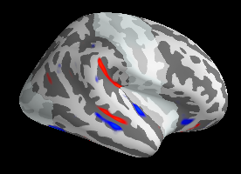
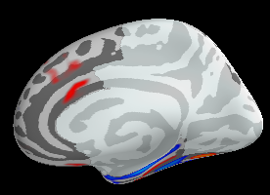
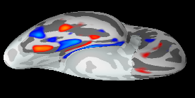
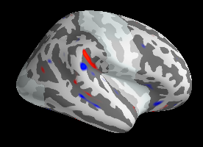
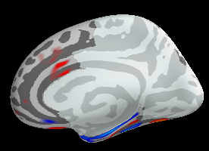
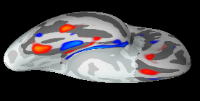
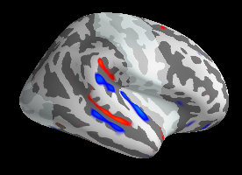
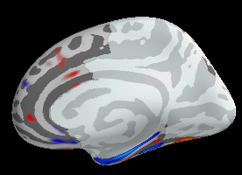
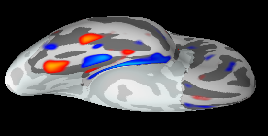
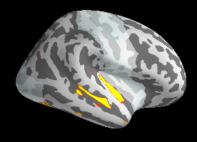

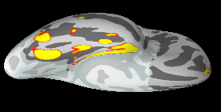

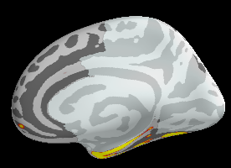

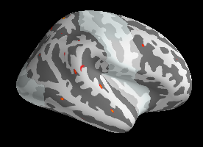
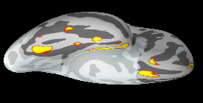

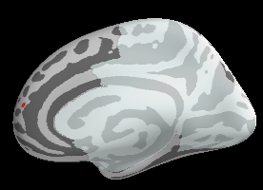
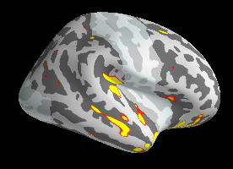

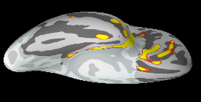

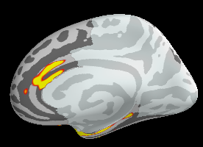
dSPMs: Expected
600-800ms
300-500ms
Statistical Contrast:
800-1000ms
0.15
-0.55
0.55
F-value
-0.15
200-300
300-400
400-500
500-600
600-700
Statistical Contrast:

Anomalous
versus
Expected
700-800
800-900
900-1000
200-300
300-400
400-500
dSPMs: Anomalous
500-600
600-700
700-800
800-900
900-1000
1.7
-log10(p)
1.3
(p=0.02)
(p=0.05)

Top and middle: Signed dSPMs produced by the anomalous and the expected critical words, shown at 100ms intervals from 200ms until 1000ms. All dSPMs are thresholded at 0.15, with red indicating outgoing dipoles and blue indicating ingoing dipoles. Bottom: Statistical maps contrasting the anomalous and expected critical words within our three a priori time windows of interest: 300-500ms, 600-800ms, and 800-1000ms. Red circles indicate regions that reached cluster-level significance. Within the 300-500ms time window, the anomalous critical words evoked significantly more activity than the expected critical words within the right lateral temporal cortex, the right anterior inferior frontal cortex, and the right anterior cingulate cortex. This contrast also revealed an effect in the right medial temporal cortex, which was driven by dipoles going in opposite directions to the anomalous (outgoing) and the expected (ingoing) critical words. The locations of these effects were similar to those observed over the left hemisphere, but they appeared to be less robust. Between 600-1000ms, the anomalous critical words produced more activity within the right fusiform cortex than the expected critical words (significant in both the 600-800ms and the 800-1000ms windows). Between 600-800ms, anomalous critical words also produced significantly more activity than the expected critical words within the right medial temporal cortex, and the right superior temporal cortex.

Supplementary Figure 5. FMRI: Whole brain exploratory analysis.
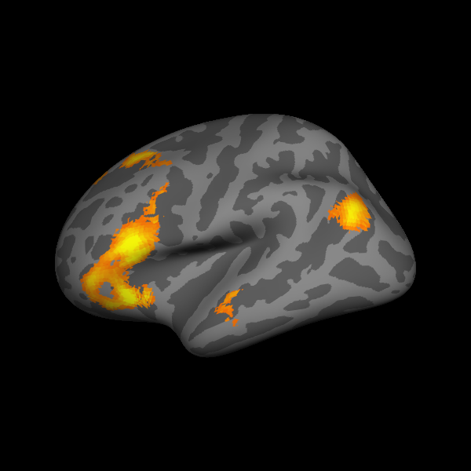
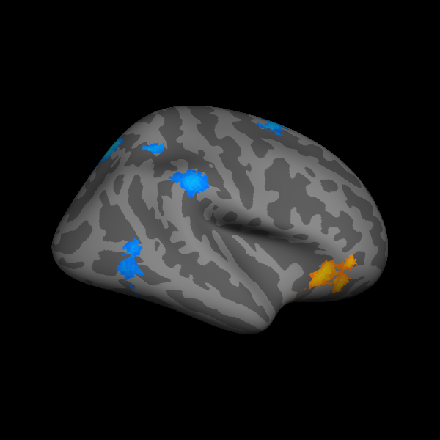
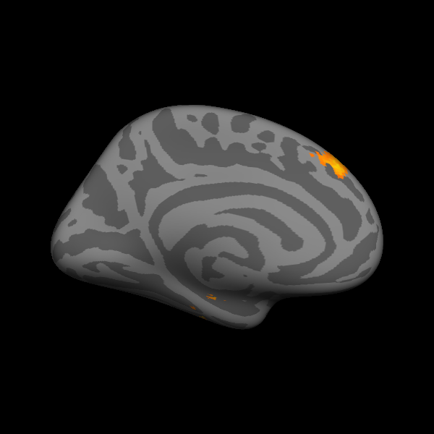
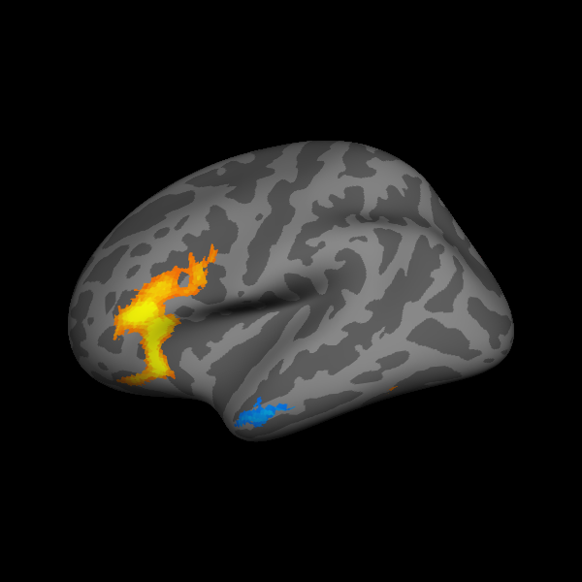
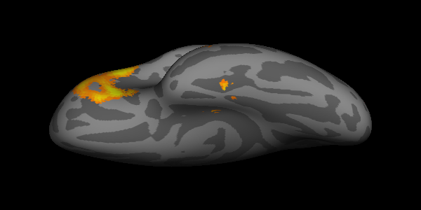
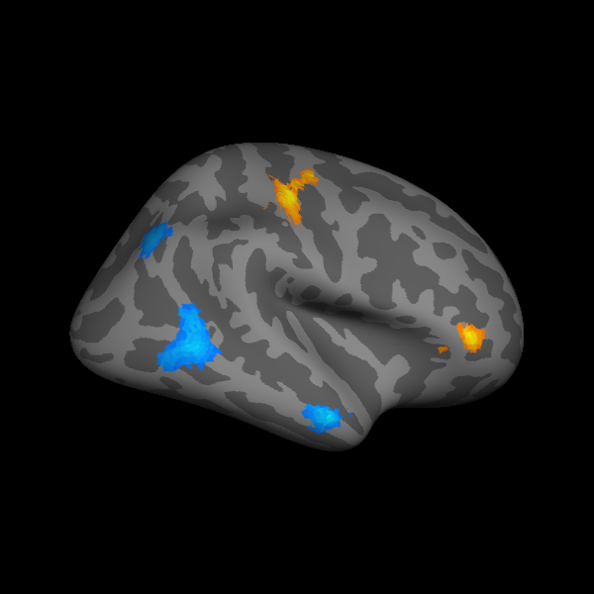
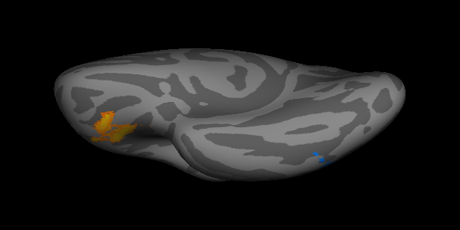
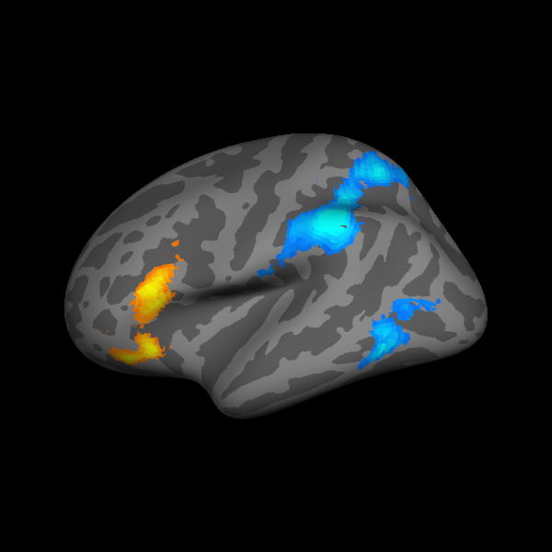
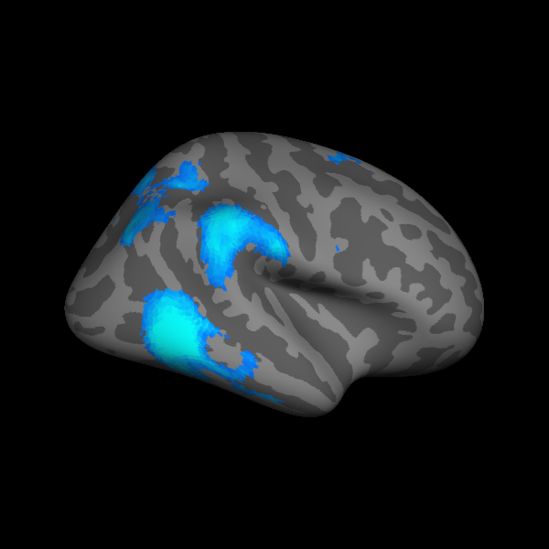
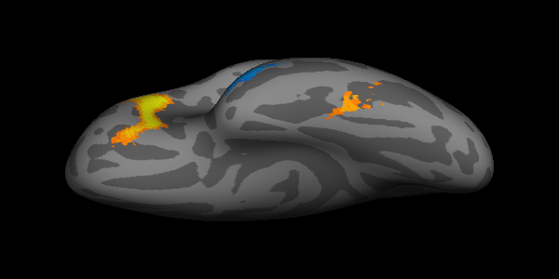
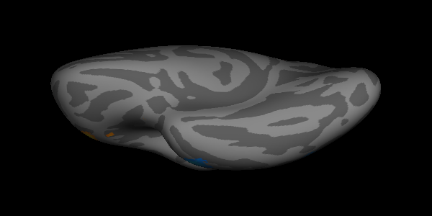
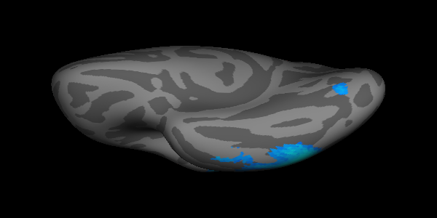
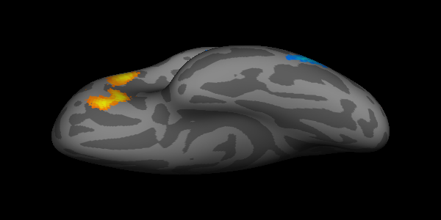
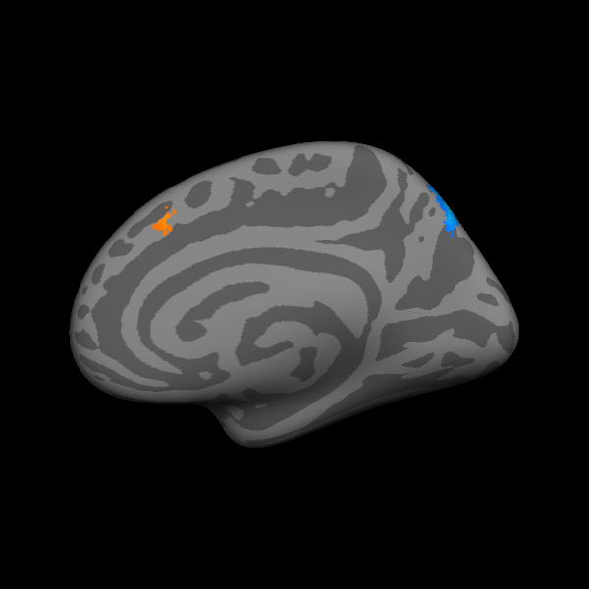
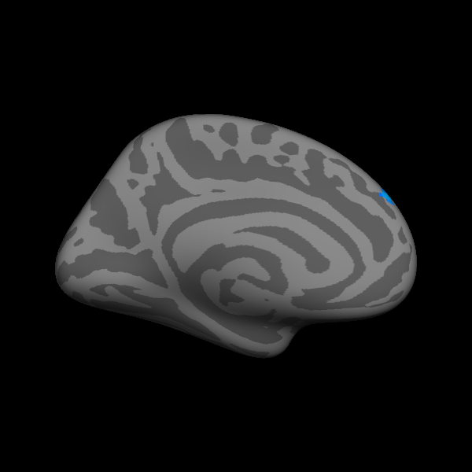
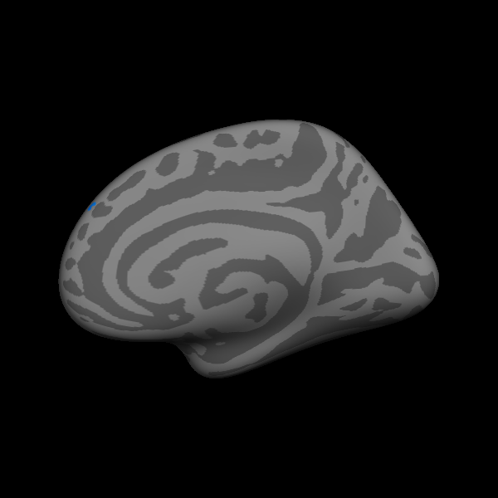
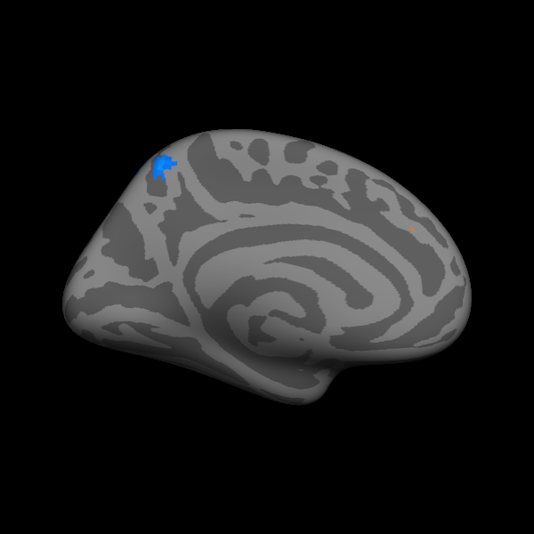
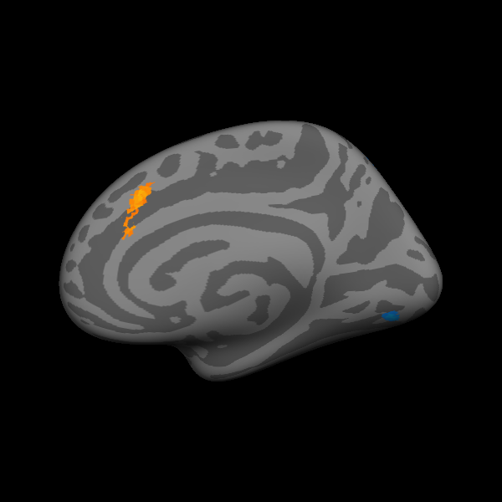
Low Constraint Unexpected
versus
Expected
L
R
L
R
L
R
0.05
0.001
0.001
P value
(Unpredictable >
Expected)
High Constraint Unexpected
versus
Expected
Anomalous
versus
Expected
(Unpredictable <
Expected)

FMRI statistical maps contrasting hemodynamic activity produced by critical words in each of the three unpredictable conditions (low constraint unexpected, high constraint unexpected, anomalous) with activity produced by the expected critical words across all brain regions in both hemispheres. Yellow/red: significantly more activity to the unpredictable critical words than to the expected critical words. Blue: significantly more activity to the expected critical words than to the unpredictable critical words. R: Right. L: Left. All effects shown reached a cluster-level significance threshold, after family-wise error (FWE) correction, of p < 0.05. Although fMRI analyses were carried out in MNI volume space, here the results are plotted on the “fsaverage” FreeSurfer surface²¹. A full list of the regions that showed significant or marginally significant effects over the right hemisphere are listed in Supplementary Table 2.

Supplementary Tables

Supplementary Table 1. A detailed description of the left lateralized search region used for MEG and fMRI analysis
Region | Number | Desikan-Killiany atlas | AAL atlas
Lateral temporal cortex
#Superior temporal cortex | 1A | superiortemporal-lh  bankssts-lh  transversetemporal-lh | Temporal_Sup_L  Heschl_L
Middle temporal cortex | 1B | middletemporal-lh | Temporal_Mid_L
Inferior temporal cortex | 1C | inferiortemporal-lh | Temporal_Inf_L
Temporal pole | 1D | temporalpole-lh | Temporal_Pole_Sup_L  Temporal_Pole_Mid_L
Ventral temporal cortex
Fusiform cortex | 2 | fusiform-lh | Fusiform_L
Medial temporal cortex
Medial temporal cortex | 3 | parahippocampal-lh  entorhinal-lh | Parahippocampus_L
Lateral parietal cortex
Inferior parietal lobule | 4A | inferiorparietal-lh  supramarginal-lh | Angular_L  Parietal_Inf_L  Supramarginal_L
Superior parietal cortex | 4B | superiorparietal-lh | Parietal_Sup_L
Lateral frontal cortex
^Inferior frontal cortex | 5A | parsorbitalis-lh  parstriangularis-lh  parsopercularis-lh lateralorbitofrontal-lh  frontalpole-lh | Frontal_Inf_Orb_L  Frontal_Mid_Orb_L Frontal_Sup_Orb_L  Frontal_Inf_Tri_L  Frontal_Inf_Oper_L
Middle frontal cortex | 5B | caudalmiddlefrontal-lh  rostralmiddlefrontal-lh | Frontal_Mid_L
*Superior frontal cortex | 5C | superiorfrontal-lh | Frontal_Sup_L  Frontal_Sup_Medial_L  Supp_Motor_Area_L
Medial frontal cortex
**Anterior cingulate cortex | 6A | rostralanteriorcingulate-lh  caudalanteriorcingulate-lh | Cingulum_Mid_L  Cingulum_Ant_L
Medial orbitofrontal cortex | 6B | medialorbitofrontal-lh | Frontal_Med_Orb_L

The names and numbers of each region correspond to those indicated in Figure 6 (main manuscript), which illustrates the full search region. For the MEG analysis, regions were defined on the “fsaverage” FreeSurfer surface²¹, using the Desikan–Killiany atlas²². For the fMRI analysis, they were defined in Montreal Neurological Institute (MNI) volumetric space using the automated anatomical labeling (AAL) atlas²³. This table lists the correspondences between the numbers and names of the regions shown in Figure 6 (main manuscript) and the names of the regions from the Desikan–Killiany and AAL atlases. The numbers also correspond to those used to label the fMRI and MEG activity shown in Figure 5 (main manuscript), as well as those in Table 2 (main manuscript), which lists the fMRI results.
#We grouped multiple gyri defined in the Desikan-Killiany atlas into one cortical region. The gyrus defined in the Desikan-Killiany atlas includes the part visible on the pial view plus its adjacent banks of the sulci delineating this gyrus.
^In the Desikan–Killiany atlas, the lateral portion of the orbitofrontal cortex and frontal pole are included in the left inferior frontal cortex.
*In the Desikan–Killiany atlas, both lateral and medial surfaces are included within the superior frontal region, whereas the AAL atlas distinguishes between the lateral and medial portions.
**In the Desikan–Killiany atlas, both anterior and middle surfaces are included within the anterior cingulate cortex, whereas the AAL atlas distinguishes between the anterior and middle portions.

Supplementary Table 2. FMRI exploratory whole brain analysis results: Clusters showing significant difference in hemodynamic activity in contrasting the low constraint unexpected, high constraint unexpected and anomalous critical words, with the expected critical words.
 | L/R | Voxel  p-value | z-score | MNI  (x, y, z) | *Size | ⁺Cluster p-value
Low Constraint Unexpected > Expected
Inferior frontal gyrus  (pars triangularis) | L | <0.0001 | 5.18 | 48, 24, 12 | 1150 | <0.0001
Inferior frontal gyrus (pars orbitalis) | L | <0.0001 | 5.16 | -38, 28, -10 | 1150 | <0.0001
Insula | L | <0.0001 | 4.50 | -34, 26, -2 | 1150 | <0.0001
Middle cingulate cortex | R | <0.0001 | 4.24 | 8, 24, 36 | 440 | <0.0001
Anterior cingulate cortex | R | <0.0001 | 4.16 | 10, 28, 28 | 440 | <0.0001
Anterior cingulate cortex | L | <0.0001 | 3.78 | -6, 32, 28 | 440 | <0.0001
Supplementary motor area | L | <0.0001 | 4.02 | -2, 18, 46 | 440 | <0.0001
Low Constraint Unexpected < Expected
Inferior parietal lobule (other) | L | <0.0001 | 6.44 | -56, -34, 54 | 3017 | <0.0001
Superior parietal lobule | L | <0.0001 | 4.96 | -30, -56, 58 | 3017 | <0.0001
Inferior parietal lobule (supramarginal gyrus) | L | <0.0001 | 4.02 | -64, -24, 22 | 3017 | <0.0001
Postcentral gyrus | L | < 0.001 | 3.64 | -56, -18, 18 | 3017 | <0.0001
Precuneus | L | < 0.001 | 3.54 | -10, -56, 54 | 3017 | <0.0001
Cerebellum | L | <0.0001 | 6.36 | -22, -74, -38 | 3980 | <0.0001
Cerebellum | R | <0.0001 | 6.04 | 24, -74, -36 | 3980 | <0.0001
Inferior temporal cortex (posterior) | R | <0.0001 | 6.10 | 50, -50, -6 | 5659 | <0.0001
Middle temporal cortex (posterior) | R | <0.0001 | 5.97 | 56, -48, -6 | 5659 | <0.0001
Inferior parietal lobule (supramarginal gyrus) | R | <0.0001 | 4.99 | 58, -40, 46 | 5659 | <0.0001
Occipital cortex (lateral) | R | <0.0001 | 4.43 | 32, -70, 36 | 5659 | <0.0001
Superior parietal lobule | R | <0.0001 | 4.16 | 18, -68, 56 | 5659 | <0.0001
Inferior temporal cortex (posterior) | L | <0.0001 | 5.21 | -56, -62, -12 | 801 | <0.0001
Occipital cortex (lateral) | L | <0.0001 | 4.74 | -54, -68, -4 | 801 | <0.0001
Middle temporal cortex (posterior) | L | <0.0001 | 4.12 | -50, -68, 6 | 801 | <0.0001
Precentral gyrus | R | <0.0001 | 4.47 | 54, 8, 42 | 235 | <0.02
Inferior frontal gyrus (pars opercularis) | R | <0.0001 | 3.90 | 50, 10, 28 | 235 | <0.02
Superior frontal cortex (lateral) | R | <0.0001 | 4.13 | 24, 12, 62 | 207 | <0.03
High constraint Unexpected > Expected
Inferior frontal gyrus (pars orbitalis) | L | <0.0001 | 6.41 | -36, 24, -8 | 2615 | <0.0001
Inferior frontal gyrus (pars triangularis) | L | <0.0001 | 5.36 | -48, 22, 18 | 2615 | <0.0001
Inferior parietal lobule (angular gyrus) | L | <0.0001 | 4.81 | -42, -64, 26 | 685 | <0.0001
Inferior parietal lobule (other) | L | <0.0001 | 3.58 | -32, -82,44 | 685 | <0.0001
Middle frontal cortex | L | <0.0001 | 4.65 | -20, 20, 46 | 909 | <0.0001
Superior frontal cortex (medial) | L | <0.0001 | 4.55 | -6, 38, 40 | 909 | <0.0001
Superior frontal cortex (lateral) | L | <0.0001 | 3.89 | -12, 40, 50 | 909 | <0.0001
Supplementary motor area | L | <0.0001 | 3.67 | -2, 20, 52 | 909 | <0.0001
Supplementary motor area | R | <0.0001 | 3.43 | 10, 22, 46 | 909 | <0.0001
Middle cingulate cortex | R | <0.0001 | 3.49 | 8, 24, 40 | 909 | <0.0001
Fusiform cortex (temporal) | L | <0.0001 | 4.49 | -40, -24, -18 | 196 | 0.0325
Middle temporal cortex (anterior) | L | <0.0001 | 3.77 | -56, -16, -8 | 196 | 0.0325
Inferior temporal cortex | L | <0.0001 | 3.65 | -46, -16, -20 | 196 | 0.0325
Inferior frontal gyrus (pars orbitalis) | R | <0.0001 | 4.48 | 36, 32, -8 | 471 | 0.0003
Insula | R | <0.0001 | 4.29 | 32, 20, -10 | 471 | 0.0003
High Constraint Unexpected < Expected
Cerebellum | R | <0.0001 | 4.96 | 16, -68, 50 | 395 | 0.001
Inferior parietal lobule (supramarginal gyrus) | R | <0.0001 | 4.08 | 62, -28, 40 | 462 | 0.0004
Inferior parietal lobule (other) | R | <0.0005 | 3.47 | 60, -34, 48 | 462 | 0.0004
Middle temporal cortex (posterior) | R | <0.0001 | 3.78 | 52, -62, 2 | 218 | 0.0019
Inferior temporal cortex (posterior) | R | 0.0001 | 3.70 | 50, -54, -10 | 218 | 0.0019
Anomalous > Expected
Inferior frontal gyrus (pars triangularis) | L | <0.0001 | 5.86 | -46, 28, 8 | 2072 | <0.0001
Inferior frontal gyrus (pars orbitalis) | L | <0.0001 | 5.83 | -36, 28, -8 | 2072 | <0.0001
Inferior frontal gyrus (pars opercularis) | L | <0.0001 | 4.33 | -40, 8,22 | 2072 | <0.0001
Postcentral gyrus | R | <0.0001 | 5.07 | 40, -22, 48 | 699 | <0.0001
Precentral gyrus | R | <0.0001 | 4.93 | 38, -12, 68 | 699 | <0.0001
^Inferior frontal gyrus (pars triangularis) | R | <0.0001 | 4.77 | 44, 38 2 | 156 | <0.08
^Insula | R | <0.0001 | 4.72 | 44, 14, -12 | 163 | <0.07
^Fusiform | L | <0.0001 | 4.56 | -44, -48, -20 | 168 | <0.06
Anomalous < Expected
Superior frontal cortex (lateral) | L | < 0.0001 | 4.88 | -12, 54, 42 | 240 | 0.0141
Superior frontal cortex (medial) | L | < 0.0001 | 3.75 | 2, 50, 36 | 240 | 0.0141
Middle temporal cortex (anterior) | R | < 0.0001 | 4.80 | 60, -4, -24 | 317 | 0.0036
Middle temporal cortex (anterior) | L | < 0.0001 | 4.74 | -58, 2, -30 | 414 | 0.0008
Inferior temporal cortex | L | < 0.0001 | 4.58 | -60, -6, -28 | 414 | 0.0008
Middle temporal cortex (posterior) | R | < 0.0001 | 4.48 | 60, -54, 0 | 410 | 0.0008
Inferior parietal lobule (angular gyrus) | R | < 0.0001 | 4.00 | 34, -72, 42 | 345 | 0.0023

We report clusters that reached significance or that approached significance (indicated with ^) at a cluster-level significance threshold after family-wise error (FWE) correction, across the whole brain, of p < 0.05.
Anatomical locations and Montreal Neurological Institute (MNI) template coordinates correspond to the p-values and z-scores of representative peaks within each cluster. We used the automated anatomical labeling (AAL) atlas to define the anatomical regions reported. Only one peak per anatomical region is reported.
*Size of cluster: the number of contiguous voxels within each cluster.
⁺Cluster p-values: the cluster-level significance after FWE correction of p < 0.05.
Supplementary videos. Dynamic source activation is shown from onset of the critical word until 1000ms, with each frame showing the averaged dSPM values within 10ms.

References
1 Kuperberg, G. R., Brothers, T. & Wlotko, E. A tale of two positivities and the N400: Distinct neural signatures are evoked by confirmed and violated predictions at different levels of representation. J Cogn Neurosci 32, 12-35, doi:10.1162/jocn_a_01465 (2020).
2 Taylor, W. 'Cloze' procedure: A new tool for measuring readability. Journalism Quart 30, 415-433 (1953).
3 Federmeier, K. D., Wlotko, E. W., De Ochoa-Dewald, E. & Kutas, M. Multiple effects of sentential constraint on word processing. Brain Res 1146, 75-84, doi:10.1016/j.brainres.2006.06.101 (2007).
4 Schwanenflugel, P. J. & Lacount, K. L. Semantic relatedness and the scope of facilitation for upcoming words in sentences. J Exp Psychol Learn Mem Cognit 14, 344-354, doi:10.1037//0278-7393.14.2.344 (1988).
5 Levin, B. English Verb Classes And Alternations: A Preliminary Investigation. (University of Chicago Press, 1993).
6 Paczynski, M. & Kuperberg, G. R. Electrophysiological evidence for use of the animacy hierarchy, but not thematic role assignment, during verb argument processing. Lang Cogn Process 26, 1402-1456, doi:10.1080/01690965.2011.580143 (2011).
7 Paczynski, M. & Kuperberg, G. R. Multiple influences of semantic memory on sentence processing: Distinct effects of semantic relatedness on violations of real-world event/state knowledge and animacy selection restrictions. J Mem Lang 67, 426-448, doi:10.1016/j.jml.2012.07.003 (2012).
8 Lund, K. & Burgess, C. Producing high-dimensional semantic spaces from lexical co-occurrence. Behav Res Meth Instr 28, 203-208 (1996).
9 Balota, D. A. et al. The English lexicon project. Behav Res Methods 39, 445-459 (2007).
10 Kuperberg, G. R., Kreher, D. A., Sitnikova, T., Caplan, D. N. & Holcomb, P. J. The role of animacy and thematic relationships in processing active English sentences: evidence from event-related potentials. Brain Lang 100, 223-237, doi:10.1016/j.bandl.2005.12.006 (2007).
11 Brouwer, H. & Crocker, M. W. On the proper treatment of the N400 and P600 in language comprehension. Front Psychol 8, 1327, doi:10.3389/fpsyg.2017.01327 (2017).
12 Ahlfors, S. P., Han, J., Belliveau, J. W. & Hämäläinen, M. S. Sensitivity of MEG and EEG to source orientation. Brain Topogr 23, 227-232 (2010).
13 Ahlfors, S. P. et al. Cancellation of EEG and MEG signals generated by extended and distributed sources. Hum Brain Mapp 31, 140-149 (2010).
14 Siedenberg, R., Goodin, D. S., Aminoff, M. J., Rowley, H. A. & Roberts, T. P. L. Comparison of late components in simultaneously recorded event-related electrical potentials and event-related magnetic fields. Electroencephalogr Clin Neurophysiol 99, 191-197, doi:10.1016/0013-4694(96)95215-3 (1996).
15 Coulson, S., King, J. W. & Kutas, M. Expect the unexpected: Event-related brain responses to morphosyntactic violations. Lang Cogn Process 13, 21-58, doi:10.1080/016909698386582 (1998).
16 Osterhout, L., Kim, A. & Kuperberg, G. R. in The Cambridge Handbook of Psycholinguistics (eds M. Spivey, M. Joannisse, & K. McRae) 365-389 (Cambridge University Press, 2012).
17 Sassenhagen, J., Schlesewsky, M. & Bornkessel-Schlesewsky, I. The P600-as-P3 hypothesis revisited: single-trial analyses reveal that the late EEG positivity following linguistically deviant material is reaction time aligned. Brain Lang 137, 29-39, doi:10.1016/j.bandl.2014.07.010 (2014).
18 Sassenhagen, J. & Fiebach, C. J. Finding the P3 in the P600: Decoding shared neural mechanisms of responses to syntactic violations and oddball targets. NeuroImage 200, 425-436, doi:10.1016/j.neuroimage.2019.06.048 (2019).
19 Vartiainen, J., Liljestrom, M., Koskinen, M., Renvall, H. & Salmelin, R. Functional magnetic resonance imaging blood oxygenation level-dependent signal and magnetoencephalography evoked responses yield different neural functionality in reading. J Neurosci 31, 1048-1058, doi:10.1523/JNEUROSCI.3113-10.2011 (2011).
20 Furey, M. L. et al. Dissociation of face-selective cortical responses by attention. Proc Natl Acad Sci U S A 103, 1065-1070, doi:10.1073/pnas.0510124103 (2006).
21 Fischl, B., Sereno, M. I. & Dale, A. M. Cortical surface-based analysis. II: Inflation, flattening, and a surface-based coordinate system. NeuroImage 9, 195-207, doi:10.1006/nimg.1998.0396 (1999).
22 Desikan, R. S. et al. An automated labeling system for subdividing the human cerebral cortex on MRI scans into gyral based regions of interest. NeuroImage 31, 968-980, doi:10.1016/j.neuroimage.2006.01.021 (2006).
23 Tzourio-Mazoyer, N. et al. Automated anatomical labeling of activations in SPM using a macroscopic anatomical parcellation of the MNI MRI single-subject brain. NeuroImage 15, 273-289, doi:10.1006/nimg.2001.0978 (2002).

