Figures
Fig S1 Site characteristics, a) porewater constituents, b) leaf P and N concentrations
Fig S2 Multi-metric fingerprints including 3 replicates from the Finkol Riverine site
Fig S3 f13C/P vs. RGR

Tables
Table S1 Measured leaf data
Table S2 Measured bark data
Table S3 Measured soil data
Table S4 Measured porewater data
Table S5 Leaf averages by species
Table S6 Leaf averages 2 site groups
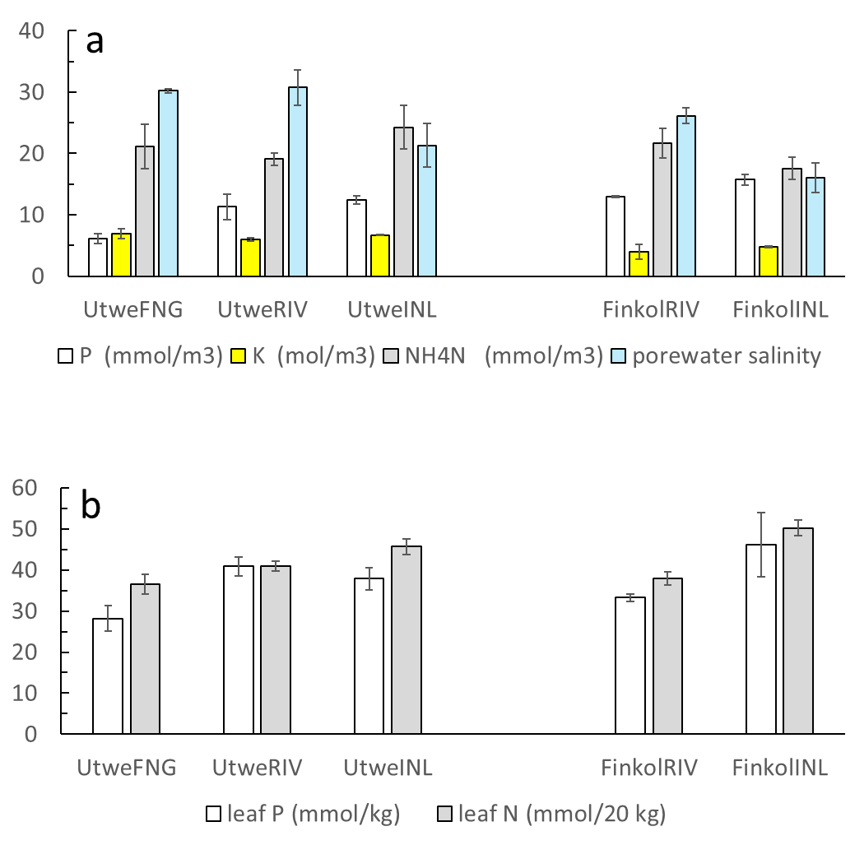

Fig. S1. Site characteristics, a) porewater constituents, b) leaf P and N concentrations.

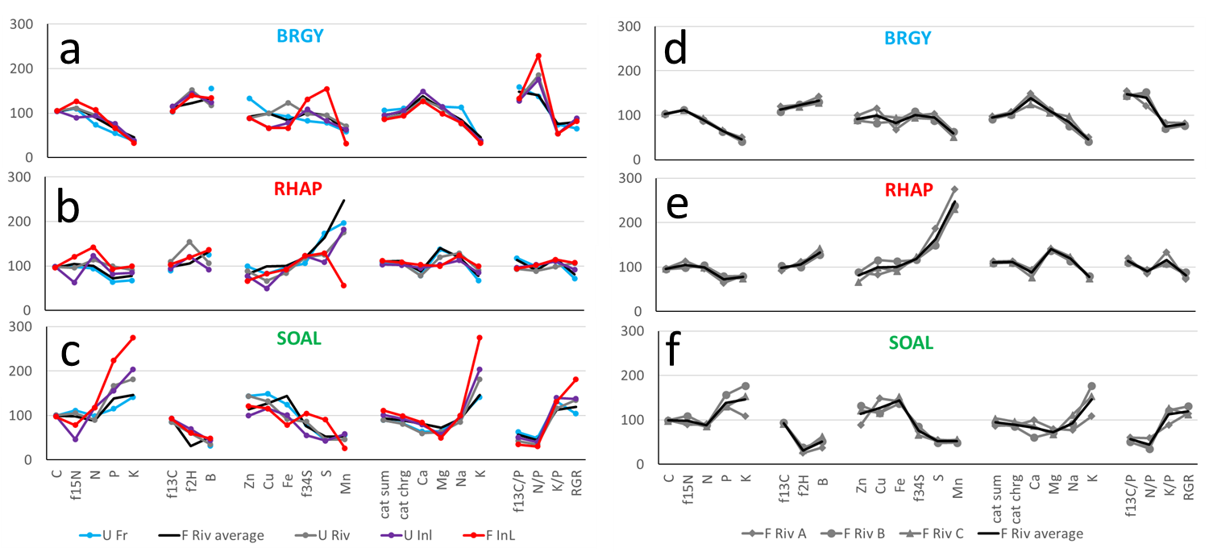

Fig. S2. Leaf chemical metrics for each species at the 5 sites (a-c) and data for replicates at one site, Finkol Riverine (d-f). Data in each panel are expressed relative to the species mean = 100. Panels A-C are the same as Fig. 9 in the main article.

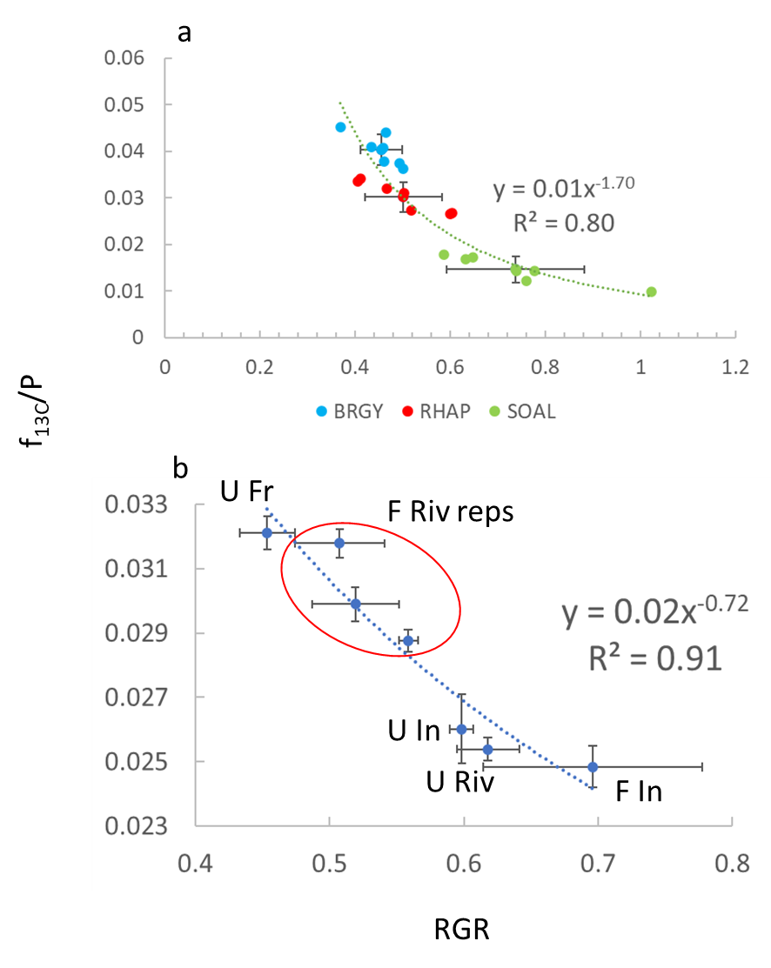

Fig. S3. f_{13C}/P vs. RGR, a) Species, measured data; curve is best fit to all data. b) Sites, data has been normalized for species effects prior to calculating f_{13C}/P and RGR. In both a) and b), RGR = (f_{P} + 0.5*f_{N} + 0.5*f_{13C})/2; model c in Fig. 8.

Supplemental Tables

Table S1. Leaf data. For each mangrove species, samples were obtained from 5 individual trees, with three sun leaves per tree composited per species, so that a total of 15 leaves were composited per species per site or plot. The leaf samples were obtained with a pole from the forest canopy open to the sun at 3-7 m heights. Leaves were sun leaves, not larger thinner shade leaves.
Site | Reps | Species | C | N | P | S | δ²H_{SMOW} | δ¹³C_{VPDB}
 |  |  | mol/kg | mmol/kg | mmol/kg | mmol/kg | ‰ | ‰
FinkolINL | A | BRGY | 38.1 | 878.4 | 23.9 | 272.3 | -88.6 | -31.0
FinkolRIV | A | BRGY | 36.8 | 713.5 | 23.5 | 183.0 | -83.2 | -32.4
UtweFNG | A | BRGY | 37.5 | 602.9 | 19.7 | 138.1 |  | -30.9
UtweINL | A | BRGY | 37.9 | 767.4 | 27.4 | 145.2 | -90.5 | -32.0
UtweRIV | A | BRGY | 38.3 | 784.0 | 26.5 | 167.2 | -92.8 | -31.9
FinkolRIV | B | BRGY | 37.4 | 728.7 | 22.9 | 155.6 | -83.5 | -31.4
FinkolRIV | C | BRGY | 37.9 | 762.6 | 23.9 | 161.4 | -81.5 | -31.7
FinkolINL | A | RHAP | 35.0 | 1167.1 | 33.5 | 227.0 | -81.5 | -31.0
FinkolRIV | A | RHAP | 35.2 | 788.5 | 23.2 | 329.1 | -79.1 | -29.9
UtweFNG | A | RHAP | 35.6 | 772.8 | 23.2 | 306.2 |  | -29.8
UtweINL | A | RHAP | 35.9 | 1009.5 | 29.7 | 191.3 | -82.2 | -30.1
UtweRIV | A | RHAP | 35.3 | 932.7 | 35.8 | 220.9 | -93.6 | -31.5
FinkolRIV | B | RHAP | 34.5 | 855.3 | 28.7 | 262.6 | -75.0 | -30.9
FinkolRIV | C | RHAP | 34.9 | 808.8 | 26.8 | 272.7 | -76.5 | -30.6
FinkolINL | A | SOAL | 35.4 | 969.5 | 81.0 | 159.7 | -61.2 | -30.1
FinkolRIV | A | SOAL | 36.2 | 744.5 | 47.1 | 98.0 | -48.9 | -30.1
UtweFNG | A | SOAL | 36.0 | 814.0 | 41.6 | 78.5 |  | -29.4
UtweINL | A | SOAL | 35.9 | 961.8 | 56.4 | 76.6 | -64.2 | -30.1
UtweRIV | A | SOAL | 36.6 | 738.4 | 60.3 | 80.6 | -61.1 | -29.4
FinkolRIV | B | SOAL | 36.0 | 727.1 | 56.5 | 84.9 | -53.2 | -30.1
FinkolRIV | C | SOAL | 35.5 | 699.3 | 46.8 | 92.5 | -50.9 | -29.9
Site | Reps | Species | δ¹⁵N_{AIR} | δ³⁴S_{VCDT} | K | Ca | Mg | Na
 |  |  | ‰ | ‰ | mmol/kg | mmol/kg | mmol/kg | mmol/kg
FinkolINL | A | BRGY | 1.6 | -14.0 | 71.8 | 425.0 | 287.5 | 565.2
FinkolRIV | A | BRGY | 2.0 | -5.6 | 110.3 | 502.5 | 329.2 | 591.3
UtweFNG | A | BRGY | 2.0 | -1.0 | 82.1 | 432.5 | 333.3 | 821.7
UtweINL | A | BRGY | 2.5 | -8.0 | 82.1 | 500.0 | 333.3 | 573.9
UtweRIV | A | BRGY | 2.0 | -5.2 | 79.5 | 437.5 | 325.0 | 552.2
FinkolRIV | B | BRGY | 1.9 | -8.2 | 89.7 | 472.5 | 320.8 | 552.2
FinkolRIV | C | BRGY | 2.0 | -4.2 | 97.4 | 417.5 | 308.3 | 708.7
FinkolINL | A | RHAP | 1.7 | -11.8 | 215.4 | 345.0 | 291.7 | 900.0
FinkolRIV | A | RHAP | 1.9 | -10.3 | 174.4 | 317.5 | 412.5 | 869.6
UtweFNG | A | RHAP | 2.3 | -7.3 | 146.2 | 265.0 | 400.0 | 873.9
UtweINL | A | RHAP | 3.3 | -11.9 | 184.6 | 320.0 | 300.0 | 821.7
UtweRIV | A | RHAP | 2.4 | -10.7 | 197.4 | 262.5 | 350.0 | 939.1
FinkolRIV | B | RHAP | 2.3 | -10.1 | 174.4 | 310.0 | 400.0 | 826.1
FinkolRIV | C | RHAP | 2.2 | -11.9 | 161.5 | 257.5 | 416.7 | 900.0
FinkolINL | A | SOAL | 2.9 | -7.0 | 597.4 | 285.0 | 145.8 | 726.1
FinkolRIV | A | SOAL | 2.6 | 1.0 | 235.9 | 335.0 | 233.3 | 560.9
UtweFNG | A | SOAL | 2.0 | -0.3 | 307.7 | 215.0 | 187.5 | 695.7
UtweINL | A | SOAL | 3.7 | 6.1 | 443.6 | 267.5 | 166.7 | 717.4
UtweRIV | A | SOAL | 2.1 | -2.0 | 394.9 | 202.5 | 183.3 | 626.1
FinkolRIV | B | SOAL | 2.0 | -1.8 | 384.6 | 202.5 | 208.3 | 665.2
FinkolRIV | C | SOAL | 2.4 | 3.3 | 333.3 | 290.0 | 195.8 | 808.7
Site | Reps | Species | Fe | Mn | Zn | Cu | B
 |  |  | mmol/kg | mmol/kg | mmol/kg | mmol/kg | mmol/kg
FinkolINL | A | BRGY | 0.79 | 0.24 | 0.12 | 0.06 | 5.82
FinkolRIV | A | BRGY | 0.80 | 0.47 | 0.14 | 0.11 | 6.18
UtweFNG | A | BRGY | 1.09 | 0.44 | 0.18 | 0.09 | 6.73
UtweINL | A | BRGY | 0.93 | 0.47 | 0.12 | 0.06 | 5.36
UtweRIV | A | BRGY | 1.46 | 0.53 | 0.12 | 0.09 | 5.09
FinkolRIV | B | BRGY | 1.02 | 0.47 | 0.12 | 0.08 | 5.64
FinkolRIV | C | BRGY | 1.13 | 0.38 | 0.12 | 0.09 | 5.55
FinkolINL | A | RHAP | 1.09 | 0.42 | 0.09 | 0.08 | 5.91
FinkolRIV | A | RHAP | 1.14 | 2.05 | 0.12 | 0.08 | 5.55
UtweFNG | A | RHAP | 1.14 | 1.47 | 0.14 | 0.08 | 5.45
UtweINL | A | RHAP | 1.11 | 1.36 | 0.11 | 0.05 | 4.00
UtweRIV | A | RHAP | 1.00 | 1.31 | 0.12 | 0.06 | 4.64
FinkolRIV | B | RHAP | 1.34 | 1.78 | 0.12 | 0.11 | 5.55
FinkolRIV | C | RHAP | 1.07 | 1.73 | 0.09 | 0.09 | 6.18
FinkolINL | A | SOAL | 0.93 | 0.20 | 0.17 | 0.11 | 2.09
FinkolRIV | A | SOAL | 1.68 | 0.40 | 0.12 | 0.14 | 1.64
UtweFNG | A | SOAL | 1.48 | 0.42 | 0.20 | 0.14 | 1.36
UtweINL | A | SOAL | 1.20 | 0.44 | 0.14 | 0.11 | 1.91
UtweRIV | A | SOAL | 1.09 | 0.35 | 0.20 | 0.13 | 1.55
FinkolRIV | B | SOAL | 1.63 | 0.36 | 0.18 | 0.11 | 2.27
FinkolRIV | C | SOAL | 1.80 | 0.42 | 0.17 | 0.11 | 2.73

Table S2. Bark data. At each site, 4 samples equally spaced around tree trunks were taken at breast height from 5 individual trees in close proximity to the trees sampled for leaves, so that species composites contained 20 bark pieces.
Site | Reps | Species | C | N | P | S | δ²H_{SMOW} | δ¹³C_{VPDB}
 |  |  | mol/kg | mmol/kg | mmol/kg | mmol/kg | ‰ | ‰
FinkolINL | A | BRGY | 42.75 | 244.22 | 3.23 | 68.26 | -40.2 | -30.0
FinkolRIV | A | BRGY | 42.12 | 290.97 | 3.23 | 61.62 | -49.3 | -30.9
UtweFNG | A | BRGY | 41.80 | 291.53 | 3.23 | 66.31 | -60.7 | -29.6
UtweINL | A | BRGY | 42.12 | 298.72 | 3.23 | 67.31 | -48.9 | -30.5
UtweRIV | A | BRGY | 41.44 | 377.05 | 3.23 | 71.73 | -84.3 | -29.7
FinkolRIV | B | BRGY | 41.63 | 268.72 | 3.23 | 63.02 | -54.1 | -30.3
FinkolRIV | C | BRGY | 42.66 | 263.32 | 3.23 | 57.71 | -43.8 | -30.3
FinkolINL | A | RHAP | 43.33 | 176.69 | 3.23 | 24.12 | -81.7 | -31.7
FinkolRIV | A | RHAP | 43.26 | 85.90 | 3.23 | 21.40 | -80.2 | -30.4
UtweFNG | A | RHAP | 42.86 | 140.42 | 3.23 | 15.87 | -103.7 | -29.5
UtweINL | A | RHAP | 42.33 | 158.29 | 3.23 | 17.00 | -77.2 | -28.7
UtweRIV | A | RHAP | 42.53 | 152.75 | 3.23 | 19.12 | -75.4 | -29.2
FinkolRIV | B | RHAP | 42.25 | 151.77 | 3.23 | 20.16 | . | -30.8
FinkolRIV | C | RHAP | 43.25 | 157.58 | 3.23 | 22.28 | -80.0 | -30.6
FinkolINL | A | SOAL | 41.38 | 464.30 | 9.68 | 82.59 | -47.7 | -27.8
FinkolRIV | A | SOAL | 39.10 | 476.28 | 9.68 | 78.40 | -53.1 | -28.7
UtweFNG | A | SOAL | 40.74 | 345.68 | 6.45 | 56.26 | -50.3 | -27.8
UtweINL | A | SOAL | 39.69 | 384.26 | 6.45 | 73.33 | -45.3 | -28.1
UtweRIV | A | SOAL | 39.13 | 380.34 | 6.45 | 74.68 | -78.0 | -27.2
FinkolRIV | B | SOAL | 40.70 | 358.48 | 6.45 | 70.80 | -57.0 | -28.2
FinkolRIV | C | SOAL | 40.41 | 338.47 | 6.45 | 70.44 | -52.0 | -28.0
Site | Reps | Species | δ¹⁵N_{AIR} | δ³⁴S_{VCDT} | K | Ca | Mg | Na
 |  |  | ‰ | ‰ | mmol/kg | mmol/kg | mmol/kg | mmol/kg
FinkolINL | A | BRGY | 1.1 | -14.0 | 4.49 | 125.00 | 33.33 | 8.70
FinkolRIV | A | BRGY | 1.3 | -5.6 | 19.23 | 147.50 | 54.17 | 30.43
UtweFNG | A | BRGY | 1.2 | -1.8 | 11.44 | 170.00 | 104.17 | 13.04
UtweINL | A | BRGY | 2.5 | -8.5 | 16.51 | 125.00 | 58.33 | 30.43
UtweRIV | A | BRGY | 0.9 | -7.5 | 10.00 | 167.50 | 62.50 | 8.70
FinkolRIV | B | BRGY | 0.6 | 1.6 | 38.97 | 137.50 | 79.17 | 186.96
FinkolRIV | C | BRGY | 1.0 | -2.0 | 18.72 | 180.00 | 45.83 | 47.83
FinkolINL | A | RHAP | -0.9 | -7.8 | 17.44 | 127.50 | 75.00 | 47.83
FinkolRIV | A | RHAP | 0.5 | 0.5 | 25.13 | 80.00 | 62.50 | 56.52
UtweFNG | A | RHAP | 1.6 | 1.5 | 11.51 | 92.50 | 79.17 | 8.70
UtweINL | A | RHAP | 1.1 | -3.0 | 3.23 | 115.00 | 75.00 | 4.35
UtweRIV | A | RHAP | 0.2 | 2.1 | 17.69 | 107.50 | 87.50 | 39.13
FinkolRIV | B | RHAP | 0.9 | 3.7 | 23.33 | 122.50 | 87.50 | 65.22
FinkolRIV | C | RHAP | 0.0 | 4.1 | 22.31 | 137.50 | 91.67 | 65.22
FinkolINL | A | SOAL | 2.9 | -9.9 | 36.67 | 342.50 | 41.67 | 47.83
FinkolRIV | A | SOAL | 0.6 | -0.6 | 50.00 | 592.50 | 83.33 | 156.52
UtweFNG | A | SOAL | -0.3 | 2.4 | 31.54 | 167.50 | 120.83 | 156.52
UtweINL | A | SOAL | 2.8 | 2.3 | 58.82 | 297.50 | 75.00 | 191.30
UtweRIV | A | SOAL | 1.3 | -2.7 | 33.44 | 435.00 | 79.17 | 73.91
FinkolRIV | B | SOAL | 0.4 | 0.6 | 39.49 | 247.50 | 87.50 | 204.35
FinkolRIV | C | SOAL | 0.6 | 3.2 | 64.62 | 307.50 | 95.83 | 252.17
Site | Reps | Species | Fe | Mn | Zn | Cu | B
 |  |  | mmol/kg | mmol/kg | mmol/kg | mmol/kg | mmol/kg
FinkolINL | A | BRGY | 4.21 | 0.07 | 0.05 | 0.03 | 3.73
FinkolRIV | A | BRGY | 9.18 | 0.27 | 0.06 | 0.06 | 5.18
UtweFNG | A | BRGY | 16.36 | 0.36 | 0.05 | 0.05 | 2.45
UtweINL | A | BRGY | 22.52 | 0.18 | 0.08 | 0.05 | 1.82
UtweRIV | A | BRGY | 20.96 | 0.24 | 0.06 | 0.05 | 4.55
FinkolRIV | B | BRGY | 12.30 | 0.29 | 0.06 | 0.06 | 5.09
FinkolRIV | C | BRGY | 7.82 | 0.18 | 0.08 | 0.05 | 5.00
FinkolINL | A | RHAP | 4.46 | 0.76 | 0.06 | 0.05 | 3.27
FinkolRIV | A | RHAP | 4.48 | 2.96 | 0.09 | 0.13 | 4.09
UtweFNG | A | RHAP | 4.86 | 1.47 | 0.08 | 0.03 | 2.18
UtweINL | A | RHAP | 11.54 | 1.53 | 0.08 | 0.03 | 3.55
UtweRIV | A | RHAP | 9.09 | 2.80 | 0.06 | 0.05 | 2.27
FinkolRIV | B | RHAP | 4.20 | 4.13 | 0.06 | 0.08 | 3.91
FinkolRIV | C | RHAP | 6.45 | 7.04 | 0.06 | 0.05 | 4.64
FinkolINL | A | SOAL | 3.95 | 0.07 | 0.06 | 0.08 | 4.36
FinkolRIV | A | SOAL | 4.71 | 0.15 | 0.11 | 0.08 | 8.91
UtweFNG | A | SOAL | 11.23 | 0.15 | 0.06 | 0.06 | 5.91
UtweINL | A | SOAL | 11.25 | 0.11 | 0.11 | 0.06 | 3.91
UtweRIV | A | SOAL | 8.41 | 0.16 | 0.09 | 0.09 | 5.45
FinkolRIV | B | SOAL | 5.30 | 0.13 | 0.06 | 0.06 | 6.09
FinkolRIV | C | SOAL | 4.75 | 0.16 | 0.08 | 0.06 | 7.55

Table S3. Soil data. The upper 1 cm of sediment collected from 4 locations within 2m of the trees sampled for bark; sediments from 5 trees per species were composited so that composites contained 20 surface sediment collections. Samples were placed in plastic bags in the field, then later rinsed with deionized water and dried to 60ºC. Sediment samples were acid-treated to remove carbonates prior to drying for organic C and N analysis.

Column1 | Column2 | Column3 | C | N | AvgTP | S | δ¹³C_{VPDB} | δ¹⁵N_{AIR}
Site | Reps | Species | mol/kg | mol/kg | mol/kg | mol/kg | ‰ | ‰
UtweFNG | A | BRGY | 11.3 | 0.3 | 0.0 | 0.5 | -28.4 | 1.5
UtweRIV | A | BRGY | 12.5 | 0.4 | 0.0 | 1.3 | -28.5 | 0.9
UtweINL | A | BRGY | 10.3 | 0.3 | 0.0 | 1.5 | -28.7 | 1.1
FinkolINL | A | BRGY | 27.5 | 0.9 | 0.0 | 1.7 | -28.6 | 0.6
FinkolRIV | A | BRGY | 18.4 | 0.7 | 0.0 | 0.6 | -28.6 | 1.8
FinkolRIV | B | BRGY | 19.6 | 0.6 | 0.0 | 0.9 | -28.5 | 1.8
FinkolRIV | C | BRGY | 19.5 | 0.7 | 0.0 | 0.5 | -28.4 | 1.8
UtweFNG | A | RHAP | 12.2 | 0.4 | 0.0 | 0.7 | -28.4 | 1.1
UtweRIV | A | RHAP | 8.9 | 0.2 | 0.0 | 1.7 | -28.6 | 0.9
UtweINL | A | RHAP | 8.8 | 0.3 | 0.0 | 1.9 | -28.3 | 1.4
FinkolINL | A | RHAP | 28.5 | 0.9 | 0.0 | 1.5 | -28.8 | 1.1
FinkolRIV | A | RHAP | 19.3 | 0.6 | 0.0 | 0.7 | -28.4 | 1.7
FinkolRIV | B | RHAP | 19.7 | 0.6 | 0.0 | 0.6 | -28.7 | 1.7
FinkolRIV | C | RHAP | 19.4 | 0.7 | 0.0 | 0.7 | -28.5 | 1.7
UtweFNG | A | SOAL | 13.3 | 0.4 | 0.0 | 0.8 | -28.3 | 1.2
UtweRIV | A | SOAL | 15.8 | 0.4 | 0.0 | 1.0 | -28.9 | 1.0
UtweINL | A | SOAL | 10.8 | 0.3 | 0.0 | 1.2 | -28.5 | 1.3
FinkolINL | A | SOAL | 29.5 | 0.9 | 0.0 | 1.2 | -28.6 | 0.4
FinkolRIV | A | SOAL | 21.5 | 0.8 | 0.0 | 0.6 | -28.7 | 1.6
FinkolRIV | B | SOAL | 20.6 | 0.3 | 0.0 | 0.7 | -28.5 | 1.6
FinkolRIV | C | SOAL | 19.8 | 0.7 | 0.0 | 0.6 | -28.5 | 1.4
 |  |  | δ³⁴S_{VCDT} | AvgTK | AvgTCa | AvgTMg | AvgTNa | Avg TFe
Site | Reps | Species | ‰ | mol/kg | mol/kg | mol/kg | mol/kg | mmol/kg
UtweFNG | A | BRGY | -23.8 | 0.05 | 0.14 | 0.34 | 1.12 | 211.7
UtweRIV | A | BRGY | -28.4 | 0.05 | 0.15 | 0.34 | 1.07 | 218.8
UtweINL | A | BRGY | -29.1 | 0.04 | 0.11 | 0.25 | 0.79 | 122.3
FinkolINL | A | BRGY | -17.0 | 0.05 | 0.22 | 0.43 | 1.55 | 150.0
FinkolRIV | A | BRGY | -19.8 | 0.05 | 0.21 | 0.44 | 1.35 | 123.5
FinkolRIV | B | BRGY | -22.1 | 0.06 | 0.23 | 0.46 | 1.54 | 243.7
FinkolRIV | C | BRGY | -18.6 | 0.05 | 0.22 | 0.41 | 1.20 | 155.0
UtweFNG | A | RHAP | -22.3 | 0.05 | 0.16 | 0.39 | 1.52 | 205.8
UtweRIV | A | RHAP | -30.6 | 0.04 | 0.12 | 0.30 | 0.81 | 98.7
UtweINL | A | RHAP | -29.3 | 0.03 | 0.11 | 0.21 | 0.58 | 86.3
FinkolINL | A | RHAP | -16.5 | 0.08 | 0.23 | 0.40 | 1.48 | 246.7
FinkolRIV | A | RHAP | -19.6 | 0.05 | 0.23 | 0.46 | 1.48 | 157.8
FinkolRIV | B | RHAP | -19.3 | 0.06 | 0.21 | 0.48 | 1.66 | 92.9
FinkolRIV | C | RHAP | -20.4 | 0.05 | 0.22 | 0.43 | 1.27 | 152.8
UtweFNG | A | SOAL | -24.1 | 0.06 | 0.17 | 0.40 | 1.45 | 217.3
UtweRIV | A | SOAL | -27.1 | 0.05 | 0.16 | 0.34 | 1.20 | 122.7
UtweINL | A | SOAL | -26.1 | 0.04 | 0.11 | 0.26 | 0.85 | 117.6
FinkolINL | A | SOAL | -13.3 | 0.05 | 0.23 | 0.41 | 1.43 | 360.7
FinkolRIV | A | SOAL | -19.1 | 0.12 | 0.23 | 0.44 | 1.43 | 155.2
FinkolRIV | B | SOAL | -20.9 | 0.06 | 0.23 | 0.46 | 1.54 | 230.6
FinkolRIV | C | SOAL | -20.6 | 0.08 | 0.22 | 0.41 | 1.28 | 393.7
 |  |  | TMn | Avg TZn | Avg TCu | Avg TB | NH₄N
Site | Reps | Species | mmol/kg | mmol/kg | mmol/kg | mmol/kg | (ug/ml)
 |  |  |  |  |  |  | from bulk soil
UtweFNG | A | BRGY | 1.75 | 0.89 | 0.49 | 15.6 | 2.0
UtweRIV | A | BRGY | 2.00 | 1.05 | 0.67 | 19.6 | 1.2
UtweINL | A | BRGY | 2.15 | 0.89 | 0.57 | 20.2 | 1.9
FinkolINL | A | BRGY | 0.69 | 0.67 | 0.39 | 19.9 | 12.9
FinkolRIV | A | BRGY | 2.31 | 0.87 | 0.72 | 17.4 | 11.3
FinkolRIV | B | BRGY | 1.99 | 0.81 | 0.69 | 18.9 | 11.3
FinkolRIV | C | BRGY | 1.87 | 0.88 | 0.67 | 18.1 | 11.3
UtweFNG | A | RHAP | 1.68 | 0.88 | 0.54 | 16.9 | 2.0
UtweRIV | A | RHAP | 2.25 | 1.10 | 0.63 | 14.1 | 3.7
UtweINL | A | RHAP | 2.43 | 0.88 | 0.53 | 20.6 | 3.0
FinkolINL | A | RHAP | 0.74 | 0.34 | 0.70 | 20.0 | 20.9
FinkolRIV | A | RHAP | 2.52 | 0.84 | 0.67 | 18.4 | 16.4
FinkolRIV | B | RHAP | 1.61 | 0.66 | 0.58 | 15.3 | 16.4
FinkolRIV | C | RHAP | 2.03 | 0.83 | 0.66 | 16.9 | 16.4
UtweFNG | A | SOAL | 1.80 | 1.12 | 0.57 | 18.3 | 5.1
UtweRIV | A | SOAL | 1.38 | 0.82 | 0.56 | 16.1 | 4.6
UtweINL | A | SOAL | 1.87 | 0.87 | 0.55 | 17.7 | 7.1
FinkolINL | A | SOAL | 0.49 | 0.42 | 0.39 | 18.5 | 10.5
FinkolRIV | A | SOAL | 1.49 | 0.75 | 0.66 | 16.7 | 7.8
FinkolRIV | B | SOAL | 1.50 | 0.78 | 0.68 | 17.7 | 7.8
FinkolRIV | C | SOAL | 1.75 | 1.01 | 0.64 | 17.4 | 7.8

Table S4. Porewater analyses. Porewater was collected once per site from a porewater well installed for about 1 hour prior to sampling at 10cm with a syringe. H isotopes in porewater were analyzed by H₂-water equilibration (Koehler et al. 2000), Salinity was estimated from refractometer measurements.
Site | Species | P | K | Ca | Mg | Na | Fe | Mn
 |  | (mmol/m3) | (mol/m3) | (mol/m3) | (mol/m3) | (mol/m3) | (mmol/m3) | (mmol/m3)
FinkolINL | BRGY | 15.61 | 4.74 | 4.95 | 30.14 | 267.00 | 0.54 | 0.18
FinkolRIV | BRGY | 13.29 | 5.08 | 5.71 | 36.83 | 312.91 | 0.18 | 0.55
UtweFNG | BRGY | 5.65 | 5.35 | 5.32 | 33.25 | 295.96 | 0.00 | 0.36
UtweINL | BRGY | 12.29 | 6.76 | 7.15 | 48.88 | 312.87 | 0.18 | 0.18
UtweRIV | BRGY | 15.28 | 5.43 | 5.73 | 36.98 | 312.09 | 0.00 | 0.18
FinkolINL | RHAP | 14.29 | 4.93 | 5.66 | 35.65 | 301.00 | 0.54 | 0.18
FinkolRIV | RHAP | 12.96 | 5.31 | 5.68 | 37.74 | 312.65 | 0.18 | 0.36
UtweFNG | RHAP | 4.98 | 7.86 | 7.19 | 46.46 | 313.13 | 0.00 | 0.36
UtweINL | RHAP | 11.30 | 6.71 | 6.94 | 48.50 | 312.87 | 0.18 | 0.18
UtweRIV | RHAP | 10.30 | 6.11 | 6.53 | 41.92 | 312.61 | 0.00 | 0.18
FinkolINL | SOAL | 17.28 | 4.67 | 5.15 | 33.12 | 288.48 | 0.36 | 0.18
FinkolRIV | SOAL | 12.62 | 1.49 | 1.63 | 9.77 | 94.39 | 0.18 | 0.18
UtweFNG | SOAL | 7.64 | 7.62 | 7.73 | 48.75 | 313.52 | 0.00 | 0.36
UtweINL | SOAL | 13.62 | 6.59 | 6.72 | 47.33 | 312.61 | 0.00 | 0.18
UtweRIV | SOAL | 8.31 | 6.28 | 6.29 | 43.92 | 312.65 | 0.00 | 0.18
Site | Species | Zn | Cu | B | NH4N | δ²H_{SMOW} | salinity
 |  | (mmol/m3) | (mmol/m3) | (mol/m3) | (mmol/m3) | (o/oo) | unitless
FinkolINL | BRGY | 0.92 | 2.50 | 0.17 | 14.79 | -16.74 | 17
FinkolRIV | BRGY | 1.54 | 2.03 | 0.20 | 23.43 | -8.18 | 26
UtweFNG | BRGY | 0.46 | 0.47 | 0.20 | 17.29 | 0.73 | 29
UtweINL | BRGY | 2.15 | 2.34 | 0.25 | 28.79 | -5.35 | 22
UtweRIV | BRGY | 0.62 | 1.72 | 0.19 | 17.29 | 0.98 | 31
FinkolINL | RHAP | 0.46 | 1.88 | 0.19 | 21.00 | -12.05 | 17
FinkolRIV | RHAP | 1.54 | 2.03 | 0.21 | 16.86 | -11.51 | 26
UtweFNG | RHAP | 0.15 | 0.31 | 0.29 | 17.71 | 0.91 | 29
UtweINL | RHAP | 0.62 | 2.50 | 0.24 | 17.29 | -3.50 | 22
UtweRIV | RHAP | 0.77 | 1.88 | 0.22 | 20.57 | -0.67 | 31
FinkolINL | SOAL | 0.62 | 2.50 | 0.19 | 16.86 | -11.04 | 17
FinkolRIV | SOAL | 1.38 | 2.19 | 0.06 | 24.64 | -10.45 | 26
UtweFNG | SOAL | 0.46 | 1.25 | 0.27 | 28.36 | 1.31 | 29
UtweINL | SOAL | 0.77 | 1.72 | 0.25 | 26.71 | -12.46 | 22
UtweRIV | SOAL | 0.31 | 1.41 | 0.24 | 19.36 | -6.40 | 31

Table S5. Species averages, SEM, significance differences between species groups a, b, and c (BRGY, RHAP and SOAL) at p<0.05, Tukey’s HSD t test. Final column shows significance groups for data that has first been normalized for sites (SiteMeAdj) prior to testing for species differences. For example,“ab signif grp” indicates that means for group a (BRGY) and group b (RHAP) are significant different; group c is (SOAL). N = 7 for each mean, except N = 6 for δ²H.
parameter | units | BRGY mean | RHAP mean | SOAL mean | BRGY sem | RHAP sem | SOAL sem | Signif Grps | Signif Grps
 |  | group a | group b | group c |  |  |  | Measured data | SiteMeAdj
C | mol/kg | 37.70 | 35.20 | 35.94 | 0.18 | 0.17 | 0.15 | a,b,c | a,b,c
δ¹⁵N_{AIR} | ‰ | 1.99 | 2.31 | 2.53 | 0.11 | 0.19 | 0.24 | - | ac
N | mmol/kg | 748.21 | 904.96 | 807.79 | 31.43 | 54.15 | 42.82 | - | ab, bc
N/C | molar | 19.84 | 25.71 | 22.49 | 0.78 | 1.53 | 1.24 | ab | a,b,c
P | mmol/kg | 23.96 | 28.71 | 55.66 | 0.95 | 1.82 | 4.91 | ac,bc | ac,bc
P/C | molar | 0.64 | 0.82 | 1.55 | 0.02 | 0.05 | 0.14 | ac,bc | ac,bc
K | mmol/kg | 87.55 | 179.12 | 385.35 | 4.86 | 8.62 | 43.52 | ac,bc | a,b,c
 |  |  |  |  |  |  |  |  | a,b,c
δ¹³C_{VPDB} | ‰ | -31.61 | -30.54 | -29.86 | 0.20 | 0.24 | 0.13 | ab, ac | a,b,c
δ²Η_{SMOW} | ‰ | -86.69 | -81.33 | -56.59 | 1.86 | 2.71 | 2.59 | ac,bc | a,b,c
Zn | mmol/kg | 0.13 | 0.11 | 0.17 | 0.01 | 0.01 | 0.01 | ac,bc | ac,bc
Cu | mmol/kg | 0.08 | 0.08 | 0.12 | 0.01 | 0.01 | 0.01 | ac,bc | ac,bc
Fe | mmol/kg | 1.03 | 1.13 | 1.40 | 0.09 | 0.04 | 0.13 | ac,bc | ac,bc
δ³⁴S_{VCDT} | ‰ | -6.60 | -10.58 | -0.10 | 1.54 | 0.62 | 1.58 | ac,bc | a,b,c
S | mmol/kg | 174.68 | 258.53 | 95.81 | 17.19 | 18.52 | 11.04 | a,b,c | a,b,c
S/C | molar | 4.63 | 7.35 | 2.67 | 0.45 | 0.53 | 0.32 | a,b,c | a,b,c
Mn | mmol/kg | 0.43 | 1.45 | 0.37 | 0.04 | 0.20 | 0.03 | ab, bc | ab, bc
cat sum | mmol/kg | 1486.15 | 1718.94 | 1516.54 | 40.15 | 18.96 | 54.66 | ab,bc | ab, bc
cat charge | mmol/kg | 2261.15 | 2382.99 | 1962.01 | 47.95 | 29.68 | 57.46 | ac,bc | ac,bc
Ca | mmol/kg | 455.36 | 296.79 | 256.79 | 13.54 | 13.09 | 19.38 | ab, ac | a,b,c
Mg | mmol/kg | 319.64 | 367.26 | 188.69 | 6.28 | 20.22 | 10.67 | ac,bc | a,b,c
Na | mmol/kg | 623.60 | 875.78 | 685.71 | 38.92 | 15.90 | 29.85 | ab, bc | ab,bc
K | mmol/kg | 87.55 | 179.12 | 385.35 | 4.86 | 8.62 | 43.52 | ac,bc | a,b,c
B | mmol/kg | 5.77 | 5.32 | 1.94 | 0.21 | 0.29 | 0.18 | ac,bc | ac,bc
N/P | molar | 31.30 | 31.73 | 14.92 | 1.05 | 1.20 | 1.06 | ac,bc | ac,bc
f_{13C}/P | 100/mmol/kg | 4.04 | 3.02 | 1.47 | 0.13 | 0.12 | 0.11 | a,b,c | a,b,c
K/P | molar | 3.69 | 6.29 | 6.88 | 0.26 | 0.23 | 0.35 | ab,ac | ab,ac

Table S6. Leaf averages 2 site groups., SEM, significance significance differences between site groups at p<0.05, Tukey’s HSD t test. Group 1 = (Ufr+Friv(3reps)) vs. group 2 = (UtweRiverine + Utwe Inland + Finkol Inland). Final column shows F values (where significant) from ANOVA for data that has first been normalized for species prior to testing for site differences. N = 12 for group 1 means except N = 9 for δ²H; N = 9 for group 2 means.
parameter | units | group 1 mean | group2 mean | grp 1 sem | grp 2 sem | F where sign
C | mol/kg | 36.11 | 36.47 | 0.11 | 0.14 | -
δ¹⁵N_{AIR} | ‰ | 2.14 | 2.47 | 0.06 | 0.21 | -
N | mmol/kg | 755.60 | 916.17 | 15.36 | 32.90 | 23.10
N/C | molar | 20.98 | 25.24 | 0.44 | 0.99 | 18.60
P | mmol/kg | 30.78 | 40.40 | 1.32 | 2.59 | 12.70
P/C | molar | 0.86 | 1.12 | 0.04 | 0.08 | 10.90
K | mmol/kg | 182.58 | 242.98 | 13.80 | 23.50 | 5.49
δ¹³C_{VPDB} | ‰ | -30.65 | -30.84 | 0.14 | 0.17 | -
δ²Η_{SMOW} | ‰ | -53.48 | -80.33 | 9.39 | 1.25 | -
Zn | mmol/kg | 0.14 | 0.13 | 0.01 | 0.01 | -
Cu | mmol/kg | 0.10 | 0.08 | 0.00 | 0.00 | 10.19
Fe | mmol/kg | 1.28 | 1.07 | 0.05 | 0.08 | 5.32
δ³⁴S_{VCDT} | ‰ | -4.89 | -7.36 | 0.65 | 1.36 | -
S | mmol/kg | 184.99 | 175.99 | 8.56 | 17.41 | -
S/C | molar | 5.16 | 4.83 | 0.24 | 0.48 | -
Mn | mmol/kg | 0.89 | 0.61 | 0.06 | 0.11 | 5.56
cat sum | mmol/kg | 1586.24 | 1576.88 | 26.91 | 39.48 | -
cat charge | mmol/kg | 2245.31 | 2192.15 | 28.80 | 45.37 | -
Ca | mmol/kg | 341.48 | 345.02 | 12.16 | 12.41 | -
Mg | mmol/kg | 317.58 | 270.24 | 5.86 | 10.24 | 18.10
Na | mmol/kg | 744.61 | 718.64 | 25.45 | 17.76 | -
K | mmol/kg | 182.58 | 242.98 | 13.80 | 23.50 | 5.49
B | mmol/kg | 4.71 | 4.18 | 0.14 | 0.19 | 5.33
N/P | molar | 26.95 | 26.30 | 0.56 | 1.24 | -
f_{13C}/P | 100/mmol/kg | 3.14 | 2.62 | 0.05 | 0.04 | 66.60
K/P | molar | 5.71 | 5.39 | 0.22 | 0.21 | -
RGR |  | 51.08 | 63.85 | 2.65 | 5.23 | 5.05

