Appendix A: Data appendix

Appendix A.1: Preliminary adjustments to top 1% in ALife
A few adjustments are performed in ALife before it is combined with survey data for the top 1%.
Incomes and income components are not top coded in ALife, with one exception: in each year, the 24 largest ‘employment termination’ (redundancy) payments in the entire tax filer population are reduced to the level of the 25th-largest payment value. Between 1991 and 2017, this represented a total adjustment of between $8 million and $57 million in total and (noting that ALife is a 10% sample) affected between 0 and 7 individuals in ALife each year (see Table A.1). We distribute the portion of Employment Termination Payment that was cut due to top-coding: we take 10% of the total shortfall and divide it between all top-coded observations in ALife.
Table A.1: ATO adjustment of Employment Termination Payments (1991-2017, in current dollars)
Tax year | Total adjustment | Mean adjustment
1991 | -8,241,221 | -343,384
1992 | -14,613,357 | -608,890
1993 | -11,291,962 | -470,498
1994 | -15,332,505 | -638,854
1995 | -15,336,185 | -639,008
1996 | -10,649,353 | -443,723
1997 | -16,235,498 | -676,479
1998 | -16,477,313 | -686,555
1999 | -27,519,147 | -1,146,631
2000 | -42,319,718 | -1,763,322
2001 | -15,676,018 | -653,167
2002 | -27,836,179 | -1,159,841
2003 | -24,939,858 | -1,039,161
2004 | -18,548,200 | -772,842
2005 | -20,565,614 | -856,901
2006 | -21,123,878 | -880,162
2007 | -32,612,964 | -1,358,874
2008 | -47,913,907 | -1,996,413
2009 | -51,932,913 | -2,163,871
2010 | -51,184,871 | -2,132,703
2011 | -56,628,558 | -2,359,523
2012 | -34,672,593 | -1,444,691
2013 | -20,742,471 | -864,270
2014 | -36,156,344 | -1,506,514
2015 | -14,594,126 | -608,089
2016 | -23,385,390 | -974,391
2017 | -19,181,113 | -799,213
Notes: Employment termination payment is a lump sum payment made as a result of the termination of a person’s employment.
Source: ATO (private communication).
As ALife is a 10% random sample of tax filers, it is subject to sampling error. We address this issue by reconciling top income outliers (defined here the top 100 individuals in terms of taxable gross income in Australia each year) with the ATO full population for which the ATO has provided us mean income values (separately for the top 100 to 50 and the top 50 individuals). We average income for top 100 to 50 and top 50 individuals in Australia to adjust incomes of the top 10 and top 5 individuals in ALife. All income components are scaled up by a constant factor. This approach fixes the top 0.001% but sampling error may still affect income groups below the top 0.001%, with the issue likely to be more important the smaller the income group. In practice, top income shares for groups smaller than 0.1% of the population and above the top 0.1% may not be reliable.

Appendix A.2: Grossing-up factors
Table A.2.1: Survey to National Account grossing-up factors (1991-2018)
Year | Employee income | Mixed income | Non-pension capital income | Personal income tax | Cash benefits
1991 | 1.11 | 1.74 | 2.93 | 1.14 | 0.98
1992 | 1.10 | 1.40 | 3.18 | 1.05 | 1.12
1993 | 1.14 | 1.58 | 3.51 | 1.06 | 1.20
1994 | 1.17 | 1.54 | 3.76 | 1.12 | 1.28
1995 | 1.18 | 1.24 | 3.87 | 1.14 | 1.25
1996 | 1.18 | 1.40 | 3.24 | 1.18 | 1.25
1997 | 1.19 | 1.32 | 3.51 | 1.19 | 1.26
1998 | 1.17 | 1.56 | 3.24 | 1.16 | 1.25
1999 | 1.18 | 1.41 | 2.69 | 1.17 | 1.28
2000 | 1.16 | 1.56 | 3.15 | 1.16 | 1.29
2001 | 1.16 | 1.02 | 3.34 | 1.02 | 1.38
2002 | 1.16 | 1.83 | 3.43 | 1.12 | 1.39
2003 | 1.17 | 1.49 | 3.40 | 1.12 | 1.33
2004 | 1.17 | 1.64 | 3.25 | 1.12 | 1.45
2005 | 1.18 | 1.86 | 2.70 | 1.12 | 1.44
2006 | 1.19 | 1.85 | 2.68 | 1.19 | 1.52
2007 | 1.23 | 1.47 | 2.60 | 1.15 | 1.53
2008 | 1.27 | 2.00 | 2.43 | 1.23 | 1.65
2009 | 1.16 | 2.02 | 3.36 | 1.22 | 1.46
2010 | 1.16 | 2.17 | 3.14 | 1.16 | 1.36
2011 | 1.17 | 2.24 | 3.35 | 1.16 | 1.44
2012 | 1.19 | 2.12 | 3.07 | 1.17 | 1.46
2013 | 1.19 | 2.09 | 2.40 | 1.14 | 1.47
2014 | 1.19 | 2.09 | 2.48 | 1.11 | 1.46
2015 | 1.17 | 2.80 | 2.34 | 1.12 | 1.39
2016 | 1.14 | 2.56 | 1.88 | 1.09 | 1.39
2017 | 1.14 | 2.90 | 2.19 | 1.11 | 1.34
2018 | 1.12 | 2.50 | 2.01 | 1.10 | 1.30
Notes: Constant factors by which each income component has to be multiplied in the survey data (complemented by tax data for the top 1%) to restore consistency with National Account. For instance, a factor of 2 means that incomes have to be doubled.

Appendix A.3: Superannuation balance regression estimates
Table A.3.1: Superannuation balance regression estimates (adults under 60 years of age)
 | 2003 |  | 2005 |  | 2009 |  | 2011 |  | 2013 |  | 2015 |  | 2018
 | Coef. | S.E. | Coef. | S.E. | Coef. | S.E. | Coef. | S.E. | Coef. | S.E. | Coef. | S.E. | Coef. | S.E.
Age | 872*** | 66.3 | 992*** | 86.5 | 1,241*** | 80.3 | 1,496*** | 101.5 | 1,635*** | 109.4 | 2,266*** | 106.8 | 2,385*** | 122.3
Labour income (in $1,000s) | -1,092*** | 69.1 | -1,316*** | 77.1 | -1,307*** | 61.7 | -1,306*** | 68.5 | -1,439*** | 69.8 | -1,458*** | 70.2 | -1,147*** | 67.1
Labour income (in $1,000s) squared | -1.589*** | 0.15 | -1.026*** | 0.07 | -0.925*** | 0.04 | -0.577*** | 0.04 | -1.219*** | 0.05 | -0.214*** | 0.01 | -0.346*** | 0.02
Age x labour income ($1,000s) | 52.1*** | 1.6 | 58.5*** | 1.7 | 55.7*** | 1.4 | 57.0*** | 1.5 | 63.9*** | 1.6 | 56.4*** | 1.5 | 52.3*** | 1.4
Female | 19,138*** | 3,023 | 16,908*** | 4,113 | 15,137*** | 3,729 | 20,744*** | 4,870 | 16,960*** | 5,171 | 23,683*** | 5,166 | 9,736* | 5,901
Female x age | -755*** | 77.5 | -617*** | 104.3 | -618*** | 94.6 | -770*** | 122.7 | -632*** | 130.3 | -946*** | 129.1 | -463*** | 148.3
Zero labour income | 9,600*** | 1,426 | 13,820*** | 1,854 | 7,525*** | 1,635 | 18,261*** | 2,215 | 12,849*** | 2,327 | 4,912** | 2,209 | 9,153*** | 2,680
Constant | -23,828*** | 2,584 | -27,555*** | 3,439 | -29,054*** | 3,162 | -39,385*** | 4,049 | -41,409*** | 4,336 | -46,995*** | 4,372 | -54,929*** | 4,991
Sample size | 17,491 |  | 14,800 |  | 23,666 |  | 20,896 |  | 19,783 |  | 23,072 |  | 18,883
Adjusted R² | 0.273 |  | 0.287 |  | 0.271 |  | 0.273 |  | 0.322 |  | 0.303 |  | 0.347
Notes: Ordinary Least Square estimates. ‘x’ denotes interaction terms. * p < 0.10, ** p < 0.05, *** p < 0.01.
Table A.3.2: Superannuation balance regression estimates (adults over 59 years of age)
 | 2003 |  | 2005 |  | 2009 |  | 2011 |  | 2013 |  | 2015 |  | 2018
 | Coef. | S.E. | Coef. | S.E. | Coef. | S.E. | Coef. | S.E. | Coef. | S.E. | Coef. | S.E. | Coef. | S.E.
Age | -2,066*** | 351.3 | -2,999*** | 496.8 | -2,677*** | 391.1 | -3,848*** | 577.8 | -5,273*** | 570.1 | -4,190*** | 492.3 | -4,743*** | 609.2
Superannuation income (in $1,000s) | 30,463*** | 1793.7 | 19,297*** | 2282.3 | 17,273*** | 1676.9 | 11,652*** | 1765.3 | 7,598*** | 1632.4 | 11,144*** | 1478.7 | 24,516*** | 1431.4
Superannuation income (in $1,000s) squared | -14.27*** | 2.66 | 5.69*** | 2.09 | -4.00 | 3.95 | -31.72*** | 1.65 | -24.73*** | 1.21 | -16.22*** | 2.16 | -17.38*** | 0.89
Age x superannuation income ($1,000s) | -358*** | 25.2 | -202*** | 33.0 | -132*** | 24.6 | -7 | 25.8 | 26 | 23.7 | -12 | 21.1 | -186*** | 20.3
Female | -114,578*** | 30,515 | -105,355** | 42,529 | -26,962 | 34,548 | -93,112* | 49,348 | -83,279* | 49,324 | -35,430 | 43,155 | -96,150* | 53,620
Female x age | 1,467*** | 434 | 1,369** | 603 | 273 | 488 | 1,159* | 705 | 1,054 | 704 | 482 | 607 | 1,347* | 757
Zero labour income | 461 | 4,461 | 18,713*** | 6,927 | 3,658 | 4,477 | 5,796 | 6,834 | -12,831* | 6,628 | -22,210*** | 6,474 | -17,068** | 8,117
Labour income (in $1000s) | 1,804*** | 82 | 3,089*** | 146 | 2,027*** | 73 | 2,227*** | 93 | 1,841*** | 77 | 1,744*** | 84 | 2,035*** | 82
Sample size | 4,792 |  | 4,386 |  | 10,265 |  | 7,307 |  | 7,479 |  | 10,811 |  | 7,952
Adjusted R² | 0.314 |  | 0.298 |  | 0.307 |  | 0.357 |  | 0.356 |  | 0.366 |  | 0.468
Notes: Ordinary Least Square estimates. ‘x’ denotes interaction terms. * p < 0.10, ** p < 0.05, *** p < 0.01.

Appendix A.4: Imputed rent regression estimates
Table A.4.1: Weekly imputed rent regression estimates (2005-06)
 | Gross imputed rent |  |  |  | Net imputed rent
 | (1) |  | (2) |  | (1) |  | (2)
 | Coef. | S.E. | Coef. | S.E. | Coef. | S.E. | Coef. | S.E.
Tenure type (ref. is owner without a mortgage
Owner with a mortgage | -0.003 | 0.010 |  |  | -0.198*** | 0.009
Renter | -1.361*** | 0.095 |  |  | 0.450*** | 0.096
Other | -0.048* | 0.028 |  |  | 0.218*** | 0.023
Has a mortgage | 0.000 |  | 0.009 | 0.010 |  |  | -0.274*** | 0.010
State of residence (ref. is NSW)
VIC | -0.121*** | 0.012 | -0.119*** | 0.012 | -0.001 | 0.010 | -0.003 | 0.010
QLD | -0.093*** | 0.012 | -0.092*** | 0.012 | 0.004 | 0.010 | 0.006 | 0.010
SA | -0.205*** | 0.013 | -0.204*** | 0.013 | -0.046*** | 0.012 | -0.049*** | 0.012
WA | -0.244*** | 0.013 | -0.242*** | 0.013 | -0.013 | 0.012 | -0.017 | 0.012
Tas | -0.184*** | 0.016 | -0.179*** | 0.016 | -0.016 | 0.016 | -0.021 | 0.016
ACT & NT | 0.008 | 0.018 | 0.008 | 0.018 | 0.056*** | 0.013 | 0.057*** | 0.013
Area of residence (ref. is Capital city)
Balance of State | -0.198*** | 0.009 | -0.198*** | 0.009 | -0.033*** | 0.008 | -0.035*** | 0.008
Number of bedrooms | 0.128*** | 0.005 | 0.131*** | 0.005 | 0.028*** | 0.004 | 0.025*** | 0.004
Household gross income decile (ref. is 1)
2 | -0.005 | 0.017 | -0.001 | 0.017 | -0.001 | 0.016 | -0.004 | 0.016
3 | -0.043** | 0.017 | -0.036** | 0.017 | -0.017 | 0.016 | -0.026 | 0.016
4 | -0.018 | 0.017 | -0.019 | 0.017 | -0.037** | 0.016 | -0.042*** | 0.016
5 | 0.001 | 0.018 | 0.000 | 0.018 | -0.044*** | 0.016 | -0.052*** | 0.016
6 | 0.004 | 0.018 | 0.005 | 0.018 | -0.054*** | 0.016 | -0.057*** | 0.016
7 | -0.007 | 0.018 | -0.011 | 0.018 | -0.073*** | 0.016 | -0.080*** | 0.016
8 | 0.015 | 0.018 | 0.012 | 0.019 | -0.050*** | 0.016 | -0.055*** | 0.016
9 | 0.051*** | 0.019 | 0.048** | 0.019 | -0.058*** | 0.016 | -0.072*** | 0.016
10 | 0.109*** | 0.019 | 0.109*** | 0.019 | -0.022 | 0.016 | -0.042*** | 0.016
Landlord type (ref. is real estate agent)
No landlord | 3.962*** | 0.095 | 5.313*** | 0.013 | 2.311*** | 0.381 | 1.862*** | 0.379
State or territory housing authority | 5.140*** | 0.020 | 5.167*** | 0.020 | 1.596*** | 0.391 | 1.590*** | 0.379
Parent | 5.300*** | 0.034 | 5.307*** | 0.035 | 1.423*** | 0.392 | 1.420*** | 0.380
Other person | 0.053*** | 0.019 | 0.058*** | 0.019 | 1.682*** | 0.419 | 1.621*** | 0.418
Other | 3.941*** | 0.029 | 3.946*** | 0.029 | 1.492*** | 0.392 | 1.492*** | 0.380
Mortgage weekly repayments |  |  |  |  | -0.439*** | 0.005 | -0.396*** | 0.006
Gross imputed rent |  |  |  |  | -1.636*** | 0.381 | -1.170*** | 0.379
Sample size | 9,857 |  | 9,857 |  | 9,857 |  | 9,857
Adjusted R2 | 0.969 |  | 0.968 |  | 0.690 |  | 0.692
Notes: Ordinary Least Square estimates. Model (1) is with tenure type, model (2) is without tenure type. In the net imputed rent models all variables are interacted with gross imputed rent, with the exception of mortgage weekly repayments and gross imputed rent. * p < 0.10, ** p < 0.05, *** p < 0.01.

Appendix B: Supplementary results
Table B.1: Mean pre-tax adult income by income group (current dollars, 1991-2018)
 | Income group
 | Bottom 50% | Middle 40% | Top 10% to 1% | Top 1% | All
1991 | 10,197 | 30,406 | 58,550 | 162,852 | 24,141
1992 | 10,823 | 30,620 | 58,278 | 161,773 | 24,511
1993 | 11,337 | 32,337 | 62,629 | 182,177 | 26,037
1994 | 11,927 | 33,992 | 66,201 | 201,152 | 27,528
1995 | 12,532 | 35,053 | 69,946 | 195,753 | 28,523
1996 | 13,324 | 36,809 | 73,666 | 225,678 | 30,266
1997 | 13,812 | 38,918 | 76,736 | 221,114 | 31,538
1998 | 14,223 | 40,462 | 80,723 | 248,906 | 33,043
1999 | 14,561 | 42,077 | 83,216 | 269,915 | 34,283
2000 | 15,439 | 44,256 | 89,952 | 284,875 | 36,361
2001 | 16,834 | 46,084 | 92,993 | 308,709 | 38,301
2002 | 16,670 | 48,744 | 99,508 | 349,734 | 40,277
2003 | 17,251 | 50,659 | 105,894 | 379,418 | 42,199
2004 | 18,409 | 53,773 | 114,852 | 427,802 | 45,316
2005 | 18,658 | 56,123 | 121,404 | 455,394 | 47,248
2006 | 20,238 | 59,310 | 128,463 | 472,402 | 50,114
2007 | 22,497 | 63,609 | 137,018 | 558,410 | 54,534
2008 | 23,864 | 68,142 | 147,157 | 579,469 | 58,208
2009 | 23,765 | 69,375 | 157,164 | 634,094 | 60,103
2010 | 23,821 | 70,147 | 156,412 | 622,404 | 60,258
2011 | 25,685 | 75,252 | 168,774 | 689,945 | 65,029
2012 | 26,993 | 79,637 | 182,466 | 706,888 | 68,830
2013 | 27,259 | 81,324 | 187,210 | 685,060 | 69,827
2014 | 28,025 | 82,976 | 186,245 | 709,438 | 71,037
2015 | 27,842 | 84,142 | 185,418 | 671,095 | 70,946
2016 | 27,451 | 83,336 | 181,216 | 640,997 | 69,765
2017 | 29,186 | 88,220 | 195,828 | 712,084 | 74,601
2018 | 30,125 | 89,235 | 196,108 | 702,775 | 75,417

Table B.2: Mean post-tax national adult income by income group (current dollars, 1991-2018)
 | Income group
 | Bottom 50% | Middle 40% | Top 10% to 1% | Top 1% | All
1991 | 15,131 | 27,911 | 47,320 | 123,522 | 24,221
1992 | 15,621 | 28,254 | 47,442 | 120,227 | 24,582
1993 | 16,318 | 29,867 | 51,326 | 136,344 | 26,079
1994 | 17,411 | 31,344 | 53,972 | 150,189 | 27,596
1995 | 18,227 | 32,333 | 55,481 | 159,939 | 28,630
1996 | 19,601 | 34,009 | 59,151 | 166,351 | 30,386
1997 | 20,590 | 35,840 | 60,493 | 163,170 | 31,694
1998 | 21,451 | 37,459 | 63,788 | 179,679 | 33,237
1999 | 22,352 | 38,890 | 65,559 | 187,608 | 34,487
2000 | 23,819 | 40,992 | 69,169 | 202,323 | 36,552
2001 | 25,090 | 42,992 | 73,715 | 214,010 | 38,511
2002 | 25,464 | 45,333 | 80,060 | 246,504 | 40,526
2003 | 27,016 | 47,331 | 82,365 | 252,877 | 42,380
2004 | 29,096 | 50,453 | 89,305 | 281,936 | 45,578
2005 | 30,174 | 52,799 | 93,993 | 291,275 | 47,576
2006 | 32,171 | 56,219 | 99,703 | 293,952 | 50,476
2007 | 35,292 | 60,995 | 106,681 | 333,825 | 54,975
2008 | 36,634 | 65,215 | 116,352 | 362,085 | 58,488
2009 | 36,442 | 66,421 | 125,183 | 428,971 | 60,319
2010 | 36,171 | 66,782 | 126,392 | 438,939 | 60,544
2011 | 39,284 | 71,313 | 135,625 | 483,792 | 65,201
2012 | 41,446 | 75,736 | 146,016 | 477,770 | 68,926
2013 | 42,121 | 77,541 | 149,839 | 455,603 | 70,114
2014 | 43,167 | 79,345 | 150,176 | 486,384 | 71,673
2015 | 43,100 | 80,091 | 149,701 | 459,942 | 71,645
2016 | 42,973 | 78,695 | 144,544 | 425,162 | 70,217
2017 | 45,552 | 83,598 | 156,873 | 479,191 | 75,107
2018 | 47,380 | 84,389 | 154,612 | 456,248 | 75,918

Appendix C: Results for post-tax disposable income
Figure C.1: Income shares 1991-2018
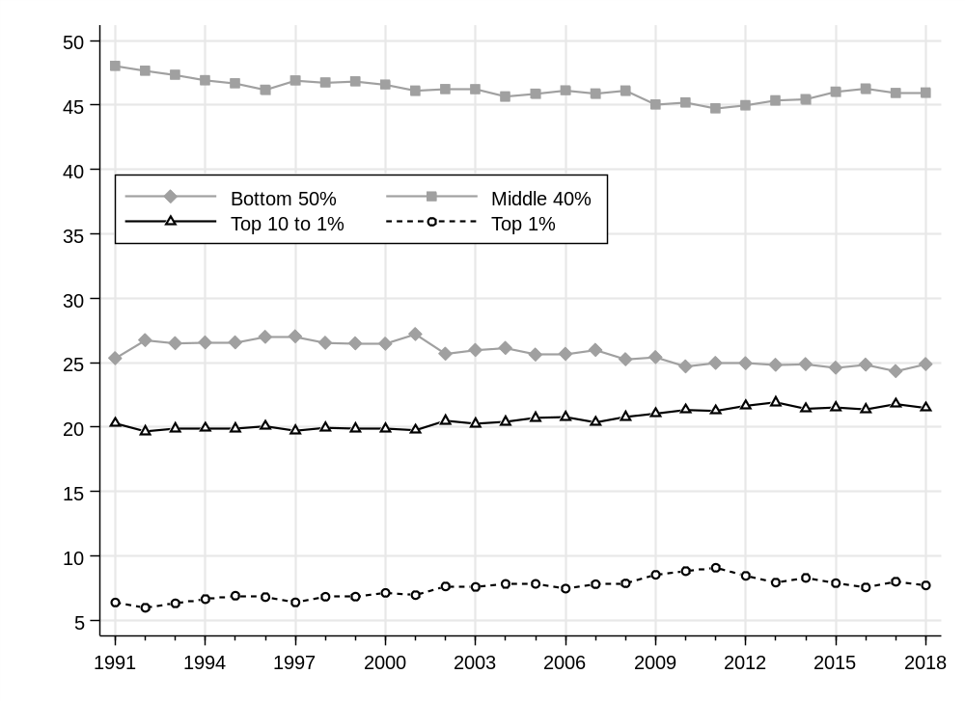
Notes: Distribution of post-tax disposable income (after all taxes and transfers) among adults. Broad equal-split adults series (household income equally split among adults).
Stata graph net_split2_incsh_a
Figure C.2: Mean adult income by income group 1991-2018
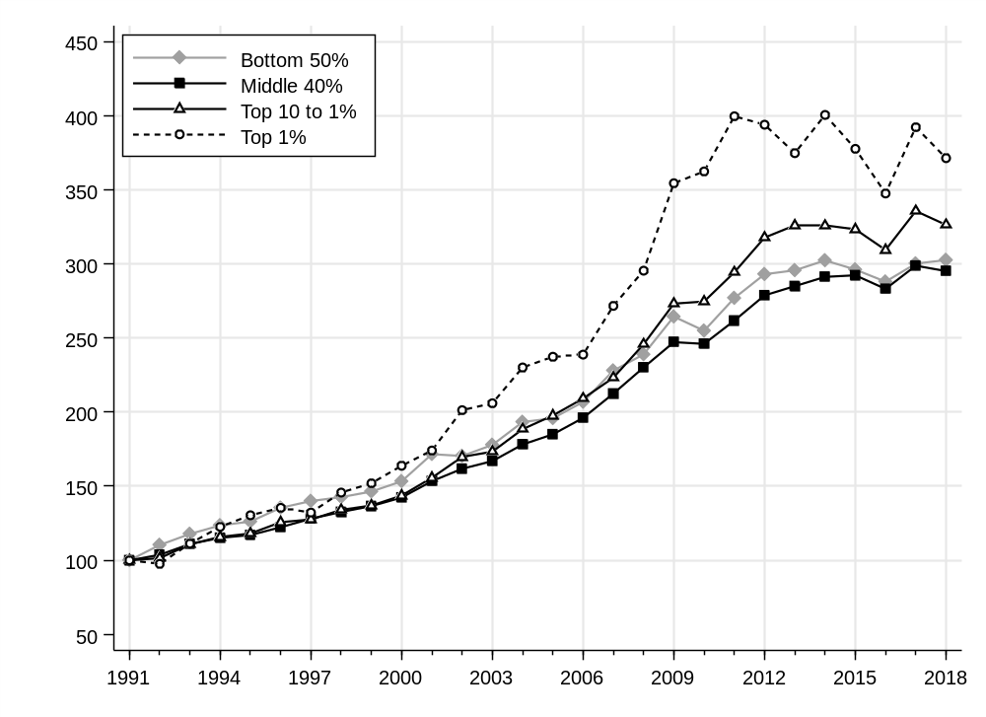
Notes: Distribution of post-tax disposable income (before all taxes and transfers, except age pensions) among adults. Broad equal-split adults series (household income equally split among adults). Index based on mean incomes in current dollars.
Stata graph net_split2_mean_index_a
Figure C.3: Top 10% and bottom 50% income shares: Australia, US and France 1991-2018
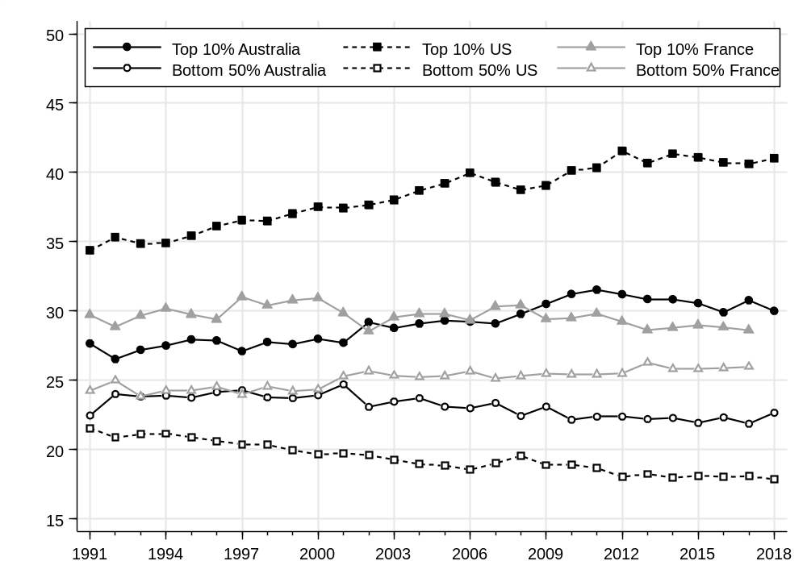
Notes: Distribution of post-tax disposable income (after all taxes and transfers) among adults. Narrow-equal-split adults series (income of married couples divided by two).
Stata graph intcomp_net_sh1
Figure C.4: Top 1% and middle 40% income shares: Australia, US and France 1991-2018
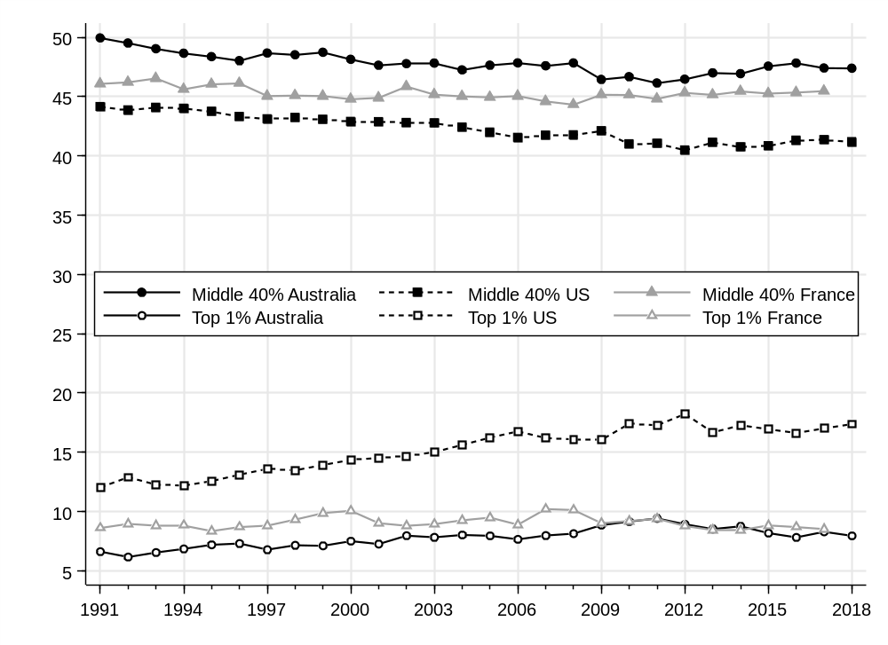
Notes: Distribution of post-tax disposable income (after all taxes and transfers) among adults. Narrow-split-adults series (income of married couples divided by two).
Stata graph intcomp_net_sh2
Table C.1: Mean post-tax disposable adult income by income group (current dollars, 1991-2018)
 | Income group
 | Bottom 50% | Middle 40% | Top 10% to 1% | Top 1% | All
1991 | 9,327 | 22,107 | 41,517 | 117,719 | 18,417
1992 | 10,291 | 22,925 | 42,113 | 114,898 | 19,252
1993 | 10,986 | 24,536 | 45,995 | 131,012 | 20,747
1994 | 11,522 | 25,454 | 48,082 | 144,299 | 21,706
1995 | 11,765 | 25,871 | 49,019 | 153,476 | 22,167
1996 | 12,630 | 27,037 | 52,179 | 159,379 | 23,415
1997 | 13,055 | 28,304 | 52,957 | 155,635 | 24,159
1998 | 13,301 | 29,309 | 55,637 | 171,529 | 25,087
1999 | 13,652 | 30,190 | 56,859 | 178,908 | 25,787
2000 | 14,297 | 31,470 | 59,647 | 192,801 | 27,030
2001 | 16,004 | 33,906 | 64,628 | 204,923 | 29,424
2002 | 15,890 | 35,759 | 70,486 | 236,930 | 30,952
2003 | 16,587 | 36,902 | 71,936 | 242,448 | 31,951
2004 | 18,028 | 39,384 | 78,236 | 270,868 | 34,510
2005 | 18,264 | 40,889 | 82,083 | 279,365 | 35,667
2006 | 19,290 | 43,338 | 86,822 | 281,070 | 37,594
2007 | 21,260 | 46,963 | 92,650 | 319,793 | 40,944
2008 | 22,282 | 50,862 | 102,000 | 347,733 | 44,135
2009 | 24,656 | 54,635 | 113,397 | 417,185 | 48,533
2010 | 23,769 | 54,381 | 113,990 | 426,537 | 48,142
2011 | 25,825 | 57,854 | 122,167 | 470,334 | 51,743
2012 | 27,327 | 61,617 | 131,897 | 463,651 | 54,806
2013 | 27,571 | 62,990 | 135,288 | 441,052 | 55,563
2014 | 28,194 | 64,373 | 135,203 | 471,410 | 56,701
2015 | 27,619 | 64,610 | 134,219 | 444,461 | 56,163
2016 | 26,855 | 62,577 | 128,426 | 409,045 | 54,099
2017 | 27,995 | 66,040 | 139,315 | 461,633 | 57,550
2018 | 28,219 | 65,227 | 135,450 | 437,086 | 56,756

Appendix D: Population shares by demographic group
Figure D.1: Adult population shares by age group (1991-2018)
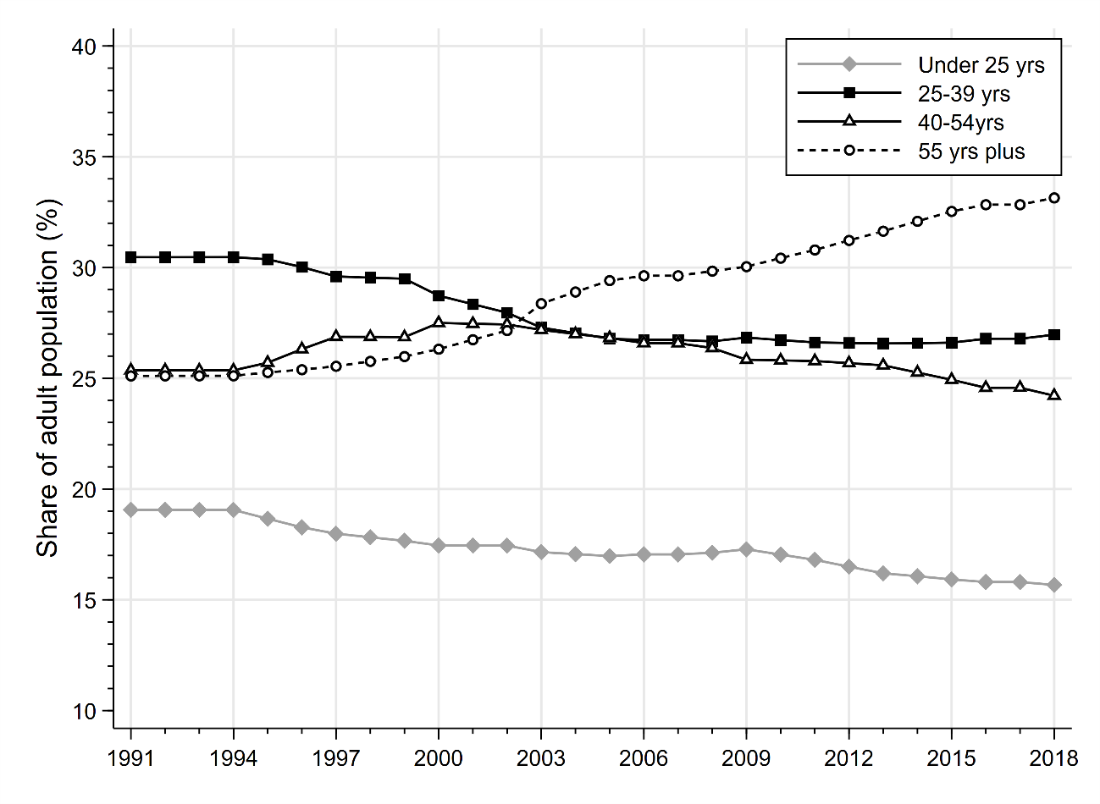
Figure D.2: Adult population shares by education attainment (1991-2018)
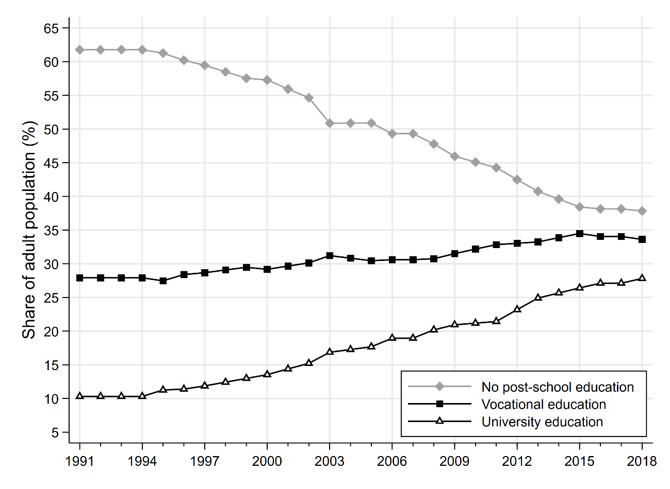
Figure D.3: Adult population shares for natives and immigrants (1991-2018)
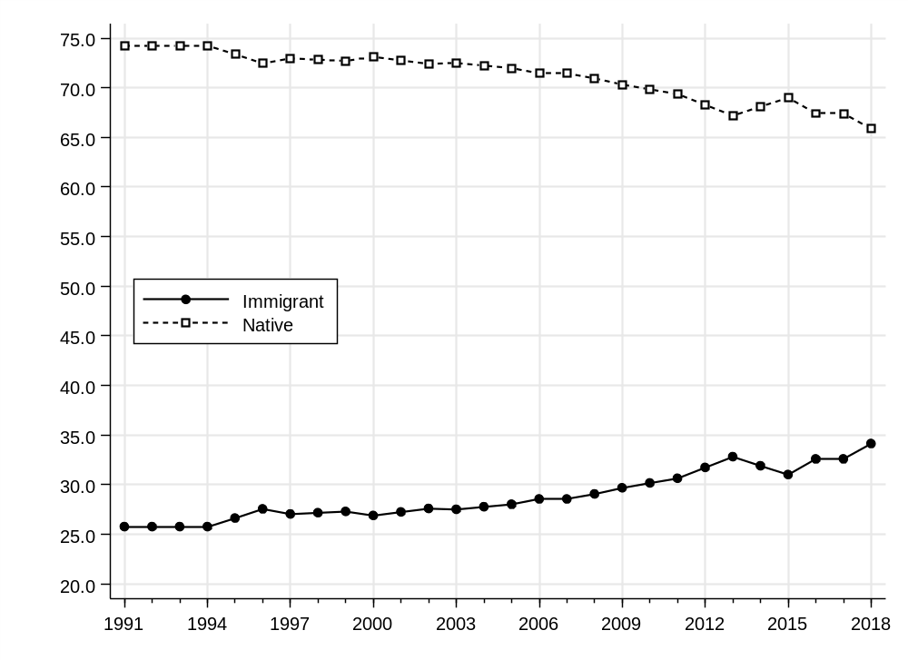
Figure D.4: Adult population shares by area of residence (1991-2018)
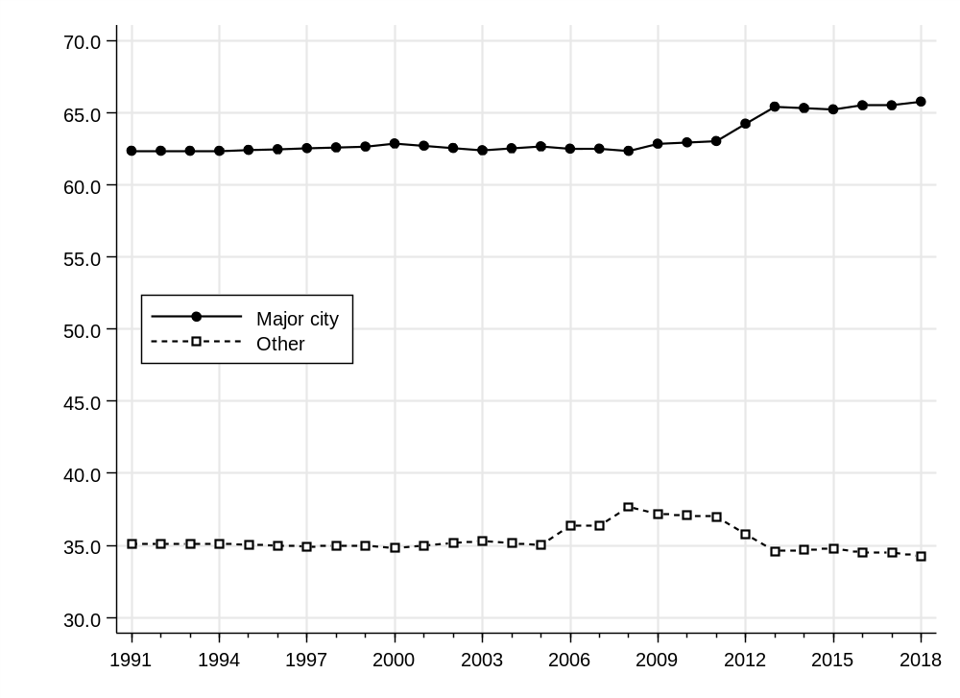

Appendix E: Inequality by demographic group: Individualistic series
Figure E.1: Mean post-tax national income per adult by sex (1991-2018)
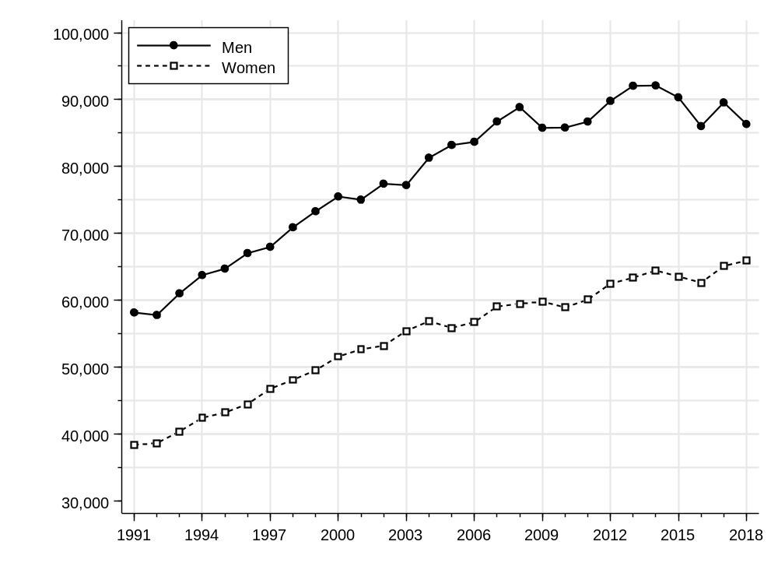
Stata graph ptninc_mean_split0_sex_b
Figure E.2: Post-tax national income shares among men and women (1991-2018)
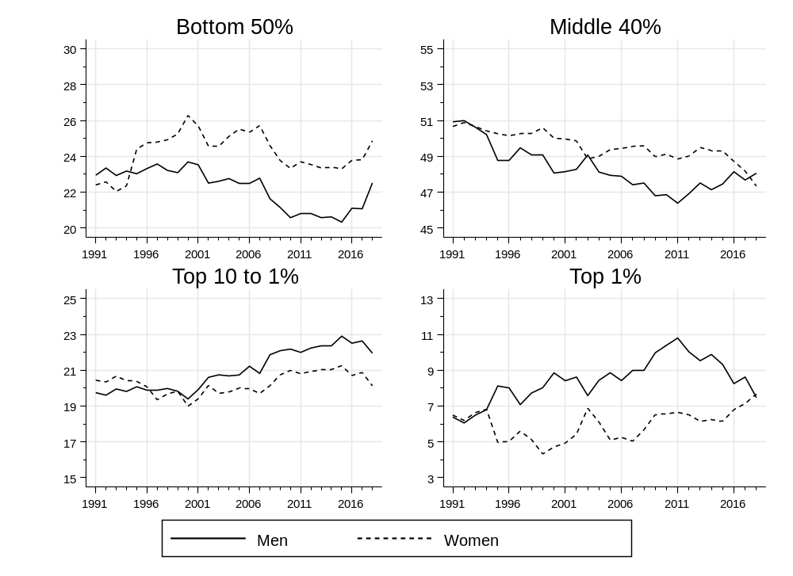
Stata graph pshares_split0_sexp_ptninc_b
Figure E.3: Mean post-tax national income per adult by educational attainment (1991-2018)
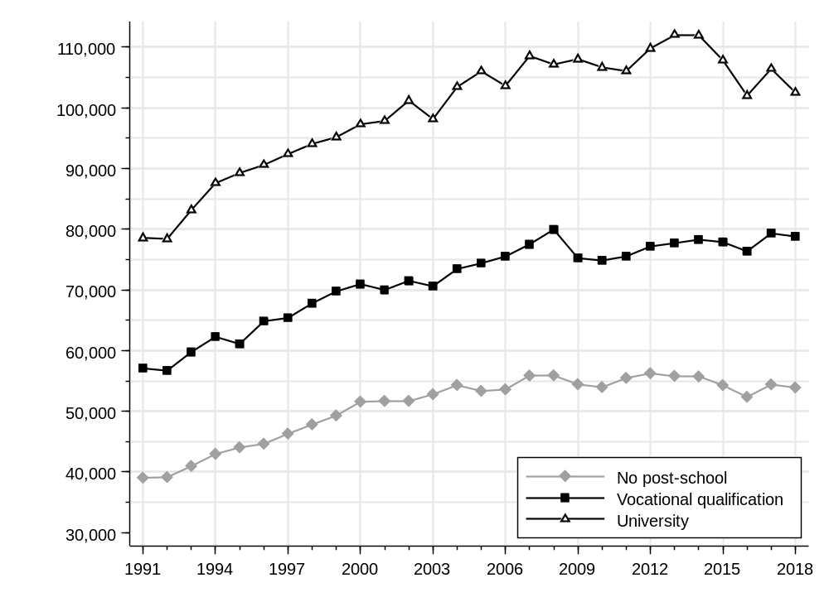
Stata graph ptninc_mean_split0_edu_b
Figure E.4: Post-tax national income shares within education groups (1991-2018)
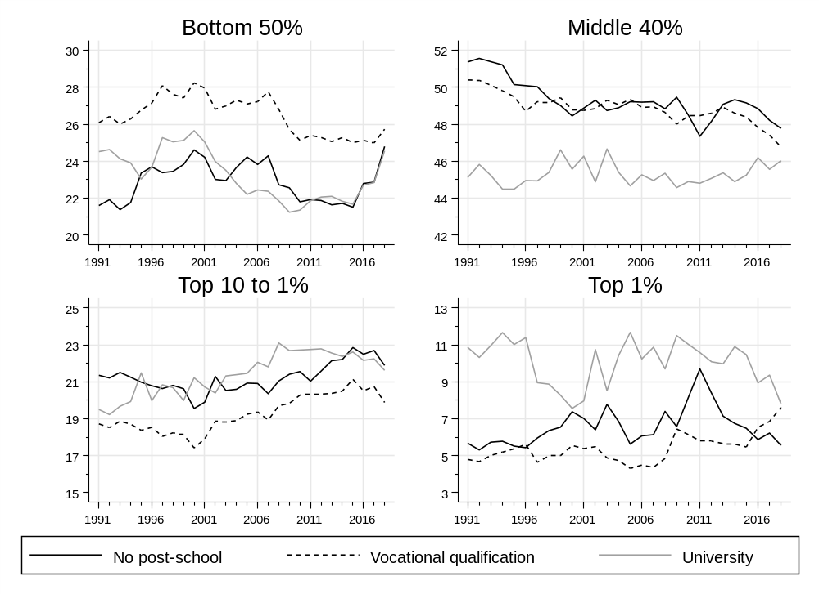
Stata graph pshares_split0_edu_ptninc_b

