Author’s Biography and Pictures
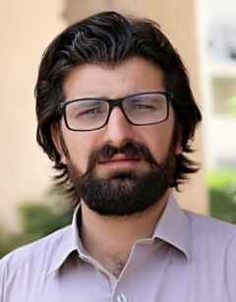
Muhammad Ayaz received the Bachelor and Master degrees in Computer Science from The University of Agriculture Peshawar, Pakistan in 2014 and 2018, respectively. He worked at The University of Agriculture as a Student Research Scholar from 2018-2020. He has published many research papers including survey/review and conference papers. His research interest includes Wireless Networks, Sensor Networks, Deep Learning, and HCI.

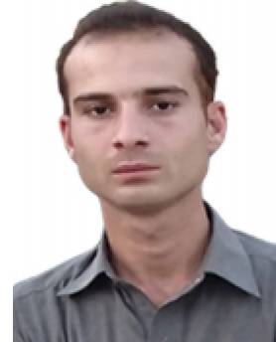
Tariq Hussain received the M.S. degree with the Institute of computer sciences and information technology the agriculture university Pesha-war in 2019. and B.S. degree from University of Malakand Pakistan, in 2015, Now he is a Doctorial student at School of Computer Science and Information Engineering, Zhejiang Gongshang University Hang-zhou China. His research interests are Big Data, Internet of Thangs and Cloud Computing. Data analytics and AI.

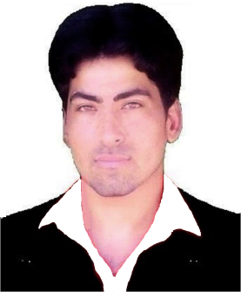
Altaf Hussain received the Bachelor and Master degrees in Computer Science from University of Peshawar, Pakistan in 2013 and The University of Agriculture Peshawar, Pakistan in 2017, respectively. He has published many research papers including survey/review and conference papers. He is working as a Research Assistant with the Department of Accounting and Information Systems, College of Business and Economics, Qatar University since June 2021. His research interest includes Wireless Networks, Sensor Networks, Unmanned Aerial Ad-hoc Network, Deep Learning, and 3D Point Cloud.
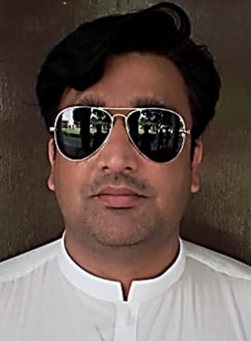
Iqtidar Ali received has MSc degree Professional Networking (MERIT) from Shefeld Hallam University (UK), in 2012. B.S. degree in Computer Science from University of Peshawar, in 2008. Now he is a PhD student at institute of Computer Science and information tech-nology, The Agriculture University Peshawar. His current research interests include routing and scheduling techniques, QoS, security and privacy in Wireless Sensor Network and Ad Hoc Network.

