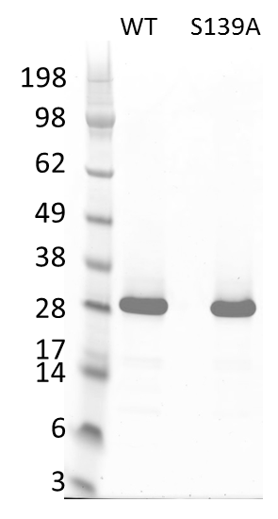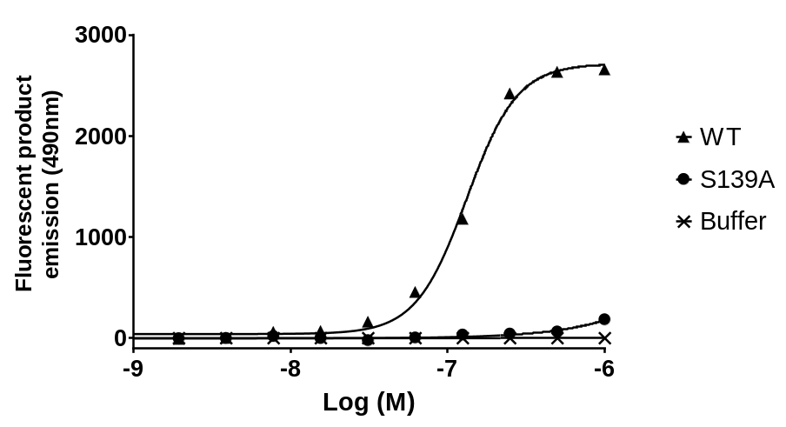
b
a
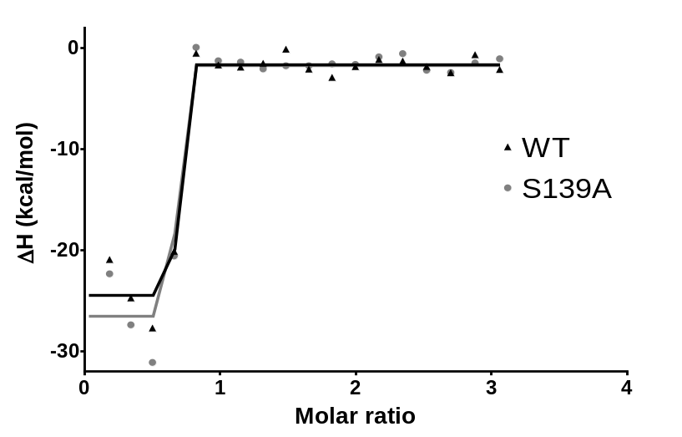
K_{d} ~ 1 pM
c

Suppl. Fig 1: Characterization of the S139A active site variant of HCV NS3/4A PR. (a) SDS-PAGE gel of purified recombinant WT and S139A HCV NS3/4A PR. (b) S139A mutant of HCV NS3/4A PR exhibits minimal activity relative to WT HCV NS3/4A PR in a peptide cleavage assay. (c) The WT and S139A version of HCV NS3/4A PR exhibit equivalent affinity as measured by isothermal calorimetry.

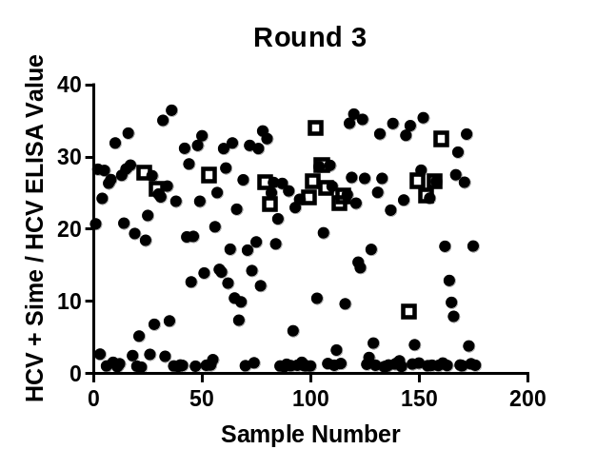
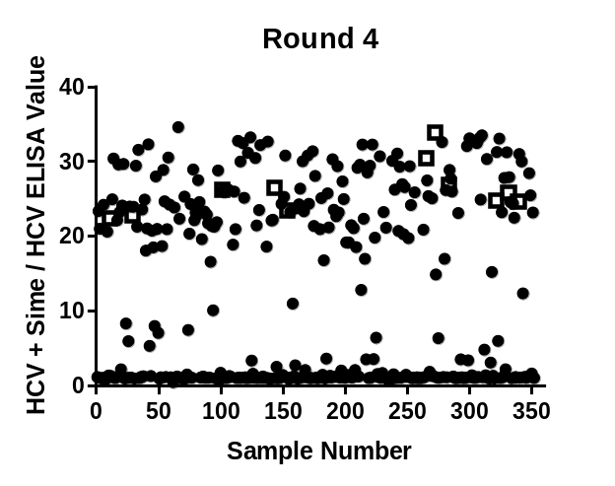

Suppl. Fig 2: Selectivity of individual clones from phage display selection outputs 3 and 4 for binding to the HCV NS3/4A PR:simeprevir complex over the HCV NS3/4A PR alone was determined by phage ELISA.

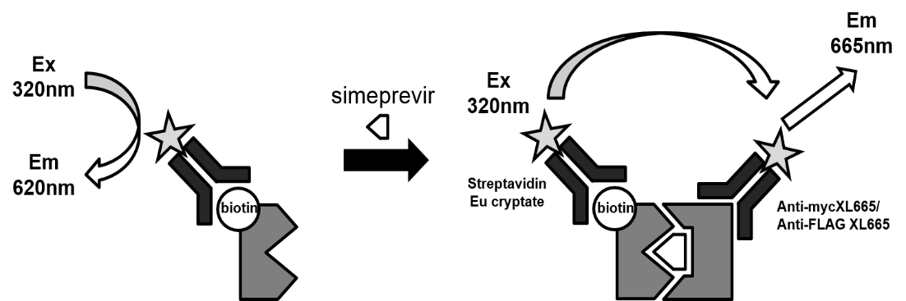

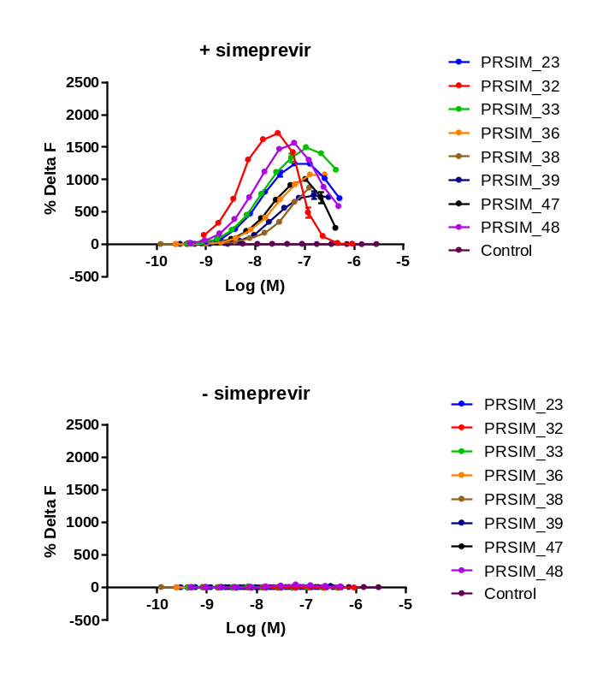

Suppl. Fig 3: (Top) Schematic of the homogeneous time-resolved fluorescence (HTRF) assay employed to measure the binding of PRSIM molecules to HCV NS3/4A PR (S139A) alone or in complex with simeprevir. (Middle) PRSIM molecules binding to the HCV NS3/4A PR:simeprevir complex but not the HCV NS3/4A PR alone (bottom) in an HTRF assay.

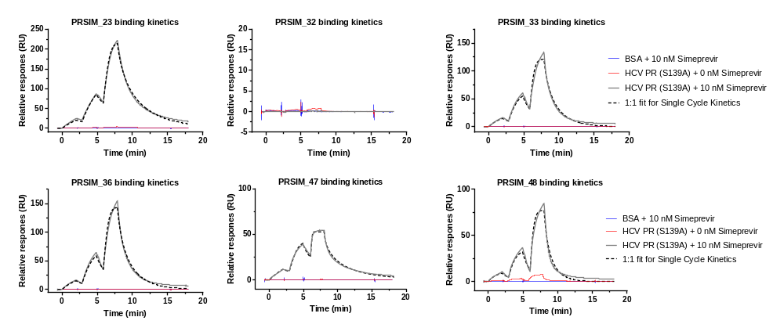

Suppl. Fig. 4: Binding of HCV PR, or BSA control, to PRSIM binding molecules in the presence or absence of simeprevir. The interactions between HCV PR (or BSA) and PRSIM binding molecules were measured by Surface Plasmon Resonance (SPR) using a Biacore 8K instrument at 25 °C. HCV PR bound to five PRSIM binding molecules strongly and selectively in the presence of simeprevir (grey lines). Only one molecule (PRSIM_48) showed significant non-specific binding to HCV PR alone (red lines). BSA did not bind to the PRSIM binding molecules in the presence of simeprevir (blue lines). Solid grey lines represent measured data points and the dashed black lines represent the 1:1 fit for Single Cycle Kinetics data used for analysis.

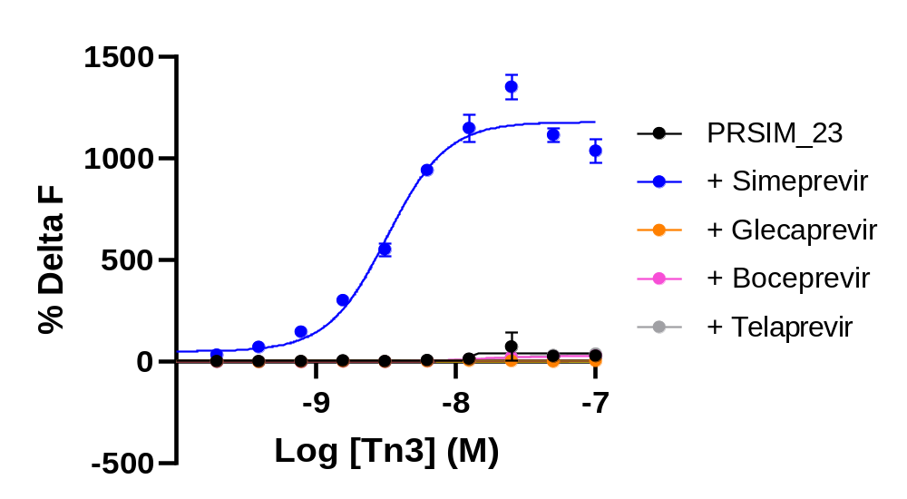

Suppl. Fig 5: PRSIM_23 binds to HCV PR in complex with simeprevir (blue closed circles) but not to HCV PR in complex with covalent HCV protease inhibitors in an HTRF assay.

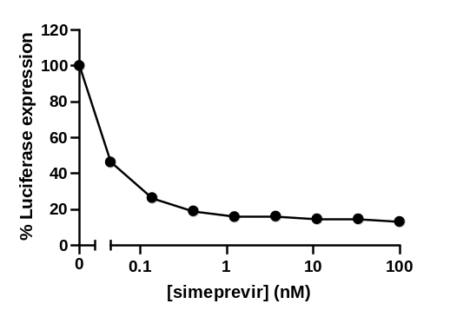
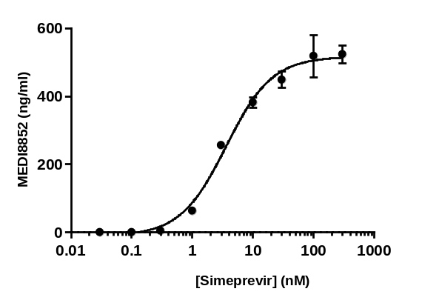

Suppl. Fig. 6: (Left) Simeprevir-induced dose-dependent expression of MEDI8852 IgG via the PRSIM_23-CID module-based split transcription factor. MEDI8852 concentrations were measured using the Singleplex Human/NHP IgG Isotyping Kit (Mesoscale Discovery). (Right) Simeprevir dose-dependent inhibition of luciferase expression after induction of shRNA targeting luciferase via the PRSIM_23-CID module-based split transcription factor.

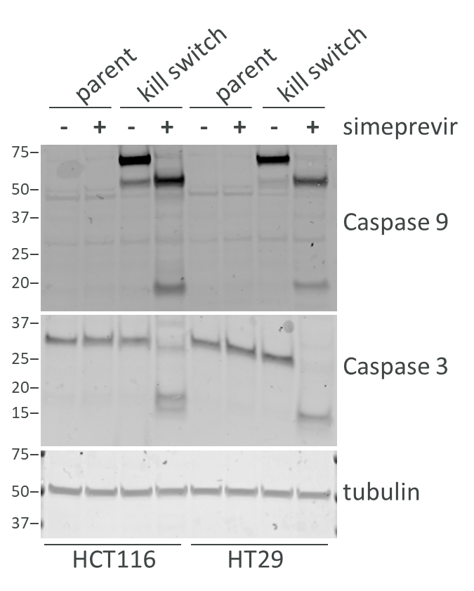

Suppl. Fig. 7: Western blot of cell lysates shows cleavage of Caspase9 incorporated into the PRSIM_23-based kill switch and downstream Caspase 3 in HCT116 and HT29 cells stably transduced with the kill switch, but not in the parental cells after 3-4h treatment with 10nM simeprevir. Tubulin is the loading control.

Supplementary Tables

Supplementary Table 1: Tn3 PRSIM binding molecules that are selective for the HCV PR:simeprevir complex over HCV PR alone were identified in homogeneous time-resolved fluorescence (HTRF) assays run in parallel to measure binding in the presence and absence of simeprevir.
Clone Name | Selection round | Binding fold change [(HCV protease + simeprevir binding) / HCV protease alone] | HTRF max. signal (% delta F)
PRSIM_23 | 4 | 23.8 | 1573
PRSIM_24 | 3 | 31.5 | 561
PRSIM_25 | 4 | 24.0 | 577
PRSIM_26 | 4 | 25.5 | 304
PRSIM_27 | 4 | 25.3 | 422
PRSIM_28 | 3 | 27.1 | 692
PRSIM_29 | 3 | 26.0 | 365
PRSIM_30 | 3 | 25.4 | 550
PRSIM_31 | 4 | 25.0 | 351
PRSIM_32 | 4 | 22.4 | 1955
PRSIM_33 | 3 | 29.9 | 1704
PRSIM_34 | 3 | 22.2 | 614
PRSIM_35 | 3 | 24.8 | 437
PRSIM_36 | 3 | 27.9 | 1440
PRSIM_37 | 3 | 25.3 | 867
PRSIM_38 | 3 | 23.3 | 1061
PRSIM_39 | 4 | 24.9 | 1015
PRSIM_40 | 3 | 26.1 | 218
PRSIM_41 | 4 | 22.8 | 964
PRSIM_42 | 3 | 8.8 | 1895
PRSIM_43 | 3 | 28.6 | 317
PRSIM_44 | 3 | 25.6 | 340
PRSIM_45 | 4 | 33.3 | 842
PRSIM_46 | 3 | 33.3 | 362
PRSIM_47 | 3 | 25.3 | 1367
PRSIM_48 | 3 | 26.6 | 1780
PRSIM_49 | 4 | 30.0 | 761
PRSIM_50 | 4 | 26.3 | 897

Supplementary Table 2: Kinetics of HCV PR binding to PRSIM binding molecules in the presence of simeprevir.

 |  | HCV NS3/NS4A (S139A) + 10 nM simeprevir
 | ID | k_{a} (M⁻¹ s⁻¹) | k_{d} (s⁻¹) | K_{D} (nM) | %R_{max}¥ (RUs)
Tn3 | PRSIM_23 | 6.07 (± 1) × 10⁶ | 3.72 (± 0.5) × 10⁻² | 6.14 (± 0.2) | 24 (± 4)
Tn3 | PRSIM_32 | N.D. | N.D. | # | N.D.
Tn3 | PRSIM_33 | 6.71 (± 9) × 10⁸ | 3.88 (± 5) × 10⁰ | 6.99 (± 1.4) | 12 (± 3)
Tn3 | PRSIM_36 | 8.67 (± 3) × 10⁶ | 9.63 (± 4) × 10⁻² | 10.9 (± 1) | 19 (± 1)
Tn3 | PRSIM_47 | 4.16 (± 5) × 10¹⁰ | 7.90 (± 9) × 10¹ | 1.96 (± 0.1) | 23 (± 1)
Tn3 | PRSIM_48 | 4.24 (± 7) × 10⁹ | 4.04 (± 7) × 10¹ | 12.2 (± 2.4) | 15 (± 5)

The interactions between HCV PR and PRSIM binding molecules were measured by Surface Plasmon Resonance (SPR) using a Biacore 8K instrument at 25 °C. The PRSIM binding molecules were immobilized onto CM5 chips. The HCV PR in the presence of simeprevir was then flowed over the chips in sequentially increasing concentrations (single cycle kinetics). The equilibrium dissociation constant (K_{D}) was determined using a 1:1 binding model. Data are presented as average ± standard deviation from 3 independent experiments. N.D. = indicates the values could not be determined due to absence of detectable binding. # = no binding. Data in italics indicates high association rate and lower than expected R_{max}. ¥= % of theoretical R_{max}.

