Supplementary Table 1: Eigenvalues and Percentage Variance Explained by Five Principal Components (PC’s)
PC | Eigenvalue | Variance (%) | Cumulative Variance (%)
1 | 3.95 | 13.16 | 13.16
2 | 3.20 | 10.67 | 23.83
3 | 2.54 | 8.47 | 32.29
4 | 2.33 | 7.76 | 40.05
5 | 1.73 | 5.75 | 45.80
6 | 1.58 | 5.26 | 51.06
7 | 1.46 | 4.85 | 55.91
8 | 1.33 | 4.43 | 60.34

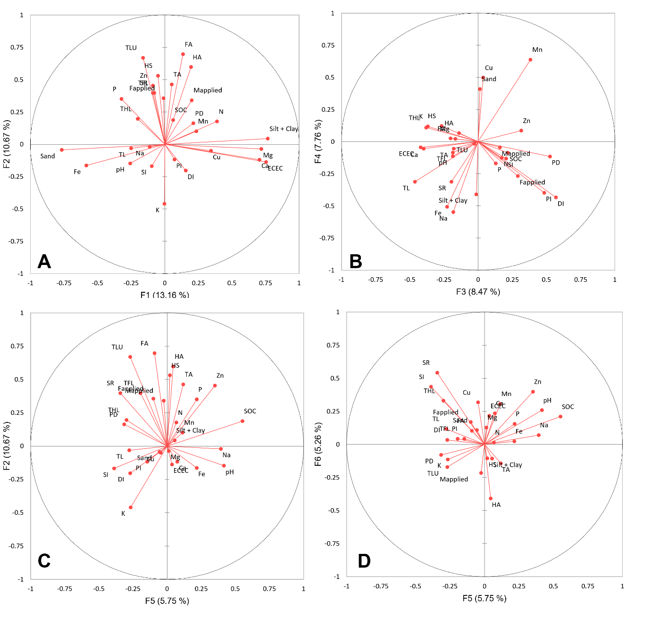
Supplementary Figure 2: 2A-1D shows the contribution and directions of socio-economic and biophysical variables in the first six components resulting from principal component analysis.

