Quantitative CT texture-based method to predict diagnosis and prognosis of fibrosing interstitial lung disease patterns

Babak Haghighi¹, Warren B. Gefter¹, Lauren Pantalone¹, Despina Kontos¹, Eduardo J. Mortani Barbosa Jr.^{1*}
1: Perelman School of Medicine, University of Pennsylvania, Philadelphia, PA, USA.

*Corresponding author:
Dr. Eduardo J. Mortani Barbosa, Jr., Address: Division of Cardiothoracic Imaging, Department of Radiology, Perelman Scholl of Medicine, University of Pennsylvania, 3400 Spruce Street, Ground Floor Founders Bldg. Philadelphia, PA, USA 19104
Email: Eduardo.Barbosa@pennmedicine.upenn.edu

Author Contributions and Guarantor Statement:
EB and LP had full access to all the data in the study and takes responsibility for the integrity of the data and the accuracy of the data analysis and interpretation. EB, BH, WG, and DK contributed substantially to the study design, data analysis and interpretation, and the writing of the manuscript.

Supplementary
Lattice-based texture estimation adopted for lung 3D CT scan was used for feature extraction. Three sets of features were derived: Gray-level histogram, Co-occurrence, Run-length features [1].
Gray-level histogram features are first-order histogram statistics calculated from the gray-level intensity histogram of each image.
Feature | Mathematical Notation | Qualitative description
Mean | $$\frac{\sum_{k}{k*g(k)}}{K}$$ | Mean gray-level value
Min | min($k$) | Minimum gray-level value
Max | max($k$) | Maximum gray-level value
5th Percentile | $k$: 5% of values ≤ $k$ | The histogram bin that 5% of gray-level values are less than or equal to.
5th Mean | $\frac{\sum_{k}{k*g(k)}}{\sum_{k}{g(k)}}$ for $k$ ≤ 5th Percentile | Mean value of the gray-level values which less than or equal to the 5th Percentile.
95th Percentile | $k$: 95% of values ≥ $k$ | The histogram bin that 95% of gray-level values are less than or equal to.
95th Mean | $\frac{\sum_{k}{k*g(k)}}{\sum_{k}{g(k)}}$ for $k$ ≥ 95th Percentile | Mean value of the gray-level values which larger than or equal to the 95th Percentile.
Sum | $$\sum_{k}{k*g(k)}$$ | Sum of gray-level values
Sigma | $$\sqrt{\sum_{k}{{\left(k-Mean\right)}^{2}*g(k)}}$$ | Variation of gray-level values around the Mean
Entropy | $$-\sum_{k}{g\left(k\right)*log⁡(g(k))}$$ | Measure of histogram uniformity
Kurtosis | $$Sigma^{-4}\sum_{k}{{\left(k-Mean\right)}^{4}*g(k)}-3$$ | Measure of histogram flatness
Skewness | $$Sigma^{-3}\sum_{k}{{\left(k-Mean\right)}^{3}*g(k)}$$ | Measure of histogram symmetry
where $k$ is the histogram bin, g is the frequency of the histogram bin and $K=\sum_{k}{g(k)}$.

Co-occurrence features capture the spatial relationship between pixels and are based on the gray-level co-occurrence matrix (GLCM). In a GLCM, each element, $f(i,j)$, corresponds to the frequency with which two neighboring pixels, one with gray level $i$ and the other with $j$, occur within a specified distance ($d$). In our study, the GLCM matrices were estimated using different $window sizes=4, 6, 8, 10, 12, 14, 16, 18, 20$ pixels.

Feature | Mathematical Notation | Qualitative description
Cluster Shade | $$\sum_{ij}{{\left(i-µ_{i}+j-µ_{j}\right)}^{3}*f(i,j)}$$ | Asymmetry in gray-level values
Correlation | $$\sum_{ij}{\frac{\left(i-µ_{i}\right)*\left(j-µ_{j}\right)*f(i,j)}{σ_{i}{*σ}_{j}}}$$ | Linear gray-level dependence
Haralick Correlation | $$\sum_{ij}{\frac{ij*f\left(i,j\right)-µ_{i}*µ_{j}}{σ_{i}{*σ}_{j}}}$$ | Linear gray-level dependence
Energy | $$\sum_{ij}{f{\left(i,j\right)}^{2}}$$ | Certainty of gray-level co-occurrence
Entropy | $$-\sum_{ij}{f\left(i,j\right)*log⁡(f\left(i,j\right))}$$ | Uncertainty of gray-level co-occurrence
Inertia | $$\sum_{ij}{{\left(i-j\right)}^{2}*f(i,j)}$$ | Local variation of gray-level intensity
Inverse Difference Moment | $$\sum_{ij}{\frac{f(i,j)}{1+{\left(i-j\right)}^{2}}}$$ | Local homogeneity in gray-level values
where $μ_{i}=\sum_{j}{i*f(i,j)}$, $μ_{j}=\sum_{i}{j*f(i,j)}$, $σ_{i}^{2}=\sum_{j}{{\left(i-μ_{i}\right)}^{2}*f(i,j)}$, and $σ_{j}^{2}=\sum_{i}{{\left(j-μ_{j}\right)}^{2}*f(i,j)}$.

Run-length features capture the coarseness of a texture in specified directions, where a run is defined as a string of consecutive pixels with similar gray-level intensity along specific linear orientation. Similar to GLCMs, a run-length matrix $R$ is defined, with each element, $R\left(i,j\right)$, representing the number of runs with pixels of gray-level intensity equal to $i$ and length of run equal to $j$ along the specific orientation. The size of the matrix $R$ is $M×N$, where $N$ is equal to the maximum run length. The following run-length statistics were estimated using different $window sizes=4, 6, 8, 10, 12, 14, 16, 18, 20$ pixels.

Feature | Mathematical Notation | Qualitative description
Gray Level Non-uniformity | $$\frac{1}{n_{r}}{\sum_{i=1}^{M}{\left(\sum_{j=1}^{N}{R\left(i,j\right)}\right)}}^{2}$$ | Dissimilarity in runs across gray-level values
High Gray Level Run Emphasis | $$\frac{1}{n_{r}}\sum_{i=1}^{M}{\sum_{j=1}^{N}{R\left(i,j\right)*i^{2}}}$$ | Runs of high-gray-level values
Long Run Emphasis | $$\frac{1}{n_{r}}\sum_{i=1}^{M}{\sum_{j=1}^{N}{R\left(i,j\right)*j^{2}}}$$ | Emphasis on the long runs
Low Gray Level Run Emphasis | $$\frac{1}{n_{r}}\sum_{i=1}^{M}{\sum_{j=1}^{N}{\frac{R\left(i,j\right)}{i^{2}}}}$$ | Runs of low-gray-level values
Run Length Non-uniformity | $$\frac{1}{n_{r}}{\sum_{j=1}^{N}{\left(\sum_{i=1}^{M}{R\left(i,j\right)}\right)}}^{2}$$ | Dissimilarity in runs across lengths
Run Percentage | $$\frac{n_{r}}{\#pixels}$$ | Homogeneity and distribution of runs
Short Run Emphasis | $$\frac{1}{n_{r}}\sum_{i=1}^{M}{\sum_{j=1}^{N}{\frac{R\left(i,j\right)}{j^{2}}}}$$ | Emphasis on the short runs
where $n_{r}=\sum_{i=1}^{M}{\sum_{j=1}^{N}{R\left(i,j\right)}}$ is the total number of runs.

Deep Learning Classification
The multi-layer neural network consists of two hidden layers with 64 nodes was used for UIP vs non-UIP classification. The input imaging features was normalized (Figure S1) and was then processed layer by layer from the first to the final output. The results showed 75 accuracy with 5-folds cross validation for window size=4mm.
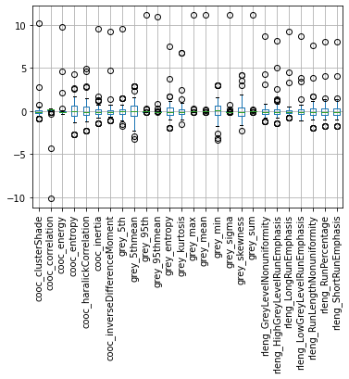
Figure. S1: 26 3D normalized features for feeding into neural network.

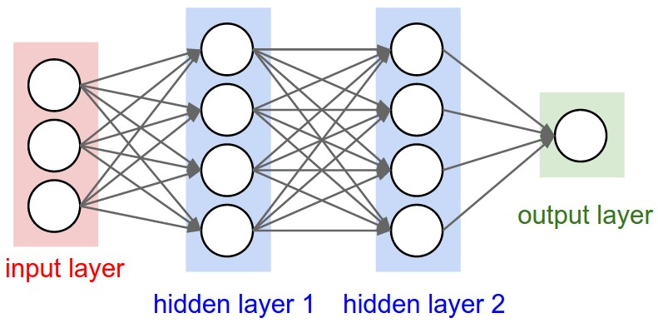
Figure. S2: The schematic of the neural network used for classification with input layer (imaging features) and output (UIP vs non-UIP).

References
- Zheng Y, Keller BM, Ray S, Wang Y, Conant EF, Gee JC, Kontos D. Parenchymal texture analysis in digital mammography: A fully automated pipeline for breast cancer risk assessment. Med Phys. 2015;42:4149–4160.

