Appendix 2

In this model, we standardize the payoffs by assigning 0 to the lowest payoff and 1 to the highest payoff. For the physician, the highest payoff (payoff of 1) occurs when transplant is given to a curable addict or refused to a refractory addict; in this second case we tacitly assume that the organ is passed to a nonadict. The second highest payoff (payoff of α, 0<α<1) is obtained when a curable addict is refused a transplant. And, finally, the lowest payoff (payoff of 0) obtains when a transplant is given to an refractory addict.

For the payoffs to a patient we use the following notation and assumptions: For a curable patient we will denote the payoff to getting a transplant by β_{C} , the payoff to not getting a transplant by β_{C}* and the cost of signaling by ε_{C}. The only assumption we make is that: β_{C} > β_{C}* > 0. We don’t assume anything about ε_{C}, other than ε_{C} > 0. In other words, incurring this cost diminishes player’s utility by ε_{C} , that is, adds -ε_{C} to this utility. Similarly, for a refractory patient β_{R} is the payoff to getting a transplant, β_{R}* the payoff to not getting a transplant, and ε_{R} the cost of signaling. We only assume that β_{R} > β_{R}* > 0. Again, the cost of signaling ε_{R} > 0 diminishes player’s utility by ε_{R}. It is important to note that we don’t assume anything about how the payoffs to a curable patient compare to the payoffs to refractory patient.

Strategies of the patient: {S_{C} S_{R}, S_{C} NS_{R}, NS_{C} S_{R}, NS_{C} NS_{R}}; strategies of the physician: {T_{S} NT_{NS}, T_{S} NT_{NS}, NT_{S} T_{NS}, NT_{S} NT_{NS}}. Payoffs for the physician are pooled from both types of patients since the physician does not know which types he is playing against. More specifically:

u(T_{S} T_{NS} ,S_{C} S_{R}) = u(T_{S} T_{NS} ,S_{C} NS_{R}) = u(T_{S} T_{NS} ,NS_{C} S_{R}) = u(T_{S} T_{NS} ,NS_{C} NS_{R}) = u(T_{S} NT_{NS} ,S_{C} S_{R}) = u(NT_{S} T_{NS} ,NS_{C} NS_{R}) = p • 1 + (1-p) • 0 = p

u(NT_{S} NT_{NS} ,S_{C} S_{R}) = u(NT_{S} NT_{NS} ,S_{C} NS_{R}) = u(NT_{S} NT_{NS} ,NS_{C} S_{R}) = u(NT_{S} NT_{NS} ,NS_{C} NS_{R}) = u(T_{S} NT_{NS} ,NS_{C} NS_{R}) = u(NT_{S} T_{NS} ,S_{C} S_{R}) = p • α + (1-p) • 1 = 1-p+pα

u(T_{S} NT_{NS} ,S_{C} NS_{R}) = u(NT_{S} T_{NS} ,NS_{C} S_{R}) = p • 1 + (1-p) • 1 = 1

u(NT_{S} T_{NS} ,S_{C} NS_{R}) = u(T_{S} NT_{NS} ,NS_{C} S_{R}) = p • α + (1-p) • 0 = pα .

We used this model to identify the payoff conditions necessary for the 6-month rule to work. For the 6-month rule to work we would need to have an equilibrium where one type of patient signals while the other one does not so that the physician can separate the two types by their signaling behavior.

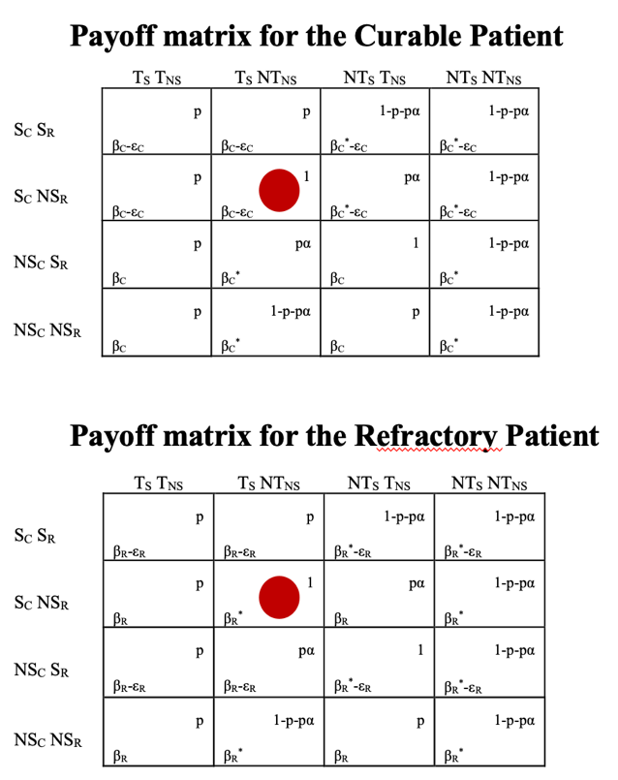
The first case to consider is when the curable patient signals and refractory patient does not, and the physician decides to transplant a patient who signals and not to transplant a patient who does not. Location of separating equilibria are marked with red dots.

For the pair of strategies for a curable patient (the first payoff matrix) to be in Nash equilibrium we need β_{C}-ε_{C} > β_{C}* i.e., β_{C}- β_{C}* > ε_{C} which means that the difference in payoffs between getting a transplant (β_{C}) and not getting it (β_{C}*) is larger than the cost of signaling. In other words, abstaining for 6 months is worthwhile if it results in getting a transplant.

For a refractory patient (the second payoff matrix) we need β_{R}-ε_{R} < β_{R}* i.e., β_{R}- β_{R}* < ε_{R} which means that the cost of signaling is larger than the difference between getting (β_{R}) and not getting (β_{R}*) a transplant. In other words, the price of abstaining for 6 months is so large that it is not worthwhile getting a transplant.

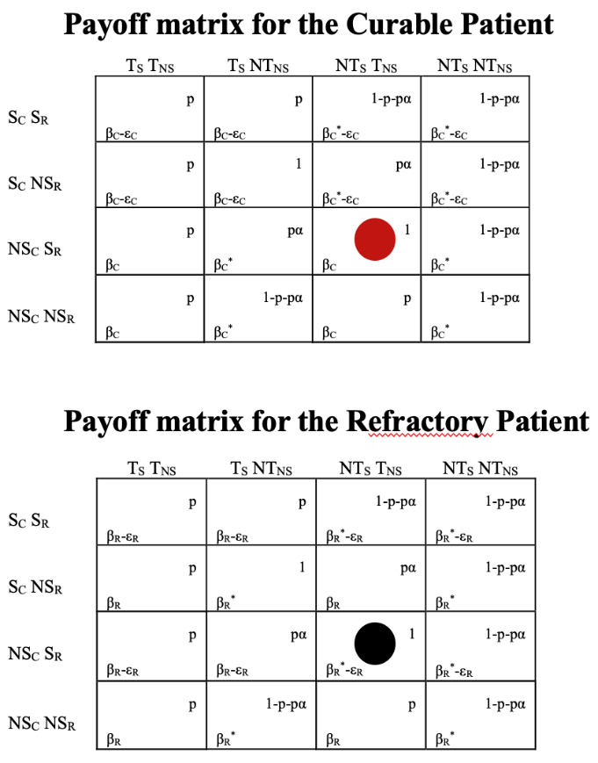

The second case to consider is when the curable patient does not signal and refractory patient does, and the physician transplants when a patient does not signal and does not transplant otherwise. Location of separating equilibria are marked with dots.

For the pair of strategies for a curable patient (the first payoff matrix) to be in Nash equilibrium we need β_{C} > β_{C}*-ε_{C} which, obviously, holds given that β_{C} > β_{C}* and ε_{C} > 0.
For the pair of strategies for a refractory patient (the second payoff matrix) to be in Nash equilibrium we would need β_{R}*- ε_{R} > β_{R}. This, however, does not hold given that β_{R} > β_{R}* and ε_{R} > 0.

Hence, the second case does not yield a separating equilibrium where the two types of players signal differently allowing the physician to distinguish between them.

Takeaways

The 6-month rule works only in the unlikely case that the cost of abstaining for refractory patients is so large that it outweighs the benefits of getting a transplant. In other words, this results in a ridiculous scenario where a refractory patient is better off continuing to drink and not getting a transplant than abstaining for 6 months and getting a transplant. The necessary condition for a curable patient is that the payoff difference between getting and not getting a transplant is larger than the cost of signaling. These are testable payoff conditions, and their validity can be assessed from the data.

